**Project Title - Discussion Forum**

Team Members: Chaitanya Kintali   
Amulya Prodduturi

Prashanth Minkuri

Di Wu

## ***PROJECT PROPOSAL***

**Content, Scope and Objectives**

**Objective:**

The objective of this project is to build a web based discussion forum which acts as a platform where Users can post their queries, read about different topics, answer and solve the questions posted. Each post/query can be tagged with a category. A user can choose the categories that he is interested in and will be shown all the posts that belong to that category. Once a query is solved, the user who posted that query can mark it done and close the thread. A leaderboard is maintained to track the contributions made by the user to the forum. An admin can have the privileges to delete a post, ban a user and monitor the forum.

## ***PROJECT ENVIRONMENT***

Languages used :

|  |  |
| --- | --- |
| Frontend | HTML5, CSS3, Bootstrap4, Javascript |
| Middleware | Java(1.8) and Spring Boot(2.0) |
| Database | MySql (5.5) |

## 

## ***HIGH LEVEL REQUIREMENTS***

### **Initial user roles**

|  |  |
| --- | --- |
| **User Role** | **Description** |
| Admin | Admin monitors the forum. |
| Student (user) | Users can post their queries and answer the queries already posted. |

### **Initial user story descriptions**

|  |  |
| --- | --- |
| **Story ID** | **Story description** |
| US1 | As a User, I want to create an account. |
| US2 | As a User, I want to log in/ log out from my account. |
| US3 | As a User, I want to choose topic(s) that I am interested in, so that I can easily find the related queries. |
| US4 | As a User, I can post queries. |
| US5 | As a User, I can answer queries. |
| US6 | As a User, I can comment on others’ comments. |
| US7 | As a User, I can tag several categories to queries. |
| US8 | As a User, I can report queries and comments to Admin |
| US9 | As an Admin, I want to create a topic to classify the queries. |
| US10 | As an Admin, I can delete/hide the queries and answers posted in the forum. |

**Note**: User can be referred to both Student and Admin

## 

## ***HIGH LEVEL CONCEPTUAL DESIGN***

Entities:

**ROLE**

Attributes:

Role_id (single-valued)

Role_Name (single-valued)

**User**

Attributes:

User_ID (single-valued)

User_Name(single-valued)

Role_id (single-valued)

Date_of_birth [composite, single-valued]

addr_line1 [composite]

addr_line2 [composite]

city (single-valued)

state (single-valued)

zip_code (single-valued)

**Queries**

Query_ID (single-valued)

Query_Desc [composite]

Posted_Date (single-valued)

User_ID (single-valued)

Resolved (single-valued)

isActive (single-valued)

**Query_detail**

Querydetail_id(single-valued)

Query_ID (single-valued)

Category_ID (single-valued)

**Comments**

Comment_ID(single-valued)

Comment_Desc [composite]

Comment_Date [composite]

User_ID(single-valued)

Query_Id (single-valued)

Commented_On (single-valued)

Comment_desc [composite]

**Categories**

Category_ID (single-valued)

Category_name (single-valued)

**Leaderboard**

User_id(single-valued)

User_name (single-valued)

Points(single-valued)

**Message**

MessageId (single-valued)

SenderId (single-valued)

ReciverId(single-valued)

Message [composite]

IsRead bool, (single-valued)

Relationships:

**User** has **role**

Cardinality: Many to One

Participation:

User has Partial participation

Role has Total participation

**User** posts **Queries**

Cardinality: One to many

Participation:

User has partial participation

Queries has total participation

**User** answers **Comments**

Cardinality: One to many

Participation:

User has partial participation

Comments has total participation

**Query** has **Comments**

Cardinality: One to many

Participation:

Query has partial participation

Comments has total participation

**Query** has **Categories**

Cardinality: many to many

Participation:

Query has Total participation

Categories has partial participation

**User** hide/delete **Queries**

Cardinality: One to many

Participation:

User has partial participation

Queries has total participation

**User** sends **Message**

Cardinality : One to many

Participation:

User has partial participation

Message has total participation

## ***LOGICAL DESIGN WITH NORMAL FORM IDENTIFICATION***

Table : **Role**

Columns:

Role_id (PK)

Role_Name (single-valued)

**Highest Normalization: 4NF**

**Justification:**

1. The table is in BCNF

2. The table does not have multi-valued dependencies.

**Indexes**:

Index 1: clustered

Columns: Role_id

**Justification:** Role_id is the primary key of this table, and it is necessary to have at least one unique attribute in a table. We are using the order of this clustered index to store our records and also using this order to scan all the record when doing any queries.

It has already been created automatically.

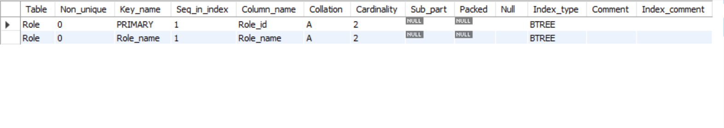

Table : **User**

Columns:

User_ID (PK)

User_Name

Role_id [foreign key; references PK of **Role**]

Date_of_birth [composite, single-valued]

addr_line1

addr_line2

city

state

zipcode

**Highest Normalization: 2NF**

**Justification:**

1. The table is in 1NF

2. There are no partial dependencies

**Violations:**

Table contains transitive dependencies(A non-prime attribute determining the

non-prime attribute). Non-prime attribute Zip-code can be used to determine

State(non-prime attribute). Splitting the entity to make it to 3NF would result in performance overhead for joining the table for an attribute.

**Indexes**:

Index 1: clustered

Columns: User_id

**Justification:** User_id is the primary key of this table, and it is necessary to have at least one unique attribute in a table. We are using the order of this clustered index to store our records and also using this order to scan all the record when doing any queries.

It has already been created automatically.

Index 2: non-clustered

Columns: User_name

**Justification:** It is very common that users search for details of some specific users through their names. So query are often used in some JOIN queries as condition. So we can create index for User_name to increase the speed.

It has already been created automatically.

CREATE INDEX index_UserUser_id ON User (User_name);

SHOW INDEX FROM User;

Index 3: non-clustered

Columns: addr_line1;addr_line2;city

**Justification:** It is very common that users search for details of some specific users through their address. So query are often used in some JOIN queries as condition. So we can create index for address to increase the speed.

It has already been created automatically.

CREATE INDEX index_UserAddress ON User (addr_line1,addr_line2,city);

SHOW INDEX FROM User;

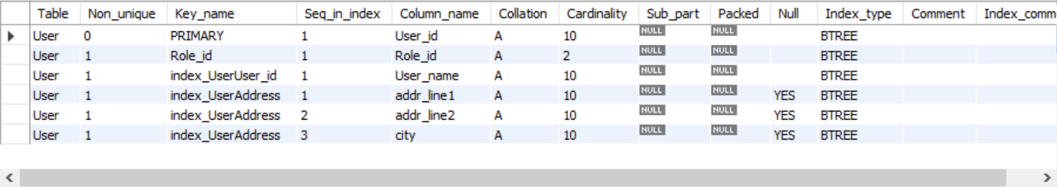

Table : **Queries**

Columns:

Query_ID (PK)

Query_Desc [composite]

Posted_Date (single-valued)

User_ID [foreign key; references PK of **User**]

Resolved (single-valued)

isActive (single-valued)

**Highest Normalization: 4NF**

**Justification:**

1. The table is in BCNF

2. The table does not have multi-valued dependencies.

**Indexes**:

Index 1: clustered

Columns: Query_ID

**Justification:** Query_ID is the primary key of this table, and it is necessary to have at least one unique attribute in a table. We are using the order of this clustered index to store our records and also using this order to scan all the record when doing any queries.

It has already been created automatically.

Index 2: non-clustered

Columns: User_ID

**Justification:** It is very common that users search for Query of some specific user. So User_ID are often used in some JOIN queries as condition. So we can create index for User_ID to increase the speed.

It has already been created automatically.

SHOW INDEX FROM Queries;

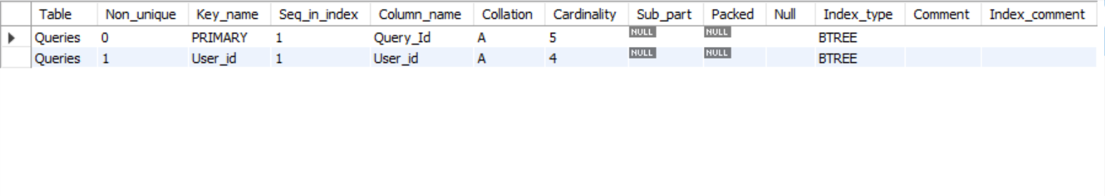

**Cross reference table:**

Table : **Query_detail**

Columns:

Querydetail_id (PK)

Query_ID [foreign key; references PK of **Queries**]

Category_ID [foreign key; references PK of **Categories**]

**Cross reference table justification:** Query_detail table is created to represent the many to many relationship between Queries and Categories

**Highest Normalization: 4NF**

**Justification:**

1. The table is in BCNF

2. The table does not have multi-valued dependencies.

**Indexes**:

Index 1: clustered

Columns: Query_detail_id

**Justification:** Query_detail_id is the primary key of this table, and it is necessary to have at least one unique attribute in a table. We are using the order of this clustered index to store our records and also using this order to scan all the record when doing any queries.

It has already been created automatically.

Index 2: non-clustered

Columns: Query_ID

**Justification:** It is very common that users search for details of some specific query. So query are often used in some JOIN queries as condition. So we can create index for Query_ID to increase the speed.

It has already been created automatically.

Index 3: non-clustered

Columns: Category_ID

**Justification:** It is very common that users search for details of some specific query through category. So Category_ID are often used in some JOIN queries as condition. So we can create index for Category_ID to increase the speed.

It has already been created automatically.

SHOW INDEX FROM Query_detail;

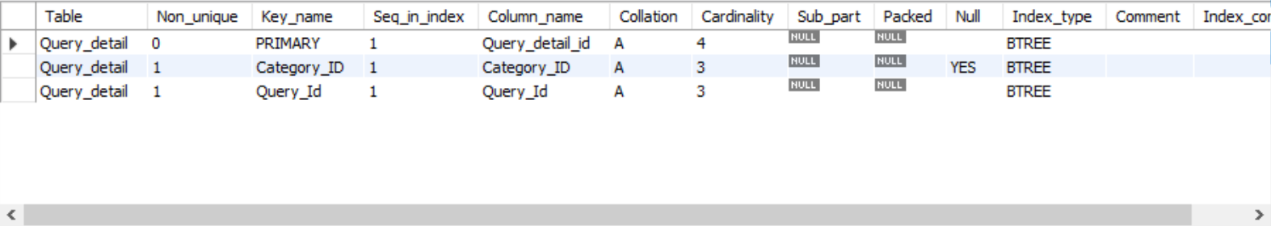

Table : **Comments**

Columns:

Comment_ID (PK)

Comment_Desc

Comment_Date [composite]

User_ID [foreign key; references PK of **User**]

Query_Id [foreign key; references PK of **Queries**]

Commented_On

Comment_desc

**Highest Normalization: 4NF**

**Justification:**

1. The table is in BCNF

2. The table does not have multi-valued dependencies

**Indexes**:

Index 1: clustered

Columns: Comment_ID

**Justification:** Comment_ID is the primary key of this table, and it is necessary to have at least one unique attribute in a table. We are using the order of this clustered index to store our records and also using this order to scan all the record when doing any queries.

It has already been created automatically.

Index 2: non-clustered

Columns: User_id

**Justification:** It is very common that users search for comments of some specific user. So we can create index for user_id to increase the speed.

Index 3: non-clustered

Columns: Commented_On

**Justification:** It is very common that users search for comments of some specific queries. So we can create index for attribute Commented_On to increase the speed.

Create INDEX index_CommentUser_ID ON Comments(User_id);

Create INDEX index_Comment Commented_On ON Comments(Commented_On);

SHOW INDEX FROM Comments;

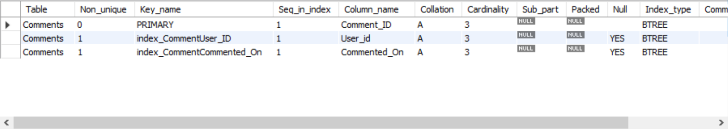

Table : **Categories**

Columns:

Category_ID (PK)

Category_name

**Highest Normalization: 4NF**

**Justification:**

1. The table is in BCNF

2. The table does not have multi-valued dependencies.

**Indexes**:

Index 1: clustered

Columns: Category_ID

**Justification:** Category_ID is the primary key of this table, and it is necessary to have at least one unique attribute in a table. We are using the order of this clustered index to store our records and also using this order to scan all the record when doing any queries. It has already been created automatically.

Index 2: non-clustered

Columns: Category_name

**Justification:** It is very common to search for a specific category according to its name. So we can create an index for them so that we can increase the speed when doing queries.

CREATE INDEX index_Categoryname ON Categories(Category_name);

SHOW INDEX FROM Categories;

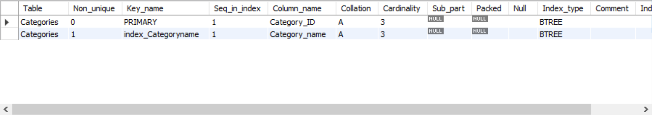

Table : **Leaderboard**

Columns:

leaderrank (PK)

User_id [foreign key; references PK of **User**]

Points (single-valued)

**Highest Normalization: 4NF**

**Justification:**

1. The table is in BCNF

2. The table does not have multi-valued dependencies.

**Indexes**:

Index 1: clustered

Columns: User_id

**Justification:** User_id is the primary key of this table, and it is necessary to have at least one unique attribute in a table. We are using the order of this clustered index to store our records and also using this order to scan all the record when doing any queries.

It has already been created automatically.

Index 2: non-clustered

Columns: User_Name

**Justification:** It is very common that users search for leaderrank information of some specific user. So we can create index for User_name to increase the speed.

CREATE INDEX index_LeaderboardUser_id ON Leaderboard (User_Name);

SHOW INDEX FROM Leaderboard;

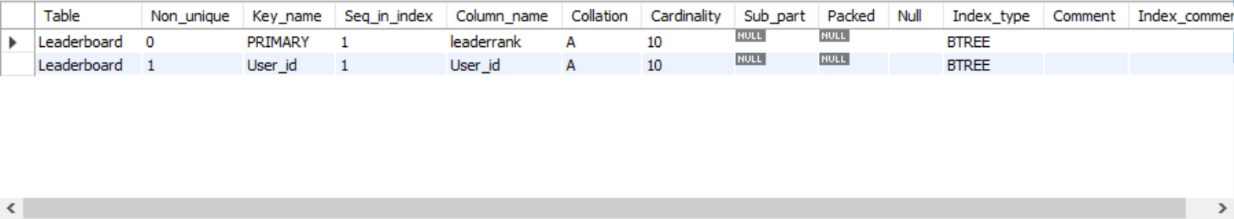

Table : **Message**

Columns:

MessageId (PK)

SenderId [foreign key; references PK of **User**]

ReciverId [foreign key; references PK of **User**]

Message [composite]

IsRead bool, [single-valued]

**Highest Normalization: 4NF**

**Justification:**

1. The table is in BCNF

2. The table does not have multi-valued dependencies.

**Indexes**:

Index 1: clustered

Columns: MessageID

**Justification:** MessageID is the primary key of this table, and it is necessary to have at least one unique attribute in a table. We are using the order of this clustered index to store our records and also using this order to scan all the record when doing any queries.

It has already been created automatically.

Index 2: non-clustered

Columns: SenderID

**Justification:** It is very common that users search for message of some specific sender. So senderID are often used in some JOIN queries as condition. So we can create index for senderID to increase the speed.

It has already been created automatically.

Index 3: non-clustered

Columns: ReceiverID

**Justification:** It is very common that users search for message of some specific receiver. So receiverID are often used in some JOIN queries as condition. So we can create index for receiverID to increase the speed.

It has already been created automatically.

SHOW INDEX FROM Message;

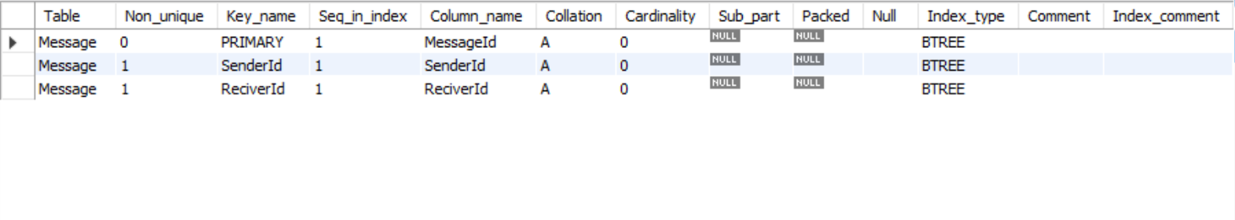

Table : **Query_AuditBackup**

Columns:

Query_ID (PK)

Query_Desc [composite]

Posted_Date (single-valued)

User_ID [foreign key; references PK of **User**]

Resolved (single-valued)

isActive (single-valued)

modified_timestamp

**Highest Normalization: 4NF**

**Justification:**

1. The table is in BCNF

2. The table does not have multi-valued dependencies.

**Indexes**:

Index 1: clustered

Columns: Query_ID

**Justification:** Query_ID is the primary key of this table, and it is necessary to have at least one unique attribute in a table. We are using the order of this clustered index to store our records and also using this order to scan all the record when doing any queries.

It has already been created automatically.

Index 2: non-clustered

Columns: User_ID

**Justification:** It is very common that users search for details of some specific users through their ID. So query are often used in some JOIN queries as condition. So we can create index for User_ID to increase the speed.

It has already been created automatically.

SHOW INDEX FROM Query_AuditBackup;

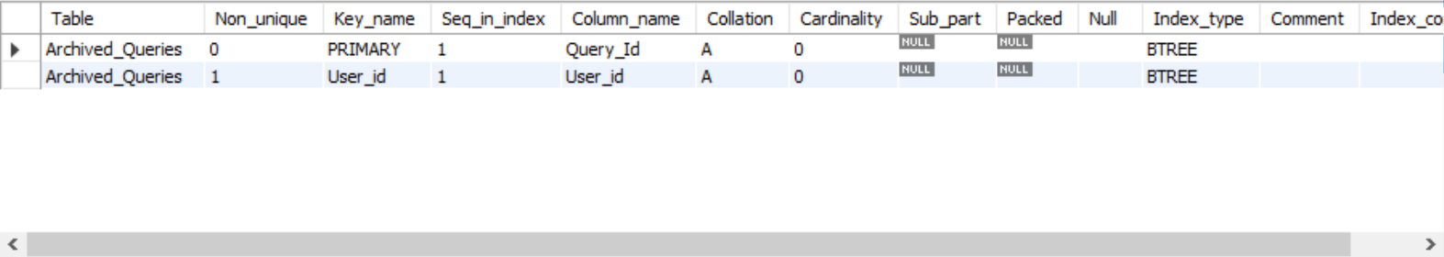

Table : **Backup_Queries**

Columns:

Query_ID (PK)

Query_Desc [composite]

Posted_Date (single-valued)

User_ID [foreign key; references PK of **User**]

Resolved (single-valued)

isActive (single-valued)

**Highest Normalization: 4NF**

**Justification:**

1. The table is in BCNF

2. The table does not have multi-valued dependencies.

**Indexes**:

Index 1: clustered

Columns: Query_ID

**Justification:** Query_ID is the primary key of this table, and it is necessary to have at least one unique attribute in a table. We are using the order of this clustered index to store our records and also using this order to scan all the record when doing any queries.

It has already been created automatically.

Index 2: non-clustered

Columns: User_ID

**Justification:** It is very common that users search for details of some specific users through their ID. So query are often used in some JOIN queries as condition. So we can create index for User_ID to increase the speed.

It has already been created automatically.

SHOW INDEX FROM BACKUP_QUERIES;

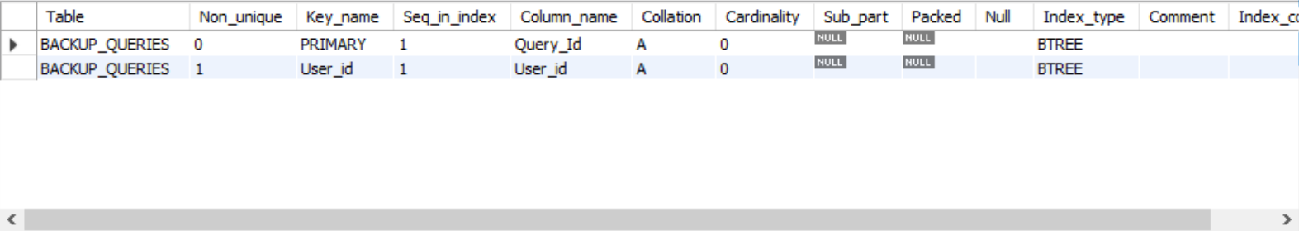

## ***SQL QUERIES***

**1. Query to retrieve all students:**

SELECT u.* FROM User u inner join Role r on u.Role_id = r.Role_id where r.Role_id = 2;

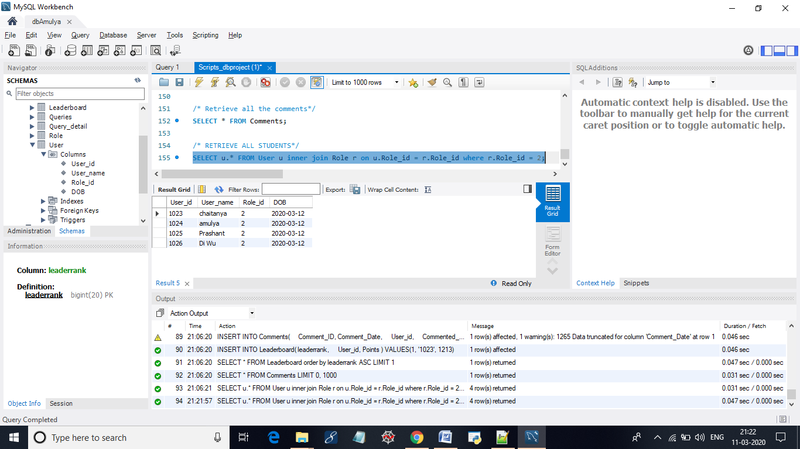

**2. Query to select top one in Leaderboard:**

SELECT * FROM Leaderboard order by leaderrank ASC LIMIT 1;

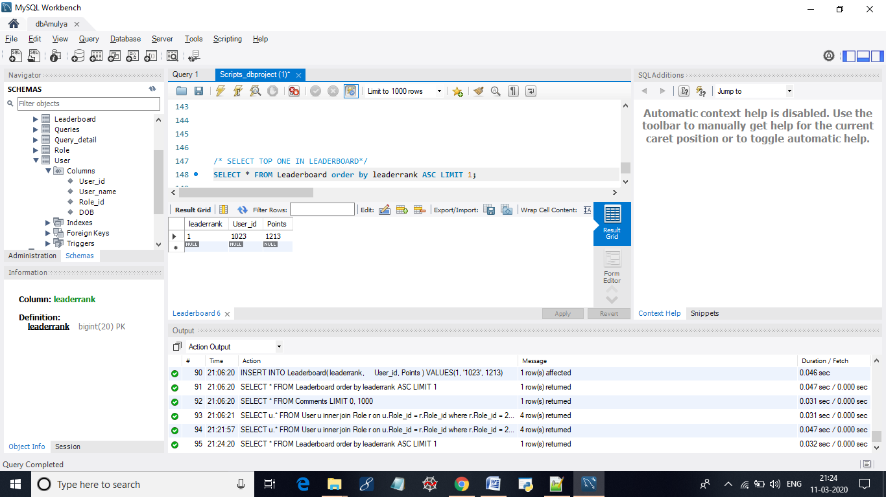

**3. Query to retrieve all comments:**

SELECT * FROM Comments;

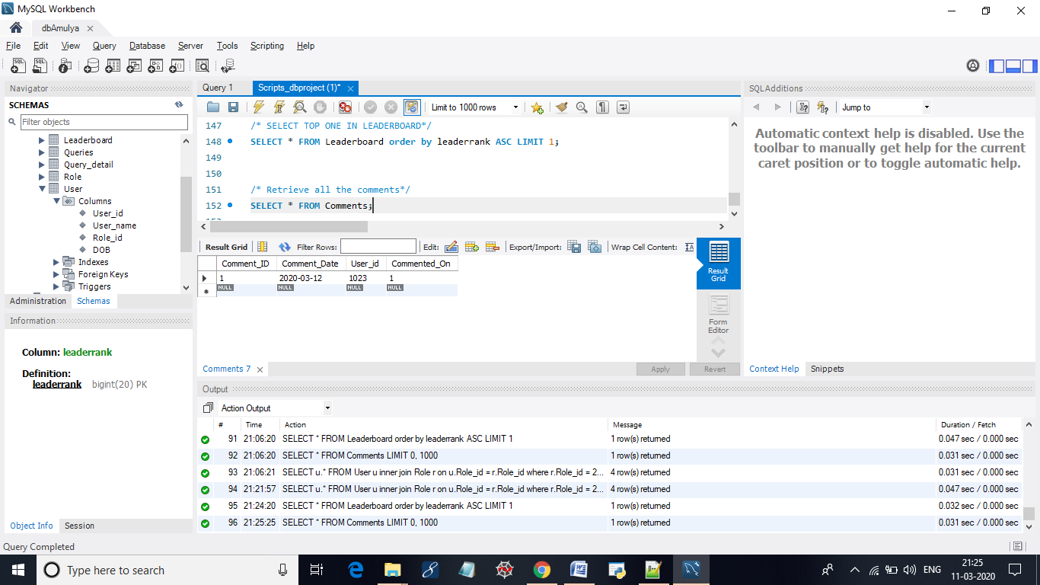

**4. Display all the queries which belong to both computerscience and Mathematics**

select Query_id, Query_desc from Queries where Query_id in

( select Query_id from Query_detail inner join Categories on

Query_detail.Category_ID = Categories.Category_ID

where Category_name = "computer science")

AND

Query_id in

(select Query_id from Query_detail inner join Categories on

Query_detail.Category_ID = Categories.Category_ID

where Category_name = "Mathematics");

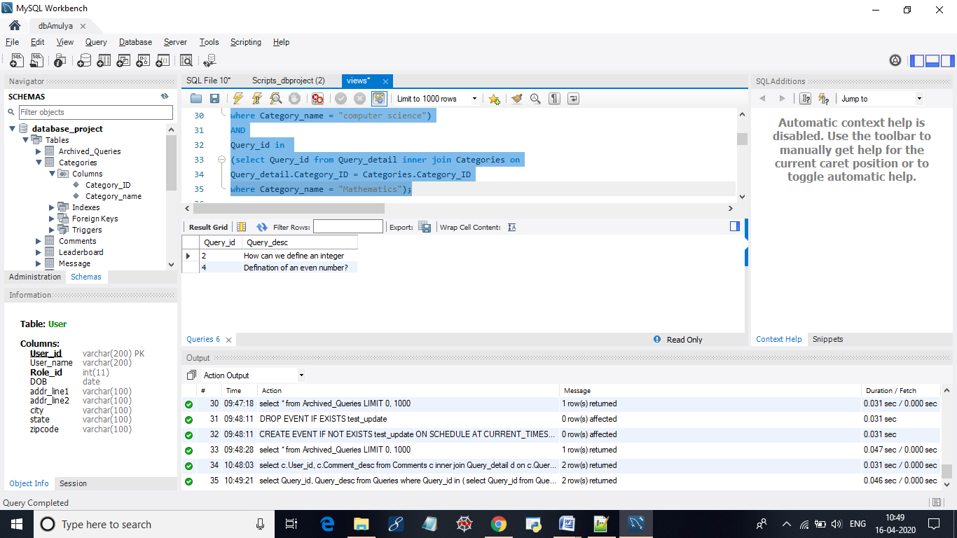

**5 .Query to select the two most recent queries posted by the users.**

select * from Queries order by Posted_Date desc limit 2;

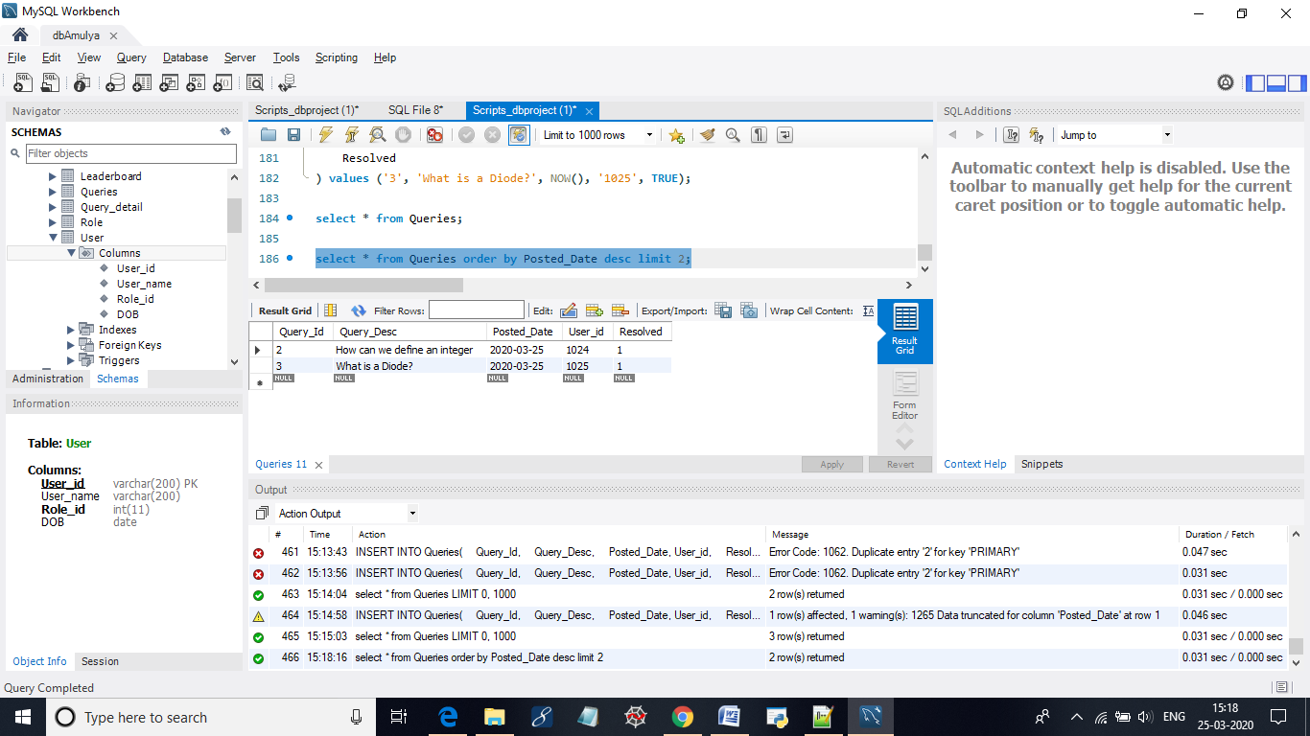

**6. Select the user who has scored maximum points**

select User_id, max(Points) as max_points from Leaderboard;

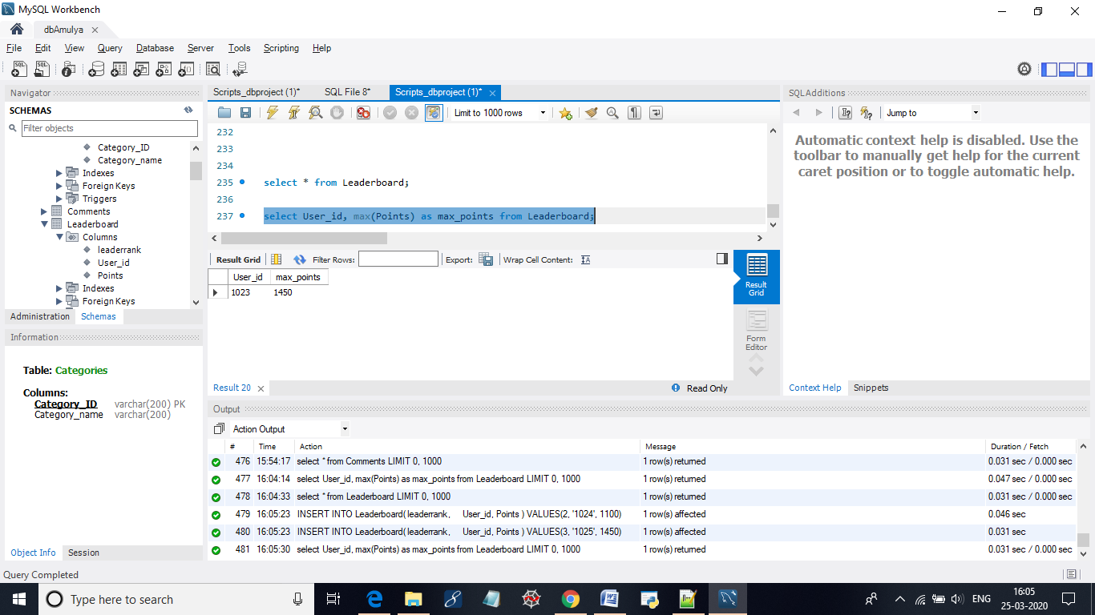

**7. Display all the users who has commented on the queries which are posted today(current date)**

select User_id from Comments where Comment_Date = current_date();

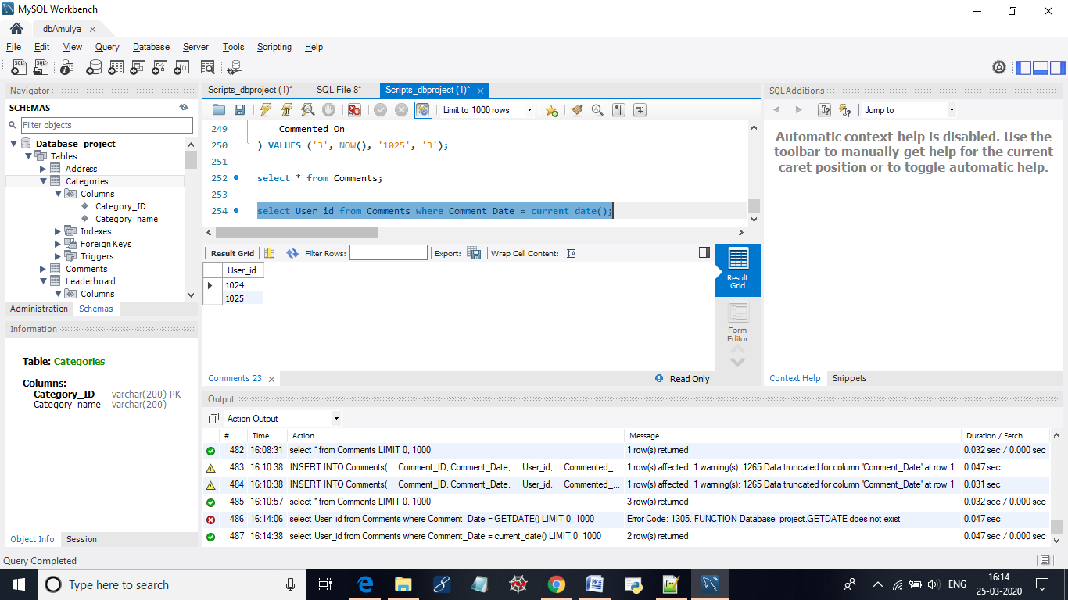

**8. Display all users who has commented on queries that belong to electronics category**

select c.User_id, c.Comment_desc from Comments c

inner join Query_detail d on c.Query_Id = d.Query_Id

inner join Categories cg on d.Category_ID = cg.Category_ID

and cg.Category_name = "Electronics";

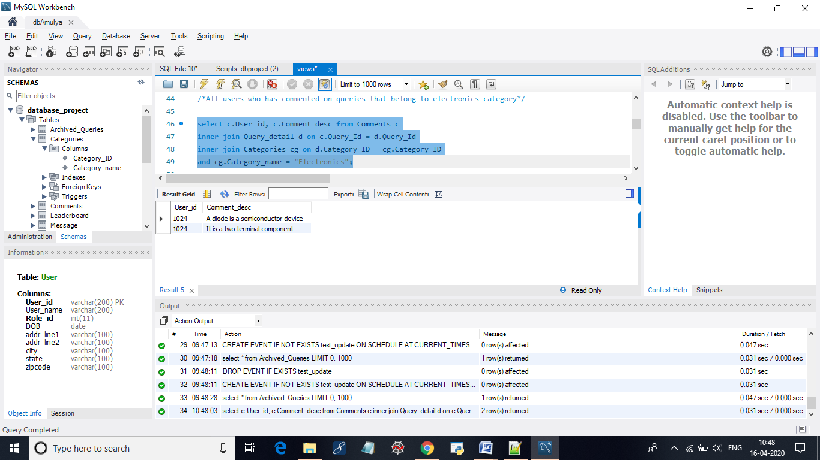

**9. Select all the Queries which are not resolved by the users**

select Query_Id, Query_Desc from Queries where Resolved = "0";

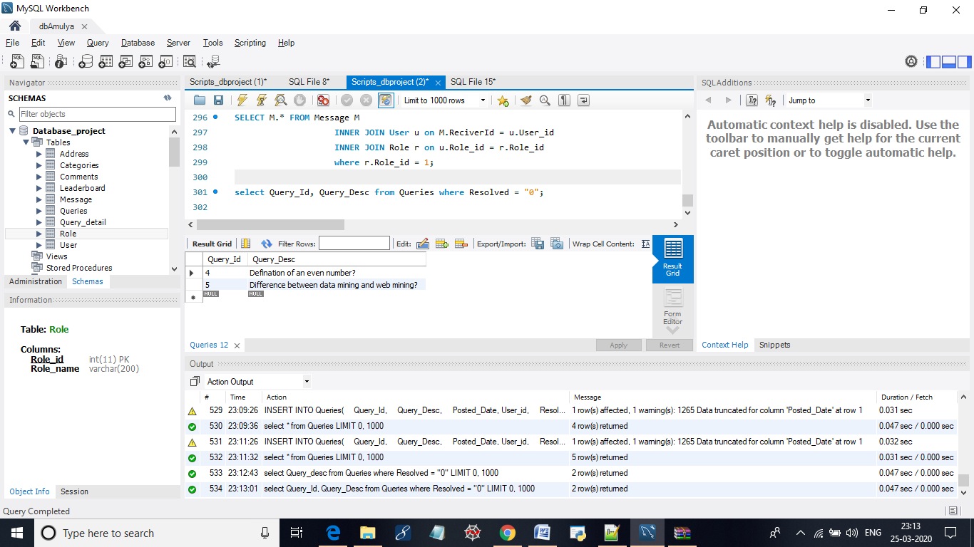

**10. Find the list of all messages which are read by Admin**

select MessageId, Message from Message where IsRead = "1";

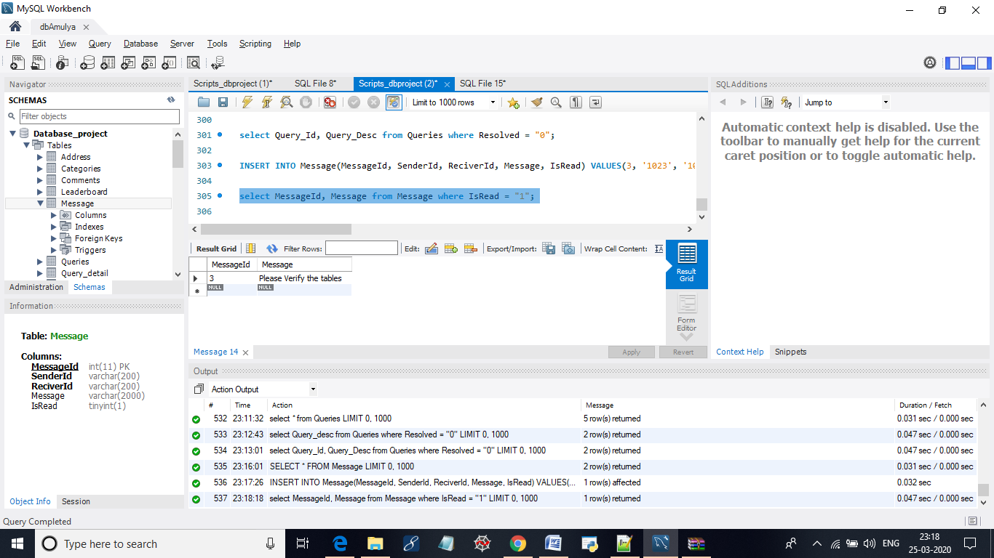

## ***VIEWS AND STORED PROGRAMS:***

**View:** student

Goal: This view is created to get the list of all the students in the system

create view student as

select u.User_id, u.User_name, u.addr_line1,

u.addr_line2, u.city, u.state, u.zipcode from User u

inner join Role r on u.Role_id = r.Role_id where r.Role_id="2";

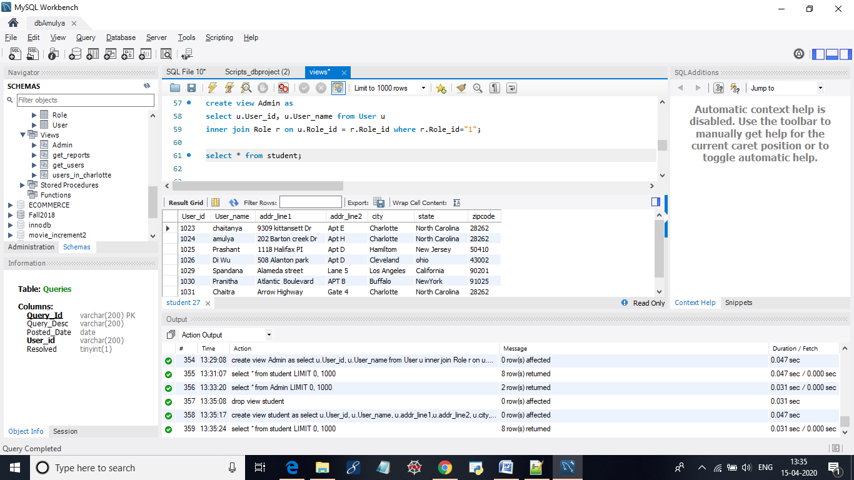

**View:** get_reports

Goal: This view is created to display list of all the reports sent to admin

create view get_reports as

SELECT M.* FROM Message M

INNER JOIN User u on M.ReciverId = u.User_id

INNER JOIN Role r on u.Role_id = r.Role_id

where r.Role_id = 1 ;

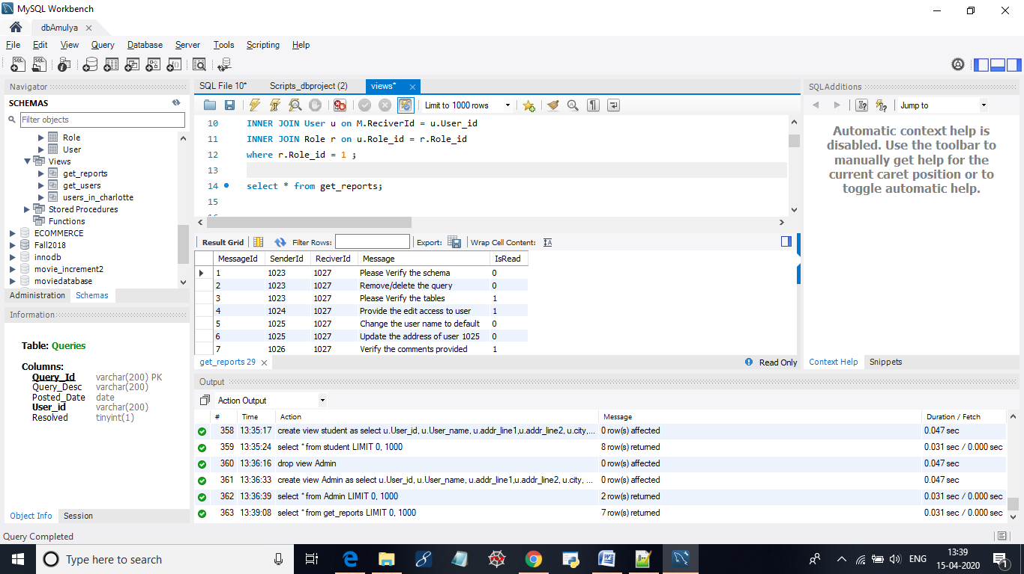

**View:** get_details

Goal: This view is created to display all the queries with their corresponding comments

create view get_details as

select q.Query_Id, q.Query_Desc, group_concat(c.Comment_desc) as comments

from Queries q inner join Comments c

on q.Query_Id= c.Query_id group by q.Query_ID order by Query_id asc;

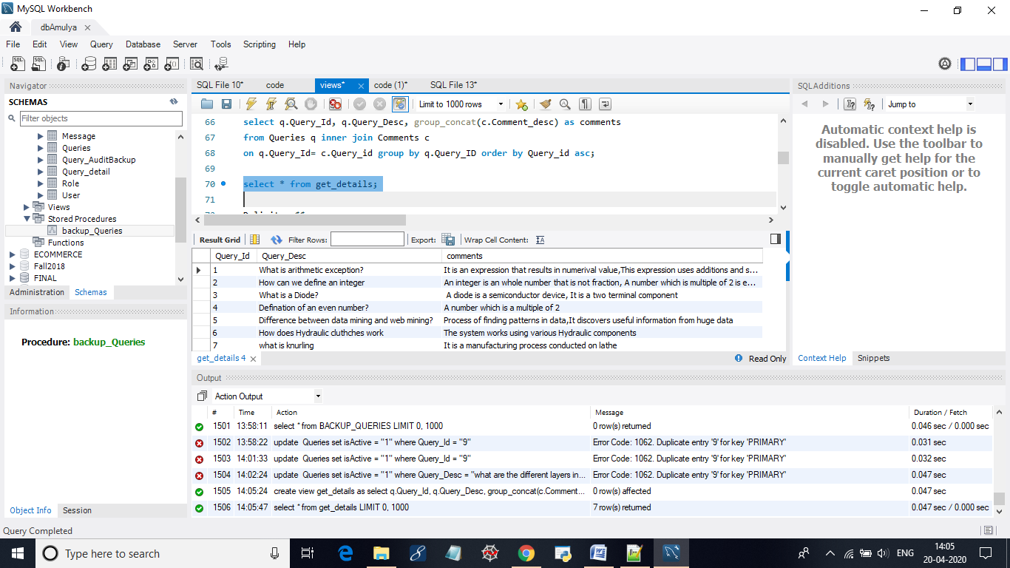

**View:** users_in _charlotte

This view is created to get all the users who belong to a particular location.

create view users_in_charlotte as

select u.User_id, u.User_name,u.Role_id, u.DOB,u.addr_line1,u.addr_line2,

u.city,u.state,u.zipcode

from User u inner join Role r

on u.Role_id = r.Role_id

and u.city = "charlotte" and r.Role_name = "student";

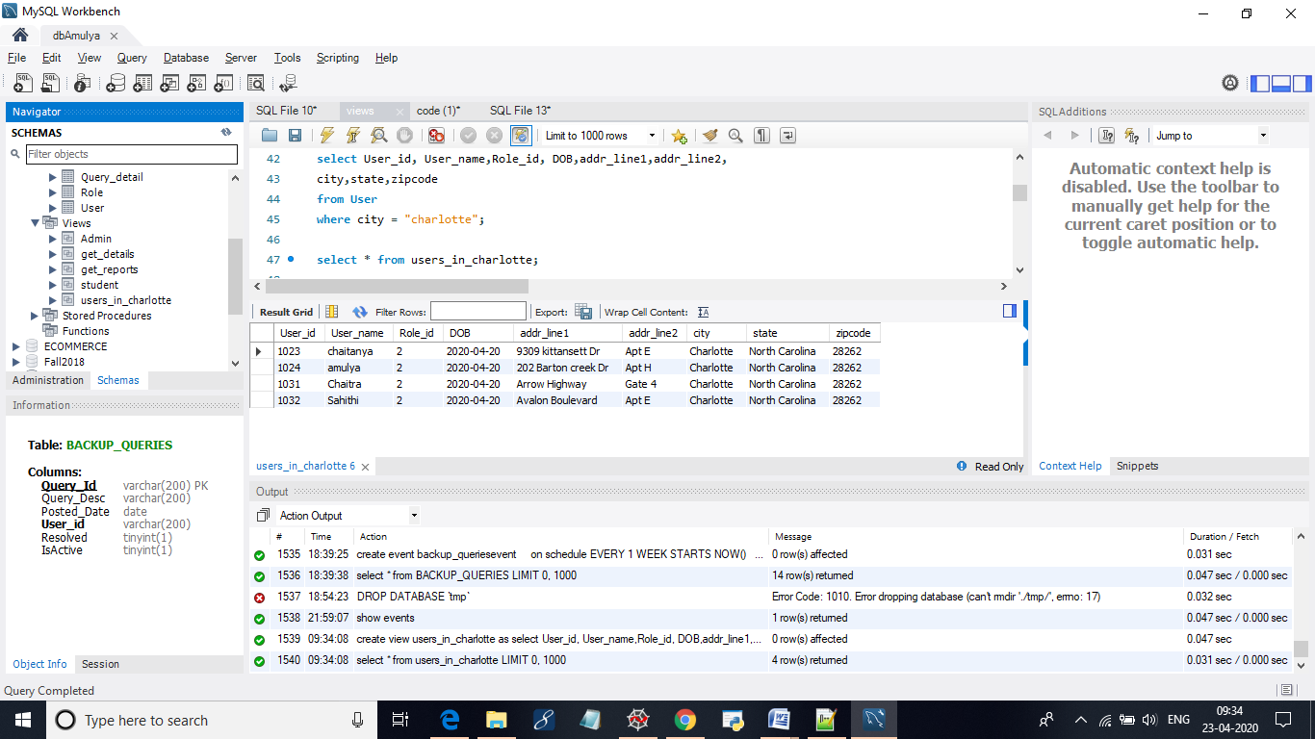

***PROCEDURES:***

**Procedure:** TopFiveActiveUsers()

Goal: This procedure is created to retrieve the top five active users from the system.

CREATE DEFINER=`pminkuri`@`%` PROCEDURE `TopFiveActiveUsers`()

BEGIN

select User_id, User_name from Comments inner join User using (User_id) group by User_id order by count(User_id) desc limit 5;

END

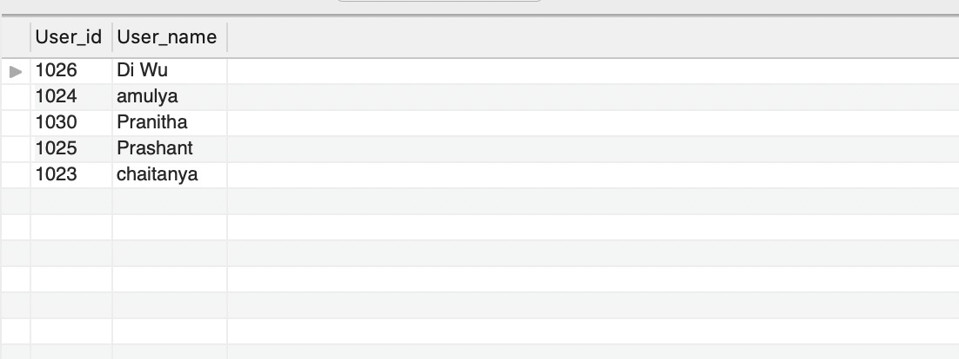

**Procedure :** UserActivity()

Goal: This procedure is created to search for the recent activity done by a particular user.

CREATE DEFINER=`pminkuri`@`%` PROCEDURE `UserActivity`(in userid varchar(20))

BEGIN

select Comment_desc Posts ,Comment_Date Dated from Comments where User_id=userid

union

select Query_Desc,Posted_Date from Queries where User_id=userid;

END

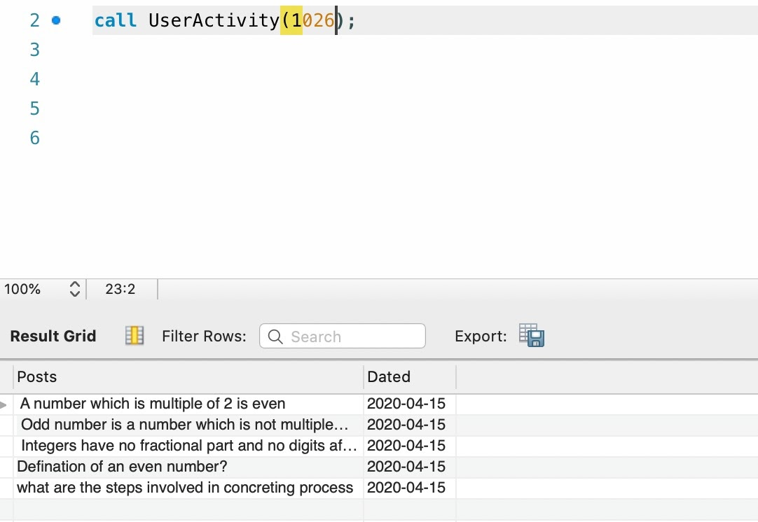

**Procedure:** ResolvedQueries()

Goal: This procedure is created to display all the queries which are resolved by user

CREATE DEFINER=`pminkuri`@`%` PROCEDURE `ResolvedQueries`()

BEGIN

select * from Queries where Resolved=true;

END

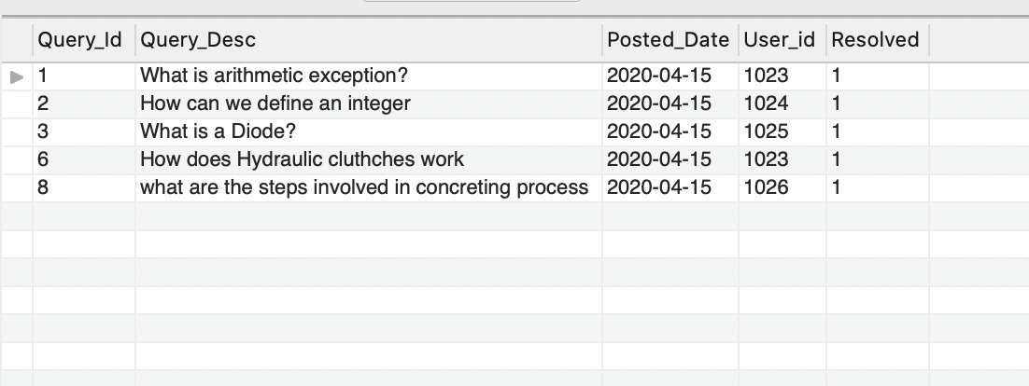

## ***TRIGGERS AND EVENTS:***

**1. Trigger to update points in the leaderboard when a user posts a new comment:**

DELIMITER $$

CREATE TRIGGER updateLeaderboard_trig

AFTER INSERT ON `Comments` FOR EACH ROW

begin

UPDATE leaderboard

SET Points = Points + 1

WHERE User_id = NEW.User_id;

END;

$$

DELIMITER ;

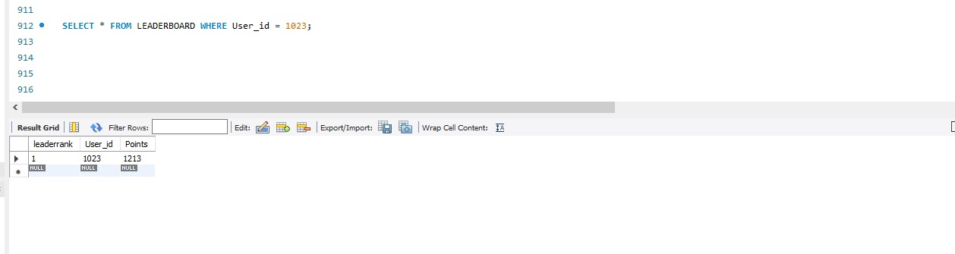

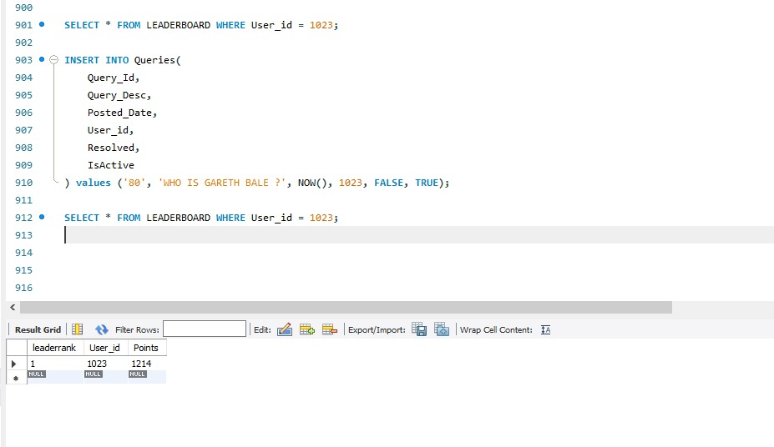

**2. Trigger to add new records in the audit table after deleting a query from Queries table:**

DELIMITER $$

CREATE TRIGGER addrecordsAuditQuery_trig

AFTER DELETE ON `Queries` FOR EACH ROW

begin

INSERT INTO Query_AuditBackup(

Query_Id,

Query_Desc,

Posted_Date,

User_id,

Resolved,

IsActive,

modified_TIMESTAMP

) values (OLD.Query_Id,

OLD.Query_Desc,

OLD.Posted_Date,

OLD.User_id,

OLD.Resolved,

OLD.IsActive,

NOW());

END;

$$

DELIMITER ;

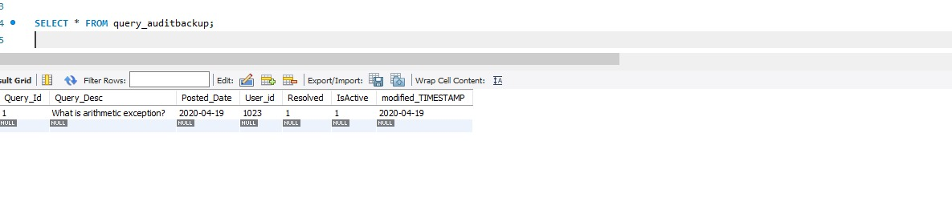

**3. Trigger to update records in the audit table:**

DELIMITER $$

CREATE TRIGGER updaterecordsAuditQuery_trig

AFTER UPDATE ON `Queries` FOR EACH ROW

begin

INSERT INTO Query_AuditBackup(

Query_Id,

Query_Desc,

Posted_Date,

User_id,

Resolved,

IsActive,

modified_TIMESTAMP

) values (OLD.Query_Id,

OLD.Query_Desc,

OLD.Posted_Date,

OLD.User_id,

OLD.Resolved,

OLD.IsActive,

NOW());

END;

$$

DELIMITER ;

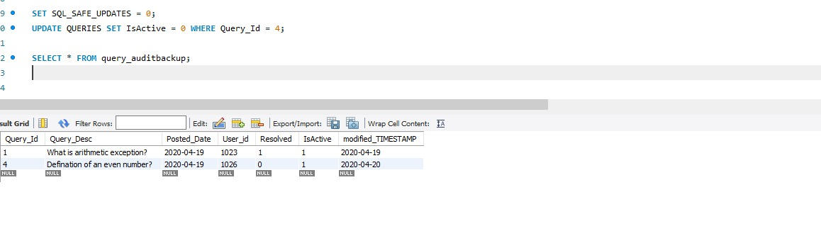

**/*EVENTS*/**

delimiter $$

create procedure backup_Queries()

begin

insert into BACKUP_QUERIES select * from Queries;

end $$

delimiter ;

**-- Now, suposing that you want to execute this procedure every one week:**

delimiter $$

create event backup_queriesevent

on schedule EVERY 1 WEEK STARTS NOW()

do

begin

call backup_Queries();

end $$

delimiter ;

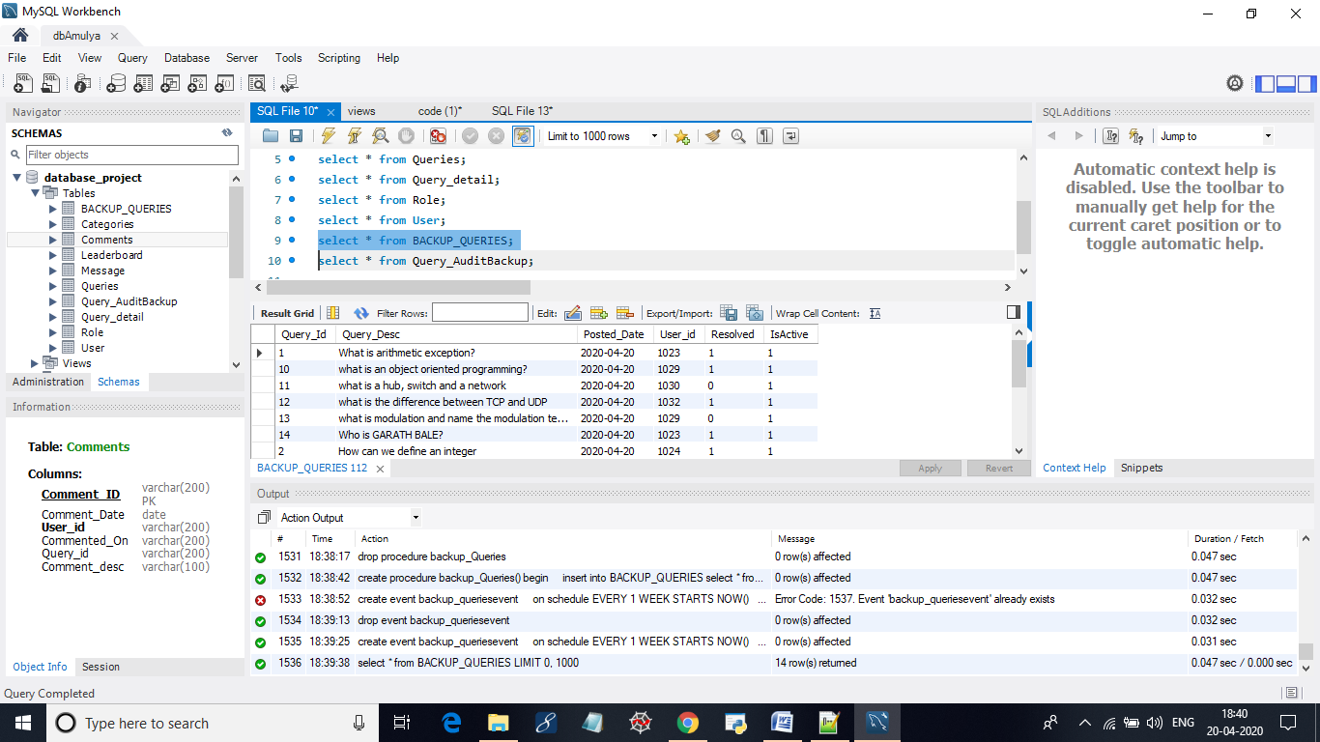

***SPLUNK:***

1. Created a dashboard which displays the points and rank for the corresponding user.

User can select the leader rank, and see the points assigned for the user.

The dashboard also has single valued panel to show the number of resolved queries and active .

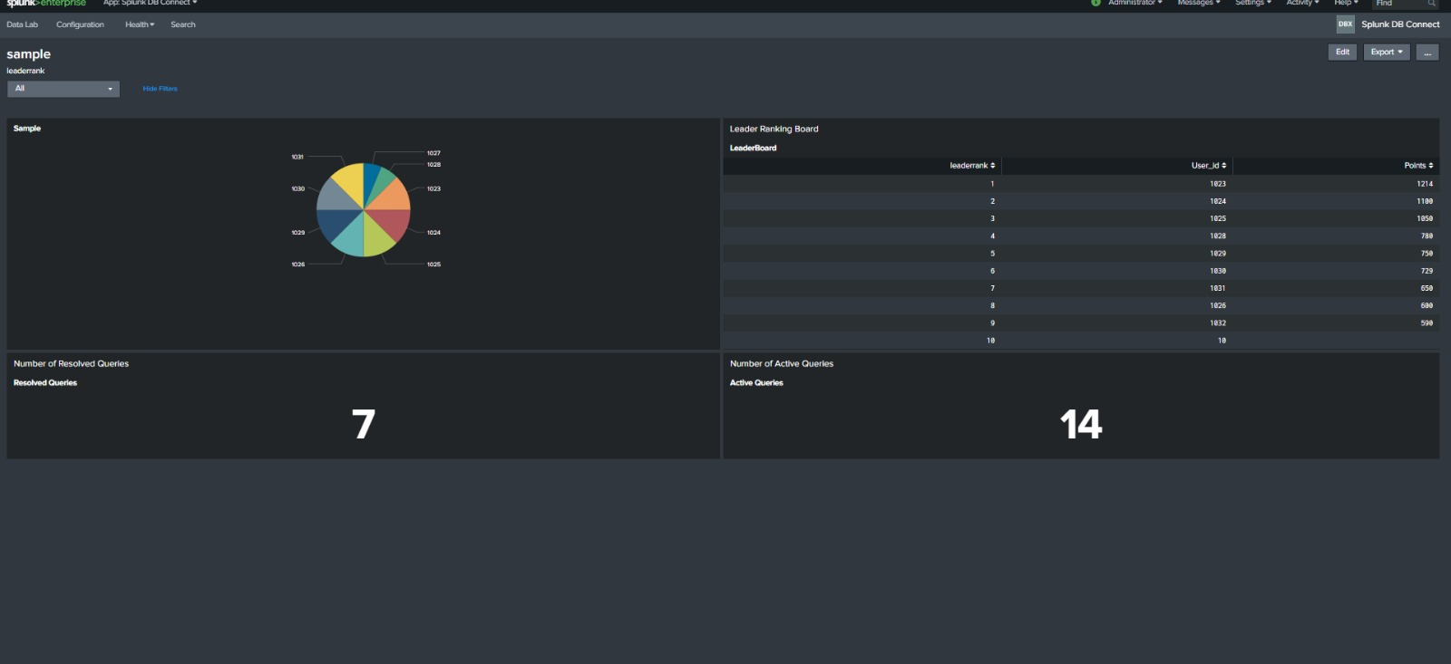

2.Comments Dashboard

Comments Dashboard facilaites users to see all the queries for that id and retrieve the comments from query and pie char explaining the most commented query and user’s who contributed the most in the form of comments.

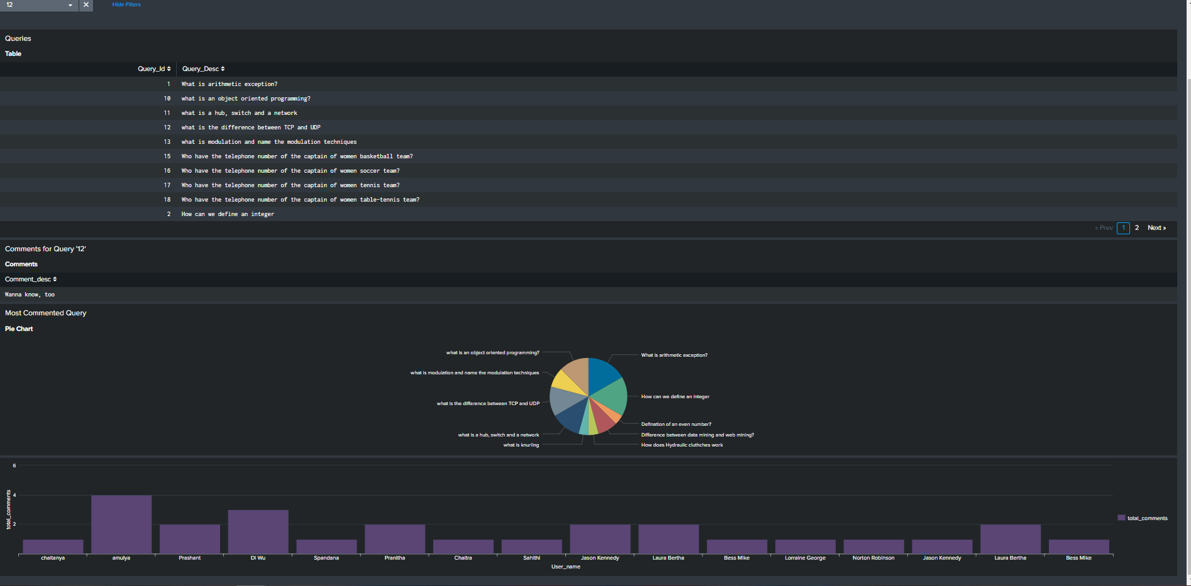

2. Category

Category dashboard displays all the queries for the selected category, Number of queries unresolved, resolved in that category, and a bar graph with user name with most query contribution for that category

