The difference between 1.png and 1.png is : 20.0%  
1.png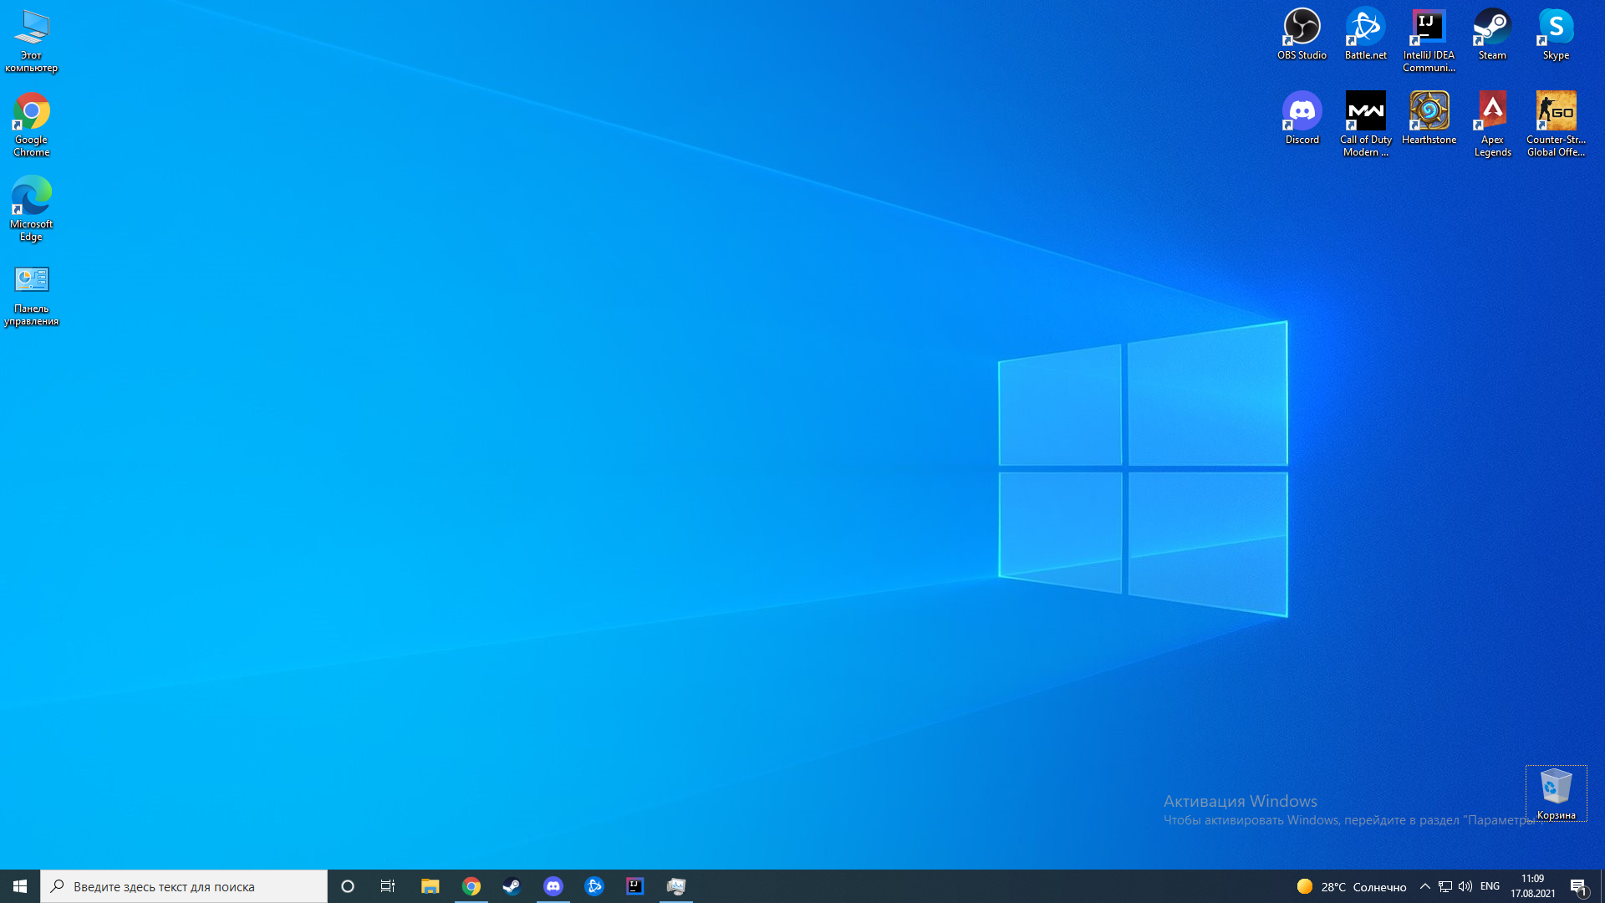1.png  
  
The difference between 2.png and 2.png is : 0.0%  
2.png2.png  
  
The difference between compare_two_images.jpg and compare_two_images.jpg is : 0.0%  
compare_two_images.jpgcompare_two_images.jpg  
  
The difference between compare_two_images1.jpg and compare_two_images1.jpg is : 3.5294117647058822%  
compare_two_images1.jpgcompare_two_images1.jpg