PMIx: The Process Management Interface – Exascale Standard
Version 2.0
July 15, 2017

This document describes the Process Management Interface-Exascale standard, version 2.0.
Comments: Please send comments on PMIx to the PMIx Community by subscribing to the PMIx developers mailing list at https://groups.google.com/forum/#!forum/pmix. Please include the version of the PMIx standard you are commenting about, and the page and line numbers you are referencing. Please note that messages sent from an unsubscribed e-mail address will be ignored.
Version 2.0: July xx, 2017.

Table of Contents
Table of Contents 4
Acknowledgments 6
Chapter 1: Introduction to PMIx 7
1.1 Charter 7
1.2 Overview 7
1.3 History 7
1.4 Who Should Use This Standard? 7
1.5 What Platforms Are Targets For Implementation? 7
1.6 What is included in the Standard? 7
1.7 What is not Included in the Standard? 8
1.7.1 The PMIx Convenience Library 8
1.7.2 The PMIx Reference Server 8
1.8 Organization of this Document 8
Chapter 2: PMIx Terms and Conventions 10
2.1 Notation Conventions 10
2.2 Semantics 10
2.3 Naming Conventions 10
2.4 Procedure Specification 10
Chapter 3: PMIx: The Concept 12
3.1 Conceptual Architecture 12
3.2 Launch Support 13
Chapter 4: Client-Side APIs 16
4.1 Client initialization 16
PMIx_Init(proc, info, ninfo) 16
PMIx_server_init(module, info, ninfo) 16

Figure 1. PMIx Integration Architecture 10
Figure 2. PMIx: Messenger vs Doer 10
Figure 3. Traditional launch sequence 12
Figure 4. Gen2 launch sequence 12
Figure 5. PMIx launch sequence 13

Acknowledgments
This document represents the work of a number of people who have contributed their time, ideas, and code over the course of several years.

Chapter 1: Introduction to PMIx
The Process Management Interface (PMI) has been used for quite some time as a means of exchanging wireup information needed for interprocess communication. Two versions (PMI-1 and PMI-2) have been released as part of the MPICH effort. While PMI-2 demonstrates better scaling properties than its PMI-1 predecessor, attaining rapid launch and wireup of the roughly 1M processes executing across 100k nodes expected for exascale operations remains challenging.
PMI Exascale (PMIx) represents an attempt to resolve these questions by providing an extended version of the PMI definitions specifically designed to support clusters up to and including exascale sizes. The overall objective of the project is not to branch the existing definitions - in fact, PMIx fully supports both of the existing PMI-1 and PMI-2 APIs - but rather to (a) augment and extend those APIs to eliminate some current restrictions that impact scalability, (b) establish a standards-like body for maintaining the definitions, and (c) provide a reference implementation of the PMIx standard that demonstrates the desired level of scalability.

1.1 Charter
The charter of the PMIx community is to:
- Define a set of agnostic APIs (not affiliated with any specific programming model code base) to support interactions between application processes and the system management software stack (SMS)
- Develop an open source (non-copy-left licensed) standalone “convenience” library to facilitate adoption of the PMIx standard
- Retain transparent backward compatibility with the existing PMI-1 and PMI-2 definitions, any future PMI releases, and across all PMIx versions
- Support the Instant On initiative for rapid startup of applications at exascale and beyond
- Work with the HPC community to define and implement new APIs that support evolving programming model requirements for application-RM interactions.
Participation in the PMIx community is open to anyone, and not restricted to only code contributors to the convenience library.

1.2 Overview

1.3 History

1.4 Who Should Use This Standard?

1.5 What Platforms Are Targets For Implementation?

1.6 What is included in the Standard?

1.7 What is not Included in the Standard?

The PMIx Standard does not include anything, either stated or implied, regarding implementation. It instead focuses exclusively on defining APIs and associated attribute key strings, and describing the expected behavior of those entities. How that behavior is realized is entirely at the discretion of the implementer.

As previously noted, system environments and PMIx library implementers are always free to return “not supported” for any request. Thus, users should

1.7.1 The PMIx Convenience Library
Note that the definition of the PMIx standard is not contingent upon use of the convenience library. Any implementation that supports the defined APIs is perfectly acceptable, and some environments have chosen to pursue their own custom implementation. The convenience library is provided solely for the following purposes:
- Validation of the standard. No proposed change and/or extension to the standard is accepted without an accompanying prototype implementation in the convenience library. This ensures that the proposal has undergone at least some minimal level of scrutiny and testing before being considered.
- Ease of adoption. The PMIx convenience library is designed to be particularly easy for resource managers (and the SMS in general) to adopt, thus facilitating a rapid uptake into that community for application portability. Both client and server libraries are included, along with reference examples of client usage and server-side integration. A list of supported environments and versions is provided here - please check regularly as the list is changing!
The convenience library targets support for the Linux operating system. A reasonable effort is made to support all major, modern Linux distributions; however, validation is limited to the most recent 2-3 releases of RedHat Enterprise Linux (RHEL), Fedora, CentOS, and SUSE Linux Enterprise Server (SLES). In addition, development support is maintained for Mac OSX. Production support for vendor-specific operating systems is included as provided by the vendor.

1.7.2 The PMIx Reference Server

1.8 Organization of this Document

- Chapter 2: PMIx Terms and Conventions, explains notational terms and conventions used throughout the document
- Chapter 3: PMIx Flow of Control reviews the concepts underpinning the PMIx approach to application-work flow orchestration.
- Chapter 4: Initialization defines the basic APIs for initializing PMIx clients, servers, and tools
- Chapter 5: Wireup defines the functions and methods associated with obtaining information required for establishing inter-process communication. This includes an overall explanation of the PMIx “Instant On” launch procedure.
- Chapter 6:

Chapter 2: PMIx Terms and Conventions
Define “attributes” and how they are used, intent is to allow for definition of flexible APIs that can change behavior based on attributes instead of modifying function signature. Include description of data types.

This document borrows freely from other standards (most notably from the MPI Forum) in its use of notation and conventions in an attempt to reduce confusion.

2.1 Notation Conventions
- Rationale. Throughout this document, the rationale for the design choices made in the interface specification is set off in this format and with a blue bar on the right margin. Some readers may wish to skip these sections, while readers interested in interface design may want to read them carefully.

- Advice to users. Throughout this document, material aimed at users and that illustrates usage is set off in this format and with an orange bar on the right margin. Some readers may wish to skip these sections, while readers interested in programming in MPI may want to read them carefully

- Advice to implementers. Throughout this document, material that is primarily commentary to implementers is set off with in this format and with a green bar on the right margin. Some readers may wish to skip these sections, while readers interested in PMIx implementations may want to read them carefully.

2.2 Semantics

The following terms will be taken to mean:
- shall and will indicate that the specified behavior is required of all conforming implementations
- should and may indicate behaviors that a quality implementation would include, but are not required of all conforming implementations

2.3 Naming Conventions

2.4 Procedure Specification

While current PMIx implementations are solely based on the C programming language, it is not the intent of the PMIx Standard to preclude the use of other languages. Accordingly, the procedure specifications in the Standard are written in a language-independent syntax with the arguments marked as IN, OUT, or INOUT. The meanings of these are:
- IN: the call may use the input value but does not update the argument from the perspective of the caller at any time during the call’s execution,
- OUT: the call may update the argument but does not use its input value
- INOUT: the call may both use and update the argument.
There is one special case — if an argument is a handle to an opaque object (these terms are defined in Section 2.5.1), and the object is updated by the procedure call, then the argument is marked INOUT or OUT. It is marked this way even though the handle itself is not modified — we use the INOUT or OUT attribute to denote that what the handle references is updated.
Rationale. The definition of MPI tries to avoid, to the largest possible extent, the use of INOUT arguments, because such use is error-prone, especially for scalar arguments. (End of rationale.)
MPI’s use of IN, OUT, and INOUT is intended to indicate to the user how an argument is to be used, but does not provide a rigorous classification that can be translated directly into all language bindings (e.g., INTENT in Fortran 90 bindings or const in C bindings). For instance, the “constant” MPI_BOTTOM can usually be passed to OUT buffer arguments. Similarly, MPI_STATUS_IGNORE can be passed as the OUT status argument.
A common occurrence for MPI functions is an argument that is used as IN by some pro- cesses and OUT by other processes. Such an argument is, syntactically, an INOUT argument and is marked as such, although, semantically, it is not used in one call both for input and for output on a single process.

Chapter 3: PMIx: The Concept

3.1 Conceptual Architecture
PMIx as messenger, not doer. Funnel all interactions thru the local RM daemon/server to minimize connectivity and induced jitter.

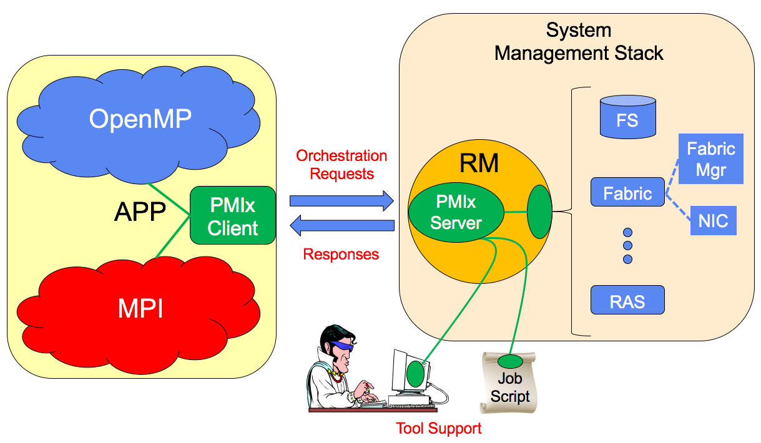
Figure 1. PMIx Integration Architecture

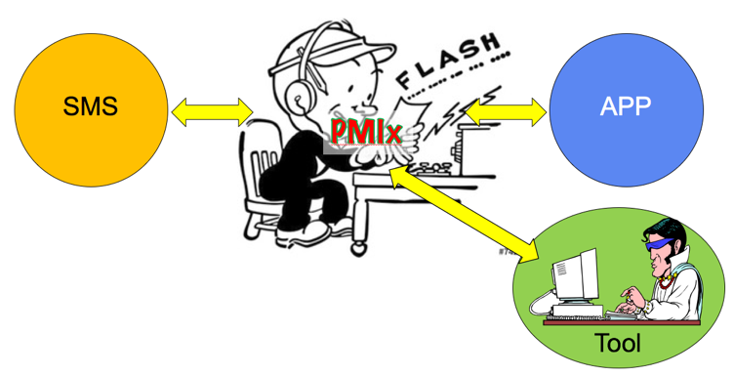
Figure 2. PMIx: Messenger vs Doer

3.2 Launch Support
Studies performed during the RoadRunner project provided valuable insights into the breakdown of time spent during launch. While the detailed timings have of course changed since that time, the overall distribution and the sequence of events during startup has remained relatively consistent. Launch of a typical parallel application can be separated into six distinct stages, as shown in Fig. 1:
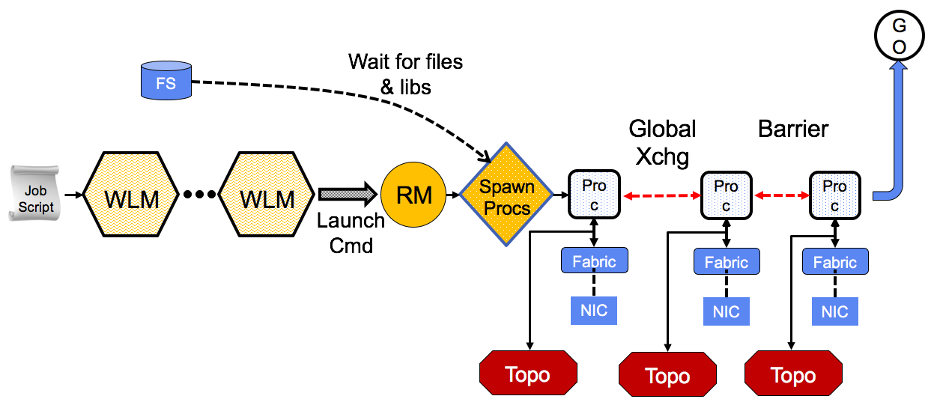
Figure 3. Traditional launch sequence
1. User submits a job (either in the form of a script or a request 204 for an interactive session) to the WLM. The request typically will 205 include descriptions of the type and amount of resources required 206 for the job. Historically, resource requests have been considered 207 immutable once allocated, but demand and support for dynamically 208 modi able resource allocations is growing. 209 2. Depending upon resource availability, relative priorities, and 210 scheduling algorithm, at some point in the future the WLM will as- 211 sign resources to the requested job and inform the RM daemons that 212 control those resources of their assignment. The precise sequence 213 of steps used by an RM daemon to spawn its local application pro- 214 cesses varies, but the overall result is that the application binary 215 executable is retrieved from the FS, instantiated on the compute 216 node, and executed. At this time, any dynamic library dependencies 217 will result in calls to retrieve the corresponding libraries from the 218 FS. 219 Scalably dealing with the library retrieval "storm" caused by mul- 220 tiple processes from a large number of nodes near-simultaneously 221 requesting a library has been the subject of signi cant investiga- 222 tion. Some systems simply utilize static builds to avoid the storm 223 altogether, while others cache the rst request on an intermedi- 224 ate location (e.g., a "burst bu er") and then serve all subsequent 225 requests from the cache (cfe, SPINDLE [11]). 226 3. Once instantiated, each process in the application must dis- 227 cover local information required for interactions with its peers. 228 This information consists of at least the process rank and com- 229 munication endpoint (e.g., an IP address and TCP socket number), 230 but typically includes any process a nity that has been applied,

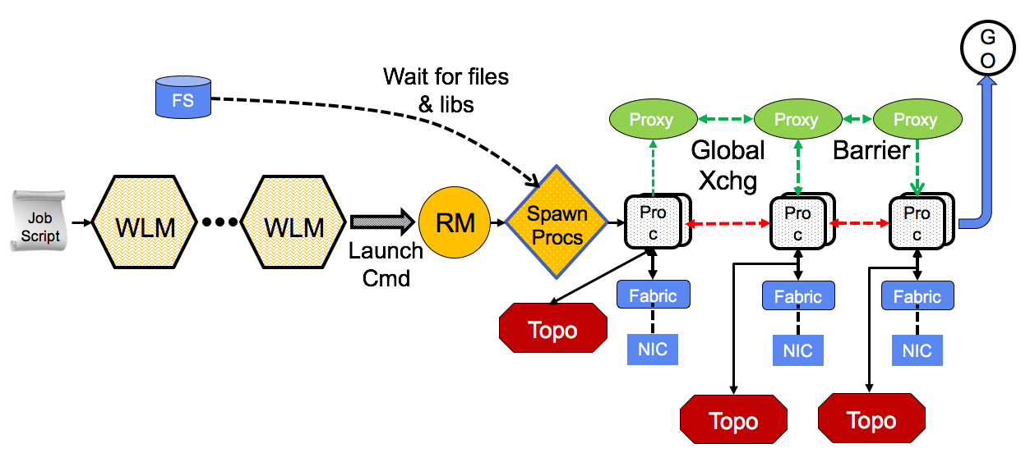
Figure 4. Gen2 launch sequence
More recently, launch systems have been updated to a more hierarchical topology, as shown in Figure 4.

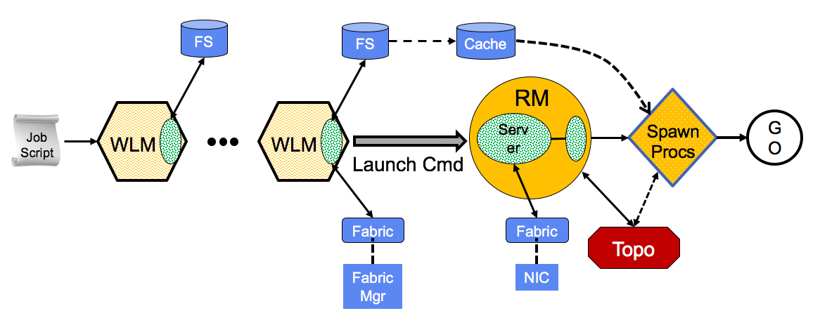
Figure 5. PMIx launch sequence
As previously discussed, the largest time costs during application startup has historically been the time required to collectively share connection endpoints, followed by the barrier prior to commencing operations. Analysis of exchanged data revealed that over 90% of it was known to the local RM daemon at the time it started an application process, but that the daemon had no mechanism for communicating that information to the client process. The remainder was dynamically-assigned endpoint connections that client processes independently discovered and then contributed to the collective operation. The PMIx community addressed the launch sequence with a goal of completely eliminating both the global exchange of information and the subsequent global barrier, regardless of application scale. In addition, the community determined that the le system retrieval bottleneck could be effectively eliminated by pre-positioning the required information. The revised launch sequence, illustrated in Fig. 3, consists of only four stages:
612 1. User submits a job (either in the form of a script or a request
613 for an interactive session) to the WLM. The request typically will
614 include descriptions of the type and amount of resources required
615 for the job. In addition to logging the request into the appropriate
616 queue, the WLM uses a PMIx interface to pass a request to the le
617 system for estimated retrieval times of all user-identi ed executa-
618 bles, supporting libraries, and data les. The resulting estimates can
619 then be factored into the scheduling algorithm, especially important
620 as hot/warm/cold storage policies become more common.
- 621 The burden on the user to identify all required libraries is often an
- 622 issue. Hence, PMIx provides another interface by which the WLM
- 623 can rst request that a job script be analyzed to return a list of
- 624 associated libraries (e.g., the equivalent to the output of a standard
- 625 POSIX ldd command) that can be included in the FS request for
- 626 retrieval time. It is expected that the development of increasingly
- 627 accurate analyzers will become a research area of interest.
- 628 2. Depending upon resource availability, relative priorities, and
- 629 scheduling algorithm, at some point in the future the WLM will
- 630 assign resources to the requested job. This assignment typically
- 631 occurs when the WLM is noti ed of job completion and just prior
- 632 to initiation of the epilog portion of the prior job. In addition, the
- 633 need to aggregate resources for larger jobs often results in at least
- 634 some portion of the allocation becoming available on a rolling basis.
- 635 Thus, there is some amount of time available to the SMS for pre-
- 636 conditioning of the allocation prior to start of the newly scheduled
- 637 job.

Chapter 4: Client-Side APIs
General explanation of the category

4.1 PMIx_Init
Syntax:

PMIx_Init(proc, info, ninfo)
INOUT | proc | Pointer to a pmix_proc_t structure
IN | info | Array of pmix_info_t structures (optional)
IN | ninfo | Number of elements in info array
pmix_status_t PMIx_Init(pmix_proc_t *proc, pmix_info_t info[], size_t ninfo)
Description:
Initialize the PMIx client, returning the process identifier assigned to this client's application in the provided pmix_proc_t struct. Passing a value of NULL for this parameter is allowed if the user wishes solely to initialize the PMIx system and does not require return of the identifier at that time.
When called, the PMIx client shall check for the required connection information of the local PMIx server and establish the connection. If the information is not found, or the server connection fails, then an appropriate error constant shall be returned.
If successful, the function shall return PMIX_SUCCESS and fill the provided structure with the server-assigned namespace and rank of the process within the application. In addition, all startup information provided by the resource manager shall be made available to the client process via subsequent calls to PMIx_Get.
The PMIx client library shall be referenced counted, and so multiple calls to PMIx_Init are allowed by the standard. Thus, one way for an application process to obtain its namespace and rank is to simply call PMIx_Init with a non-NULL proc parameter. Note that each call to PMIx_Init must be balanced with a call to PMIx_Finalize to maintain the reference count.

4.2 PMIx_Finalize
Syntax:

PMIx_Finalize(info, ninfo)
IN | info | Array of pmix_info_t structures (optional)
IN | ninfo | Number of elements in info array
pmix_status_t PMIx_Finalize(const pmix_info_t info[], size_t ninfo)
Description:
Decrement the PMIx client library reference count. When the reference count reaches zero, the library will finalize the PMIx client, closing the connection with the local PMIx server and releasing all malloc'd memory. By default, PMIx_Finalize will not include an internal barrier operation. Users desiring a barrier as part of the finalize operation can request it by including the PMIX_EMBED_BARRIER attribute in the provided pmix_info_t array.
Return value:
PMIX_SUCCESS or a negative value corresponding to a PMIx error constant

4.3 PMIx_Initialized
Syntax:

PMIx_Initialized(void)
int PMIx_Initialized(void)
Description:
Check to see if the PMIx library has been initialized
Return value:
true if the library has been initialized, and false otherwise.

4.4 PMIx_Abort
Syntax:
PMIx_Abort(status, msg, procs, nprocs)
IN | status | Error code to return to invoking environment
IN | msg | String message to be returned to user
IN | procs | Array of pmix_proc_t structures (optional)
IN | nprocs | Number of elements in procs array
pmix_status_t PMIx_Abort(int status, const char msg[],
pmix_proc_t procs[], size_t nprocs)
Description:
Request that the host resource manager print the provided message and abort the provided array of procs. A Unix or POSIX environment should handle the provided status as a return error code from the main program that launched the application. A NULL for the proc array indicates that all processes in the caller's nspace are to be aborted. Passing a NULL msg parameter is allowed.

(Advice to users) The response to this request is somewhat dependent on the specific resource manager and its configuration (e.g., some resource managers will not abort the application if the provided status is zero unless specifically configured to do so, and some cannot abort subsets of procs in an application), and thus lies outside the control of PMIx itself. However, the PMIx client library shall inform the RM of the request that the specified procs be aborted, regardless of the value of the provided status.
Note that race conditions caused by multiple processes calling PMIx_Abort are left to the server implementation to resolve with regard to which status is returned and what messages (if any) are printed. (End of advice to users)
Return value:
PMIX_SUCCESS or a negative value corresponding to a PMIx error constant
(Advice to implementers) (End of advice to implementers)

Chapter 5. Server-Side Functions

PMIx_server_init(module, info, ninfo)
IN | module | Pointer to a pmix_server_module_t structure
IN | info | Array of pmix_info_t structures
IN | ninfo | Number of elements in info array
Syntax:
pmix_status_t PMIx_server_init(pmix_server_module_t *module,
pmix_info_t info[], size_t ninfo)

4.2 Launch

