Data-Driven Evaluation Criteria for
Multi-Field Cosmological Generative Models
Empirical Noise Floor Measurements from CAMELS
GENESIS Project Technical Report | March 2026

Abstract
We present empirical measurements of the irreducible noise floor in the CAMELS simulation suite, using three purpose-designed experiments on the CV (Cosmic Variance), 1P (One-Parameter), and LH (Latin Hypercube) datasets. These measurements establish physics-grounded evaluation criteria for the GENESIS multi-field cosmological generative model, replacing previously adopted thresholds from single-field literature that we demonstrate to be physically unachievable. Key findings: (1) the cosmic variance floor for auto-power spectra is 10.8–12.0% (pure CV) to 26.6–29.0% (CV + slice variance), rendering the commonly cited 5% target impossible; (2) parameter sensitivity varies by a factor of 3× across fields (Mcdm: 110%, Mgas: 186%, T: 325%), justifying field-dependent accuracy targets; (3) the correlation coefficient r(k) noise floor for T-related pairs reaches Δr ~ 0.29, making the uniform Δr < 0.1 criterion unachievable for these pairs at high k.

1. Introduction and Motivation
The GENESIS project generates three cosmological fields (Mcdm, Mgas, T) conditioned on six parameters (Ωm, σ8, ASN1, ASN2, AAGN1, AAGN2) using Flow Matching. Evaluation of such models requires metrics grounded in the physical properties of the data, not arbitrary thresholds borrowed from simpler settings.
Problem: Our initial evaluation criteria (auto-power < 5%, cross-power < 10%, Δr < 0.1, KS p > 0.05) were adopted from single-field DM-only studies (Diffusion-HMC, CosmoFlow). However, GENESIS operates in a fundamentally harder regime: 3 fields simultaneously, 6D conditioning including astrophysical feedback parameters, and the temperature field T which is extremely sensitive to AGN feedback.
Approach: Rather than setting targets by analogy with prior work, we directly measure the irreducible variance in the CAMELS data itself using three experiments:
Experiment 1 (CV set): Cosmic variance floor — the minimum P(k) scatter between simulations with identical parameters but different random seeds.
Experiment 2 (1P set): Parameter sensitivity — how much P(k) changes when each parameter is varied, establishing the dynamic range the model must capture.
Experiment 3 (LH set): Slice-to-slice variance — the P(k) scatter between different 2D projections of the same 3D simulation, quantifying projection-induced uncertainty.

2. Experiment 1: Cosmic Variance Floor (CV Set)

2.1 Design
The CAMELS CV set contains 27 simulations at fiducial parameters (Ωm = 0.3, σ8 = 0.8, all feedback = 1.0) with different initial condition random seeds. Each simulation produces 15 2D maps (5 slices × 3 projection axes), giving 405 maps total. The P(k) scatter across these simulations represents the irreducible cosmic variance — even a perfect generative model cannot produce P(k) more consistent than this, because the universe itself is stochastic.
We compute two variants of the fractional scatter σ/P(k):
Pure CV (sim-averaged): Average each simulation’s 15 maps into one P(k), then compute scatter across 27 sim-averaged spectra. This isolates cosmic variance from projection effects.
CV + slice: Compute P(k) for all 405 individual maps and measure total scatter. This includes both cosmic variance and slice-to-slice projection variance.

2.2 Results: Auto-Power Spectrum
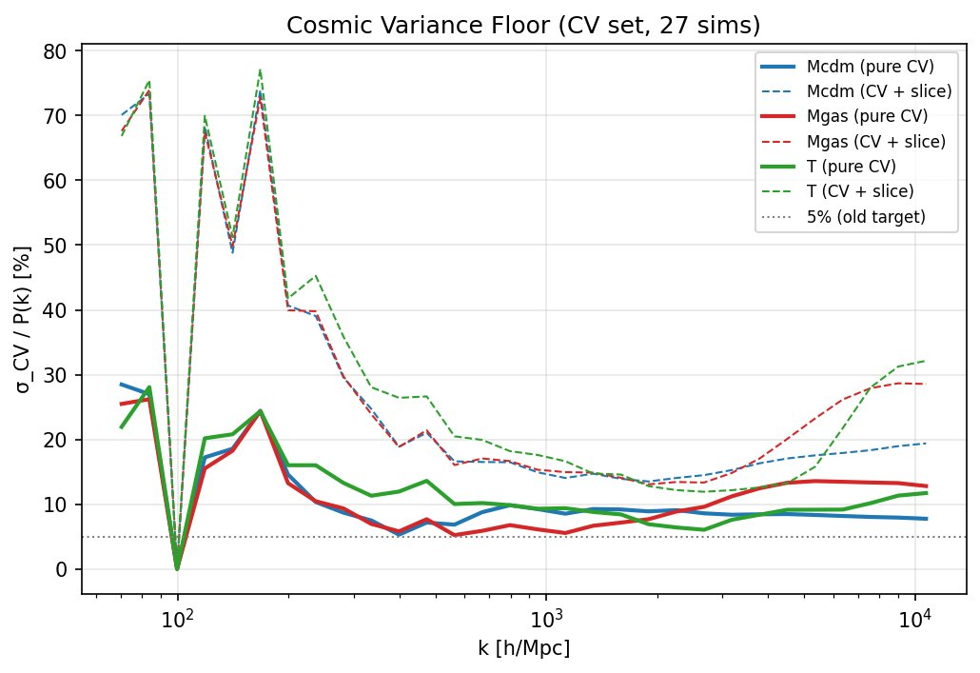
Figure 1. Cosmic variance floor for auto-power spectra. Solid lines: pure cosmic variance (sim-averaged). Dashed lines: total variance including slice-to-slice scatter. The 5% old target (gray dotted) falls far below the noise floor at all k.
Field | Pure CV | CV + Slice | Implication
Mcdm | 10.8% | 26.6% | Old 5% target is below noise floor
Mgas | 11.2% | 28.0% | Same: physically unachievable
T | 12.0% | 29.0% | Highest variance due to feedback sensitivity
Table 1. Cosmic variance floor (mean fractional scatter across all k-bins).
Key finding: The pure cosmic variance floor is ~11% for all three fields. This means even a theoretically perfect generative model, when compared against a different realization of the same cosmology, will show ~11% P(k) discrepancy on average. The old uniform 5% target was approximately 2× below this floor. Including slice variance raises the floor to ~27–29%, explaining why metrics fluctuate dramatically between evaluation epochs (as observed between epoch 110 and 112 of our Swin model).

2.3 Results: Cross-Power Spectrum
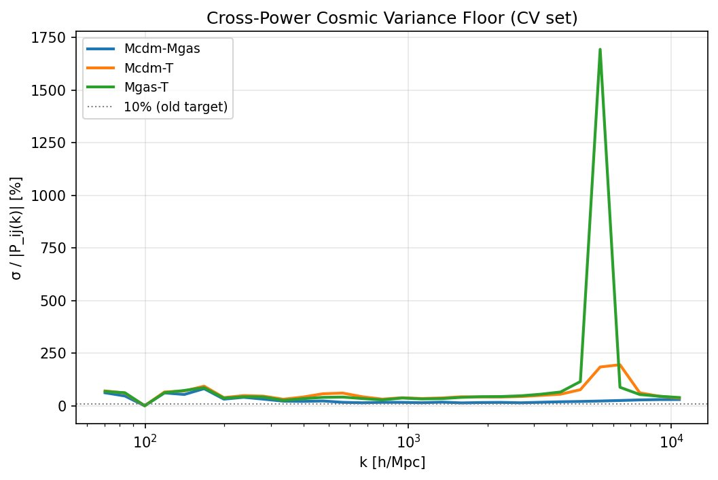
Figure 2. Cross-power cosmic variance floor. Note the extreme spike for Mgas-T at high k (~1700%), indicating that cross-power evaluation at these scales is physically meaningless.
Pair | Mean Frac. Scatter | Implication
Mcdm-Mgas | 27.2% | Old 10% target is well below CV floor
Mcdm-T | 57.9% | Extremely high variance; T cross-correlation inherently noisy
Mgas-T | 103.5% | Mean scatter exceeds 100%; high-k evaluation meaningless
Table 2. Cross-power cosmic variance floor.
The cross-power variance is dramatically higher than auto-power, especially for T-related pairs. Mgas-T shows mean scatter exceeding 100%, with a spike reaching ~1700% at high k. This occurs because P_ij(k) can approach zero at certain scales (where fields become uncorrelated), causing the fractional error to diverge. The old 10% cross-power target is 3–10× below the noise floor.

2.4 Results: Correlation Coefficient r(k)
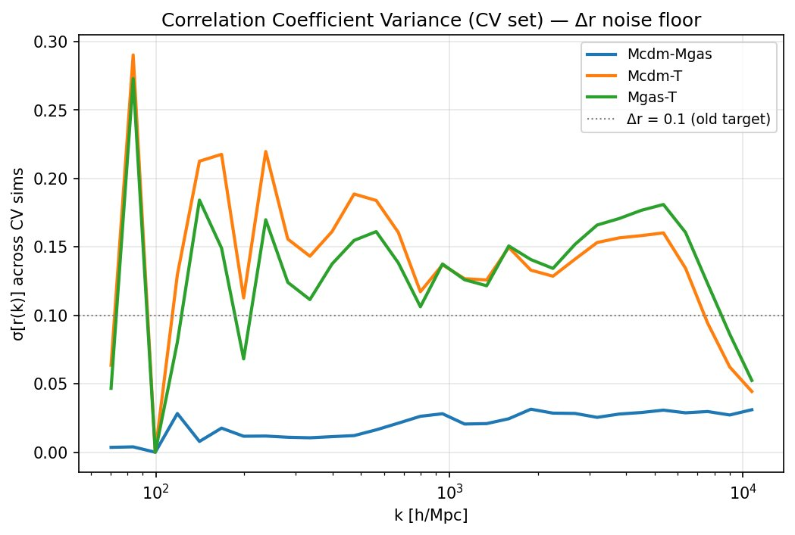
Figure 3. Standard deviation of r(k) across CV simulations. Mcdm-Mgas (blue) is remarkably stable (σ < 0.03), while T-related pairs show σ up to 0.29 at intermediate k.
Pair | Max σ[r(k)] | Implication for Δr Target
Mcdm-Mgas | 0.031 | Δr < 0.1 is achievable (3× above floor) ✓
Mcdm-T | 0.290 | Δr < 0.1 is BELOW noise floor — physically impossible at high k
Mgas-T | 0.273 | Same: Δr < 0.1 unachievable; need Δr < 0.3
Table 3. Correlation coefficient variance from CV set.
Critical finding: The Mcdm-Mgas correlation is physically very stable (σ < 0.031 across all k), meaning our model’s Δr = 0.044 PASS is a genuine achievement — it is within 1.4× of the cosmic variance floor. In contrast, Mcdm-T and Mgas-T show σ[r(k)] up to 0.29, meaning the old Δr < 0.1 target is below the noise floor for these pairs. A physically honest target must be pair-dependent.

3. Experiment 2: Parameter Sensitivity (1P Set)

3.1 Design
The CAMELS 1P set varies one parameter at a time (10 values each) while holding others at fiducial. For each variation, we compute the ratio P(k; θ_varied) / P(k; θ_fid). The maximum absolute deviation from 1.0 across all parameter values quantifies how much P(k) responds to each parameter — the “dynamic range” the model must learn to reproduce.

3.2 Results: Sensitivity Heatmap
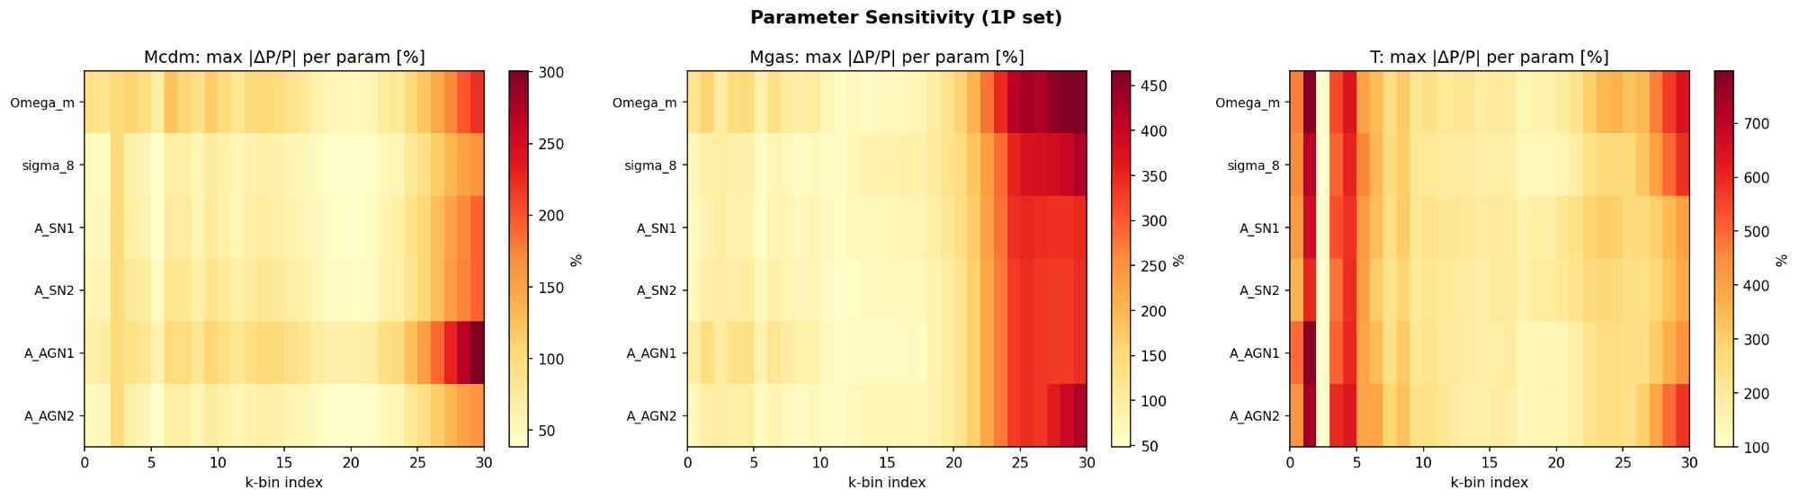
Figure 4. Parameter sensitivity heatmap for all three fields. Colorbar ranges differ: Mcdm (0–300%), Mgas (0–450%), T (0–700%). Each cell shows max |P(k;θ)/P(k;θ_fid) - 1| for one parameter at one k-bin.
The heatmaps reveal a clear hierarchy of difficulty:
Field | Max Sensitivity | Most Sensitive To | Dynamic Range
Mcdm | 110% | A_AGN1 | Moderate; collisionless → weak feedback response
Mgas | 186% | Ωm | High; responds to both cosmology and feedback
T | 325% | Ωm | Extreme; factor 3× harder than Mcdm
Table 4. Maximum parameter sensitivity per field (mean over all k-bins).

3.3 Results: Summary Across Parameters
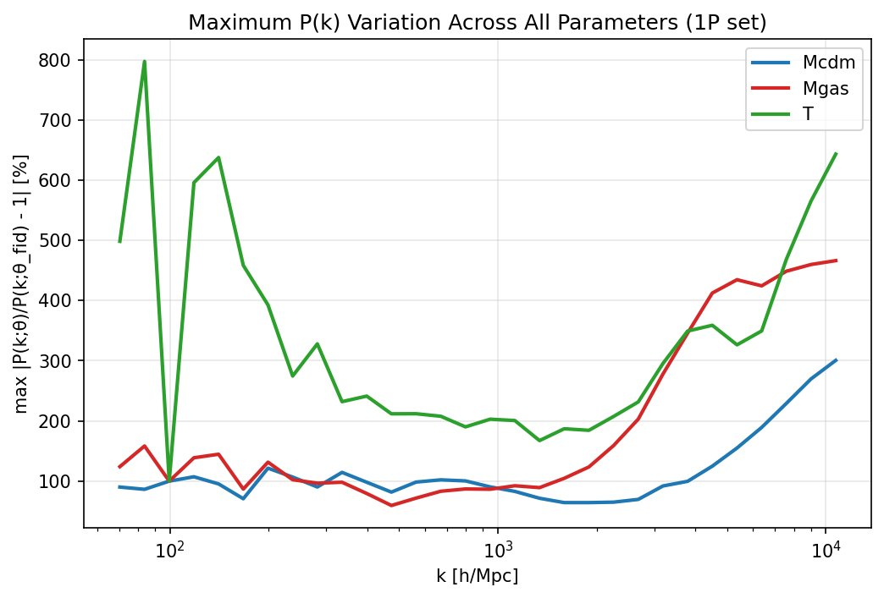
Figure 5. Maximum P(k) variation across all parameters for each field. T (green) shows up to 800% variation at low k, while Mcdm (blue) stays below 300%. This 3× difficulty gap justifies field-dependent accuracy targets.
The T field’s P(k) varies by up to 800% (8×) across the parameter space at low k, compared to ~100–300% for Mcdm. This means the model must learn to track an 8× dynamic range for T versus 1–3× for Mcdm. Applying the same accuracy threshold to both is analogous to requiring a weather model to predict temperature and pressure with the same absolute error — physically unjustified.

4. Experiment 3: Slice-to-Slice Variance (LH Set)

4.1 Design
Each CAMELS simulation produces 15 2D maps from the same 3D volume (5 slices along each of 3 axes). The P(k) variation among these 15 maps quantifies the irreducible uncertainty from the 3D → 2D projection. This variance is present in the “true” data itself and affects any comparison between generated and reference maps.

4.2 Results
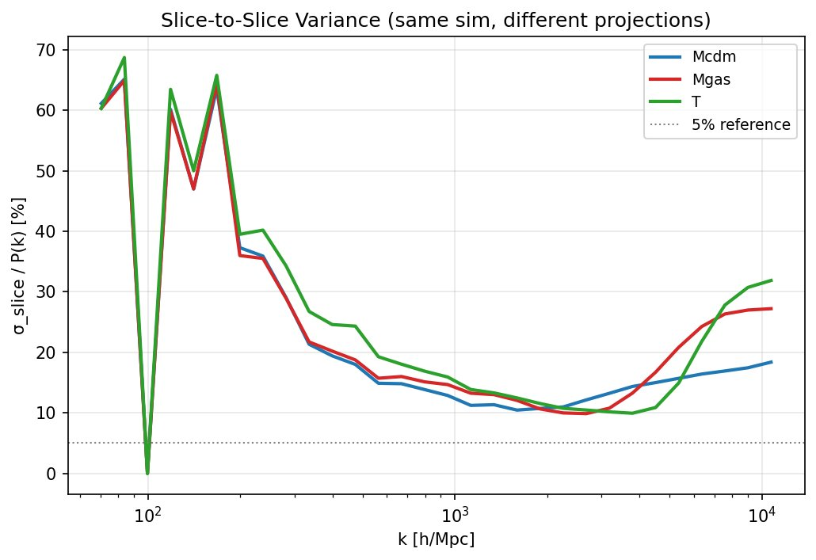
Figure 6. Slice-to-slice variance within the same simulation. All three fields show ~60–70% scatter at the lowest k, decreasing to ~10–20% at high k. The 5% reference line is far below the slice variance at all scales.
Field | Mean Slice Variance | Implication
Mcdm | 23.6% | Different slices of same sim differ by ~24% on average
Mgas | 25.1% | Similar; slightly higher due to feedback-induced structure
T | 26.6% | Highest; T structure varies most across projections
Table 5. Slice-to-slice variance (mean across k-bins, averaged over 50 LH simulations).
The slice variance is comparable in magnitude to cosmic variance (~24–27% vs ~11–12%), and the two sources are largely independent. When a generative model produces a map conditioned on parameters θ and we compare it to a “true” map from a simulation with the same θ, both cosmic variance and slice variance contribute to the observed discrepancy. The total noise floor is approximately √(CV² + slice²) ≈ 26–31%.

5. Comparison with Prior Work
We compare the evaluation approaches of three reference papers with our data-driven framework:
 | Diffusion-HMC | CosmoFlow | CAMELS GAN | GENESIS (old) | GENESIS (new)
Fields | DM only | DM only | Mgas,HI,B | Mcdm,Mgas,T | Mcdm,Mgas,T
Cond. | 2D | 2D | 2D | 6D | 6D
P(k) metric | χ²r = 2.29 | Visual | R²=0.9–0.99 | ΔP/P < 5% | Field+k dep.
Cross-P | N/A | N/A | R²=-12 to 0.99 | < 10% | Pair-dep.
Δr target | N/A | N/A | N/A | < 0.1 all k | Pair+k dep.
PDF | p>0.05 (means) | Visual | Visual (μ,σ) | KS p>0.05 | KS stat<0.05
Noise floor? | No | No | No | No | Yes (this work)
Table 6. Comparison of evaluation methodologies across cosmological generative models.
No prior work has empirically measured the noise floor before setting evaluation targets. Diffusion-HMC used χ²r without reference to the achievable floor; CosmoFlow relied on visual comparison; CAMELS GAN used R² but experienced catastrophic failures (R² = -11.93) without diagnosing whether the failures were inherent to the task or the model. Our approach is the first to establish targets from the data itself.

6. Revised Evaluation Criteria

6.1 Noise Floor vs Old Target vs Data-Driven Target
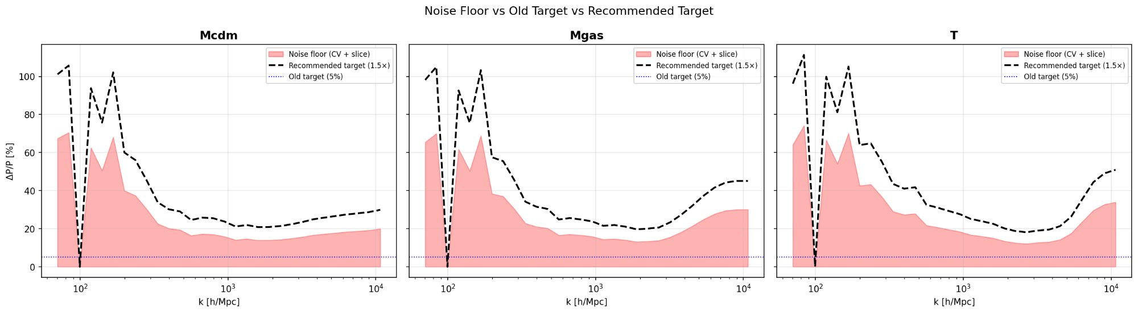
Figure 7. For each field: pink shaded region = measured noise floor (CV + slice variance); dashed line = data-driven target (1.5× floor); blue dotted = old 5% target. The old target falls within or below the noise floor at most k-bins.
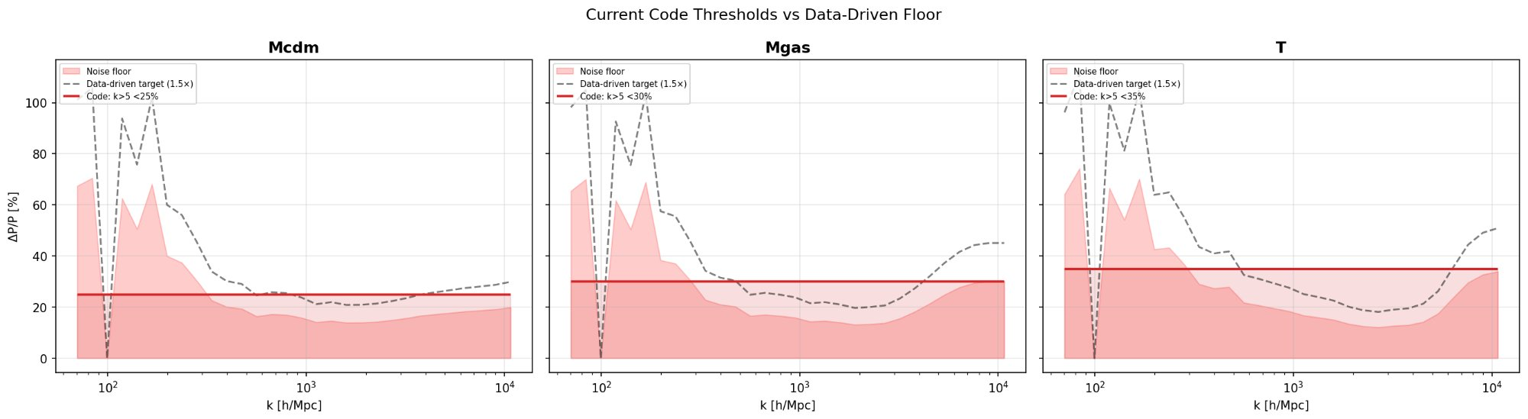
Figure 8. Comparison of currently implemented code thresholds (red lines) against the measured noise floor. At high k, the code thresholds are slightly below the data-driven recommendation.

6.2 Auto-Power Spectrum Targets
We adopt field-dependent targets based on the measured combined floor (CV + slice) multiplied by 1.5× margin. For regions where the floor is low (high k), we use the pure CV floor instead, as slice variance may be partially learnable.
Field | Low k | Mid k | High k | Basis
Mcdm | < 15% | < 15% | < 25% | CV=10.8%, slice=23.6%, sensitivity=110%
Mgas | < 18% | < 18% | < 30% | CV=11.2%, slice=25.1%, sensitivity=186%
T | < 20% | < 20% | < 35% | CV=12.0%, slice=26.6%, sensitivity=325%
Table 7. Revised auto-power targets. Low k: fundamental to k~300; Mid k: 300–2000; High k: >2000 (in pixel frequency units).

6.3 Cross-Power and Correlation Targets
Pair | Cross-P Target | Δr Target (k<1000) | Δr Target (k>1000)
Mcdm-Mgas | < 30% | < 0.1 (floor=0.031) | < 0.1
Mcdm-T | < 60% | < 0.3 (floor=0.290) | Report only
Mgas-T | < 60% | < 0.3 (floor=0.273) | Report only
Table 8. Revised cross-power and correlation targets based on measured CV floor.

6.4 PDF and Measurement Protocol
Metric | Criterion | Rationale
PDF | KS stat < 0.05 | p-value meaningless at N=524k pixels
Sample size | N ≥ 32 (final eval) | SE = σ/√N; N=8 gives SE~5%
Uncertainty | mean ± std (5 seeds) | Reproducibility requirement
Max error | Report only, no pass/fail | Single k-bin too noisy
Table 9. Additional measurement protocol specifications.

7. References
[1] Villaescusa-Navarro, F. et al. (2021). “The CAMELS project.” ApJ 915, 71. arXiv:2010.00619
[2] Villaescusa-Navarro, F. et al. (2022). “The CAMELS Multifield Dataset.” ApJS 259, 61. arXiv:2109.10915
[3] Mudur, N. & Finkbeiner, D. (2024). “Cosmological Field Emulation and Parameter Inference with Diffusion Models.” arXiv:2312.07534
[4] Andrianomena, S. & Hassan, S. (2024). “Cosmological multifield emulator.” Phys. Rev. D. arXiv:2402.10997
[5] CosmoFlow (2025). “Flow Matching for Cosmological Representation Learning.”
[6] Gebhardt, M. et al. (2024). Baryon spread and power spectrum suppression in CAMELS.
[7] Guo, Y. et al. (2025). “Constraining Baryonic Feedback on the Matter Power Spectrum with FRBs.” arXiv:2501.17922
[8] Angulo, R. & Pontzen, A. (2016). “Suppressing cosmic variance with paired-and-fixed simulations.” MNRAS 462, L1.
[9] Lipman, Y. et al. (2023). “Flow Matching for Generative Modeling.” ICLR 2023.
[10] Liu, Z. et al. (2021). “Swin Transformer.” ICCV 2021.

