**Decoder and demux;**

**Theory:-**  
Decoder:-A decoder is a multi-input and multi-output combinational logic circuit which converts coded input into coded outputs, where the input and output coded are different.  
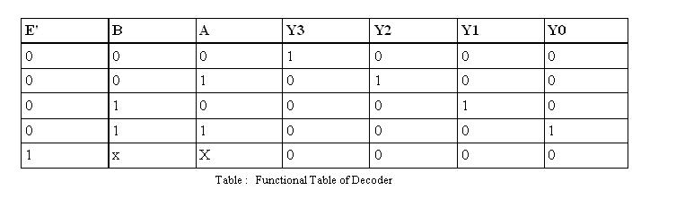Suppose we have n input bits (which can represent up to 2n distinct elements of coded information). • We need a device that allows us to select which of the 2n elements, devices, memory locations, etc. is being selected. • In general: – A decoder has n input bits – A decoder has 2n (or less) output bits – As a rule, all but one of the outputs is zero (deselected) at any time (called one-hot encoded) Demultiplexers • Perform the opposite function of multiplexers • Placing the value of a single data input onto one of the multiple data outputs • Same implementation as decoder with enable • Enable input of decoder serves as the data input for the demultiplexer   
**De- multiplexers:-.**  
A de-multiplexer is a circuit that has one input and more than one output. A de-multiplexer is often abbreviated as d-mux. It is used when a circuit wishes to send a signal to one of many devices. The output line to which the input get connected depends on the selection/control lines. This description sounds similar to the description given for a decoder, but a decoder is used to select among many devices while a demultiplexer is used to send a signal among many devices. Input  
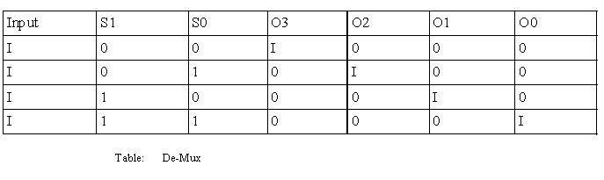  
The output logic equations are :  
O3= I.S1'.S0'  
O2= I.S1'S0  
O1= I.S1.S0'  
O0 = I.S1.S0  
And the logic diagram for the de-Multiplexer is given below: