|  |
| --- |
| Trine University |
| Space Invaders |
| CS 3933 System Analysis & Design |

|  |
| --- |
| Danin Fluke ; Paul Jackemeyer  4-25-2017 |



Contents

Abstract 2

Requirements 2

Requirements Matrix 2

Use Cases 3

Use Case Diagram 3

Class Diagram 4

Sequence Diagrams 5

General Sequence 5

Test Cases 6

References 7

# Abstract

“Space Invaders is one of the most addicting games that was ever made. The idea is very simplistic. You are a space ship who must destroy the invading enemy space ships as they descend upon your little 8-bit world. Fire your gun at the invaders and destroy them. Be careful, as these ships fire back and as you deplete their numbers, and the space invaders get faster and faster until the last remaining ship appears to move at near warp speed. To ensure you stay alive if possible, hide behind the buffer walls and develop a run-and-gun mentality.” (Pacxon.com)

# Requirements

Our objective is to recreate the core concepts of the original Space Invaders game, as closely as possible. We feel that the listed requirements below capture the core gameplay components, while leaving implementation to still be a stylistic choice.

## Requirements Matrix

|  |  |
| --- | --- |
| ID # | REQUIREMENT |
| 1 | The software shall include a user controlled defense ship |
| 2 | The software shall limit the defense ship to horizontal movement |
| 3 | The software shall include multiple enemy alien ships |
| 4 | The software shall permit any/all ships to fire projectiles |
| 5 | The software shall destroy a ship if it collides with a projectile |
| 6 | The software shall limit each ship to have one projectile at a time |
| 7 | The software shall move enemy ships via timed intervals, which rapidly grow smaller |
| 8 | The software shall contain debris walls, which protect the defense ships from enemy ships |
| 9 | The software shall destroy a segment of debris wall after it collides with 4 projectiles |
| 10 | The software shall allocate a specific point value for each ship, and award  said value to the player's score when the ship is destroyed |
| 11 | The software shall track the player's score, and display it in real time |
| 12 | The software shall track the player's lives, and display them in real time |
| 13 | The software shall include 8-bit, alien themed sprites |
| 14 | The software shall record high-scores |

# Use Cases

Overall, there are very few use cases for the *Space Invaders Game* project. The two actors across the set of our use cases are either The Player, or The Game. Whereas the Player refers to the human who is the physical user providing inputs to the software, and whereas the Game abstractly refers to the software itself and its members.

List of Use Cases by Actor:

|  |  |
| --- | --- |
| Player | Game |
| Start Game | Perform Movement |
| View About | Check for Collisions |
| View Scores | Update GUI |
| Quit Game | Calculate Score |
| Move Player |  |
| Fire Bullet |  |

## Use Case Diagram

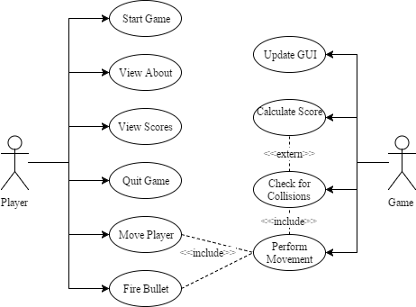

# Class Diagram

TODO

# Sequence Diagrams

## General Sequence

TODO

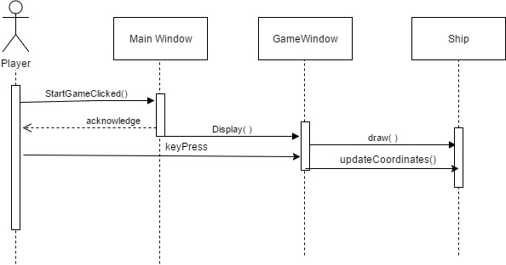

# Test Cases

Based on the rules of the game and our design logic, we list all the test cases we see fit.

1. The game should begin upon clicking the Start Game Button. The aliens should begin moving and the player shall begin in the middle of the screen.
2. When the player presses the left or right arrow keys the player ship shall move left or right. Upon releasing the key, the ship should stop moving.
3. When the player presses the spacebar the player ship should fire a bullet at the aliens. If it hits an alien, the alien should be destroyed.
4. When the player presses ‘P’ the game should pause.
5. The aliens should fire back at the player. If the alien bullet hits the player, the player ship is destroyed and the game should end.
6. The aliens should slowly descend, down the screen, if they reach the player ship then the game should end.
7. When the game ends, the player should enter his name. If his score is in the top 10 all-time then it should appear in the high scores table seen upon clicking the ‘High Scores’ button.
8. The barriers in the game should each sustain four hits before being destroyed. Each hit should change the color of the barrier.

# References

http://www.pacxon4u.com/space-invaders/