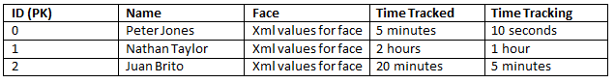Old –

This was our first idea, which was meant to save specific face data to be able to track a specific person.

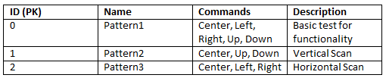New -

This database will store specific movements for the purpose of either testing or security if you wanted to automatically change the cameras view.