EXPT 1: Simulation and Comparative Performance Evaluation of Zigbee, 6LoWPAN and NB-IoT Communication Protocols for IoE Applications

Objective:
- To simulate Zigbee, 6LoWPAN, and NB-IoT communication protocols using Python.
- To calculate the Bit Error Rate (BER) at different transmission distances.
- To analyze the effect of distance on signal-to-noise ratio (SNR) and BER.
- To compare the communication performance of the three protocols.
- To evaluate the suitability of these protocols for Internet of Everything (IoE) applications.
Procedure:
- Import the required Python libraries: NumPy, Matplotlib, and SciPy.
- Define the transmission distance from 10 m to 1000 m.
- Set the transmission power, path loss, path loss exponent, and noise power for each communication protocol.
- Calculate the path loss and received signal power at different distances.
- Determine the Signal-to-Noise Ratio (SNR) for each protocol.
- Calculate the Bit Error Rate (BER) using the complementary error function.
- Plot BER versus distance for Zigbee, 6LoWPAN, and NB-IoT separately using a logarithmic scale.
- Compare the plotted graphs to evaluate the effect of distance on communication performance.
Program:
import numpy as np
import matplotlib.pyplot as plt
from scipy.special import erfc
distance = np.linspace(10, 1000, 100)
# =====================================================
# Common BER equation
# BER = 0.5 * erfc(sqrt(SNR))
#=====================================================
# 1. ZIGBEE
# =====================================================
Pt = 0 # Transmit power (dBm)
PL0 = 40 # Path loss at 1 m (dB)
n = 3 # Path loss exponent
N = -87 # Noise power (dBm)
PL = PL0 + 10*n*np.log10(distance)
Pr = Pt - PL
SNR = Pr - N
BER = 0.5 * erfc(np.sqrt(10**(SNR/10)))
print(BER[1])
plt.figure(figsize=(7,5))
plt.semilogy(distance, BER)
plt.xlabel("Distance (m)")
plt.ylabel("Bit Error Rate (BER)")
plt.title("Zigbee: BER vs Distance")
plt.grid(True)
plt.show()
# =====================================================
# 2. 6LoWPAN
# =====================================================
Pt = 0
PL0 = 40
n = 3
N = -87
PL = PL0 + 10*n*np.log10(distance)
Pr = Pt - PL
SNR = Pr - N
BER = 0.5 * erfc(np.sqrt(10**(SNR/10)))
print(BER[1])
plt.figure(figsize=(7,5))
plt.semilogy(distance, BER)
plt.xlabel("Distance (m)")
plt.ylabel("Bit Error Rate (BER)")
plt.title("6LoWPAN: BER vs Distance")
plt.grid(True)
plt.show()
# =====================================================
# 3. NB-IoT
# =====================================================

Pt = 23
PL0 = 31
n = 3.5
N = -87

PL = PL0 + 10*n*np.log10(distance)
Pr = Pt - PL
SNR = Pr - N
BER = 0.5 * erfc(np.sqrt(10**(SNR/10)))
print(BER[40])
plt.figure(figsize=(7,5))
plt.semilogy(distance, BER)
plt.xlabel("Distance (m)")
plt.ylabel("Bit Error Rate (BER)")
plt.title("NB-IoT: BER vs Distance")
plt.grid(True)
plt.show()

Table:

ZIGBEE (10m) |  | 1.30E-56 | Pt = 0 | 5.69E-02 | Pt = 0 | 2.00E-04 | Pt = 0 | 0
ZIGBEE (10m) | PL0 = 40 | 1.30E-56 | PL0 = 40 | 5.69E-02 | PL0 = 40 | 2.00E-04 | PL0 = 40 | 0
ZIGBEE (10m) | n = 3.0 | 1.30E-56 | n = 3.0 | 5.69E-02 | n = 3.0 | 2.00E-04 | n = 3.0 | 0
ZIGBEE (10m) | N = -100 | 1.30E-56 | N = -80 | 5.69E-02 | N = -87 | 2.00E-04 | N = -111 | 0
6LoWPAN(20m) | Pt = 0 | 1.30E-56 | Pt = 0 | 5.69E-02 | Pt = 0 | 2.00E-04 | Pt = 0 | 0
6LoWPAN(20m) | PL0 = 40 | 1.30E-56 | PL0 = 40 | 5.69E-02 | PL0 = 40 | 2.00E-04 | PL0 = 40 | 0
6LoWPAN(20m) | n = 3.0 | 1.30E-56 | n = 3.0 | 5.69E-02 | n = 3.0 | 2.00E-04 | n = 3.0 | 0
6LoWPAN(20m) | N = -100 | 1.30E-56 | N = -80 | 5.69E-02 | N = -87 | 2.00E-04 | N = -111 | 0
NB-IoT(400m) | Pt = 23 | 1.26E-51 | Pt = 23 | 4.40E-01 | Pt = 23 | 3.68E-01 | Pt = 23 | 4.46E-08
NB-IoT(400m) | PL0 = 31 | 1.26E-51 | PL0 = 31 | 4.40E-01 | PL0 = 31 | 3.68E-01 | PL0 = 31 | 4.46E-08
NB-IoT(400m) | n = 3.5 | 1.26E-51 | n = 3.5 | 4.40E-01 | n = 3.5 | 3.68E-01 | n = 3.5 | 4.46E-08
NB-IoT(400m) | N = -120 | 1.26E-51 | N = -80 | 4.40E-01 | N = -87 | 3.68E-01 | N = -111 | 4.46E-08

Output:
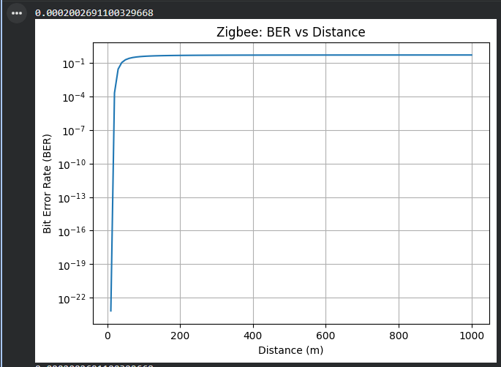
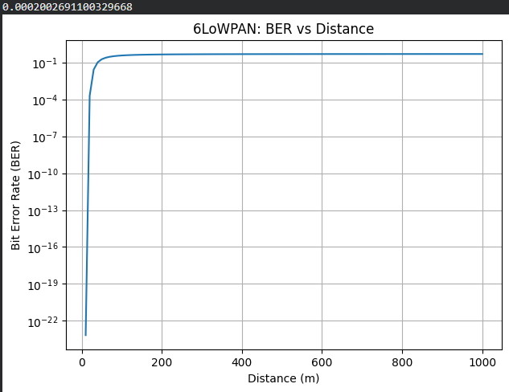
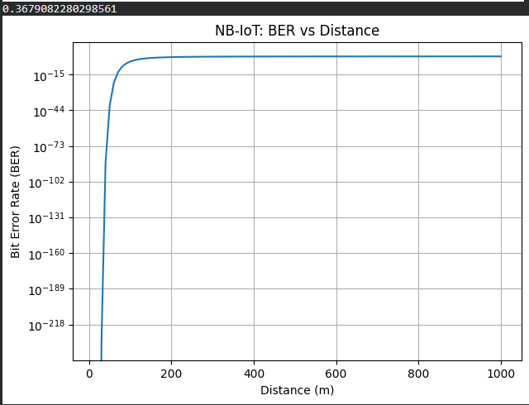

Result:
The simulation was performed successfully, and the BER performance of Zigbee, 6LoWPAN, and NB-IoT was analyzed over different transmission distances. The results show that BER generally increases as distance increases due to increased path loss and reduced SNR. Under the given simulation parameters, NB-IoT is expected to provide better long-distance coverage because of its higher transmission power and lower assumed noise power. Zigbee and 6LoWPAN produce identical results because the same simulation parameters are used for both protocols.

