Ex. No:9
Date:
Data Flow Diagram
Aim:
To construct a structured Data Flow Diagram (DFD) that represents the interaction between different functional modules of an Online Food Ordering System, ensuring efficient data movement, logical separation of system components, and clarity in process handling.
Problem Description:
Online food ordering platforms involve multiple interconnected operations such as customer interaction, order processing, menu handling, and administrative control. The key challenge lies in designing a system that coordinates these processes efficiently while avoiding complexity and maintaining clarity. Additionally, the system must ensure that each functional domain manages its own data securely without overlap or redundancy.
Given Conditions / Constraints:
The system design follows these essential constraints:
- Centralized Processing Unit:
All operations must be controlled through a single core system. Direct communication between modules is not permitted.
- Dedicated Data Storage:
Each functional area must maintain its own separate database (Customer DB, Order DB, Food DB, Category DB, User DB), avoiding data mixing.
- Clear Role Differentiation:
The system must distinguish between customer-side operations and administrative functionalities, ensuring proper access control.
- Two-Way Communication:
Data exchange between the core system, modules, and databases must support both input and output flow.
Approach / Methodology:
The system design adopts a modular DFD approach with the following characteristics:
- Centralized Hub Model:
The main system acts as a controller, managing communication between all external modules.
- Domain-Based Structuring:
Each module is aligned with a specific data domain (e.g., Order Management linked with Order DB), ensuring organized processing.
- Layered Representation:
The design reflects a Level-0/Level-1 DFD, providing both high-level overview and functional clarity.
Planning and Estimation:
The development process can be divided into distinct phases:
- Phase 1 – Data Layer Setup:
Creation and structuring of individual databases for each domain.
- Phase 2 – Core System Development:
Implementation of the central processing unit responsible for routing and control.
- Phase 3 – Module Implementation:
Independent development of functional modules such as Customer Management, Order Management, and User Management.
Scheduling / Design Considerations:
- Performance Optimization:
The central system must handle high request loads efficiently, avoiding delays or system failure.
- Standard Communication Interfaces:
APIs (such as REST or similar protocols) should be defined to ensure smooth data exchange between components.
- Parallel Development Strategy:
Since modules are independent, development tasks can be executed simultaneously to reduce overall project duration.
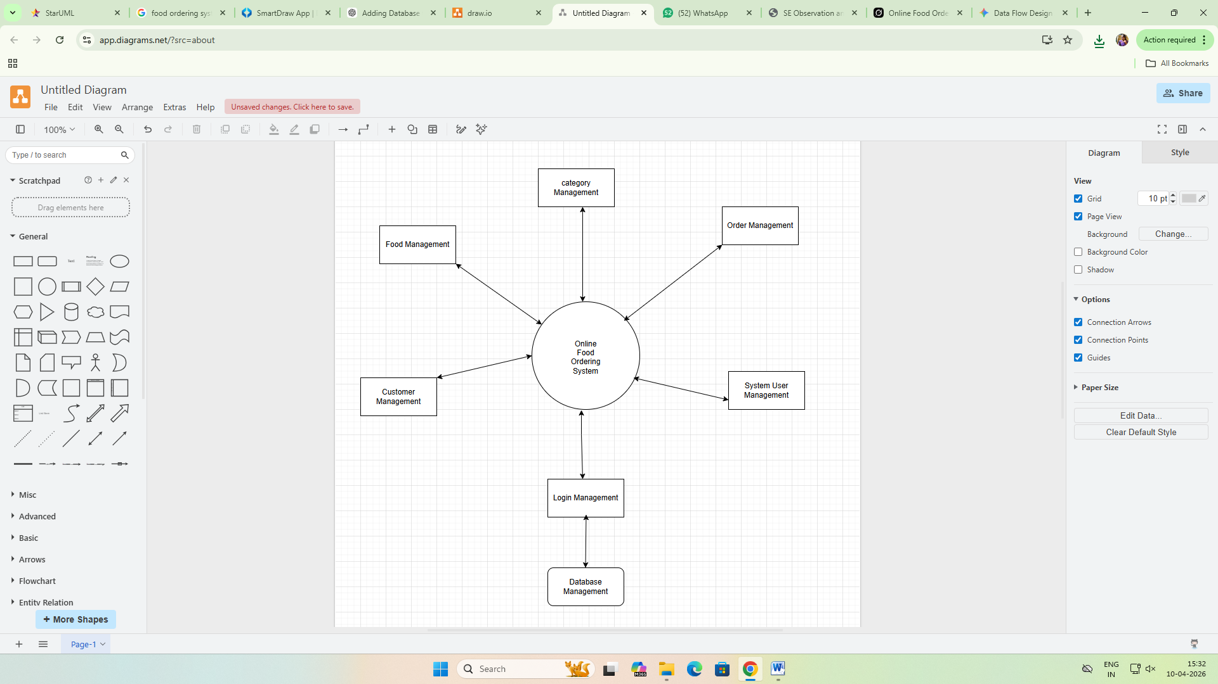
Feasibility Analysis:
- Technical Feasibility:
The proposed structure is practical and aligns with standard software engineering practices. It can be implemented using widely available database systems and programming frameworks.
- Operational Feasibility:
The modular design supports easy management and division of responsibilities among teams, improving operational efficiency.
Result:
The designed Data Flow Diagram clearly represents the system structure, including all processes, data stores, and interactions. It ensures a well-organized flow of data across different system components.
Conclusion:
The developed DFD provides a scalable and maintainable framework for the Online Food Ordering System. By separating responsibilities and organizing data flow effectively, the system achieves better performance, security, and ease of maintenance. This design serves as a strong foundation for further detailed implementation and development.

