**Overview of available data from the Svartisen Subglacial Laboratory (SSL) and surrounding meteorological/hydrological stations.**

**

Pierre-Marie Lefeuvre

May 2016

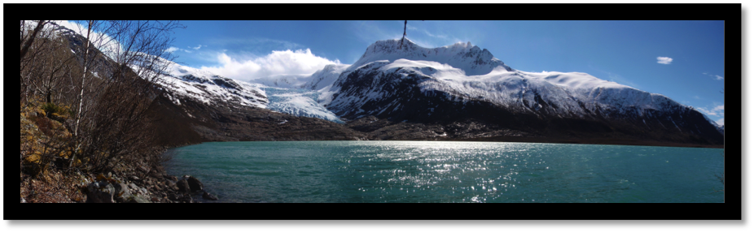

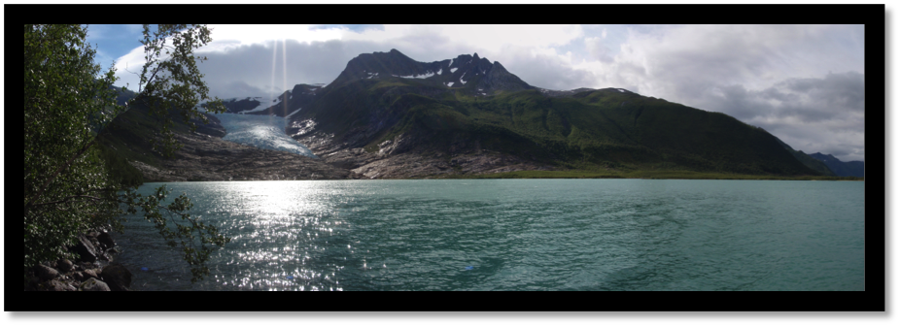

*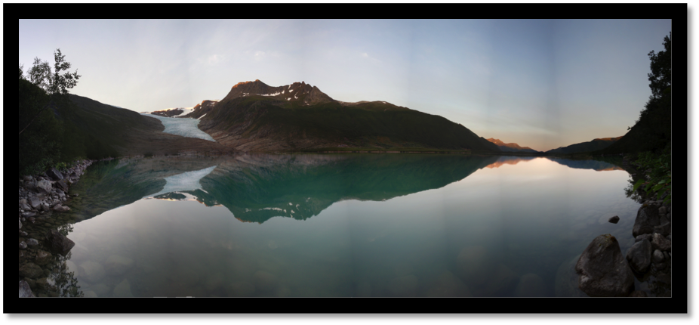*

Table of contents

INTRODUCTION 4

SVARTISEN SUBGLACIAL LABORATORY 4

MAPS 4

TIME SPAN 6

STATION DESCRIPTION 7

> Load cells (Geonor Earth pressure sensor) 7

General Description (More information in Lefeuvre et al., 2016, Chapter 3.) 7

- LC1e 8

- LC01 8

- LC2a 8

- LC2b 8

- LC4 9

- LC6 9

- LC7 / LC7b 9

- LC97\_1 / LC12\_2 10

- LC97\_2 / LC12\_1 10

Notes 11

> Hydrological station 12

- Sediment Chamber 12

- Fonndalstunnelen, Crump 12

- Fonndalstunnelen, Fjellsterkel 12

- Engabreelv 12

- Engabrevatn 12

> Meteorological station 13

- Skjaeret 13

- Glomfjord 13

- Reipaa 13

- Engabrevatn 13

Notes 13

DETAILED YEARLY DESCRIPTION OF TIME COVERAGE AND NOISE 14

> 1992 – Little LC data 14

> 1993 – Spring and summer only 15

> 1994 – LC noisy and large gaps, but interesting dataset 16

> 1995 – Little LC data 17

> 1996 – Little LC data 18

> 1997 – GOOD YEAR 19

> 1998 – GOOD YEAR 20

> 1999 – GOOD YEAR (but data gap in spring for the LCs) 21

> 2000 – Good, but large gap in spring and late autumn for the LCs 22

> 2001 – GOOD YEAR (but data gap in late winter and spring) 23

> 2002 – Good, but large gap of LC data in end of summer and autumn 24

> 2003 – Good, but overall has a higher level of noise 25

> 2004 – Gap in LC data, Precip. station in Glomfjord stops and Air. Temp. station at Skjaeret less reliable. 26

> 2005 – GOOD YEAR for data continuity 27

> 2006 – GOOD YEAR, but lower quality for LC data 28

> 2007 – GOOD YEAR 29

> 2008 – GOOD YEAR, but lower quality for LC data 30

> 2009 – GOOD YEAR, but lower quality for LC data 31

> 2010 – GOOD YEAR, but lower quality for LC data 32

> 2011 – GOOD YEAR, but lower quality for LC data 33

> 2012 – GOOD YEAR, but lower quality for LC data 34

> 2013 – GOOD YEAR 35

> 2014 – GOOD YEAR, but lower quality for LC data 36

> 2015 37

REFERENCES 38

# 

# INTRODUCTION

**-----------------------------**

We report data availability from the Svartisen Subglacial Laboratory (SSL) located in Northern Norway and surrounding hydrological and meteorological stations (Fig. 1 and 2). This summary includes a detailed description of the load cell sensors and nearby stations, and a qualitative control of the datasets.

The construction of the Glomfjord hydro-power plant in the vicinity of the Svartisen Ice Cap has led to a long-term monitoring of the Saltfjellet-Svartisen hydrological system and in particular Engabreen, a maritime outlet glacier. Since 1992, the SSL built underneath the glacier has been the place of glaciological and hydrological investigations, in which the Norwegian Water Resource and Energy Directed (NVE – owner of the SSL) has largely contributed. Direct observations of the glacier bed are key to understand the relationship between subglacial hydrology and glacier dynamics. In this report, data from the SSL are presented with data from hydrological and meteorological stations (Fig. 2).

# SVARTISEN SUBGLACIAL LABORATORY (SSL)

**-----------------------------------------------------------**

The SSL is part of a rock tunnel network located under ~200m of ice. One of the subglacial intakes is currently used for scientific purposes and consists of a horizontal and a vertical research shaft (see Fig. 3 “Horiz.” And “Vert.”). From these entrances, an ice cave can be melted using a hot-water drilling system. After clearing a part of the bedrock, instruments are installed to monitor variations in basal pressure, ice closure and also samples of subglacial ice can be collected. The ice cave will close at a mean rate of 25 cm/day in each direction, leading to complete closure over three-five days.

# MAPS

**-----------------------------**

**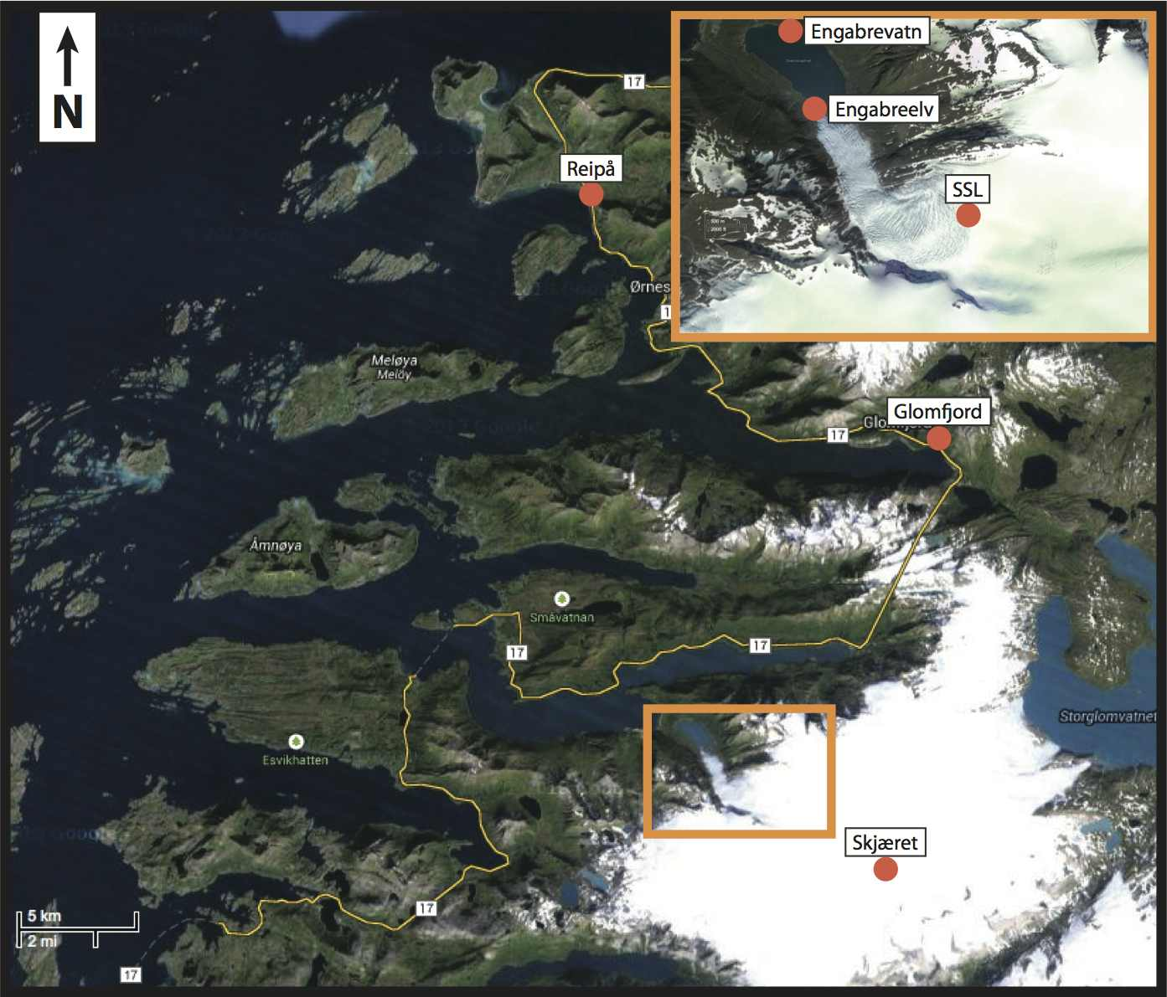**

**Fig. 1**: Location of the meteorological and hydrological stations and close-up on Engabreen (inset) (image from GoogleEarth).

**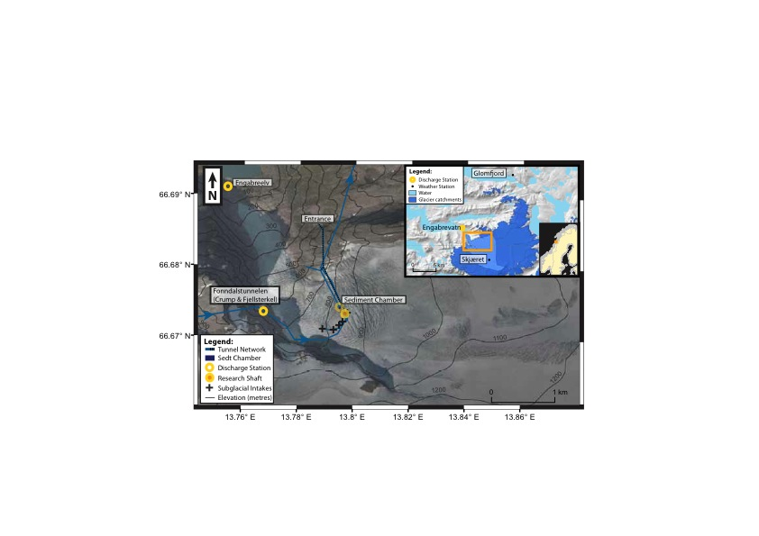**

**Fig. 2**: Satellite image of Engabreen from 2009 (source: Kartverket) with 100 m elevation contour lines, location of the rock tunnel network, research shaft and hydrological stations. The inset shows glacierised areas, Engabreen’s catchment (lighter blue), hydrological and meteorological stations (Glomfjord, and Skjæret).

**Macintosh HD:Users:PiM:Desktop:NVE_work:Documentation:Data_assessment:Maps:LC-BH_map_b-eps-converted-to.pdf**

**Fig. 3:** Map of the bedrock surrounding the research shafts with location of the load cells (white points) and shaft accesses (black frames), published in Lappegard et al. (2006).

# TIME SPAN

**-----------------------------**

**Series of years with good data:**

* **1997-2000 (or 2002):** High coverage during this period for the load cell data, subglacial discharge, air temperature/precipitation in Glomfjord and air temperature at Skjaeret.
* **2005-2009:** High data coverage (good subglacial discharge), but lower quality for LC97s, LC1e, and LC7, Precipitation in Glomfjord is down – use Reipaa then.
* **2012-2016:** Good data continuity and increasing number of Met./Hydro. stations, although there aresome data gaps and a lower quality for LC data.

Macintosh HD:Users:PiM:Desktop:NVE_work:Documentation:Data_assessment:TimeSpanData:Timespan7.pdf

**Fig. 4**: Time span of the load cell, discharge, air temperature, precipitation and, mineral/organic sediment concentration.

# STATION DESCRIPTION

**-----------------------------**

## > Load cells (Geonor Earth pressure sensor)

### General Description (More information in [Lefeuvre et al., 2016](https://www.duo.uio.no/bitstream/handle/10852/49237/PhD-Lefeuvre-DUO.pdf?sequence=4&isAllowed=y), Chapter 3.)

The load cells consist of a plate, under which a wire under tension is attached to two vertical pins (Fig. 5). The applied load causes the plate to bend and the distance between the screws increases changing the frequency at which the wire vibrates. The measured frequency has been calibrated up to 9 MPa with an error of less than 1% for the total range, according to the manufacturer [GEONOR].

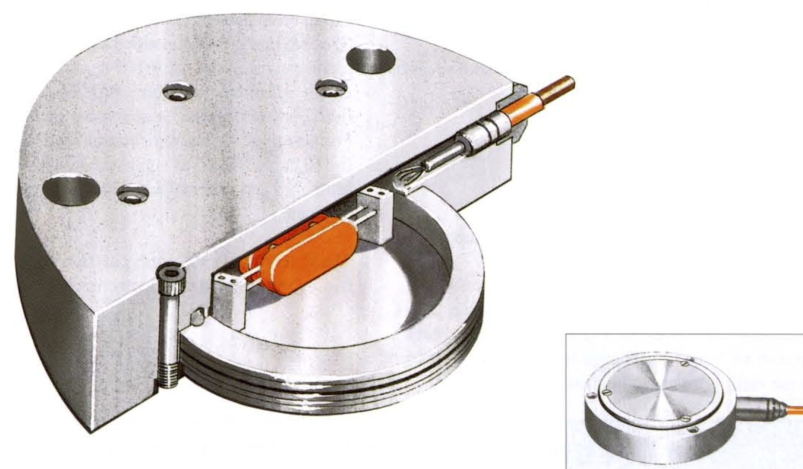

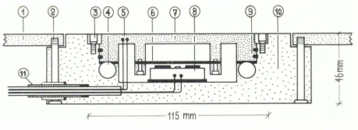

Fig. 5: Sketch of the load cell and its components

In 1992-1993, seven load cells were drilled into the bedrock: LC1e, LC2a, LC2b, LC4, LC6 and LC7. In 1997, LC97\_1 and LC97\_2 were installed and in 2012 were replaced with LC12\_1 and LC12\_2. The map in Figure 4 shows their location and that of the research shaft. The load cell LC01 added in 2001, failed to work after its first year.

The Time Series are not continuous, but span the period from late 1992 to 2016. Problems with batteries and data loggers caused most of the data gaps. Failure of the load cells could result from over-loading due to a rock passing over as seen on sensor 97\_2, where evidence of gauging of the load cell plate was visible. Connections with the datalogger can deteriorate over time as occurred with LC1e, which became loose due to work in the tunnel.

Load cells sheltered from ice flow by an ice cliff (e.g. LC4 and LC6) vary significantly less and present less noise as opposed to the rest of the sensors. LC97\_1 and LC97\_2 are located on a more exposed area of the bed and show larger variations in pressure.

### - LC1e

Sensor type: P-105

Azimuth: 180 with tilt: 31°

UTM 33W coordinates: 446816.507 m East - 7395459.37 m North

Elevation: 630.71 m a.s.l.

---

Calibration ID: 36892 (Least square fit)

Calibration function: P(bar)=A\* (f(Hz) - f\_0) + B\* (f(Hz) - f\_0) ^2

Calibration frequency f\_0: 1157.3 Hz

Calibration parameter A: 0.03344655152

Calibration parameter B: 0.00001780579

Max. non-linearity error: 0.36% of full range

---

Start date: 1992-12-11

End date: 2012-03-19

### - LC01

Sensor type: P-105

Azimuth: *NaN* with tilt: *NaN*

UTM 33W coordinates: 446820 m East - 7395454 m North (source:NVE)

Elevation: *NaN* m a.s.l.

---

Calibration ID: 37892 (Least square fit)

Calibration function: P(bar)=A\* (f(Hz) - f\_0) + B\* (f(Hz) - f\_0) ^2

Calibration frequency f\_0: 1239.0 Hz

Calibration parameter A: 0.03590285970

Calibration parameter B: 0.00001707230

Max. non-linearity error: 0.15% of full range

---

Date start: 2001-03-20

Date end: 2002-04-21

### - LC2a

Sensor type: P-100

Azimuth: 170 with tilt: 13°

UTM 33W coordinates: 446808.314 m East – 7395460.69 m North

Elevation: 632.59 m a.s.l.

---

Calibration ID: 34892 (Least square fit)

Calibration function: P(bar)=K\* ( f\_0^2 - f(Hz)^2 ) + A

Calibration frequency f\_0: 1106.0 Hz

Calibration parameter A: -0.32367

Calibration parameter K: -0.00000909709

Max. non-linearity error: 0.69% of full range

---

Date start: 1992-12-09

Date end: *still active*

### - LC2b

Sensor type: P-105

Azimuth: *NaN* with tilt: 0°

UTM 33W coordinates: 446810.726 m East – 7395458.93 m North

Elevation: 632.53 m a.s.l.

---

Calibration ID: 36792 (Least square fit)

Calibration function: P(bar)=A\* (f(Hz) - f\_0) + B\* (f(Hz) - f\_0) ^2

Calibration frequency f\_0: 1178.0 Hz

Calibration parameter A: 0.03041779663

Calibration parameter B: 0.00001562228

Max. non-linearity error: 0.74% of full range

---

Date start: 1992-12-09

Date end: 1998-03-13

### - LC4

Sensor type: P-100

Azimuth: 170 with tilt: 125°

UTM 33W coordinates: 446801.877 m East – 7395464.25m North

Elevation: 631.73 m a.s.l.

---

Calibration ID: 34792 (Least square fit)

Calibration function: P(bar)=K\* ( f\_0^2 - f(Hz)^2 ) + A

Calibration frequency f\_0: 1105.0 Hz

Calibration parameter A: -0.31762

Calibration parameter K: -0.00000904647

Max. non-linearity error: 0.85% of full range

---

Date start: 1992-12-09

Date end: *still active*

### - LC6

Sensor type: P-100

Azimuth: 140 with tilt: 12°

UTM 33W coordinates: 446801.864 m East – 7395463.81m North

Elevation: 630.61 m a.s.l.

---

Calibration ID: 34992 (Least square fit)

Calibration function: P(bar)=K\* ( f\_0^2 - f(Hz)^2 ) + A

Calibration frequency f\_0: 1061.5 Hz

Calibration parameter A: -0.32476

Calibration parameter K: -0.00000922481

Max. non-linearity error: 0.69% of full range

---

Date start: 1992-12-09

Date end: *still active*

### - LC7 / LC7b

Sensor type: P-105

Azimuth: 190 with tilt: 13°

UTM 33W coordinates: 446813.904 m East – 7395457.53 m North

Elevation: 630.85 m a.s.l.

---

Calibration ID: 36992 (Least square fit)

Calibration function: P(bar)=A\* (f(Hz) - f\_0) + B\* (f(Hz) - f\_0) ^2

Calibration frequency f\_0: 1115.0 Hz

Calibration parameter A: 0.03444747180

Calibration parameter B: 0.00001708080

Max. non-linearity error: 0.34% of full range

---

Date start: 1992-12-09

Date end: 2001-03-20

**Replaced on 2003-11-11 by LC7b?** (source: Gaute Lappegard PhD thesis, 2006)

Sensor type: P-105

---

Calibration ID: 37992 (Least square fit)

Calibration function: P(bar)=A\* (f(Hz) - f\_0) + B\* (f(Hz) - f\_0) ^2

Calibration frequency f\_0: 1196.3 Hz

Calibration parameter A: 0.03583835982

Calibration parameter B: 0.00001629819

Max. non-linearity error: 0.28% of full range

---

Date start: 2003-11-11

Date end: 2008-06-19

### - LC97\_1 / LC12\_2

Sensor type: P-105

Azimuth: 250 with tilt: 9°

UTM 33W coordinates: 446822.068 m East – 7395456.96 m North

Elevation: 630.70 m a.s.l.

---

Calibration ID: 37692 (Least square fit)

Calibration function: P(bar)=A\* (f(Hz) - f\_0) + B\* (f(Hz) - f\_0) ^2

Calibration frequency f\_0: 1230.0 Hz

Calibration parameter A: 0.03732795492

Calibration parameter B: 0.00001812624

Max. non-linearity error: 0.10% of full range

---

Date start: 1997-11-13

Date end: 2010-07-11

**Replaced on 2012-03-24 by LC12\_2**

Sensor type: P-105

---

Calibration ID: 38092 (Least square fit)

Calibration function: P(bar)=A\* (f(Hz) - f\_0) + B\* (f(Hz) - f\_0) ^2

Calibration frequency f\_0: 1176.0 Hz

Calibration parameter A: 0.03612602035

Calibration parameter B: 0.00001641125

Max. non-linearity error: 0.62% of full range

---

Date start: 2012-03-24

Date end: *still active*

### - LC97\_2 / LC12\_1

Sensor type: P-105

Azimuth: 250 with tilt: 14°

UTM 33W coordinates: 446821.748 m East – 7395456.81 m North

Elevation: 630.60 m a.s.l.

---

Calibration ID: 38292 (Least square fit)

Calibration function: P(bar)=A\* (f(Hz) - f\_0) + B\* (f(Hz) - f\_0) ^2

Calibration frequency f\_0: 1191.8 Hz

Calibration parameter A: 0.03527084300

Calibration parameter B: 0.00001688219

Max. non-linearity error: 0.18% of full range

---

Date start: 1997-11-13

Date end: 2011-12-14

**Replaced on 2012-03-24 by LC12\_1**

Sensor type: P-105

---

Calibration ID: 37092 (Least square fit)

Calibration function: P(bar)=A\* (f(Hz) - f\_0) + B\* (f(Hz) - f\_0) ^2

Calibration frequency f\_0: 1150.6 Hz

Calibration parameter A: 0.03658517636

Calibration parameter B: 0.00001535245

Max. non-linearity error: 0.40% of full range

---

Date start: 2012-03-24

Date end: *still active*

---

---

### Notes

---------------

**Location of the Svartisen Subglacial Laboratory (Research Shaft):**

The SSL coordinates in UTM 33W and taken from the mean of load cell positions are: East: 446811.3 m ±7.4 m, North: 7395456.1 m ±3.5 m, Elevation: 630.74 m ±1.6 m a.s.l..

**Ice thickness above the SSL:**

- The glacier surface above the SSL is about 822-826m based on the 2013 DEM of Engabreen, which gives an ice thickness of around 192-196m. (Lefeuvre, 2016).

- In Norgeskart.no, the elevation above the SSL is 830m, giving 200 m of ice thickness (DEM unknown – 2008?).

- Lappegard et al., 2005 (Journal of Glaciology) uses an ice thickness of 210 m above the SSL (DEM unknown – 2003 or earlier?).

**Time**

The datalogger records only in winter time that is UTC+1 also called Norwegian Mean Time (NMT).

**References**

Analysis of the load cells and their data can be found in Lappegard et al., 2005, Lappegard, 2006, Lefeuvre et al., 2015 and Lefeuvre, 2016.

## > Hydrological station

### - Sediment Chamber

Discharge station run by NVE for Statkraft

Catchment: 33 km2 (glacierised at 100%)

UTM 33 coordinates: 446700 m East – 7395740 m North

Elevation: 608.5 m a.s.l. (from tunnel maps)

Other measurements: Sediment concentration and Water temperature

---

Date start: 1994-01-13

Date end: *still active*

### - Fonndalstunnelen, Crump

Discharge station run by NVE for Statkraft

Catchment: ~16.6 km2 (glacierised at ~84%) (source: NVE Atlas)

UTM 33 coordinates: 445500 m East – 7395560 m North

Elevation: 615.0 m a.s.l.

Other measurements: Water temperature

---

Date start: 1998-04-22

Date end: *still active*

### - Fonndalstunnelen, Fjellsterkel

Discharge station run by NVE for Statkraft

Catchment: ~16.6 km2 (glacierised at ~84 %) (source: NVE Atlas)

UTM 33 coordinates: 445660 m East – 7395400 m North

Elevation: 614 m a.s.l.

Other measurements: Water temperature

---

Date start: 1999-12-02

Date end: *still active*

### - Engabreelv

Discharge station run and owned by NVE

Catchment: 40.4 km2 (glacierised at 94.1%)

UTM 33 coordinates: 445005 m East – 7397524 m North

Elevation: 15 m a.s.l. (Geoide: NN54)

Other measurements: Sediment concentration, Air and Water temperature

---

Date start: 1993-10-15

Date end: 1997-10-12

Reinstalled: 2012-05-02

Date end: *still active*

### - Engabrevatn

Discharge station run by NVE for Statkraft

Catchment: 53.3 km2 (glacierised at 74.7%)

UTM 33 coordinates: 444698 m East – 7398782 m North

Elevation: 5 m a.s.l. (Geoide: NN54)

Other measurements: Sediment concentration, Air and Water temperature

---

Date start: 1970-05-03

Date end: *still active*

## > Meteorological station

### - Skjaeret

Meteorological station maintained by NVE (on a nunatak)

UTM 33 coordinates: 452656 m East – 7392012 m North

Elevation: 1362 m a.s.l. (Geoide: NN54)

Measurement: Air Temp. (Poor reliability of Precip. – snow drift).

---

Date start: 1995-01-12

Date end: 2009-04-13

**New Weather station at the same location**

Date start: 2008-09-02

Date end: *still active*

### - Glomfjord

Meteorological station maintained by Norwegian Meteorological Institute

UTM 33 coordinates: 455237 m East – 7410565 m North

Elevation: 39 m a.s.l.

Measurement: Air Temp. and Precip.

---

Date start: 1916-01-01

Date end: *still active*

(Precip. measurements stop in 2004, decrease in reliability from 2003)

### - Reipaa

Meteorological station maintained by Norwegian Meteorological Institute

UTM 33 coordinates: 440732 m East – 7421267 m North

Elevation: 9 m a.s.l.

Measurement: Air Temp. and Precip.

---

Date start: 1995-01-12

Date end: 2009-04-13

### - Engabrevatn

Station maintained by NVE (Air Temp. only)

UTM 33 coordinates: 444698 m East – 7398782 m North

Elevation: 5 m a.s.l. (Geoide: NN54)

Measurement: Air Temp.

---

Date start: 2010-06-21

Date end: *still active*

---

---

### Notes

---------------

Find more info on the [stations](http://eklima.met.no/Help/Stations/toDay/all/en_Stations.html) and data from the Norwegian Met. Institute on [eklima.no](http://sharki.oslo.dnmi.no/portal/page?_pageid=73,39035,73_39049&_dad=portal&_sche) and more info on the stations from [NVE](https://www.nve.no/hydrologi/hydrologiske-data/) on [Sildre](http://sildre.nve.no/).

# DESCRIPTION OF THE DATA FOR EACH YEAR (TIME COVERAGE AND NOISE)

**-----------------------------**

## > 1992 – Little LC data

*Load cells* (installation from 1992-12-09)

- LC6: 23 days (544 pts)

- LC1e: 21 days (488 pts)

- LC4: 23 days (544 pts)

- LC2a: 23 days (544 pts)

- LC7: 23 days (535 pts)

- LC2b: 23 days (544 pts)

*Air Temperature*

- Glomfjord: 366 days (1098 pts)

*Precipitation*

- Glomfjord: 366 days (366 pts)

*Discharge*

- SedimentChamber: 150 days (523 pts)

- Engabreelv: 218 days (3808 pts) (outliers)

- Engabrevatn: 366 days (1992 pts)

*Mineral Sediment Concentration*  
- Engabreelv: 146 days (545 pts)  
  
*Organic Sediment Concentration*  
- Engabreelv: 146 days (528 pts)

## > 1993 – Spring and summer only

*Load cells*

- LC6: 198 days (12552 pts)

- LC1e: 197 days (12542 pts)

- LC4: 195 days (12497 pts)

- LC2a: 199 days (12898 pts) --- Noise: med ---

- LC7: 198 days (12804 pts) --- Noise: med ---

- LC2b: 199 days (12898 pts) --- Noise: med ---

*Air Temperature*

- Glomfjord: 365 days (1095 pts)

*Precipitation*

- Glomfjord: 365 days (365 pts)

*Discharge*

- SedimentChamber: 167 days (1293 pts) --- Noise: med. --- (high hourly in Jul.-Aug.) --- Calibration curve correct? Too high discharge?

- Engabreelv: 340 days (6622 pts)

- Engabrevatn: 320 days (1466 pts)

*Mineral Sediment Concentration*  
- Engabreelv: 167 days (479 pts)  
  
*Organic Sediment Concentration*  
- Engabreelv: 166 days (477 pts)

## > 1994 – LC noisy and large gaps, but interesting dataset

*Load cells*

- LC6: 246 days (23352 pts)

- LC1e: 246 days (23362 pts)

- LC4: 246 days (23338 pts)

- LC2a: 246 days (23342 pts) --- Noise: med ---

- LC7: 246 days (23351 pts) --- Noise: low-med ---

- LC2b: 246 days (23342 pts) --- Noise: med-high ---

*Air Temperature*

- Glomfjord: 365 days (1095 pts)

*Precipitation*

- Glomfjord: 365 days (365 pts)

*Discharge*

- SedimentChamber: 134 days (4527 pts) (large gap in autumn)

- Engabreelv: 174 days (6285 pts) --- Noise: med --- (especially hourly & drift of zero?)

- Engabrevatn: 319 days (2097 pts) (issue in spring = ice?)

*Mineral Sediment Concentration*  
- Engabreelv: 167 days (496 pts)  
  
*Organic Sediment Concentration*  
- Engabreelv: 167 days (489 pts)

## > 1995 – Little LC data

*Load cells* (noise caused by datalogger?)

- LC6: 70 days (4752 pts) --- Noise: high ---

- LC1e: 60 days (4226 pts) --- Noise: high ---

- LC4: 70 days (4707 pts) --- Noise: high ---

- LC2a: 70 days (4756 pts) --- Noise: high ---

- LC7: 61 days (4328 pts) --- Noise: high ---

- LC2b: 70 days (4756 pts) --- Noise: high ---

*Air Temperature*

- Glomfjord: 365 days (1095 pts)

- Skjaeret1: 355 days (8339 pts)

*Precipitation*

- Glomfjord: 365 days (365 pts)

- Reipaa: 184 days (184 pts) (station installed in autumn)

*Discharge*

- SedimentChamber: 74 days (2854 pts) (large gap)

- Engabreelv: 275 days (5430 pts) --- Noise: med --- (some data jumps)

- Engabrevatn: 310 days (2928 pts)

*Mineral Sediment Concentration*  
- Engabreelv: 146 days (422 pts)  
  
*Organic Sediment Concentration*  
- Engabreelv: 146 days (420 pts)

## > 1996 – Little LC data

*Load cells*

- LC6: 103 days (9851 pts)

- LC1e: 103 days (9851 pts) --- Noise: low-med ---

- LC4: 103 days (9851 pts)

- LC2a: 103 days (9851 pts) --- Noise: high --- (are LC2a and LC2b swapped?)

- LC2b: 103 days (9851 pts) --- Noise: med ---

*Air Temperature*

- Glomfjord: 366 days (1098 pts)

- Skjaeret1: 367 days (8632 pts) --- Noise: med --- (especially hourly)

*Precipitation*

- Glomfjord: 366 days (366 pts)

- Reipaa: 366 days (366 pts)

*Discharge*

- SedimentChamber: 82 days (870 pts) (data only from autumn)

- Engabreelv: 164 days (3444 pts) --- Noise: med --- (especially hourly)

- Engabrevatn: 291 days (2548 pts)

*Mineral Sediment Concentration*  
- Engabreelv: 145 days (420 pts)  
  
*Organic Sediment Concentration*  
- Engabreelv: 145 days (422 pts)

## > 1997 – GOOD YEAR

*Load cells* (New LCs – LC97\_1 and LC97\_2)

- LC6: 365 days (35040 pts)

- LC1e: 365 days (35040 pts)

- LC4: 365 days (35040 pts)

- LC2a: 365 days (35040 pts) --- Noise: med-high ---

- LC97\_2: 49 days (4648 pts) (installed in November)

- LC97\_1: 49 days (4648 pts) (installed in November)

- LC2b: 365 days (35040 pts) --- Noise: med-high ---

*Air Temperature*

- Glomfjord: 366 days (3272 pts)

- Skjaeret1: 188 days (4419 pts) (med in winter?)

*Precipitation*

- Glomfjord: 364 days (364 pts)

- Reipaa: 365 days (365 pts)

*Discharge*

- SedimentChamber: 323 days (5384 pts)

- Engabrevatn: 306 days (3430 pts)

*Mineral Sediment Concentration*  
- Engabreelv: 148 days (502 pts)  
  
*Organic Sediment Concentration*  
- Engabreelv: 148 days (501 pts)

## > 1998 – GOOD YEAR

*Load cells*

- LC6: 351 days (35603 pts)

- LC1e: 351 days (35603 pts)

- LC4: 351 days (35603 pts)

- LC2a: 351 days (35605 pts) --- Noise: med ---

- LC97\_2: 351 days (35603 pts) --- Noise: med ---

- LC97\_1: 351 days (35603 pts) --- Noise: med ---

- LC2b: 105 days (9252 pts) --- Noise: med-high --- (stops in spring)

*Air Temperature*

- Glomfjord: 366 days (8176 pts) --- Noise: med --- (high hourly variation?)

- Skjaeret1: 94 days (2188 pts) --- Noise: low-med --- (only from autumn)

*Precipitation*

- Glomfjord: 365 days (365 pts)

- Reipaa: 365 days (365 pts)

*Discharge*

- Fonndal\_crump: 365 days (5312 pts)

- SedimentChamber: 339 days (5914 pts)

- Subglacial(Fc): 313 days (4916 pts)

- Engabrevatn: 309 days (3401 pts)

*Mineral Sediment Concentration*  
- Engabreelv: 160 days (526 pts)  
  
*Organic Sediment Concentration*  
- Engabreelv: 160 days (526 pts)

## > 1999 – GOOD YEAR (but data gap in spring for the LCs)

*Load cells* (Gap in spring)

- LC6: 284 days (24845 pts)

- LC1e: 284 days (24844 pts)

- LC4: 284 days (24840 pts)

- LC2a: 284 days (24843 pts)

- LC97\_2: 284 days (24842 pts)

- LC97\_1: 284 days (24845 pts)

*Air Temperature*

- Glomfjord: 366 days (8450 pts) --- Noise: low-med --- (high hourly variation?)

- Skjaeret1: 365 days (8603 pts) --- Noise: low-med --- (high hourly variation?)

*Precipitation*

- Glomfjord: 365 days (365 pts)

- Reipaa: 365 days (365 pts)

*Discharge*

- Fonndal\_crump: 365 days (6801 pts)

- Fonndal\_fjell: 320 days (5070 pts)

- SedimentChamber: 318 days (5801 pts) (Gaps)

- Subglacial(Fc): 316 days (5594 pts)

- Subglacial(Ff): 282 days (4716 pts)

- Engabrevatn: 315 days (3807 pts) (Gaps)

*Mineral Sediment Concentration*  
- Engabreelv: 166 days (419 pts)

- Engabrevatn: 194 days (412 pts)  
  
*Organic Sediment Concentration*  
- Engabreelv: 166 days (419 pts)  
- Engabrevatn: 194 days (412 pts)

## > 2000 – Good, but large gap in spring and late autumn for the LCs

*Load cells*

- LC6: 252 days (24056 pts)

- LC1e: 252 days (24056 pts)

- LC4: 252 days (24056 pts)

- LC2a: 252 days (24056 pts) --- Noise: med-high ---

- LC97\_2: 252 days (24056 pts) --- Noise: low-med ---

- LC97\_1: 252 days (24056 pts) --- Noise: low-med ---

*Air Temperature*

- Glomfjord: 367 days (8784 pts) --- Noise: low-med --- (high hourly variation?)

- Skjaeret1: 361 days (8478 pts) --- Noise: low-med --- (high hourly variation?)

*Precipitation*

- Glomfjord: 366 days (366 pts)

- Reipaa: 366 days (366 pts)

*Discharge*

- Fonndal\_crump: 366 days (7050 pts)

- Fonndal\_fjell: 103 days (1008 pts) (only before spring)

- SedimentChamber: 365 days (6782 pts)

- Subglacial(Fc): 362 days (6664 pts)

- Subglacial(Ff): 101 days (1095 pts) (only before spring)

- Engabrevatn: 363 days (4392 pts)

*Mineral Sediment Concentration*  
- SedimentChamber: 165 days (350 pts)  
- Engabreelv: 148 days (390 pts)  
- Engabrevatn: 164 days (323 pts)  
  
*Organic Sediment Concentration*  
- SedimentChamber: 165 days (350 pts)  
- Engabreelv: 148 days (390 pts)  
- Engabrevatn: 164 days (323 pts)

## > 2001 – GOOD YEAR (but data gap in late winter and spring)

*Load cells*

- LC6: 247 days (29838 pts)

- LC1e: 247 days (29735 pts)

- LC4: 247 days (29838 pts)

- LC2a: 247 days (29838 pts) --- Noise: med ---

- LC97\_2: 247 days (29838 pts) --- Noise: low-med ---

- LC97\_1: 247 days (29838 pts) --- Noise: low-med ---

- LC7: 3 days (209 pts) --- Noise: high --- (no data – just outliers)

- LC01: 60 days (10996 pts) --- Noise: high --- (outliers)

*Air Temperature*

- Glomfjord: 366 days (8753 pts) --- Noise: low-med --- (high hourly variation?)

- Skjaeret1: 365 days (8585 pts)

*Precipitation*

- Glomfjord: 365 days (365 pts)

- Reipaa: 365 days (365 pts)

*Discharge*

- Fonndal\_crump: 363 days (6839 pts)

- SedimentChamber: 361 days (6374 pts)

- Subglacial(Fc): 357 days (6144 pts)

- Engabrevatn: 353 days (4700 pts)

*Mineral Sediment Concentration*  
- SedimentChamber: 160 days (369 pts)  
- Engabreelv: 138 days (382 pts)  
- Engabrevatn: 152 days (292 pts)  
  
*Organic Sediment Concentration*  
- SedimentChamber: 160 days (369 pts)  
- Engabreelv: 138 days (382 pts)  
- Engabrevatn: 152 days (292 pts)

## > 2002 – Good, but large gap of LC data in end of summer and autumn

*Load cells*

- LC6: 236 days (27905 pts)

- LC1e: 236 days (27905 pts)

- LC4: 236 days (27905 pts)

- LC2a: 236 days (27905 pts) --- Noise: med-high ---

- LC97\_2: 236 days (27905 pts) --- Noise: med ---

- LC97\_1: 236 days (27905 pts) --- Noise: med ---

- LC01: 8 days (1497 pts) --- Noise: high --- (no data – just outliers)

*Air Temperature*

- Glomfjord: 366 days (8759 pts) --- Noise: low-med --- (high hourly variation?)

- Skjaeret1: 365 days (8609 pts)

*Precipitation*

- Glomfjord: 365 days (365 pts)

- Reipaa: 365 days (365 pts)

*Discharge*

- Fonndal\_crump: 142 days (2500 pts) (stops in Spring)

- SedimentChamber: 354 days (6050 pts)

- Subglacial(Fc): 142 days (2246 pts) (stops in Spring)

- Engabrevatn: 351 days (4897 pts)

*Mineral Sediment Concentration*  
- SedimentChamber: 181 days (404 pts)  
- Engabreelv: 134 days (238 pts)  
- Engabrevatn: 125 days (246 pts)  
  
*Organic Sediment Concentration*  
- SedimentChamber: 181 days (404 pts)  
- Engabreelv: 134 days (238 pts)  
- Engabrevatn: 125 days (246 pts)

## > 2003 – Good, but overall has a higher level of noise

*Load cells*

- LC6: 317 days (42851 pts)

- LC1e: 317 days (42854 pts)

- LC4: 317 days (42854 pts)

- LC2a: 317 days (42853 pts) --- Noise: med ---

- LC97\_2: 317 days (42854 pts) --- Noise: med ---

- LC97\_1: 317 days (42854 pts) --- Noise: med ---

- LC7: 51 days (6287 pts) --- Noise: high --- (no data – just outliers)

*Air Temperature*

- Glomfjord: 365 days (8663 pts) --- Noise: low-med --- (high hourly variation?)

- Skjaeret1: 55 days (1194 pts) --- Noise: med --- (data for too short periods)

*Precipitation*

- Glomfjord: 365 days (365 pts)

- Reipaa: 365 days (365 pts)

*Discharge*

- Fonndal\_crump: 331 days (3574 pts) (outliers)

- Fonndal\_fjell: 130 days (1197 pts) (in summer & few outliers)

- SedimentChamber: 352 days (6705 pts) --- Noise: low-med --- (high hourly variation? & few outliers)

- Subglacial(Fc): 317 days (6036 pts) (outliers)

- Subglacial(Ff): 117 days (2131 pts) (in summer & few outliers)

- Engabrevatn: 360 days (5155 pts)

*Mineral Sediment Concentration*  
- SedimentChamber: 189 days (433 pts)  
- Engabreelv: 115 days (222 pts)  
- Engabrevatn: 157 days (318 pts)  
  
*Organic Sediment Concentration*  
- SedimentChamber: 189 days (433 pts)  
- Engabreelv: 115 days (219 pts)  
- Engabrevatn: 157 days (318 pts)

## > 2004 – Gap in LC data, Precip. station in Glomfjord stops and Air. Temp. station at Skjaeret less reliable.

*Load cells*

- LC6: 296 days (31796 pts)

- LC1e: 296 days (31796 pts) --- Noise: med ---

- LC4: 296 days (31796 pts)

- LC2a: 296 days (31797 pts) --- Noise: med-high ---

- LC97\_2: 296 days (31797 pts) --- Noise: low-med ---

- LC97\_1: 296 days (31785 pts) --- Noise: low-med --- (rock passing over?)

- LC7: 148 days (16601 pts) --- Noise: med-high --- (stops in spring)

*Air Temperature*

- Glomfjord: 367 days (8782 pts) --- Noise: low-med --- (high hourly variation?)

- Skjaeret1: 281 days (6524 pts) (many gaps early in the year)

*Precipitation*

- Glomfjord: 288 days (288 pts) --- Noise: high --- (drift in zero?)

- Reipaa: 366 days (366 pts)

*Discharge*

- Fonndal\_crump: 61 days (502 pts) (stops before spring)

- Fonndal\_fjell: 294 days (2120 pts) (works from spring)

- SedimentChamber: 350 days (7520 pts)

- Subglacial(Fc): 61 days (1230 pts) (stops before spring)

- Subglacial(Ff): 274 days (3784 pts) (works from spring)

- Engabrevatn: 364 days (4919 pts)

*Mineral Sediment Concentration*  
- SedimentChamber: 187 days (446 pts)  
  
*Organic Sediment Concentration*  
- SedimentChamber: 187 days (446 pts)

## > 2005 – GOOD YEAR for data continuity

*Load cells*

- LC6: 365 days (35040 pts)

- LC1e: 365 days (35040 pts) --- Noise: med ---

- LC4: 365 days (35040 pts)

- LC2a: 365 days (35040 pts) --- Noise: med-high ---

- LC97\_2: 365 days (35040 pts)

- LC97\_1: 365 days (35040 pts)

- LC7: 365 days (35040 pts)

*Air Temperature*

- Glomfjord: 365 days (8755 pts) --- Noise: low-med --- (high hourly variation?)

- Skjaeret1: 365 days (8558 pts)

*Precipitation*

- Reipaa: 349 days (349 pts)

*Discharge*

- Fonndal\_fjell: 357 days (2924 pts) (high hourly variations)

- SedimentChamber: 338 days (6028 pts) --- Noise: med --- (high hourly variations, especially in late summer and autumn)

- Subglacial(Ff): 324 days (4889 pts) (high hourly variations)

- Engabrevatn: 334 days (4406 pts)

## > 2006 – GOOD YEAR, but lower quality for LC data

*Load cells*

- LC6: 365 days (35039 pts)

- LC1e: 365 days (35039 pts) --- Noise: low-med ---

- LC4: 365 days (35039 pts)

- LC2a: 365 days (35039 pts) --- Noise: med-high ---

- LC97\_2: 365 days (35039 pts) --- Noise: med ---

- LC97\_1: 365 days (35039 pts) --- Noise: med ---

- LC7: 365 days (35039 pts) --- Noise: med ---

*Air Temperature*

- Glomfjord: 366 days (8752 pts) --- Noise: low-med --- (high hourly variation?)

- Skjaeret1: 365 days (8611 pts)

*Precipitation*

- Glomfjord: 139 days (139 pts) --- Noise: low-med --- (uncertain reliability – data only in summer)

- Reipaa: 361 days (361 pts)

*Discharge*

- Fonndal\_crump: 250 days (2831 pts)

- Fonndal\_fjell: 361 days (3204 pts)

- SedimentChamber: 326 days (5804 pts)

- Subglacial(Fc): 235 days (4697 pts)

- Subglacial(Ff): 316 days (4871 pts)

- Engabrevatn: 358 days (4949 pts)

## > 2007 – GOOD YEAR

*Load cells*

- LC6: 335 days (32042 pts)

- LC1e: 335 days (32042 pts)

- LC4: 335 days (32042 pts)

- LC2a: 335 days (32042 pts) --- Noise: med-high ---

- LC97\_2: 335 days (32042 pts) --- Noise: med ---

- LC97\_1: 335 days (32042 pts) --- Noise: med ---

- LC7: 335 days (32042 pts)

*Air Temperature*

- Glomfjord: 364 days (8684 pts) --- Noise: low-med --- (high hourly variation?)

- Skjaeret1: 365 days (8609 pts)

*Precipitation*

- Glomfjord: 35 days (35 pts) --- Noise: med --- (uncertain reliability)

- Reipaa: 338 days (338 pts)

*Discharge*

- Fonndal\_crump: 366 days (3860 pts)

- Fonndal\_fjell: 311 days (3626 pts)

- SedimentChamber: 313 days (5791 pts)

- Subglacial(Fc): 311 days (5646 pts)

- Subglacial(Ff): 290 days (5442 pts)

- Engabrevatn: 363 days (7232 pts)

## > 2008 – GOOD YEAR, but lower quality for LC data

*Load cells*

- LC6: 285 days (31448 pts)

- LC1e: 201 days (17403 pts) --- Noise: high --- (many outliers & stops working)

- LC4: 285 days (31447 pts)

- LC2a: 285 days (31448 pts) --- Noise: med-high ---

- LC97\_2: 285 days (31447 pts) --- Noise: med ---

- LC97\_1: 281 days (26209 pts) --- Noise: med-high --- (many outliers)

- LC7: 171 days (20521 pts) --- Noise: med-high --- (stops working end of spring)

*Air Temperature*

- Glomfjord: 367 days (8731 pts) --- Noise: low-med --- (high hourly variation?)

- Skjaeret1: 366 days (8654 pts)

- Skjaeret2: 109 days (4618 pts)

*Precipitation*

- Reipaa: 336 days (336 pts)

*Discharge*

- Fonndal\_crump: 366 days (4162 pts)

- Fonndal\_fjell: 367 days (4356 pts)

- SedimentChamber: 345 days (7625 pts)

- Subglacial(Fc): 345 days (7585 pts)

- Subglacial(Ff): 345 days (7625 pts)

- Engabrevatn: 244 days (2252 pts) (stops in autumn)

## > 2009 – GOOD YEAR, but lower quality for LC data

*Load cells*

- LC6: 330 days (31624 pts)

- LC1e: 275 days (16086 pts) --- Noise: high --- (many outliers)

- LC4: 330 days (31625 pts)

- LC2a: 330 days (31625 pts) --- Noise: med-high ---

- LC97\_2: 330 days (31625 pts) --- Noise: med ---

- LC97\_1: 87 days (6805 pts) --- Noise: high --- (outliers and inconsistent data)

*Air Temperature*

- Glomfjord: 366 days (8761 pts) --- Noise: low-med --- (high hourly variation?)

- Reipaa: 185 days (4405 pts) --- Noise: low-med --- (high hourly variation?)

- Skjaeret1: 103 days (2445 pts)

- Skjaeret2: 352 days (16045 pts)

*Precipitation*

- Reipaa: 337 days (337 pts)

*Discharge*

- Fonndal\_crump: 366 days (4380 pts)

- Fonndal\_fjell: 366 days (7685 pts)

- SedimentChamber: 299 days (6908 pts) --- Noise: med ---

- Subglacial(Fc): 299 days (6908 pts)

- Subglacial(Ff): 299 days (6908 pts)

- Engabrevatn: 198 days (4716 pts)

## > 2010 – GOOD YEAR, but lower quality for LC data

*Load cells*

- LC6: 186 days (64295 pts)

- LC1e: 144 days (11889 pts) --- Noise: high --- (outliers and inconsistent data)

- LC4: 186 days (64273 pts)

- LC2a: 186 days (64282 pts) --- Noise: med-high ---

- LC97\_2: 186 days (64286 pts) --- Noise: med-high ---

- LC97\_1: 110 days (48591 pts) --- Noise: high --- (outliers)

*Air Temperature*

- Glomfjord: 365 days (1461 pts) --- Noise: med-high --- (high hourly variation?)

- Reipaa: 361 days (8607 pts) --- Noise: low-med --- (high hourly variation?)

- Skjaeret2: 366 days (16632 pts)

- Engabrevatn: 194 days (4524 pts) --- Noise: low-med --- (high variation?)

*Precipitation*

- Reipaa: 275 days (275 pts) (starts in early spring)

*Discharge*

- Fonndal\_crump: 366 days (7783 pts)

- Fonndal\_fjell: 366 days (8761 pts)

- SedimentChamber: 363 days (8574 pts)

- Subglacial(Fc): 363 days (8574 pts)

- Subglacial(Ff): 363 days (8574 pts)

- Engabrevatn: 366 days (8746 pts)

## > 2011 – GOOD YEAR, but lower quality for LC data

*Load cells*

- LC6: 225 days (48948 pts)

- LC1e: 225 days (48947 pts) --- Noise: med-high --- (especially in autumn)

- LC4: 225 days (48952 pts)

- LC2a: 225 days (48889 pts) --- Noise: med-high ---

- LC97\_2: 225 days (48944 pts) --- Noise: med ---

- LC97\_1: 39 days (20898 pts) --- Noise: high --- (no data - just outliers)

*Air Temperature*

- Glomfjord: 365 days (1460 pts) --- Noise: low-med --- (high hourly variation?)

- Reipaa: 366 days (8734 pts) --- Noise: low-med --- (high hourly variation?)

- Skjaeret2: 296 days (13127 pts) (gap in autumn)

- Engabrevatn: 366 days (8685 pts) --- Noise: low-med --- (high variation?)

*Precipitation*

- Reipaa: 341 days (341 pts)

*Discharge*

- Fonndal\_crump: 366 days (8344 pts)

- Fonndal\_fjell: 82 days (1945 pts) (ends in spring)

- SedimentChamber: 347 days (7606 pts)

- Subglacial(Fc): 347 days (7575 pts)

- Subglacial(Ff): 82 days (1945 pts) (ends in spring)

- Engabrevatn: 366 days (8754 pts)

## > 2012 – GOOD YEAR, but lower quality for LC data

*Load cells* (replacement of LC97\_1 and LC97\_2 by LC12\_2 and LC12\_1, respectively)

- LC6: 286 days (200601 pts)

- LC1e: 24 days (582 pts) --- Noise: high --- (no data - just outliers)

- LC4: 286 days (200618 pts)

- LC2a: 286 days (200618 pts) --- Noise: med ---

- LC12\_1: 286 days (200445 pts) --- Noise: med ---

- LC12\_2: 282 days (196351 pts) --- Noise: med ---

- LC7: 2 days (18 pts) --- Noise: high --- (no data - just outliers)

*Air Temperature*

- Glomfjord: 366 days (1464 pts)

- Reipaa: 367 days (8785 pts) --- Noise: low-med --- (high hourly variation?)

- Skjaeret2: 198 days (6477 pts) --- Noise: med-high --- (outliers & end in spring)

- Engabrevatn: 367 days (8693 pts) --- Noise: low-med --- (high variation?)

*Precipitation*

- Reipaa: 357 days (357 pts)

*Discharge*

- Fonndal\_crump: 366 days (8237 pts)

- Fonndal\_fjell: 288 days (6877 pts)

- SedimentChamber: 366 days (7675 pts)

- Subglacial(Fc): 365 days (7640 pts)

- Subglacial(Ff): 287 days (6411 pts)

- Engabreelv: 225 days (5262 pts) --- Noise: low-med --- (high variation?)

- Engabrevatn: 367 days (7161 pts)

## > 2013 – GOOD YEAR

*Load cells*

- LC6: 365 days (262800 pts)

- LC1e: 12 days (66 pts) --- Noise: high --- (no data - just outliers)

- LC4: 365 days (262800 pts)

- LC2a: 365 days (262800 pts) --- Noise: med ---

- LC12\_1: 365 days (262800 pts) --- Noise: med ---

- LC12\_2: 365 days (262800 pts) --- Noise: med ---

*Air Temperature*

- Glomfjord: 365 days (1460 pts) --- Noise: low-med --- (high hourly variation?)

- Reipaa: 366 days (8761 pts) --- Noise: low-med --- (high hourly variation?)

- Skjaeret2: 270 days (12843 pts)

- Engabrevatn: 366 days (8732 pts) --- Noise: low-med --- (high variation?)

*Precipitation*

- Reipaa: 360 days (360 pts)

*Discharge*

- Fonndal\_crump: 366 days (8761 pts)

- Fonndal\_fjell: 366 days (8761 pts)

- SedimentChamber: 356 days (8290 pts) --- Noise: low-med ---

- Subglacial(Fc): 356 days (8290 pts)

- Subglacial(Ff): 356 days (8290 pts)

- Engabreelv: 256 days (9727 pts) --- Noise: low-med --- (high variation?)

- Engabrevatn: 366 days (9093 pts)

## > 2014 – GOOD YEAR, but lower quality for LC data

*Load cells*

- LC6: 365 days (83316 pts)

- LC1e: 314 days (53515 pts) --- Noise: high --- (no data - just outliers)

- LC4: 365 days (83316 pts)

- LC2a: 365 days (83316 pts) --- Noise: med ---

- LC12\_1: 365 days (83316 pts) --- Noise: med ---

- LC12\_2: 365 days (83240 pts) --- Noise: high --- (in winter, spring & summer)

*Air Temperature*

- Glomfjord: 365 days (1460 pts) --- Noise: low-med --- (high hourly variation?)

- Reipaa: 365 days (1460 pts) --- Noise: low-med --- (high hourly variation?)

- Skjaeret2: 339 days (15663 pts) --- Noise: low-med --- (high hourly variation?)

- Engabrevatn: 366 days (8749 pts) --- Noise: low-med --- (high variation?)

*Precipitation*

- Reipaa: 365 days (365 pts)

*Discharge*

- Fonndal\_crump: 78 days (1866 pts) (no data after spring)

- Fonndal\_fjell: 78 days (1866 pts) (no data after spring)

- SedimentChamber: 315 days (7372 pts)

- Subglacial(Fc): 55 days (1311 pts) (no data after spring)

- Subglacial(Ff): 55 days (1311 pts) (no data after spring)

- Engabreelv: 366 days (8761 pts) --- Noise: low-med --- (outliers)

- Engabrevatn: 366 days (8748 pts)

## > 2015

*Load cells*

- LC6: 365 days (35040 pts)

- LC1e: 270 days (16561 pts) --- Noise: high --- (no data - just outliers)

- LC4: 365 days (35039 pts)

- LC2a: 365 days (35040 pts) --- Noise: med ---

- LC12\_1: 365 days (35040 pts) --- Noise: med ---

- LC12\_2: 365 days (35040 pts) --- Noise: med ---

*Air Temperature*

- Glomfjord: 365 days (1460 pts) --- Noise: low-med --- (high hourly variation?)

- Reipaa: 360 days (1436 pts) --- Noise: low-med --- (high hourly variation?)

- Skjaeret2: 332 days (15316 pts)

- Engabrevatn: 366 days (8756 pts) --- Noise: low-med --- (high variation?)

*Precipitation*

- Reipaa: 357 days (357 pts)

*Discharge*

- Fonndal\_crump: 366 days (8760 pts)

- Fonndal\_fjell: 366 days (8760 pts)

- SedimentChamber: 361 days (8569 pts)

- Subglacial(Fc): 361 days (8568 pts)

- Subglacial(Ff): 361 days (8568 pts)

- Engabreelv: 366 days (27672 pts) --- Noise: low-med ---

- Engabrevatn: 366 days (8756 pts)

# REFERENCES

**-----------------------------**