Assignment

**1 What is software? What is software engineering?**

🡪 Software is a set of instruction, data or program used to operate computers and to do specific work.

🡪Software engineering is a process of analyzing user needs and designing an application which satisfy the user needs.

**2 Explain types of software.**

🡪 There are 5 types of software

● Application software ● System software ● Driver software ● Middleware ● Programming software

1) **Application Software**

🡪 It is the most common type of software.

🡪 It performs specific function for users.

🡪 Application can be self-contained, or it can be a group of programs that run the application for the user.

🡪 **Example**: Microsoft Office, Paint, Powerpoint etc..

2) **System Software**

🡪 System Software is designed to run a computer's application programs and hardware.

🡪 System software coordinates the activities and functions of the hardware and software.

🡪 The OS is the best example of system software; it manages all the other computer programs.

🡪 **Example**: Notepad, Calculator, etc…

3) D**river Software**

🡪 Also known as device drivers, this software is often considered a type of system software.

🡪 Driver software is a set of files that tells a piece of hardware how to function by communicating with a computer's operating system.

🡪 **Example**: Audio Driver,Video Driver etc..

4) **Middleware**

🡪 Middleware is software that lies between an operating system and the applications running on it.

🡪 Middleware enables Microsoft Windows to talk to Excel and Word.

🡪 It is also used to send a remote work request from an application in a computer that has one kind of OS, to an application in a computer with a different OS. It also enables newer applications to work with legacy ones.

🡪 **Example**: database, middleware application, server middleware

5) **Programming Software**

🡪 Computer programming is the process of performing particular computations, usually by designing and building executable computer programs. Programming involves tasks such as analysis, generating algorithms, profiling algorithms' accuracy and resource consumption, and the implementation of algorithms.

🡪 Computer programmers use programming software to write code. Programming software and programming tools enable developers to develop, write, test and debug other software programs.

🡪 **Example**: Turbo c, Eclipse, Sublime etc.

**3 What is SDLC? Explain each phase of SDLC.**

🡪 The Software Development Life Cycle (SDLC) refers to a methodology with clearly defined processes for creating high-quality software.  
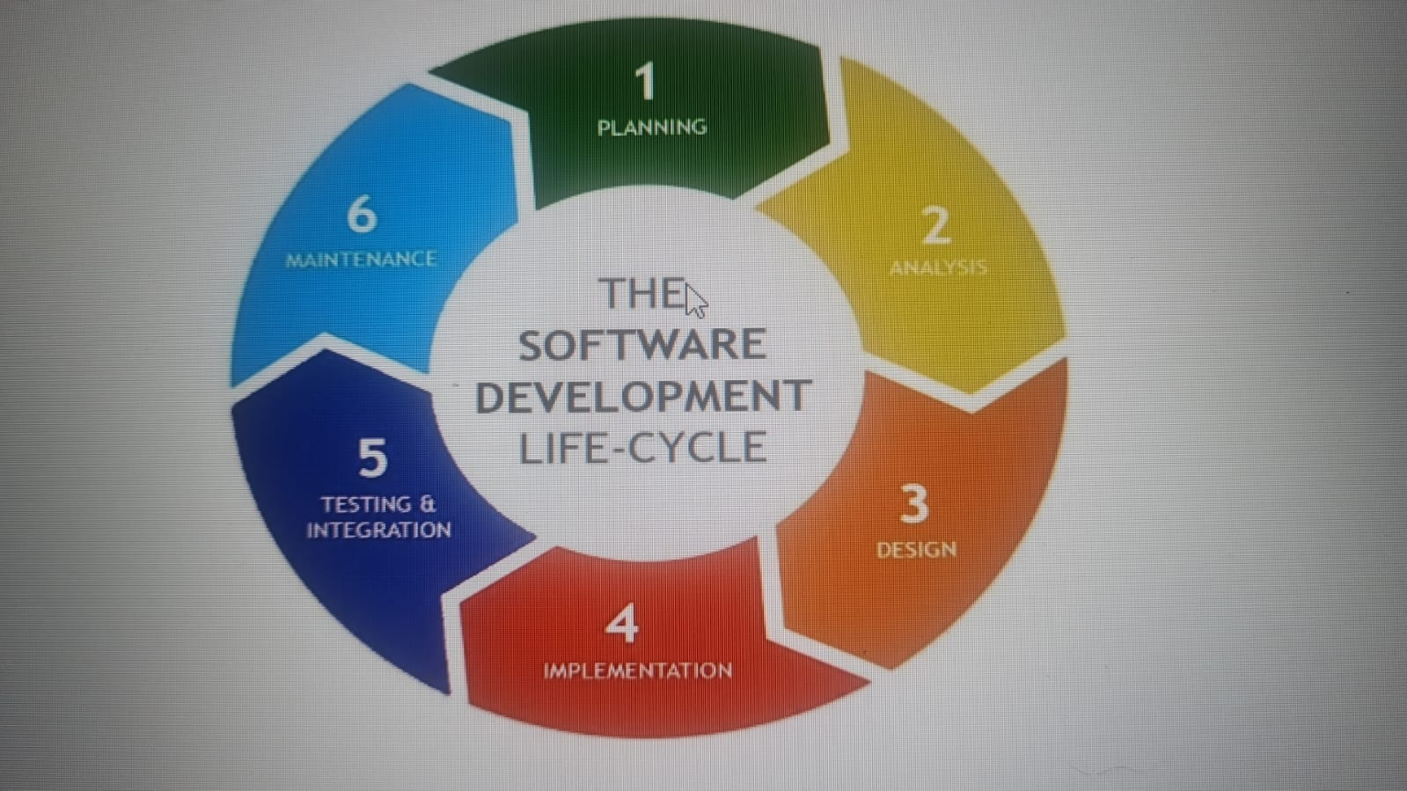

🡪 There are 6 phase in SDLC

* Requirement gathering and analysis
* Design
* Implementation or coding
* Testing
* Deployment
* Maintenance

1) Requirement gathering and analysis

🡪 During this phase, all the relevant information is collected from the customer to develop a product as per their expectation.

2) Design

🡪 In this phase, gathered information is used as an input and software architecture that is used for implementing system development is derived.

3) Implementation

🡪 Implementation starts when developer receives the design document. Once they receive document they start translating it into source code.

4) Testing

🡪 Testing starts once the coding is completed, the developed software is tested whether it works or not properly, when there is problem it is again sent to implementation stage to correct it and then again it is tested. This process continuous until the product satisfy the user.

5) Deployment

🡪 Once product passes all the test it is made available for customers.

6) Maintenance

🡪 This process starts after making product available for consumer and ends when the product is ended.

**4) What is DFD? Create a DFD diagram on Flipkart**

🡪 DFD is a graphical or visual representation using a standardized set of symbols and notations to describe a business’s operations through data movement.

Customer Management

A,m

a

Payment Management

System user Management

Shopping Management

Order Management

Login management

**5) What is Flow chart? Create a flowchart to make addition of two numbers**

🡪 A diagram that shows the connection between different stages of a process or parts of a system.

Start

stop

Display c

c=a+b

Read a,b

Add a, b, c

**6) What is Use case Diagram? Create a use-case on bill payment on paytm.**

**Ans:** A use case diagram is used to represent the dynamic behavior of a system. It encapsulates the system's functionality by incorporating use cases, actors, and their relationships. It models the tasks, services, and functions required by a system/subsystem of an application. It depicts the high-level functionality of a system and also tells how the user handles a system.

