进程关系视图
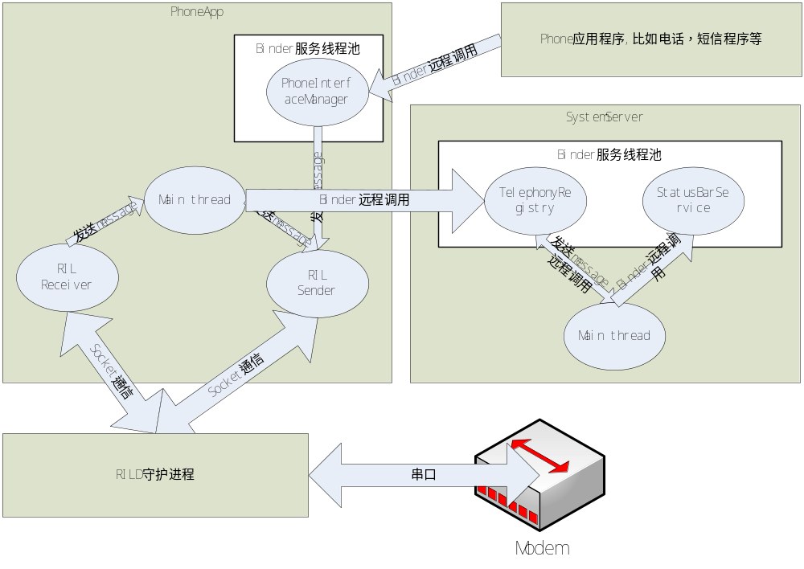

PhoneApp对象结构
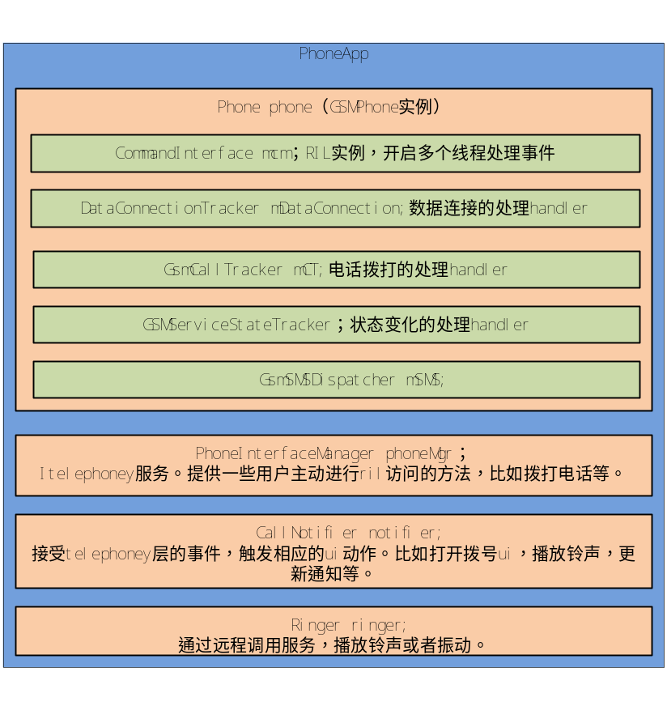

启动流程
联通2g卡默认启动流程
Network Mode set to 1 | 网络模式设置为gsm only
Cdma Subscription set to 1 | Cdma设置为nv类型
Connected to 'rild' socket | 连接到rild的Socket
RIL_UNSOL_RESPONSE_RADIO_STATE_CHANGED  事件 | mAvailRegistrants.notifyRegistrants() →  GsmDataConnectionTracker::onRadioAvailable()
[0000]> SCREEN_STATE: true | 发送屏幕状态，不涉及到at命令，作用未知
[0001]> RIL_REQUEST_REPORT_STK_SERVICE_IS_RUNNING  D/AT ( 1538): AT> AT+GTKREADY  D/AT ( 1538): AT< OK | StkService(SIM Toolkit Telephony Service)  mCmdIf.reportStkServiceIsRunning(null);  通知rild stk service 已经运行
[0002]> GET_CURRENT_CALLS
D/AT ( 1538): AT> AT+CLCC
D/AT ( 1538): AT< OK
D/RILJ ( 1676): [0003]> OPERATOR  D/RILJ ( 1676): [0004]> GPRS_REGISTRATION_STATE  D/RILJ ( 1676): [0005]> REGISTRATION_STATE  D/RILJ ( 1676): [0006]> QUERY_NETWORK_SELECTION_MODE | GsmServiceStateTracker ::handleMessage  → EVENT_SIM_READY  GsmServiceStateTracker::EVENT_SIM_READY viceStateTracker::Pollstate

工作流程

网络状态变化的Unsolicited事件处理流程
PhoneApp收到一个RIL_UNSOL_RESPONSE_NETWORK_STATE_CHANGED网络状态变化事件。发送message通知mCallStateRegistrants。在ServiceStateTracker的构造方法将GsmServiceStateTracker对象本身注册到mNetworkStateRegistrants。
RIL.java：
PhoneApp->GSMPhone(phone)->RIL(mCM)->RILReceiver(mReceiver)::run()
readRilMessage(InputStream is, byte[] buffer)
processResponse(Parcel p)
processUnsolicited(Parcel p)
RegistrantList(mNetworkStateRegistrants)::notifyRegistrants(AsyncResult ar)
GsmServiceStateTracker检测到事件类型为网络状态变，发送主动请求获取新的状态信息等.
GsmServiceStateTracker.java：
PhoneApp->GSMPhone(phone)->GsmServiceStateTracker(mSST)::handleMessage(Message msg)
pollState()
cm.getOperator(msg)
cm.getGPRSRegistrationState(msg)
cm.getRegistrationState(msg)
cm.getNetworkSelectionMode(msg)
PhoneApp收到主动请求的响应结果。将结果绑定的请求的消息发回给所属的handler
RIL.java：
PhoneApp->GSMPhone(phone)->RIL(mCM)->RILReceiver(mReceiver)::run()
readRilMessage(InputStream is, byte[] buffer)
processResponse(Parcel p)
processSolicited(Parcel p)
rr.mResult.sendToTarget()
GsmServiceStateTracker检测事件类型为网络状态变化响应结果，如果网络类型改变则通过binder调用TelephonyRegistry服务的notifyDataConnection方法。
GsmServiceStateTracker.java：
PhoneApp->GSMPhone(phone)->GsmServiceStateTracker(mSST)::handleMessage(Message msg)
handlePollStateResult(int what, AsyncResult ar)
pollStateDone()
if (hasNetworkTypeChanged)phone.notifyDataConnection(null)
PhoneApp->GSMPhone(phone)->DefaultPhoneNotifier(mNotifier)::notifyDataConnection()
PhoneApp->GSMPhone(phone)->DefaultPhoneNotifier(mNotifier)->ITelephonyRegistry(mRegistry)::notifyDataConnection()
SystemServer中的TelephonyRegistry服务notifyDataConnection方法。注意这里的执行上下文已经到了systemserver进程中。notifyDataConnection根据条件调用已经注册的callback。
通过TelephonyManager的ITelephonyRegistry远程代理listen接口能够在TelephonyRegistry服务中注册callback。实际上android已经在SystemServer中通过
com.android.server.status.StatusBarPolicy.installIcons(context, statusBar)向TelephonyRegistry服务注册了一个callback。这个callback本身是IPhoneStateListener的一个远程代理对象。（实际上IPhoneStateListener的远程服务也在当前SystemServer进程）
TelephonyRegistry::notifyDataConnection()
if ((r.events & PhoneStateListener.LISTEN_DATA_CONNECTION_STATE) != 0)r.callback.onDataConnectionStateChanged(state, networkType);
callback远程服务执行环境是在SystemServer进程中的。构造一个message发送给mhandler。
StatusBarPolicy->匿名PhoneStateListener子类(mPhoneStateListener)->匿名binder服务类(callback)::onDataConnectionStateChanged
Message.obtain(mHandler, LISTEN_DATA_CONNECTION_STATE, state, networkType, null).sendToTarget();
mHandler是StatusBarPolicy->PhoneStateListener成员属性。使用的是主线程的默认loop，也就是SystemServer的主线程。然后调用statusbarservice更新状态栏图标。
StatusBarPolicy->PhoneStateListener(mPhoneStateListener)->Handler(handler)::handleMessage()
PhoneStateListener.this.onDataConnectionStateChanged(msg.arg1, msg.arg2);
updateDataNetType(networkType);
updateDataIcon();

接电话流程(语音信箱问题)
ril.java:processUnsolicited()->RIL_UNSOL_RESPONSE_CALL_STATE_CHANGED->mNetworkStateRegistrants.notifyRegistrants(new AsyncResult(null, null, null))
gsmcalltracker.java:handleMessage()->EVENT_CALL_STATE_CHANGE->pollCallsWhenSafe()->cm.getCurrentCalls(lastRelevantPoll)
ril.java:getCurrentCalls()->send(rr)
ril.java:processSolicited()->RIL_REQUEST_GET_CURRENT_CALLS->responseCallList()->rr.mResult.sendToTarget()
gsmcalltracker.java:handleMessage()->EVENT_POLL_CALLS_RESULT->handlePollCalls()->phone.notifyNewRingingConnection(newRinging)
CallNotifier.java->handleMessage()->PHONE_NEW_RINGING_CONNECTION->onNewRingingConnection()->startIncomingCallQuery(c)->onQueryComplete()->PhoneUtils.hangupRingingCall(mPhone)

