Android2.3传感器框架。SensorService在2.2是在java实现的，在2.3是在native c++层实现的。

框架

进程角度：
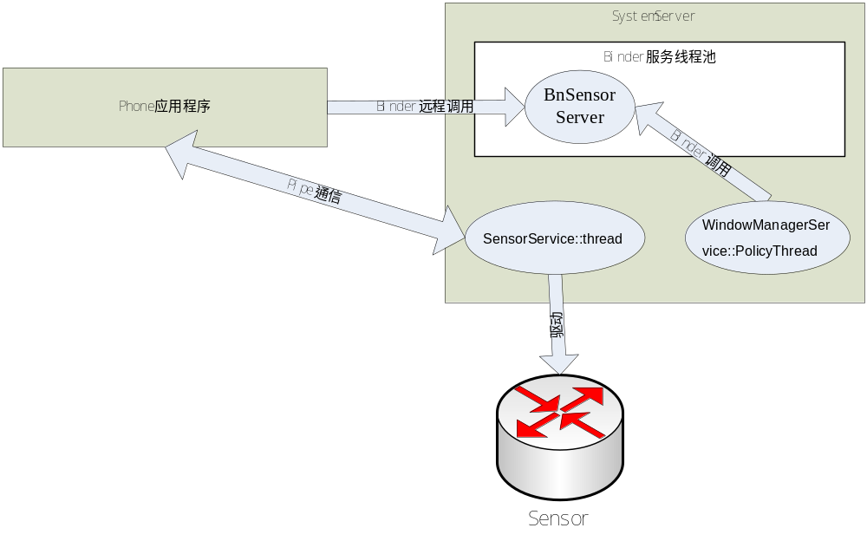

类图：

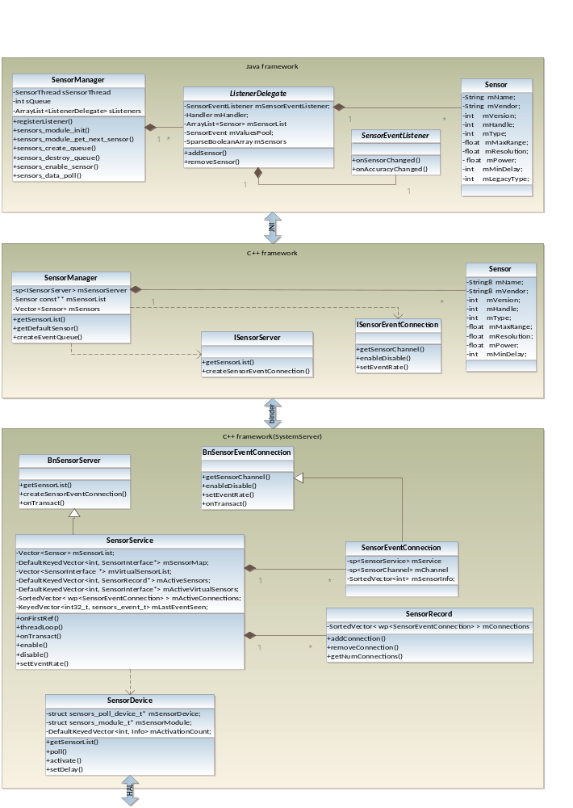工作流程：
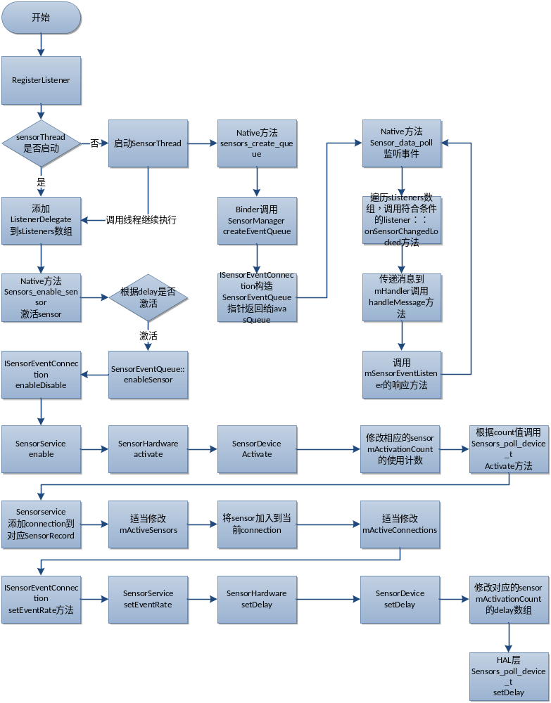

Java层
传感器的java层框架。应用程序直接使用java层框架，透过jni方法访问到底层方法和数据。

SystemServer
（ framework/base/services/java/com/android/server/SystemServer.java）
在system_server进程中 ：
Main（）{
…
System.loadLibrary("android_servers");
init1(args);
…
}
Init1是native方法。在c++的对应的android_server_SystemServer_init1方法中调用到了
// 启动了传感器服务
SensorService::instantiate();

SensorManager
(framework/base/core/java/anroid/hardware/SenorManager.java)
JAVA层传感器的核心管理类。Java应用程序通过SensorManager操作和访问设备。
private static native void nativeClassInit();

private static native int sensors_module_init();
private static native int sensors_module_get_next_sensor(Sensor sensor, int next);

// Used within this module from outside SensorManager, don't make private
static native int sensors_create_queue();
static native void sensors_destroy_queue(int queue);
static native boolean sensors_enable_sensor(int queue, String name, int sensor, int enable);
static native int sensors_data_poll(int queue, float[] values, int[] status, long[] timestamp);

这个thread一个进程只有一个（需要时才创建），在这个线程内部会通过native方法sensors_data_poll读取相应的连接上面的事件。这些事件是sensorservice调用硬件抽象层的poll产生的，然后发送到各个激活的连接上，激活的连接就是通过这个线程来接受事件的。接受到事件之后会调用所有注册到连接上的listener的回调方法。
private static SensorThread sSensorThread;

registerListener
注册一个listener到sensorManager。根据SensorEventListener创建相应的ListenerDelegate，将ListenerDelegate加入到sListener数组中。

public boolean registerListener(SensorEventListener listener, Sensor sensor, int rate,
Handler handler) {
if (listener == null || sensor == null) {
return false;
}
boolean result = true;
int delay = -1;
switch (rate) {
case SENSOR_DELAY_FASTEST:
delay = 0;
break;
case SENSOR_DELAY_GAME:
delay = 20000;
break;
case SENSOR_DELAY_UI:
delay = 60000;
break;
case SENSOR_DELAY_NORMAL:
delay = 200000;
break;
default:
delay = rate;
break;
}

synchronized (sListeners) {
// look for this listener in our list
ListenerDelegate l = null;
for (ListenerDelegate i : sListeners) {
if (i.getListener() == listener) {
l = i;
break;
}
}

// if we don't find it, add it to the list
if (l == null) {
l = new ListenerDelegate(listener, sensor, handler);
sListeners.add(l);
// if the list is not empty, start our main thread
if (!sListeners.isEmpty()) {
if (sSensorThread.startLocked()) {
if (!enableSensorLocked(sensor, delay)) {
// oops. there was an error
sListeners.remove(l);
result = false;
}
} else {
// there was an error, remove the listener
sListeners.remove(l);
result = false;
}
} else {
// weird, we couldn't add the listener
result = false;
}
} else {
l.addSensor(sensor);
if (!enableSensorLocked(sensor, delay)) {
// oops. there was an error
l.removeSensor(sensor);
result = false;
}
}
}

return result;
}
通过native方法激活queue相应的连接。queue是在SensorThread中通过sensors_create_queue方法创建的。
private boolean enableSensorLocked(Sensor sensor, int delay) {
boolean result = false;
for (ListenerDelegate i : sListeners) {
if (i.hasSensor(sensor)) {
String name = sensor.getName();
int handle = sensor.getHandle();
result = sensors_enable_sensor(sQueue, name, handle, delay);
break;
}
}
return result;
}

SensorThreadRunnable
每个SensorManager都有一个sensor thread,这个thread方法的作用就是通过native方法读取相应queue上面的连接的事件。然后分别调用注册的listener的回调方法。
private class SensorThreadRunnable implements Runnable {
SensorThreadRunnable() {
}

private boolean open() {
// NOTE: this cannot synchronize on sListeners, since
// it's held in the main thread at least until we
// return from here.
sQueue = sensors_create_queue();
return true;
}

public void run() {
//Log.d(TAG, "entering main sensor thread");
final float[] values = new float[3];
final int[] status = new int[1];
final long timestamp[] = new long[1];
Process.setThreadPriority(Process.THREAD_PRIORITY_URGENT_DISPLAY);

if (!open()) {
return;
}

synchronized (this) {
// we've open the driver, we're ready to open the sensors
mSensorsReady = true;
this.notify();
}

while (true) {
// wait for an event
final int sensor = sensors_data_poll(sQueue, values, status, timestamp);

int accuracy = status[0];
synchronized (sListeners) {
if (sensor == -1 || sListeners.isEmpty()) {
// we lost the connection to the event stream. this happens
// when the last listener is removed or if there is an error
if (sensor == -1 && !sListeners.isEmpty()) {
// log a warning in case of abnormal termination
Log.e(TAG, "_sensors_data_poll() failed, we bail out: sensors=" + sensor);
}
// we have no more listeners or polling failed, terminate the thread
sensors_destroy_queue(sQueue);
sQueue = 0;
mThread = null;
break;
}
final Sensor sensorObject = sHandleToSensor.get(sensor);
if (sensorObject != null) {
// report the sensor event to all listeners that
// care about it.
final int size = sListeners.size();
for (int i=0 ; i<size ; i++) {
ListenerDelegate listener = sListeners.get(i);
if (listener.hasSensor(sensorObject)) {
// this is asynchronous (okay to call
// with sListeners lock held).
listener.onSensorChangedLocked(sensorObject,
values, timestamp, accuracy);
}
}
}
}
}
//Log.d(TAG, "exiting main sensor thread");
}
}
}

Jni层
Frameworks/base/core/jni/android_hardware_SenorManager.cpp
SensorManager.java的jni层，定义了一组jni方法，在内部调用了c++框架中的SensorManager的各个方法。
static JNINativeMethod gMethods[] = {
{"nativeClassInit", "()V", (void*)nativeClassInit },
{"sensors_module_init","()I", (void*)sensors_module_init },
{"sensors_module_get_next_sensor","(Landroid/hardware/Sensor;I)I",
(void*)sensors_module_get_next_sensor },

{"sensors_create_queue", "()I", (void*)sensors_create_queue },
{"sensors_destroy_queue", "(I)V", (void*)sensors_destroy_queue },
{"sensors_enable_sensor", "(ILjava/lang/String;II)Z",
(void*)sensors_enable_sensor },

{"sensors_data_poll", "(I[F[I[J)I", (void*)sensors_data_poll },
};

sensors_module_init
获取sensorservice的访问代理。初始化sensor列表。
static jint sensors_module_init(JNIEnv *env, jclass clazz)
{
SensorManager::getInstance();
return 0;
}

sensors_module_get_next_sensor
将sensormanager管理的sensor封装成java层需要的结构返回。
static jint
sensors_module_get_next_sensor(JNIEnv *env, jobject clazz, jobject sensor, jint next)
{
SensorManager& mgr(SensorManager::getInstance());

Sensor const* const* sensorList;
size_t count = mgr.getSensorList(&sensorList);
if (size_t(next) >= count)
return -1;

Sensor const* const list = sensorList[next];
const SensorOffsets& sensorOffsets(gSensorOffsets);
jstring name = env->NewStringUTF(list->getName().string());
jstring vendor = env->NewStringUTF(list->getVendor().string());
env->SetObjectField(sensor, sensorOffsets.name, name);
env->SetObjectField(sensor, sensorOffsets.vendor, vendor);
env->SetIntField(sensor, sensorOffsets.version, 1);
env->SetIntField(sensor, sensorOffsets.handle, list->getHandle());
env->SetIntField(sensor, sensorOffsets.type, list->getType());
env->SetFloatField(sensor, sensorOffsets.range, list->getMaxValue());
env->SetFloatField(sensor, sensorOffsets.resolution, list->getResolution());
env->SetFloatField(sensor, sensorOffsets.power, list->getPowerUsage());
env->SetIntField(sensor, sensorOffsets.minDelay, list->getMinDelay());

next++;
return size_t(next) < count ? next : 0;
}

sensors_create_queue
通过sp<ISensorServer>远程代理创建一个连接，并且建立相应的queue。
static jint sensors_create_queue(JNIEnv *env, jclass clazz)
{
SensorManager& mgr(SensorManager::getInstance());
sp<SensorEventQueue> queue(mgr.createEventQueue());
queue->incStrong(clazz);
return reinterpret_cast<int>(queue.get());
}

sensors_destroy_queue
通过sp<ISensorEventConnection>远程代理禁止一个queue相应的连接。

sensors_enable_sensor
通过sp<ISensorEventConnection>远程代理激活一个queue相应的连接。

sensors_data_poll
重要的方法。通过queue相应的连接来读取连接上面的事件并且返回到java层。在sensorService的threadLoop已经看到了service会将硬件抽象层poll到的事件发送到所以已经建立好的连接上。这里的sensors_data_poll
就是接受事件的方法。
static jint sensors_data_poll(JNIEnv *env, jclass clazz, jint nativeQueue,
jfloatArray values, jintArray status, jlongArray timestamp)
{
sp<SensorEventQueue> queue(reinterpret_cast<SensorEventQueue *>(nativeQueue));
if (queue == 0) return -1;

status_t res;
ASensorEvent event;

res = queue->read(&event, 1);
if (res == -EAGAIN) {
res = queue->waitForEvent();
if (res != NO_ERROR)
return -1;
res = queue->read(&event, 1);
}
if (res < 0)
return -1;

jint accuracy = event.vector.status;
env->SetFloatArrayRegion(values, 0, 3, event.vector.v);
env->SetIntArrayRegion(status, 0, 1, &accuracy);
env->SetLongArrayRegion(timestamp, 0, 1, &event.timestamp);

return event.sensor;
}

C++层
整个传感器的核心。其中SensorService实现了ISensorServer和ISensorEventConnection接口的服务供远程代理访问，在内部通过SensorDevice访问硬件抽象层。SensorManager是java层SensorManager的本地框架。通过SensorManager可以远程访问SensorService提供的服务。

SensorService
framworks/base/services/sensorservice/SensorService.cpp
在c++层实现了SensorService这个native服务。传感器框架的核心类。在system_server进程启动的时候注册了该服务。内部管理了HardwareSensor的列表从而访问到硬件抽象层的设备。
class SensorService :
public BinderService<SensorService>,
public BnSensorServer,
protected Thread {

// constants
Vector<Sensor> mSensorList;
DefaultKeyedVector<int, SensorInterface*> mSensorMap;
Vector<SensorInterface *> mVirtualSensorList;
Permission mDump;
status_t mInitCheck;

// protected by mLock
mutable Mutex mLock;
DefaultKeyedVector<int, SensorRecord*> mActiveSensors;
DefaultKeyedVector<int, SensorInterface*> mActiveVirtualSensors;
SortedVector< wp<SensorEventConnection> > mActiveConnections;

// The size of this vector is constant, only the items are mutable
KeyedVector<int32_t, sensors_event_t> mLastEventSeen;
…
};
这个类就是传感器本地服务类的实现。它继承了三个类：
BinderService<SensorService>：实现instantiate方法从而注册该service到servicemanager
BnSensorServer：继承了ISensorServer：BBinder。实现了本地服务的接口
Thread：作为system_server的一个线程poll设备发送事件到各个注册的连接

SensorService::instantiate()
在system_server->init1()中将会调用SensorService::instantiate()注册传感器服务,该方法继承与模板类BinderService
template<typename SERVICE>
class BinderService
{
public:
static status_t publish() {
sp<IServiceManager> sm(defaultServiceManager());
return sm->addService(String16(SERVICE::getServiceName()), new SERVICE());
}

static void publishAndJoinThreadPool() {
sp<ProcessState> proc(ProcessState::self());
sp<IServiceManager> sm(defaultServiceManager());
sm->addService(String16(SERVICE::getServiceName()), new SERVICE());
ProcessState::self()->startThreadPool();
IPCThreadState::self()->joinThreadPool();
}

static void instantiate() { publish(); }
};
经过分析，等同于下面的调用：
sm->addService(“sensorservice”, new SensorService());
将该服务注册到了servicemanager。 new SensorService()通过SensorDevice对象同硬件抽象层交互进行了初始化，并且启动服务线程循环。

SensorService::onFirstRef()
在addService方法中，会间接的调用到RefBase::onFirstRef()方法。在这个方法中，主要是初始化SensorDevice对象，以及开启runloop线程循环。
void SensorService::onFirstRef()
{
LOGD("nuSensorService starting...");
//初始化SensorDevice,主要管理了sensors_module_t和sensors_poll_device_t
SensorDevice& dev(SensorDevice::getInstance());

if (dev.initCheck() == NO_ERROR) {
uint32_t virtualSensorsNeeds =
(1<<SENSOR_TYPE_GRAVITY) |
(1<<SENSOR_TYPE_LINEAR_ACCELERATION) |
(1<<SENSOR_TYPE_ROTATION_VECTOR);
sensor_t const* list;
//SensorDevice->sensors_module_t->get_sensor_list
int count = dev.getSensorList(&list);
mLastEventSeen.setCapacity(count);
//通过sensor_t初始化HardwareSensor。注意有3种虚拟的sensor，如果硬件没有提供的话，则会注册相应的虚拟sensor。
for (int i=0 ; i<count ; i++) {
registerSensor( new HardwareSensor(list[i]) );
switch (list[i].type) {
case SENSOR_TYPE_GRAVITY:
case SENSOR_TYPE_LINEAR_ACCELERATION:
case SENSOR_TYPE_ROTATION_VECTOR:
virtualSensorsNeeds &= ~(1<<list[i].type);
break;
}
}

if (virtualSensorsNeeds & (1<<SENSOR_TYPE_GRAVITY)) {
registerVirtualSensor( new GravitySensor(list, count) );
}
if (virtualSensorsNeeds & (1<<SENSOR_TYPE_LINEAR_ACCELERATION)) {
registerVirtualSensor( new LinearAccelerationSensor(list, count) );
}
if (virtualSensorsNeeds & (1<<SENSOR_TYPE_ROTATION_VECTOR)) {
registerVirtualSensor( new RotationVectorSensor(list, count) );
}

run("SensorService", PRIORITY_URGENT_DISPLAY);
mInitCheck = NO_ERROR;
}
}
SensorDevice是对硬件抽象层的封装。其中sensors_poll_device_t和sensors_module_t指针实现了和HAL交互，并且包装了设备访问方法。SensorDevic的方法被封装到了HardwareSensor结构体，间接的通过调用HardwareSensor的方法来访问到真正的设备。而HardwareSensor又是被SensorService管理的。
class SensorDevice : public Singleton<SensorDevice> {
friend class Singleton<SensorDevice>;
struct sensors_poll_device_t* mSensorDevice;
struct sensors_module_t* mSensorModule;
Mutex mLock; // protect mActivationCount[].rates
// fixed-size array after construction
struct Info {
Info() : count(0) { }
int32_t count;
KeyedVector<void*, nsecs_t> rates;
};
DefaultKeyedVector<int, Info> mActivationCount;

SensorDevice();
public:
ssize_t getSensorList(sensor_t const** list);
status_t initCheck() const;
ssize_t poll(sensors_event_t* buffer, size_t count);
status_t activate(void* ident, int handle, int enabled);
status_t setDelay(void* ident, int handle, int64_t ns);
void dump(String8& result, char* buffer, size_t SIZE);
};

SensorService::registerSensor()
将描述sensor硬件和方法的HardwareSensor对象注册到SensorService。
void SensorService::registerSensor(SensorInterface* s)
{
sensors_event_t event;
memset(&event, 0, sizeof(event));

const Sensor sensor(s->getSensor());
// add to the sensor list (returned to clients)
mSensorList.add(sensor);
// add to our handle->SensorInterface mapping
mSensorMap.add(sensor.getHandle(), s);
// create an entry in the mLastEventSeen array
mLastEventSeen.add(sensor.getHandle(), event);
}

//描述了一个具体的sensor设备（Sensor）以及访问该设备的方法（SensorDevice）。
class HardwareSensor : public SensorInterface
{
//实际的sensor设备。包含了sensor_module_t,sensor_device_t指针。
SensorDevice& mSensorDevice;
//对应于抽象层的sensor_t
Sensor mSensor;
bool mEnabled;

public:
HardwareSensor(const sensor_t& sensor);

virtual ~HardwareSensor();

virtual bool process(sensors_event_t* outEvent,
const sensors_event_t& event);

virtual bool isEnabled() const;
virtual status_t activate(void* ident, bool enabled);
virtual status_t setDelay(void* ident, int handle, int64_t ns);
virtual Sensor getSensor() const;
virtual bool isVirtual() const { return false; }
};

SensorService::threadLoop()
继承了Thread通过run("SensorService", PRIORITY_URGENT_DISPLAY)执行。在这个新的线程中保存了每种传感器的最新的值，并且发送事件到所有的已激活连接。
bool SensorService::threadLoop()
{
LOGD("nuSensorService thread starting...");

const size_t numEventMax = 16 * (1 + mVirtualSensorList.size());
sensors_event_t buffer[numEventMax];
sensors_event_t scratch[numEventMax];
SensorDevice& device(SensorDevice::getInstance());
const size_t vcount = mVirtualSensorList.size();

ssize_t count;
do {
//调用sensor_device_t->poll方法等待sensor事件。
count = device.poll(buffer, numEventMax);
if (count<0) {
LOGE("sensor poll failed (%s)", strerror(-count));
break;
}
//这个方法保存每个传感器的最近的一个事件值。（如果一个传感器产生了多次事件的话）
recordLastValue(buffer, count);

// handle virtual sensors
if (count && vcount) {
const DefaultKeyedVector<int, SensorInterface*> virtualSensors(
getActiveVirtualSensors());
const size_t activeVirtualSensorCount = virtualSensors.size();
if (activeVirtualSensorCount) {
size_t k = 0;
for (size_t i=0 ; i<size_t(count) ; i++) {
sensors_event_t const * const event = buffer;
for (size_t j=0 ; j<activeVirtualSensorCount ; j++) {
sensors_event_t out;
if (virtualSensors.valueAt(j)->process(&out, event[i])) {
buffer[count + k] = out;
k++;
}
}
}
if (k) {
// record the last synthesized values
recordLastValue(&buffer[count], k);
count += k;
// sort the buffer by time-stamps
sortEventBuffer(buffer, count);
}
}
}

// send our events to clients...
const SortedVector< wp<SensorEventConnection> > activeConnections(
getActiveConnections());
size_t numConnections = activeConnections.size();
for (size_t i=0 ; i<numConnections ; i++) {
sp<SensorEventConnection> connection(
activeConnections[i].promote());
if (connection != 0) {
connection->sendEvents(buffer, count, scratch);
}
}
} while (count >= 0 || Thread::exitPending());

LOGW("Exiting SensorService::threadLoop!");
return false;
}

Binder服务方法
通过ISensorServer接口可知，SensorService实现两个方法提供binder服务。
class ISensorServer : public IInterface
{
public:
DECLARE_META_INTERFACE(SensorServer);

virtual Vector<Sensor> getSensorList() = 0;
virtual sp<ISensorEventConnection> createSensorEventConnection() = 0;
};
Vector<Sensor> SensorService::getSensorList()
{
return mSensorList;
}
为client创建一个事件连接。在threadLoop中会发送事件到所有的激活连接。
sp<ISensorEventConnection> SensorService::createSensorEventConnection()
{
sp<SensorEventConnection> result(new SensorEventConnection(this));
return result;
}
SensorService::SensorEventConnection::SensorEventConnection(
const sp<SensorService>& service)
: mService(service), mChannel(new SensorChannel())
{
}

SensorEventConnection
SensorEventConnection是ISensorEventConnection的本地服务实现。
在SensorService::createSensorEventConnection()方法中会创建这个连接对象。通过的代理对象可以访问到该连接。
class SensorEventConnection : public BnSensorEventConnection {
virtual ~SensorEventConnection();
virtual void onFirstRef();
virtual sp<SensorChannel> getSensorChannel() const;
virtual status_t enableDisable(int handle, bool enabled);
virtual status_t setEventRate(int handle, nsecs_t ns);

sp<SensorService> const mService;
sp<SensorChannel> const mChannel;
mutable Mutex mConnectionLock;

// protected by SensorService::mLock
SortedVector<int> mSensorInfo;

public:
SensorEventConnection(const sp<SensorService>& service);

status_t sendEvents(sensors_event_t const* buffer, size_t count,
sensors_event_t* scratch = NULL);
bool hasSensor(int32_t handle) const;
bool hasAnySensor() const;
bool addSensor(int32_t handle);
bool removeSensor(int32_t handle);
};
构造方法。获取到SensorService，通过pipe建立一对fd连接以进行进程间通信。
SensorService::SensorEventConnection::SensorEventConnection(
const sp<SensorService>& service)
: mService(service), mChannel(new SensorChannel())
{
}
Binder服务方法
远程代理通过这个方法，可以使用获取接收数据的channel。
sp<SensorChannel> SensorService::SensorEventConnection::getSensorChannel() const
{
return mChannel;
}
远程代理通过这个方法，开启和禁用该连接（操作sensorservice的已激活连接列表）
status_t SensorService::SensorEventConnection::enableDisable(
int handle, bool enabled)
{
status_t err;
if (enabled) {
err = mService->enable(this, handle);
} else {
err = mService->disable(this, handle);
}
return err;
}
通过sensorservice到sensordevice到sensor_poll_device_t设置
status_t SensorService::SensorEventConnection::setEventRate(
int handle, nsecs_t ns)
{
return mService->setEventRate(this, handle, ns);
}

SensorManager
Framworks/base/libs/gui/SensorManager.cpp
SensorManager.java的c++框架层。Java框架层通过native方法可以对SensorManager对象进行访问。SensorManager每个进程只有一个单例。透过SensorManager可以和SensorService进行通信。
class SensorManager : public ASensorManager, public Singleton<SensorManager>
{
public:
SensorManager();
~SensorManager();

ssize_t getSensorList(Sensor const* const** list) const;
Sensor const* getDefaultSensor(int type);
sp<SensorEventQueue> createEventQueue();

private:
sp<ISensorServer> mSensorServer; // BnSensorServer的访问代理点
Sensor const** mSensorList;
Vector<Sensor> mSensors;
};
SensorManager::SensorManager()
: mSensorList(0)
{
const String16 name("sensorservice");
//相当于sp<ISensorServer> p = new BpSensorServer(xx)
while (getService(name, &mSensorServer) != NO_ERROR) {
usleep(250000);
}

mSensors = mSensorServer->getSensorList();
size_t count = mSensors.size();
mSensorList = (Sensor const**)malloc(count * sizeof(Sensor*));
for (size_t i=0 ; i<count ; i++) {
mSensorList[i] = mSensors.array() + i;
}
}

ssize_t SensorManager::getSensorList(Sensor const* const** list) const
{
*list = mSensorList;
return mSensors.size();
}

Sensor const* SensorManager::getDefaultSensor(int type)
{
// For now we just return the first sensor of that type we find.
// in the future it will make sense to let the SensorService make
// that decision.
for (size_t i=0 ; i<mSensors.size() ; i++) {
if (mSensorList[i]->getType() == type)
return mSensorList[i];
}
return NULL;
}

sp<SensorEventQueue> SensorManager::createEventQueue()
{
sp<SensorEventQueue> result = new SensorEventQueue(
mSensorServer->createSensorEventConnection());
return result;
}

硬件抽象层
硬件抽象层是驱动同framwork的粘合剂。硬件抽象层封装了驱动的提供的方法并且提供了一个统一的接口个framwork使用。尽可能保持硬件抽象层和framwork的独立性。

HAL框架

hw_module_t
每个硬件抽象层都必须有一个名字叫HAL_MODULE_INFO_SYM的结构体对象。这是框架访问硬件抽层的入口点。硬件抽象层实现一般会封装这个结构体，但是其中第一个成员必须是hw_module_t类型，表示了一个硬件模块。在这个对象的hw_module_methods_t->open方法中一般会初始化一个hw_device_t的对象。（当然一般也是封装了这个hw_device_t的结构体）
/**
* Every hardware module must have a data structure named HAL_MODULE_INFO_SYM
* and the fields of this data structure must begin with hw_module_t
* followed by module specific information.
*/
typedef struct hw_module_t {
/** tag must be initialized to HARDWARE_MODULE_TAG */
uint32_t tag;

/** major version number for the module */
uint16_t version_major;

/** minor version number of the module */
uint16_t version_minor;

/** Identifier of module */
const char *id;

/** Name of this module */
const char *name;

/** Author/owner/implementor of the module */
const char *author;

/** Modules methods */
struct hw_module_methods_t* methods;

/** module's dso */
void* dso;

/** padding to 128 bytes, reserved for future use */
uint32_t reserved[32-7];

} hw_module_t;

hw_module_methods_t
这个结构体是hw_module_t的方法。每个抽象层都要实现里面的open方法，C++框架层都会调用该方法激活hal层。一般这个open方法都是初始化一个具体 模块相关的继承于hw_device_t的结构体。例如sensor框架的open方法就要初始化一个sensors_poll_device_t的结构体。
typedef struct hw_module_methods_t {
/** Open a specific device */
int (*open)(const struct hw_module_t* module, const char* id,
struct hw_device_t** device);

} hw_module_methods_t;

hw_get_module
int hw_get_module(const char *id, const struct hw_module_t **module)
在c++框架层获取hw_module_t对象。HAL框架通过这种特殊的方式，提供了一个统一的接口给framwork。最大限度的将Framwork和硬件抽象层的工作独立开来。

hw_device_t
在hw_get_module之后，一般会调用hw_module_t->common->open方法初始化hw_device_t对象。同样硬件抽象层的实现一般也是对这个hw_device_t进行了封装的结构体。在抽象层的实现一般继续封装一些操作该设备的方法。
/**
* Every device data structure must begin with hw_device_t
* followed by module specific public methods and attributes.
*/
typedef struct hw_device_t {
/** tag must be initialized to HARDWARE_DEVICE_TAG */
uint32_t tag;

/** version number for hw_device_t */
uint32_t version;

/** reference to the module this device belongs to */
struct hw_module_t* module;

/** padding reserved for future use */
uint32_t reserved[12];

/** Close this device */
int (*close)(struct hw_device_t* device);

} hw_device_t;

Sensors HAL框架
(hardware/pnx67xx/compass/sensors_ak8973.c)
在hal框架基础上，定义了一批sensor用到的数据结构和接口方法的框架。具体的hal层实现需要实现这些接口。

sensors_module_t
sensors_module_t表示了sensors硬件模块。结构体相对于hw_module_t增加了一个get_sensors_list的方法从而能够获取到系统中sensor的列表。
struct hw_module_methods_t sensors_module_methods = {
open: sensors_device_open
};
const struct sensors_module_t HAL_MODULE_INFO_SYM = {
common: {
tag: HARDWARE_MODULE_TAG,
version_major: 1,
version_minor: 0,
id: SENSORS_HARDWARE_MODULE_ID,
name : "AK8973A & AK8973 & 502als Sensors Module",
author : "The Android Open Source Project",
methods: &sensors_module_methods,
},
get_sensors_list: sensors_get_sensors_list,
};

sensors_get_sensors_list
获取当前系统的sensor_t类型的sensor列表。
static const struct sensor_t sSensorList[] = {
{ "ST LIS35DE Accelerometer",
"The Android Open Source Project",
1, SENSORS_HANDLE_BASE+ID_A,
SENSOR_TYPE_ACCELEROMETER, 2.8f, 1.0f/4032.0f, 3.0f, { } },
{ "AK8973 Magnetic field sensor",
"The Android Open Source Project",
1, SENSORS_HANDLE_BASE+ID_M,
SENSOR_TYPE_MAGNETIC_FIELD, 2000.0f, 1.0f, 6.7f, { } },
{ "AK8973 Orientation sensor",
"The Android Open Source Project",
1, SENSORS_HANDLE_BASE+ID_O,
SENSOR_TYPE_ORIENTATION, 360.0f, 1.0f, 9.7f, { } },
{ "AK8973 Temperature sensor",
"The Android Open Source Project",
1, SENSORS_HANDLE_BASE+ID_T,
SENSOR_TYPE_TEMPERATURE, 80.0f, 1.0f, 0.0f, { } },
};
static int sensors_get_sensors_list(struct sensors_module_t* module,
struct sensor_t const** plist){
*plist = sSensorList;
return ARRAY_SIZE(sSensorList);
}

sensor_t
描述了一个硬件sensor，对应于framework的Sensor类。在SensorService的onFirstRef当中，首先通过SensorDevice->sensor_module_t->get_sensor_list获取到sensor_t列表，初始化相应的HardwareSensor注册到SensorService当中。
struct sensor_t {
/* name of this sensors */
const char* name;
/* vendor of the hardware part */
const char* vendor;
/* version of the hardware part + driver. The value of this field is
* left to the implementation and doesn't have to be monotonically
* increasing.
*/
int version;
/* handle that identifies this sensors. This handle is used to activate
* and deactivate this sensor. The value of the handle must be 8 bits
* in this version of the API.
*/
int handle; //sensor的ID
/* this sensor's type. */
int type;
/* maximaum range of this sensor's value in SI units */
float maxRange;
/* smallest difference between two values reported by this sensor */
float resolution;
/* rough estimate of this sensor's power consumption in mA */
float power;
/* minimum delay allowed between events in microseconds. A value of zero
* means that this sensor doesn't report events at a constant rate, but
* rather only when a new data is available */
int32_t minDelay;
/* reserved fields, must be zero */
void* reserved[8];
};

sensors_poll_device_t
sensors_poll_device_t封装了hw_device_t表示sensors硬件设备。并且封装了访问硬件sensor的方法。在framwork中的SensorDevice的各种方法都是封装了这个结构体的方法。
struct sensors_poll_device_t {
struct hw_device_t common;
//禁用或者开启一个sensor
/** Activate/deactivate one sensor.
*
* @param handle is the handle of the sensor to change.
* @param enabled set to 1 to enable, or 0 to disable the sensor.
*
* @return 0 on success, negative errno code otherwise
*/
int (*activate)(struct sensors_poll_device_t *dev,
int handle, int enabled);
//设置某个sensor的延迟时间
/**
* Set the delay between sensor events in nanoseconds for a given sensor.
* It is an error to set a delay inferior to the value defined by
* sensor_t::minDelay. If sensor_t::minDelay is zero, setDelay() is
* ignored and returns 0.
*
* @return 0 if successful, < 0 on error
*/
int (*setDelay)(struct sensors_poll_device_t *dev,
int handle, int64_t ns);
//poll设备等待事件
/**
* Returns an array of sensor data.
* This function must block until events are available.
*
* @return the number of events read on success, or -errno in case of an error.
* This function should never return 0 (no event).
*
*/
int (*poll)(struct sensors_poll_device_t *dev,
sensors_event_t* data, int count);
};

sensors_event_t
在sensors_poll_device_t的poll方法中，等待设备直到返回sensors_event_t指针，具体了描述了一个sensor事件。
/**
* Union of the various types of sensor data
* that can be returned.
*/
typedef struct sensors_event_t {
/* must be sizeof(struct sensors_event_t) */
int32_t version;
/* sensor identifier */
int32_t sensor;
/* sensor type */
int32_t type;
/* reserved */
int32_t reserved0;
/* time is in nanosecond */
int64_t timestamp;
union {
float data[16];
/* acceleration values are in meter per second per second (m/s^2) */
sensors_vec_t acceleration;
/* magnetic vector values are in micro-Tesla (uT) */
sensors_vec_t magnetic;
/* orientation values are in degrees */
sensors_vec_t orientation;
/* gyroscope values are in rad/s */
sensors_vec_t gyro;
/* temperature is in degrees centigrade (Celsius) */
float temperature;
/* distance in centimeters */
float distance;
/* light in SI lux units */
float light;
/* pressure in hectopascal (hPa) */
float pressure;
};
uint32_t reserved1[4];
} sensors_event_t;

HAL层实例
忽略。。。

