说明
- 内核版本：2.6.29。
- 芯片：ste pnx6715。
- 作者：林汉杰

硬件

Schematic diagram
可看出6715上实际使用了3x3的矩阵。
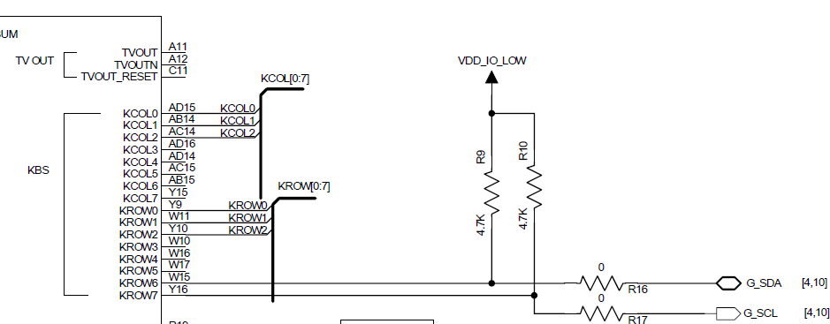

KBS Features
The KBS implements all the logic necessary to interface a rectangle matrix keyboard with
up to 64 keys (see Figure 186 on page 617) to the system controller. The KBS is
characterized by the following features:
• Up to 64 keys with multiple key detection
• Usable for any rectangle matrix keyboards up to 8x8
– Number of active column must be less or equal than number of active rows.
• Minimum power consumption, no key scan until at least one key is pressed
• Programmable key debounce times for keyboard type adjustment; debouncing is
performed for key pressure as well as for key release
• Power-on key detection capabilities (i.e. key pressed during and after reset is
correctly handled)
• Interrupt on key press and key release

Block diagram
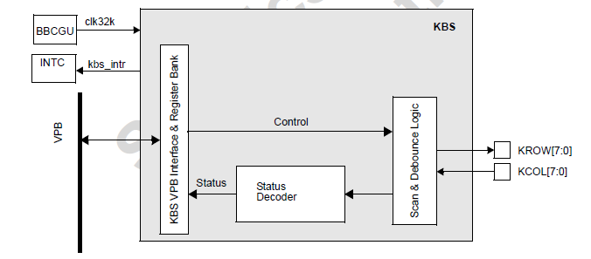

Programmable registers
名称 | 作用
kbs_deb[7:0] | 防抖动计数时间
kbs_it[0] | 是否有pending的中断。当中断发生后硬件会设置该位。中断处理程序应该往里面写任意一个值来从而响应。0表示有pending的中断。1表示没有pending的中断。
kbs_matrix_dim[3:0] | 1~8,键盘矩阵尺寸
kbs_data0[7:0] | 8位分别表示相应行对应列的状态
kbs_data1，kbs_data2, … ,kbs_data7 | 同上
kbs_it: state of the interrupt signal. The interrupts follow a standard handshake protocol. When a key is
pressed or released the interrupt signal is set active, then the software responds by an acknowledge (by writing to this register), thus releasing the interrupt. Writing any value in this register will clear the interrupt (irqn=1). Even in polling mode this bit must be acknowledged after a keypress.

Interrupt handling
1. 当有按键动作被识别（持续时间超过kbs_deb的值）
2. 硬件保存数据将到kbs_data*寄存器中
3. 硬件设置kbs_it并且产生中断
4. 中断处理程序中，获取kbs_data的值并且写kbs_it，从而使得硬件下次识别按键动作后写任意值到kbs_it(irqn会被置为1，表示没有pending的中断)，从而相应硬件。

驱动

Platform device
在bsp中定义platform设备并且注册。
static struct platform_device u6_wavex_kp_device = {
.name = "u6-keypad",
.id = -1,
.dev = {
.platform_data = &u6_wavex_keypad_data,
},
.num_resources = ARRAY_SIZE(u6_wavex_kp_resources),
.resource = u6_wavex_kp_resources,
};
其中Platform_data主要定义了键盘的硬件信息比如3*3矩阵，debounce的值，键盘映射表（kbs_data*和具体按键的映射关系）
static struct u6_kbd_platform_data u6_wavex_keypad_data = {
.rows = 3,
.cols = 3,
.keymap = u6_wavex_keymap,
.keymapsize = ARRAY_SIZE(u6_wavex_keymap),
.dbounce_delay = 10, /* 10 ms */
};

/* Keypad mapping for U67XX WaveX board */
static int u6_wavex_keymap[] = {
KEY(0, 0, KEY_VOLUMEUP), /* Col 0, Row 0 */
KEY(0, 1, KEY_VOLUMEDOWN), /* Col 0, Row 1 */
KEY(0, 2, KEY_CAMERA), /* Col 0, Row 2 */
KEY(1, 0, KEY_HOME), /* Col 1, Row 0 */
KEY(1, 1, KEY_MENU), /* Col 1, Row 1 */
KEY(1, 2, KEY_BACK), /* Col 1, Row 2 */
};
其中u6_wavex_kp_resources主要定义了kbs需要的硬件资源，中断和内存。
static struct resource u6_wavex_kp_resources [] = {
[0] = {
.start = KBS_BASE, /* Physical address */
.end = KBS_BASE + SZ_4K - 1,
.flags = IORESOURCE_MEM,
},
[1] = {
.start = IRQ_KBS,
.flags = IORESOURCE_IRQ,
},
};

platform driver
static struct platform_driver u6_kbd_driver = {
.probe = u6_kbd_probe,
.remove = u6_kbd_remove,
.suspend = u6_kbd_suspend,
.resume = u6_kbd_resume,
.driver = {
.name = "u6-keypad",
},
};

u6_kbd_probe
tatic int __init u6_kbd_probe(struct platform_device *pdev)
{
unsigned long long keycode = 0;
//获取kbs的硬件定义信息
struct u6_kbd_platform_data *pdata = pdev->dev.platform_data;
int irq = 0, i, ret = -EINVAL;
int *sKeymap;
int row, col;

u32 tmp_row, old_row, status;
u32 mask;

/* Determine the keyboard matrix size (hardware board configuration) */
sKbd_rows = pdata->rows;
sKbd_cols = pdata->cols;

if (!sKbd_rows || !sKbd_cols || !pdata->keymap || sKbd_cols > sKbd_rows
|| sKbd_rows > MAX_ROWS) {
printk(KERN_ERR "Bad values for rows, cols or keymap from pdata\n");
return -EINVAL;
}

//分配input device
sKeypad_dev = input_allocate_device();
if (!sKeypad_dev) {
printk(KERN_ERR "Cannot allocate input device for keypad\n");
return -EINVAL;
}

platform_set_drvdata(pdev, sKeypad_dev);

/* Get keymap from platform device data */
sKeymap = pdata->keymap;

/* setup input device */
set_bit(EV_KEY, sKeypad_dev->evbit);
for (i = 0; sKeymap[i] != 0; i++)
set_bit(sKeymap[i] & KEY_MAX, sKeypad_dev->keybit);
set_bit(KEY_END, sKeypad_dev->keybit);

sKeypad_dev->name = "U6XXX-Keypad";
sKeypad_dev->phys = "input0";
sKeypad_dev->dev.parent = &pdev->dev;

sKeypad_dev->id.bustype = BUS_HOST;
sKeypad_dev->id.vendor = 0x0123;
sKeypad_dev->id.product = 0x5220 /*dummy value*/;
sKeypad_dev->id.version = 0x0100;

sKeypad_dev->keycode = sKeymap;
sKeypad_dev->keycodesize = sizeof(unsigned int);
sKeypad_dev->keycodemax = pdata->keymapsize;

//注册input设备。
if (input_register_device(sKeypad_dev) < 0) {
printk(KERN_ERR "Unable to register U6XXX-keypad input device\n");
goto err1;
}

/* set kbsEn in clock gating */
sKbd_clk = clk_get(NULL, "KBS");
if (IS_ERR(sKbd_clk)) {
printk(KERN_WARNING "input: U6XXX keypad driver can't get clock !!!\n");
ret = -EBUSY;
goto err2;
}
clk_enable(sKbd_clk);

//设置dbounce的值。KBS_DEB_REG已经是线性地址了。
writel(32*pdata->dbounce_delay/sKbd_rows, KBS_DEB_REG);
//设置matrix dimension。同样线性地址
writel(sKbd_rows, KBS_MATRIX_DIM_REG);
//响应kbs。
writel(1, KBS_IT_REG);

//注册power键的回调函数。Power键中断是由pcf50623电源管理芯片实现的，在其中断处理函数中会调用该回调函数。
pcf506XX_registerOnkeyFct(u6_kbd_onkeypmu);

//读取kbs_data*的值，并且转换成相应的key值并且发送input事件。
keycode = u6_kbd_readmatrix();
mask = (1<<sKbd_rows)-1;
/* check if there are some changes */
if (keycode != old_keycode) {
for (row = 0; row < sKbd_rows; row++) {
/* analyse row by row */
tmp_row = (keycode >> (row * sKbd_rows)) & mask;
old_row = (old_keycode >> (row * sKbd_rows)) & mask;

status = tmp_row ^ old_row;

for (col = 0; col < sKbd_cols; col++) {
if (status & (1 << col)) {
int key = u6_kbd_find_key(sKeypad_dev->keycode, col, row);
if (key < 0) {
printk(KERN_WARNING "u6_keypad: Spurious key event row=%d-col=%d\n", row, col);
} else {
/* One change report it */
input_report_key(sKeypad_dev, key, (tmp_row & (1<<col)) ? 1 : 0);
dbg("key %d %s, row=%d col=%d\n", key,
(tmp_row&(1<<col)) ? "pressed" : "released", row, col);
}
}
}
}
/* save current status */
old_keycode = keycode;
}

//注册中断处理函数，功能和上面一段代码相同都是从kbs_data*读取值并且发送input事件。
irq = platform_get_irq(pdev, 0);
if (irq == 0)
goto err1;
if (request_irq(irq, &u6_kbs_interrupt, IRQF_DISABLED, "U6XXX KBS", NULL)) {
printk(KERN_WARNING "input: U6XXX keypad driver can't register IRQ !!!\n");
goto err5;
}
return 0;
err5:
pcf506XX_unregisterOnkeyFct();
if (u6_keypad_mode)
input_unregister_device(sKeypad_raw_dev);
err4:
if (u6_keypad_mode)
input_free_device(sKeypad_raw_dev);
err3:
/* reset kbsEn in clock gating */
clk_disable(sKbd_clk);
clk_put(sKbd_clk);
err2:
input_unregister_device(sKeypad_dev);
err1:
input_free_device(sKeypad_dev);
return ret;
}

