Software:
- GameAnalytics UE SDK

Key Features
- User behavior insights (new, active, returning)
- Daily, weekly, monthly reporting
- Metrics API
- Live Ops (A/B testing, real-time data)
- Heatmaps for visualizing player activity
- Funnel analysis and user segmentation

Pros
- The ability to A/B test up to 100 tests at a time.
- Provides event stream updates every 15 seconds for timely insights.
- Free version with many key features (including remote config and funnels).

Cons
- Requires separate projects for iOS and Android, limiting cross-platform comparisons.
- No path analysis visualization.
- User interface is not so visually attractive, which can affect user experience.
- Event tracking can be cumbersome and challenging.
- Performance may decline with high user volumes, creating scalability issues for large games.

- Azure PlayFab Telemetry
- Amplitude Unreal SDK
Key Features
  - Product analytics
  - Web analysis
  - Session replay
  - Feature experimentation/management
  - A/B testing

Pros
  - Highly customizable for creating fast, custom reports.
  - Analytics insights to improve decision-making.
  - Powerful visualizations make data easy to understand (plus unified data views across multiple devices/channels).

Cons
  - Complex setup can create a steep learning curve for new, non-technical users.
  - Sessions automatically close after 30 minutes, limiting flexibility for some applications.
  - Can be costly for high-traffic, low-margin businesses.
  - Interface updates can disrupt overall user experience.
- Google Analytics (UE plugin)

Key Features
- Real-time analytics
- Google Ads
- Segmentation and optimization
- A/B testing
- Integration with AdMob

Pros
- User-friendly implementation, including a demo project to assist with the tutorial.
- Great for storage, editing, retrieving, and synchronizing data.
- Responsive customer support.

Cons
- A/B testing requires a cooldown period of 1-2 days between tests.
- Certain analytics data can take up to 24 hours to fully update.
- Advanced tools can be expensive.
- Can’t segment large user bases.
- Not the most customizable platform.

- Keewano

Key Features
  - Proactive Insights: Automatic detection of churn patterns, monetization shifts, and technical bugs.
  - AI Agent Interface: Ask free-text questions (e.g., ARPU, retention, user progression) and get instant answers.
  - Real-Time Analysis: No lag between player activity and insights—streaming at game speed.
  - Built-In Dashboards: Lightweight visualizations to support key product metrics.
  - Low-Level Session Replay: Understand user experience and friction points on a session level.

Pros
  - Natural Language Querying: Ask about product performance (ARPU, retention, engagement) without SQL or setup.
  - Proactive Analysis with Root Cause Detection: AI agents automatically highlight and explain key issues and opportunities.
  - Fast, Simple Integration: SDK-based setup requires no manual data mapping or LLM training.
  - Purpose-Built for Games: Tailored for game mechanics, monetization models, and user behavior nuances.
Cons
  - Limited Third-Party Integrations: Currently supports a narrow range of external tools.
  - Mobile-Only Support: Currently optimized for mobile games (PC and console coming later).
  - Lightweight Dashboards: Focused on AI-driven insight delivery, not full BI visualization suites.
- Devtodev (acquired by Appsflyer)

Key Features
- User segmentation
- Results prediction
- User behavior analysis
- Performance monitoring

Pros
- Users consistently praise the responsive customer support.
- Includes a straightforward SDK integration.
- Regularly releases new features without additional costs.

Cons
- Requires extensive planning and event mapping, which can lead to analysis paralysis.
- Dashboard takes five minutes to update, limiting real-time data analysis.
- Users have noted that its user interface is not very user-friendly.

- Getgud.io

Key Features
  - Automated cheat detection
  - Visibility into game elements
  - Automated actions and webhooks
  - User report management
  - Filter system
  - Visualized analytics

Pros
  - Provides detailed analytics for monitoring player behavior.
  - Users can replay matches for better analysis.

Cons
  - Primarily focused on cheating/toxic behavior, limited to broader analytical capabilities and a smaller audience.
  - Can be challenging to integrate with existing game infrastructure.
  - Some users might find pricing to be on the higher side.

- Unity Analytics

Key Features
- Customizable dashboards
- Reporting and insights
- Data retention
- Data visualization for games

Pros
- User interface is easy and quick to learn for beginners and advanced users.
- Provides real-time data updates.
- A wide range of features at an affordable price.

Cons
- Prone to bugs, errors, and lag during peak usage.
- Integrating data from external sources can be cumbersome.
- Has some graphic limitations.
- Customer service can be slow to respond.

- ByteBrew

Key Features
- Real-time analytics
- Player journey analysis
- Customizable dashboards
- Monetization performance metrics

Pros
- Completely free solution, making it accessible for various developers and studios.
- Offers a basic set of essential, easy-to-use analytics reports.
- Ability to integrate with various tools, including ad networks.

Cons
- Steep learning curve.
- Wide range of metrics can be overwhelming for new users.
- Yet to be tested at scale with high-volume games.
- A completely free model raises questions about long-term commercial sustainability.

- MixPanel

Key Features
- A/B testing for games
- Reporting (funnels, retention, insights)
- Customizable dashboards
- Real-time data analysis

Pros
- Includes powerful visualization of user paths, improving understanding of behavior patterns.
- Can easily unify analytics across platforms (Web, mobile, game engines, APIs, and frameworks).
- Provides detailed insights on user behavior and journeys to improve game experience.

Cons
- The overwhelming UI with various options can provide a steep learning curve for new users.
- Exporting data can be challenging, hindering analysis and reporting.
- Some users have commented on data privacy issues.
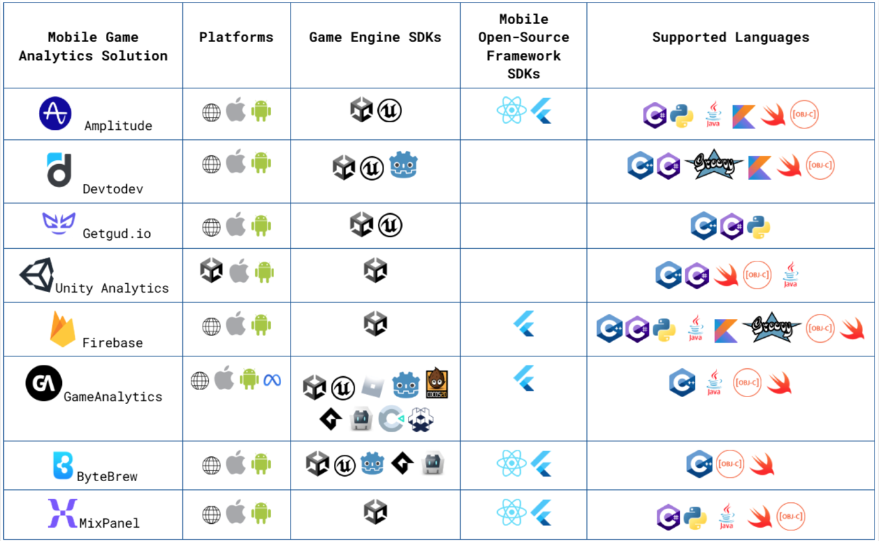
- Missing some advanced features like automatic error reporting.

