FINDINGS DOCUMENT
Inventory Transaction Visibility — SQL Analysis Results
ClearView Medical Supplies | Week 1 Mini Project
Document Version | v1.0
Date Completed | 2026/0519
Prepared By | Kgomotso Mokhoro
Stakeholder | Naledi Mokoena, Head of Procurement & Inventory
Dataset | Inventory_Transactions.csv — 1,415 rows, 9 columns
Tool Used | MySQL Workbench + Power BI

1. Data Overview
Before running any queries, the following was confirmed about the dataset:

Attribute | Detail
Total rows | 1,415 transactions
Date range | January 2025 to September 2025
Locations | North, South, East, West
SKU categories | SURG, LENS, FRM, SOL
Risk levels | Low Risk (418), Medium Risk (805), High Risk (192)
Lead time values | 7, 14, 30, 45 days (categorical)
Staff members | Optician_A, Optician_B, Optician_C, Surgeon_K

2. Data Cleaning Summary
The following issues were identified and resolved before importing into MySQL:

# | Issue Found | Fix Applied | Status
1 | Semicolon delimiter (not comma) | Data was fixed when using Power Query | Resolved
2 | Revenue column stored as text | Changed data type to Decimal Number via Power Query using English (US) locale | Resolved

3. Query Findings
Each use case from the URD was tested using MySQL. Results, screenshots, and plain-language interpretations are recorded below.

UC-01: All High Risk Transactions
Query used:
SELECT order_id, date, SKU, quantity_sold, location, lead_time, risk_level FROM inventory_transactions WHERE risk_level = 'High Risk' ORDER BY lead_time DESC;

Query result screenshot:
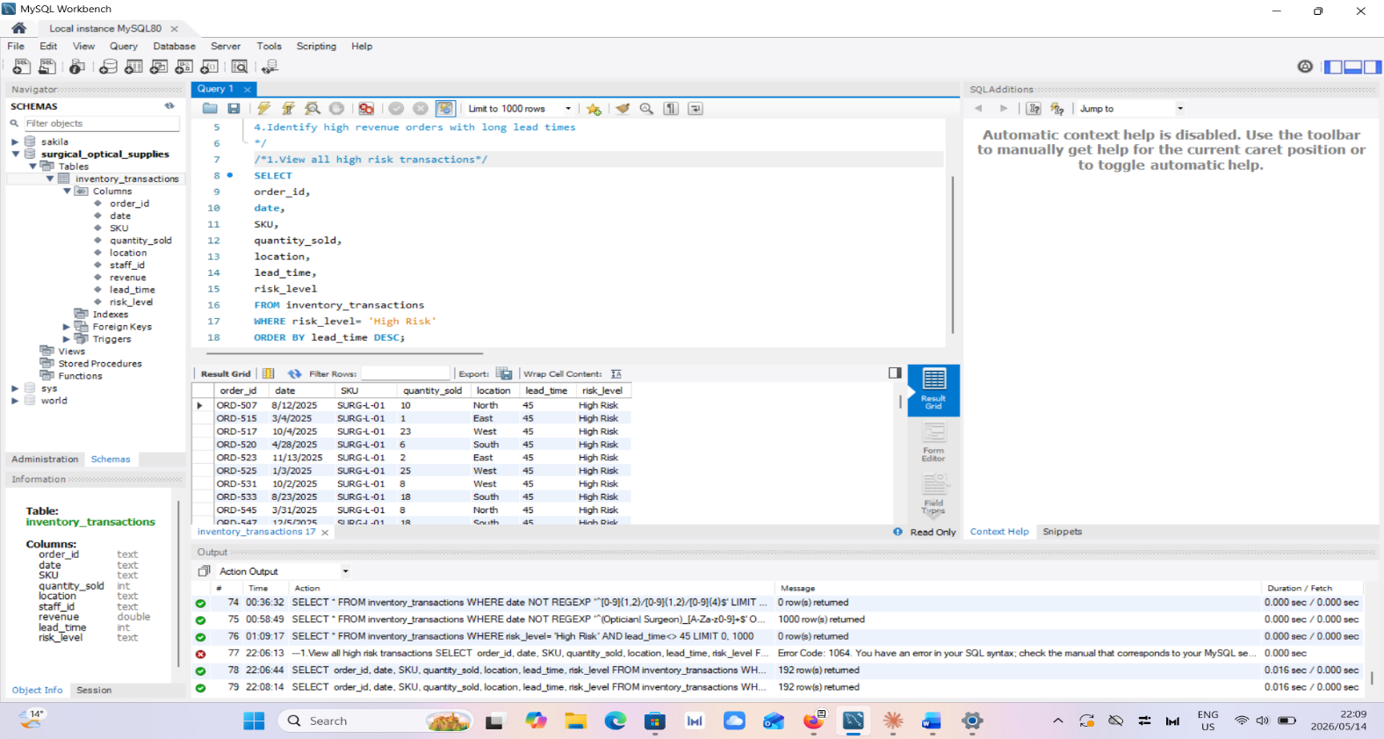

Result summary:
Field | Value
Total rows returned | 192
Key column(s) observed | SKU
Unexpected findings | N/A

Finding:192 transactions were flagged as high risk, they all had a lead time of 45 days, SURG was the only SKU that came up.
Recommendation: Seeing all high risk products are SURG, with a lead time 45 days. These products should be prioritised and moving forward be ordered 6 weeks in advance.

UC-02: Top 10 Largest Orders by Quantity
Query used:
SELECT order_id, SKU, quantity_sold, location, staff_id, revenue FROM inventory_transactions ORDER BY quantity_sold DESC LIMIT 10;

Query result screenshot:
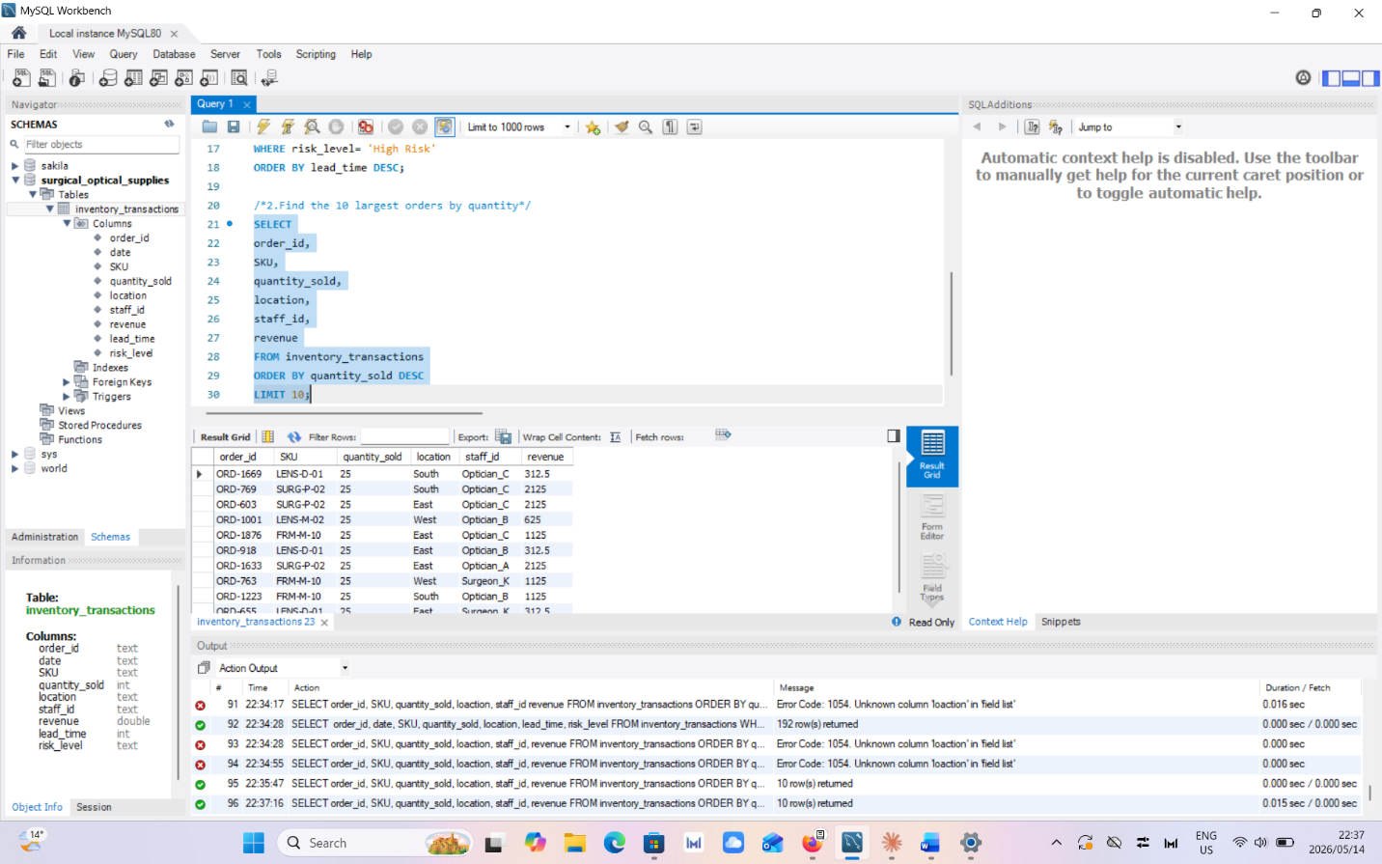

Result summary:
Field | Value
Total rows returned | 10
Key column(s) observed | SKU, Quantity sold, Revenue
Unexpected findings | The North branch does not come up in top 10 largest order by quantity

Finding: The 10 largest order were a range of products namely FRM,SURG,LENS. Most of these orders were placed by an Optician.
Recommendation: These three products move fast so it is best we keep close eye on stock levels and order frequently to meet demand.

UC-03: Medium and High Risk Orders at South Branch
Query used:
SELECT order_id, date, SKU, quantity_sold, lead_time, risk_level FROM inventory_transactions WHERE location = 'South' AND (risk_level = 'Medium Risk' OR risk_level = 'High Risk') ORDER BY risk_level, lead_time DESC;

Query result screenshot:
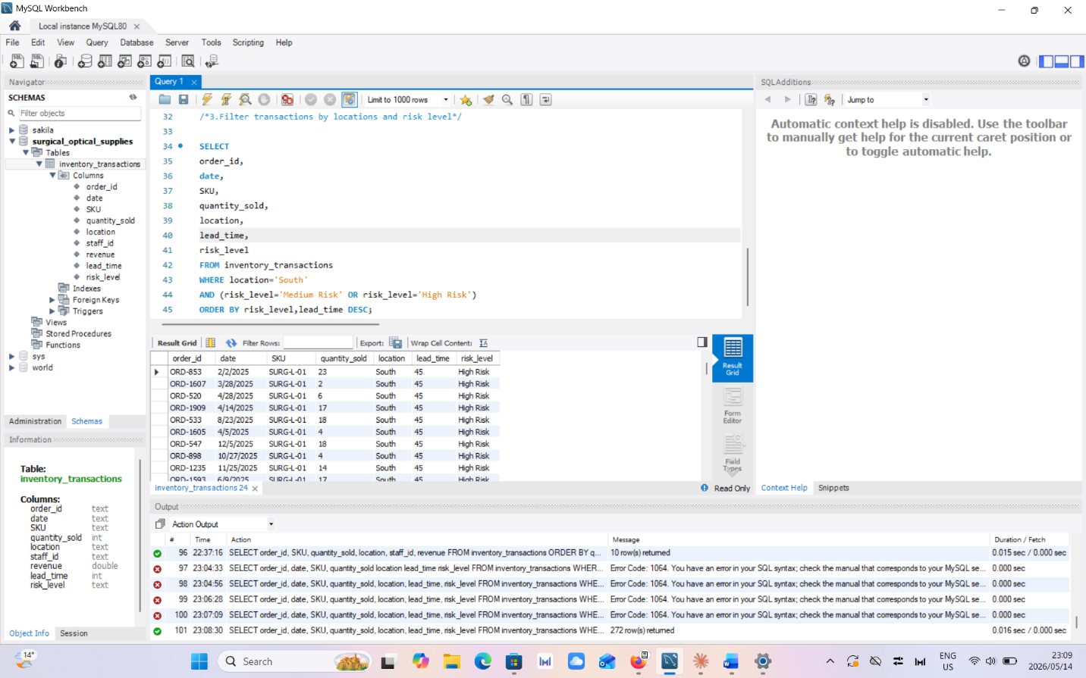

Result summary:
Field | Value
Total rows returned | 272
Key column(s) observed | Risk level, location
Unexpected findings | N/A

Finding: The 3 products that came up in this query was SURG,LENS,FRM. The south branch had 209 Medium risk and 63 High risk transactions.
Recommendation: The orders the South branch manager should prioritise are(in this order) SURG,FRM,LENS. SURG being a high risk item should be looked at closely and ordered in advance.

UC-04: High Revenue Orders with Long Lead Times
Query used:
SELECT order_id, date, SKU, location, revenue, lead_time, risk_level FROM inventory_transactions WHERE revenue > 500 AND lead_time >= 30 ORDER BY revenue DESC;

Query result screenshot:
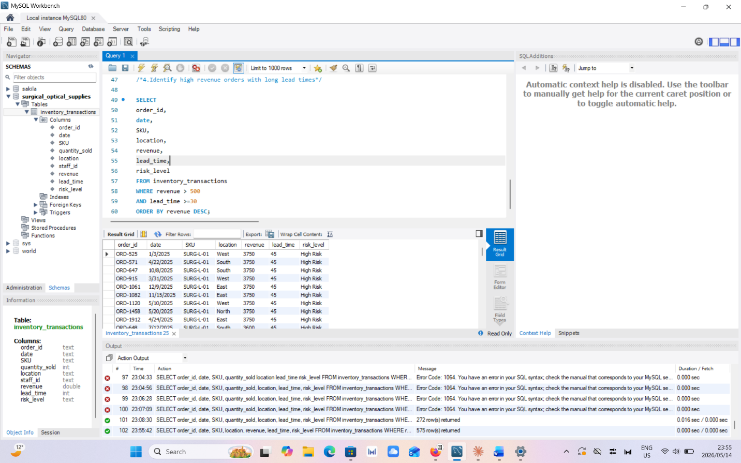

Result summary:
Field | Value
Total rows returned | 575
Key column(s) observed | Revenue, lead times
Unexpected findings | N/A

Finding: This query gave us the highest quantity sold, corresponding lead times and highest revenue sold for a single order which was R3750. The item was a high risk SKU and it was SURG product.
Recommendation: My recommendation would be to order SURG products in advance as they have the highest lead time and products with a lead time of 30 days should have minimum safety stock and when that safety stock reaches below the minimum it should trigger a reorder for the 30 lead time products.

4. Overall Summary of Findings
The following key insights were surfaced across all four use cases:
- 192 High Risk orders all carry a 45-day lead time, making them the most urgent replenishment priority
SURG SKUs dominate both the High Risk and high-revenue categories
- The South branch has the highest transaction volume and the most risk exposure
- Clear view needs to add a new column, stock levels the floor and safety stock

5. Recommendations for Naledi
Based on the analysis, the following actions are recommended:

# | Recommendation | Owner | Priority
1 | Trigger reorder for all High Risk SURG SKUs immediately | Procurement Team | High
2 | Set a weekly review cadence for the High Risk transaction list | Branch Managers | High
3 | Flag any order with revenue > R500 and lead time >= 30 days for escalation ] | Naledi Mokoena | Medium
4 | Add 2 more columns to keep 30 day lead time item stock levels healthy | Procurement Team | Medium

6. Power BI Dashboard
The findings above were visualised in a Power BI report containing the following elements:

- 4 KPI cards: Total Transactions, Total Revenue, Average Lead Time, High Risk Orders
- Bar chart: Orders by Risk Level (Low / Medium / High)
- Bar chart: Revenue by SKU Category (SURG / LENS / FRM / SOL)
- Stacked bar chart: Risk Level by Location
- Column chart: Lead Time Distribution (7 / 14 / 30 / 45 days)
- Table visual: High Risk Transactions filtered list
- Slicers: Location, Risk Level, Staff ID

Dashboard screenshot:
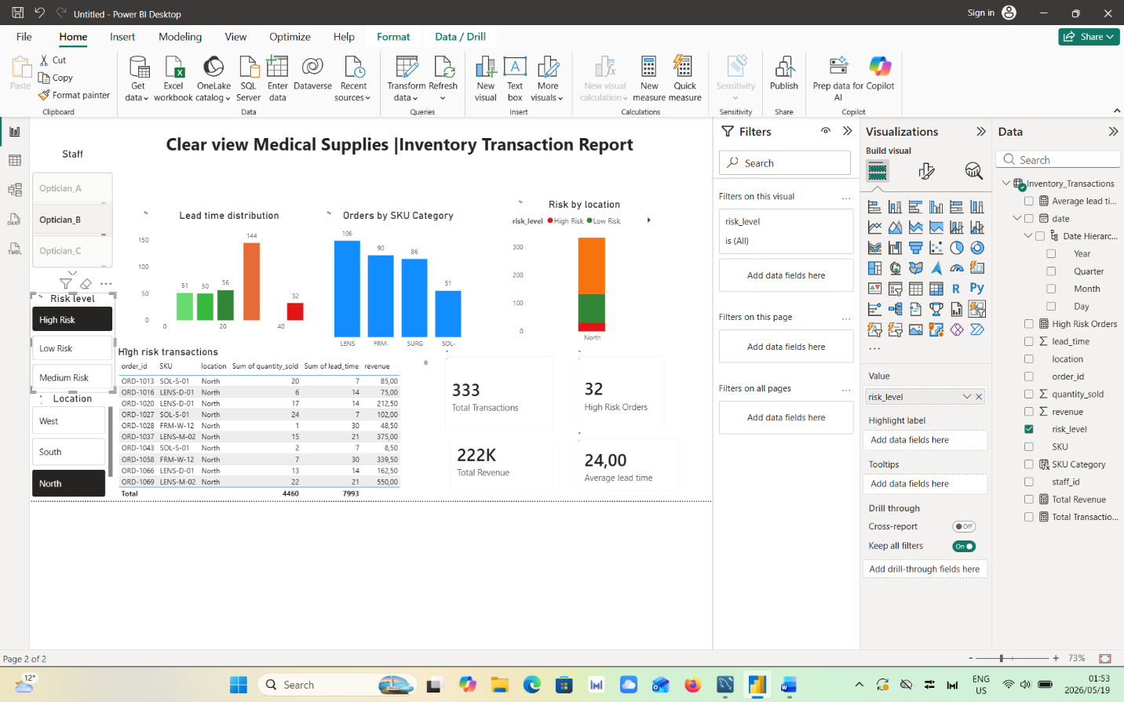

7. Sign Off
 | Analyst | Stakeholder (Naledi)
Name | Kgomotso Mokhoro | Naledi Mokoena
Date | 2026/05/19 | 2026/05/19
Signature

ClearView Medical Supplies — Confidential & Internal Use Only

