Attendance File (Monthly)
User Manual
For HR Users — Step-by-Step Guide

Butler Leather HRMS

1. What is the Attendance File?
Every month, once the HR Admin creates a new attendance file from the Attendance Control Center, all monthly attendance data is entered and managed inside that file. The attendance file is a Google Sheets workbook that holds one complete month of attendance information for all active employees — including daily marks, late-arrival records, overtime, leave balances, carry-forwarded leave, other payments/deductions, and salary advance deductions.

The file has several dedicated sheets, each serving a specific purpose. The main sheet is "Attendance entry" — this is where the HR team marks each employee as Present (P), Absent (A), Half Day Present (HD), or Layoff (LO) for every working day. Sundays are automatically filled with WO (Week Off) and locked. The file also has an "Attendance" custom menu and a "Leave" menu and a "Salary Advance" menu in Google Sheets for running the different actions each month.

The file is created fresh each month from a standard template, so its structure is always consistent. Once the monthly data is complete and verified, the Leave balances are fetched — which LOCKS the file. After that, Salary Advance EMI deductions are loaded. The locked file is then passed to Payroll for salary processing.

Who Uses This Module?
User | What They Do
HR Admin / PMO (pmo@butlerleather.com) | Runs all menu actions directly. Can run Refresh Month, Sync New Employees, Remove Inactive, Get Leave Balances, Calculate Late Penalty, and Salary Advance EMI.
HR Assistant (hrassist@butlerleather.com) | Uses the same menu buttons. All write operations are securely routed through the Web App (running as the owner account). The result is shown as a pop-up.
HR Data Entry Team | Fills in daily attendance marks, late entry minutes, OT data, other payments/deductions, carry-forwarded leave, and HR decisions in the Salary Advance sheet.

What Happens Each Month?
- A fresh attendance file is created for the month and pre-labelled with the payroll month.
- Refresh Month populates all employee names and date columns, and clears any old data.
- HR data entry team fills in attendance marks and other supporting data throughout the month.
- Late Penalty is calculated from the Late Entry sheet.
- Get Leave Balances fetches leave data for every employee, writes it into the Leave Balances sheet, and LOCKS the attendance file.
- Salary Advance EMI is loaded into the Salary Advance deductions sheet (requires file to be locked first).
- The locked file is handed over to the Payroll team for salary generation.

2. Before You Start
Check all of the following before using any menu action:

Checklist Item | Why It Matters
You have opened the correct monthly attendance file for the month you are working on (e.g. "Attendance_January_2025"). | Actions work on the active file. Running in the wrong file corrupts the wrong month's data.
The "Attendance entry" sheet tab exists and has column headers in row 1. | All menu actions depend on this sheet. Missing headers will cause errors.
Refresh Month has been run at least once for this file before entering any data. | Without a Refresh, employee names and date columns are blank. Late Entry also needs Refresh before Sync.
The Employee Master spreadsheet has the correct employee roster with STATUS values. | Refresh Month and Sync New Employees read directly from Employee Master. Stale data leads to wrong rosters.
You are using an authorised account (pmo or hrassist). | All other accounts are blocked by the access gate on every menu action.
You are on the correct sheet tab before clicking certain buttons. | Calculate Late Penalty requires the Late Entry tab to be active. Salary Advance buttons require the Salary Advance deductions tab to be active.

NOTE: All menu actions must be performed in strict monthly order. Refresh Month must come before Sync or Remove. Get Leave Balances must come before Salary Advance EMI. Do not skip steps.

As more modules are added to the HRMS, additional pre-checks will be listed here.

3. Step-by-Step Guide
Step 1: Open the correct monthly attendance file
Open the attendance file for the current month by going to the Attendance Control Center spreadsheet and clicking the file link in the MONTHLY_ATTENDANCE_FILE_ID column for the relevant month. Do not open the file directly from Google Drive or use any copy that is not registered in the Attendance Control Center.

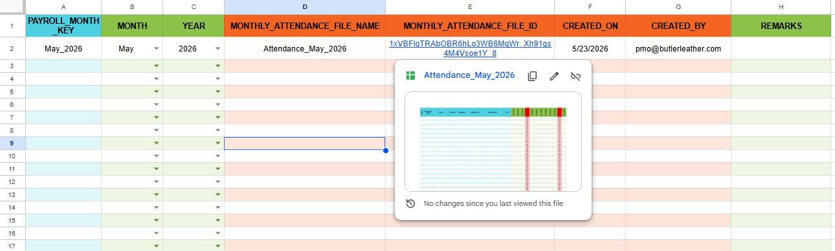

Step 2: Run Refresh Month (start of each new month)
In the Menu Click Attendance > Refresh the attendance month - full sheet.
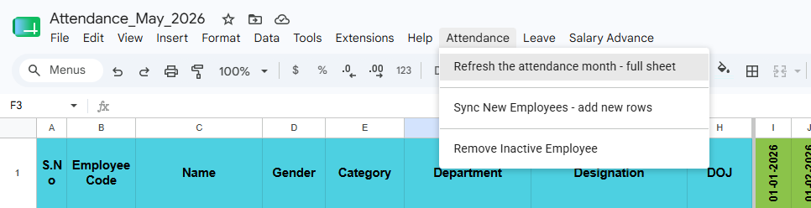

Step 2a: Authorization (First time only) If this is the first time you are running any script action in this file, Google will immediately show an "Authorization required" popup saying "A script attached to this document needs your permission to run." Click OK.

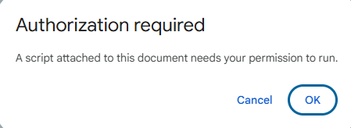

Step 2b: Sign in to your Google Account A sign-in window opens showing "Sign in to HR-Attendance workings". Your account (hrassist@butlerleather.com) will already be pre-selected. Click Continue.
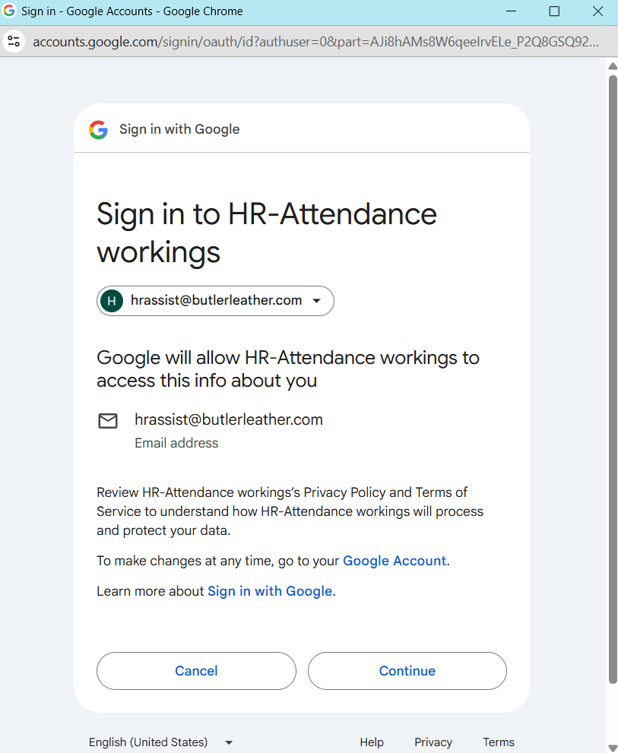

Step 2c: Grant permissions Google shows a permissions screen listing what the script needs access to — Google Drive files, Google Sheets spreadsheets, and an external service connection. All checkboxes will be unchecked by default. Tick "Select all" to check all three boxes at once.
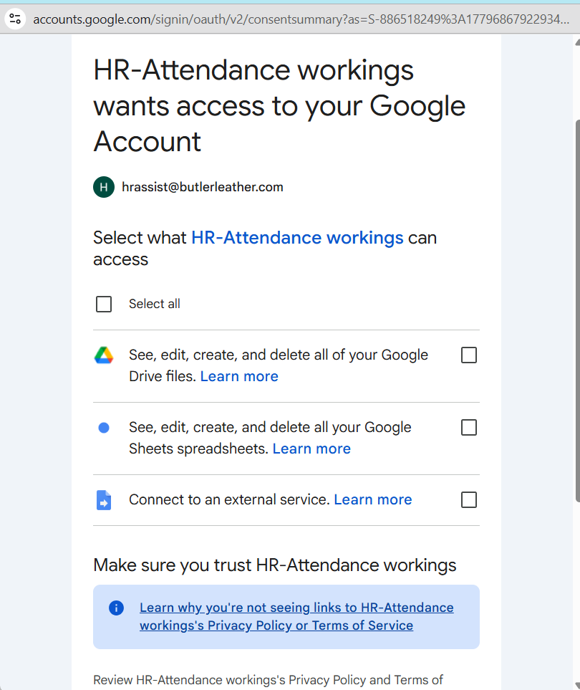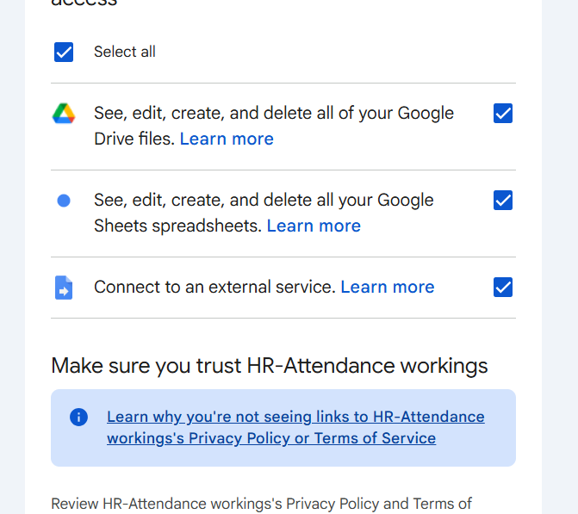

Step 2d: Confirm permissions Scroll down and click Continue to grant the permissions. This completes the one-time authorization. You will not see this screen again for this file.

Step 2e: Enter the month and year The prompt "Refresh Attendance Month" now appears. Type the month and year in either format — "January 2025" or "2025-01". Click OK.
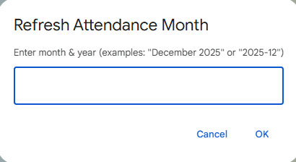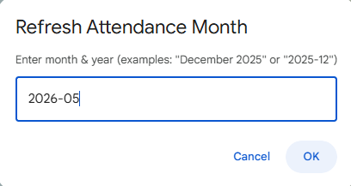
Step 2f: Wait for completion The script runs in the background — this may take 15–30 seconds. Once complete, a confirmation popup appears saying "Attendance refreshed for May 2026." Click OK. The employee roster will now be populated, date columns will be set up, Sundays will be marked in red with WO, and the Late Entry sheet will be rebuilt.
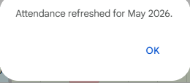

NOTE: Refresh Month clears all data across all sheets (Attendance entry, Late Entry, Leave Balances, OT Entry, Other Payments, Other Deductions, Salary Advance deductions, Carry Forwarded). Run this at the very start of the month before any data entry.

Step 3: Enter attendance, late entry, OT, and other data throughout the month
The HR data entry team fills in data across multiple sheets throughout the month. Each sheet has a specific purpose. Work through them as described below.

Step 3a: Attendance entry — daily marks Click the "Attendance entry" sheet tab. For each employee row, select the daily attendance mark from the dropdown under each date column. The available values are:
- P — Present
- A — Absent
- HD — Half Day Present
- LO — Layoff
Sunday columns are already filled with WO (Week Off) and are locked — you cannot edit them. Update each employee's mark daily and ensure all working days are filled before the end of the month.
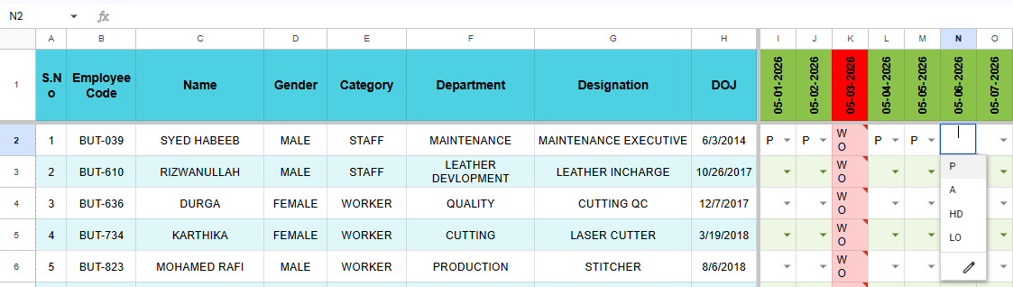

Step 3b: Late Entry — late arrival minutes Click the "Late Entry" sheet tab. For each employee who arrived late on a given day, enter the number of minutes late under that date column (e.g. 5 for 5 minutes late). Leave the cell blank if the employee was on time. Sunday columns show WO and are locked.

For permitted permission arrivals, the rules are:
Worker — 1 hour permission is allowed per month. Enter P60 on the day the permitted late arrival is used. Once used, any further late arrivals are counted as penalty.
Staff — 2 hours permission is allowed per month. This can be used either as P120 on one day (full 2 hours at once), or as P60 on two separate days (1 hour each time). Once the permitted allowance is used up, any further late arrivals are counted as penalty.

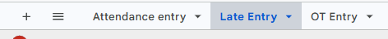

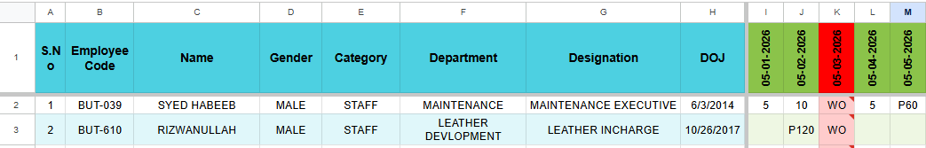

Step 3c: OT Entry — overtime details Click the "OT Entry" sheet tab. For each employee who worked overtime, enter one row per day per employee. The sheet has the following columns — fill them as described:
- Date — Enter the date in MM/DD/YY format (e.g. 01/15/25 for 15th January 2025).
- Employee Code — Enter the employee code in the format BUT-1234.
- Name, Department, Designation — These columns are auto-filled by formula once the Employee Code is entered. Do not type in these columns manually.
- OT Start — Enter the overtime start time in HH:MM format (e.g. 18:00).
- OT End — Enter the overtime end time in HH:MM format (e.g. 20:00).
- Total OT Hours — This column is auto-calculated. Do not edit manually.
- OT Purpose — Enter the reason for overtime (e.g. "Month-end stock count"). This field is mandatory — rows without an OT Purpose will be flagged during payroll validation.
Multiple overtime entries for the same employee on different days go in separate rows.

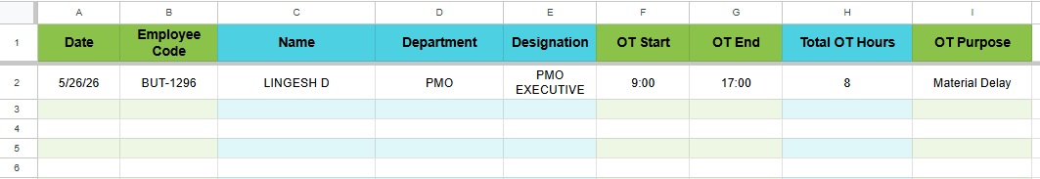
Note: OT purpose: Mandatory field

Step 3d: Carry Forwarded — carry forwarded leave Click the "Carry Forwarded" sheet tab. For any employee whose days are being carried forward from a previous period, enter one row per employee. The sheet has the following columns — fill them as described:
- Employee Code — Enter the employee code in the format BUT-1234.
- Name, Department, Designation — These columns are auto-filled by formula once the Employee Code is entered. Do not type in these columns manually.
- Carry Forwarded Days — Enter the number of days being carried forward. Accepted values are 0.5 to 30 (e.g. 1, 2.5, 5).
- Carry Forwarded From Month [MM/DD/YY] — Enter the first date of the month from which the days are being carried forward, in MM/DD/YY format. This must always be a previous month — never the current or a future month (e.g. if the current payroll month is May 2025, enter 04/01/25 for April 2025).
- Carry Forwarded Type — Select from the dropdown. Available options are:
  - PENDING WORK DAYS
  - MISSED EMPLOYEE LAST MONTH
  - OTHER
- Remarks — Enter any notes for HR reference. This field is optional and does not affect payroll processing.

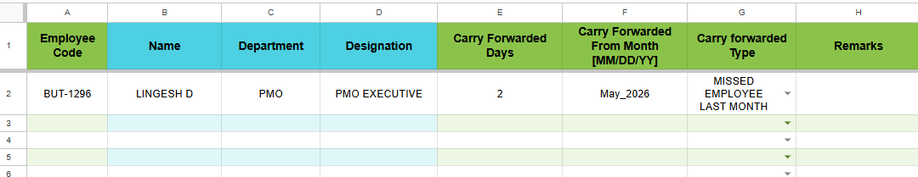

Step 3e: Other Payments — additional payments Click the "Other Payments" sheet tab. For any additional payment to be made to an employee outside of regular salary, enter one row per payment. The sheet has the following columns — fill them as described:
- Employee Code — Enter the employee code in the format BUT-1234.
- Name, Department, Designation — These columns are auto-filled by formula once the Employee Code is entered. Do not type in these columns manually.
- Payment Type — Select from the dropdown. Available options are:
  - GROSS ARREAR PAY
  - NET ARREAR PAY
  - INCENTIVE
  - SPECIAL ALLOWANCE
  - SHIFT ALLOWANCE
  - PF ADJUSTMENT
  - ESI ADJUSTMENT
  - PT ADJUSTMENT
  - TDS ADJUSTMENT
  - REIMBURSEMENT - TRAVEL
  - REIMBURSEMENT - PHONE/INTERNET
  - REIMBURSEMENT - OTHER
- Payment Nature — Auto-filled by formula based on the Payment Type selected. Do not edit manually.
- Consider Under — Auto-filled by formula based on the Payment Type selected. Do not edit manually.
- Amount — Enter the payment amount as a whole number only. Decimal values are not accepted (e.g. enter 500, not 500.50).
- Month Applicable [MM/DD/YY] — Enter the first date of the month this payment applies to in MM/DD/YY format (e.g. 05/01/25 for May 2025).
- Remarks — Enter any notes for HR reference. This field is optional.
- Approved By — Select the approving authority from the dropdown. This field is mandatory. Available options are:
  - Mr. Zafar
  - Mr. Ajmal
  - Ms. Nazneen
  - Mr. Noor
  - Ms. Anjum

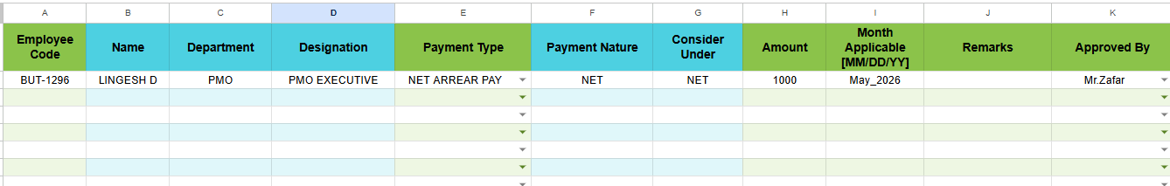

Step 3f: Other Deductions — additional deductions Click the "Other Deductions" sheet tab. For any deduction to be applied to an employee's salary, enter one row per deduction. The sheet has the following columns — fill them as described:

- Employee Code — Enter the employee code in the format BUT-1234.
- Name, Department, Designation — These columns are auto-filled by formula once the Employee Code is entered. Do not type in these columns manually.
- Deduction Type — Select from the dropdown. Available options are:

  - DAMAGE / LOSS RECOVERY
  - EXCESS PAYMENT RECOVERY
  - ROOM RENT
  - ELECTRICITY
  - WATER CHARGES
  - TRANSPORT DEDUCTION
  - MOBILE USAGE FINE
  - MESS DEDUCTION
  - MOBILE INTERNET DEDUCTION
  - MEDICAL INSURANCE PREMIUM
  - UNIFORM / SHOES RECOVERY
  - ID CARD

- Consider Under — Auto-filled by formula based on the Deduction Type selected. Do not edit manually.

- Amount — Enter the deduction amount as a whole number only. Decimal values are not accepted (e.g. enter 200, not 200.50).

- Month Applicable [MM/DD/YY] — Enter the first date of the month this deduction applies to in MM/DD/YY format (e.g. 05/01/25 for May 2025).
- Remarks — Enter any notes for HR reference. This field is optional

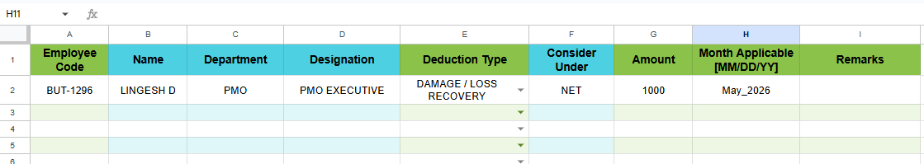

Enter attendance, late entry, OT, and other data throughout the month
- The HR team fills in data across multiple sheets throughout the month.
- Step 3a & 3b (Attendance entry and Late Entry) — update these every working day without fail.
- Step 3c (OT Entry) — fill in whenever an employee works overtime.
- Step 3d (Carry Forwarded) — fill in whenever leave is being carried forward for an employee.
- Step 3e (Other Payments) — fill in whenever an additional payment needs to be made.
- Step 3f (Other Deductions) — fill in whenever a deduction needs to be applied.

Step 4: Sync New Employees (if new joiners mid-month): In Attendance entry tab,
- Run this step only if one or more new employees joined the company after the last Refresh Month was run.
- In the Menu Click Attendance > Sync New Employees - add new rows.
- The script checks the Employee Master for any ACTIVE employees who are not yet present in the Attendance entry sheet.
- New employee rows are appended at the bottom of the Attendance entry sheet and the Late Entry sheet.
- Existing employee rows and their entered data are not touched.
- Sunday columns are automatically filled with WO for the newly added rows.
- If no new employees are found, a message will appear saying "No new ACTIVE employees to append."
- After sync, fill in the attendance marks and late entry data for the new employees from their date of joining for the current month.
.

NOTE: Sync New Employees only adds new employees — it never modifies or removes existing rows. If no new employees are found, you will see "No new ACTIVE employees to append."

Step 5: Remove Inactive Employee (if someone resigned mid-month)
Run this step only if an employee who has left the company has no present days recorded for the current payroll month. In the Menu Click Attendance > Remove Inactive Employee. A warning confirmation will appear — read it carefully before proceeding. Confirm YES, then enter the employee code when prompted. The employee will be removed from both the Attendance entry sheet and the Late Entry sheet.
Before running this step, ensure the following rules are met:
- The employee must already be marked INACTIVE in Employee Master before running this action. If they are still ACTIVE, the script will block the removal with an error.
- The attendance file must not be locked. If Get Leave Balances has already been run, this action is blocked.
- Only one employee can be removed at a time. Repeat the process for each employee if multiple removals are needed.
- This action is permanent and cannot be undone — all attendance data entered for that employee for the current month will be deleted.
- Their payroll will not be processed for this month once removed.

NOTE: The employee must already be marked INACTIVE in Employee Master before you can remove them. If they are still ACTIVE, the action will be blocked with an error. This action cannot be undone — the attendance data for that employee is permanently deleted.

NOTE: All sheets must be completed and reviewed, all new employee syncs must be done, and any inactive employee removals must be completed before proceeding to Step 6.

Step 6: Get Leave Balances — this LOCKS the file
Once all data entry is complete for the month, In the Menu click Leave > Get Leave Balances. A YES/NO confirmation appears: "Shall I lock the file and fetch leave balances? (This action is ONE TIME only.)". Click YES.
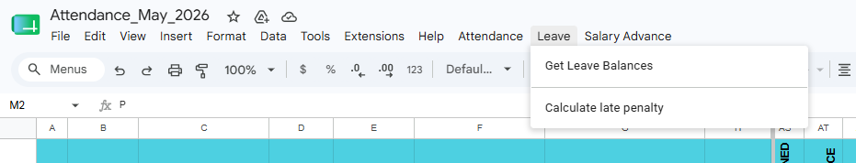

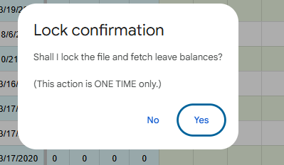

Once confirmed, the following happens automatically:

- Leave balances for all employees are fetched from the Leave Master and written into the Leave Balances sheet.
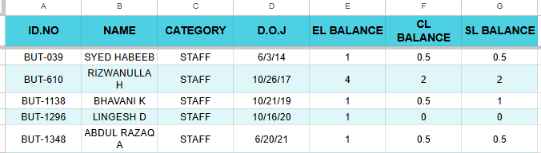
- The LOCKED STATUS column in the Attendance entry sheet is filled with the lock timestamp and protected.
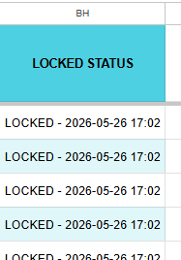
- The Leave Balances sheet is protected — no manual edits are allowed after this.
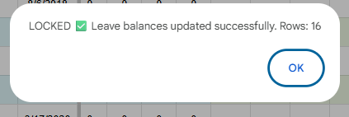

- Refresh Month, Sync New Employees, and Remove Inactive Employee are all blocked from this point.
- This action is ONE TIME only per month and cannot be undone.
Before clicking YES, make sure:
- All attendance marks are entered and reviewed.
- All late entry data is filled.
- All OT, Other Payments, Other Deductions, and Carry Forwarded entries are complete.
- Sync New Employees and Remove Inactive Employee have been completed if required.
NOTE: This action is ONE TIME only per month. Once the file is locked, you cannot re-run Get Leave Balances, Refresh Month, Sync New Employees, or Remove Inactive Employee. Make sure all attendance data is complete and reviewed before clicking YES.

Step 6.a: Leave Approval Rules — Columns AW to AZ (Attendance entry sheet)
These columns are filled by HR after the attendance file is locked and the Leave Balances are fetched (Step 6 — Get Leave Balances). Only then will the employee's EL, CL, and SL balances be available to validate the entries. They control how many leave days are approved for each employee and affect the Final Payable Days calculation.
General Rules (apply to all leave types):
- Leave can only be approved if the employee has absent days recorded for the month.
- Leave cannot be approved if the employee has Layoff days (BG > 0).
- Minimum leave entry is 0.5 days. Values below 0.5 are not accepted.
- Total approved leave across EL + CL + SL cannot exceed total absent days.

AW — Approved EL Days (Earned Leave)
- Minimum: 0.5 days
- Cannot exceed the employee's available EL Balance
- Without Management Approval — maximum 1 day can be approved
- With Management Approval (AZ = APPROVED) — can approve more than 1 day, up to the full EL balance (after deducting CL and SL already approved)
AX — Approved CL Days (Casual Leave)
- Minimum: 0.5 days, Maximum: 1 day per month
- Cannot exceed the employee's available CL Balance
- Cannot exceed absent days minus EL and SL already approved
AY — Approved SL Days (Sick Leave)
- Minimum: 0.5 days
- Cannot exceed the employee's available SL Balance
- Cannot exceed absent days minus EL and CL already approved
AZ — Management Approval for Long Leaves
- Dropdown: select APPROVED or DECLINED
- Select APPROVED only when the employee needs more than 1 day of EL approved
- If left blank or DECLINED, EL is capped at 1 day maximum

Step 7: Calculate Late Penalty (from the Late Entry sheet)
NOTE: You must be on the "Late Entry" sheet when you click this button. Clicking from any other sheet will show an error asking you to navigate to Late Entry first.

7.a First, navigate to the "Late Entry" sheet tab. Then click Leave > Calculate late penalty. The script reads the daily late durations for each employee, applies the grace and penalty rules by category, and writes the LATE PENALTY COUNT for each employee. That column is then protected.

7.b
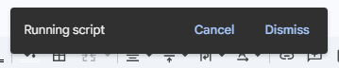

7.c
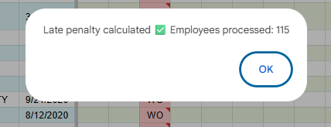

The penalty rules applied are:
- Worker — 1 permitted late slot per month (P60). Any late arrival beyond the permitted slot is counted as penalty.
- Staff — 2 permitted late slots per month (either P120 once or P60 twice). Any late arrival beyond the permitted slots is counted as penalty.
- Late arrivals of 5 minutes or less are ignored — no penalty applied.
- Late arrivals between 6 and 10 minutes — a grace count is used (maximum 3 grace uses per employee per month).
- Late arrivals above 10 minutes up to 270 minutes — 0.5 penalty count added.
- Late arrivals above 270 minutes — 1 full penalty count added.

Step 8: Get Salary Advance EMI (from Salary Advance deductions sheet)
NOTE: You must be on the "Salary Advance deductions" tab when clicking this button. The attendance file must be LOCKED (Step 7 complete). If Payroll Status is already filled (payroll has been generated), this button will be blocked.

8.a Navigate to the "Salary Advance deductions" sheet tab. In the Menu, Click Salary Advance > Get Salary Advance EMI. The script loads the EMI deduction rows for this month from the Salary Advance Master and writes them into the Salary Advance deductions sheet.
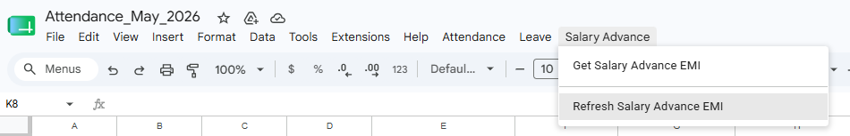

8.b

8.c
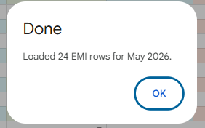

The following happens automatically:
- EMI rows for the current payroll month are fetched from the Salary Advance Master.
- If a snapshot already exists in the master for this attendance file and month, it is loaded directly.
- If no snapshot exists, the script fetches all ACTIVE EMI rows from the master schedule and saves a snapshot before writing to the sheet.
- A timestamp is written in the SA Run Timestamp column in row 2 — this is stamped even if no EMI rows are found.
- If no EMI rows are found for this month, an info message will appear stating the same.
Before running this step, ensure:
- The attendance file is LOCKED (Step 7 — Get Leave Balances must be completed first).
- You are on the "Salary Advance deductions" sheet tab when clicking the button.
- Payroll has not been generated yet — if Payroll Status is already filled, this button will be blocked.

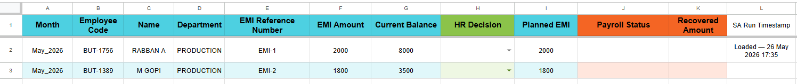

Step 9: Refresh Salary Advance EMI (if EMI schedule changed after initial load)
Run this step only if the EMI schedule in the Salary Advance Master was updated after you already ran Get Salary Advance EMI in Step 8. Click Salary Advance > Refresh Salary Advance EMI.
The following happens automatically:

- The latest ACTIVE EMI rows are re-fetched from the Salary Advance Master for the current payroll month.
- Any new EMI entries that were not in the previous snapshot are appended to the master summary (duplicates are automatically skipped).
- The full updated list is reloaded into the Salary Advance deductions sheet, replacing the previously loaded data.
- A fresh timestamp is written in the SA Run Timestamp column.
Before running this step, ensure:
- The attendance file is LOCKED (Step 8 — Get Leave Balances must be completed first).
- You are on the "Salary Advance deductions" sheet tab when clicking the button.
- Payroll has not been generated yet — if Payroll Status is already filled, this button will be blocked.

After loading EMI data — HR Decision column
Once the EMI rows are loaded into the Salary Advance deductions sheet, the HR team must review each row and fill in the HR Decision column where required. The following columns are relevant:

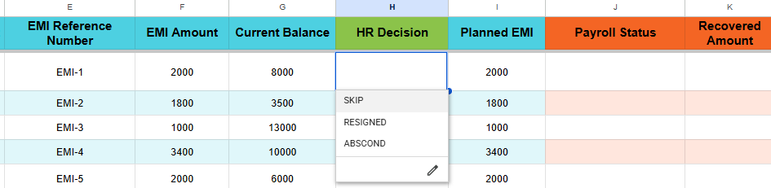

- Month — Payroll month for the EMI (e.g. May_2026). Auto-filled by script.
- Employee Code, Name, Department — Auto-filled by script.
- EMI Reference Number — Unique EMI reference from the master. Auto-filled by script.
- EMI Amount — The regular monthly instalment amount. Auto-filled by script.
- Current Balance — Remaining loan balance. Auto-filled by script.
- HR Decision — Select from the dropdown if a special decision applies for this employee this month. Available options are:
  - SKIP — EMI is skipped for this month. The Planned EMI becomes 0, so no amount is deducted in the current payroll. One additional EMI will be automatically scheduled after the last scheduled EMI month in the master.
  - RESIGNED — Employee has resigned. The full Current Balance becomes the Planned EMI — the entire remaining loan amount will be deducted in this payroll.
  - ABSCOND — Employee has absconded. Same as RESIGNED — the full Current Balance becomes the Planned EMI.
  - Leave blank — If no special decision, leave this cell empty. The regular EMI Amount will be deducted.
- Planned EMI — Auto-calculated by formula based on the HR Decision:
  - Blank HR Decision → Planned EMI = EMI Amount
  - SKIP → Planned EMI = 0
  - RESIGNED or ABSCOND → Planned EMI = Current Balance
- Payroll Status — Filled automatically by the Payroll module after salary is generated. Do not edit manually.
- Recovered Amount — Filled automatically by the Payroll module. Do not edit manually.

Step 10: Verify and hand off to Payroll
Before handing off to the Payroll team, ensure all the following checks are met. The Payroll module will automatically validate these when "Validate Attendance" is run — any failure will block payroll processing.
Attendance entry sheet:
- Every employee row must have S.No, Name, Gender, Category, DOJ, Department, and Designation filled in.
- No duplicate Employee Codes.
- TOTAL WORKING DAYS must be greater than 0 for every employee.
- TOTAL PRESENT DAYS must be 0 or more — cannot be negative and cannot exceed TOTAL WORKING DAYS.
- LOP DAYS must be 0 or more — cannot be negative.
- FINAL PAYABLE DAYS must be 0 or more — cannot be negative and cannot exceed TOTAL WORKING DAYS.
- The attendance file must be LOCKED (LOCKED STATUS column must be filled).
Late Entry sheet:
- Every employee in Attendance entry must have a corresponding row in Late Entry.
- LATE PENALTY COUNT must be filled for every employee — run Calculate Late Penalty (Step 6) if blank.
OT Entry sheet:
- Every row that has an Employee Code must have all other columns filled (Remarks is optional).
Carry Forwarded sheet:
- Every row that has an Employee Code must have all other columns filled except Remarks.
Other Payments sheet:
- Every row that has an Employee Code must have all columns filled except Remarks.
- Consider Under value must be either GROSS or NET — no other values accepted.
Other Deductions sheet:
- Every row that has an Employee Code must have all columns filled except Remarks.
Salary Advance deductions sheet:
- SA Run Timestamp must be filled in row 2 — confirms Get/Refresh Salary Advance EMI was run.
- Every row must have Month, Employee Code, Name, Department, EMI Reference Number, EMI Amount, and Current Balance filled in.
- The Month value in every row must match the current payroll month.
- Payroll Status must NOT be LOCKED — if already locked, payroll has already been processed.

4. Monthly Workflow Summary
Step | Action
1 | Open the monthly attendance file from the Attendance Control Center by clicking the file link in the MONTHLY_ATTENDANCE_FILE_ID column.
2 | Click Attendance > Refresh the attendance month - full sheet. Enter the month and year.
3 | HR team enters daily attendance marks (P / A / HD / LO) in Attendance entry throughout the month.
4 | HR team enters late arrival minutes in Late Entry sheet daily.
5 | HR team fills OT Entry, Other Payments, Other Deductions, and Carry Forwarded as and when applicable.
6 | If new employees joined mid-month: click Attendance > Sync New Employees.
7 | If an employee left with no present days: click Attendance > Remove Inactive Employee (before locking).
8 | Click Leave > Get Leave Balances. Confirm YES. File is now LOCKED.
9 | After locking, review each employee's absent days and fill in Approved EL, CL, and SL days in the Attendance entry sheet following the leave approval rules. Use Management Approval (AZ) if EL exceeds 1 day.
10 | Navigate to Late Entry sheet. Click Leave > Calculate late penalty.
11 | Navigate to Salary Advance deductions sheet. Click Salary Advance > Get Salary Advance EMI.
12 | Review HR Decision column in Salary Advance deductions — select SKIP, RESIGNED, or ABSCOND where applicable. Leave blank for regular EMI deduction.
13 | If EMI schedule was updated: click Salary Advance > Refresh Salary Advance EMI.
14 | Review all sheets against the payroll validation checklist (Step 10). Hand off the file to the Payroll team.

TIP: If you see an error message at any step, go directly to Section 5 — it lists every possible error with the exact fix. For any error you cannot resolve, contact your system administrator.

5. Error Messages — What They Mean & What To Do
Error Message (Example) | Why It Happened | What To Do
You are not authorised to run this action. | The logged-in account is not pmo or hrassist. | Log in with an authorised account (pmo@butlerleather.com or hrassist@butlerleather.com).
Sheet "Attendance entry" not found. Please update ATTENDANCE_SHEET_NAME in script. | The Attendance entry sheet tab is missing from the file. | Contact your system administrator to restore the sheet.
File name mismatch! Selected month: December 2025. Expected: Attendance_December_2025. Current: Attendance_November_2025. | You selected a different month than what the file name indicates. | Either rename the file to match the selected month, or re-enter the correct month in the prompt.
Duplicate attendance file detected. A file named "Attendance_December_2025" already exists. | Another file with the same name already exists in the Monthly Attendance folder. | Check the folder for a duplicate and remove it, or contact the administrator.
This attendance file is LOCKED for this month. Refresh is not allowed. | The file has already been locked by Get Leave Balances for this month. | A locked file cannot be refreshed. Contact the administrator if an unlock is needed.
Invalid format. Use "December 2025" or "2025-12". | The month/year was entered in an unsupported format in the Refresh prompt. | Re-enter using one of the two supported formats: "January 2025" or "2025-01".
No ACTIVE employees found in Employee Master. | Employee Master has no rows with STATUS = ACTIVE. | Activate at least one employee in the Employee Master spreadsheet.
Cannot detect month/year from header I1. Please run "Refresh the attendance month - full sheet" once first. | Sync New Employees was clicked before Refresh Month was ever run. | Run Refresh Month first to populate the date headers, then retry Sync.
This attendance file is LOCKED. Sync New Employees is not allowed. | The file has been locked by Get Leave Balances. | Sync New Employees cannot run after the file is locked.
This attendance file is LOCKED. Removing an employee is not allowed. | The file has been locked by Get Leave Balances. | Employee removal is not allowed after the file is locked.
No employee code entered. Action cancelled. | The Remove Inactive Employee prompt was dismissed without entering a code. | Click Remove Inactive Employee again and enter the correct employee code.
Employee "EMP001" is still marked as ACTIVE in Employee Master. Please change their status to INACTIVE first. | You tried to remove an employee who is still ACTIVE. | Update the employee's STATUS to INACTIVE in Employee Master, then try again.
Employee code "EMP999" was not found in Employee Master. Please check the code and try again. | The code entered does not exist in Employee Master. | Verify the employee code by checking Employee Master directly.
Employee code "EMP001" was not found in the Attendance entry sheet. They may have already been removed. | The employee was not found in the Attendance entry sheet. | The employee may have already been removed. Check the sheet before retrying.
This attendance file is LOCKED. No changes allowed. | Get Leave Balances was clicked on an already-locked file. | Get Leave Balances can only be run once. The file is already locked.
No leave balances found. | Leave Master had no data for this attendance file name/month combination. | Check that Leave Master has data for this month, or contact your administrator.
Please run this function from the "Late Entry" sheet only. | Calculate Late Penalty was clicked from a sheet other than Late Entry. | Click the "Late Entry" tab at the bottom first, then click Calculate late penalty.
Please run this button from "Salary Advance deductions" sheet only. | A Salary Advance button was clicked from the wrong sheet. | Navigate to "Salary Advance deductions" tab first, then click the button.
Attendance entry is not LOCKED. Please lock the file first. | A Salary Advance EMI button was clicked before Get Leave Balances was run. | Complete Step 7 (Get Leave Balances) to lock the file first.
Invalid file name "MyFile". Expected like Attendance_January_2026. | The attendance file is not named in the correct pattern. | Rename the file to "Attendance_Month_Year" (e.g. Attendance_January_2026).
Payroll is LOCKED (Payroll Status is filled). Get EMI is not allowed. | Payroll has already been generated for this month. | SA EMI cannot be changed after payroll is locked. Contact the Payroll team.

6. Do's and Don'ts
✅ Dos
- Always run Refresh Month at the start of every new month before entering any data.
- Enter only P, A, HD, LO or WO in the Attendance entry date cells. Use minutes, P60, or P120 in Late Entry cells.
- Navigate to the correct sheet tab before running Calculate Late Penalty (Late Entry tab) or Salary Advance buttons (Salary Advance deductions tab).
- Complete and review all data entry before clicking Get Leave Balances — it locks the file permanently.
- Run Get Salary Advance EMI only after the file is locked.
- Use Refresh Salary Advance EMI if the EMI schedule in the master was updated after the initial EMI load.

❌ Donts
- Don't manually type in LOCKED STATUS, LATE PENALTY COUNT, Leave Balances data, or Salary Advance EMI rows — these are filled automatically by the script.
- Don't click Get Leave Balances if you haven't finished all data entry — there is no undo for the lock.
- Don't run Refresh Month mid-month after data entry has started — it will clear all entered data.
- Don't delete or rename the Sunday columns — they are auto-managed and protected.
- Don't try to edit protected cells (Sunday WO cells, LOCKED STATUS column, Leave Balances, or Late Penalty column) — they are intentionally locked.
- Don't remove an employee whose payroll needs to be processed — the removal is permanent and cannot be undone.

