LEAVE MASTER MODULE
User Manual
For HR Users — Step-by-Step Guide
Butler Leather HRMS System
June 2026

1. What is Leave Master?
The Leave Master module is the system that keeps track of which employees should have leave balance records and ensures those records are always up to date. It connects directly to the Employee Master — the company's central list of all staff — and automatically adds new employees, removes those who have left or changed role, and updates names or joining dates if anything has changed.

You do not need to manually add or delete employees from the leave register. The system does this for you, either automatically in the background or at the click of a button. Your job as an HR user is to maintain the actual leave balance numbers (Earned Leave, Casual Leave, Sick Leave) in the leave register — the system will never change those figures.

Think of the Leave Master as a self-cleaning directory. It always reflects who is currently active staff, and it always preserves the leave balances you have entered.

Who Uses This Module?
User | What They Do
PMO (Project Management Office) | Can click the sync button directly. Manages the sync schedule and deployment.
HR Assistant (hrassist) | Can click the sync button. The system routes their request securely through a Web App.
HR User (anyone authorised) | Maintains leave balance figures in the EL BALANCE, CL BALANCE, and SL BALANCE columns.

What Happens When You Sync?
- New active staff employees are added to the leave register with blank leave balance entries.
- Employees who are no longer active or no longer classified as staff are removed completely from the register.
- Identity fields (ID, Name, Category, Date of Joining) are updated if they changed in the Employee Master.
- Leave balance columns are never touched during sync — your manually entered figures are always preserved.
- The system also runs automatically in the background every few minutes via a scheduled timer.

2. Before You Start
Check the following before running a manual sync:

Checklist Item | Why It Matters
You are logged in as pmo@butlerleather.com or hrassist@butlerleather.com | Only these two accounts can trigger the sync. Others will see an 'Not authorised' message.
The Employee Master spreadsheet is accessible and not being edited mid-save | The sync reads live data from Employee Master. Partially saved changes may not be picked up correctly.
The LEAVE_MASTER sheet exists and has all seven column headers in row 1 | The sync will fail if the target sheet is missing or has incomplete headers.
Leave balance figures you have entered are saved (no unsaved edits open) | While the sync preserves balances, it is good practice to confirm your data is saved before triggering a sync.
You are in the Leave Master spreadsheet (not Employee Master or another sheet) | The sync menu only appears in the Leave Master spreadsheet.

NOTE
The automated background sync (Hash Watcher) runs every few minutes and handles routine changes. You only need to use the manual sync button when you want to force an immediate update — for example, right after a new employee is added to the Employee Master.

As more modules are added to the HRMS, additional pre-checks will be listed here.

3. Step-by-Step Guide
Step 1: Open the Leave Master Spreadsheet
Navigate to the Leave Master spreadsheet in Google Sheets. You should see a custom menu called 'Leave Master' in the menu bar at the top of the screen. If you do not see this menu, wait a few seconds and refresh the page — it appears automatically when the spreadsheet loads.
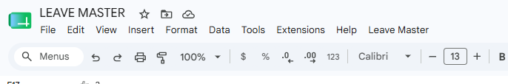

Step 2: Click on the 'Leave Master' Menu
Click on the 'Leave Master' menu in the top menu bar. A dropdown will appear with one option: 'Sync ACTIVE STAFF (Add/Remove)'. This is the only action available in this menu.
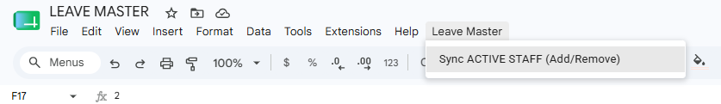
Step 3: Click 'Sync ACTIVE STAFF (Add/Remove)'
Click the 'Sync ACTIVE STAFF (Add/Remove)' option. The system will immediately check whether you are authorised to run the sync. If you are not logged in as an authorised account, you will see an 'Not authorised' message and the sync will not proceed.
NOTE
If you see 'Not authorised to run this sync.' — you are logged into a Google account that is not pmo@butlerleather.com or hrassist@butlerleather.com. Switch to an authorised account and try again.
Step 4: Review and Confirm the Sync Dialog
A confirmation dialog box will appear summarising the three operations the sync will perform: adding new active staff, removing employees who are no longer active staff, and updating identity fields. Read through this and click 'Yes' to proceed. If you click 'No', the sync will be cancelled with no changes made.

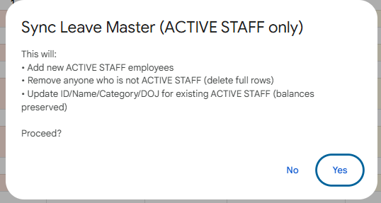
NOTE
Clicking 'Yes' immediately begins the sync. There is no undo — removed rows are deleted permanently from LEAVE_MASTER. Make sure the Employee Master data is correct before confirming.

Step 5: Wait for the Sync to Complete
After confirming, the system reads from the Employee Master, compares records with the LEAVE_MASTER sheet, adds new employees, removes those who are no longer active staff, and updates changed identity fields. This typically takes a few seconds to a minute depending on the number of employees.

If you are logged in as hrassist@butlerleather.com, the system routes your request through the Web App automatically — you do not need to do anything differently. The wait time may be slightly longer.

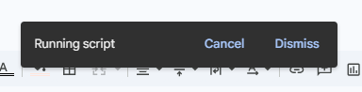
Step 6: Read the Sync Result Summary
When the sync finishes, a result dialog appears showing three numbers: Added (new employees added), Removed (employees deleted), and Updated (identity fields corrected). Click 'OK' to dismiss the dialog.

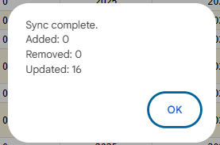
NOTE
If the dialog shows 'Sync failed: Sheet not found: LEAVE_MASTER', the target sheet is missing or has been renamed. Contact the system administrator.

Step 7: Verify the LEAVE_MASTER Sheet
After dismissing the result dialog, scroll through the LEAVE_MASTER sheet to verify the changes. New employees will appear at the bottom of the list with empty leave balance cells. Removed employees will no longer appear. Updated employees will show their corrected name, category, or date of joining — their leave balances will be unchanged.
Step 8: Enter Leave Balances for New Employees
For any newly added employees, the system will automatically credit their leave balances through the monthly EL, CL, and SL earned accrual when the next payroll is locked. The EL BALANCE, CL BALANCE, and SL BALANCE cells will appear blank until that first payroll lock runs for the new employee — no manual entry is required by HR.
Step 9: After Payroll Lock — Verify Updated Leave Balances
You do not need to take any action for this step — it happens automatically. When payroll is locked each month by the Payroll team, the system reads the NEW EL BALANCE, NEW CL BALANCE, and NEW SL BALANCE values from the attendance control panel for every employee and writes them back into the EL BALANCE, CL BALANCE, and SL BALANCE columns in LEAVE_MASTER.

This is how the leave register stays current month to month — approved leave days are deducted, the closing balances are calculated, and those closing balances become the opening balances for the next month, all without any manual entry by HR.

NOTE
After payroll is locked, always open LEAVE_MASTER and verify that the EL BALANCE, CL BALANCE, and SL BALANCE columns have been updated for all employees. The NEW balances from the attendance sheet should now appear as the current balances. If any employee's balance looks unchanged or incorrect, inform the system administrator.

Two additional automatic events happen during payroll lock at specific months of the year:

When | What Happens Automatically | What HR Should Know
December Payroll Lock | CL and SL balances are reset to zero. The closing EL balance is recorded as the carry-forward amount for the new year. | Employees start January with zero CL and SL. Their unused EL at December year-end is carried forward and tracked separately. This is hardcoded system behaviour — it applies to all staff every year without exception.
March Payroll Lock | Any carry-forward EL from the previous year that was not used by March expires and is deducted from the current EL balance. | For example, if an employee had 3 days of carried-forward EL from 2024 and did not use them by March 2025, those 3 days are removed from their EL balance in March 2025. This expiry is also hardcoded and automatic.

4. APPROVED_LEAVE_LEDGER — HR Tracking & Audit Sheet
The APPROVED_LEAVE_LEDGER is a permanent, cumulative history sheet that lives inside the Leave Master spreadsheet. Every time payroll is locked for a month, the system automatically appends one row per employee capturing a complete snapshot of that employee's leave picture for that month. No manual action is required — HR simply opens the sheet to view the data.

Over time, this sheet becomes a full month-on-month leave history for every employee in the company. HR can filter by employee, by month, or by year to answer questions like: How many EL days did BUT-610 use in February 2026? What was the CL balance for the team at the end of Q3? Which employees had carry-forward EL expire in March?

4.1 When Does the Ledger Get Updated?
The ledger is updated automatically as part of the payroll lock process. The system reads the attendance control panel data, checks whether a row for that year and month already exists in the ledger (to prevent duplicate entries), and if not, appends the full set of employee rows. The ledger is never updated manually — all writes come from the payroll lock.

NOTE
If payroll is locked more than once for the same month (e.g. a correction run), the system will detect that the year-month combination already exists and skip the ledger write. This prevents duplicate rows. Only the first lock for any given month writes to the ledger.

4.2 What Each Column Means
Column | What It Contains
ID.NO | Employee ID — used to identify the employee across all HRMS sheets.
NAME | Employee name as it appears in the attendance control panel at the time of lock.
EL EARNED | Earned Leave accrued this month (the monthly EL credit added to the employee's balance this cycle).
CL EARNED | Casual Leave accrued this month.
SL EARNED | Sick Leave accrued this month.
EL BALANCE | Opening EL balance at the start of this month (before deducting approved leave for this month).
CL BALANCE | Opening CL balance for this month.
SL BALANCE | Opening SL balance for this month.
APPROVED EL DAYS | Number of Earned Leave days approved and deducted this month.
APPROVED CL DAYS | Number of Casual Leave days approved and deducted this month.
APPROVED SL DAYS | Number of Sick Leave days approved and deducted this month.
NEW EL BALANCE | Closing EL balance after deducting approved leave. This becomes the opening balance next month.
NEW CL BALANCE | Closing CL balance after deductions.
NEW SL BALANCE | Closing SL balance after deductions.
YEAR | The calendar year this row belongs to (e.g. 2026).
MONTH | The month abbreviation this row belongs to (e.g. MAY, DEC).
EL_CF_USED | How many of the approved EL days this month were consumed from the carry-forward pool (previous year's unused EL). Zero if no carry-forward applies or all days came from current year EL.
EL_CY_USED | How many of the approved EL days this month came from the current year's EL accrual (as opposed to carry-forward).

4.3 Year-End Events Recorded in the Ledger
In addition to the standard monthly snapshot, the ledger rows for December and March carry special significance due to automatic system events that occur during those payroll locks.
Month | What the System Does | What You See in the Ledger
December | CL and SL balances are reset to 0 in LEAVE_MASTER. The closing EL balance is saved as the carry-forward amount for the new year. | The December ledger row shows the final CL and SL figures before reset. The NEW EL BALANCE in December becomes the EL carry-forward for January onwards. This is a fixed system rule — applies every year to all staff.
March | Any carry-forward EL from the previous year that remains unused is expired. That amount is deducted from the employee's current EL balance. | The March ledger row reflects the EL balance after expiry. For example, if an employee carried forward 3 EL days from 2024 and had 2 remaining unused by March 2025, the 2025 March row will show an EL balance reduced by 2. EL_CF_USED in earlier months shows how much carry-forward was consumed before expiry.

4.4 How HR Can Use the Ledger
The APPROVED_LEAVE_LEDGER is designed to be filtered and sorted directly in Google Sheets. Here are the most common ways HR uses it:
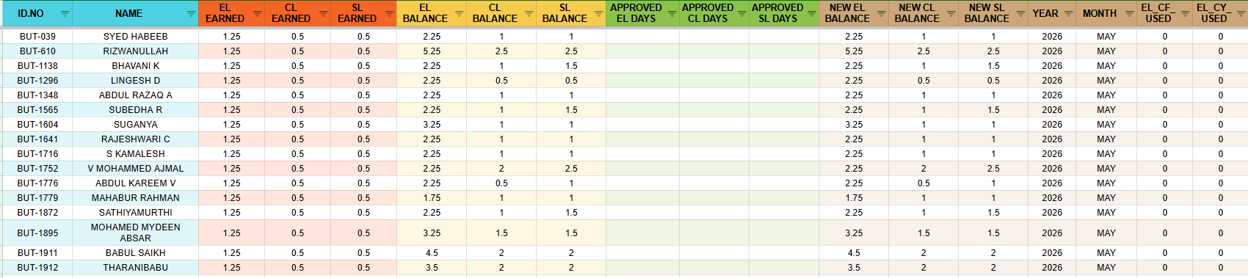
HR Scenario | How to Use the Ledger
Check one employee's full leave history | Filter the ID.NO column to the employee's ID. All rows for that employee across all months and years appear in sequence.
See how much leave the team took in a specific month | Filter the YEAR and MONTH columns to the desired period. All employees' rows for that month are shown together.
Find employees with high EL consumption | Sort the APPROVED EL DAYS column descending to identify employees with the most EL taken in any given month or period.
Audit carry-forward EL usage | Filter by EL_CF_USED > 0 to see all months where an employee consumed carry-forward EL before the March expiry deadline.
Verify December year-end reset happened | Filter MONTH = DEC. Check that NEW CL BALANCE and NEW SL BALANCE are 0 for all employees.
Verify March CF expiry happened | Filter MONTH = MAR and compare EL BALANCE vs NEW EL BALANCE for employees who had carry-forward EL.
Prepare leave summary report for management | Export or copy the filtered ledger data for the required period and pivot by employee or department.

TIP
The APPROVED_LEAVE_LEDGER is read-only for HR — never edit values directly in this sheet. All data is written automatically during payroll lock. Any manual changes will create discrepancies between the ledger and LEAVE_MASTER and cannot be undone automatically.

5. Monthly Workflow Summary
Step | Action
1 | Confirm that Employee Master has been updated with any new joiners, resignations, or category changes for the month.
2 | Open the Leave Master spreadsheet and click Leave Master > Sync ACTIVE STAFF (Add/Remove).
3 | Review the confirmation dialog and click Yes to proceed.
4 | Note the result summary (Added, Removed, Updated numbers) when sync completes.
5 | Scroll through LEAVE_MASTER and identify any new rows with blank leave balance cells.
6 | Enter the appropriate opening EL, CL, and SL balances for each new employee.
7 | Verify that all expected employees are present and no unexpected removals have occurred.
8 | Confirm leave balances for all existing employees are intact before payroll processing begins.
9 | After payroll is locked, re-open LEAVE_MASTER and verify that EL, CL, and SL balances have been updated with the post-deduction closing figures.
10 | Open APPROVED_LEAVE_LEDGER and confirm a new set of rows has been appended for the current month — one row per employee.
11 | For December payroll: confirm CL and SL balances are reset to 0 for all staff and the EL carry-forward amount has been recorded.
12 | For March payroll: confirm that employees who had unused prior-year carry-forward EL have had those days expired from their EL balance.

TIP
If you see an error message during or after sync, refer to Section 6 of this manual for a description of each message and the recommended action.

6. Error Messages — What They Mean & What To Do
Error Message (Example) | Why It Happened | What To Do
Not authorised to run this sync. | You are logged into a Google account that is not pmo@butlerleather.com or hrassist@butlerleather.com. | Switch to an authorised account and try again. Click your Google profile icon in the top right to change accounts.
Sheet not found: LEAVE_MASTER | The LEAVE_MASTER sheet tab in the Leave Master spreadsheet has been renamed or deleted. | Contact the system administrator to restore the sheet with the exact name LEAVE_MASTER.
LEAVE_MASTER missing headers: EL BALANCE, SL BALANCE | One or more required column headers are missing from row 1 of the LEAVE_MASTER sheet. | Contact the system administrator to check and restore the missing headers.
Employee Master headers missing. Required: ID.NO, NAME, CATEGORY, D.O.J, STATUS | The Employee Master spreadsheet is missing required column headers. | Contact the system administrator. The Employee Master structure may have been changed.
Employee Master sheet not found by given GID. | The Employee Master spreadsheet's sheet tab GID has changed (e.g., the tab was deleted and recreated). | Contact the system administrator to update the GID in the script.
Sync failed: Access denied. | The hrassist Web App routing detected an unexpected requestedBy value. Should not occur in normal use. | Contact the system administrator to verify the Web App deployment is current.
Sync failed: Unknown action. | The Web App received an unrecognised action payload. Should not occur in normal use. | Contact the system administrator.

5. Do's and Don'ts

✅ Do's
- Use the sync button after adding a new employee to the Employee Master if you need the Leave Master to update immediately.
- Verify the result summary (Added / Removed / Updated) after each manual sync to confirm the expected changes occurred.
- Enter leave balances for new employees manually after the sync — look for rows with empty EL, CL, and SL balance cells.
- Trust that the background sync runs automatically every few minutes — you do not need to click the button for routine daily updates.
- Check that the Employee Master record is fully saved before triggering a manual sync.

❌ Don'ts
- Do not manually add or delete employee rows in LEAVE_MASTER — the sync manages this automatically and will overwrite manual changes.
- Do not rename the LEAVE_MASTER sheet tab — the script looks for that exact name and will fail if it is changed.
- Do not add or remove column headers in row 1 of LEAVE_MASTER without informing the system administrator — the sync finds columns by name.
- Do not edit the EL BALANCE, CL BALANCE, or SL BALANCE columns of existing employees expecting the sync to preserve them if row 1 headers are changed — the column matching relies on the exact header text.
- Do not run the sync from an unauthorised account — use only pmo@butlerleather.com or hrassist@butlerleather.com.
- Do not enter 'INACTIVE' or non-staff employees manually in LEAVE_MASTER — they will be removed on the next sync.

