PAYROLL CONTROL CENTER
User Manual
For HR Users — Step-by-Step Guide

1. What is the Payroll Control Center?

The Payroll Control Center is the starting point for every payroll cycle. Before any salary calculation can begin, this module must be used to create a dedicated Payroll Workings file for that month. Think of it as a filing register — every month gets its own working folder, and the Control Center keeps a neat record of all of them in one place.
When you use this module, it automatically copies a pre-built payroll template from Google Drive, names it correctly for the month and year you select, and registers it in the control sheet. Once the file is created, the payroll team can open it and start the payroll generation process for that month.
The module also has built-in safeguards to make sure months are processed in the correct order, there are no duplicates, and the corresponding attendance file is already in place before payroll workings can be started. This keeps your payroll records clean, sequential, and audit-ready.

1.1 Who Uses This Module?
User | What They Do
PMO / Payroll Owner (pmo@butlerleather.com) | The only person authorised to trigger payroll workings generation. Uses the menu from within the Payroll Control Center spreadsheet.
HR Administrator | Sets up the MONTH and YEAR in the control sheet before triggering generation. Also ensures attendance files are uploaded.
Payroll Team | Opens the generated Payroll Workings file after it is created and proceeds with payroll processing inside that file.

1.2 What Happens When You Use It?
- A new Payroll Workings spreadsheet is created in Google Drive, named Payroll-Workings_Month_Year (e.g. Payroll-Workings_January_2025).
- The file is placed inside the Monthly Payroll Workings folder in Google Drive automatically.
- The control sheet records the file name, file ID, creation time, and who created it.
- The new file is set to OPEN status, indicating payroll processing can now begin.
- The control sheet rows are protected so that completed records cannot be accidentally edited.

2. Before You Start

Checklist Item | Why It Matters
You are using an authorised account (pmo or hrassist). | Only these accounts are authorised to generate payroll workings. Other accounts route through the Web App but the system still verifies identity.
The PAYROLL_CONTROL sheet has the correct column headers in row 1 | The module reads columns by their header names. Missing or renamed headers will cause an error.
You have entered the correct MONTH in the pending row | The month dropdown in the MONTH column must be filled before clicking Generate Payroll Workings.
You have entered the correct 4-digit YEAR in the pending row | The year must be a 4-digit number (e.g. 2025). Any other format will be rejected.
The attendance file for this month already exists in the Monthly Attendance folder | The module checks for Attendance_Month_Year (e.g. Attendance_January_2025) in the attendance folder. Generation is blocked if this file is missing.
The previous month's row is LOCKED in the control sheet (if applicable) | Months must be completed and locked in sequence. You cannot generate a new month if the previous month is still in progress.
No data exists in rows below the current pending row | The module checks for data below the pending row. Any stray data will block generation until cleared.
The CONFIG sheet has all required folder IDs and the template file ID | The module reads all configuration from the CONFIG sheet. Missing values will cause failures.

NOTE:
Process one month at a time. You cannot skip months or generate out of sequence.
Always ensure the previous month is fully LOCKED before starting the next month.
The system enforces strict calendar order — February must follow January, March must follow February, and so on.

As more modules are added to the HRMS, additional pre-checks will be listed here.

3. Step-by-Step Guide

Step 1: Open the Payroll Control Center Spreadsheet
Navigate to Google Drive and open the Payroll Control Center spreadsheet. You can bookmark it or find it in the shared HRMS folder. Wait for the spreadsheet to load fully.

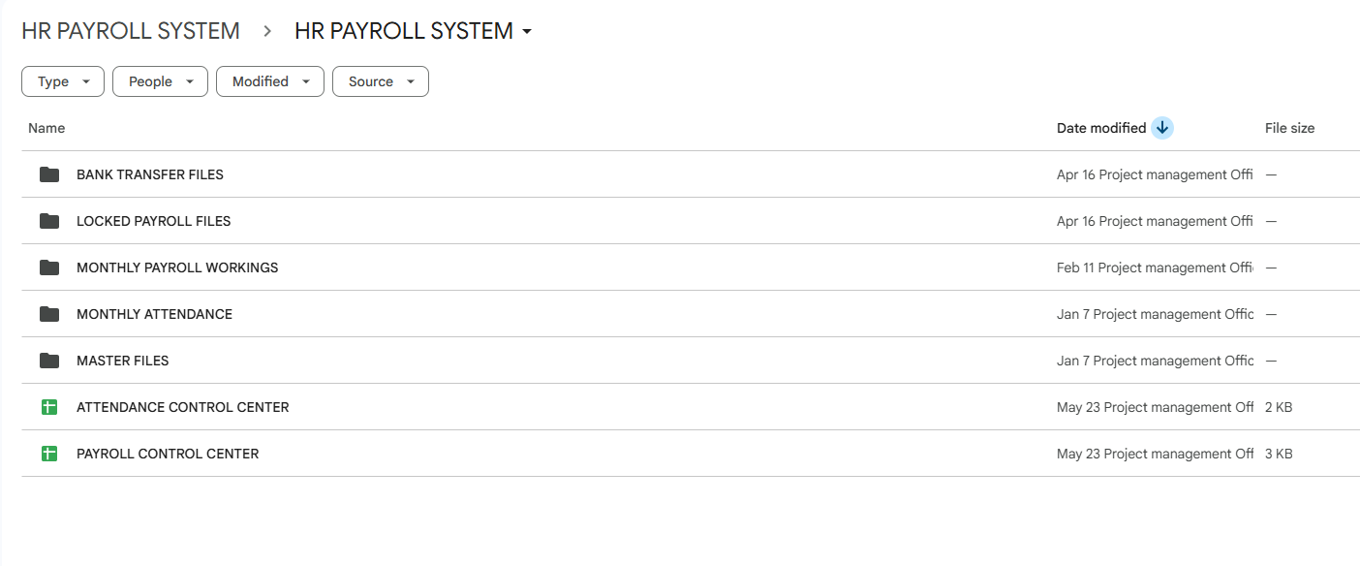

Step 2: Enter the Month in the Pending Row
Look at the PAYROLL_CONTROL sheet. Find the first row below the headers that does not have LOCKED in the LOCK_STATUS column — this is your pending row. Click on the MONTH cell in that row and select the correct month from the dropdown list (e.g. January, February, etc.).

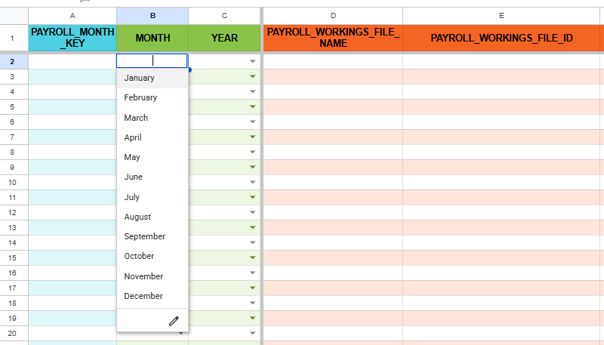

NOTE:
Only use the dropdown to select the month. Do not type the month name manually — it must match exactly.

Step 3: Enter the Year in the Pending Row
Click on the YEAR cell in the same pending row and type the 4-digit calendar year (e.g. 2025). Do not use a 2-digit year or any other format.

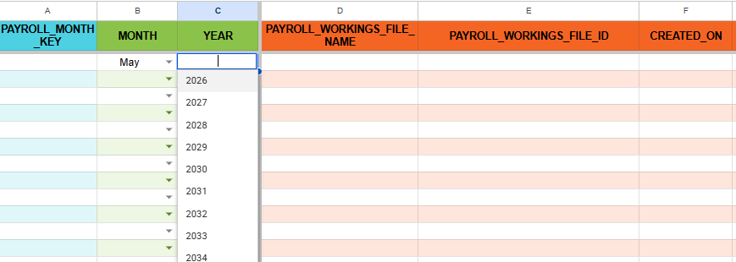
Step 4: Confirm the Attendance File is Uploaded
Before triggering generation, make sure the attendance file for this month is already present in the Monthly Attendance folder in Google Drive. The file must be named exactly Attendance_Month_Year (e.g. Attendance_January_2025). If this file is missing, the system will block generation and show an error.
Step 5: Click "Generate Payroll Workings" from the Menu
In the top menu bar, click on "Payroll Control". A dropdown will appear with a single option: "Generate Payroll Workings". Click it to start the process.
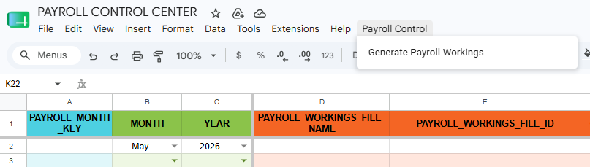

NOTE:
If you do not see the "Payroll Control" menu, refresh the spreadsheet. The menu loads when the spreadsheet opens.
If you are not logged in as the authorised owner account, the request will still go through via the Web App — but you must be logged in to the correct Google account.

Step 6: Wait for the Process to Complete
After clicking the menu item, the system will run a series of checks and then create the payroll workings file. This may take 10–30 seconds depending on Google Drive speed. Do not click the menu again while it is running.

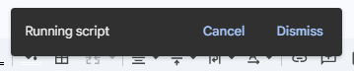

Step 7: Read the Result Alert
A pop-up dialog box will appear with the result. If the file was created successfully, the message will say "Payroll workings file created successfully" along with the file name and the row number in the control sheet. Click OK to close the dialog.
If there is an error, the message will explain exactly what went wrong. Read it carefully — see Section 5 for a complete list of error messages and how to fix them.

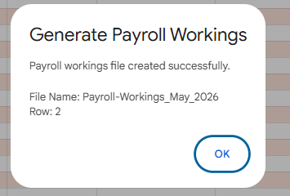

Step 8: Verify the Control Sheet Row is Populated
After clicking OK, look at the PAYROLL_CONTROL sheet. The pending row should now be filled in with the PAYROLL_MONTH_KEY, PAYROLL_WORKINGS_FILE_NAME, a hyperlink in PAYROLL_WORKINGS_FILE_ID, CREATED_ON timestamp, and CREATED_BY email. The LOCK_STATUS will show OPEN.

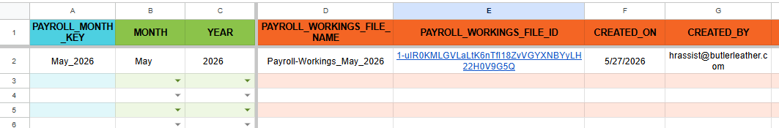

Step 9: Open the Payroll Workings File
Click on the hyperlink in the PAYROLL_WORKINGS_FILE_ID column of the populated row to open the new payroll workings file. This file is a copy of the payroll template, stamped with the correct month and year. Hand this file over to the payroll team to begin payroll processing.
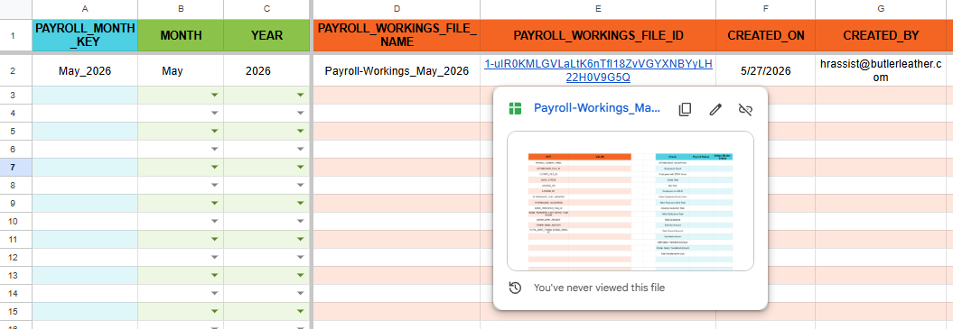

NOTE:
The LOCK_STATUS in the new file will show OPEN. It will be changed to LOCKED by the payroll team after payroll generation and approval is completed.
Do not manually edit any columns in the PAYROLL_CONTROL sheet after the row has been populated — the rows are protected and changes will be rejected.

4. Monthly Workflow Summary

Step | Action
1 | Ensure the previous month's payroll workings is LOCKED in the control sheet.
2 | Confirm the attendance file (Attendance_Month_Year) is uploaded to the Monthly Attendance folder in Google Drive.
3 | Open the Payroll Control Center spreadsheet.
4 | In the PAYROLL_CONTROL sheet, find the first unlocked (pending) row.
5 | Select the correct month from the MONTH dropdown in the pending row.
6 | Enter the 4-digit year in the YEAR column of the same row.
7 | Click Payroll Control > Generate Payroll Workings from the top menu.
8 | Wait for the alert dialog. Read the result message.
9 | If successful, verify the row is populated in the control sheet.
10 | Click the hyperlink in PAYROLL_WORKINGS_FILE_ID to open the new payroll workings file.
11 | Hand the file to the payroll team to begin payroll generation.
12 | After payroll is finalised and approved, the payroll team locks the file — LOCK_STATUS changes to LOCKED.

TIP: If you encounter any error message you do not understand, refer to Section 5 of this manual for a full explanation and the steps to fix it.
When in doubt — stop and contact your IT admin rather than retrying without addressing the root cause.

5. Error Messages — What They Mean & What To Do

Error Message (Example) | Why It Happened | What To Do
Another payroll workings generation is already running. Please wait a moment and try again. | Someone else triggered the process at the same time. The system allows only one run at a time. | Wait 30 seconds and try again.
Month is blank in row 3. Please select Month in that row first. | The MONTH cell in the pending row was empty when you triggered generation. | Go to the MONTH column in row 3, select a month from the dropdown, then retry.
Year is blank in row 3. Please select Year in that row first. | The YEAR cell in the pending row was empty. | Type the 4-digit year (e.g. 2025) in the YEAR column of row 3, then retry.
Year in row 3 must be a 4-digit value. | The year entered is not a valid 4-digit number (e.g. "25" or "2025-01"). | Correct the year to a 4-digit format (e.g. 2025) and retry.
Attendance file "Attendance_January_2025" not found in the Monthly Attendance folder. | The attendance file for this month was not uploaded yet or is named incorrectly. | Upload the attendance file with the exact name Attendance_January_2025 to the Monthly Attendance folder, then retry.
Unable to access the Monthly Attendance folder. Please verify the folder ID in CONFIG. | The folder ID stored in CONFIG is wrong, or the script does not have access to the folder. | Ask your IT admin to check MONTHLY_ATTENDANCE_FOLDER_ID in the CONFIG sheet.
Row 3 must be completed and LOCK_STATUS must be LOCKED before using lower rows. Data is already present in row 4. | Data was entered in a row below the current pending row before row 3 was completed. | Clear all data from row 4 and below. Complete row 3 first, then proceed to the next row.

Month continuity check failed. Expected: February_2025 Found: March_2025 Payroll months must be entered in strict sequential order. | The month in the pending row does not follow the last locked month in calendar sequence. | Change the MONTH in the pending row to February (the expected next month) and retry.
Row 3 already has a payroll workings reference but LOCK_STATUS is not LOCKED. | A payroll file was already created for this row but the lock process was not completed. | Complete the payroll for this month and lock it using the Payroll Generator module. Do not try to generate again.
Payroll workings already exists for month "January_2025" in row 3. Duplicate creation is blocked. | You are trying to create a workings file for a month that already has one. | Do not regenerate. Open the existing file using the hyperlink in the FILE_ID column.
This payroll month "January_2025" is already LOCKED in row 3. New workings creation is blocked. | January 2025 has already been processed and locked. No further action is needed for this month. | No action needed. Move to the next month if required.
A workings file named "Payroll-Workings_January_2025" already exists in the Monthly Payroll Workings folder. Duplicate creation is blocked. | A file with this name already exists in Drive, possibly orphaned from an earlier incomplete run. | Ask IT to check the Monthly Payroll Workings folder in Drive. Rename or remove the orphan file if it is not registered in the control sheet, then retry.
This script must run from "Payroll Control Center 2025" only. Current file: "Copy of PCC" | The script is running from a copied or wrongly named spreadsheet. | Always open and use the official Payroll Control Center spreadsheet — not a copy.
Web App URL is not configured. Please deploy the Web App and paste the URL in PCC_WEBAPP_URL. | The Web App has not been deployed yet or the URL has not been pasted into the script. | Ask IT or the developer to deploy the Web App and update the script.
Missing CONFIG value: TEMPLATE_PAYROLL_GENERATOR_FILE_ID | A required configuration value is missing from the CONFIG sheet. | Ask IT to add the missing key and value to the CONFIG sheet.

6. Do's and Don'ts

Do's
- Always enter the MONTH and YEAR in the pending row before clicking Generate Payroll Workings.
- Always upload the attendance file for the month to the Monthly Attendance folder before triggering payroll generation.
- Process months strictly in calendar order — January, February, March, and so on.
- Always ensure the previous month is LOCKED before starting a new month.
- Use the official Payroll Control Center spreadsheet — bookmark it and always open the same file.
- Read the alert message carefully after clicking Generate Payroll Workings — it tells you exactly what happened.
- Contact IT if you see a CONFIG-related error — these require admin-level fixes.

Don'ts
- Don't manually type in the MONTH column — always use the dropdown to avoid spelling mismatches.
- Don't skip a month or enter months out of order — the system will block it and show a continuity error.
- Don't click Generate Payroll Workings more than once while it is running — wait for the alert dialog to appear first.
- Don't edit cells in the PAYROLL_CONTROL sheet after a row has been populated — rows are protected.
- Don't work from a copy of the Payroll Control Center spreadsheet — always use the original.
- Don't try to create a new workings file for a month that is already LOCKED — it is not necessary and will be blocked.
- Don't delete or rename files in the Monthly Payroll Workings folder without informing IT.

