PAYROLL GENERATOR
(Payroll Workings File)
Admin User Manual
For: nazneen@butlerleather.com | Steps 1–5

1. What is the Payroll Generator?

The Payroll Generator is the monthly payroll workings file for your organisation. Each month, a fresh copy of this file is created automatically by the Payroll Control Center, named for the specific month and year (e.g. Payroll-Workings_January_2025). All salary calculations for that month happen inside this file.
As an Admin user, your role begins after the HR user has completed their steps (Validate Attendance, Get Payroll Data, and PAY_ROLL review). HR will inform you when the PAY_ROLL sheet is ready. Your responsibility covers the final stages: validating payroll figures, locking the payroll, and generating the bank transfer file.

1.1 Admin User Responsibilities
Step | Action | Menu
1 | Open the Payroll Workings File from Payroll Control Center | —
2 | Validate Payroll | Payroll-Admin
3 | Generate Locked Payroll | Payroll-Admin
4 | Generate Bank Transfer File | Payroll-Admin
5 | Verify META_DATA & Payroll Control Center | —

NOTE:
Steps 1–4 of the overall payroll process (Open File, Validate Attendance, Get Payroll Data, Review PAY_ROLL) are handled by the HR user (hrassist@butlerleather.com).
Do not begin until HR has confirmed the PAY_ROLL sheet is ready.
Do not attempt to run Payroll-HR menu actions — those are for HR only.

2. Before You Start

Checklist Item | Why It Matters
HR has completed Steps 1–4: Validate Attendance, Get Payroll Data, and PAY_ROLL review. | Do not proceed without HR confirmation. PAY_ROLL must be fully loaded before you can validate.
PAY_ROLL sheet is populated with all employee rows. | Validate Payroll reads directly from PAY_ROLL.
Employees with ZERO Gross = 0 in META_DATA Check column. | Generate Locked Payroll will block if any employee has zero gross.
Advance Deduction Total in META_DATA Check matches Planned EMI total in attendance file. | Generate Locked Payroll checks this. A mismatch stops the lock process.
META_DATA → ATTENDANCE_VALIDATION contains VALIDATED. | All Admin actions require Validate Attendance to have passed first.
META_DATA → LOCK_STATUS = OPEN. | If LOCKED, this month is already finalised — no further action needed.
Payroll Release Confirmation set to PROCEED or HOLD for all employees in PAY_ROLL. | Only PROCEED employees are included in the bank transfer.

NOTE:
Admin steps must run in order: Validate Payroll → Generate Locked Payroll → Generate Bank Transfer File.
Generate Locked Payroll is irreversible — a permanent locked copy is created. Do not run it more than once.

As more modules are added to the HRMS, additional pre-checks will be listed here.

3. Step-by-Step Guide

Step 1: Open the Payroll Workings File
Do not search for the file manually in Drive. Always open it from the Payroll Control Center.
Open the Payroll Control Center spreadsheet from Google Drive or your saved bookmark. Go to the PAYROLL_CONTROL sheet and find the row for the current month (e.g. January_2025). Click the link in the PAYROLL_WORKINGS_FILE_ID column — this opens the correct Payroll-Workings_January_2025 file directly.

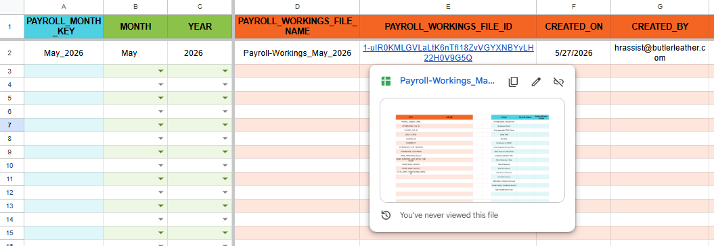

Once the file opens, confirm the file name in the browser tab matches the current month. Then open the META_DATA sheet and confirm LOCK_STATUS = OPEN — if it shows LOCKED, this month is already finalised and no further action is needed.
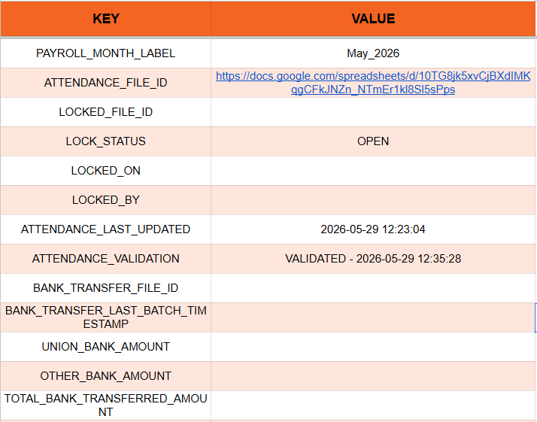
NOTE:
Always open the file from the Payroll Control Center link — never from a bookmark that may point to a previous month.
If PAYROLL_WORKINGS_FILE_ID is blank, the file has not been generated yet. Contact the PMO.

Prechecks
META_DATA → ATTENDANCE_VALIDATION | Must contain VALIDATED
META_DATA → PAYROLL_MONTH_LABEL | Must be a valid Month_Year value (e.g. January_2025)
META_DATA Check → Employees with ZERO Gross | Must equal 0
PAY_ROLL sheet | Must exist with at least one employee row and required columns
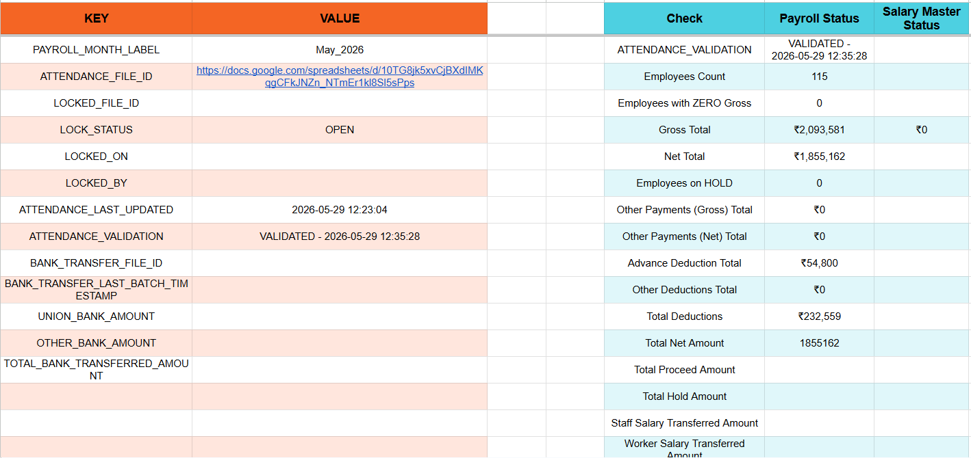

Step 2: Validate Payroll [Payroll-Admin menu]
Click Payroll-Admin → Validate Payroll. This cross-checks the salary components in PAY_ROLL against the Salary Revision History and fills the FIXED_SALARY_CHECK tab.

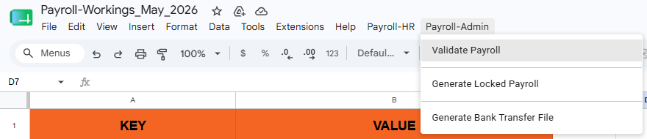

Step 2a: Authorization (First time only)
If this is the first time you are running any script action in this file, Google will immediately show an "Authorization required" popup saying "A script attached to this document needs your permission to run." Click OK.
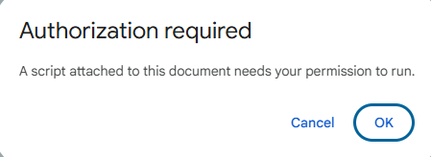
Step 2b: Confirm Permissions
A new window opens showing the permissions the script needs. Scroll down and click Continue to grant the permissions. This completes the one-time authorization. You will not see this screen again for this file.
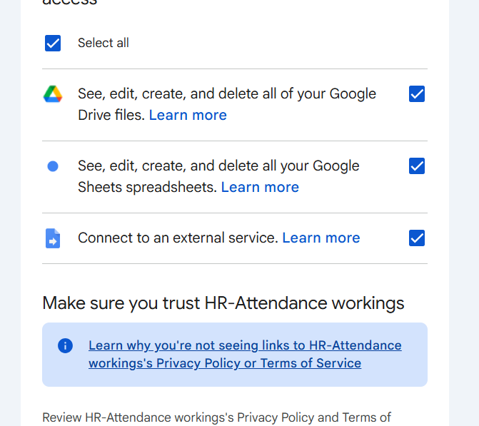

Step 2c: Wait for Completion
The script runs in the background — this may take 15–30 seconds. Once complete, a confirmation popup appears. Click OK.

After completion
FIXED_SALARY_CHECK tab | Fully protected — only pmo@butlerleather.com can edit
Success alert | Shows employee count and number of employees with no approved revision
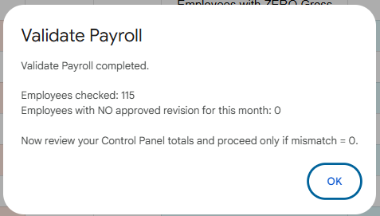

Written into FIXED_SALARY_CHECK
From PAY_ROLL | S.No, Employee Code, Name, Gender, Category, Date Of Joining, Department, Designation
From Salary Revision History | Basic, DA, HRA, Conveyance Allowance, Special Allowance (latest APPROVED revision on or before payroll month start)
If no approved revision exists | Salary component columns written as 0
Formula columns (e.g. Basic+DA) | Not touched — only script-managed columns are written

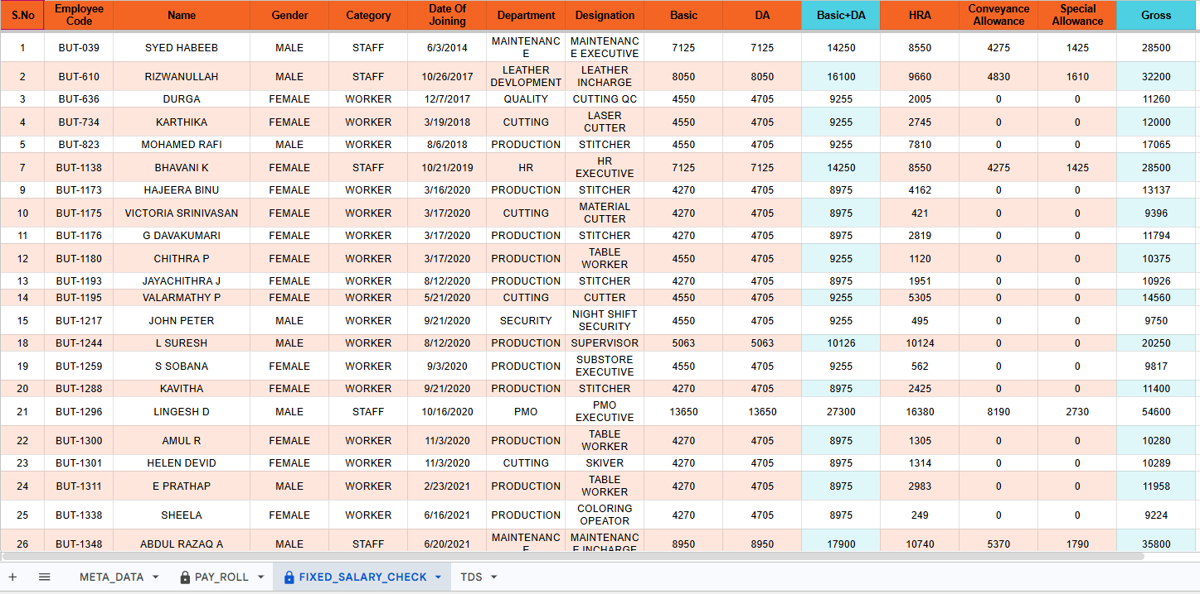

NOTE:
Compare Basic, DA, HRA in FIXED_SALARY_CHECK against PAY_ROLL. Any mismatch means the salary components differ from Revision History — contact HR to investigate.
If Employees with ZERO Gross is not 0, do not proceed. Inform HR to fix those employees in PAY_ROLL first.

META_DATA Tab:
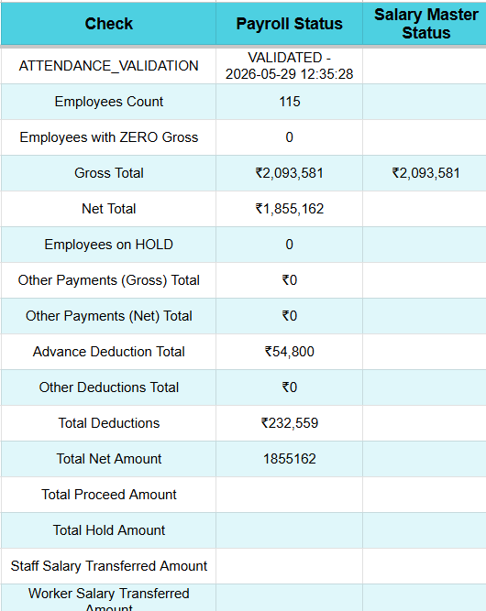

Step 3: Generate Locked Payroll [Payroll-Admin menu]
Click Payroll-Admin → Generate Locked Payroll. This is irreversible — a permanent locked copy is created. The system acquires a lock to prevent duplicate runs. Wait 1–2 minutes for completion.

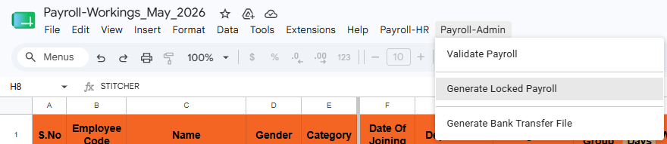

Prechecks (nothing is created if any of these fail)
META_DATA → LOCK_STATUS | Must NOT be LOCKED
META_DATA → ATTENDANCE_VALIDATION | Must contain VALIDATED
META_DATA → PAYROLL_MONTH_LABEL | Must match this file name month
META_DATA → ATTENDANCE_FILE_ID | Must exist and be a valid spreadsheet link
META_DATA → LOCKED_FILE_ID | Must be empty — if already filled, duplicate lock is blocked
PAY_ROLL tab | Must exist with data and required columns
Attendance entry → LOCKED STATUS | Must contain LOCKED
Salary Advance deductions → Payroll Status | Must NOT be LOCKED in any row
Advance Deduction Total (META_DATA Check) | Must match sum of Planned EMI in Salary Advance deductions tab (tolerance 0.0001)
Gross Total (META_DATA Check) | Payroll Status value must match Salary Master Status value (tolerance 0.0001)
Locked Payroll Files folder in Drive | Must NOT already contain a file named Payroll-Locked_January_2025

What happens when all checks pass
Locked file created | Copy saved to Locked Payroll Files folder as Payroll-Locked_January_2025 — all formulas converted to static values, file made fully read-only
Salary Advance deductions tab | Every row's Payroll Status set to LOCKED with a locked-on timestamp
Recovered Amount Ledger | Snapshot of this month's recovered deductions posted to Salary Advance Master
Leave Master | Approved leave days posted to Leave Ledger · Leave balances (EL, CL, SL) updated for each employee
Attendance file | Entire file protected — all tabs locked with no editors
This Payroll Workings file | All tabs protected — except PAY_ROLL which keeps Payroll Release Confirmation and Bank Transfer Mark Down columns editable

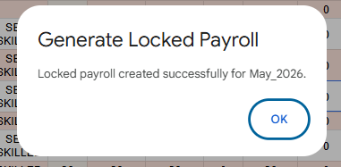

Written to META_DATA of this file
META_DATA Key | Value Written
LOCK_STATUS | LOCKED
LOCKED_FILE_ID | Clickable URL link to Payroll-Locked_January_2025
LOCKED_ON | Timestamp e.g. 2025-01-31 18:45:00
LOCKED_BY | Email of the user who triggered this action

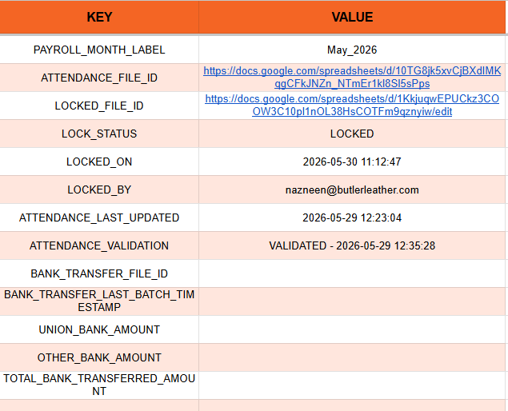

Written to Payroll Control Center (row for January_2025)
PCC Column | Value Written
LOCKED_ATTENDANCE_FILE_ID | URL link to the attendance file
LOCKED_PAYROLL_FILE_NAME | Payroll-Locked_January_2025
LOCKED_PAYROLL_FILE_ID | URL link to the locked payroll file
LOCK_STATUS | LOCKED
LOCKED_ON | Timestamp
LOCKED_BY | Triggering user's email — all 6 cells immediately protected after writing
NOTE:
Irreversible — once LOCK_STATUS = LOCKED, no further locking is possible for this month.
If a financial mismatch error appears (Advance Deduction or Gross Total), contact the PMO before retrying.
If the lock fails midway, the system automatically deletes the partially created locked file.

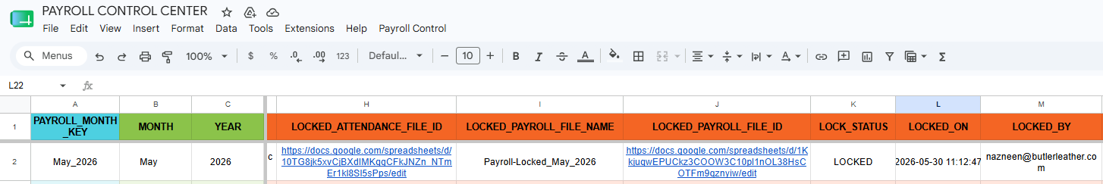

Step 4: Generate Bank Transfer File [Payroll-Admin menu]
Click Payroll-Admin → Generate Bank Transfer File. Can be run multiple times — new batch rows are appended each time. Wait 40–60 seconds for completion.

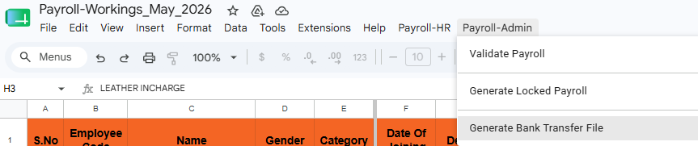

Prechecks
META_DATA → LOCK_STATUS | Must be exactly LOCKED
META_DATA → PAYROLL_MONTH_LABEL | Must exist and not be blank
PAY_ROLL tab | Must have data and required columns: Employee Code, Name, Bank Account No, IFSC Code, NET, Payroll Release Confirmation, Bank Transfer Mark Down

How employees are processed
Payroll Release Confirmation = PROCEED | Included in transfer
Payroll Release Confirmation = HOLD | Skipped entirely — not in the bank file
IFSC starts with UBIN | Routed to UNION_BANK sheet
All other IFSC codes | Routed to OTHER_BANKS sheet
NET = 0 | Written as SKIPPED - NET 0 — not transferred
NET is negative | Written as SKIPPED - NEGATIVE — not transferred
Valid transfer (positive NET, PROCEED) | Written with: Transfer_Batch_Timestamp, Employee Code, Name, Bank Account No, IFSC Code, NET Amount · Bank Transfer Mark Down cell in PAY_ROLL stamped with batch timestamp

Bank transfer file
First run | New spreadsheet BankTransfer_January_2025 created in Bank Transfer Files folder in Drive
Subsequent runs | Existing file reused — new batch rows appended
File access | nazneen@butlerleather.com added as editor · hrassist@butlerleather.com added as viewer · sheets protected after writing

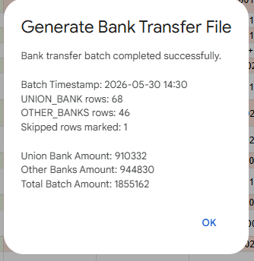

Written to META_DATA of this file
META_DATA Key | Value Written
BANK_TRANSFER_FILE_ID | URL link to BankTransfer_January_2025
BANK_TRANSFER_LAST_BATCH_TIMESTAMP | Timestamp of this batch run
UNION_BANK_AMOUNT | Total NET amount transferred to Union Bank employees
OTHER_BANK_AMOUNT | Total NET amount transferred to other bank employees
TOTAL_BANK_TRANSFERRED_AMOUNT | Combined total (Union + Other)
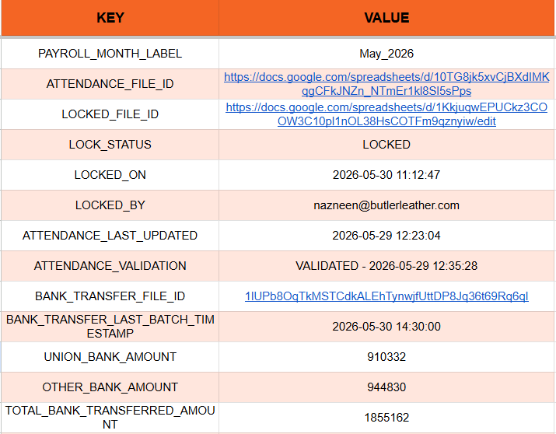
Written to Payroll Control Center (row for January_2025)
PCC Column | Value Written
BANK_TRANSFER_FILE_NAME | BankTransfer_January_2025
BANK_TRANSFER_FILE_ID | URL link to the bank transfer file — both cells immediately protected after writing

Step 5: Verify META_DATA & Payroll Control Center
Critical Reconciliation Check — Bank Transfer Amounts
The TOTAL_BANK_TRANSFERRED_AMOUNT in META_DATA must equal the Total Transferred Amount in the PAY_ROLL tab summary section. Confirm that the Status column shows MATCHED.

In META_DATA tab — Bank Transfer Keys
META_DATA Key | Value
UNION_BANK_AMOUNT | 9,10,332
OTHER_BANK_AMOUNT | 9,44,830
TOTAL_BANK_TRANSFERRED_AMOUNT | 18,55,162 ← must equal Total Transferred Amount in PAY_ROLL

In PAY_ROLL tab — Summary Section
Field | Amount | Status
Staff Salary Transferred Amount | 6,80,187 | —
Worker Salary Transferred Amount | 11,74,975 | —
Total Transferred Amount | 18,55,162 | MATCHED

⚠ IMPORTANT
The Total Transferred Amount in PAY_ROLL summary must show MATCHED.
If the status shows anything other than MATCHED — stop immediately and contact the PMO before taking any further action.
Do not share the bank transfer file or proceed with salary payments until MATCHED is confirmed.

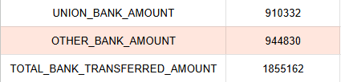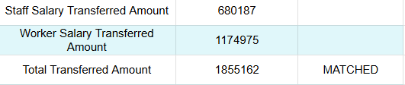

4. Monthly Workflow Summary (Admin)

Step | Action
1 | Wait for HR confirmation that PAY_ROLL sheet is ready and reviewed.
2 | Open the Payroll Workings file by clicking the PAYROLL_WORKINGS_FILE_ID link in Payroll Control Center.
3 | Confirm META_DATA → LOCK_STATUS = OPEN.
4 | Confirm META_DATA → ATTENDANCE_VALIDATION contains VALIDATED.
5 | Confirm Employees with ZERO Gross = 0 in META_DATA Check column.
6 | Confirm Advance Deduction Total in META_DATA Check matches Planned EMI total in attendance file.
7 | Click Payroll-Admin → Validate Payroll. Complete authorization if prompted (first time only).
8 | Review FIXED_SALARY_CHECK tab for any salary mismatches with Revision History.
9 | Click Payroll-Admin → Generate Locked Payroll. Wait 15–30 seconds.
10 | Verify META_DATA: LOCK_STATUS = LOCKED, LOCKED_FILE_ID, LOCKED_ON, LOCKED_BY all filled.
11 | Verify PCC row for January_2025: LOCK_STATUS = LOCKED and all 6 lock fields filled.
12 | Click Payroll-Admin → Generate Bank Transfer File. Wait 15–30 seconds.
13 | Verify META_DATA: BANK_TRANSFER_FILE_ID, UNION_BANK_AMOUNT, TOTAL_BANK_TRANSFERRED_AMOUNT filled.
14 | Verify PCC row: BANK_TRANSFER_FILE_NAME and BANK_TRANSFER_FILE_ID filled.

TIP: If you encounter any error, refer to Section 5 for a full explanation and fix.
For financial mismatch errors, always contact the PMO before retrying — do not attempt to fix these yourself.

5. Error Messages — What They Mean & What To Do

The following errors may appear during Steps 2, 3, and 4.

Error Message (Example) | Why It Happened | What To Do
Skipped: Payroll is LOCKED. | Payroll for this month is already locked. | No action needed — month is finalised.
Attendance is NOT validated. Please run "Validate Attendance" first. | ATTENDANCE_VALIDATION missing or incomplete in META_DATA. | Ask HR to run Validate Attendance first.
Validation failed: 2 employee(s) have ZERO Gross salary. | One or more employees have zero gross in PAY_ROLL. | Ask HR to fix zero-gross employees in PAY_ROLL first.
Month mismatch. Re-run "Validate Attendance". (Expected January_2025) | PAYROLL_MONTH_LABEL does not match the file name. | Ask HR to re-run Validate Attendance.
Skipped: Payroll is already LOCKED. | Generate Locked Payroll found LOCK_STATUS = LOCKED. | No action — this month is already finalised.
LOCKED_FILE_ID already exists in META_DATA. Duplicate lock blocked. | A locked file was already created. | Check the existing locked file via the LOCKED_FILE_ID link in META_DATA.
Attendance entry is not locked. Lock attendance first, then generate locked payroll. | Attendance not locked — HR needs to lock attendance first. | Ask HR to lock attendance in the ATTN module.
Salary Advance deductions already has Payroll Status = LOCKED. Duplicate payroll lock blocked. | SA deductions were already locked — payroll was already processed. | No action needed — check existing locked file.
Advance Deduction Total mismatch. META_DATA = 5000, Salary Advance deductions Planned EMI total = 4800. Lock process stopped. | Advance deduction figures do not reconcile. | Contact PMO to reconcile before retrying.
Gross Total mismatch. META_DATA Payroll Status = 1250000, Salary Master Status = 1248000. Lock process stopped. | Gross total does not match Salary Master control figure. | Contact PMO to investigate before retrying.
Locked payroll file already exists: Payroll-Locked_January_2025 | File already exists in the Locked Payroll Files Drive folder. | Ask IT to check and remove the orphan file, then retry.
Payroll Control Center row not found for January_2025. | PCC has no matching row for this month. | Contact IT — the PCC row may be missing.
Payroll is not LOCKED. Bank Transfer File can be generated only after LOCK_STATUS = LOCKED in META_DATA. | Generate Bank Transfer File ran before locking. | Run Generate Locked Payroll (Step 3) first.
Another bank transfer generation is already running. Please wait and try again. | Two users triggered Generate Bank Transfer File at the same time. | Wait 30 seconds and retry.
You are not authorized to run this function. | You are not in the authorised user list for this action. | Only pmo and nazneen can use the Payroll-Admin menu.

6. Do's and Don'ts

Do's
- Wait for HR confirmation before starting — PAY_ROLL must be fully loaded and reviewed.
- Always open the Payroll Workings file from the Payroll Control Center link — not from a direct bookmark.
- Run Admin steps in order: Validate Payroll → Generate Locked Payroll → Generate Bank Transfer File.
- Before Generate Locked Payroll, confirm Employees with ZERO Gross = 0 and Advance Deduction Total is reconciled.
- After Generate Locked Payroll, verify META_DATA: LOCK_STATUS = LOCKED and LOCKED_FILE_ID filled.
- After Generate Bank Transfer File, verify META_DATA: BANK_TRANSFER_FILE_ID and amounts filled.
- Verify the Payroll Control Center row after both Generate Locked Payroll and Generate Bank Transfer File.
- Contact the PMO for any financial mismatch error before retrying.
- Complete the one-time Google authorization if prompted on first use.

Don'ts
- Don't run Generate Locked Payroll more than once — it creates a permanent locked copy and cannot be undone.
- Don't run any Payroll-HR menu actions — those are for the HR user only.
- Don't start Admin steps without HR confirmation that PAY_ROLL is ready.
- Don't rename or move the Payroll Workings file — the month is parsed from the file name.
- Don't manually edit META_DATA — it is written exclusively by the scripts.
- Don't attempt to fix financial mismatch errors yourself — always contact the PMO.
- Don't run actions from an unauthorised account — only pmo and nazneen can use the Payroll-Admin menu.

