PAYROLL GENERATOR
(Payroll Workings File)
HR User Manual
User Manual — For HR Users — Step-by-Step Guide

1. What is the Payroll Generator?

The Payroll Generator is the monthly payroll workings file for your organisation. Each month, a fresh copy of this file is created automatically by the Payroll Control Center, named for the specific month and year (e.g. Payroll-Workings_January_2025). All salary calculations for that month happen inside this file — from the moment attendance is validated to the final bank transfer.
The module has two sets of menus for two different roles. HR users (Payroll-HR menu) handle attendance validation and payroll data loading. Admin users (Payroll-Admin menu) handle payroll validation, locking, and bank transfer. Each step must happen in order — the system will block you if you try to skip ahead.

1.1 Who Uses This Module?
User | Menu | What They Do
PMO / Payroll Owner (pmo@butlerleather.com) | Both menus (direct) | Full access to all actions.
HR Assistant (hrassist@butlerleather.com) | Payroll-HR only | Validates attendance and loads payroll data.
Finance Admin (nazneen@butlerleather.com) | Payroll-Admin only | Validates payroll, locks, and generates bank transfer.

1.2 The 6 Steps at a Glance
Step | Action | Who | Result
1 | Open Payroll Workings File | HR | Correct file opened from Payroll Control Center.
2 | Validate Attendance | HR | Attendance file verified. META_DATA stamped.
3 | Get Payroll Data | HR | PAY_ROLL sheet filled. Tab protected.
4 | Review PAY_ROLL Sheet & hand over to Admin | HR | —

2. Before You Start

Checklist Item | Why It Matters
Payroll Workings file created by the Payroll Control Center for the correct month. | Never create this file manually.
Attendance file (Attendance_January_2025) is in the Monthly Attendance folder in Drive. | Validate Attendance searches by exact file name.
Attendance is locked in the ATTN module (LOCKED STATUS present in Attendance entry). | Both Step 2 and Step 3 check for this. Unlocked attendance blocks both.
Salary Advance EMI loaded into the Salary Advance deductions tab (SA Run Timestamp in row 2 not blank). | Step 2 checks this. Missing timestamp blocks validation.
All salary revision approvals finalised in Salary Revision History. | Step 3 reads only APPROVED revisions. Pending ones are ignored.
META_DATA → LOCK_STATUS = OPEN before starting. | All actions stop immediately if already LOCKED.

NOTE:
Steps must run in order: Validate Attendance → Get Payroll Data → Validate Payroll → Generate Locked Payroll → Generate Bank Transfer File.
Do not run Generate Locked Payroll more than once — it creates a permanent locked copy.

As more modules are added to the HRMS, additional pre-checks will be listed here.

3. Step-by-Step Guide

Step 1: Open the Payroll Workings File
Do not search for the file manually in Drive. Always open it from the Payroll Control Center.
Open the Payroll Control Center spreadsheet from Google Drive or your saved bookmark. Go to the PAYROLL_CONTROL sheet and find the row for the current month (e.g. January_2025). Click the link in the PAYROLL_WORKINGS_FILE_ID column — this opens the correct Payroll-Workings_January_2025 file directly.

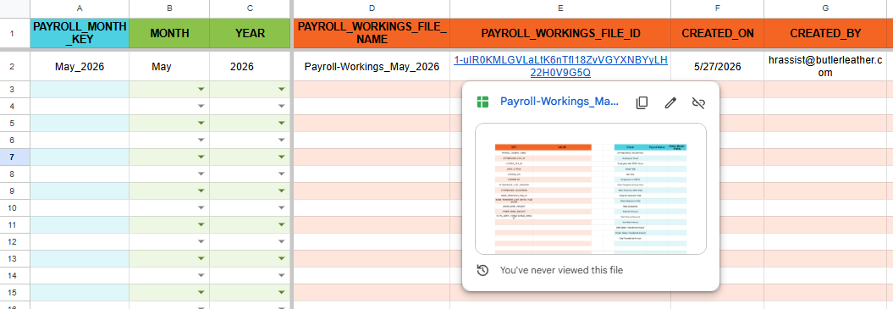

Once the file opens, confirm the file name in the browser tab matches the current month. Then open the META_DATA sheet and confirm LOCK_STATUS = OPEN — if it shows LOCKED, this month is already finalised and no further action is needed.

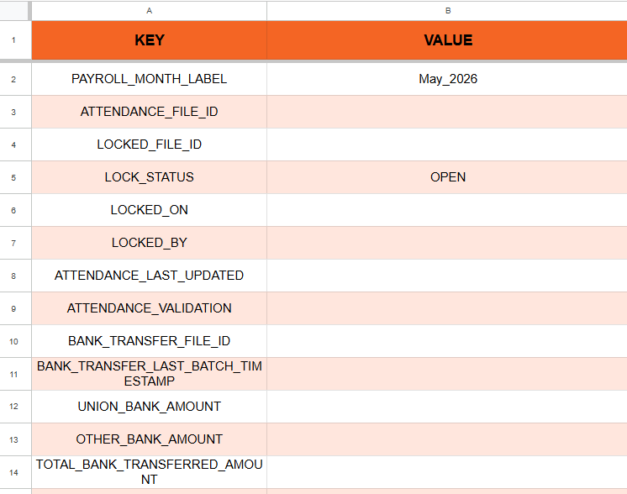

NOTE:
Always open the file from the Payroll Control Center link — never from a bookmark or shared URL that may point to a previous month.
If PAYROLL_WORKINGS_FILE_ID is blank for this month, the file has not been generated yet. Run Generate Payroll Workings in the Payroll Control Center first.
Step 2: Validate Attendance [Payroll-HR menu]
Click Payroll-HR → Validate Attendance. Runs in the order below — stops at the first failure.
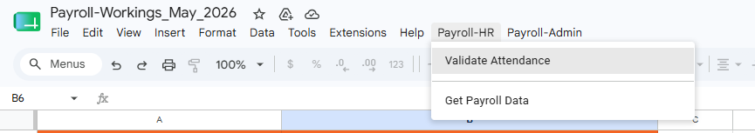
Step 2a: Authorization (First time only) If this is the first time you are running any script action in this file, Google will immediately show an "Authorization required" popup saying "A script attached to this document needs your permission to run." Click OK.
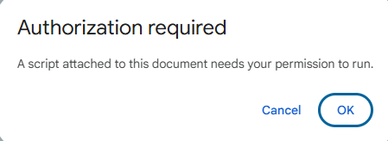
Step 2b: Confirm permissions Scroll down and click Continue to grant the permissions. This completes the one-time authorization. You will not see this screen again for this file.
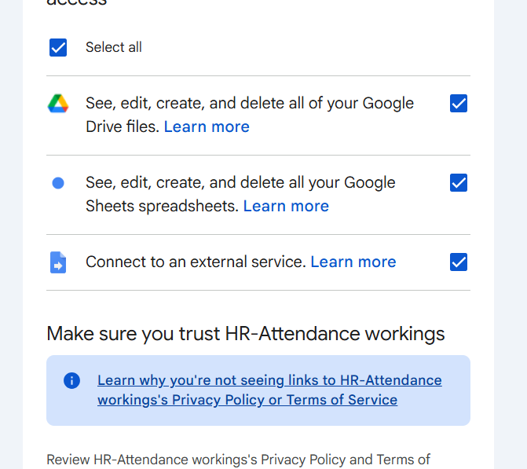
Step 2c: Wait for completion The script runs in the background — this may take 15–30 seconds. Once complete, a confirmation popup appears saying "Attendance validated successfully." Click OK
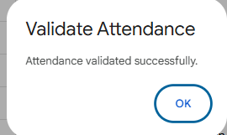
Note: Before writing anything to META_DATA, the system runs the following checks on the attendance file. Make sure all of these are in order in the attendance file before running this step.
Early checks (nothing written to META_DATA if any of these fail)
Attendance file in Drive | Named exactly Attendance_January_2025
Salary Advance deductions → Payroll Status | Must NOT be LOCKED in any row
Attendance entry → LOCKED STATUS | Must contain LOCKED in at least one row

Written to META_DATA immediately after early checks pass
META_DATA Key | Value Written
PAYROLL_MONTH_LABEL | January_2025
ATTENDANCE_FILE_ID | Clickable link to the attendance file

Tab existence check (attendance file must have all 7 tabs)
Attendance entry · Late Entry · OT Entry · Carry Forwarded · Other Payments · Other Deductions · Salary Advance deductions

Attendance entry checks
Duplicate Employee Codes | Not allowed
S.No, Name, Gender, Category, DOJ, Department, Designation | Must not be blank for any employee
TOTAL WORKING DAYS | Must be > 0
TOTAL PRESENT DAYS | 0 to TOTAL WORKING DAYS
FINAL PAYABLE DAYS | 0 to TOTAL WORKING DAYS
LOP DAYS | Must be >= 0

Other tab checks
Late Entry | Every employee must have a row · LATE PENALTY COUNT must not be blank
OT Entry | No partial rows — all columns filled (except Remarks)
Carry Forwarded | All columns filled (except Remarks)
Other Payments | All columns filled · Consider Under must be GROSS or NET only
Other Deductions | Employee Code and Amount must be filled
Salary Advance deductions | SA Run Timestamp (row 2) not blank · Month = January_2025 · Required fields filled: Month, Employee Code, Name, Department, EMI Reference Number, EMI Amount, Current Balance
Step 2d: Written to META_DATA only on full success
META_DATA Key | Value Written
ATTENDANCE_LAST_UPDATED | Drive timestamp of attendance file e.g. 2025-01-15 09:53:06
ATTENDANCE_VALIDATION | VALIDATED - 2025-01-15 09:53:06

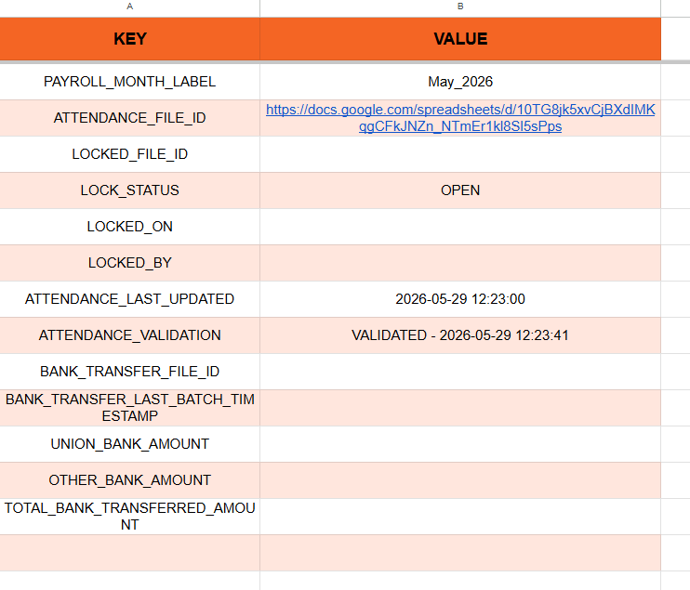

NOTE:
PAYROLL_MONTH_LABEL and ATTENDANCE_FILE_ID are written as soon as the early checks pass — so even if a later check fails, you can click the ATTENDANCE_FILE_ID link in META_DATA to open the attendance file and fix the issue.
Safe to re-run after fixing any issue.

Step 3: Get Payroll Data [Payroll-HR menu]
Click Payroll-HR → Get Payroll Data. Runs prechecks first — PAY_ROLL is not touched until all pass.
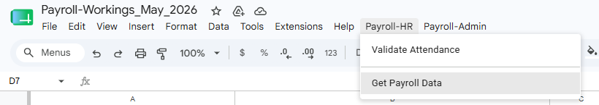

Step 3b: Wait for completion The script runs in the background — this may take 15–30 seconds. Once complete, a confirmation popup appears saying "Attendance validated successfully." Click OK.

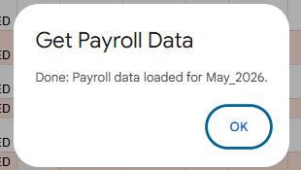

Prechecks
META_DATA → LOCK_STATUS | Must NOT be LOCKED
META_DATA → ATTENDANCE_VALIDATION | Must contain VALIDATED
META_DATA → PAYROLL_MONTH_LABEL | Must match the month in this file name
META_DATA → ATTENDANCE_FILE_ID | Must exist and be a valid spreadsheet link
Attendance file — last modified timestamp | Must match ATTENDANCE_LAST_UPDATED in META_DATA (file must not have changed after validation)
Salary Advance deductions → Payroll Status | Must NOT be LOCKED in any row
Attendance entry → LOCKED STATUS | Must contain LOCKED in at least one row

Data loaded into PAY_ROLL (one row per employee)
Attendance entry | S.No, Employee Code, Name, Gender, Category, DOJ, Department, Designation, Total Working Days, Total Present Days, LOP Days, Final Payable Days, Approved EL / CL / SL Days, Layoff Days
Late Entry | Late Penalty
OT Entry | OT Hours
Carry Forwarded | Carry Forward Days
Other Payments | Other Payments [Gross] (sum where Consider Under = GROSS) · Other Payments [Net] (sum where Consider Under = NET)
Other Deductions | Other Deductions (sum per employee)
Salary Advance deductions | Advance Deduction (Planned EMI)
Employee Master | Skill Group, UAN No, ESI No, Bank Account No, IFSC Code, Attendance Bonus Applicability, PF Applicability, ESI Applicability
Salary Revision History | Basic, DA, HRA, Conveyance Allowance, Special Allowance (latest APPROVED revision with EFFECTIVE_FROM on or before payroll month start)
Salary Revision History | Increment (only if the revision falls exactly in this month)
PETROL-CONVEYANCE_HISTORY | Petrol Conveyance (latest APPROVED entry on or before payroll month start)
Payroll Release Confirmation | Set to PROCEED for every employee row with no existing value — HOLD is never overwritten

NOTE:
Formula columns (Gross, Earned Basic, NET, etc.) are calculated by the spreadsheet and are never overwritten.
Can be re-run if needed — all managed columns are cleared and reloaded.

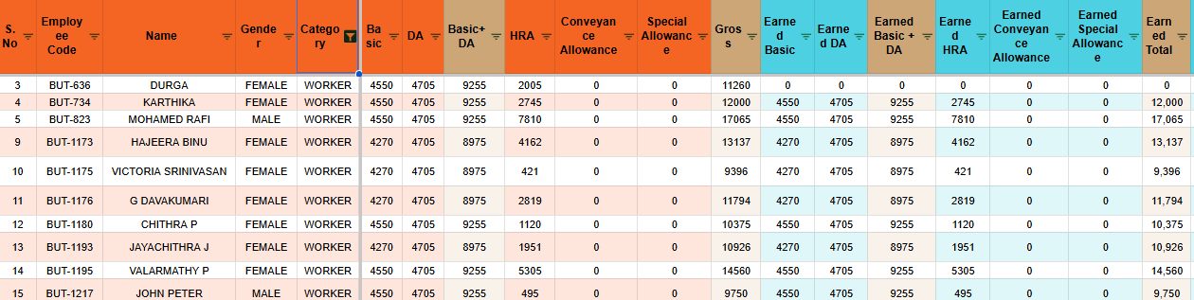
Step 4: Review the PAY_ROLL Sheet
Before running Validate Payroll, review the PAY_ROLL sheet. This is your opportunity to check the numbers and manage who gets paid. If you notice any incorrect figures, make the necessary corrections in the attendance file and re-run Get Payroll Data to reload the updated data.
Employee count | Confirm total rows match expected headcount for this month
Salary components | Spot-check Basic, DA, HRA for a few employees against the latest approved revision
Employees with ZERO Gross (META_DATA Check column) | Must show 0 before Generate Locked Payroll can run
Payroll Release Confirmation | Set to HOLD for any employee whose salary should not be processed this month
NET column | Employees with NET = 0 or negative will be marked SKIPPED in the bank transfer file
Advance Deduction Total (META_DATA Check column) | Must match the total of Planned EMI in the Salary Advance deductions tab of the attendance file

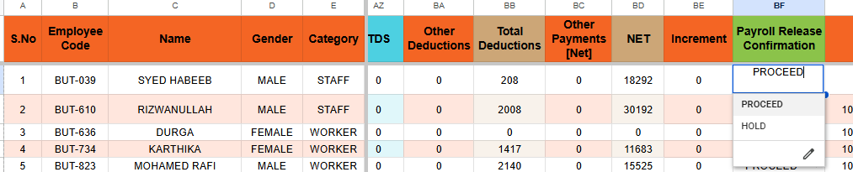

NOTE:
Once the PAY_ROLL sheet looks correct and you are satisfied with the numbers, inform the Admin user (nazneen@butlerleather.com) to continue with the remaining steps. This is where the HR user's work ends — the rest of the payroll process is handled by the Admin user.

4. Monthly Workflow Summary

Step | Action
1 | Confirm Payroll Workings file is created in Payroll Control Center for the correct month.
2 | Confirm attendance file (Attendance_January_2025) is in the Monthly Attendance folder in Drive.
3 | Confirm attendance is locked in the ATTN module — LOCKED STATUS present in Attendance entry.
4 | Confirm SA Run Timestamp (row 2 of Salary Advance deductions) is not blank.
5 | Open the Payroll Workings file by clicking the PAYROLL_WORKINGS_FILE_ID link in Payroll Control Center.
6 | Confirm META_DATA → LOCK_STATUS = OPEN.
7 | Click Payroll-HR → Validate Attendance. Confirm success toast.
8 | Verify META_DATA: PAYROLL_MONTH_LABEL, ATTENDANCE_FILE_ID, ATTENDANCE_LAST_UPDATED, ATTENDANCE_VALIDATION all filled.
9 | Click Payroll-HR → Get Payroll Data. Confirm success alert and PAY_ROLL tab is populated.
10 | Review PAY_ROLL sheet: employee count, salary components, Employees with ZERO Gross = 0, Advance Deduction Total matches, Payroll Release Confirmation set.
11 | If any figures are incorrect: fix in attendance file → re-run Get Payroll Data → re-review.
12 | Once satisfied, inform nazneen@butlerleather.com to continue with Admin steps.

TIP: If you encounter any error, refer to Section 5 for a full explanation and fix.
Always fix issues in the attendance file first, then re-run Validate Attendance or Get Payroll Data as needed.

5. Error Messages — What They Mean & What To Do

Error Message (Example) | Why It Happened | What To Do
Attendance file not found for month "January_2025". Expected name exactly like "Attendance_January_2025". | Attendance file missing or named incorrectly in Drive. | Upload with exact name Attendance_January_2025 to the Monthly Attendance folder.
Payroll already locked. | Salary Advance deductions already has Payroll Status = LOCKED. | This month was already processed. Do not re-run.
Lock the attendance then run the payroll. | Attendance entry has no LOCKED STATUS value. | Lock attendance in the ATTN module first, then retry.
Duplicate Employee Code found in Attendance entry: "E001" | Two rows have the same Employee Code. | Remove the duplicate row in the attendance file and re-run Validate Attendance.
Attendance entry incomplete for "E001": missing Gender | A required field is blank for this employee. | Fill the missing field and re-run Validate Attendance.
TOTAL PRESENT DAYS > TOTAL WORKING DAYS for "E001". | Impossible attendance value. | Correct the attendance figures for this employee.
TOTAL WORKING DAYS must be > 0 for "E001". | Total working days is zero or blank. | Fill in the correct working days in the attendance file.
LOP DAYS cannot be negative for "E001". | LOP days has a negative value. | Correct the LOP value for this employee.
Late Entry missing row for "E001". | Employee has no row in Late Entry. | Add the Late Entry row for this employee.
Tab "OT Entry" has partial row for "E001" — missing "Total OT Hours". | A row has some columns filled but not all. | Complete all columns for this row in OT Entry.
Other Payments: invalid Consider Under "BONUS" for "E001". | Consider Under must be GROSS or NET. | Fix to GROSS or NET in the attendance file.
Salary Advance EMI not loaded. Please run Get/Refresh Salary Advance EMI first. | SA Run Timestamp in row 2 of Salary Advance deductions is blank. | Run Get/Refresh Salary Advance EMI first.
Salary Advance deductions: Month mismatch for "E001". Found "December_2024", expected "January_2025". | Month column does not match the payroll month. | Update Salary Advance deductions to the correct month.
Run "Validate Attendance" first. | ATTENDANCE_VALIDATION missing in META_DATA. | Run Validate Attendance (Step 2) before Get Payroll Data.
Attendance file changed after validation. Please re-run "Validate Attendance". | Attendance file was modified after Validate Attendance ran. | Re-run Validate Attendance to refresh the timestamp.
You are not authorized to run this function. | You are not in the authorised user list. | Only pmo and hrassist can use the Payroll-HR menu.

6. Do's and Don'ts

Do's
- Always open the Payroll Workings file from the Payroll Control Center link — not from a direct bookmark.
- Run steps in order: Open File → Validate Attendance → Get Payroll Data → Review PAY_ROLL.
- Lock attendance in the ATTN module before running Validate Attendance.
- Ensure SA Run Timestamp (row 2 of Salary Advance deductions) is not blank before running Validate Attendance.
- After Validate Attendance passes, confirm all 4 META_DATA keys are filled: PAYROLL_MONTH_LABEL, ATTENDANCE_FILE_ID, ATTENDANCE_LAST_UPDATED, ATTENDANCE_VALIDATION.
- Review PAY_ROLL carefully — check employee count, salary components, Employees with ZERO Gross = 0, Advance Deduction Total.
- Fix any issues in the attendance file first, then re-run Get Payroll Data.
- Inform nazneen@butlerleather.com once PAY_ROLL review is complete.
- Read error messages carefully — each one tells you exactly what is wrong and in which tab.

Don'ts
- Don't run any Payroll-Admin menu actions — those are for the Admin user only.
- Don't rename or move the Payroll Workings file — the month is parsed from the file name.
- Don't modify the attendance file after Validate Attendance passes — Get Payroll Data will block until you re-run Validate Attendance.
- Don't manually edit META_DATA — it is written exclusively by the scripts.
- Don't hand over to Admin until Employees with ZERO Gross = 0 and Advance Deduction Total is reconciled.
- Don't run actions from an unauthorised account — only pmo and hrassist can use the Payroll-HR menu.

