SALARY ADVANCE MODULE
User Manual
For HR Users — Step-by-Step Guide

1. What is the Salary Advance Module?

The Salary Advance Module is the system used to manage salary advances given to employees. When the company approves a salary advance for an employee, this module is used to record that advance and create an EMI (Equated Monthly Instalment) schedule — a plan that shows how the advance will be recovered from the employee's salary over several months.
The module also handles cancellations, and situations where an employee who has an active EMI resigns, absconds, or needs a particular month's EMI skipped and extended. All of these actions update the relevant records automatically.
Once the Payroll Generator runs and locks the payroll for a given month, recovery data is automatically pushed into the Salary Advance Master. All related records update without any manual intervention — EMI_SCHEDULE is synced, the Payroll Status is locked, and the Advance Ledger formula columns recalculate automatically.

Who Uses This Module?
User | What They Do
PMO (pmo@butlerleather.com) | Full access. Runs all actions directly from the spreadsheet menu.
HR Authorised User (nazneen@butlerleather.com) | Runs Schedule EMI, Cancel EMI, and Refresh Employee Master. Actions are routed securely through the system.
HR / Payroll team | Runs the Payroll Generator (Generate Locked Payroll) each month. This automatically pushes salary advance recovery data into the Recovered Amount Ledger.

What Happens When You Use It?
- A monthly EMI schedule is created in the EMI_SCHEDULE sheet with one row per installment.
- The Advance Ledger is stamped with the EMI Reference Number (e.g., EMI-1) and a scheduled timestamp.
- The Shared EMI Summary is updated so Payroll can see which EMIs are due each month.
- Derived columns (Recovered Amount, Balance Amount, HR Status, EMI Status, Planned and Actual Loan Closing Month, Deviation) update automatically via their built-in formulas.
- When the Payroll Generator runs Generate Locked Payroll, recovery data is pushed automatically into the Salary Advance Master — no manual entry in the Recovered Amount Ledger is needed.
- Cancelled EMIs are marked clearly — no records are deleted.

2. Understanding the Advance Ledger

The Advance Ledger is the main sheet you work with. It has 22 columns. Some are filled by you manually, some are filled by formulas automatically, and two are stamped by the system when you run Schedule EMI.

Column Reference
Column | Column Name | How It's Filled | What It Is
A | Employee Code | Manual | Enter the employee's unique code. Leave blank to skip the row.
B | Name | Auto (formula) | Looked up from EMP master by employee code. Do not edit.
C | Department | Auto (formula) | Looked up from EMP master. Do not edit.
D | Designation | Auto (formula) | Looked up from EMP master. Do not edit.
E | Status | Auto (formula) | Employee status from EMP master (Active / Inactive). Do not edit.
F | Aadhaar No | Auto (formula) | Looked up from EMP master. Do not edit.
G | Advance Reason Category | Manual (dropdown) | Select from the dropdown: MEDICAL, EMERGENCY, FAMILY FUNCTION, EDUCATION, HOUSE RENT / DEPOSIT, TRAVEL, LOAN / DEBT CLEAR, FESTIVAL, MIGRANT WORKER FOOD EXPENSES, or OTHER.
H | Reason Details | Manual | Brief description of the reason for the advance.
I | Advance Amount | Manual | Total advance amount sanctioned (numeric).
J | Tenure | Manual | Number of monthly installments for recovery (integer, e.g., 6).
K | Advance Paid Month [MM/DD/YY] | Manual | Month the advance was actually paid to the employee. Required for scheduling.
L | EMI Start Month [MM/DD/YY] | Manual | Month when EMI recovery should begin. Required for scheduling.
M | EMI Amount | Auto (formula) | Computed as CEILING(Advance Amount / Tenure, 100). Do not edit — this is used by the system when scheduling.
N | EMI Scheduled Status | System-set | Stamped by the Schedule/Cancel EMI action. Example: Scheduled - 2026-05-23 09:29. Do not edit.
O | EMI Reference Number | System-set | Assigned on scheduling. Example: EMI-1. Do not edit.
P | Recovered Amount | Auto (formula) | Total amount already recovered, summed from EMI_SCHEDULE. Do not edit.
Q | Balance Amount | Auto (formula) | Advance Amount minus Recovered Amount. Do not edit.
R | HR Status | Auto (formula) | HR Decision from EMI_SCHEDULE (RESIGNED or ABSCOND if applicable). Do not edit.
S | EMI Status | Auto (formula) | Derived status: ACTIVE, CLOSED, CANCELLED, WRITE OFF, or INACTIVE. Do not edit.
T | Planned Loan Closing Month | Auto (formula) | Calculated from EMI Start Month + Tenure - 1. Do not edit.
U | Actual Loan Closing Month | Auto (formula) | Last actual EMI month looked up from EMI_SCHEDULE. Do not edit.
V | Deviation | Auto (formula) | Difference in months between Actual and Planned closing, or WRITE OFF if applicable. Do not edit.

NOTE: Only columns A, G, H, I, J, K, and L need to be filled manually. All other columns are either auto-populated from the Employee Master or calculated by formulas. The system reads columns I, J, K, L, and O when scheduling.

3. Understanding the Auto-Calculated Columns

Several columns in the Advance Ledger update automatically — you never need to type in them. Here is what each one shows and when it changes:

Column | Column Name | What It Shows
M | EMI Amount | Monthly installment amount, computed as CEILING(Advance Amount / Tenure, 100). Updates immediately when you fill Advance Amount or Tenure.
P | Recovered Amount | Total amount recovered so far, summed from the EMI_SCHEDULE sheet. Updates after each payroll cycle once EMI_SCHEDULE is updated by the sync.
Q | Balance Amount | Remaining advance balance (Advance Amount minus Recovered Amount). Updates when column P updates.
R | HR Status | Shows RESIGNED or ABSCOND if that HR Decision has been recorded in EMI_SCHEDULE for this reference. Blank otherwise.
S | EMI Status | Overall status of the advance. Shows: ACTIVE (recovery ongoing), CLOSED (balance = 0), CANCELLED (EMI Scheduled Status starts with CANCELLED), WRITE OFF (employee resigned/absconded), or INACTIVE.
T | Planned Loan Closing Month | Expected last EMI month, calculated as EMI Start Month + Tenure - 1.
U | Actual Loan Closing Month | The last actual EMI month from EMI_SCHEDULE for this reference.
V | Deviation | Difference in months between Actual and Planned closing. Shows WRITE OFF if employee resigned/absconded.

NOTE: Do not manually type in any of these columns. If you see an unexpected value, check whether the source data (Advance Amount, Tenure, EMI Start Month, or EMI_SCHEDULE rows) is correct.

4. Step-by-Step

Scheduling an EMI (Creating the Recovery Plan)

Step 1: Open the Salary Advance Master spreadsheet
Open the Salary Advance Master spreadsheet in Google Sheets. Wait for it to fully load — you should see the 'Advance' and 'Master' menus in the top menu bar.

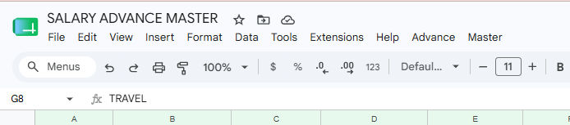
Step 2: Fill in the Advance Ledger for new advances
Go to the Advance Ledger sheet. For each new advance, fill in the following columns manually: Employee Code (A), Advance Reason Category (G — select from dropdown), Reason Details (H), Advance Amount (I), Tenure (J), Advance Paid Month (K), and EMI Start Month (L). Once you enter the Employee Code, columns B through F (Name, Department, Designation, Status, Aadhaar No) will fill automatically. Column M (EMI Amount) will also compute automatically.
Leave columns N (EMI Scheduled Status) and O (EMI Reference Number) blank — they will be filled by the system when you run Schedule EMI.

NOTE: All new advance rows must pass validation before any row is scheduled. If even one row has a blank required field (Advance Amount, Tenure, Advance Paid Month, or EMI Start Month) or shows EMI Status other than ACTIVE, the entire run is stopped and nothing is written.

Step 3: Run Schedule EMI from the menu
Click the 'Advance' menu in the top menu bar. Then click 'Schedule EMI (create schedule for new advances)'. The system will validate all eligible rows and, if all pass, create the EMI schedule.

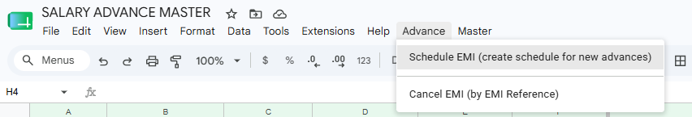

Step 4: Read the result alert
A pop-up alert will appear. If successful, it will show 'EMI Schedule created ✅' with the number of references created and EMI rows added. If there is an error, the alert will describe what went wrong — refer to Section 6 for guidance.

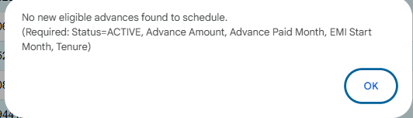
NOTE: After a successful run: the Advance Ledger rows will be stamped in column N (EMI Scheduled Status, e.g., Scheduled - 2026-05-23 09:29) and column O (EMI Reference Number, e.g., EMI-1). The EMI_SCHEDULE sheet will have the new installment rows. Row protection is applied automatically to Advance Ledger columns A–L.

Cancelling an EMI

Step 5: Find the EMI Reference Number to cancel
Open the Advance Ledger and look at column O (EMI Reference Number) for the advance you want to cancel. The format is EMI-<number> (e.g., EMI-12). You can also find it in the EMI_SCHEDULE sheet.
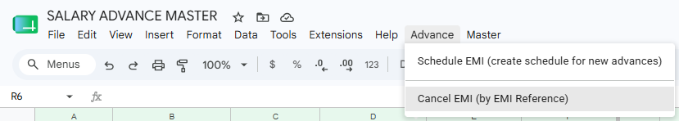
Step 6: Run Cancel EMI from the menu
Click the 'Advance' menu and select 'Cancel EMI (by EMI Reference)'. A prompt box will appear asking you to type the EMI Reference Number.

Step 7: Enter the EMI Reference Number and confirm
Type the EMI Reference Number exactly as it appears in column O (e.g., EMI-12). The system accepts both upper and lowercase. Click OK to proceed, or Cancel to abort.

Step 8: Read the result alert
A result alert will appear. If successful, it shows 'Cancel EMI completed ✅' with details. Column N (EMI Scheduled Status) will be updated to 'Cancelled - <timestamp>'. The EMI Status in column S will automatically recalculate to CANCELLED.

NOTE: Cancelling an EMI does not delete any rows. It updates STATUS values and removes Shared EMI Summary rows only where Payroll has not yet processed them. Formula columns (Recovered Amount, Balance Amount, HR Status, EMI Status) will recalculate automatically after cancellation.

Refreshing the Employee Master

Step 9: Run Refresh Employee Master from the menu
Click the 'Master' menu in the top menu bar and select 'Refresh Employee Master (EMP master)'. A confirmation dialog will appear. Click YES to proceed.

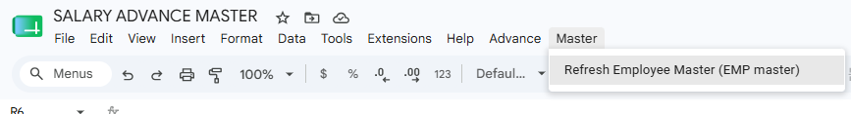
Step 10: Read the result alert
The alert will show how many employees were updated, how many were newly added, and how many source rows were read. Once refreshed, the formula columns in Advance Ledger (Name, Department, Designation, Status, Aadhaar No) will automatically reflect any employee data changes.

TIP: Run Refresh Employee Master at the start of each month or whenever new employees are added in the central Employee Master, to keep the EMP master sheet (and the Advance Ledger formula columns) up to date.

How Recovery Data Reaches the System (Automated — No Manual Entry)

You do not need to fill in the Recovered Amount Ledger manually. This sheet is populated automatically by the Payroll Generator when it runs Generate Locked Payroll for a given month.
Here is what happens automatically once Generate Locked Payroll runs:
- The Payroll Generator reads the “Salary Advance deductions” sheet inside the Attendance file for that month.
- It filters only rows where PAYROLL STATUS starts with “LOCKED” — meaning payroll has already confirmed those EMI deductions.
- It pushes those rows into the Recovered Amount Ledger in the Salary Advance Master — one push per attendance file (duplicate pushes are blocked automatically).
- A time-driven watcher detects the new data within a few minutes and triggers the sync pipeline automatically.
- EMI_SCHEDULE is updated with HR Decision and Recovered Amount. Shared EMI Summary Payroll Status is locked. HR Decision post-actions (SKIP extension, RESIGNED/ABSCOND write-off) are applied.
- Advance Ledger formula columns (Recovered Amount col P, Balance Amount col Q, HR Status col R, EMI Status col S, Actual Loan Closing Month col U, Deviation col V) recalculate automatically.

NOTE: The Recovered Amount Ledger is a system-managed sheet. Do not manually add, edit, or delete rows in it. If you notice a row is missing or incorrect after payroll has run, contact the Payroll team or system administrator — the data originates from the locked payroll run, not from manual entry.

5. Monthly Workflow Summary

Step | Action
1 | Open the Salary Advance Master spreadsheet.
2 | Run 'Refresh Employee Master' from the Master menu if new employees have joined.
3 | In the Advance Ledger, add new advance rows — fill Employee Code (A), Advance Reason Category (G), Reason Details (H), Advance Amount (I), Tenure (J), Advance Paid Month (K), EMI Start Month (L). Verify column S (EMI Status) shows ACTIVE automatically.
4 | Run 'Schedule EMI' from the Advance menu. Confirm the success alert.
5 | Once the Payroll Generator runs Generate Locked Payroll for the month, recovery data is pushed automatically into the Recovered Amount Ledger. No manual entry is needed — the system handles all updates from this point.
6 | The system automatically detects the changes and updates EMI_SCHEDULE and Shared EMI Summary. Advance Ledger formula columns (P, Q, R, S, U, V) recalculate automatically — no further action needed.
7 | If any advance needs to be cancelled, run 'Cancel EMI' from the Advance menu and enter the EMI Reference Number from column O.

TIP: If you see an unexpected value in any formula column or an error you have not seen before, refer to Section 6 (Error Messages) for guidance.

6. Error Messages — What They Mean & What To Do

Error Message (Example) | Why It Happened | What To Do
Sheet not found: Advance Ledger | The sheet tab with this exact name does not exist. | Check that the sheet tab is named exactly 'Advance Ledger' (no extra spaces).
Missing required header: "TENURE" | A required column header is missing from the Advance Ledger row 1. | Add the exact header 'TENURE' to row 1 of Advance Ledger.
Advance Ledger has no data rows. | The Advance Ledger has only a header row. | Add at least one advance row below the header.
Missing required fields in Advance Ledger — please fill all mandatory columns before scheduling. | One or more unscheduled rows (those with blank column O) have blank Advance Amount, Tenure, EMI Start Month, or Advance Paid Month — or the EMI Status is not ACTIVE. | Review every row where column O (EMI Reference Number) is blank. Fill columns I, J, K, L. Column S (EMI Status) should show ACTIVE automatically once all fields are filled.
No new eligible advances found to schedule. (Required: Status=ACTIVE, Advance Amount, Advance Paid Month, EMI Start Month, Tenure) | All rows either already have an EMI Reference Number or have EMI Status other than ACTIVE. | Check if all advances are already scheduled. For any row that should be scheduled, ensure columns I, J, K, L are filled and column O is blank.
EMI Reference not found in Advance Ledger: EMI-5 | The reference EMI-5 does not exist in column O of Advance Ledger. | Check the reference you typed. Look in column O of Advance Ledger or the EMI_SCHEDULE sheet to find the correct reference.
Invalid EMI Reference. | You clicked OK without typing anything in the Cancel EMI prompt. | Run Cancel EMI again and enter a valid reference such as EMI-12.
Access Denied | Your Google account is not authorised to run this action. | Contact the system administrator. Only pmo@ and nazneen@ can run these actions.
Web App call failed: ... | The Web App could not be reached (network issue or not deployed). | Wait a moment and try again. If it persists, contact the system administrator.

7. Do's and Don'ts

✅ Do's
- Fill only the manual columns: Employee Code (A), Advance Reason Category (G), Reason Details (H), Advance Amount (I), Tenure (J), Advance Paid Month (K), EMI Start Month (L).
- Select Advance Reason Category from the dropdown — do not type it freely.
- Use the exact EMI Reference format when cancelling (e.g., EMI-12).
- Contact the system administrator if you notice missing or incorrect data in the Recovered Amount Ledger — do not edit it manually.
- Run Refresh Employee Master whenever new employees are added in the central Employee Master.
- Read the result alert carefully after every action.
- Contact the system administrator if you encounter an Access Denied or Web App error.

❌ Don'ts
- Do not edit formula columns: Name (B), Department (C), Designation (D), Status (E), Aadhaar No (F), EMI Amount (M), Recovered Amount (P), Balance Amount (Q), HR Status (R), EMI Status (S), Planned Loan Closing Month (T), Actual Loan Closing Month (U), Deviation (V).
- Do not edit or type in the EMI Scheduled Status (N) or EMI Reference Number (O) columns — these are stamped by the system.
- Do not delete rows from Advance Ledger or EMI_SCHEDULE — use Cancel EMI if an advance needs to be stopped.
- Do not type ACTIVE, CLOSED, or WRITE OFF in any column — these are set by formulas or the system.
- Do not share your Google login credentials — system access is tied to your specific email address.

