Salary Revision Module
User Manual
For HR Users — Step-by-Step Guide

1. What is the Salary Revision Module?
The Salary Revision Module is the official system for requesting, reviewing, and recording employee salary changes at Butler Leather. It is built directly into the HR Google Spreadsheet so that the entire workflow — from entering the revised salary to receiving approval — happens in one place without any separate forms or emails to manage manually.
When HR Assist fills in the new salary details and submits the request, the system automatically sends a neatly formatted email to the approver (Nazneen) with all the key details. Once Nazneen marks the request as Approved or Rejected and runs the approval, the system moves everything into the correct history sheet and updates the payroll-ready status automatically.
Every step is access-controlled. Only authorised people can run each action. This prevents accidental changes and keeps the revision history clean and reliable for payroll processing.

Who Uses This Module
User | What They Do
HR Assist (hrassist@butlerleather.com) | Fills in salary revision details in the HR_UPDATE sheet and submits the approval request
Approver (nazneen@butlerleather.com) | Reviews the submitted request in REVISION_APPROVAL, sets status to Approved or Rejected, then runs Revision Approval
System Owner (pmo@butlerleather.com) | Can run both actions directly with full administrative access; handles corrections and re-runs

What Happens When You Use It
- Salary revision details entered in HR_UPDATE are validated and moved to REVISION_APPROVAL
- An email notification is sent to the approver with the full revision summary
- The approver sets each row to APPROVED or REJECTED and runs the approval process
- Approved revisions are written into REVISION_HISTORY marked as ACTIVE for payroll
- Any previous revision for the same employee is automatically marked IN-ACTIVE
- Rejected revisions are archived in REJECTED_HISTORY for reference
- Submitted and processed rows are cleaned from the input and staging sheets automatically

2. Before You Start
Checklist Item | Why It Matters
You are logged in with the correct Google account (hrassist for submission, nazneen for approval) | The system checks your email — an unauthorised account will be blocked with a message
You are on the correct sheet tab before running the action (HR_UPDATE for Submit, REVISION_APPROVAL for Approval) | Both actions have a tab guard — running from the wrong tab shows a "Skipped" message
Any prior month submissions have already been processed and REVISION_APPROVAL is not still holding pending rows from a previous cycle | Pending rows from prior cycles mixed with new ones may cause confusion in the approval email and history

NOTE: Process one batch at a time. Submit revisions for a group of employees, wait for approval, and then move on to the next batch. Do not submit a new batch until the previous one is fully approved or rejected.

3. Step-by-Step Guide

Part A — HR Assist: Submit for Approval

Step 1: Verify the Active Salary Policy
Before entering any revision, confirm that an active salary policy exists for the current revision cycle. The salary component columns in HR_UPDATE (BASIC, DA, HRA, CONV.ALL, SPL.ALL) calculate automatically by reading values from two policy tables: SALARY_POLICY_MASTER and WORKER_PERCENT_POLICY. If neither table has an ACTIVE row for the current month, all component columns will stay blank and SUBMIT_STATUS will never reach OK.

A. SALARY_POLICY_MASTER — Current Active Policy Values
This table holds both STAFF percentage splits and WORKER fixed slab amounts. The current active rows are shown below. Use these as your reference when verifying that the sheet is calculating correctly.
Policy ID | Category | Revision Month | BASIC% | DA% | HRA% | CONV% | SPL% | Status
STAFF-1 | STAFF | April_2026 | 25% | 25% | 30% | 15% | 5% | ACTIVE
WORKER-SKILLED-1 | WORKER | April_2026 | — | — | — | — | — | ACTIVE
WORKER-SEMI SKILLED-1 | WORKER | April_2026 | — | — | — | — | — | ACTIVE
WORKER-UNSKILLED-1 | WORKER | April_2026 | — | — | — | — | — | ACTIVE

Worker fixed slab amounts for the active policy:
Skill Group | BASIC_FIXED | DA_FIXED | Revision Month | Status
SKILLED | ₹4,550 | ₹4,705 | April_2026 | ACTIVE
SEMI SKILLED | ₹4,270 | ₹4,705 | April_2026 | ACTIVE
UNSKILLED | ₹3,980 | ₹4,705 | April_2026 | ACTIVE

B. WORKER_PERCENT_POLICY — Current Active Policy Values
This table controls percentage-based splits for Workers whose PLANNED GROSS is at or above the threshold amount. The current active row is shown below.
Policy ID | Category | Revision Month | Threshold | BASIC% | DA% | Status
WORKER-1 | WORKER | April_2026 | ₹19,000 | 25% | 25% | ACTIVE

C. How to Update the Policy for a New Revision Cycle
- Previous policy rows are never edited or deleted. They stay exactly as they are, permanently recorded as IN-ACTIVE for audit purposes.
- When a new revision cycle begins (for example May_2026), add a new row below the existing ones in the policy table with the updated percentages or fixed amounts and the new revision month.
- The STATUS column is fully automatic. It identifies the row with the highest POLICY_SERIAL for each POLICY_BASE that has all required fields filled, and marks only that row ACTIVE. All prior rows for the same base become IN-ACTIVE instantly.
- There is no button to press and no manual status change needed. The moment the new row is saved with valid values, STATUS recalculates and the new row becomes ACTIVE. HR_UPDATE then picks up the new values for all revisions entered from that point onwards.
- For STAFF policies, the five percentages (BASIC% + DA% + HRA% + CONV% + SPL%) must sum exactly to 1.0 (100%). The STAFF_TOTAL_PCT column shows ALLOWED if they do. A row showing NOT ALLOWED will never become ACTIVE even if it is the latest entry.

NOTE: If SUBMIT_STATUS is showing GROSS_MISMATCH or the component columns (BASIC, DA, HRA etc.) are blank after entering PLANNED GROSS, the first thing to check is whether both SALARY_POLICY_MASTER and WORKER_PERCENT_POLICY have an ACTIVE row. A missing, incomplete, or NOT ALLOWED policy row is the most common cause of this issue.

NOTE: For STAFF: the five percentage columns must add up to exactly 100% (entered as decimals: 0.25 + 0.25 + 0.30 + 0.15 + 0.05 = 1.0). If the total is not exactly 1.0, the STAFF_TOTAL_PCT column will show NOT ALLOWED and that row will remain IN-ACTIVE regardless of the serial number.

Step 2: Open the Salary Revision Spreadsheet
Open the Google Spreadsheet that contains the Salary Revision module. Make sure you are logged in with your hrassist@butlerleather.com account. You should see two menu buttons at the top of the spreadsheet: "Submit for Approval" and "Revision Approval".
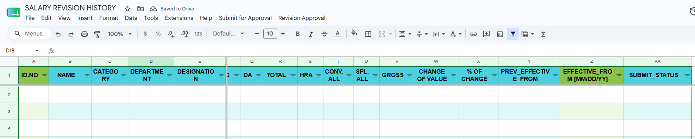

Step 3: Fill in Salary Revision Details in the HR_UPDATE Sheet
Navigate to the HR_UPDATE sheet. The sheet has 27 columns. You only need to enter data in a few of them — the rest fill in automatically once you type the Employee ID. The table below explains exactly what each column does and what you should (or should not) do with it.

Column-by-Column Guide for HR_UPDATE
Group 1 — Employee Identity (Auto-filled after you enter the ID)
Column | You Do | What Happens
ID.NO | TYPE —  Enter the Employee ID | This is your trigger column. The moment you type a valid Employee ID here, all the identity columns (NAME through OLD GROSS) fill in automatically from the Employee Master and Revision History. Clear this cell and everything else in the row goes blank too.
NAME | DO NOT EDIT | Auto-filled from Employee Master using XLOOKUP on ID.NO. Shows the employee full name.
CATEGORY | DO NOT EDIT | Auto-filled from Employee Master. Shows STAFF or WORKER. This value controls how salary components are split — so it must be accurate.
DEPARTMENT | DO NOT EDIT | Auto-filled from Employee Master (columns D to F of Employee Master cover Department, Sub-Dept, and one more field). Do not edit.
DESIGNATION | DO NOT EDIT | Auto-filled from Employee Master as part of the same XLOOKUP as Department.
SKILL GROUP | DO NOT EDIT | Auto-filled from Employee Master column K. For WORKER category employees, the Skill Group determines which salary slab and fixed amounts apply from the policy tables.

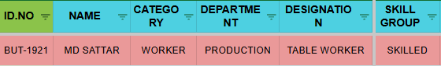

Group 2 — Current Salary Snapshot (Auto-filled from Revision History)
Column | You Do | What Happens
OLD BASIC | DO NOT EDIT | Auto-filled from REVISION_HISTORY. Picks the most recent ACTIVE revision for this employee and shows the current BASIC amount. If the employee has no revision history, falls back to Employee Master.
OLD DA | DO NOT EDIT | Auto-filled from REVISION_HISTORY. Shows current Dearness Allowance.
OLD TOTAL | DO NOT EDIT | Formula: OLD BASIC + OLD DA. Calculated automatically.
OLD HRA | DO NOT EDIT | Auto-filled from REVISION_HISTORY. Shows current House Rent Allowance.
OLD CONV.ALL | DO NOT EDIT | Auto-filled from REVISION_HISTORY. Shows current Conveyance Allowance.
OLD SPL.ALL | DO NOT EDIT | Auto-filled from REVISION_HISTORY. Shows current Special Allowance.
OLD GROSS | DO NOT EDIT | Formula: OLD BASIC + OLD DA + OLD HRA + OLD CONV.ALL + OLD SPL.ALL. This is the employee’s current gross before revision.

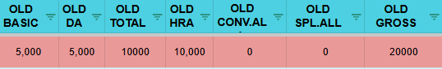

Group 3 — Revision Input (You fill these in)
Column | You Do | What Happens
REVISION_TYPE | SELECT from dropdown | Choose one of three options: SALARY FIXATION (new joinee or restructured salary), INCREMENT (standard periodic increase), or CORRECTION (fixing an error in the current salary). The choice of revision type changes how the new salary is calculated — CORRECTION uses OLD GROSS as the base; the other two use PLANNED GROSS.
PLANNED GROSS | TYPE — Enter the new target gross | The total gross salary you want the employee to receive after revision. For INCREMENT and SALARY FIXATION, this is mandatory. For CORRECTION, you can leave it blank (the system uses OLD GROSS as the base). Once you enter this, all the new salary component columns (BASIC, DA, HRA, etc.) will auto-calculate.

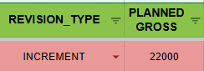
Group 4 — New Salary Components (Auto-calculated from PLANNED GROSS and Policy Tables)
These columns fill in automatically once REVISION_TYPE and PLANNED GROSS are entered. You do not type anything here. The calculation uses the active policy from two tables — SALARY_POLICY_MASTER (for component percentages and Worker fixed slabs) and WORKER_PERCENT_POLICY (for above-threshold Worker percentages). The rules differ by CATEGORY and, for Workers, by SKILL GROUP.
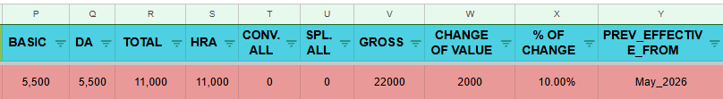
STAFF Employees — Active Policy: STAFF-1 (April_2026)
Every STAFF employee uses percentage-based splits regardless of gross amount. The active policy (STAFF-1) defines the following fixed percentages:
Component | Policy % | How It Is Calculated
BASIC | 25% | ROUND(PLANNED GROSS × 0.25, 0)
DA | 25% | ROUND(PLANNED GROSS × 0.25, 0)
TOTAL | — | BASIC + DA (formula, not a policy value)
HRA | 30% | ROUND(PLANNED GROSS × 0.30, 0)
CONV.ALL | 15% | ROUND(PLANNED GROSS × 0.15, 0)
SPL.ALL | 5% (remainder) | PLANNED GROSS − BASIC − DA − HRA − CONV.ALL (floored at 0)
GROSS | 100% | BASIC + DA + HRA + CONV.ALL + SPL.ALL

STAFF Worked Example — PLANNED GROSS = ₹30,000
Component | Calculation | Result | Running Total
BASIC | 30,000 × 25% | ₹7,500 | ₹7,500
DA | 30,000 × 25% | ₹7,500 | ₹15,000
HRA | 30,000 × 30% | ₹9,000 | ₹24,000
CONV.ALL | 30,000 × 15% | ₹4,500 | ₹28,500
SPL.ALL | 30,000 − 28,500 | ₹1,500 | ₹30,000
GROSS | Sum of all above | ₹30,000 | ✓ Matches PLANNED GROSS

WORKER Employees — Two-Tier Rule (Threshold: ₹19,000)
For Workers, the calculation depends on whether PLANNED GROSS is below or at/above the threshold of ₹19,000 (active policy: WORKER-1, April_2026).

Below ₹19,000 — Fixed Slab (from SALARY_POLICY_MASTER, active policy April_2026)
BASIC and DA are fixed amounts from the policy table based on SKILL GROUP. HRA absorbs the remainder. CONV.ALL and SPL.ALL are always ₹0 for Workers.
SKILL GROUP | BASIC | DA | TOTAL | HRA | CONV / SPL
SKILLED | ₹4,550 (fixed) | ₹4,705 (fixed) | ₹9,255 | Gross − 9,255 | ₹0 / ₹0
SEMI SKILLED | ₹4,270 (fixed) | ₹4,705 (fixed) | ₹8,975 | Gross − 8,975 | ₹0 / ₹0
UNSKILLED | ₹3,980 (fixed) | ₹4,705 (fixed) | ₹8,685 | Gross − 8,685 | ₹0 / ₹0

WORKER Worked Example — SKILLED, PLANNED GROSS = ₹15,000 (below ₹19,000)
Component | Calculation | Result | Running Total
BASIC | Fixed slab for SKILLED | ₹4,550 | ₹4,550
DA | Fixed slab for SKILLED | ₹4,705 | ₹9,255
HRA | 15,000 − 4,550 − 4,705 | ₹5,745 | ₹15,000
CONV.ALL | Always 0 for Workers | ₹0 | ₹15,000
SPL.ALL | Always 0 for Workers | ₹0 | ₹15,000
GROSS | Sum of all above | ₹15,000 | ✓ Matches PLANNED GROSS

At or Above ₹19,000 — Percentage-Based (from WORKER_PERCENT_POLICY, active policy April_2026)
When PLANNED GROSS is ₹19,000 or above, the fixed slab is replaced by percentage splits — same rule for all skill groups.
Component | Policy % | How It Is Calculated
BASIC | 25% | ROUND(PLANNED GROSS × 0.25, 0)
DA | 25% | ROUND(PLANNED GROSS × 0.25, 0)
HRA | Remainder | PLANNED GROSS − BASIC − DA (floored at 0)
CONV.ALL | 0 | Always ₹0 for Workers
SPL.ALL | 0 | Always ₹0 for Workers
GROSS | — | BASIC + DA + HRA

WORKER Worked Example — SKILLED, PLANNED GROSS = ₹22,000 (at/above ₹19,000)
Component | Calculation | Result | Running Total
BASIC | 22,000 × 25% | ₹5,500 | ₹5,500
DA | 22,000 × 25% | ₹5,500 | ₹11,000
HRA | 22,000 − 5,500 − 5,500 | ₹11,000 | ₹22,000
CONV.ALL | Always 0 for Workers | ₹0 | ₹22,000
SPL.ALL | Always 0 for Workers | ₹0 | ₹22,000
GROSS | Sum of all above | ₹22,000 | ✓ Matches PLANNED GROSS

All Group 4 Columns — Quick Reference
Column | You Do | What It Shows
BASIC | DO NOT EDIT | New Basic pay — calculated by policy as described above. Never type here.
DA | DO NOT EDIT | New Dearness Allowance — calculated by policy. Never type here.
TOTAL | DO NOT EDIT | BASIC + DA. Formula column, auto-updates when BASIC and DA change.
HRA | DO NOT EDIT | New House Rent Allowance — calculated by policy. Never type here.
CONV.ALL | DO NOT EDIT | New Conveyance Allowance — policy percentage for STAFF; always ₹0 for WORKER.
SPL.ALL | DO NOT EDIT | New Special Allowance — remainder for STAFF; always ₹0 for WORKER.
GROSS | DO NOT EDIT | BASIC + DA + HRA + CONV.ALL + SPL.ALL. Must match PLANNED GROSS within ±1 rupee for SUBMIT_STATUS to show OK. The ±1 tolerance exists because percentage calculations on different components are each rounded independently.
CHANGE OF VALUE | DO NOT EDIT | GROSS − OLD GROSS. Positive = increase, negative = decrease.
% OF CHANGE | DO NOT EDIT | CHANGE OF VALUE ÷ OLD GROSS. Shown as a decimal (e.g., 0.12 = 12% increase).

NOTE: How the Active Policy is selected: Both SALARY_POLICY_MASTER and WORKER_PERCENT_POLICY use a POLICY_SERIAL number to version policies. The row with the highest serial number for a given POLICY_BASE that has all required fields filled is automatically marked ACTIVE. All prior rows become IN-ACTIVE. This means when a new salary policy is needed (e.g., May_2026 revision cycle), a new row is simply added with the next serial number — no existing rows are ever edited or deleted. HR users never need to touch these policy tables.

Group 5 — Dates and Status (One manual entry, two auto-filled)
Column | You Do | What Happens
PREV_EFFECTIVE_FROM | DO NOT EDIT | Auto-filled from REVISION_HISTORY (most recent revision N column). If no history exists, falls back to the Employee Master join date. Shows the date the employee’s current salary was last set. Used by SUBMIT_STATUS to detect same-month duplicates.
EFFECTIVE_FROM [MM/DD/YY] | TYPE — Enter the effective date | The date from which the revised salary should apply. Must be entered in MM/DD/YY format exactly (example: 04/01/25 for 1 April 2025). This is the only date field you fill in manually.
SUBMIT_STATUS | DO NOT EDIT | Formula-driven status. Shows OK only when all conditions pass. Any other value means something needs to be fixed before submission. See the table below for all possible values and what to do.
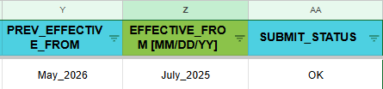

SUBMIT_STATUS Values — What Each One Means
SUBMIT_STATUS Value | Why You See It | What To Do
OK | All checks passed. The row is ready to submit. | No action needed. This row will be included in the next Submit run.
MISSING_REQUIRED_FIELDS | One or more of the required fields is empty: CATEGORY, DESIGNATION, REVISION_TYPE, PLANNED GROSS, or SKILL GROUP (for Workers). | Fill in all required fields. For Worker employees, make sure SKILL GROUP is also populated in the Employee Master.
MISSING_EFFECTIVE_DATE | EFFECTIVE_FROM is blank. | Enter the effective date in MM/DD/YY format in the EFFECTIVE_FROM column.
GROSS_MISMATCH | The calculated GROSS does not match PLANNED GROSS by more than ±1 rupee. Each salary component percentage is rounded independently, so a difference of exactly 1 is normal and accepted. A larger difference means a policy row is missing or inactive. | Check that SALARY_POLICY_MASTER has an ACTIVE row for STAFF-1 (or the latest staff policy), and that WORKER_PERCENT_POLICY has an ACTIVE WORKER row. For Workers, also confirm the SKILL GROUP is correctly set in the Employee Master. If all policies look correct, contact pmo.
SAME_MONTH_DUPLICATE | The EFFECTIVE_FROM month is the same as PREV_EFFECTIVE_FROM month and the employee already has a non-zero salary on record. | Verify you are not revising the same employee twice for the same month. If this is intentional (e.g., a correction), check with pmo.
DUPLICATE_ID_IN_HR_UPDATE | The same Employee ID appears more than once in the HR_UPDATE sheet. | Remove the duplicate row. Each employee should appear only once per submission batch.
PENDING_IN_APPROVAL | This employee already has a row sitting in REVISION_APPROVAL that has not been approved or rejected yet. | Wait for the current pending revision to be processed before submitting a new one for the same employee.
ALREADY_IN_HISTORY | A revision for this employee with the same effective month already exists in REVISION_HISTORY. | This revision has already been approved and recorded. If you need to correct it, contact pmo.
MAKE EMPLOYEE ACTIVE | The employee’s status in Employee Master is not ACTIVE. | Update the employee status to ACTIVE in the Employee Master before submitting a revision.

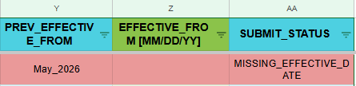
NOTE: EFFECTIVE_FROM must be entered exactly in MM/DD/YY format (example: 04/01/25 for April 1, 2025). An incorrect format will result in MISSING_EFFECTIVE_DATE status and the row will not be submitted.
Step 4: Verify SUBMIT_STATUS Shows OK
Before submitting, check the SUBMIT_STATUS column for each row. Only rows showing "OK" will be picked up by the system. If a row is showing something other than OK, it means one or more required fields are still missing or invalid — review and complete them first.
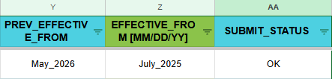
Step 5: Make Sure You Are on the HR_UPDATE Tab
This is a critical step. The Submit for Approval action has a tab guard — it will only run if you are currently on the HR_UPDATE sheet. If you accidentally run it from another tab, you will see a "Skipped" message and nothing will be submitted. Click the HR_UPDATE tab at the bottom of the spreadsheet to make sure it is active.
Step 6: Run Submit for Approval
Click the "Submit for Approval" menu at the top of the spreadsheet, then click "Run". The system will process all eligible rows (SUBMIT_STATUS = OK with all required fields filled), copy them to the REVISION_APPROVAL sheet, clear the input fields in HR_UPDATE, and send an approval email to the approver. A toast notification will appear at the bottom right of the screen showing how many rows were submitted and how many were skipped.
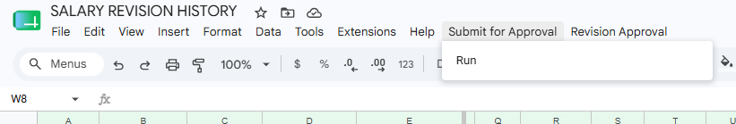

NOTE: After submission, only four fields are cleared per row: ID.NO, REVISION_TYPE, PLANNED GROSS, and EFFECTIVE_FROM. Other columns such as NAME, DEPARTMENT, and formula-based fields remain intact.

Part B — Approver: Revision Approval
Step 7: Check the Approval Email
After HR Assist submits the revision request, you (Nazneen) will receive an email from Butler Leather HR with the subject "Salary Revision Approval Request [SR-APPROVAL]". The email contains a table listing all submitted employees with their revised salary details, effective date, revision type, and percentage of change. Review this table carefully before approving or rejecting.

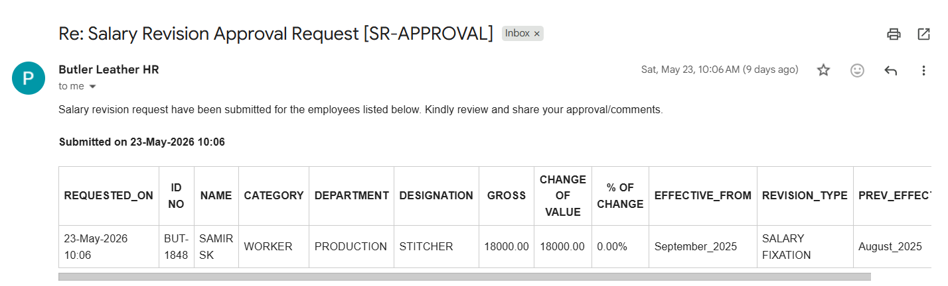
Step 8: Open the Spreadsheet and Navigate to REVISION_APPROVAL
Open the Salary Revision spreadsheet with your nazneen@butlerleather.com account. Click on the REVISION_APPROVAL sheet tab. You will see all the pending revision rows that HR Assist has submitted. Each row has an APPROVAL_STATUS column which is currently empty.
Step 9: Set APPROVAL_STATUS for Each Row
For each pending row, type either APPROVED or REJECTED in the APPROVAL_STATUS column. You can approve some and reject others in the same run. Make sure to spell the status exactly — the system checks for an exact case-insensitive match. Rows without a status set will remain untouched and will not be moved or deleted.
Note: the approver will manually verify the details against the profile before giving approval. The APPROVED status should only be entered in the dropdown once Zafar sir has physically reviewed the document and provided his signature on the revision.

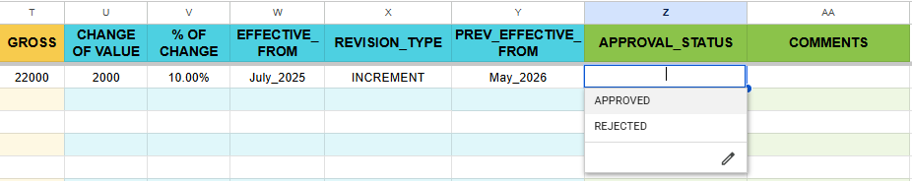

Step 10: Make Sure You Are on the REVISION_APPROVAL Tab
Just like the Submit action, the Revision Approval has a tab guard. You must be on the REVISION_APPROVAL tab when you run the action. Verify the tab is active at the bottom of the screen before proceeding.

Step 11: Run Revision Approval
Click the "Revision Approval" menu at the top of the spreadsheet and click "Run". The system will move all APPROVED rows into the REVISION_HISTORY sheet (marked as ACTIVE for payroll), move all REJECTED rows into the REJECTED_HISTORY sheet, mark previous revisions for the same employees as IN-ACTIVE, and delete the processed rows from REVISION_APPROVAL. A toast message will confirm the count of approved and rejected revisions.

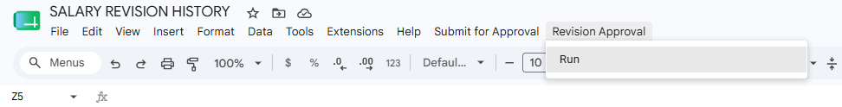
Step 12: Verify the Revision History
After running the approval, navigate to the REVISION_HISTORY sheet to confirm that the approved rows have been added correctly. The ACTIVE_FOR_PAYROLL column should show "ACTIVE" for the newly approved revisions and "IN-ACTIVE" for any older revisions of the same employees. Also check REJECTED_HISTORY to confirm rejected rows are archived.

Part C — HR Assist & Approver: Petrol Conveyance
The PETROL_CONVEYANCE_HISTORY sheet is maintained separately from the salary revision workflow. HR enters the employee ID and the petrol conveyance amount for the relevant month, and the approver sets the APPROVAL_STATUS. Only approved rows are picked up by the Payroll Generator during payroll processing.

Step 13: Open the PETROL_CONVEYANCE_HISTORY Sheet
Navigate to the PETROL_CONVEYANCE_HISTORY tab in the Salary Revision History file. This sheet tracks petrol conveyance payments separately from the main salary revision workflow. You will see employee records with columns for identity details (auto-filled), the effective month, the conveyance amount, the approval status, and an approved effective date column that feeds payroll.

Step 14: Enter the Employee ID and Petrol Conveyance Amount
In column A (ID.NO), type the Employee ID. The NAME, CATEGORY, DEPARTMENT, and DESIGNATION columns (B through E) will fill in automatically from the Employee Master. In column F (EFFECTIVE_FROM [MM/DD/YY]), enter the month this conveyance applies to. In column G (PETROL CONVEYANCE), enter the rupee amount. Leave the APPROVAL_STATUS and EFFECTIVE_FROM (col I) columns alone — these are handled separately.

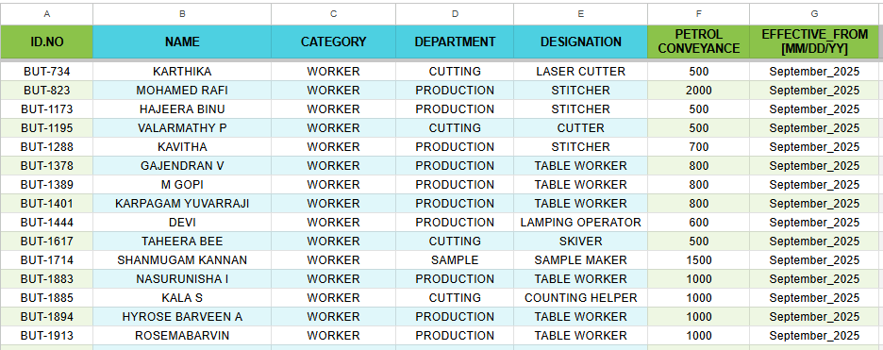

Step 15: Approver Sets APPROVAL_STATUS
Once HR has filled in the ID, effective month, and petrol conveyance amount, the approver reviews the entries and sets the APPROVAL_STATUS column (col H) to either APPROVED or REJECTED using the dropdown. As soon as APPROVED is selected, column I (EFFECTIVE_FROM) automatically shows the effective month date from col F. This is the value the Payroll Generator reads at payroll time. Rows with REJECTED or blank APPROVAL_STATUS will have a blank col I and will not be included in payroll.

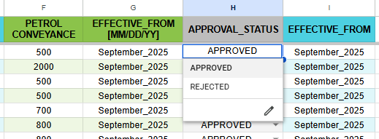

4. Monthly Workflow Summary
Step | Action
1 | HR Assist: Open SALARY_POLICY_MASTER and WORKER_PERCENT_POLICY and confirm both have an ACTIVE row for the current revision month
2 | HR Assist: If a new revision cycle has started, add a new policy row with the updated values and the new revision month — STATUS will auto-update
3 | HR Assist: Open the Salary Revision spreadsheet with the hrassist@butlerleather.com account
4 | HR Assist: Navigate to the HR_UPDATE sheet and enter the Employee ID — verify identity and old salary columns auto-fill
5 | HR Assist: Select REVISION_TYPE from the dropdown and enter PLANNED GROSS — verify new salary components auto-calculate
6 | HR Assist: Enter EFFECTIVE_FROM in MM/DD/YY format for each row
7 | HR Assist: Verify SUBMIT_STATUS shows OK for all rows to be submitted
8 | HR Assist: Confirm the HR_UPDATE tab is active, then click Submit for Approval → Run
9 | HR Assist: Note the Submitted / Skipped toast count and inform the approver that requests have been sent
10 | Approver: Check email for the "Salary Revision Approval Request [SR-APPROVAL]" notification and review the table
11 | Approver: Open the spreadsheet with the nazneen@butlerleather.com account, go to REVISION_APPROVAL, and set APPROVAL_STATUS to APPROVED or REJECTED for each row
12 | Approver: Confirm the REVISION_APPROVAL tab is active, click Revision Approval → Run, and verify REVISION_HISTORY shows the correct ACTIVE entries

TIP: If you encounter any error message not listed in Section 4, take a screenshot of the toast or error text and share it with pmo@butlerleather.com for resolution.

5. Error Messages — What They Mean & What To Do
Error Message (Example) | Why It Happened | What To Do
Skipped: open "HR_UPDATE" tab and run again. | You ran Submit for Approval while you were on a different sheet tab (e.g., REVISION_APPROVAL) | Click the HR_UPDATE tab at the bottom of the spreadsheet so it becomes active, then run Submit for Approval again
Skipped: open "REVISION_APPROVAL" tab and run again. | You ran Revision Approval while you were on a different sheet tab (e.g., HR_UPDATE) | Click the REVISION_APPROVAL tab at the bottom, then run Revision Approval again
You are not authorised to run Submit for Approval. | You are logged in with an account that is not hrassist@butlerleather.com or pmo@butlerleather.com | Switch to the correct Google account in your browser and reopen the spreadsheet
You are not authorised to run Revision Approval. | You are logged in with an account that is not nazneen@butlerleather.com or pmo@butlerleather.com | Switch to the nazneen@butlerleather.com account and reopen the spreadsheet
Submitted: 0 | Skipped: 4 | All rows in HR_UPDATE either have missing required fields or SUBMIT_STATUS is not OK | Check each row in HR_UPDATE — ensure ID.NO, BASIC, DA, HRA, CONV.ALL, SPL.ALL, EFFECTIVE_FROM, REVISION_TYPE are all filled and SUBMIT_STATUS shows OK
No APPROVED / REJECTED rows found. | You ran Revision Approval but no rows in REVISION_APPROVAL have APPROVAL_STATUS set to APPROVED or REJECTED | Go to REVISION_APPROVAL, type APPROVED or REJECTED in the APPROVAL_STATUS column for the relevant rows, then run Revision Approval again
Missing required sheet(s). Check exact tab names: HR_UPDATE and REVISION_APPROVAL. | One of the required sheets has been renamed, deleted, or does not exist in this spreadsheet | Contact pmo@butlerleather.com — a required sheet is missing and must be recreated by the system owner
HR_UPDATE missing required column: CONV.ALL | The column CONV.ALL is missing from row 1 of the HR_UPDATE sheet (column was deleted or renamed) | Contact pmo@butlerleather.com — a required column header needs to be restored in the sheet
Error: Web App call failed: ... | The connection to the Web App server failed (network issue or the Web App URL has changed) | Try again after a few minutes. If the problem persists, contact pmo@butlerleather.com to check the Web App deployment

6. Do's and Don'ts

✅ Do's
- Always make sure you are on the correct sheet tab (HR_UPDATE for Submit; REVISION_APPROVAL for Approval) before running any action.
- Enter EFFECTIVE_FROM in exactly MM/DD/YY format — for example, 04/01/25 for April 1, 2025.
- Check that SUBMIT_STATUS shows OK for every row you want to submit before running Submit for Approval.
- Review the approval email carefully before setting APPROVAL_STATUS in the spreadsheet.
- Type APPROVAL_STATUS values in all-caps exactly: APPROVED or REJECTED.
- Verify REVISION_HISTORY after each approval run to confirm ACTIVE_FOR_PAYROLL is correct.
- Contact pmo@butlerleather.com if you see a sheet error or missing column error — do not try to fix it yourself.

❌ Don'ts
- Don't run Submit for Approval from any sheet other than HR_UPDATE — it will be skipped.
- Don't run Revision Approval from any sheet other than REVISION_APPROVAL — it will be skipped.
- Don't type anything other than APPROVED or REJECTED in the APPROVAL_STATUS column — other values will be ignored.
- Don't manually delete rows from REVISION_APPROVAL — only the Revision Approval action should remove rows from this sheet.
- Don't rename any sheet tabs (HR_UPDATE, REVISION_APPROVAL, REVISION_HISTORY, REJECTED_HISTORY) — the system uses exact names.
- Don't submit a new batch while a previous batch is still pending approval in REVISION_APPROVAL — process one batch at a time.
- Don't manually edit data in REVISION_HISTORY or REJECTED_HISTORY — these are system-managed audit logs.

