Intensity and time-resolved photoluminescence analysis of horizontal and vertical phased Ruddlesden-Popper n=3 layer films.

Priyanka Mocherla

September 2017

Imperial College London

***This paper presents the results of intensity and time-resolved photoluminescence analysis of n=3 PentAMAPI Ruddlesden-Popper films and a reference MAPI film. Using a short algorithm, the photoluminescence intensity data was fitted with a gaussian line shape, and the bandgap and full-width at half maximum (FWHM) of the major intensity peaks were extracted and analysed. MAPI confirmed the results of previous studies, shown to have a bandgap around 1.6 eV and undergo a phase transition at 160K. The horizontally phased PentAMAPI film showed a constant bandgap energy and FWHM of 1.68 ± 0.01 eV and 0.91 ± 0.01 eV respectively, whilst the vertically phased films bandgap varied between 1.64 eV – 1.69 eV and the FWHM between 0.08 eV – 0.12 eV. The latter sample also displayed evidence of localisation, indicated by its inverse s-shaped bandgap and FWHM curves. By assuming a bimodal decay model for the time-resolved photoluminescence decay curves, an algorithm was written to extract the lifetimes and the amplitudes of each decay mode. Both PentAMAPI samples had dominant slow decay modes, which were of order ten times larger than the fast modes. The average lifetime of both samples was shown to peak at 150K, suggesting an increase in non-radiative recombination at higher temperatures and therefore a transition from a direct to indirect bandgap of the perovskite.***

# Introduction

Organic-inorganic perovskites solar cells have incited interest due to their efficient carrier transport, achieving power conversion efficiencies of over twenty per cent. A key issue stopping their widespread use is their instability upon environmental exposure. Habisreutinger et al. found that the degradation of standard MAPbI3 (or MAPI) perovskite devices occurs due to the hydrophilicity and volatility of the methylammonium cations (MA+), making them vulnerable to humidity and heat.[1] Through cation engineering, Ruddlesden-Popper layered perovskite devices aim to alleviate this issue and have indeed shown promising stability. By introducing an organic spacer between the perovskite layers, their increased tunability and the flexibility of their photo-physical properties makes them a popular choice for solar cell devices.[2]

Initial experiments show that Ruddlesden-Popper layered devices have a much lower efficiency of less than five per cent, associated with the prevention of out of plane charge transport due to the insulating properties of the organic cation layers. As a solution, Ruddlesden-Popper thin film devices have been synthesised to increase the out of plane transport and thus increase efficiency. It can be noted that solution processed perovskites films have been able to read efficiencies of 20%, whilst having a good level of stability in humidity and heat. [3]

The layers in a Ruddlesden-Popper perovskites are held together by a combination of columbic and hydrophobic forces. They can be regarded as multiple quantum wells where the semiconducting inorganic layers act as potential wells and the insulating organic layers act as potential barriers. Studies determined that the electronic confinement in the layers induces a generation of stable excitons with high binding energies.[4]

Most research into Ruddlesden-Popper devices has centred on the optoelectronic properties of introducing butylammonium (BA) spacers between perovskite layers. In 2016, Tsai et al. achieved a breakthrough power conversion efficiency of BA Ruddlesden-Popper films of 12.5%, with a lifetime of >2000 hours.[5]

By increasing the chain length by one, pentylammonium (PentA) is a less studied but viable candidate for a spacer, due to easy control of its phase orientation (vertically or horizontally) and phase pureness, in addition to straightforward synthesis from commercially available precursors.[2] This study will thus investigate the optoelectronic properties of PentAMAPI films using photoluminescence and time-resolved photoluminescence measurements, and compare the results to that of a reference MAPI film.

# Method

For efficient data analysis, short alorithms were written to fit the photoluminescence (PL) intensity and time-resolved photoluminescence (TRPL) measurements. These algorithms were able to automatically fit the data using specified parameters.

The photoluminescence measurements were taken at a range of temperatures between 20K and 300K, in a vacuum-sealed cryostat, for vertically (v-) and horizontially (h-) phase-orientated PentAMAPI and a MAPI reference sample. The time-resolved photoluminescence peaks were also measured in this temperature range, at wavelengths corresponding to the peak intensities in the PL data.

## The Algorithms

### Photoluminescence Peak Fitting

Figure 1 presents an example PL intensity curve for v-PentAMAPI. By assuming a gaussian line-shape for the peaks, the algorithm was written to prioritise fitting the side of the peak less affected by inhomogeneous broadening. The algorithm was suitable for fitting the major peak of the data. For analysis of sub-peaks, the algorithm would need to be extended to fit the data according to a superposition of multiple Gaussian states.

Figure : A TRPL curve of v-PentAMAPI measured at 150K. Two decay components have been identified and fitted onto the data. The fast decay component has greater amplitude than the slow component. The time scale is in natural units and time units should be multiplied by step-size (500/1024 for this data) to identify real time scales.

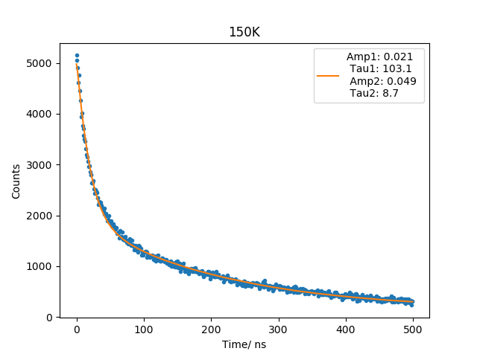

Figure : A normalised PL curve of v-PentAMAPI measured at 167K. The fit has been optimised for the low energy side, which appears more homogeneous in broadening. The multiple peaks indicate transitions, band-to-band or otherwise, occurring at this temperature. The pale blue dashed lines represent the final interval chosen for fitting, with initial settings at [1.4,1.7] eV.

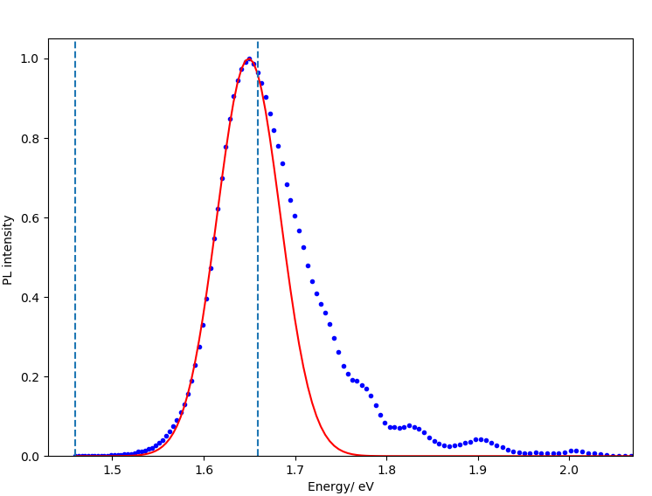

Using the LMFit package for fitting, and inputting the maximum energy interval in which the major peak is located, the algorithm was able to find a new interval in which the fit had been minimised. To ensure a sufficient number of data points were included in the fit, a tolerance parameter was incorporated and instantiated to a minimum of fifty data points.

### TRPL Decay Fitting

Analysis of the TRPL data showed that the decay curves had a multiexponential form. Due to computational limitations, a simplified biexponential model was assumed and used to fit the decay curves. Figure 2 shows an example fit of a v-PentAMAPI decay at the major peak wavelength of 750nm. The decay fitting algorithm had to take into account the instrument response function (IRF), thus a re-convolutional fit approach was used: A test function of the biexponential form in Equation 1, where and are the amplitudes and lifetimes of each decay component, was convoluted with the IRF.

(1)

By minimising the residual of the data and the trial function, the parameters were optimised to find the best fit.

# Results and Analysis

## PL Measurements

Using the fitting algorithm outlined in Section 2.1.1, the PL intensity peaks were fitted and the peak energy and full-width at half maximum (FWHM) were extracted. The visualised PL data can be found in Section 6.1.

The MAPI sample showed no obvious sub peaks, however due to the multi-peaked nature of the PentAMAPI PL data, only the main peak was fitted. The multiple peaks suggest that additional transitions between nearby valence and conduction bands in the samples occur at higher energies. These higher energy transitions were more prominent at lower temperatures, suggesting a lower carrier liberation rate at the main bandgap energy at these temperatures. The multiple peaks could also be associated with a phase impurity of the sample, producing extra peaks alongside the samples band-to-band transitions. The asymmetry of the peaks is a feature found in 2D perovskites and has been previously attributed trap states in the perovskites, which is higher in 2D materials, and therefore produces a larger effect.[6]

MAPI was confirmed to have a bandgap of approximately 1.6 eV across the temperature range, as cited in various studies.[7][8] Figure 3 shows the variation of the bandgap and the FWHM of the peak across the temperature range. It undergoes a structural change around 150K indicated by the blue-shift in both the bandgap and the FWHM. This transition is mentioned in other studies as being a transition from an orthorhombic to tetragonal phase with increasing temperature.[9] Wang et al. also found that there is a similar blue-shift with increasing pressure, as the MAPI bandgap transitions from direct to indirect, which may also apply to an increase in temperature.[10]

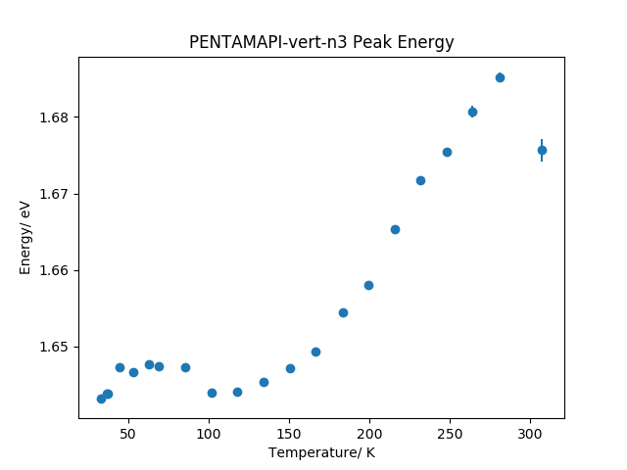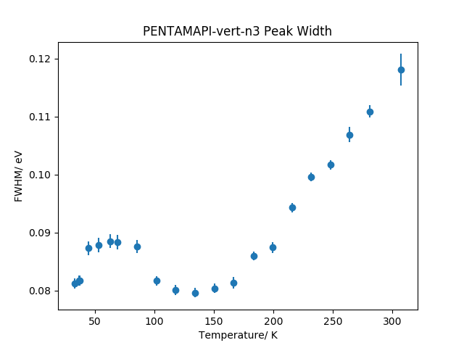

a)

b)

Figure 4: a) The change in bandgap with temperature of v-PentAMAPI has an inverse s-shaped curve, indicative of localisation effects. The sharp blue-shift could indicate a structural change of the sample. b) The FWHM also has a similar structure to the bandgap variation with a similar magnitude of variation. Errors were calculated from the fitting.

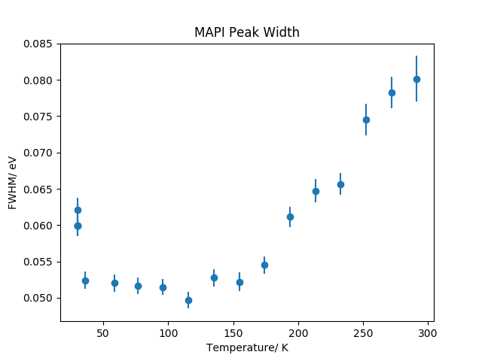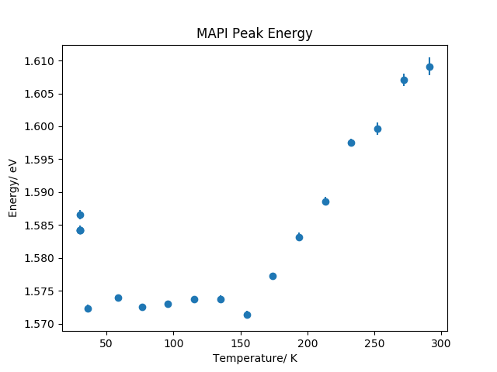

b)

a)

Figure : a) Variation of the bandgap energy with temperature for the MAPI sample. The bandgap is largely constant at low temperatures, however at 150K there is a sudden blue-shift in the energy. b) The linewidth of the MAPI peak shows a similar response as the peak energy, undergoing a blue-shift at 150K. Measurements taken at 20K can be considered anomalous. The errors were calculated from the fitting.

The peak energies and the FWHM of v-PentAMAPI showed similar results to MAPI and the peak bandgap energy varied by approximately 50 meV across the temperature range. This may indicate a structural change in the sample. Unlike MAPI however, both the linewidth and the bandgap display an inverse S-shape curve, shown in Figure 4. It has been suggested that an S-shaped curve is characteristic of localisation effects in quantum wells, as a result of the redistribution of carriers within localised states and thermal escape of carriers from higher energy states:

The model proposes that the carriers become thermally activated and relax into other strongly localised states, resulting in a red shift in peak energy and reduction in linewidth. As the temperatures increase, the carriers achieve thermal equilibrium and can occupy higher energy states, resulting in a blue shift. A rapid increase in linewidth thus occurs as carriers become thermalized. [11]

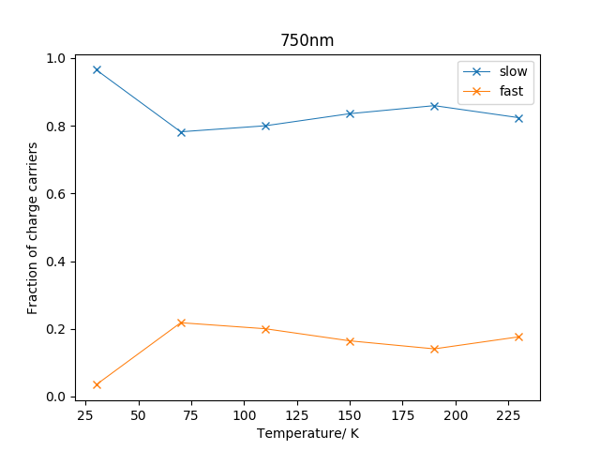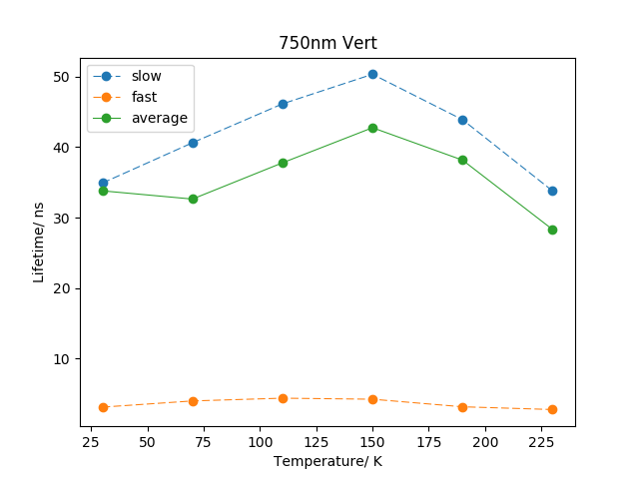

a)

b)

Figure : a) The lifetime of each fast and slow decay component of the v-PentAMAPI sample taken at 750nm, the wavelength of the major peak. The two components are clearly distinguishable and the average lifetime peaks at 150K. b) The weight of the slow decay component dominates the decay over the temperature range.

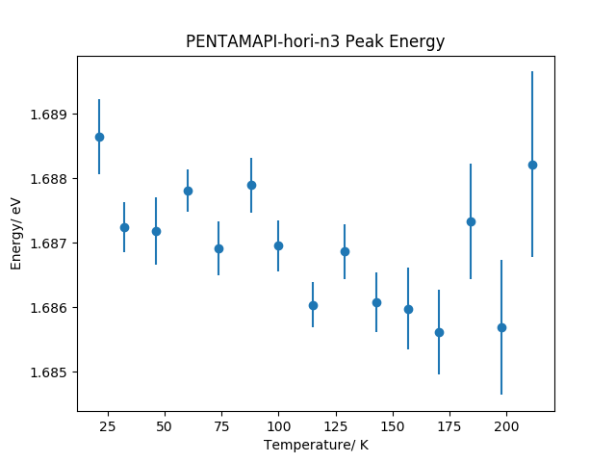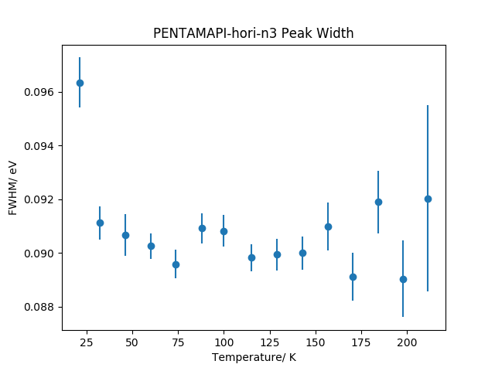

a)

b)

Figure 5: a) The bandgap energy of h-PentAMAPI does not change over the temperature range, suggesting no structural change in the sample. b) The linewidth of the peak also does not change over the temperature range. Errors were calculated from the fitting.

Applying the same analysis on h-PentAMAPI, Figure 5 displays the peak energy and FWHM relationship with temperature. Interestingly, the data shows no change in the peak energy or FWHM, within error, suggesting no structural change in the sample with temperature. The main bandgap occurs at 1.68 ± 0.01 eV with a linewidth of 0.91 ± 0.01.

## TRPL Analysis

Exciting the sample at the peak wavelengths of the PL spectra, the decay lifetimes times of the fast and slow components were extracted using the algorithm outlined in Section 2.1.2. The PentAMAPI data was fitted using a biexponential approximation, which indicated the existence of two decay components. The weight of each component was calculated using the formula:

(2)

thus, the average lifetime was calculated using:

(3)

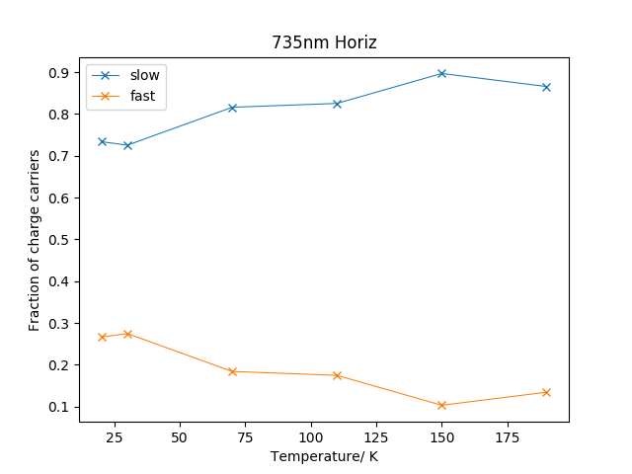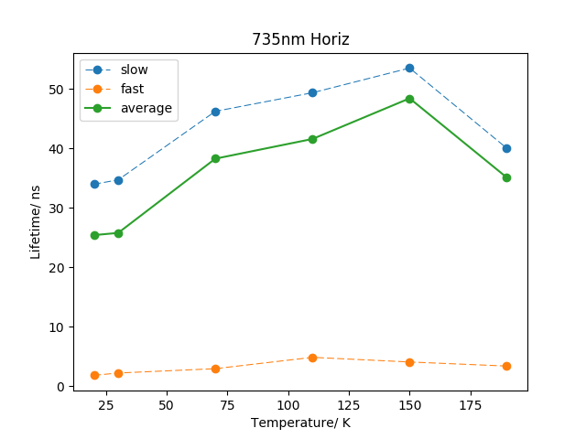

a)

b)

Figure : a) The lifetimes of the decay components and their average. The lifetime peaks at 150K, similar to the v-PentAMAPI sample. b) The slow decay component dominates the decay, and is shown to increase with increasing temperature.

Figures 6 and 7 show the weights and lifetimes of the main PL peak of each PentAMAPI sample. For both samples, at each measured wavelength, the slow decay component had a larger weight than the fast decay component, indicating that most luminescence originated from the slow process. In addition, the average lifetime of the datasets peaked at an intermediate temperature of 150K. This suggests that the radiative recombination contribution increased with temperature, however at high temperatures there was a non-radiative contribution that started to dominate.

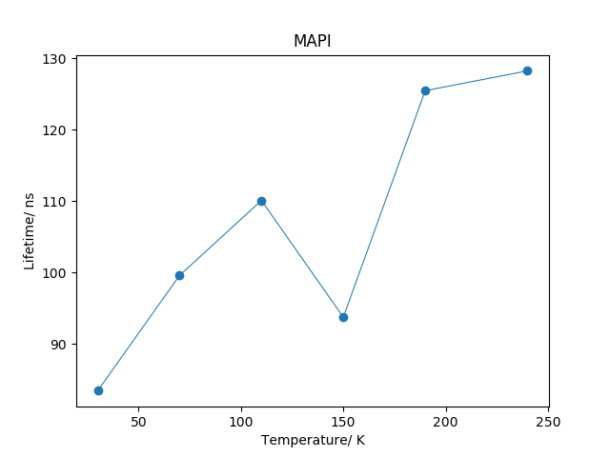

Figure 9: The average lifetime of MAPI TRPL data. The lifetime increases with temperature. Due to the high level of noise in the data and a residual error of 14ns, the data can only indicate the order of magnitude of the lifetimes.

Interestingly, the 618nm v-PentAMAPI and 620nm h-PentAMAPI transitions show no discernable slow or fast decay components, and the weight of both components vary much more than at other wavelengths. This results in a largely constant average lifetime, at higher temperatures (plots in Section 6.2)

A migration-limited process can describe the existence of two decay components: After the laser pulse reaches the sample, a fast redistribution of carriers occurs, producing the fast component of decay. After this initial effect, carriers in lower energy regions escape and recombine. Previous studies found that the low energy states occur in MAPI3-x-Clx hybrids due to surface band bending effects on the energy levels in a vacuum.[12] In addition, the increase in non-radiative recombination supports hypothesis that the sample undergoes transition from a direct to indirect bandgap with increasing temperature.

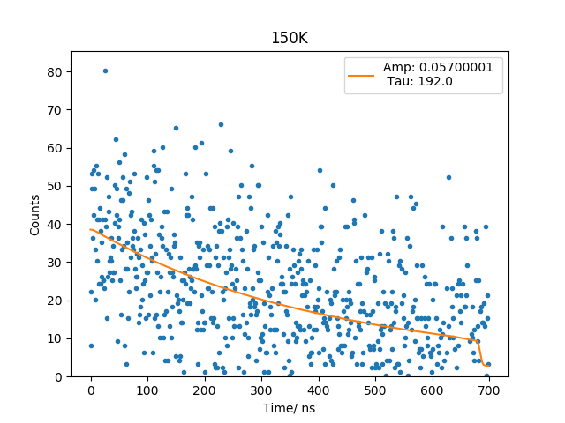

Figure 8: An example fitting of MAPI TRPL measurements at 150K. The data is not well defined, but an average fit was conducted to extract the lifetime.

For MAPI, due to the high noise level in the data, a monoexponential fit was conducted on the TRPL curves, an example shown in Figure 8. Overall, the average decay times were of order two times larger than the PentAMAPI samples and are displayed in Figure 9.

# Conclusion

In summary, PL and TRPL measurements were taken of vertically and horizontally orientated PentAMAPI samples, as well as a MAPI reference sample. Using a short algorithm, the data fitting was streamlined to extract key values.

Analysing the main peaks of each sample showed varying results as to the change in bandgap and linewidth of the peaks. h-PentAMAPI was found to undergo no obvious structural change across the temperature range, however MAPI and v-PentAMAPI showed that at around 150K a sharp blue shift in both the linewidth and bandgap occurred. This indicates a structural change occurring within the structure. More specifically however, v-PentAMAPI showed an inverse s-shaped relationship with temperature, which is attributed to state localisation and carrier redistribution.

The PentAMAPI samples both had TRPL curves indicating a two-component decay. These two components are hypothesised to be due to trapped states, possibly a product of band bending, which has been previously evidenced in MAPI. The transition from a direct to indirect bandgap in MAPI could also support the fact that the lifetimes on average tended to peak at intermediate temperatures. Overall, the MAPI carrier lifetime was longer than that of the PentAMAPI samples, although the slow decay component of the PentAMAPI sample decays dominated carrier transport across the temperature range, excluding measurements taken at 620nm.

# References

[1] Habisreutinger, S. N.  McMeekin, D. P. Snaith, H.J. and Nicholas, R. J. (2016) Research Update: Strategies for improving the stability of perovskite solar cells, *APL Materials*4, 091503, available from DOI: <http://dx.doi.org/10.1063/1.4961210> [Accessed 10th September 2017]

[2] Tsai, H et al. (2016) High-efficiency two-dimensional Ruddlesden–Popper perovskite solar cells *Nature* **536**, 312–316, available from DOI: 10.1038/nature18306 [Accessed 9th September 2017]

[3] Cao, D.H. et al. (2017) Thin Films and Solar Cells Based on Semiconducting Two-Dimensional Ruddlesden–Popper (CH3(CH2)3NH3)2(CH3NH3)*n*−1Sn*n*I3*n*+1 Perovskites. *ACS Energy Lett.*, *2* (5), 982–990, available from DOI: 10.1021/acsenergylett.7b00202 [Accessed 9th September 2017]

[4] Stoumpos, C.C, et al. (2016) Ruddlesden−Popper Hybrid Lead Iodide Perovskite 2D Homologous Semiconductors. *Chem. Mater.*, **2016**, *28* (8), 2852–2867, available from DOI: 10.1021/acs.chemmater.6b00847 [Accessed on 10th September 2017]

[5] Koh, T.M. Febriansyah, B. Matthews, N. (2016) Ruddlesden-Popper Perovskite Solar Cells. *Chem*, 2 (3) 427-440, available from DOI: [https://doi.org/10.1016/j.chempr.2017.02.015](https://doi.org/10.1016/j.chempr.2017.02.015" \o "Persistent link using digital object identifier" \t "_blank)

[Accessed 8th September 2017]

[6] Wu, X. et al. (2015) Trap States in Lead Iodide Perovskites. *J. Am. Chem. Soc*. 2015, 137, 2089−2096, available at DOI: [10.1021/ja512833n](https://doi.org/10.1021/ja512833n) [Accessed on 10th September 2017]

[7] Nayak, P. (2017) How to Avoid Artifacts in Surface Photovoltage Measurements: A Case Study with Halide Perovskites. *J. Phys. Chem. Lett*., 8 (13), 2941−2943, available at DOI: 10.1021/acs.jpclett.7b01332 [Accessed on 10th September 2017]

[8] Butler, K.T. et al. (2014) Band alignment of the hybrid halide perovskites CH3NH3PbCl3, CH3NH3PbBr3 and CH3NH3PbI3. *Mater. Horiz.*, 2, 228-231 available at DOI: :10.1039/C4MH00174E [Accessed on 10th September 2017]

[9] Whitfield, P.S. et al. (2016) Structures, Phase Transitions and Tricritical Behavior of the Hybrid Perovskite Methyl Ammonium Lead Iodide.*Sci Rep*. 2016; 6: 35685, available at DOI: [10.1038/srep35685](https://dx.doi.org/10.1038%2Fsrep35685" \t "pmc_ext) [Accessed on 9th September 2017]

[10] Wang, T. et al. (2017) Indirect to direct bandgap transition in methylammonium lead halide perovskite. *Energy Environ. Sci.*, 2017,10, 509-515,Top of FormBottom of Form available at DOI: 10.1039/C6EE03474H [Accessed 10th September 2017]

[11] Dixit, V.K. et al. (2014) A versatile phenomenological model for the S-shaped temperature dependence of photoluminescence energy for an accurate determination of the exciton localization energy in bulk and quantum well structures. *J. Phys. D: Appl. Phys*. 47 065103,

Bottom of Form

available at DOI: <http://iopscience.iop.org/0022-3727/47/6/0651030.1039/C6EE03474H> [Accessed 13th September 2017]

[12] Li, J. et al. (2017) Ambience dependent photoluminescence reveals the localization and trap filling effects in CH3NH3PbI3−xClx perovskite films. *J. Mater. Chem. C*, 2017,5, 54-58, available at DOI: 10.1039/C6TC04411E [Accessed 14th September 2017]

# Appendix

## PL Curve Visualisation

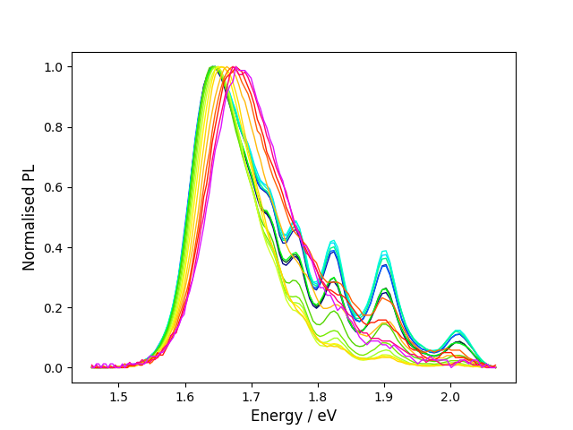 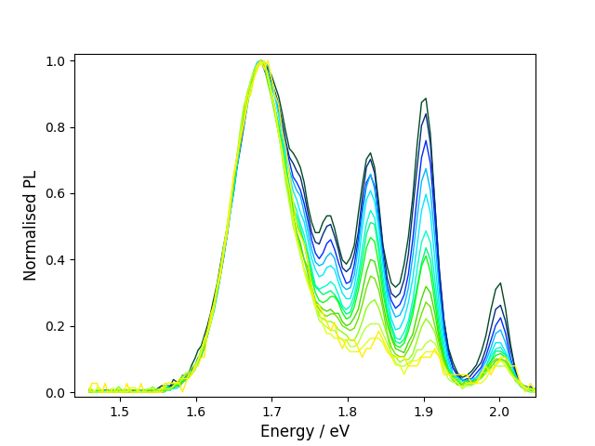

Normalised h-PentAMAPI PL curves from temperature gradient 20K – 200K of from dark blue to yellow.

MAPI PL curves from temperature gradient 30K – 300K from dark blue to red.

Normalised v-PentAMAPI PL curves from temperature gradient 30K – 280K of from dark blue to red.

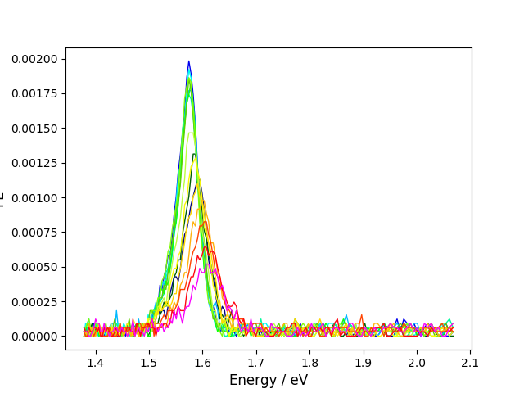

## TRPL Transitions (620nm)

Weight and lifetime plots of the decay components of the 620nm transition in h-PentAMAPI.

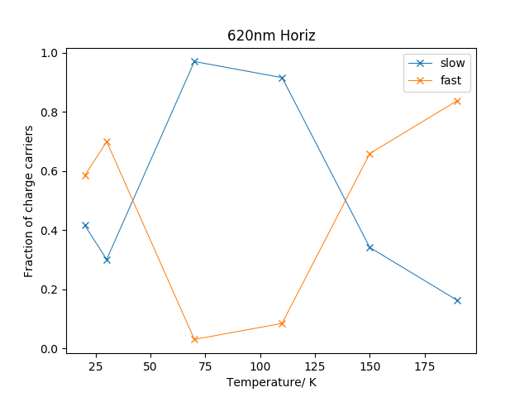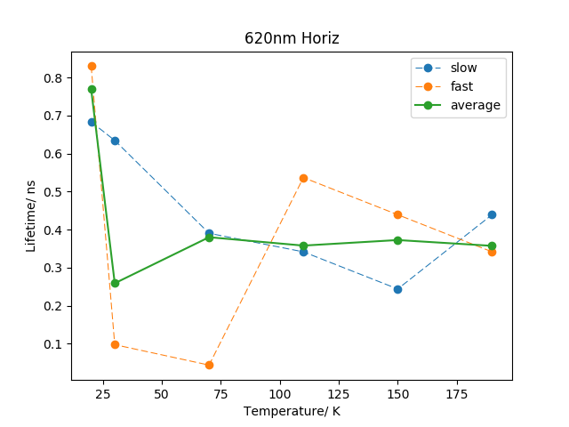

Weight and lifetime plots of the decay components of the 618nm transition in v-PentAMAPI.

