|  |  |  |  |
| --- | --- | --- | --- |
| **Title** | **BATTLE ROOMS** | | |
| **Tag Line** | **“Leave your friends behind!”** | | |
| **Authors:** | Katrina Anderson  Patrick Modafferi  Christopher Di Fulvio  Matthew Tam | | |
| **Genre** | Party Game - Adventure | | |
| **Platforms** | Xbox 360 (2D) | | |
| **Market** | Recreational Gamers, Families  *Logo or Box Art* | | |
| **Setting** | Magical room that hosts a series of mini games players must win to escape an evil wizard | | |
| **Plays Like** | Mario Party | meets | Wario Ware |

**Summary**:

Four friends are trapped by an evil wizard in a magical room. The room has the magic ability to transform completely, transporting players to imaginary places in a flash. The wizard forces them to compete in a series of cruel yet comical mini games. Players who perform well in these games are rewarded. For those who loose, the consequences are dire.

The competitive aspect will play out like an elimination based tournament where only one player survives and is crowned champion of the magical wizard games. The mini games will be randomly selected from a list. These games are short survival, timing and reflex based games which can be free-for-all, 2vs. 2 or 1 vs. 3. Players can also opt to select mini games from a list as opposed to the more competitive story mode.

|  |  |  |
| --- | --- | --- |
| **Mechanics** | 1. Gladiator | 3. Precision Timing |
| 2. Mini Games | 4. Team Coordination |

|  |  |  |
| --- | --- | --- |
| **Reference Art** | 1. Final Fantasy I to VI | 4. The Holodeck (Star Trek) |
| 2. Mario Party | 5. Dreamatorium (Community) |
| 3. Wario Ware | 6. Secrets of the Mirage |

**Related Games:**

1. *Mario Party 9*, Wii; Nintendo, 2012

Mario Party 9 is the latest installment in its franchise and, like Battle Rooms, is a mini-game based console game. Similar to Mario Party, Battle Rooms’ mini games can feature up to four human players and can be a free-for-all, 2 vs. 2 or 3 vs. 1. In addition, Battle Room has two game play types: “Tournament” and “Mini Games”, much like Mario Party’s “Party Mode” and “Minigame Mode.” Battle Rooms will be aimed at the same demographic as Mario Party; Social situations for people of all ages who wish to enjoy a light gaming atmosphere.

2. *Fuzion Frenzy*, Xbox & Xbox 360; Microsoft Game Studios, 2001

Fusion Frenzy is also a party genre program composed of mini-games that can be played by up to 4 human players. Like Battle Rooms, Fusion Frenzy features two game modes: "Tournament" or "Mini-Game Frenzy" and is aimed at the same demographic, everyone.

3. *Rayman Raving Rabbids;* Wii; Ubisoft, 2006

Rayman Raving Rabbids is a party game where up to four players play in two different modes. The more important to Battle Rooms of these two is the 'Score mode'. This mode allows the players to get points for each mini-game that they play. The player with the most points at the end of a set number of mini-games is declared the winner.

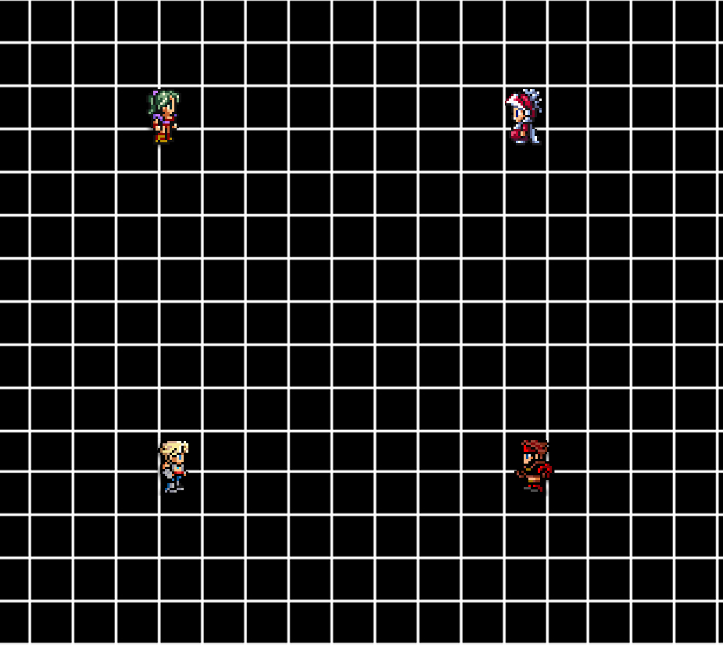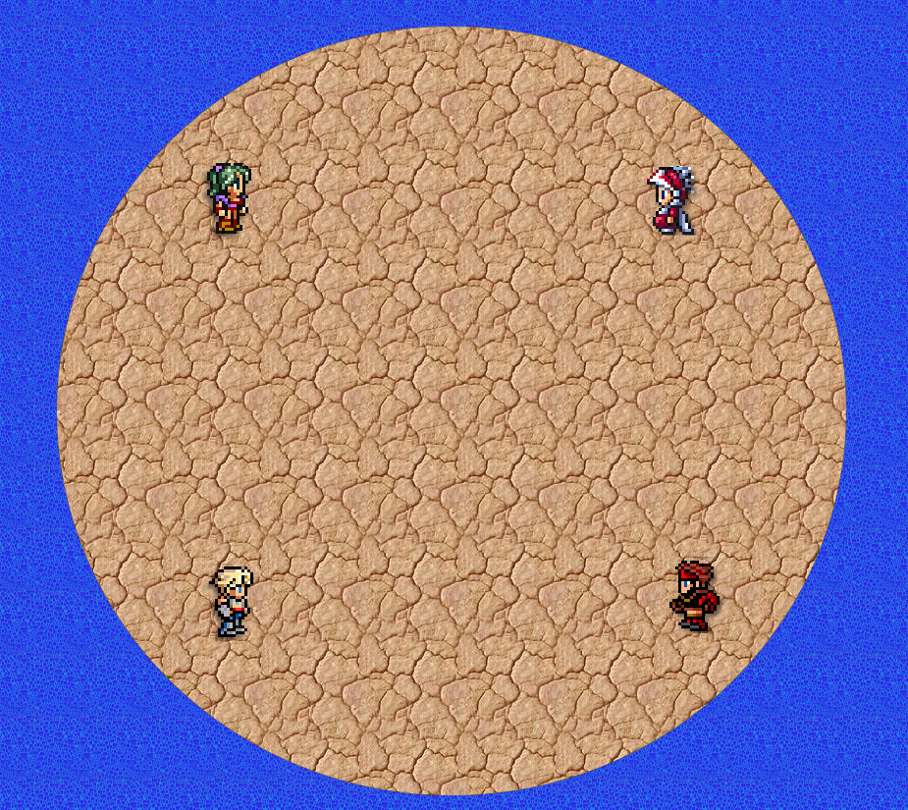

*Supporting Screenshot*