Why trapped?

Evil Wizard plays games .beats his favorite game. Bored of playing it on TV wants the real thing.

Why Them?

Seeks out the developers. 4 of them. Makes them play in the mini games they created

Whats the reward?

Winner faces the wizard at his own game.

**INT. DARK ROOM – WIZARD’S HOUSE**

Background: A “holodeck” looking room, with the main menu music playing.

NARRATOR

An evil wizard named Kostaba once lived in a faraway place. Despite being evil, he was a regular person when it came to hobbies. He enjoyed fishing, baseball but most of all gaming. His favorite game was Battle Rooms, a multiplayer party game (yes like Mario Party) created by 4 young developers. One day, Kostaba grew weary of the same old games.

[Press A to continue]

So Kostaba did what any rational evil wizard would do; he kidnapped the game developers and trapped them in a room. After the wizard demanded them to create for him a new Battle Rooms game, the lead developer explained that this could not be done since the copyrights belonged to Apple.

[Press A to continue]

A new idea arose, the wizard could re create the game using his spectacular magic powers while the developers would compete for the championship. The prize for victory would be a single wish granted by the wizard…

[Press A to continue]

**EXT. FOREST – NIGHT – INSTRUCTION SCREEN**

Background: A forest with a bright moon, where the wizard stands. The Mario Party instruction music plays. A parchment to the left of the screen displays the following instructions:

DescriptionLumberjack*

[Press A to continue]

**EXT. FOREST – NIGHT – LUMBERJACK BUSTLE MINI GAME**

Background: A thick forest with a vortex spinning behind each player. The Benny Hill theme music plays.

[End Mini Game]

**SCORE SCREEN**

Background: The “holodeck” looking room, with rising colored bars that represent the score of each player. The “Mario Party” instruction music plays.

[Press A to continue]

WIZARD

Your next test will be a team game. Let’s balance out the teams by matching 1st place with last place.

[Press A to continue]

**EXT. UNICORN FOUNTAIN – DAY – INSTRUCTION SCREEN**

Background: A sparkly unicorn is the background, while the wizard stands before the players. The “Mario Party” instruction music plays. A parchment to the left of the screen displays the instructions:

DescriptionBB*

[Press A to Continue]

**EXT. FROZEN ICECAP – DAY – BUMPER BALLS MINI GAME**

Background: An icecap surrounded by water that is slowly melting. The “Benny Hill” music plays.

[End Mini Game]

**SCORE SCREEN**

Background: The “holodeck” looking room, with rising colored bars that represent the score of each player. The “Mario Party” instruction music plays.

[Press A to continue]

WIZARD

PLAYER X seems to be doing poorly. However! This can still be anybody’s game. Our lucky loser has a chance to redeem themselves with a win on this 1 vs. 3 type game.

**INT. VOLCANO – DAY – INSTRUCTION SCREEN**

Background: The evil wizard stands in front of a fiery volcano that looks to be ready to erupt. The “Mario Party” instruction music plays. A parchment to the left of the screen displays the following instructions:

DescriptionFT*

[Press A to continue]

**INT. VOLCANO – DAY – BUMPER BALLS MINI GAME**

Background: The interior of the volcano is split into two levels, with the lowest scoring player on the top level and the remaining three players on the bottom. There are two roaring fires on either end of the screen where the three players are running.

[End Mini Game]

**SCORE SCREEN**

Background: The “holodeck” looking room, with rising colored bars that represent the score of each player. The “Mario Party” instruction music plays.

[Press A to continue]

WIZARD

Ladies and gentlemen, our two finalists await their final test. Who will be the last one standing . . .

[Press A to continue]

**EXT. DRY DESERT – DAY – INSTRUCTION SCREEN**

Background: The evil wizard stands in the middle of huge sand dunes. The “Mario Party” instruction music plays. A parchment to the left of the screen displays the following instructions:

DescriptionDuel*

[Press A to continue]

**EXT. SWIRLING SAND PIT – DAY – DUELING DUNES MINI GAME**

Background: A swirling sand pit pulls the two dueling players towards the middle. The “Benny Hill” theme music plays.

[End Mini Game]

**SCORE SCREEN**

Background: The “holodeck” looking room, with rising colored bars that represent the score of each player. The “Mario Party” instruction music plays.

[Press A to continue]

**INT. DARK ROOM – WIZARD’S HOUSE – CLOSING SCENE**

WIZARD

Congratulations PLAYER X (player who wins Dueling Dunes)! You have won, what is your wish?

[Press A to continue]

NARRATOR

Even though these games were fun, the hero wished to return home with the rest of the team. They all missed their families and their day jobs as game developers. After crying for 6 hours, the wizard finally fulfilled his promise and granted the wish. He would have to wait for Battle Rooms 2 like everyone else.

[Press A to Continue]

Credits Roll

*Represents a Tag Name. See table in next section for the actual values.

Tags

A string localization system is used to keep track of these tags in the code. The following is the table called Strings.resx which can be used to access each of the tag values from anywhere in the code.

|  |  |  |  |
| --- | --- | --- | --- |
|  | Tage Name | Tag Value |  |
|  | AButtonDuel | Run |  |
|  | AButtonFT | Jump / Shoot |  |
|  | AButtonLumberjack | Jump |  |
|  | BButtonDuel | Run |  |
|  | BButtonFT | Special Attack |  |
|  | ChooseMode | Minigames |  |
|  | Credits | Credits |  |
|  | CurrentLocale | Current culture: {0} |  |
|  | DescriptionBB | Stranded on a melting iceberg  and forced to spin uncontrollably,  you must survive this wizard`s test. Bump your so called friends  off the island to be the last player  standing. Work as a team to win.  Press "A" to start. |  |
|  | DescriptionDuel | The final test is for the two best. Fight the pull of the sinking sands  by pushing the designated button repeatedly. Watch your opponent  sink into the abyss, making you the  ultimate champion!  Press "A" to start. |  |
|  | DescriptionFT | One will throw fire, while the others flee in this wizard's test. Setting three ablaze will allow for one to be the best.  Press "A" to start. |  |
|  | DescriptionLumberjack | Race through the wizard's  dark forest and secure your place in the living. Careful, the wizard has placed traps you must duck under, jump over or chop  through or be slowed down.  Press "A" to start. |  |
|  | DirectionalPadBB | Move |  |
|  | DirectionalPadFT | Move |  |
|  | DirectionalPadLumberjack | Slide |  |
|  | ExitGame | Exit Game |  |
|  | LeftStickFT | Move |  |
|  | PressAContinue | Press "A" to continue |  |
|  | ScoreTitle | Scores |  |
|  | StoryMode | Story Mode |  |
|  | TitleBB | Bumper Balls |  |
|  | TitleDuel | Dueling Dunes |  |
|  | TitleFT | Fireball Tactics |  |
|  | TitleLumberjack | Lumberjack Bustle |  |
|  | XButtonDuel | Run |  |
|  | XButtonFT | Duck |  |
|  | XButtonLumberjack | Slash |  |
|  | YButtonDuel | Run |  |

Note: Any other tags found in the gam are N/A by default

## Primary Market:

### Casual Gamers Profile

TJ Newbie is a 17-year-old student who just graduated high school. He lives with his parents who grant him a generous allowance of $5 per week. He is outgoing with many friends. He likes to play competitive games with his friends on the weekends, like Super Smash Bros Brawl and NHL 13. He owns an iPhone 4 where he likes to play Angry Birds, Bejeweled and The Simpsons Tapped Out when he is on the bus. He prefers games that don’t take up a lot of time and that he can play with groups of people. He is also a soccer fan, and plays on his team three nights a week. When he is not playing games, studying or playing soccer, he likes to watch Criminal Minds and Bones on TV.

## Secondary Market:

### Children Gamer Profile

Emma Von Vlunjgervoot is a 10-year-old girl who is in primary school. She is a very social girl who likes to make friends. She likes to play outside and paint. Her favorite uncle usually gives her video games for the holidays and her birthday, like Club Penguin and Super Mario for her Nintendo DS. She also likes to play board games with her family. She isn’t allowed to play games until she has finished all her homework. On the weekends, she likes to watch morning TV on the Disney Channel like iCarly and Hannah Montana. She also listens to the sounds of Justin Bieber and One Direction on her iPod Touch.

### Family Gamers Profile

Michael is a family man. He has a wife and two kids. He is a history professor who works many hours in one week. His wife is a bank teller, and his two kids are both students in middle school. They all have different interests and schedules, so Michael has set aside one day a week where they do activities together as a family. They like to play board games like Monopoly and The Game of Life. They also tend to play games on their Wii together, like Mario Kart and Wii Sports. Sometimes they will go to a movie in theatres together, usually choosing action movies like those from Marvel. When possible, Michael likes to invite his sister and her family over, so that all of the cousins, aunts and uncles can bond and spend time together, often playing sports like touch football or ball hockey.

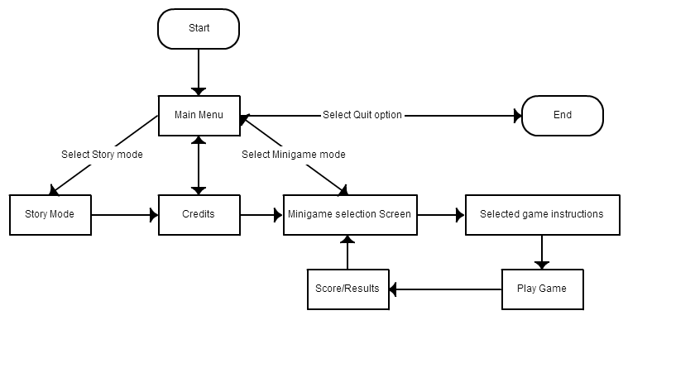Plot graph for menus

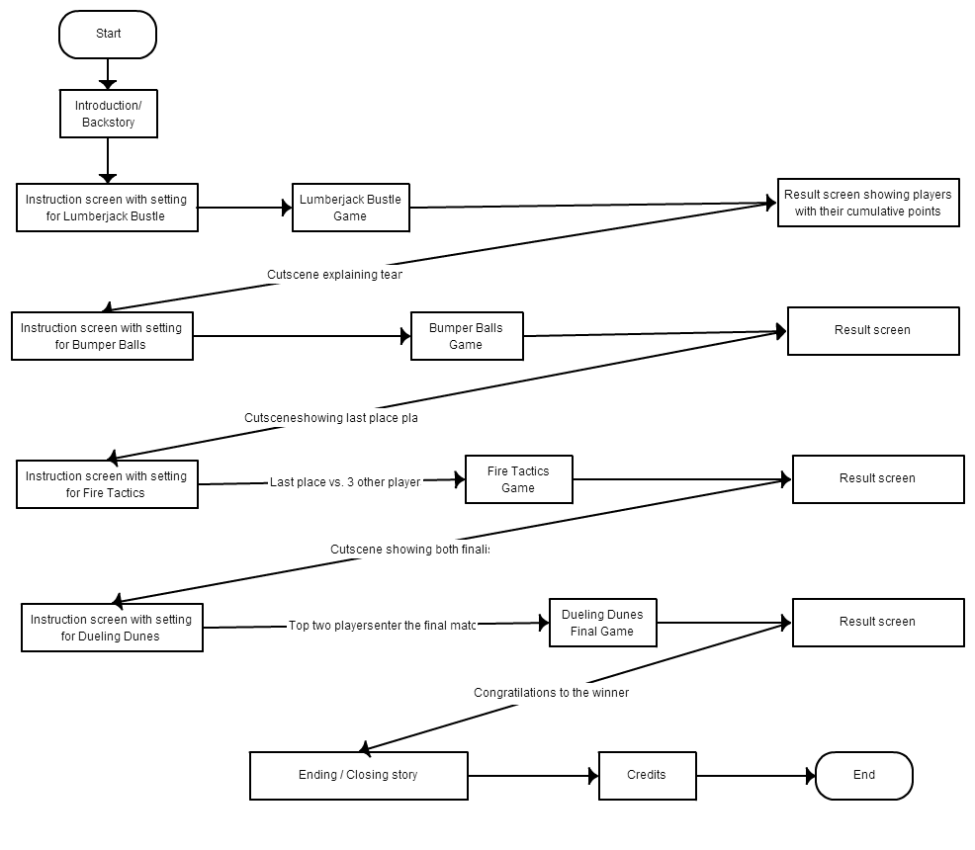

World

Setting

Era: Sometime in the mid-near future.

Theme: Fantasy mixed with science fiction.

Tone: Light, family friendly and slight humor.

Narrative

The Evil Wizard plays video games in his spare time. He gets bored of playing the same old games on TV wants a more fully immersive experience. He seeks out the developers and makes them play in the mini games they created. The winner receives one wish from the wizard.

Please refer to section “6 – Characters“ for back story on the characters in the world

Please refer to section “10 – Script and Dialogue” introduction part for motivations and premise for gameplay

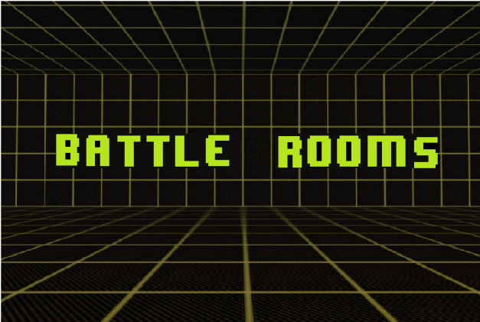Overview

|  |  |  |  |
| --- | --- | --- | --- |
| **Title** | **BATTLE ROOMS** | | |
| **Tag Line** | **“Leave your friends behind!”** | | |
| **Authors:** | Katrina Anderson (9106251)  Patrick Modafferi (9401377)  Christopher Di Fulvio (9614605)  Matthew Tam (9675701) | | |
| **Genre** | Party Game (Mini Game) - Adventure  *Logo or Box Art* | | |
| **Platforms** | Xbox 360 (2D) | | |
| **Setting** | Magical room that hosts a series of mini games players must win to escape an evil wizard. Science fiction mixed with Fantasy | | |
| **Plays Like** | Mario Party | meets | Wario Ware |

Four friends are trapped by an evil wizard in a magical room. The room has the magic ability to transform completely, transporting players to imaginary places in a flash. The wizard forces them to compete in a series of cruel yet comical mini games. Players who perform well in these games are rewarded. For those who loose, the consequences are dire.

In this document, we will discuss more in depth on the topics listed below along with tags, dialogues, UI progressions and script. Level design and controls for each mini gam will be given. This work will also contain managerial artifact like technology used, change logs, schedule, and budget and meeting times.

**Market:**

The primary target market for this game is the casual crowd of gamers who enjoy playing with others. A secondary target is families and early teen children. We will elaborate more on player profiles in section 4 of this document.

**Gameplay and Mechanics**:

The story mode will play out like a gladiator type tournament where only one player survives and is crowned champion of the magical wizard games. These mini games are short survival, precision timing and reflex based games which can be free-for-all, 2vs.2 1vs.1 or 1vs.3 and the teams will be selected based on the current scores. These teams will have to be coordinated in order to progress. Players can also opt to select mini games from a list as opposed to the more competitive story mode.

Please refer to section “15 - Mechanics Analysis” for more details

**Selling points:**

What sets this game apart from other mini game based games is the storyline which can be engaging to a general audience. This game can also be appealing due to the level of complexity of each of the mini games. Rather than settling for many simple games, battle rooms consists of fewer games which are complete with environment decor, random factors, balanced gameplay and multiple mechanics per game. Another selling point would be how expandable the game is. The framework, described in more detail in the section 12 - Software Architecture, allows for scalability and maintainability of the source code. Future iterations on the game would be simple since a mini game can simply be coded then pasted in to fit the frameworks parameters.

**Reference Art:**

The reference art for this game is a light fantasy, older styled game like Final Fantasy for the mini game universe. And a more cartoon science fiction look for the menus in the “real world” universe.

Please refer to section “8 – Art Direction” for more information about art.

**Related Games:**

Some related games include Fuzion Frenzy, Mario Party franchise and Rayman Raving Rabbids. For more related games and details on these related games refers to section 3 in this document.