|  |
| --- |
| **Concordia University**  **Department of Computer Science**  **and Software Engineering** |
|  |

|  |
| --- |
| **Touch For Food** |

|  |
| --- |
| **Architecture** |

|  |
| --- |
| **SOEN 490**  **Capstone Project**  **Fall 2012 – Winter 2013** |

|  |  |
| --- | --- |
| **CloudNine** |  |
| Josh Hum (Team Leader) | 9583157 |
| Katrina Anderson | 9106251 |
| Cristian Asenjo | 9280014 |
| Christian Daher | 9599673 |
| Cynthia Donato | 9353852 |
| Mikhail Levkovsky | 9583165 |
| Patrick Modafferi | 9401377 |
| Ryan Nasr | 9605614 |
| Matthew Tam | 9675701 |

**Table of Contents**

1 Introduction 6

1.1 Purpose 6

1.2 Scope 6

1.3 Definitions, Acronyms and Abbreviations 6

1.4 References 6

1.5 Overview 6

2 Architectural Representation 6

2.1 Use Case View 7

2.2 Logical View 7

2.3 Process View 7

2.4 Physical/Deployment View 7

3 Architectural Goals and Constraints 8

3.1 MVC vs. 3-Tier Architecture 8

4 Logical View 9

4.1 Sequence Diagrams 9

4.2 Class Diagram 16

4.3 ERD Diagram 20

5 Process View 21

5.1 Activity Diagrams 21

5.2 State Diagrams 22

6 Physical View 24

6.1 Deployment Diagram 24

7 Size & Performance 25

8 Quality 25

9 Concurrency 25

Appendix A References 26

**List of Figures**

Figure 3‑1 Diagram for a typical MVVM Pattern that goes with MVC [1] 8

Figure 4‑1 Order Item Management Sequence Diagram 9

Figure 4‑2 Create Menu Sequence Diagram 10

Figure 4‑3 Create Category Sequence Diagram 11

Figure 4‑4 Create Item Sequence Diagram 12

Figure 4‑5 Service Request Sequence Diagram 13

Figure 4‑6 Login to Personal Profile Sequence Diagram 14

Figure 4‑7 Submit Review Sequence Diagram 15

Figure 4‑8 Class Diagram 17

Figure 4‑9 Class Diagram (Model) 18

Figure 4‑10 Class Diagram (Model) 2 19

Figure 4‑11 ERD Diagram 20

Figure 5‑1 Process Order 21

Figure 5‑2 State Diagram for Order Food 22

Figure 5‑3 Call Waiter State Diagram 23

Figure 5‑4 Login to Personal Profile State Diagram 23

Figure 6‑1 Deployment Diagram 24

**List of Tables**

Table 2‑1 Diagram Types Vs. Views 7

|  |
| --- |
| **Touch For Food** |

|  |
| --- |
| **Architecture** |

|  |
| --- |
| **Version 11.48** |

**Revision History**

|  |  |  |  |
| --- | --- | --- | --- |
| **Date** | **Rev.** | **Description** | **Author(s)** |
| 2012-09-17 | 0.00 | Document Creation | Katrina Anderson |
| 2012-09-26 | 0.01 | Contributed to Section 3 Architectural Goals and Constraints | Mikhail Levkovsky |
| 2012-09-26 | 0.02 | Contributed to Section 10 Quality | Mikhail Levkovsky |
| 2012-09-28 | 0.03 | Contributed to Section 1 and 2 | Patrick Modafferi |
| 2012-09-29 | 0.04 | Contributed to Section 8 (Physical View) and 9 (Size & Performance) | Cristian Asenjo |
| 2012-10-01 | 0.05 | Contributed to Section 5.2 and 5.3. added the figures to Table of Figures | Christian Daher/ Ryan Nasr |
| 2012-10-14 | 0.06 | Contributed to Section 7.1 | Matthew Tam |
| 2012-10-20 | 1.07 | Updated to sprint 1Contributed section 4.3 | Patrick Modafferi/ Mikhail Levkovsky |
| 2012-10-26 | 1.08 | Added Sequence Diagrams Populate Menu and updated actor goal list | Mikhail Levkovsky |
| 2012-10-27 | 1.09 | Added Communication Diagrams Populate Menu | Patrick Modafferi |
| 2012-11-04 | 2.10 | Reviewed and made minor corrections | Josh Hum |
| 2012-12-16 | 3.11 | Added clarification for load balancing solution. | Cristian Asenjo |
| 2012-12-19 | 4.12 | Removed outdated use cases, updated use case models, included use case 2.1 | Katrina Anderson |
| 2012-12-20 | 4.13 | Updated class diagram & domain model | Josh Hum & Matthew Tam |
| 2012-12-21 | 4.14 | Reviewed document and reduced redundancies | Katrina Anderson |
| 2013-01-10 | 5.15 | Added Appendix B Prototypes | Katrina Anderson |
| 2013-01-14 | 5.16 | Updated Section 3 | Mikhail Levkovsky |
| 2013-01-16 | 5.17 | Added Prototypes to the Appendix | Patrick Modafferi |
| 2013-01-27 | 6.18 | Added sequence diagram 5.3.2 and state diagram 6.4.2 | Cynthia Donato |
| 2013-01-27 | 6.19 | Review and update sections | Patrick Modafferi |
| 2013-01-28 | 6.20 | Added logging in activity diagram | Cristian Asenjo |
| 2013-01-28 | 6.21 | Added logging in sequence diagram | Cristian Asenjo |
| 2013-01-28 | 6.22 | Added Review prototype | Patrick Modafferi |
| 2013-02-02 | 7.23 | Added Communication Diagram and Sequence Diagram | Mikhail Levkovsky |
| 2013-02-02 | 7.24 | Added ERD diagram | Mikhail Levkovsky |
| 2013-02-04 | 7.25 | Added Sequence Diagram | Mikhail Levkovsky |
| 2013-02-07 | 7.26 | Added a diagram for MVVM | Patrick Modafferi |
| 2013-02-08 | 7.27 | Updated Class diagram | Christian Daher |
| 2013-02-10 | 7.28 | Added Activity Diagram 6-5 | Matthew Tam |
| 2013-02-11 | 7.29 | Added Sequence diagrams 5-6 and 5-7 | Cynthia Donato |
| 2013-02-12 | 7.30 | Added System Sequence diagram – Create Menu | Josh Hum |
| 2013-02-12 | 7.31 | Added Placing Order activity diagram | Cristian Asenjo |
| 2013-02-12 | 7.32 | Updated Domain Model | Cynthia Donato |
| 2013-02-12 | 7.33 | Reviewed SAD and added Create Review Prototype | Mikhail Levkovsky |
| 2013-02-12 | 7.34 | Reviewed SAD for formatting mistakes | Josh Hum |
| 2013-02-28 | 9.35 | Removed some sections and put them in Requirements doc and Analysis doc. Made corrections to reflect that some information is no longer here. Updated references. Fixed formatting issues. | Josh Hum |
| 2013-03-02 | 9.36 | Added SD27.1 Create Menu sequence diagram | Josh Hum |
| 2013-03-02 | 9.37 | Updated Review Sequence Diagram | Mikhail Levkovksy |
| 2013-03-02 | 9.38 | Repasted Cynthia’s SD34.1 into document. | Katrina Anderson |
| 2013-03-02 | 9.39 | Added Login to Personal Profile state diagram | Cristian Asenjo |
| 2013-03-02 | 9.40 | Added Login to Personal Profile sequence diagram | Cristian Asenjo |
| 2013-03-03 | 9.41 | Added Place order Sequence Diagram | Patrick Modafferi |
| 2013-03-05 | 9.42 | Updated section 2 | Josh Hum |
| 2013-03-05 | 9.43 | Added section on concurrency | Cynthia Donato |
| 2013-03-05 | 9.44 | Fixed state diagrams | Ryan Nasr |
| 2013-03-06 | 9.45 | Split up the Class Diagram more | Christian Daher |
| 2013-03-06 | 9.46 | Removed and Updated Activity Diagram | Matthew Tam |
| 2013-03-06 | 9.47 | Reviewed document | Josh Hum |
| 2013-03-30 | 11.48 | Reviewed document | Matthew Tam |
|  |  |  |  |

# Introduction

## Purpose

The purpose of this document is to determine, on an architectural level, how each part of the TFF application will work. These architectural diagrams represent the inner workings of the system. When it comes to implementing, developers should refer to this document to save time and maintain consistency.

There are many types of diagrams some help determine the flow of the system and some explain how components interact with one another. The class diagram shows how objects are related. Finally, some diagrams show more physical elements like the deployment diagram.

Another reason for this documentation is scalability, maintainability and reusability. In order to allow for someone to potentially expand on this project, reuse it for something else or maintain the finished product, the documentation must be able to serve as a road map or a guide for any future developer.

## Scope

The scope of the architecture artifacts cover the main components of the system. As TFF is developed, the components planned for each sprint will be designed. The resulting architecture and design diagrams will be added to the document. In this way, the document will incrementally be built up to a final document containing diagrams for the essential components in the system.

## Definitions, Acronyms and Abbreviations

Refer to the Requirements document - Appendix B Glossary and Appendix C Acronyms for a complete list of terms and definitions.

## References

Please see Appendix A, References, of this document.

## Overview

The document is organized into four main views to show four of the 4+1 architectural views: Logical, Development, Process and Physical (See section 2 for more details). The Use Case view can be found in the Analysis document. As needed, other items will be discussed such as Quality, Size and Performance. This document will also discuss architecture styles and constraints as well as a comparative analysis to justify some decisions that were taken. As a whole, the document should completely represent all the architecture of the system.

# Architectural Representation

Section 2 of this document provides a summary of the architecture that represents TFF. The remaining sections represent the four of the 4+1 views of the TFF system. This section of the document summarises what architectural artifacts are found in each view.

Table 2‑1 Diagram Types Vs. Views

|  |  |  |  |  |
| --- | --- | --- | --- | --- |
| Views | Use Case | Logical | Process | Physical |
| Diagram Types | Actor-Goal List | Domain Model | Activity Diagrams | Deployment Diagram |
| Use Case Diagrams | Class Diagram | State Diagrams |  |
| Use Cases | Sequence Diagrams |  |  |

## **Use Case View**

The use case view represents important requirements through fully detailed use cases. Use case designations are also represented through actor goal lists and use case models.

## **Logical View**

The logical view determines how the layers, packages, classes and other software elements are organized in the system.

## Process View

The process view illustrates processes and threads in the system. Could show how some elements interact and collaborate throughout a process.

## **Physical/Deployment View**

The physical view represents the components, processes, communications and important structures of the system.

# Architectural Goals and Constraints

TFF will be designed using an MVC architecture. Reasons for choosing an MVC architecture are the following:

* Decouples presentation, data and domain logic
* Allows multiple people to work on different parts of the same project
* Promotes low coupling between different components
* Promotes organization and code reuse
* Promotes consistent and well defined interfaces between each layer

Well-structured MVC architecture will also allow us to swap out or update any component independently of the others as long as the interfaces are respected. The Model-View-View-Model architecture will also be employed, which is an extra component to the classic MVC architecture.

MVC consists of:

* Model – The models will be database driven, that will be used to represent the state of the application
* View – Determines how to present the model data to the user
* Controller – Passes the information between the user requests and the model, and vice-versa.
* View Model – Will be used when extra logic is required for the view to properly render. (see Figure 3-1)

Some constraints of the MVC architecture are:

* Tracing end-to-end flows of data can be challenging as the system grows

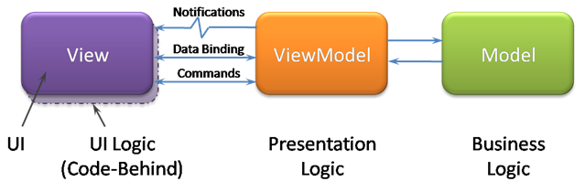

Figure 3‑1 Diagram for a typical MVVM Pattern that goes with MVC [1]

## MVC vs. 3-Tier Architecture

Since 3-Tier Architecture is used for large scale enterprise solutions which require physical separation, MVC has been chosen to develop TFF. MVC allows us to represent each component of the system as its own encapsulated part. If needed, MVC can be converted to a 3-Tier Architecture.

# Logical View

## Sequence Diagrams

### SD27.1 Order Item Management

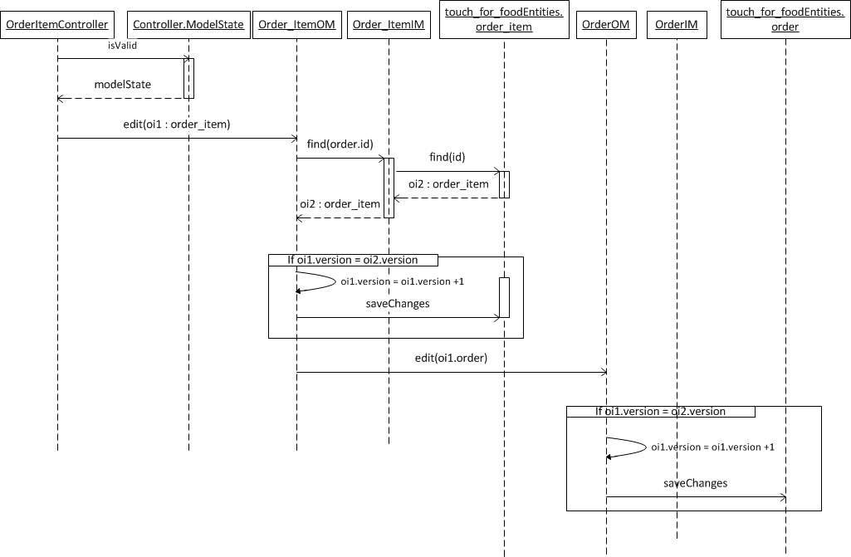

Figure 4‑1 Order Item Management Sequence Diagram

### SD27.2 Create Menu

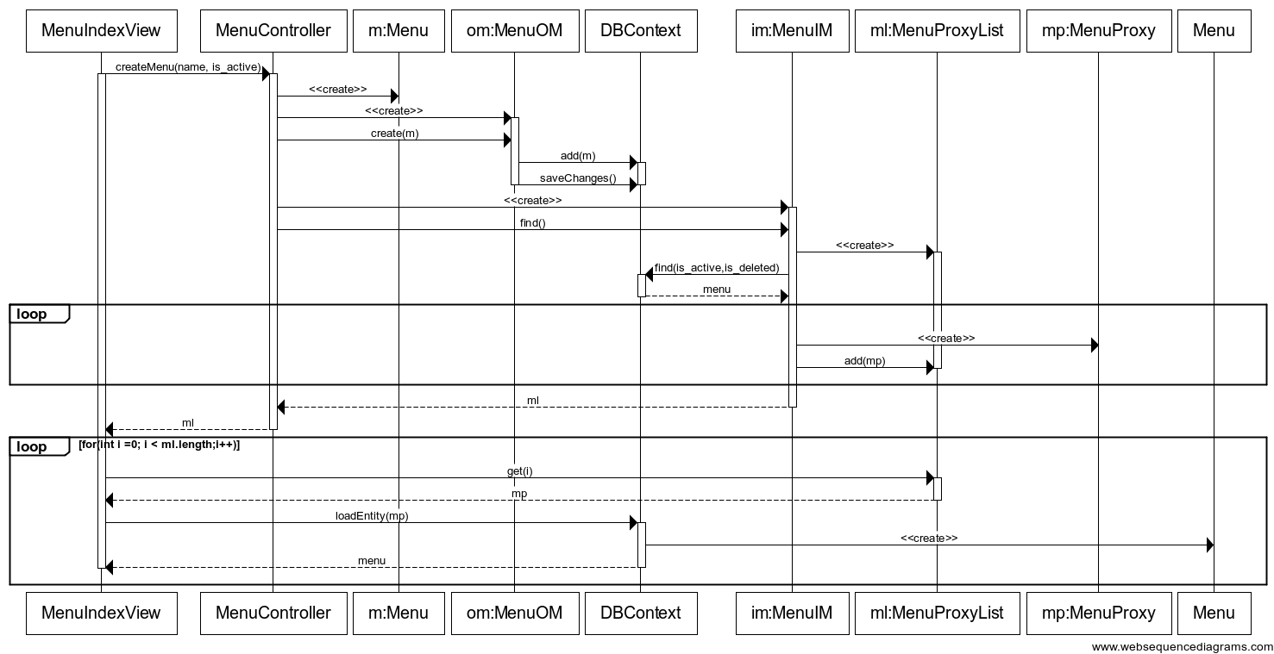

Figure 4‑2 Create Menu Sequence Diagram

### SD27.3 Create Category

To view a larger version of this diagram in a browser, follow this link: <http://goo.gl/atX2l>

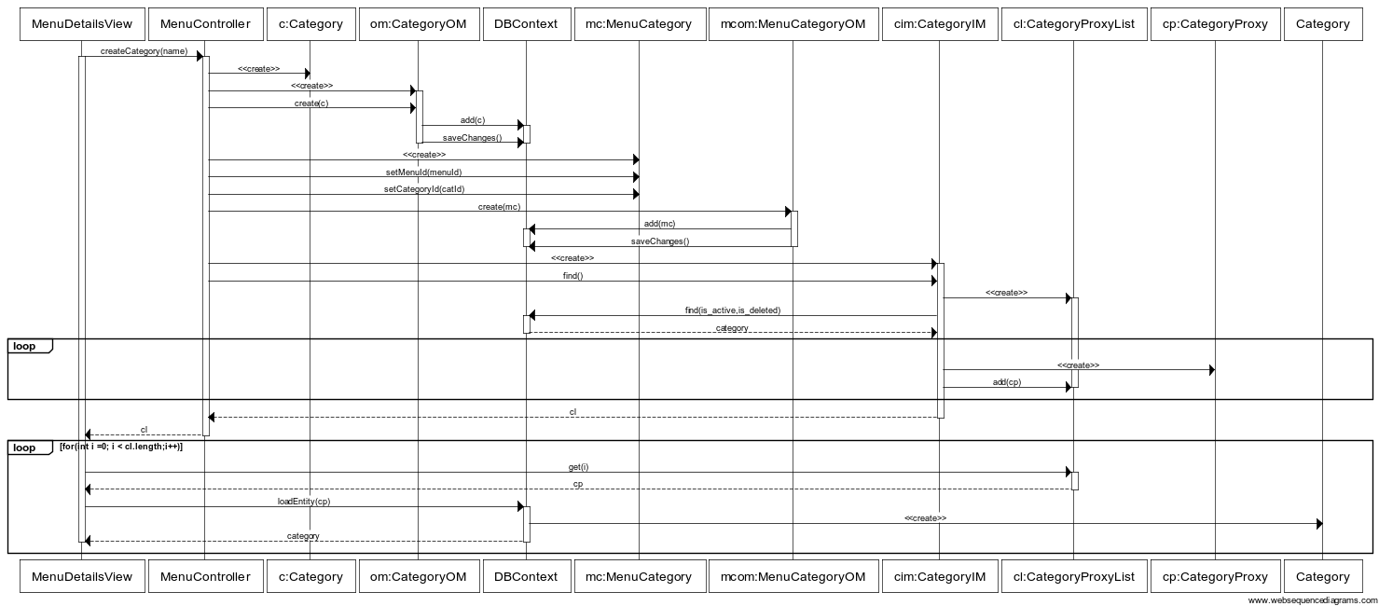

Figure 4‑3 Create Category Sequence Diagram

### SD27.4 Create Item

To view a larger version of this diagram in a browser, follow this link: <http://goo.gl/ZdqO4>

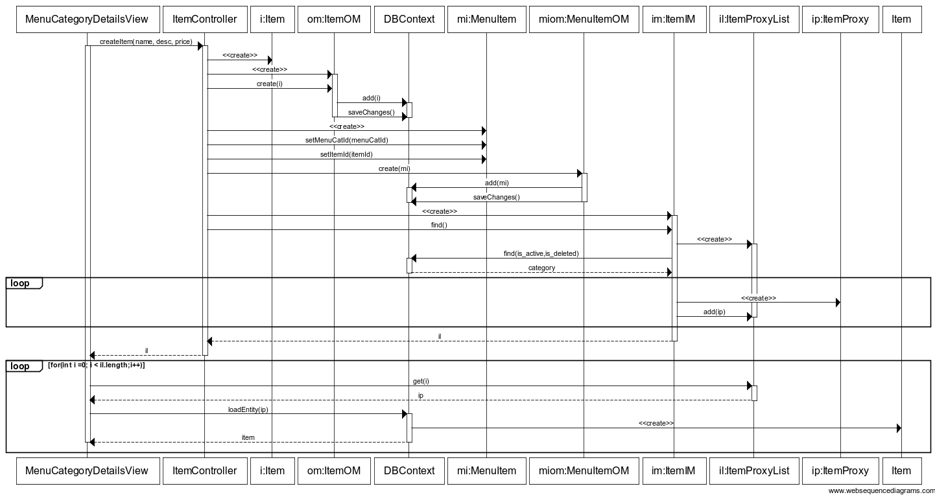

Figure 4‑4 Create Item Sequence Diagram

### SD34.1 Service Request



Figure 4‑5 Service Request Sequence Diagram

### SD35.2 Login to Personal Profile



Figure 4‑6 Login to Personal Profile Sequence Diagram

### SD39.1 Submit a Review

To view a larger version of this diagram in a browser, follow this link: <http://goo.gl/RKL6n>

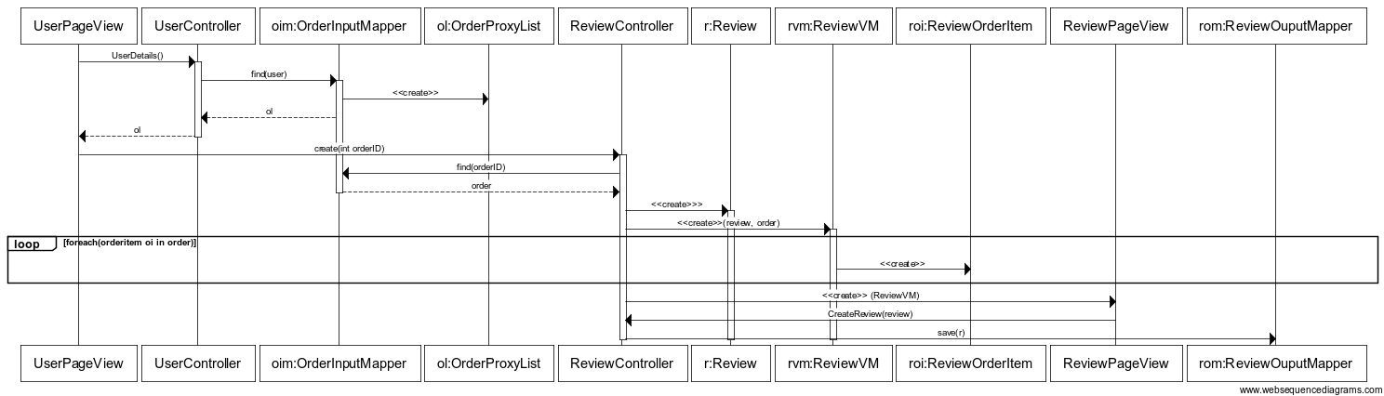

Figure 4‑7 Submit Review Sequence Diagram

## Class Diagram

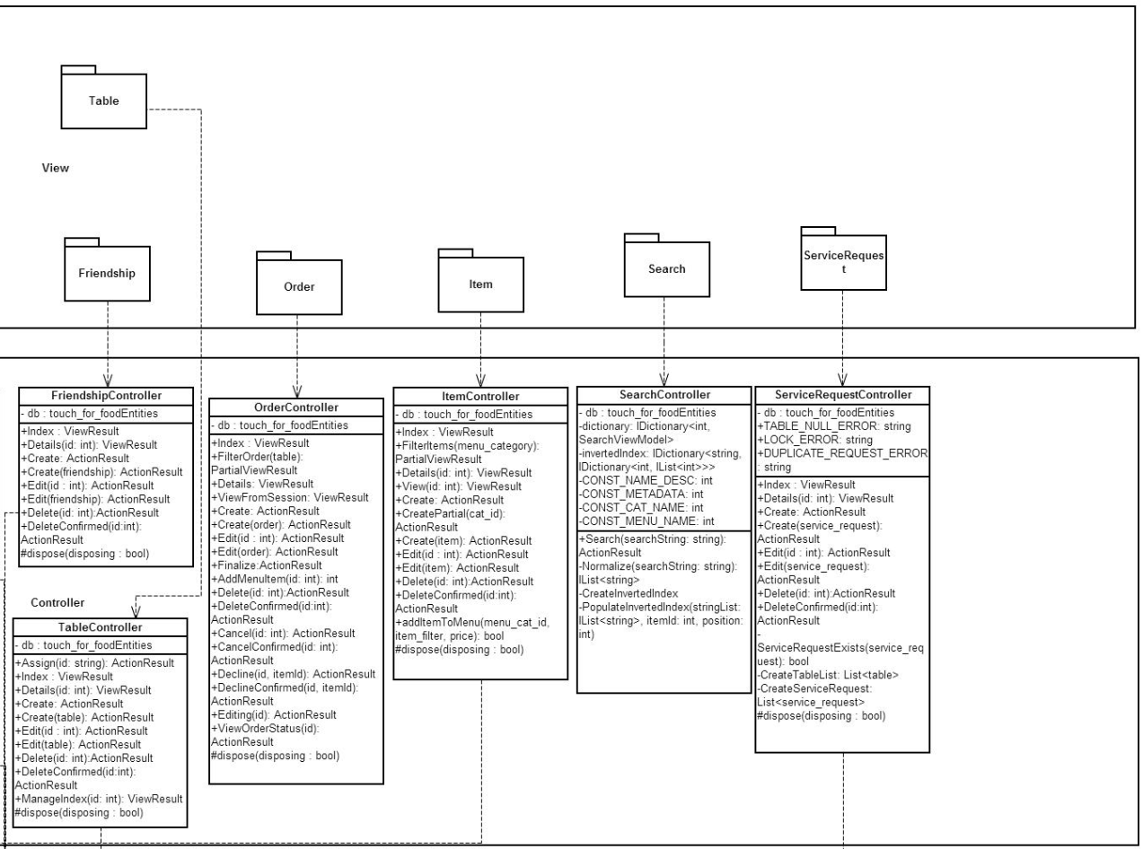

Figure 4‑8 Class Diagram

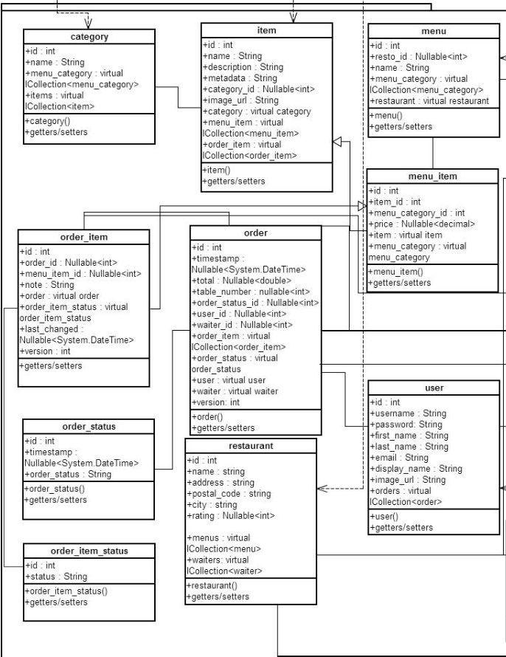

Figure 4‑9 Class Diagram (Model)

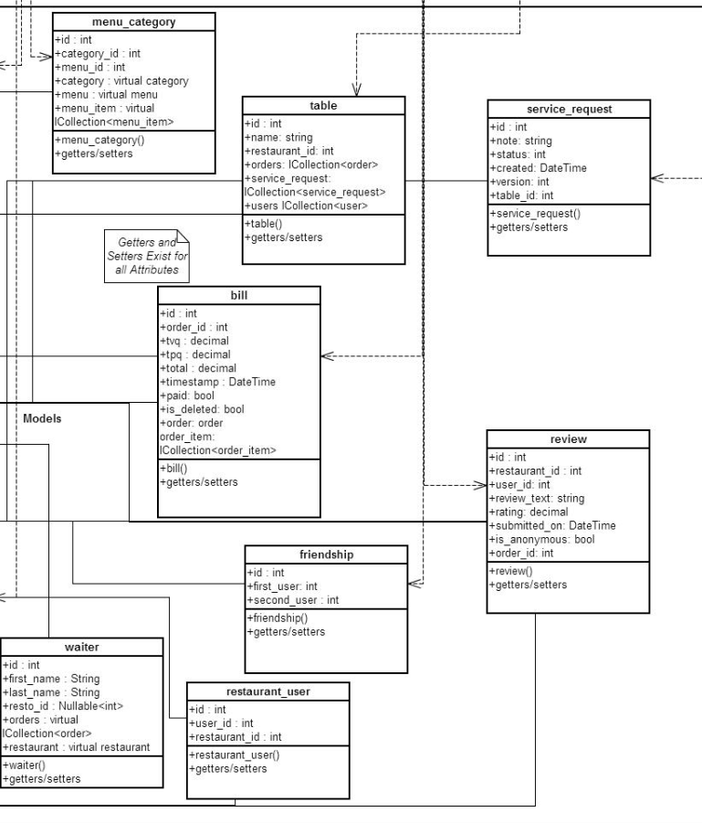

Figure 4‑10 Class Diagram (Model) 2

## ERD Diagram

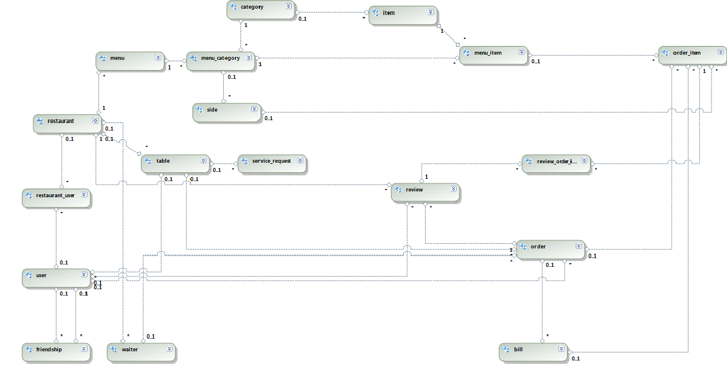

Figure 4‑11 ERD Diagram

# Process View

## Activity Diagrams

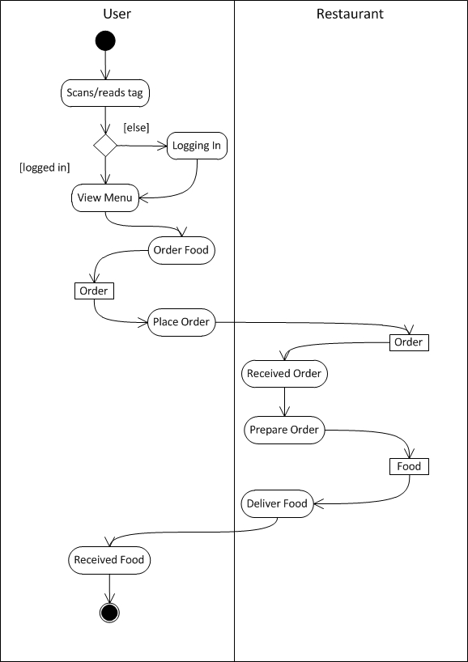

Figure 5‑1 Process Order

## State Diagrams

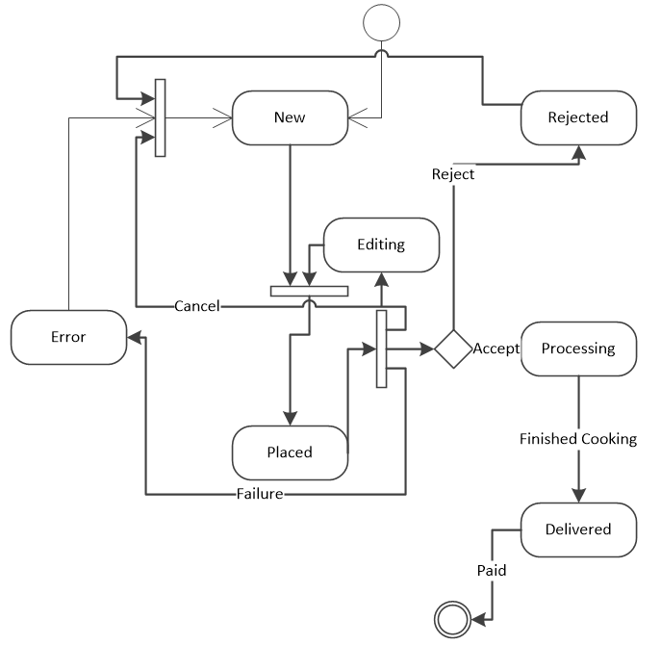

Figure 5‑2 State Diagram for Order Food

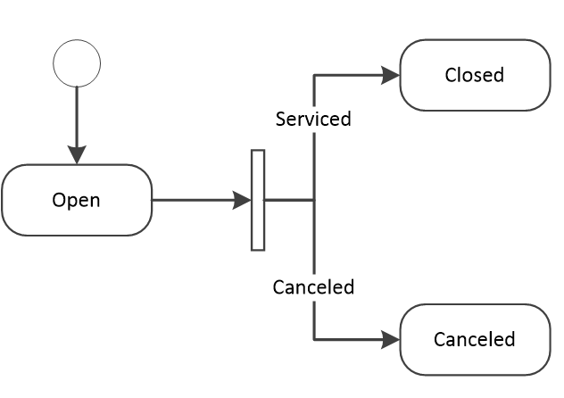

Figure 5‑3 Call Waiter State Diagram

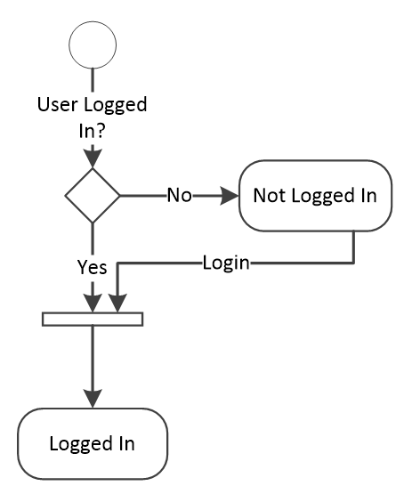

Figure 5‑4 Login to Personal Profile State Diagram

# Physical View

## Deployment Diagram

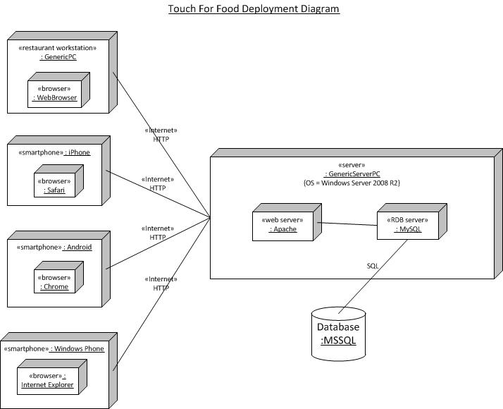

Figure 6‑1 Deployment Diagram

# ****Size & Performance****

From a backend point of view, the element that will impact the performance the most will be the .Net framework along with the MSSQL database server. Many functions used in TFF are already included in the framework and as such are optimized to work better with the MSSQL database server, as opposed to a third party solution like MySQL. Additionally, the .Net framework includes functions and tools that can be used to form relations between different elements in the most efficient way possible.

In terms of the front end, the performance will greatly depend on the power the device accessing the mobile application (or website) actually has. In order to mitigate this potential performance hit, a JavaScript library such as JQuery or Dojo will be used. Additionally, if the user is accessing the system through the mobile application, the use of native (i.e. compiled) code will also help the overall performance of it.

The size of the system will initially be small, with one server to provide the order services. When/if the system begins to grow, then more servers will have to be deployed in order to maintain a balanced load across all of them. Windows Server 2008 R2 has an optional Network Load Balancing (NLB) component which would be used in order to configure a NLB cluster. This NLB cluster would be seen by the outside world as a single virtual server which would distribute the traffic equally between each server that makes up the cluster.

# ****Quality****

TFF is being developed with quality in mind. The architectural designs have been discussed and made to ensure that the quality of TFF is high.

Maintainability, scalability, security and portability are the 4 focuses of TFF. The code base needs to be flexible and easily maintained. Bugs should be easy to locate within TFF’s code base. New and different components must be easy to add/modify. This will be ensured by keeping a consistent architecture as well as deploying necessary GRASP patterns.

Since TFF will be exposed to the internet, and it collects user data, security will also be a main focus. Steps will be taken to ensure that malicious users and hackers do not get access to the system and are not able to abuse it.

For more information on NFR related quality measures, please refer to the Requirements document, Supplementary Specifications section.

# Concurrency

The TFF application allows multiple users to access and update shared data. For this reason it was imperative that concurrency be addressed by the TFF system. The TFF system manages concurrency using an optimistic offline lock. The lock is implemented through the use of a version field in the database. All data that is stored and can be updated concurrently in the database has such a field. This field is represented by a simple integer that is incremented with each change to the particular line item in the database.

Each time an update is made to the particular line item in the database the version field is first verified to make sure that the in memory object and the stored object are the same. If they are the same, the necessary updates to that field are performed as well as incrementing the value of the version.

This ensures that if two users are accessing the same page and updating it at the same time, the user who saves first will be granted the rights to save their changes. When the second user then goes to save their changes, their save will have failed. They will be informed that someone else has updated that particular item and that they should refresh and try again.

# ****Appendix A References****

x

|  |  |
| --- | --- |
| [1] | David Hill's WebLog. (2013) http://blogs.msdn.com/b/dphill/archive/2009/01/31/the-viewmodel-pattern.aspx. [Online]. <http://blogs.msdn.com/b/dphill/archive/2009/01/31/the-viewmodel-pattern.aspx> |

x