Code Analysis Settings

# Set up

1. Right click on the solution and choose “properties.”

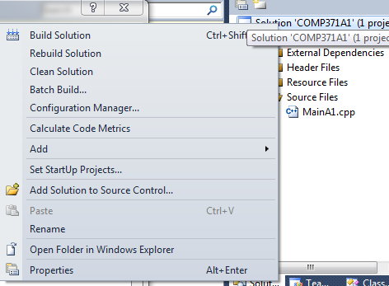

2. In the left hand pane, expand the “Code Analysis” node.

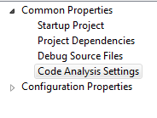

3. Change “Microsoft Minimum Recommended Rules” to “Microsoft All Rules” for every project and click okay.

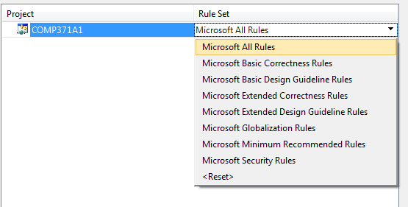

# Overriding a warning

At times you will get rules or warnings that you may evaluate to be inconsequential or useless and you will want to prevent them from appearing again. To turn off a warning do the following:

1. Right click on a project and navigate to the “Code analysis” and then “General” section of a projects properties and click open. This will open a tab in visual studio with all the warnings.

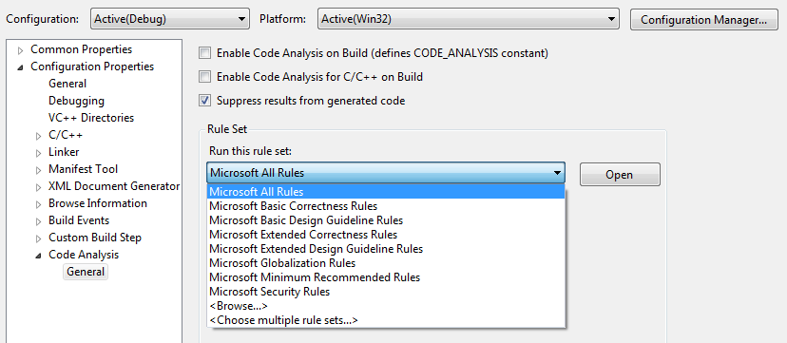

2. Use the search function to find the number for the warning you would like to turn off. For example if I want to turn off warning “CA1900.”

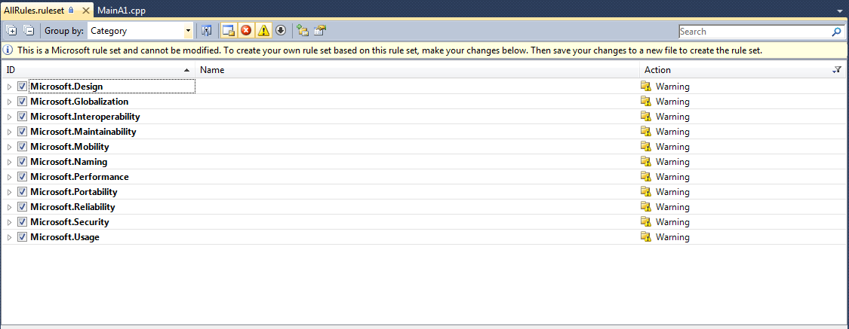

3. Uncheck the warning and save your ruleset.

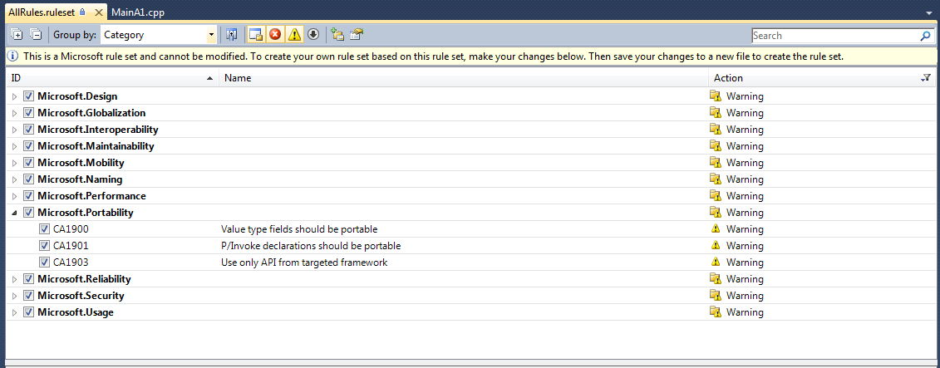

4. Change the ruleset on all your projects to your new saved custom ruleset. Right click on a project and navigate to the “Code analysis” and then “General” section of a projects properties and click browse. Choose the ruleset file you just saved.

