Code Coverage (Visual Studio 2010)

1. In the “Solution Explorer”, double click on “Test Settings.”

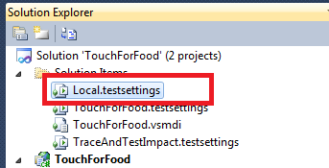

2. Select “Data and Diagnostics” and check off “Code Coverage.”

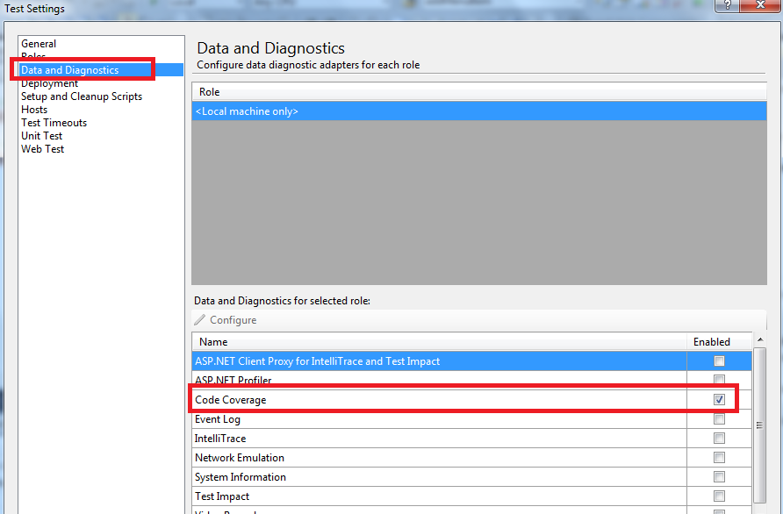

3. Highlight “Code Coverage” and click on “Configure.”

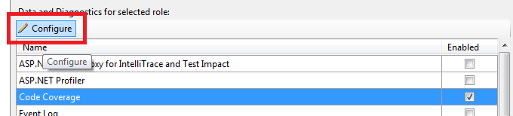

4. Select TouchForFood

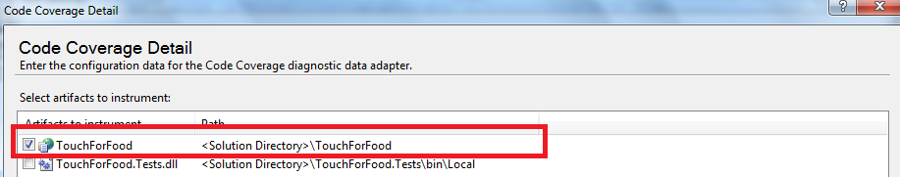

5. Select “Okay” and “Save As” and then click “Save” in the dialogue box (click yes to replace the file).

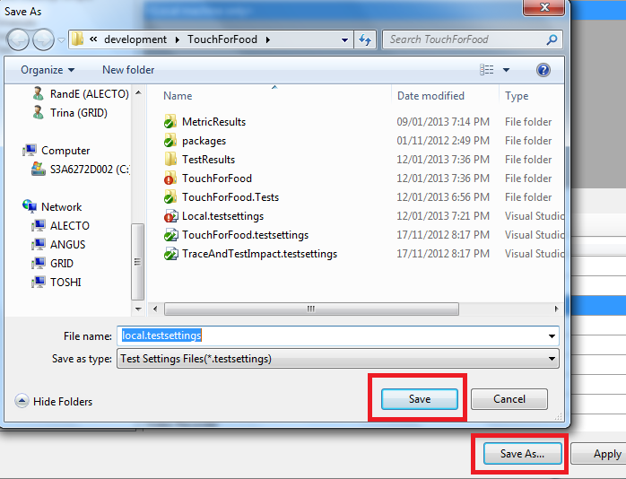

6. Under the “Test” menu click on “Select Active Test Settings” and put a check mark next to “Local”

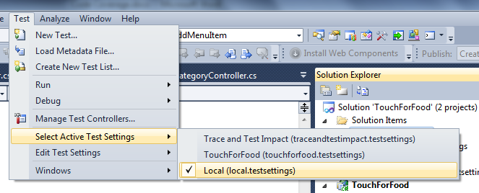

7. In the “Test List Editor”, right click and select “Run Checked Tests”

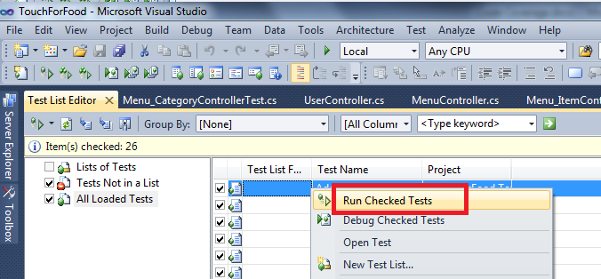

8. On the Test Tools toolbar, click “Code Coverage Results”. In the window a breakdown of the test results will appear in hierarchical form. We care about the controller layer which we are testing.

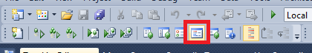

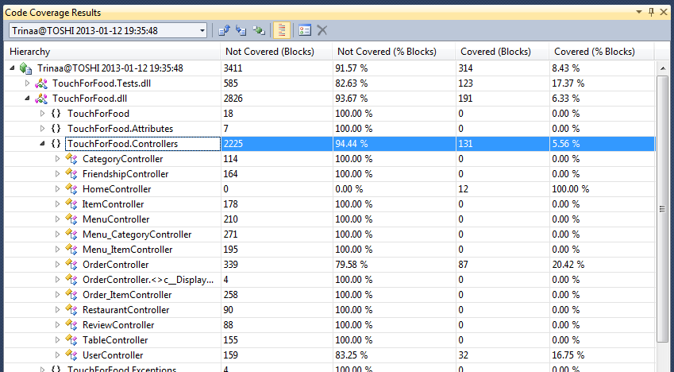

9. To have a more in depth view of what pieces of code were covered; select “Show Code Coverage Coloring”

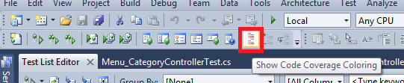

In the project classes lines of code will be highlighted:

BLUE = Covered

BROWN/YELLOW = Partially Covered

RED = Not Covered

