# Time Logging

## When it is time to log your time, try and decide if your task is...

Part of a **Sub-Task** or User **Story** in the current sprint

Part of a **Bug/Defect**

Some **Overhead/Other** like

* Meeting
* Email
* Phone Call
* Set up
* Anything that is NOT coding, bug fixing or related to a user story

## If it is a Sub-Task or User Story

 Part of the **Sub-Task** or **User Story** assigned to the current sprint can be testing, subtask or even design and prototyping of the user story. For this situation, it is best to never log time under the story itself. Log all your work on the subtasks. When updating the work done on any subtask, first click the subtasks name to go to the main page for that task.

Click more actions -> log work. If you are logging late, you can adjust to the correct date on this window.

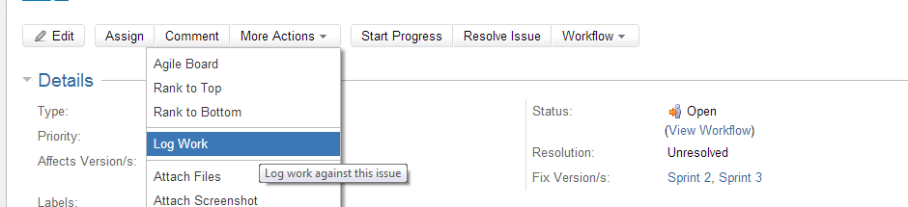

If you feel the task is done: Set its status to resolved and set the remaining time estimate to 0h

1. From the sub-tasks main page, click on Resolve Issue -> Under Resolution select Fixed -> click resolve

If there is an overestimation of time (you did you task faster than expected congratulations!)

1. Click Edit or ‘e’ (woah hotkeys) -> under Remaining Estimate put 0h (not blank)

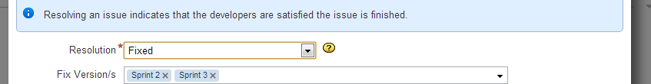

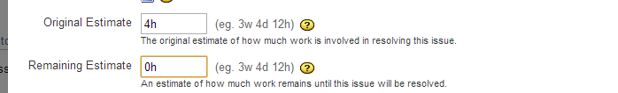

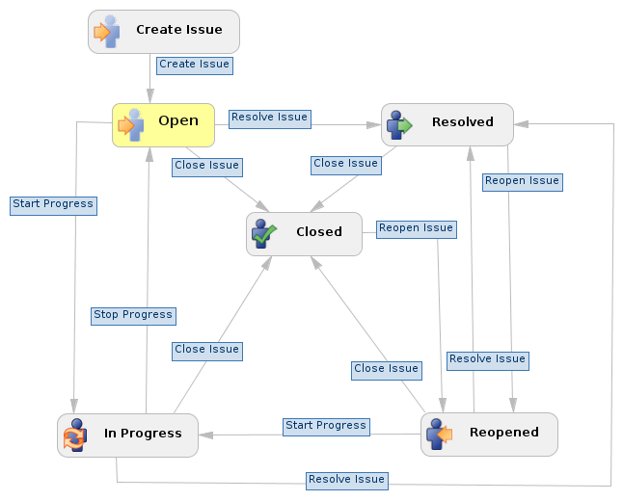When we do our post sprint meeting, the team will go over all the tasks that we set to resolved, if they are accepted then we can set to closed. If not, they must be reopened and then we can add to the remaining estimate depending on how much work is still needed to close out this task.

You can access this illustration by clicking the (View Workflow) link under the Status field if you are not sure what to do:

## For any other type of task

Just find the task. (see using the filters to find task faster) Then log the time you did.

## Assignees

All tasks are assigned to Josh Hum by default since he is the project owner. If you see a task that is currently assigned to default and does not have the status “in progress” you can begin working on it by going to the page for that task and click on “Assign To Me“ at the top. Once this is done you can begin progress by clicking “Start Progress”. This last step is important since it indicated to everyone that someone is now working on solving this problem.

# Navigation

## Filters

First go to Issues-> Manage Filters-> Popular

And star all the filters I created. Now when you click Issue, these filters should show up in your favourite filters. When it comes to logging your work, you can save time by using these.

## Where’s the sprint

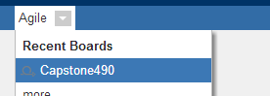Click Agile - > Capstone490

Click an issue ID to view quick facts on the right hand side

Ctrl-Click the ID to open the issue’s main page to view/update progress

## Hotkeys

Click the arrow next to your name -> click Keyboard Shortcuts and memorize every hotkey!

# But why?

It is important to log things in the right places and keep correct status on each task because it will give a better representation of each person’s work and it will help Josh generate more accurate and complete reports in the end. It will also help better coordinate the team.