|  |
| --- |
| **Concordia University**  **Department of Computer Science**  **and Software Engineering** |

|  |
| --- |
| **F.S.T.S.**  ***Family Services Tracking System*** |

|  |
| --- |
| **I.C. Document & User Guide** |

|  |
| --- |
| **SOEN 390**  **Software Development Project**  **Winter 2012** |

**JAM PACK**

Katrina Anderson

Cynthia Donato

Joshua Hum

Mikhael Levkovsky

Adrian Lloyd

Patrick Modafferi

**Table of Contents**

**Installation & Commissioning Document 5**

1. Introduction 6

2. Installing F.S.T.S. 6

2.1 Requirements 6

2.2 F.S.T.S. Documentation 7

2.3 F.S.T.S. Installation 7

2.4 Upgrading F.S.T.S. 10

2.5 Uninstalling F.S.T.S. 10

3. Commissioning F.S.T.S. 11

3.1 Setting up main.php file 11

3.2 Populating Database 11

4. Building F.S.T.S. 12

4.1 Obtaining Source Code 12

4.2 Running Tests 12

4.3 Creating Installation Bundle 12

**User Guide 13**

1. Introduction 14

2. Features 14

2.1 Administrative Panel 14

2.2 Client File Management 17

2.3 Event & Appointment Management 23

2.4 Reporting 31

2.5 Searching 37

3. Usage Notes 40

3.1 User Roles 40

3.2 Navigation 40

3.3 Sample Data 40

**APPENDIX A F.S.T.S. Keyboard Shortcuts 41**

**Table of Figures**

Figure 2.1.1 Side Menu For Country Client File Field 14

Figure 2.1.2 - Set Inactive Script Configuration 15

Figure 2.1.3 - Create User 16

Figure 2.2.1 - Creating a Client 17

Figure 2.2.2 - Entering a Medicare Number 18

Figure 2.2.3 - Checking the Address 18

Figure 2.2.4 - Address Conflicts Error Message 19

Figure 2.2.5 - Drop-Down Lists 19

Figure 2.2.6 - Creating the Client File 20

Figure 2.2.7 - Saving or Deleting a Client File 20

Figure 2.2.8 – Adding Household Members 21

Figure 2.2.9 - Adding Income Sources 21

Figure 2.2.10 - Viewing Upcoming Appointments 21

Figure 2.2.11 - Notes 22

Figure 2.2.12 - Different Types of Flags 22

Figure 2.2.13 – Degrees of Severity 22

Figure 2.3.1 - Event Template 24

Figure 2.3.2 - Event Occurrence 26

Figure 2.3.3 - Available Timeslots 27

Figure 2.3.4 - Add Appointment 28

Figure 2.3.5 - Create Appointment 28

Figure 2.3.6 Client File Waiting List 29

Figure 2.3.7 Waiting List Give Appointment 29

Figure 2.3.8 - List of appointments 30

Figure 2.3.9 - Event Check-In Per Household 30

Figure 2.3.10 - Check-In Per Person 31

Figure 2.4.1 - Managing Statistical Reports 31

Figure 2.4.2 - Creating a Statistical Report 32

Figure 2.4.3 - Event Information 35

Figure 2.4.4 Current Appointments 36

Figure 2.4.5 Current Appointments Attendance Record 36

Figure 2.4.6 Waiting List 36

Figure 2.5.1 - Client Search View 37

Figure 3.2.1 Top Menu Bar 40

Figure 3.2.2 Side Menu 40

|  |
| --- |
| **F.S.T.S.** |

|  |
| --- |
| **Installation & Commissioning Document** |

# Installation & Commissioning Document

|  |
| --- |
| **Version 6.9** |

**Revision History**

|  |  |  |  |
| --- | --- | --- | --- |
| **Date** | **Rev.** | **Description** | **Author(s)** |
| 2012-03-18 | 5.0 | Set-up document | Katrina Anderson |
| 2012-03-20 | 5.1 | Initial Installation & Commission Information | Adrian Lloyd |
| 2012-03-21 | 5.2 | Updated Installation & Commission Information | Adrian Lloyd |
| 2012-03-22 | 5.3 | Document review | Mikhail Levkovksy |
| 2012-03-22 | 5.4 | Document Updates and Revision | Adrian Lloyd |
| 2012-03-25 | 5.5 | Document Revision | Katrina Anderson |
| 2012-04-10 | 6.6 | Document Formatting & Revision | Katrina Anderson |
| 2012-04-10 | 6.7 | Document Revision | Cynthia Donato |
| 2012-04-10 | 6.8 | Document Revision | Adrian Lloyd |
| 2012-04-10 | 6.9 | Document Updates for Volume Testing | Patrick Modafferi |

# Introduction

This document is the reference for the installation and commissioning of the Family Services Tracking System (F.S.T.S.). The information within this document explains how to install and uninstall F.S.T.S., how to commission and populate the database, and how to build and run the system.

# Installing F.S.T.S.

The product to be installed will be a live version of F.S.T.S. This section provides general information and guidelines on how to install our product.

The documentation is comprised of all the relevant information used for the maintenance of this product as well as the user guide. More information about the documentation to be provided is detailed below (section 2.2).

## Requirements

The following specifications are the minimum requirements for the server to host F.S.T.S.:

* Windows Server 2008 R2
* Apache 2.2.21
* PHP 5.3.8
* MySQL 5.5.16 or MSSQL 2008 R2

The basic installation of F.S.T.S. consists of copying the directory that contains all the files onto the desired server. The database must also be located on the server that the application is located on.

The following system and software requirements are the minimum required to run F.S.T.S. on a desktop personal computer (PC):

* Operating System (can use any one of the following)
  + Windows XP (or higher)
  + Linux Ubuntu 10 (or higher)
  + Apple Mac OS X v10.5 (or higher)
  + Apple iOS 5.1 (or higher)
* A Web Browser (can use one or more of the following)
  + Internet Explorer 8 (or higher)
  + Mozilla Firefox 3.6 (or higher)
  + Google Chrome v12 (or higher)
  + Apple Safari 5.1 (or higher)

F.S.T.S. also comes with a mobile component. This component is customized for the iPad (any version).

## F.S.T.S. Documentation

The following is the documentation supplied:

Of interest to users:

* Installation & User Guide

Of interest to developers:

* Architecture – The architectural artifacts that define the F.S.T.S.
* Planning & Reports–The plans and reports for the development of F.S.T.S. user stories
* Testing – The testing done for modules created & defects
* Vision & Requirements – The functional and non-functional requirements for the F.S.T.S.
* UIR – The information about the user interface

## F.S.T.S. Installation

The following are the standard steps to fully set up the F.S.T.S. system

### Setting up the server

The server should be set up in a WAMP (Windows, Apache, MySQL/MSSQL,and PHP) environment. Please see Section 2.1 for versions of the software to install.

### Setting up the database

F.S.T.S. is dependent on the existence of a database that has the exact same structure to that which is provided by us. The static data (e.g. Languages, Countries, Marital Status…) should then be populated via the Admin Panel provided with F.S.T.S.

### Copying the F.S.T.S.

Once the server and database are set up, F.S.T.S. should be added to the Welcome Hall Mission designated server. The installation package contains the F.S.T.S. system packages. Copy this folder into the desired drive on the server. To link the database to F.S.T.S., see Section 3.1.

### Setting up Script Tasks

Once the server contains F.S.T.S., the F.S.T.S. scripts can be set up to run at regular intervals on the server. These scripts are used to keep F.S.T.S. running efficiently by “cleaning up” unused data. Note that the “Archive Settings” in the Administrator Panel are to set the properties used within the scripts. The “Archive Settings” **do not** determine when the scripts run. This is done by creating a Windows Task. The scripts to be set are located in “[file path to FSTS]\protected\commands\scripts\”.

Instructions to set up a Windows task can be found here (on a Windows Environment):

<http://www.sevenforums.com/tutorials/12444-task-scheduler-create-new-task.html>

### Setting up the F.S.T.S. Homepage Link

This section is for the computers that will be used by the employees of Welcome Hall Mission that will be working with F.S.T.S.

1. Open the desired browser to use the system
2. Type in the address bar “localhost/[file path to F.S.T.S.] /index.php”
3. The F.S.T.S. index page should be displayed. Save the page as the homepage (consult the browser’s website if having troubles in this section)
4. Restart the browser. The F.S.T.S. index page should appear.

### Accessing F.S.T.S. from any computer in the Welcome Hall Mission

It is important to note that F.S.T.S. was designed to be run within the internal network of the F.S.T.S. This being said, there are two ways for users to access the system through the URL of the web browser.

1. Type in the address bar “IP_of_apache_server”/[file path to F.S.T.S.]/index.php
2. Type in the address bar “machine_name_of_apache_server”/[file path to F.S.T.S.]/index.php

It is also necessary to configure httpd.conf file to allow all IP addresses within the network access to the server. This can be done by removing the *Deny from All* option in the section or by adding the specific IP addresses that should have access by specifying *Allow from*.

<Directory "c:/wamp/www/">

Options Indexes FollowSymLinks

AllowOverride all

Order Deny,Allow

Deny from all

Allow from 127.0.0.1

</Directory>

### Setting up the F.S.T.S. Testing Environment and Running Tests

This section is for F.S.T.S. maintenance and testing purposes. Unit Testing shall be done with Netbeans and PHPUnit. System Testing shall be done with Netbeans and Selenium.

#### PHPUnit

The following are instructions on how to configure PHPUnit to work with Netbeans (PHPUnit is included in the F.S.T.S. software). “...” symbolizes the location of the F.S.T.S. folder.

1. Import F.S.T.S. as a project into Netbeans (for these instructions we shall name the project as “project”)
2. Go to Tool>Option>PHP>Unit Testing
3. Click Browse and select “phpunit.bat”. Ignore any warning messages.
4. Right click on the project then go to Properties>PHPUnit
5. Check bootstrap, use the path: ...\FSTS\project\protected\tests\bootstrap.php
6. Check XML, use the path: ...\FSTS\project\protected\tests\phpunit.xml
7. When prompted for a path for the Test Files folder select: ...\FSTS\project\protected\tests\unit
8. Restart Netbeans, now you should have a folder called TestFiles
9. Right click the Test Files folder and create a new PHP Class
10. Copy Paste the code found here into the new class (Ex4.1): http://www.phpunit.de/manual/3.6/en/writing-tests-for-phpunit.html
11. Save all and press ALT+F6,there should be a Green bar with 100% in it (Ex 4.1 test passed)

#### Selenium

The following are instructions on how to configure Selenium to work with Netbeans. “...” symbolizes the location of the F.S.T.S. folder.

1. Download the Selenium Server JAR file from <http://seleniumhq.org/download/> (under the section “Selenium Server(formerly the Selenium RC Server)”)
2. Rename the downloaded JAR file to “selenium-server.jar”
3. Put the selenium-server.jar in your server’s bin folder
4. In the php.ini configuration file located in (bin\php\[php-version-number-folder]) find the test “extension=php_curl.dll” and remove the semi-colon at the start
5. Open the command line and run java -jar [file path to bin folder]\bin\selenium-server.jar
6. Open Netbeans and go to Tools>Plugins
7. A pop-up window should be open. Go to the “Available Plugins” tab
8. Search for “Selenium Module for PHP” and check the check box for it
9. Click the “Install” button that appears below the pop-up window
10. Follow the installation procedures to install the Selenium Module for PHP
11. Click the Finish button when the installation is complete
12. Click the Close button to close the pop-up window

#### ****Volume Testing****

**The following section will aid any tester charged with the task of performing a volume test by more explicitly describing each step in detail. A typical example of the performing of a volume test is as follows:**

1. **Populate the database with the needed data**

**Thanks to PHPUnit’s CDBTestCase class, we can run code which interacts with our actual test database and ensure that the proper amount of records is successfully added. Furthermore, the fact that this process is automated allows us to simply change the control variables to create as many records as the tester needs.**

**In order t**o achieve as good of a simulation as possible, the algorithm generates random names and Medicare numbers as well as random countries of origin and languages. Due to the fact that these demographics (country, language) are foreign keys, the scrip can simply check how many languages are in the database table for languages and generate a random number between 1 and the size of that table in rows, for example. Furthermore, the names and Medicare numbers are composed of random characters which are stored in an alphabet array. In the end, the algorithm will take random characters and form some random names so that not all the entries look the same and the search can actually be tested properly.

Refer to unit test code project/protected/tests/unit/StressTest.php

1. **Code time and memory tracking**

**Due to the lack of a good tool, in order to produce results on memory allocation and performance of the algorithms, the tester must manually place the tracing code to output during execution. Here is some sample code:**

**$callStartTime = microtime(true);**

**…The code/part of the code being tested**

**$callEndTime = microtime(true);**

**$callTime = $callEndTime - $callStartTime;**

**echo '<br />Generated in '.sprintf('%.4f',$callTime);**

**echo '- Mem Usage: ' . (memory_get_usage(true) / 1024 / 1024) . ' MB';**

**Basically, microtime() returns the system time and memory_det_usage() returns the memory usage of the current PHP scrip being run. We simply output using echo and convert the output to seconds with 4 decimals and memory usage into MB.**

1. **Run the test**

**Once the database and code are set up to produce results, the test can run the paths where the code has been placed and will observe the results. Here is an example of what these ‘echo’ return after execution:**

**Generated Report 2012-01-01 to 2013-01-01 - 96.5414**

**- Mem Usage6: 270 MB**

**Generated Report 2012-01-01 to 2012-02-01 - 13.1641**

**- Mem Usage6: 272.5 MB**

## Upgrading F.S.T.S.

F.S.T.S. shall be upgraded at the disclosure of Welcome Hall Mission. It is suggested that a PHP programmer with experience with the Yii Framework be hired to provide changes to the system as needed by the Welcome Hall Mission.

## Uninstalling F.S.T.S.

To uninstall F.S.T.S. simply remove the F.S.T.S. folder on the server and remove the database associated with F.S.T.S. Users who try to link to F.S.T.S. will get a 404 Error Message (missing page error).

# Commissioning F.S.T.S.

This section describes how to link the database to F.S.T.S. via the main configuration file and how to populate the database.

## Setting up main.php file

To link F.S.T.S. to its database, go to main.php (located in FSTS\project\protected\config) and in the database section, link the database to F.S.T.S. by inserting or replacing the necessary information. For more information, please see the “Establishing Database Connection” on the Yii’s Documentation site:

[*http://www.yiiframework.com/doc/guide/1.1/en/database.dao*](http://www.yiiframework.com/doc/guide/1.1/en/database.dao)

## Populating Database

To populate the database with generic data that is needed for everyday operations (e.g. Languages, Countries, Residences…) go through the Admin Panel. The client information should be populated via the forms provided.

# Building F.S.T.S.

## Obtaining Source Code

The source code will be available from an SVN repository where the latest version of the F.S.T.S. can be found. Authentication is required and can be provided by team JAMPACK . The path is:

[*https://subversion.assembla.com/svn/soen390_ftfs/*](https://subversion.assembla.com/svn/soen390_ftfs/)

If another transfer of source code is desirable (e.g. via USB, CD…) this can be arranged as needed.

## Running Tests

Unit tests can be ran in Netbeans with PHPUnit. PHPUnit is already supplied along with F.S.T.S. To run unit tests, please follow the instructions in Section 2.3.6

Selenium testing can be run in Netbeans. To run system tests, please follow the instructions in Section 2.3.6

## Creating Installation Bundle

As stated in the introduction in Section 2, F.S.T.S. is comprised of the F.S.T.S. Documentation and the F.S.T.S. program (with the Yii Framework included). The F.S.T.S. program is located online on a Subversion repository (see section 4.1). How to install F.S.T.S. is described in Section 2

.

|  |
| --- |
| **F.S.T.S.** |

|  |
| --- |
| **User Guide** |

# User Guide

|  |
| --- |
| **Version 6.9** |

**Revision History**

|  |  |  |  |
| --- | --- | --- | --- |
| **Date** | **Rev.** | **Description** | **Author(s)** |
| 2012-03-18 | 5.0 | Set-up document | Katrina Anderson |
| 2012-03-23 | 5.1 | Added Client File and Reports Section. | Patrick Modafferi |
| 2012-03-24 | 5.2 | Added Search Section | Josh Hum |
| 2012-03-25 | 5.3 | Added Event, Appointment, Check-in and administrative panel sections | Cynthia Donato |
| 2012-03-25 | 5.4 | Added Usage Section and revised entire document. | Katrina Anderson |
| 2012-04-10 | 6.5 | Review of Reporting | Mikhail Levkovsky |
| 2012-04-10 | 6.6 | Formatting & Review | Katrina Anderson |
| 2012-04-10 | 6.7 | Updated Reporting | Patrick Modafferi |
| 2012-04-10 | 6.8 | Revised Document | Adrian Lloyd |
| 2012-04-10 | 6.9 | Revised Document | Cynthia Donato |

# Introduction

The purpose of this document is to highlight the main features of the F.S.T.S, which was designed for the employees of the Welcome Hall Mission. This document was designed for users at all levels of computing ability.

# Features

## Administrative Panel

The administrative panel is visible to all users with administrative user permissions and can be used to customize attributes in the client file, define event templates, control inactive settings and manage users.

### Client File Attributes

The administrative panel allows for the customization of eleven fields in the client file:

* Country
* Citizenship Status
* Flags
* Income Type
* Income Period
* Languages
* Marital Status
* Postal Code
* Referral
* Relationship
* Work Status

All client file attributes can be updated or deleted through the *Admin Panel* section. This section can be accessed through the top menu bar or by using the *Alt+5* shortcut key.

Creating a Field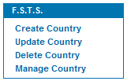

Figure 2.1.1 Side Menu For Country Client File Field

1. Choose the type of attribute you would like to create from the list of options mentioned above.
2. A list of all existing types of attributes will be displayed.
3. Select the ***Create*** *Type* option located on the right hand side menu
4. Fill in the necessary information and click *Create*.

Updating a Field

1. Choose the type of attribute you would like to create from the list of options mentioned above.
2. A list of all existing types of attributes will be displayed.
3. Select the update () icon for the attribute type you would like to modify
4. The attribute information is displayed.
5. Make the necessary updates and click S*ave.*

Deleting a Field

1. Choose the type of attribute you would like to create from the list of options mentioned above.
2. A list of all existing types of attributes will be displayed.
3. Select the delete () icon for the attribute type you would like to delete

### Event Attributes

#### Templates

See section 2.3.1 Event Templates for further information.

### Administrative Controls

#### Activation Settings

This section defines the length of time after which a client file is set to inactive. An inactive client cannot be booked for an appointment, unless the inactive status is removed by an F.S.T.S. user.

To set the inactive time frame:

1. Enter the timeframe you wish to use to configure the script
2. Click the save button

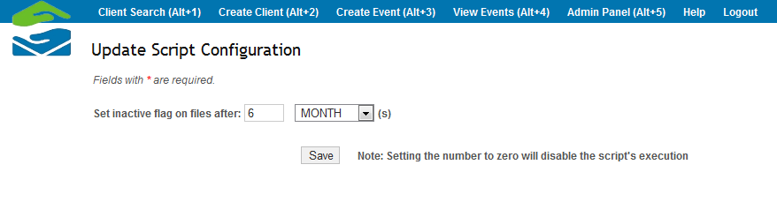

Figure 2.1.2 - Set Inactive Script Configuration

#### User Permissions

This section defines the permissions for F.S.T.S. users, allows for the creation of new users and the modification of passwords.

**Create User**

1. Select the *Create User* option form the right hand menu
2. Provide the mandatory information
3. Click the *Create* button

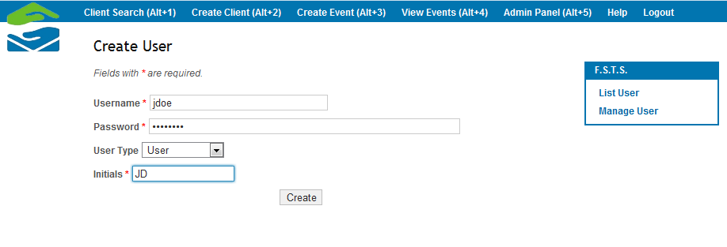

Figure 2.1.3 - Create User

**Update User**

1. A list of all users is displayed
2. Select the update () option for the user you would like to update
3. The current information for the user is displayed
4. Make the necessary updated
5. Click the *Save* button

**Delete User**

1. A list of all users is displayed
2. Select the delete () option for the user you would like to delete

**Statistical Reports**

See Section 2.4.1 Stat Reports

## Client File Management

To create a client file, navigate to the Create Client tab (Alt+2). The client file represents a household who require services from the Welcome Hall Mission. This file will contain a head of household (main representative), household members, income sources, flags, notes and a list of appointments.

### Main Representative

The first step is to create the main representative. The rest of the functions of the client file are dependent on this head of household, as is shown in the screenshot below.

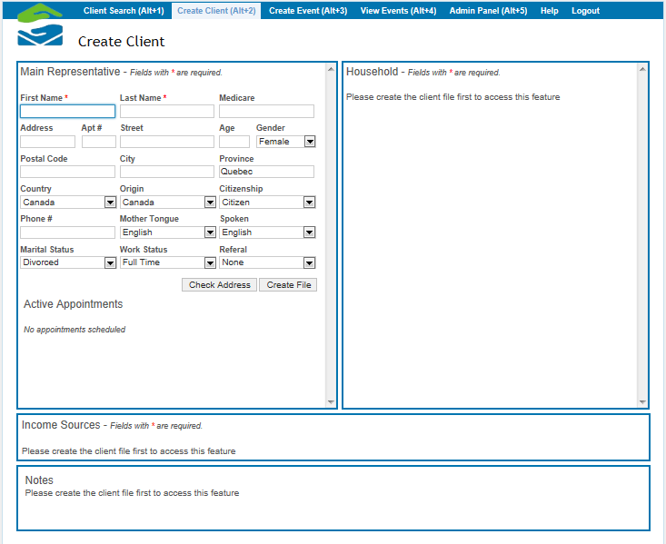

Figure 2.2.1 - Creating a Client

The main representative in the client file is the head of the household. The required fields are the first and last name of the client; however, there are many other characteristics and information about the client that can be entered into the system. Of note is the Medicare and residence information.

#### Medicare

Once the Medicare card is entered and the user either clicks outside the Medicare field or presses tab, the system auto-generates the client’s age and gender. The age and gender remain modifiable. All Medicare numbers are validated, meaning F.S.T.S. will search the database for duplicates and indicate if any are found.

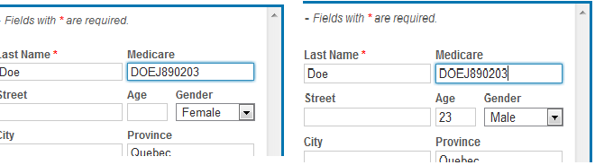

Figure 2.2.2 - Entering a Medicare Number

#### Residence

Residence is defined by the following fields: Street name, house number, postal code, city, province and country. Entering a postal code will auto-generate the city field. Once all of this information has been entered, the user can opt to check the address in order to verify that it is not in conflict with that of another client. If the user does not do so, the system will validate the address upon creation and display an error message if a conflict is found. (*Hint:* In order to save time, it is important to validate the address before creating the file to avoid creating an entire client file only to later find out that the address is conflicting).

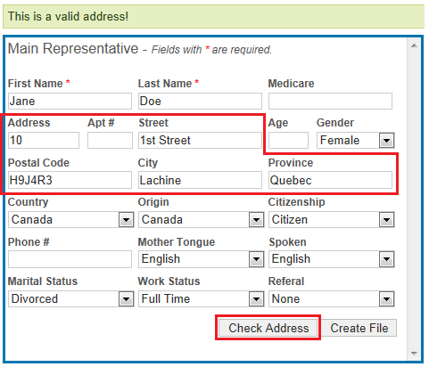

Figure 2.2.3 - Checking the Address

In the event that a conflict with the address is found, a new window will appear containing the client file of the person that is in conflict with your current file. The user can choose to either change the address of the conflict, or to terminate the creation of the new client. The user should revalidate until he gets the green success message pictured above in order to continue with the creation of the client file.

**WARNING:** It is important for pop-ups to be enabled in the user’s browser in order for either of these steps to be taken.

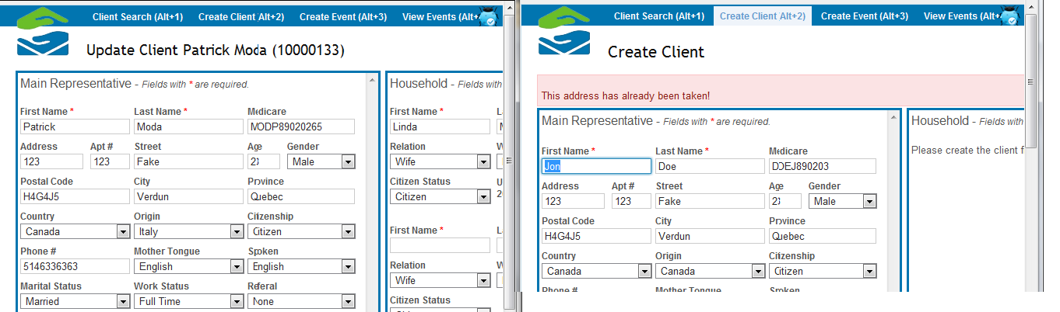

Figure 2.2.4 - Address Conflicts Error Message

#### Other Fields

The following fields are all drop-down menus and can be modified via the Admin Panel (see section 2.1.1.).

* **Country:** Country refers to the country that the client is currently living in and is considered part of the residence.
* **Origin:** Origin refers to the country that the client was born.
* **Citizenship:** Citizenship status of the client.
* **Mother Tongue:** The first language of the client.
* **Spoken:** The language that the client prefers to use when communicating with employees, usualy english or french.
* **Marital Status:** Whether the client is single, married or divorced.
* **Work Status:** Whether the client is a student, unemployed, part-time or full-time worker.
* **Referral:** How the client came across the Welcome Hall Mission.
* **Phone Number:** This is the primary number where the client can be reached when necessary.

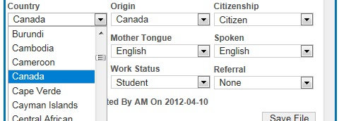

Figure 2.2.5 - Drop-Down Lists

Once all of the fields have been filled in, the user may proceed to create the file. Once the file has been created, the rest of the file options will become available.

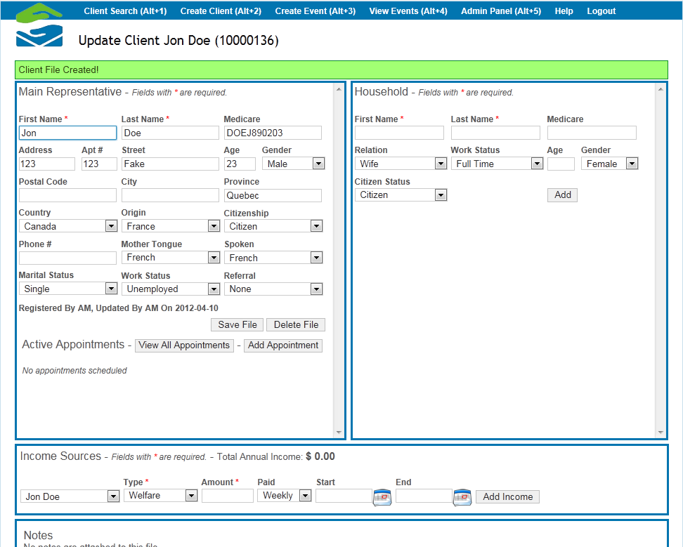

Figure 2.2.6 - Creating the Client File

Save File updates the client file, and the Delete File option will only work if the client has no appointments.

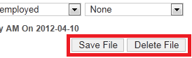

Figure 2.2.7 - Saving or Deleting a Client File

### Household

Once the main representative has been created, other members of the household may be added to the file, if applicable. The user can enter the name and Medicare number of the dependent, as well as their relation to the main representative. As with the main representative, the age and gender of the dependent will automatically be generated once the user enters the Medicare field. The user may also choose a work status for the dependent, as well as a citizen status. Clicking “Add” will add the dependent to the file.

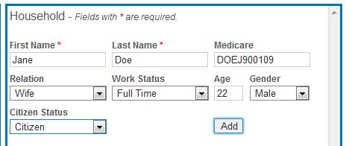

Figure 2.2.8 – Adding Household Members

### Income Sources

Income sources can be entered for each member of the household. Household members are chosen from a drop-down menu and the type of income they receive, how much they make and the frequency of income are defined in additional fields and dropdowns. The user also has the option of adding start and end dates to the income sources. Start and end dates that are left blank indicate that the payments are ongoing. For example, if the client has a job for which he does not foresee termination in the near future, the end date can be left blank and will default to the date 0000-00-00.

Every time an income source is added, the total annual income is automatically calculated. This annual income is the total for all of the members of the household, and is calculated for the year starting January 1st and ending December 31st of the same year.

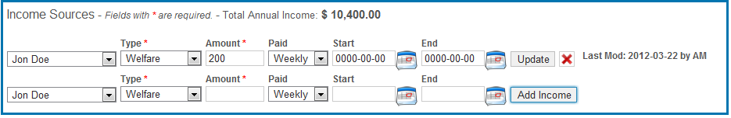

Figure 2.2.9 - Adding Income Sources

Income types and frequency of payments can be modified in the Admin Panel (see section 2.1.1). Income can be added, deleted and modified at any time.

### Appointments

Once a client file has been created, the options to view existing appointments and to add new appointments becomes available.

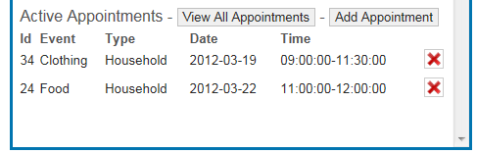

Figure 2.2.10 - Viewing Upcoming Appointments

Please See Section 2.3.3 Appointment Management

Notes

The notes section is available for the user to make note of anything that needs to stay in the client’s file. Some notes may be auto-generated by the system. For example, if a client is banned due to absence from a scheduled appointment, the system will enter this into the notes section as well as add the date of the ban.

An infinite number of notes can be created. Notes can be added, deleted and modified at any time.

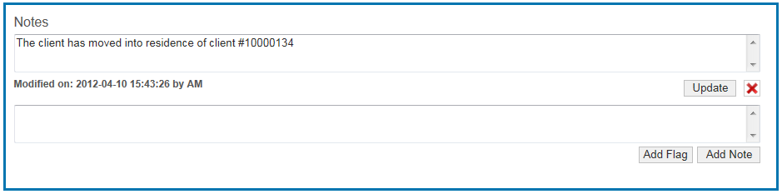

Figure 2.2.11 - Notes

### Flags

The user has the option of flagging the client in the client file. There are 5 different flags that the user can choose from: banned, proof of address, inactive client, proof of income and dangerous. Furthermore, customized flags can be created and existing ones modified in the Admin Panel

(See section 2.1.1).

Once flags are added, they appear at the top of the client file and can be removed at any time.

The color of the flag represents the degree of severity.

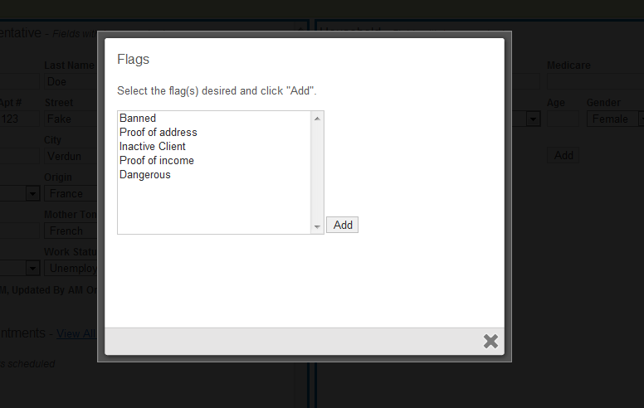

Figure 2.2.12 - Different Types of Flags

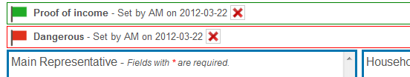

Figure 2.2.13 – Degrees of Severity

## Event & Appointment Management

### Event Templates

Creating, updating and deleting event templates can be done by an administrator from the administrator panel.

Below is a list of all fields and their expected values:

* **Name:** The name(type) of event
* **Appointment Needed:** Do households or individuals need to make appointments to attend these types of event?
* **Appointment Taken By:** Are appointments made by household or by person?
* **Appointments Taken By:** Are appointments made per day or per hour?
* **Repeatable:**  Does this type of event repeat?
* **Weekday:** If the event repeats, on what days does it repeat?
* **Repeat times:** How many times should this event repeat?
* **Day duration:** How many days long is each individual event?
* **Timeslot duration:**  If the events are taken by hour, how long should the individual timeslots be? This value should represent hours or fractions of hours.
* **Start time:**  What time does this event start each day?
* **End time:** What time does this event end each day?

### Create an Event Template

1. To create an event template, navigate to the *Admin Panel* using the top menu bar or by hitting the *Alt+5* shortcut key.
2. A list of options to modify will be presented. Select the *Templates* option from the Event Attributes section.
3. A list of existing event templates is displayed. Select the *Create Event Template* option from the right-hand side menu.
4. Fill in all required fields and press the *Create* button.

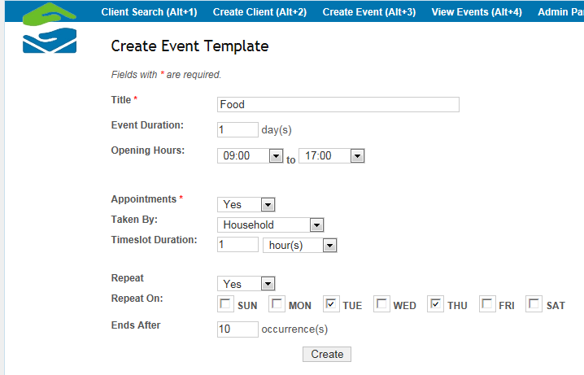

Figure 2.3.1 - Event Template

### Update an Event Template

1. To update an event template, navigate to the *Admin Panel* using the top menu bar or by hitting the *Alt+5* shortcut key.
2. A list of options to modify will be presented. Select the *Templates* option from the Event Attributes section.
3. A list of existing event templates is displayed. Select the update option () for the particular event template you wish to update.
4. The event information will be displayed as in Figure 18 – Event Template. Make any necessary updates and select the *Save* button.

### Delete an Event Template

1. To create an event template, navigate to the *Admin Panel* using the top menu bar or by hitting the *Alt+5* shortcut key.
2. A list of options to modify will be presented. Select the *Templates* option from the Event Attributes section.
3. A list of existing event templates is displayed. Select the delete option () for the particular event template you wish to remove.

### Event Management

This section describes how to create individual event occurrences that clients can register for.

Below is a description of the individual fields and the expected values for each:

* **Event:** Select an event template from the provided list
* **Start Date:** The starting date of the individual event
* **End Date:** The end date for the individual event
* **Start/End Time:** The start and end time for the individual event
* **Appointments Per:** Are appointments taken per person or per household?
* **Timeslot Duration:** If appointments per hour are needed, how long should each timeslot be?
* **Appointments Needed:** Do we need to make appointments to attend this event?
* **Taken By:**  If appointments are needed, should they be by day or by hour?
* **Repeatable:** Does this event repeat?
* **# Repeats:**  If the event repeats, how many times should it repeat?
* **Weekday:** If the event repeats, on which days?
* **Active:** Should this event be available in the list of events for which we can make appointments?
* **Amount:** The total value of the event.

### Create an Event

1. To create an event, navigate to the *Create Event* section using the top menu bar or by hitting the *Alt+3* shortcut key.
2. A form that allows for the creation of the event will be presented.
3. Selecting an event will automatically populate all fields with the default values from the template.
4. Update and fields that should not use the defaults and set the start and end date for the event.
5. Select the *Create* button

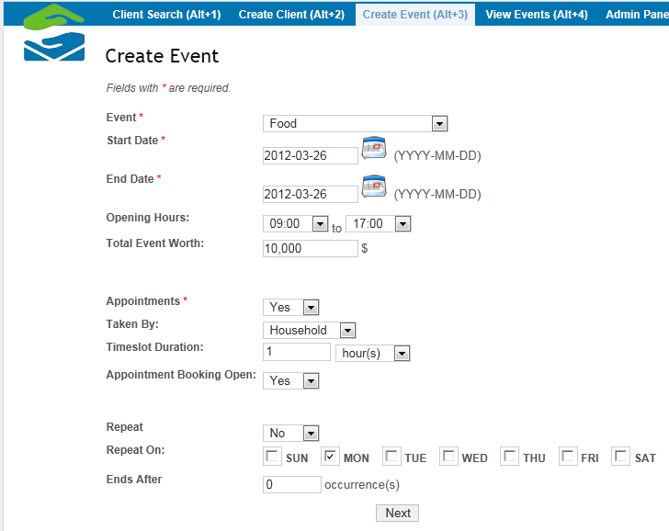

Figure 2.3.2 - Event Occurrence

### Update an Event

1. To update an event, navigate to the *View Events* section using the top menu bar or by hitting the *Alt+4* shortcut key.
2. A list of all Open events will be displayed
3. Select the update option () for the specific event they would like to update
4. The event and all of its information will be displayed. Make any necessary updates and hit the *Save* button.

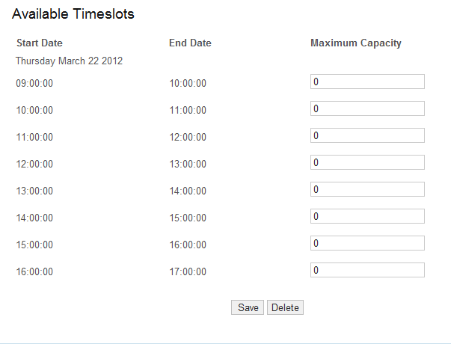

Figure 2.3.3 - Available Timeslots

All available timeslots will be shown in the update view. This allows you to also update the maximum capacity per timeslot. As shown in Figure 3 – Available Timeslots

### Delete an Event

1. In order to delete an event occurrence, the user must navigate to the *View Events* section using the navigation bar or by hitting the *Alt+4* shortcut key.
2. A list of existing event occurrences is displayed. Select the delete option () for the particular event template you wish to remove.

**WARNING:** Only event occurrences that do not have appointments associated to them can be deleted.

### Appointment Management

### Book an Appointment

Appointments are booked in two ways, per household or per event. This depends on the setup of the individual event occurrence.

1. Search for the client file you wish to create an appointment for. See section 2.5 Searching for further information on search options.
2. In the *Main Representative* section select the *Add Appointment* option just above the list of current appointments.
3. A list of active appointments will be displayed. Select the *New Appointment* option for the specific event you wish to make an appointment for.

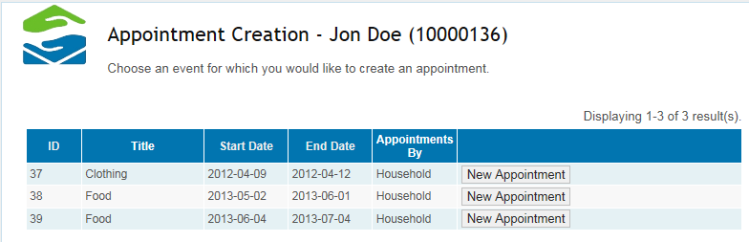

Figure 2.3.4 - Add Appointment

1. Select a timeslot you would like to create an appointment for and press the respective *Create Appointment* button.

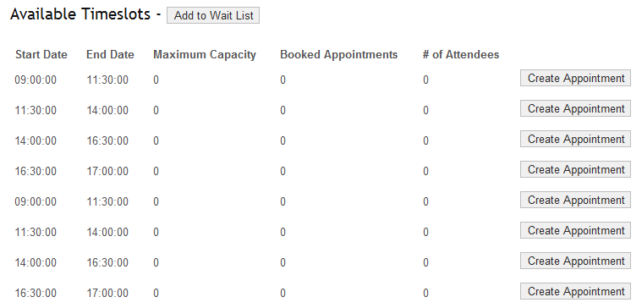

Figure 2.3.5 - Create Appointment

### The Wait List

From any given client file, the option to View All Appointments appears in the *Appointment* section. Selecting this option will open the following window which contains a more thorough and descriptive view of the list of appointments related to the current user. It also contains a table of waiting lists the client file is found on. The waiting lists contain an event id and type. The household member along with the date and time at which they have been added are also visible.

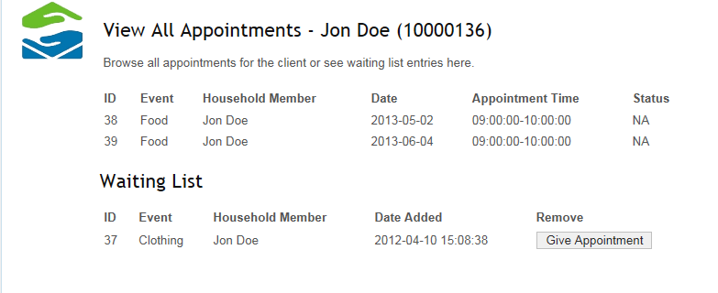

Figure 2.3.6 Client File Waiting List

The waiting list contains an option named *Give Appointment*. This action will remove the household member from the waiting list for that specific event and open up the option for booking an appointment for the client on that given event occurrence as shown in the figure below..

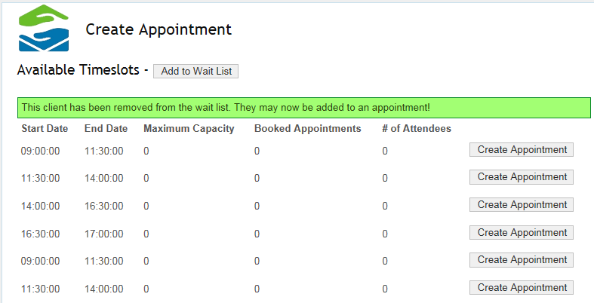

Figure 2.3.7 Waiting List Give Appointment

### Cancel an Appointment

1. Search for the client file you wish to create an appointment for. See section 2.5 Searching for further information on search options.
2. A list of current appointments is displayed in the *Main Representative* section. Select the delete option for the appointment you wish to cancel.

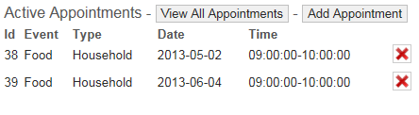

Figure 2.3.8 - List of appointments

### Appointment Check-In

**Check-In**

1. In order to check a household into an event, navigate to the *View Events* section using the navigation bar or the *Alt+4* shortcut.
2. A list of all events will be displayed
3. Select the *Check-In* option for the event you to fulfill appointments for
4. A list of all attending households will be displayed.
5. Select the check-in button for each person that arrives at the event

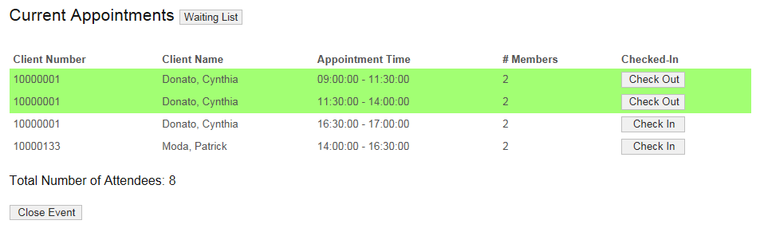

Figure 2.3.9 - Event Check-In Per Household

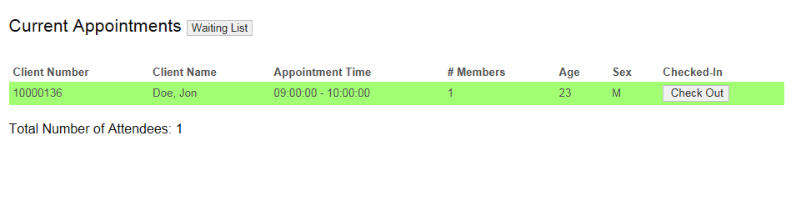

Figure 2.3.10 - Check-In Per Person

## Reporting

There will be two major types of reporting that can be achieved through the F.S.T.S.; Statistical and Operational. Operational includes records of attendance and waiting lists.

### Statistical Report

In order to generate a report, the user must navigate to the Admin Panel (Alt+5). The user will then select “Statistical Reports” in the Administrative Controls section.

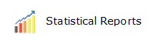

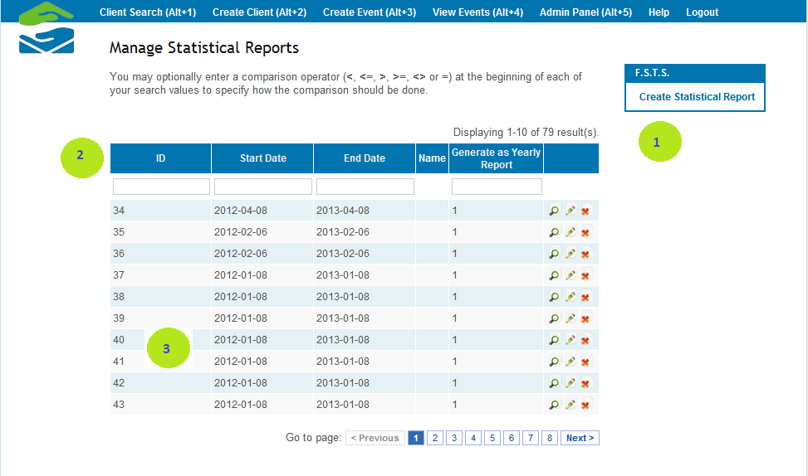

Figure 2.4.1 - Managing Statistical Reports

1. On this page, select “Create StatReport”. A start date, end date, and event type will be chosen, after which the report can be created.
2. To find a report that has already been generated, use the advanced search bars.
3. Look through the list of previously generated reports and use them to re generate the same report under these conditions.

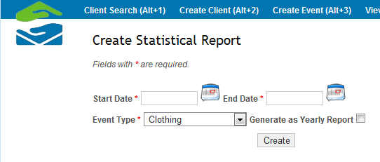

Figure 2.4.2 - Creating a Statistical Report

If there is no data for the event type on the dates chosen, a message will be displayed to change either the date or the event type.

If there is data for the event type on the dates chosen, a PDF will be displayed in the user web browser containing all the relevant information. The PDF can then be saved or printed.

If the “Generate as Yearly Report” is selected then only a “Start Date” is required. The system will then generate and download an Excel file that gives the yearly information about all of the events including a breakdown of information per month. The file is named StatisticalReport####.xls, where the #### corresponds to a timestamp. The following are elements of the statistical report:

|  |  |
| --- | --- |
| **Income** | Income is referring to the distribution of the sources of income among the clients who visited during the given time period. There may be more sources of income than the number of people who visited because it takes into account every source of income in the household. |
| **Mother Tongue** | Mother tongue is displaying the distribution of the mother tongues spoken among the visitors for the given time period. |
| **Country of Origin** | Country of Origin is displaying the distribution of the origins among the visitors for the given time period. |
| **Family Composition** | **Total Head of House:** This section displays how many heads of the household visited during the given time period.  **Total Household Members**: Displays the total amount of household members that are associated to these heads. It also displays the distribution of the relationships held by these household members to their head of household.  **Family Size:**  This section displays the distribution of different sizes of families that visited during the given time period. It will display how many families of a given size visited as well as the percentage that size made up of the total visits. This section will also display the average size of the families that visited in the given time frame. |
| **Number of Visits** | This section displays how many families made a certain amount of visits during the given time frame, as well as the average number of visits per family. |
| **Age of Head of Household** | The distribution of the ages of the heads of house that visited during the given time frame is displayed here. The average age will also be displayed. |
| **Age Including Household Members** | The distribution of the ages of the people who visited, which includes both the heads of the households and the household members, are displayed here. This will also show the average age of the visitors. |
| **Gender of Head of Household** | The distribution of the genders of the heads of the households that visited during the given time period. |
| **Gender Including Household Members** | The distribution of the genders of all of the visitors during the given time period, including the heads. |
| **Clients on File** | Displays the amount of clients files in the system on the given date. |

The figure table below is a sample output of a yearly report. The output can be easily formatted to fit on a single page by reducing font size and adjusting column and row sizes:

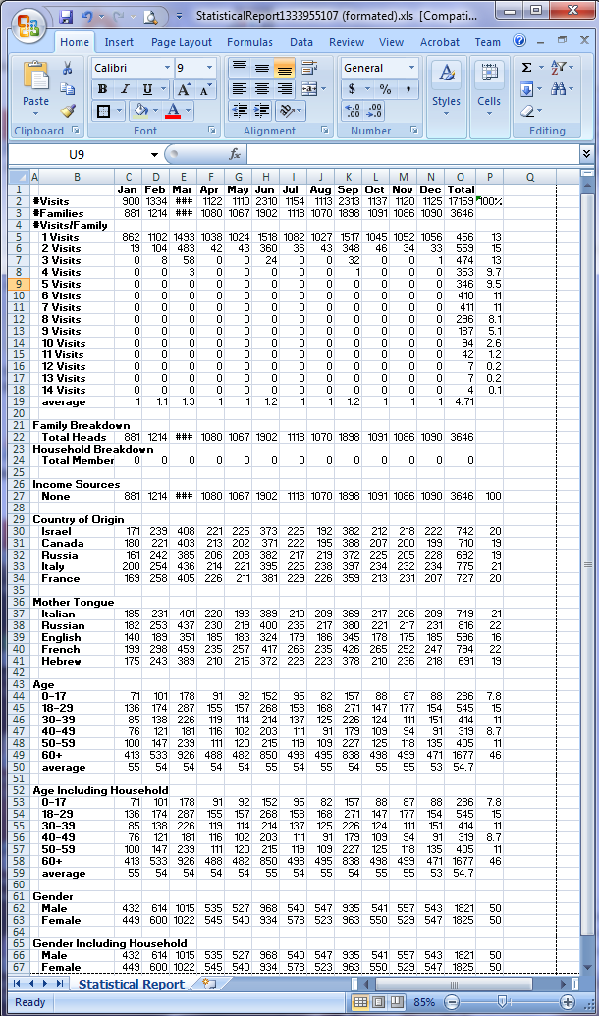

### Operating Report

The operating report gives information on a particular event. In order to generate a report, navigate to View Events (Alt+4), then select an event from those displayed or do a search for a specific event using the advanced search.

Once an event is chosen and the Check In column in the table is clicked, the system generates information relevant to the event. The information displayed is shown in the figure below. Furthermore, information on the check in list and the waiting list are available on this page.

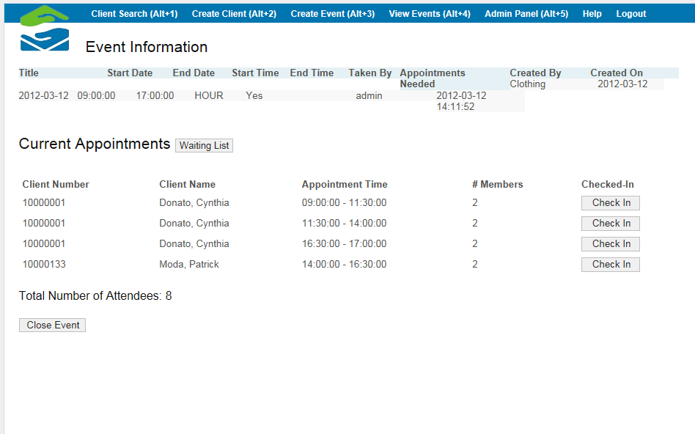

Figure 2.4.3 - Event Information

#### Check-In Lists

The list of people who are currently checked in or awaiting check-in for the particular event is displayed. The user can check the appointment time of each client as well as how many members of the household will be attending. The client name will be the head of the household if appointments are made under the main representative or the dependent’s name if appointments are taken for individual people. The user can check clients in or check them out using these lists (see section 2.3.4).

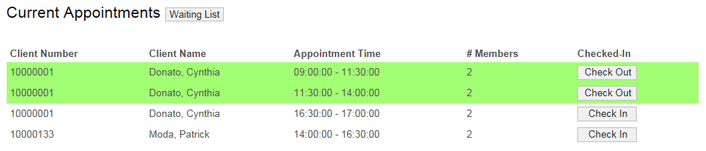

Figure 2.4.4 Current Appointments

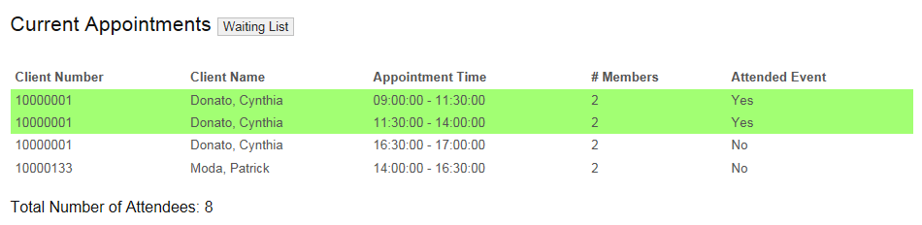

Figure 2.4.5 Current Appointments Attendance Record

Clients highlighted in green have already been checked into the event.

#### Wait Lists

The list of people waiting for an appointment is displayed in the operating report as well. If the reservation was made for the individual and not for the household in general, there will be a star (*) displayed next to the client number. The time that the client was registered is displayed as well as the phone number they can be reached at. The user can remove the client from the waiting list from this page; however, the user can only add the client to the event waiting list or give them an appointment via the client’s file.

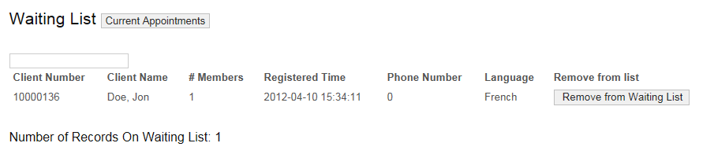

Figure 2.4.6 Waiting List

## Searching

### Search Fields

A client file can be found by entering any one of or combination of the following 6 fields into the search bar.

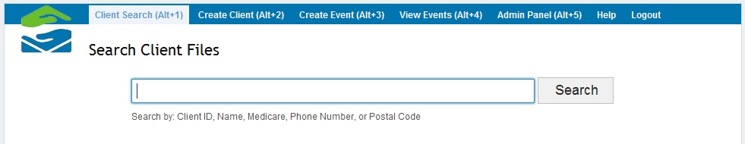

Figure 2.5.1 - Client Search View

### Client ID

Every client ID is unique. Therefore, when searching by **only** client ID, there will always be a single client file found. This is the fastest and easiest way to find a client file.

Simply enter the client ID and the file will be found. You may enter part of the client ID (ex. 1234 instead of 12345678) but it is suggested that you enter the whole client ID for the most accurate results.

Suggested search by Client ID: 12345678

### First Name

You may search by any client or household member’s first name. You may enter part of the name instead of the whole name (ex. Brit instead of Britney) but it is suggested that you enter the entire first name for the most accurate results.

Suggested search by First Name: Melissa

### Last Name

You may search by any client or household member’s last name. You may enter part of the name instead of the whole name (ex. John instead of Johnson) but it is suggested that you enter the entire last name for the most accurate results.

Suggested search by Last Name: McAdams

### Medicare Number

You may search by any client or household member’s Medicare card number. You may enter the beginning of the Medicare number instead of the whole number (ex. JOHL89 instead of JOHL89030596) but it is suggested that you enter the entire Medicare number for the most accurate results.

Suggested search by Medicare Number: MCAM88521247

### Postal Code

You may search by the client’s postal code to find their file. You must enter at least the first three characters of the postal code for it to be taken into account during the search (ex. H4M). However, it is suggested that you enter the entire postal code in the format H4M1K3 **without** spaces for the most accurate results.

Suggested search by Postal Code: H4M2L4

### Phone Number

You may search by the client’s phone number. You may enter part of the phone number instead of the whole number (ex. 514484 instead of 5144842727) but it is suggested that you enter the entire phone number for the most accurate results. Do **not** put any spaces or dashes between the numbers.

Suggested search by Phone Number: 5144842727

### Search Results

The more fields entered, the more likely there are to be multiple search results. Search results are ranked according to the number of words matched from the input to the client file. The more matches found, the higher the client file will be ranked in the results.

Anytime there is a match found, that field will be **bolded** in the search results.

It is important to note that household members will **not** show up in the search results unless there is a match in their first name, last name or Medicare number.

### Search Examples

The following are some examples of the search and the given results:

### By Client ID

10000134

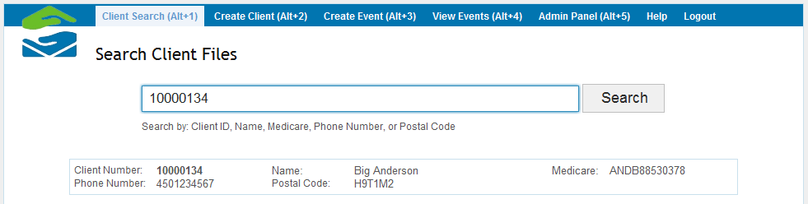

### By Client ID and First Name

10000134 Big

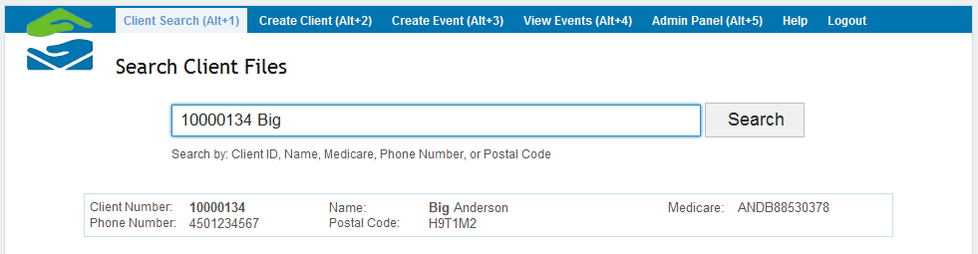

### By Household Member First Name and Last Name

Little Anderson

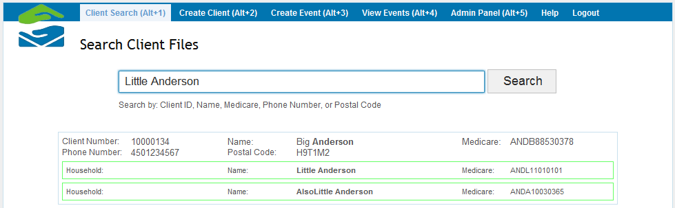

### By Postal Code

H9T1M2

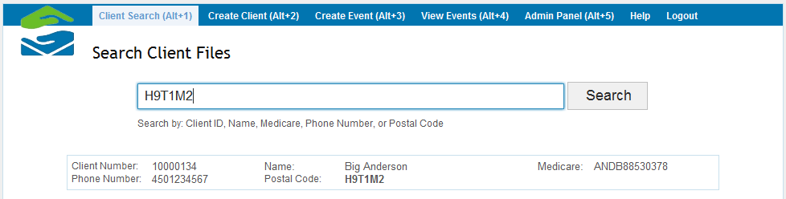

### By Medicare Number and Phone Number

ANDB88530378 4501234567

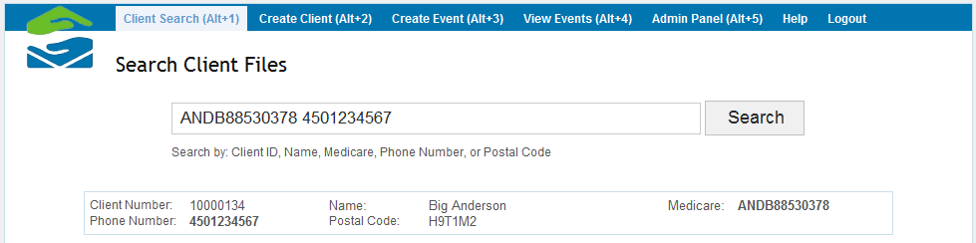

# Usage Notes

## User Roles

The F.S.T.S. Implements two types of user roles:

* Regular User
* Administrator.

These roles are determined upon authentication and dictate what features users have access to. Administrators can control the designation of users in the Admin Panel. See Section 2.1 – Administrative Panel for more details.

## Navigation

Once a user has been authenticated, they receive access to three navigation tools:

### Top Menu

The top menu, seen below, is the main navigation component and is the gateway to all features of the F.S.T.S. A highlighting feature indicates the section of the F.S.T.S. the user is in and added function keys allow for faster keyboard navigation.



Figure 3.2.1 Top Menu Bar

### Side Menu

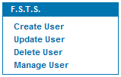

Figure 3.2.2 Side Menu

The side menu, seen on the right, is used as a secondary tool to the top menu. It allows users to refine how they want to manipulate each feature.

### Browser Navigation

The F.S.T.S. is a web application, as such users can take advantage of a browsers built in navigation shortcuts. See Appendix A – F.S.T.S. Keyboard Shortcuts for more details.

## Sample Data

The system is not delivered with sample data.

# APPENDIX A F.S.T.S. Keyboard Shortcuts

Please note these shortcuts were optimised for Internet Explorer 9 and are subject to change:

|  |  |
| --- | --- |
| **SHORTCUT KEYS** | **DESCRIPTION** |
| ALT+1 | Client Search |
| ALT+2 | Create Client |
| ALT+3 | Create Event |
| ALT+4 | View Events |
| ALT+5 | Admin Panel |
| F1 | Display Internet Explorer Help or to display context Help about an item in a dialog box |
| F5  CTRL+F5  CTRL+R | Refresh the current Web page |
| F11 | Toggle between full-screen and other views in the browser |
| TAB | Move forward through the items on a Web page, the Address box, or the Links box. |
| SHIFT + TAB | Move through the items on a Web page, the Address box, or the Links box |
| ALT+RIGHT ARROW | Go to the next page |
| ALT+LEFT ARROW  BACKSPACE | Go to the previous page |
| UP ARROW | Scroll toward the beginning of a document |
| DOWN ARROW | Scroll toward the end of a document |
| RIGHT ARROW | Scroll toward the right of a document |
| LEFT ARROW | Scroll toward the left of a document |
| PAGE UP | Scroll toward the beginning of a document in larger increments |
| PAGE DOWN | Scroll toward the end of a document in larger increments |
| HOME | Move to the beginning of a document |
| END | Move to the end of a document |
| CTRL+N | Open a new window |
| CTRL+W | Close the current window |
| CTRL+P | Print the current page or active frame |