|  |
| --- |
| **Concordia University**  **Department of Computer Science**  **and Software Engineering** |

|  |
| --- |
| **F.S.T.S.**  ***Family Services Tracking System*** |

|  |
| --- |
| **Iteration Planning and Reports** |

|  |
| --- |
| **SOEN 390**  **Software Development Project**  **Winter 2012** |

**JAM PACK**

Katrina Anderson

Cynthia Donato

Joshua Hum

Mikhael Levkovsky

Adrian Lloyd

Patrick Modafferi

**Table of Contents**

1. Overall Person Hour Estimation 6

2. Iteration 1 Plan 11

2.1 Planned User Stories and Story Point Total 11

2.2 Person-Hour Estimation 11

3. Iteration 1 Report 12

3.1 Person-Hour Work Log 12

3.2 Work Log Person-Hour Summary 18

3.3 Cumulative Velocities vs. Time 20

3.4 Cumulative Activity Velocity vs. Time 21

3.5 Cumulative Group Member Velocity vs. Time 22

3.6 Story Point Iteration Burndown Chart 23

3.7 Line Counter Statistics for Iteration 1 24

3.8 Retrospective 25

4. Iteration 2 Plan 27

4.1 Planned User Stories and Story Point Total 27

4.2 Person-Hour Estimation 27

5. Iteration 2 Report 28

5.1 Person-Hour Work Log 28

5.2 Work Log Person-Hour Summary 35

5.3 Cumulative Velocities vs. Time 37

5.4 Cumulative Activity Velocity vs. Time 38

5.5 Cumulative Group Member Velocity vs. Time 39

5.6 Story Point Iteration Burndown Chart 40

5.7 Line Counter Statistics for Iteration 2 41

5.8 Code Quality Analysis 42

5.9 Retrospective 44

6. Iteration 3 Plan 46

6.1 Planned User Stories and Story Point Total 46

6.2 Person-Hour Estimation 46

6.3 Code Quality Goals 47

7. Iteration 3 Report 48

7.1 Person-Hour Work Log 48

7.2 Work Log Person-Hour Summary 53

7.3 Cumulative Velocities vs. Time 56

7.4 Cumulative Activity Velocity vs. Time 57

7.5 Cumulative Group Member Velocity vs. Time 58

7.6 Story Point Iteration Burndown Chart 59

7.7 Line Counter Statistics for Iteration 3 60

7.8 Code Quality Analysis 61

7.9 Retrospective 64

8. Iteration 4 Plan 67

8.1 Planned User Stories and Story Point Total 67

8.2 Person-Hour Estimation 67

8.3 Code Quality Goals 68

9. Iteration 4 Report 69

9.1 Person-Hour Work Log 69

9.2 Work Log Person-Hour Summary 74

9.3 Cumulative Velocities vs. Time 76

9.4 Cumulative Activity Velocity vs. Time 77

9.5 Cumulative Group Member Velocity vs. Time 78

9.6 Story Point Iteration Burndown Chart 79

9.7 Line Counter Statistics for Iteration 4 80

9.8 Code Quality Analysis 81

9.9 Retrospective 84

10. Iteration 5 Plan 86

10.1 Planned User Stories and Story Point Total 86

10.2 Person-Hour Estimation 86

10.3 Code Quality Goals 87

11. Iteration 5 Report 88

11.1 Person-Hour Work Log 88

11.2 Work Log Person-Hour Summary 93

11.3 Cumulative Velocities vs. Time 96

11.4 Cumulative Activity Velocity vs. Time 97

11.5 Cumulative Group Member Velocity vs. Time 98

11.6 Story Point Iteration Burndown Chart 99

11.7 Line Counter Statistics for Iteration 5 100

11.8 PHP Depend Code Quality Analysis 101

11.9 Measurement Report 104

11.10 Retrospective 111

12. Iteration 6 Plan 114

12.1 Planned Activities & Person-Hour Estimation 114

12.2 Code Quality Goals 114

13. Iteration 6 Report 115

13.1 Person-Hour Work Log 115

13.2 Work Log Person-Hour Summary 119

13.3 Cumulative Velocities vs. Time 122

13.4 Cumulative Activity Velocity vs. Time 122

13.5 Cumulative Group Member Velocity vs. Time 123

13.6 Story Point Iteration Burndown Chart 123

13.7 Line Counter Statistics for Iteration 6 124

13.8 PHP Depend Code Quality Analysis 125

13.9 Measurement Report 128

13.10 Retrospective 137

14. Project Retrospective 139

14.1 What We Would Do the Same: 139

14.2 What We Would Do Differently: 139

14.3 Project Goals and Conclusion: 140

Appendix A References 141

|  |
| --- |
| **F.S.T.S.** |

|  |
| --- |
| **Iteration Planning & Reports** |

|  |
| --- |
| **Version 6.21** |

**Revision History**

|  |  |  |  |
| --- | --- | --- | --- |
| **Date** | **Rev.** | **Description** | **Author(s)** |
| 2012-01-29 | 1.0 | Overall Person Hour and Iteration Plan 1 | Katrina Anderson |
| 2012-01-29 | 1.1 | Inserted work log, Work log summary & Graphs | Katrina Anderson |
| 2012-01-29 | 1.2 | Updated Iteration 2 Plan | Adrian Lloyd |
| 2012-01-29 | 1.3 | Contributed Section 3.7 Retrospective | Josh Hum |
| 2012-01-30 | 1.4 | Revised Document | Katrina Anderson |
| 2012-02-12 | 2.5 | Added log, and person hour statistics and code quality analysis for Iteration 2 Report. | Katrina Anderson |
| 2012-02-12 | 2.6 | Added person-hour estimation and code quality goals to Iteration 3 Plan | Katrina Anderson |
| 2012-02-13 | 2.7 | Added sections 5.7 Line Counter Statistics and 5.9 Retrospective | Josh Hum |
| 2012-02-13 | 2.8 | Added to Iteration 3 Plan. | Adrian Lloyd |
| 2012-02-13 | 2.9 | Revised Document | Katrina Anderson |
| 2012-02-25 | 3.10 | Contributed to Iteration 3 Summary and Iteration 4 Plan | Katrina Anderson |
| 2012-02-25 | 3.11 | Contributed to Iteration 3 Summary | Josh Hum |
| 2012-02-25 | 3.12 | Contributed to Iteration 4 Plan | Adrian Lloyd |
| 2012-03-11 | 4.13 | Contributed to Iteration 4 Retrospective and Iteration 5 Plan | Katrina Anderson |
| 2012-03-11 | 4.14 | Contributed to Iteration 5 plan | Adrian Lloyd |
| 2012-03-11 | 4.15 | Contributed to Iteration 4 Retrospective | Josh Hum |
| 2012-03-24 | 5.16 | Iteration 5 Report | Katrina Anderson |
| 2012-03-25 | 5.17 | Iteration 6 Plan | Katrina Anderson |
| 2012-03-25 | 5.18 | Corrections: Adding actual hours toactivities. | Katrina Anderson |
| 2012-03-25 | 5.19 | Iteration 5 Retrospective | Josh Hum |
| 2012-04-10 | 6.20 | Iteration 6 Report & Document Review | Katrina Anderson |
| 2012-04-10 | 6.21 | Document Review | Josh Hum |

# Overall Person Hour Estimation

|  |  |  |  |  |  |  |  |
| --- | --- | --- | --- | --- | --- | --- | --- |
| **User Story ID** | **Feature Group** | **User Stories** | **Worst Case** | **Most Likely Case** | **Best Case** | **Expected Case** | **Acctual**  **Value** |
| US01 | Administrative Controls | As an administrator, I want to create users for the FSTS, so that traceability is maintained by associating users with actions. | 9.60 | 6.00 | 3.60 | 6.20 | 0.50 |
| US02 | Administrative Controls | As an administrator, I want to update user information, so that the system remains relevant. | 11.20 | 7.00 | 4.20 | 7.23 | 2.00 |
| US03 | Administrative Controls | As an administrator, I want to delete users from the FSTS, so that the system remains relevant and can only be accessed by proper personnel. | 11.20 | 7.00 | 4.20 | 7.23 | 0.50 |
| US04 | Administrative Controls | As an administrator, I want to assign permissions to users, so that I may control what actions users are allowed to execute. | 20.80 | 13.00 | 7.80 | 13.43 | 2.00 |
| US05 | Administrative Controls | As an administrator, I want to view a summary of all users and their permissions, so that I may create, update and delete users appropriately. | 11.20 | 7.00 | 4.20 | 7.23 | 2.00 |
| US06 | Administrative Controls | As an administrator, I want users to log into FSTS, so that client information remains secure and user capabilities can be controlled. | 11.20 | 7.00 | 4.20 | 7.23 | 2.50 |
| US07 | Appointment Fulfillment | As a user, I want to view a list of all clients coming to an event, so that I may check-in families on a computing device. | 12.80 | 8.00 | 4.80 | 8.27 | 3.50 |
| US08 | Appointment Fulfillment | As a user, I want to view a list of all clients coming to an event, so that I may print the list and manually check-in families. | 19.20 | 12.00 | 7.20 | 12.40 | 2.50 |
| US09 | Appointment Fulfillment | As a user, I want to close an event for the day, so that all no-shows are automatically flagged. | 12.80 | 8.00 | 4.80 | 8.27 | 3.50 |
| US10 | Appointment Management | As a user, I want to create an appointment, so that clients can be registered for an event occurrence. | 12.80 | 8.00 | 4.80 | 8.27 | 8.00 |
| US11 | Appointment Management | As a user, I want to update appointments, so that clients may change their appointment times. | 9.60 | 6.00 | 3.60 | 6.20 | 3.00 |
| US12 | Appointment Management | As a user, I want to cancel appointments, so that clients will no longer be accounted for in the event capacity or listed for the event attendance. | 9.60 | 6.00 | 3.60 | 6.20 | 3.00 |

|  |  |  |  |  |  |  |  |
| --- | --- | --- | --- | --- | --- | --- | --- |
| US13 | Appointment Management | As a user, I want client appointment eligibility to be validated, so that appointments go to families who best fit the criteria. | 25.60 | 16.00 | 9.60 | 16.53 | 3.00 |
| US14 | Appointment Management | As a user, I want to view a summary of clients with appointments to events, so that I can prepare supplies accordingly. | 12.80 | 8.00 | 4.80 | 8.27 | 0.50 |
| ~~US15~~ | ~~Bilingual System~~ | ~~As a user, I want to view the system in both French and English, so that I comply with user preferences and provincial law.~~ | ~~12.80~~ | ~~8.00~~ | ~~4.80~~ | ~~8.27~~ |  |
| US16 | Client File Management | As a user, I want to create new client files, so that I may gather necessary information about new clients. | 22.40 | 14.00 | 8.40 | 14.47 | 2.00 |
| US17 | Client File Management | As a user, I want to update client files, so that the client information remains relevant and so that errors may be rectified. | 12.80 | 8.00 | 4.80 | 8.27 | 8.00 |
| US18 | Client File Management | As a user, I want to change client file status to active or inactive, so that I can properly filter out clients that no longer require services more quickly. | 12.80 | 8.00 | 4.80 | 8.27 | 2.00 |
| US19 | Client File Management | As an administrator, I want to automatically change the status of active client files to inactive after a mutable period of time, so that I maintain the relevance of the client database. | 19.20 | 12.00 | 7.20 | 12.40 | 8.00 |
| US20 | Client File Management | As an administrator, I want to archive client files after a mutable time period of inactivity, so that I maintain the relevance of the client database and reduce search overhead. | 25.60 | 16.00 | 9.60 | 16.53 | 8.00 |
| US21 | Client File Management | As an administrator, I want to create and automate predefined flags/notes, so that I may reduce data entry overhead for common client file exceptions. | 19.20 | 12.00 | 7.20 | 12.40 | 4.00 |
| US22 | Client File Management | As an administrator, I want to delete predefined flags/notes, so that flags/notes remain relevant to company standards. | 12.80 | 8.00 | 4.80 | 8.27 | 1.50 |
| US23 | Client File Management | As an administrator, I want to update predefined flags/notes, so that flags/notes remain relevant to company standards. | 9.60 | 6.00 | 3.60 | 6.20 | 1.00 |
| US24 | Client File Management | As a user, I want to add predefined flags/notes to client files, so that I may keep track of client exceptions. | 12.80 | 8.00 | 4.80 | 8.27 | 17.95 |
| US25 | Client File Management | As a user, I want to remove predefined flags/notes to client files, so that I may keep client exceptions relevant. | 12.80 | 8.00 | 4.80 | 8.27 | 11.25 |
| US26 | Client File Management | As a user, I want to create custom flags/notes to client files, so that I may keep track of client exceptions. | 19.20 | 12.00 | 7.20 | 12.40 | 5.50 |
| US27 | Client File Management | As a user, I want to delete custom flags/notes to client files, so that I may keep client exceptions relevant. | 12.80 | 8.00 | 4.80 | 8.27 | 8.50 |
| US28 | Client File Management | As a user, I want to update custom flags/notes to client files, so that I may keep client exceptions relevant. | 12.80 | 8.00 | 4.80 | 8.27 | 7.50 |
| US29 | Client File Management | As a user, I want to create dependents for client files, so that I may gather relevant information about all members in a client family. | 12.80 | 8.00 | 4.80 | 8.27 | 14.00 |
| US30 | Client File Management | As a user, I want to delete dependents from client files, so that family information remains relevant. | 12.80 | 8.00 | 4.80 | 8.27 | 2.00 |
| US31 | Client File Management | As a user, I want to update dependents associated with client files, so that family information remains relevant. | 12.80 | 8.00 | 4.80 | 8.27 | 2.00 |
| US32 | Client File Management | As an administrator, I want to associate postal codes with city locations around the city, so that I may reduce data entry overhead in client files. | 25.60 | 16.00 | 9.60 | 16.53 | 17.00 |
| US33 | Client File Management | As an administrator, I want to add rows/options to drop-down fields in client files, so that I can create client files with customized options. | 16.00 | 10.00 | 6.00 | 10.33 | 2.00 |
| US34 | Client File Management | As an administrator, I want to update rows/options to drop-down fields in client files, so that I can create client files with customized options. | 9.60 | 6.00 | 3.60 | 6.20 | 2.00 |
| US35 | Client File Management | As an administrator, I want to delete rows/options to drop-down fields in client files, so that I can create client files with customized options. | 9.60 | 6.00 | 3.60 | 6.20 | 2.00 |
| US36 | Client File Management | As a user, I want to view all client information, related dependents and flags/notes in one concise screen, so that I reduce time spent navigating to find client information. | 9.60 | 6.00 | 3.60 | 6.20 | 48.00 |
| US37 | Client File Search | As a user, I want to be able to search for client files by family id so that I may quickly access the family information. | 16.00 | 10.00 | 6.00 | 10.33 | 23.50 |
| US38 | Client File Search | As a user, I would like to be able to make an advanced search for a client file so that I may located client files for clients who do not have their file id with them | 38.40 | 24.00 | 14.40 | 24.80 | 15.50 |
| US39 | Event Management | As an administrator, I would like to create event templates, so that data-entry is reduced and event and appointment creation are cohesive. | 38.40 | 24.00 | 14.40 | 24.80 | 3.75 |
| US40 | Event Management | As an administrator, I want to delete event templates, so that stored event templates remain relevant. | 12.80 | 8.00 | 4.80 | 8.27 | 2.75 |
| US41 | Event Management | As an administrator, I would like to update event templates, so that errors can be rectified and variables remain relevant. | 12.80 | 8.00 | 4.80 | 8.27 | 2.75 |
| US42 | Event Management | As an administrator, I would like to view a summary of event templates, so that I may create event templates appropriately. | 12.80 | 8.00 | 4.80 | 8.27 | 2.75 |
| US43 | Event Management | As an administrator, I would like to create/schedule events from event templates, so that activities can be managed and appointments created. | 9.60 | 6.00 | 3.60 | 6.20 | 4.00 |
| US44 | Event Management | As a user, I want to cancel events, so that events with poor attendance or special circumstances can be removes from the schedule. | 9.60 | 6.00 | 3.60 | 6.20 | 1.50 |
| US45 | Event Management | As an administrator, I want to update an event, so that variables remain relevant and errors can be corrected. | 9.60 | 6.00 | 3.60 | 6.20 | 1.50 |
| US46 | Event Management | As a user, I want to view a list of all active event occurrences, so that I may plan accordingly. | 9.60 | 6.00 | 3.60 | 6.20 | 1.00 |
| US47 | Event Management | As a user, I want to view all information about individual event occurrences, so that I may validate that capacity is not exceeded. | 12.80 | 8.00 | 4.80 | 8.27 | 1.00 |
| US48 | Operating Reports | As a user, I want to create operational reports, so that I may view concise information related to the day-to-day operation of the Welcome Hall Mission. | 115.20 | 72.00 | 43.20 | 74.40 | 20 |
| ~~US49~~ | ~~Special Query and Reporting~~ | ~~As a user, I want to create special query reports, to generate mutable information not provided in the operational or statistical reports.~~ | ~~182.40~~ | ~~114.00~~ | ~~68.40~~ | ~~117.80~~ |  |
| US50 | Statistical Reports | As a user, I want to create statistical reports, so that I may view concise information related to the clientele of the Welcome Hall Mission. | 115.20 | 72.00 | 43.20 | 74.40 | 2.00 |
| US51 | Client File Management | As a user, I want to add income and work information to clients and dependants, so that I can derive statistical information. | 14.40 | 9.00 | 5.40 | 9.30 | 20.50 |

|  |  |  |  |  |  |  |  |
| --- | --- | --- | --- | --- | --- | --- | --- |
| US52 | Client File Management | As a user, I want to delete income and work information to clients and dependants, so that I can derive statistical information. | 4.80 | 3.00 | 1.80 | 3.10 | 4.00 |
| US53 | Client File Management | As a user, I want to update income and work information to clients and dependants, so that I can derive statistical information. | 9.60 | 6.00 | 3.60 | 6.20 | 2.00 |
| US54 | Client File Management | As a user, I want to view income and work information to clients and dependants, so that I can derive statistical information. | 9.60 | 6.00 | 3.60 | 6.20 | 8.50 |
| US55 | Appointment Management | As a user, Iwant to add clients to a waiting list for events that have reached capacity, so that I may assure full attendance to events and service to clients. | 182.40 | 114.00 | 68.40 | 117.80 | 11.00 |

# Iteration 1 Plan

## Planned User Stories and Story Point Total

We will be using VersionOne to document the progression of our story points. VersionOne automatically generates the estimated velocities of our project.

|  |  |  |
| --- | --- | --- |
| **User Story ID** | **Total Story Points** | **Related Use Cases** |
| **US06, US16, US17, US18, US21, US22, US23, US24, US25, US29, US30, US31, US32, US33, US34, US35, US36, US39, US40, US41, US42** | **34.00** | **UC1.1, UC1.4, UC1.5, UC2.1, UC2.2, UC2.3, UC2.4, UC6.1, UC6.2** |

## Person-Hour Estimation

Estimated person-hour measurements where calculated with the Expert Judgment Method. The table below illustrates our velocity predictions.The pessimistic and optimistic durations were calculated from the expected duration with a margin of 60% between them. Meaning the optimistic estimate is 30% lower than the expected duration estimate, while the pessimistic duration estimate is 30% higher than the expected duration estimate.

|  |  |  |  |  |
| --- | --- | --- | --- | --- |
| **User Story ID** | **Pessimistic (ph)** | **Expected (ph)** | **Optimistic (ph)** | **Most Likely (ph)** |
| US06 | 11.20 | 7.00 | 4.20 | 7.23 |
| US16 | 22.40 | 14.00 | 8.40 | 14.47 |
| US17 | 12.80 | 8.00 | 4.80 | 8.27 |
| US18 | 12.80 | 8.00 | 4.80 | 8.27 |
| US21 | 19.20 | 12.00 | 7.20 | 12.40 |
| US22 | 12.80 | 8.00 | 4.80 | 8.27 |
| US23 | 9.60 | 6.00 | 3.60 | 6.20 |
| US24 | 12.80 | 8.00 | 4.80 | 8.27 |
| US25 | 12.80 | 8.00 | 4.80 | 8.27 |
| US29 | 12.80 | 8.00 | 4.80 | 8.27 |
| US30 | 12.80 | 8.00 | 4.80 | 8.27 |
| US31 | 12.80 | 8.00 | 4.80 | 8.27 |
| US32 | 25.60 | 16.00 | 9.60 | 16.53 |
| US33 | 16.00 | 10.00 | 6.00 | 10.33 |
| US34 | 9.60 | 6.00 | 3.60 | 6.20 |
| US35 | 9.60 | 6.00 | 3.60 | 6.20 |
| US36 | 9.60 | 6.00 | 3.60 | 6.20 |
| US39 | 38.40 | 24.00 | 14.40 | 24.80 |
| US40 | 12.80 | 8.00 | 4.80 | 8.27 |
| US41 | 12.80 | 8.00 | 4.80 | 8.27 |
| US42 | 12.80 | 8.00 | 4.80 | 8.27 |
| **Total (ph)** | **312.00** | **195.00** | **117.00** | **201.50** |
| **Velocity(ph/day)** | **22.29** | **13.93** | **8.36** | **14.39** |

# Iteration 1 Report

## Person-Hour Work Log

|  |  |  |  |  |  |
| --- | --- | --- | --- | --- | --- |
| **Date** | **Artifact Type** | **Artifact Name** | **Artifact Description** | **Cost (Hours)** | **Initials** |
| 1/17/2012 | Documentation & Organization | Use Case Specifications | Update the domain model | 1 | JH |
| 1/17/2012 | Documentation & Organization | Use Case Specifications | A domain model to represent the FSTS system | 4 | ML |
| 1/17/2012 | Other | Database Setup | Create the database | 3 | JH |
| 1/18/2012 | Documentation & Organization | Meeting | Weekly Wednesday Meeting | 1.5 | AL |
| 1/18/2012 | Documentation & Organization | Meeting | Weekly Wednesday Meeting | 1.5 | JH |
| 1/18/2012 | Documentation & Organization | Meeting | Weekly Wednesday Meeting | 1.5 | KA |
| 1/18/2012 | Documentation & Organization | Meeting | Weekly Wednesday Meeting | 1.5 | ML |
| 1/18/2012 | Documentation & Organization | Meeting | Weekly Wednesday Meeting | 1.5 | PM |
| 1/18/2012 | Other | Database Setup | Setup the MySQL database based on the domain model | 1 | ML |
| 1/20/2012 | Learning | Yii Tutorial | Created a blog application to learn how to use the Yii PHP framework | 3 | ML |
| 1/20/2012 | Learning | Yii Tutorial | Created a blog application to learn how to use the Yii PHP framework | 5 | PM |
| 1/21/2012 | Learning | Yii Tutorial | Created a blog application to learn how to use the Yii PHP framework | 5 | AL |
| 1/21/2012 | Learning | Yii Tutorial | Getting familiar with Yii framework including doing the blog tutorial | 3 | CD |
| 1/21/2012 | Learning | Yii Tutorial | Learn how to use Yii | 5 | JH |
| 1/21/2012 | Other | Environment Setup | Setup work environment including WAMP, Yii and Netbeans installation | 0.5 | CD |
| 1/21/2012 | Other | Environment Setup | Setup work environment including WAMP, Yii and Netbeans installation | 0.5 | PM |
| 1/22/2012 | Learning | Yii Tutorial | Created a blog application to learn how to use the Yii PHP framework | 3 | KA |
| 1/22/2012 | Other | Database Setup | Designed and updated database structure to include tbl_event and tbl_event_occurrence | 0.5 | CD |
| 1/22/2012 | Other | Environment Setup | Setup work environment including WAMP, Yii on home computer | 0.5 | KA |
| 1/22/2012 | User Stories | US39 | Coded basic functionality for creating event templates | 0.75 | CD |
| 1/22/2012 | User Stories | US40 | Coded basic functionality for updating event templates | 0.75 | CD |
| 1/22/2012 | User Stories | US41 | Coded basic functionality for deleting event templates | 0.75 | CD |
| 1/22/2012 | User Stories | US42 | Coded basic functionality for viewing event templates | 0.75 | CD |
| 1/23/2012 | Learning | Yii Tutorial | Reading the book on Yii to learn more about the Yii framework | 4 | PM |
| 1/24/2012 | Documentation & Organization | Meeting | Organization for weekly Wednesday Meeting | 1 | KA |
| 1/24/2012 | Learning | Yii Testing | Research on Yii unit testing unit (PHPUnit) | 1 | AL |
| 1/24/2012 | User Stories | US17 | CRUD for basic Client File fields | 2 | ML |
| 1/24/2012 | User Stories | US18 | CRUD for basic Client File fields | 2 | ML |
| 1/24/2012 | User Stories | US21 | CRUD for flag administration | 0.5 | AL |
| 1/24/2012 | User Stories | US22 | CRUD for flag administration | 0.5 | AL |
| 1/24/2012 | User Stories | US29 | CRUD for basic Client File fields | 2 | PM |
| 1/24/2012 | User Stories | US30 | CRUD for basic Client File fields | 1 | PM |
| 1/24/2012 | User Stories | US31 | CRUD for basic Client File fields | 1 | PM |
| 1/24/2012 | User Stories | US32 | Link postal code and city | 2 | JH |
| 1/25/2012 | Documentation & Organization | Meeting | Weekly Wednesday Meeting | 2 | AL |
| 1/25/2012 | Documentation & Organization | Meeting | Weekly Wednesday Meeting | 2 | CD |
| 1/25/2012 | Documentation & Organization | Meeting | Weekly Wednesday Meeting | 2 | JH |
| 1/25/2012 | Documentation & Organization | Meeting | Weekly Wednesday Meeting | 2 | KA |
| 1/25/2012 | Documentation & Organization | Meeting | Meeting with group members | 2 | ML |
| 1/25/2012 | Documentation & Organization | Meeting | Weekly Wednesday Meeting | 2 | PM |
| 1/25/2012 | Documentation & Organization | VersionOne | Created feature groups and split up 5 existing user stories into separate user stories(each task became a user story) including adding detailed descriptions and dependencies | 2 | CD |
| 1/25/2012 | Documentation & Organization | VersionOne | Reorganizing | 5 | KA |
| 1/25/2012 | Documentation & Organization | VersionOne | Learning to use the Version One Tool and determining course of action | 2 | KA |
| 1/25/2012 | Documentation & Organization | VersionOne | Learning to use the Version One Tool and determining course of action | 1 | PM |
| 1/25/2012 | Learning | Yii Testing | Research on Yii testing unit, PHPUnit, Pear installation and how to create test cases in Yii | 2 | CD |
| 1/25/2012 | User Stories | US17 | Created all the dependant models (refer to Domain Model) to be able to create a client file. | 3 | ML |
| 1/26/2012 | Documentation & Organization | Iteration Planning & Reports | Setup Iteration1 document | 0.5 | KA |
| 1/26/2012 | Documentation & Organization | Presentation | Setup Iteration1 Presentation document | 0.5 | KA |
| 1/26/2012 | Documentation & Organization | Use Case Specifications | Update AHP to comply with VersionOne | 1 | KA |
| 1/26/2012 | Documentation & Organization | VersionOne | Managing small tasks and tests in Version One Tool | 1 | PM |
| 1/26/2012 | Documentation & Organization | Vision Document | Update Vision Doc Section 4 Product Overview  to comply with VersionOne | 1 | KA |
| 1/27/2012 | Documentation & Organization | SRS | Updated elements from iteration0 documentation | 0.5 | PM |
| 1/27/2012 | Documentation & Organization | Tractability Links | Needs vs. Features Traceability Matrix | 0.5 | PM |
| 1/27/2012 | Documentation & Organization | VersionOne | Add tasks and test cases to Version One | 0.5 | JH |
| 1/27/2012 | User Stories | US32 | Work on auto-generating the city when the postal code is entered using AJAX and query | 3 | JH |
| 1/28/2012 | Documentation & Organization | SRS | Updates Sections 6, 13, and 14 of SRS | 1 | AL |
| 1/28/2012 | Documentation & Organization | SRS | Review and update SRS | 0.25 | JH |
| 1/28/2012 | Documentation & Organization | Use Case Specifications | Update Use Case Model | 0.5 | CD |
| 1/28/2012 | Documentation & Organization | Use Case Specifications | Update Use Case | 0.25 | CD |
| 1/28/2012 | Documentation & Organization | Use Case Specifications | Update Use Case | 0.25 | CD |
| 1/28/2012 | Documentation & Organization | Use Case Specifications | Update Use Case | 0.25 | CD |
| 1/28/2012 | Documentation & Organization | Use Case Specifications | Wrote Use Case Add Note | 0.25 | CD |
| 1/28/2012 | Documentation & Organization | Use Case Specifications | Wrote Use Case Add Flag | 0.25 | CD |
| 1/28/2012 | Documentation & Organization | Use Case Specifications | Wrote Use Case Set Flag Inactive | 0.25 | CD |
| 1/28/2012 | Documentation & Organization | Use Case Specifications | Wrote Use Case Create Flag | 0.25 | CD |
| 1/28/2012 | Documentation & Organization | Use Case Specifications | Wrote Use Cases Create Client File | 0.25 | CD |
| 1/28/2012 | Documentation & Organization | Use Case Specifications | Wrote Use Case Update Client File | 0.25 | CD |
| 1/28/2012 | Documentation & Organization | Use Case Specifications | Wrote Use Case Delete Client File | 0.25 | CD |
| 1/28/2012 | Documentation & Organization | VersionOne | Added Use Case ID's to VersionOne | 0.25 | KA |
| 1/28/2012 | Documentation & Organization | VersionOne | Managed and Cleared Tasks and Tests | 2 | PM |
| 1/28/2012 | Documentation & Organization | Vision Document | Review and update Vision Document | 0.25 | JH |
| 1/28/2012 | Other | Excel Macro | Wrote Excel Macro that organizes Log into summary | 3 | KA |
| 1/28/2012 | Other | PEAR Installation | Attempted to install and configure PARE | 1 | CD |
| 1/28/2012 | User Stories | US06 | CRUD for User model, md5 the password before saving, tweak the form | 1 | JH |
| 1/28/2012 | User Stories | US16 | Wrote and executed test cases | 1 | ML |
| 1/28/2012 | User Stories | US16 | Wrote and executed test cases | 1 | PM |
| 1/28/2012 | User Stories | US17 | Wrote and executed test cases | 1 | ML |
| 1/28/2012 | User Stories | US17 | Wrote and executed test cases | 1 | PM |
| 1/28/2012 | User Stories | US17 | Coding | 1 | PM |
| 1/28/2012 | User Stories | US21 | Updated Flag Admin Form | 2 | AL |
| 1/28/2012 | User Stories | US21 | Wrote and executed test cases | 1 | AL |
| 1/28/2012 | User Stories | US22 | Wrote and executed test cases | 1 | AL |
| 1/28/2012 | User Stories | US23 | Wrote and executed test cases | 1 | AL |
| 1/28/2012 | User Stories | US24 | Wrote test cases | 0.5 | AL |
| 1/28/2012 | User Stories | US24 | Worked on Client Flags | 1.5 | AL |
| 1/28/2012 | User Stories | US25 | Wrote test cases | 0.5 | AL |
| 1/28/2012 | User Stories | US25 | Worked on Client Flags | 1.5 | AL |
| 1/28/2012 | User Stories | US26 | Wrote test cases | 0.5 | AL |
| 1/28/2012 | User Stories | US27 | Wrote test cases | 0.5 | AL |
| 1/28/2012 | User Stories | US28 | Wrote test cases | 0.5 | AL |
| 1/28/2012 | User Stories | US29 | Coding | 3 | PM |
| 1/28/2012 | User Stories | US32 | Work on auto-generating the city when the postal code is entered using AJAX and jQuery | 6 | JH |
| 1/28/2012 | User Stories | US36 | Wrote and executed test cases | 2 | ML |
| 1/28/2012 | User Stories | US36 | Wrote and executed test cases | 2 | PM |
| 1/28/2012 | User Stories | US39 | Wrote and executed test cases | 1.5 | CD |
| 1/28/2012 | User Stories | US39 | Wrote and executed test cases | 1.5 | KA |
| 1/28/2012 | User Stories | US40 | Wrote and executed test cases | 1 | CD |
| 1/28/2012 | User Stories | US40 | Wrote and executed test cases | 1 | KA |
| 1/28/2012 | User Stories | US41 | Wrote and executed test cases | 1 | CD |
| 1/28/2012 | User Stories | US41 | Wrote and executed test cases | 1 | KA |
| 1/28/2012 | User Stories | US42 | Wrote and executed test cases | 1 | CD |
| 1/28/2012 | User Stories | US42 | Wrote and executed test cases | 1 | KA |
| 1/29/2012 | Documentation & Organization | Iteration Planning & Reports | Iteration 2 Plan | 1 | AL |
| 1/29/2012 | Documentation & Organization | Iteration Planning & Reports | Iteration 1 Summary | 2 | JH |
| 1/29/2012 | Documentation & Organization | Iteration Planning & Reports | Person Hour Analysis and graph generation. | 4 | KA |
| 1/29/2012 | Documentation & Organization | Presentation | Prepare Event demo | 0.5 | CD |
| 1/29/2012 | Documentation & Organization | Presentation | Prepared slides for presentation | 1 | KA |
| 1/29/2012 | Documentation & Organization | Presentation | Prepared architecture information for FSTS | 0.5 | ML |
| 1/29/2012 | Documentation & Organization | Presentation | Presentation Questionnaire | 1 | PM |
| 1/29/2012 | Documentation & Organization | SRS | Revision | 0.5 | KA |
| 1/29/2012 | Documentation & Organization | SRS | Updated the SRS | 0.5 | ML |
| 1/29/2012 | Documentation & Organization | Test Cases | Contributed and revised | 1.5 | KA |
| 1/29/2012 | Documentation & Organization | Test Cases | Revised test cases | 1 | PM |
| 1/29/2012 | Documentation & Organization | Traceability Links | Tractability matrix Feature vs. Use Case | 1 | CD |
| 1/29/2012 | Documentation & Organization | Traceability Links | Contributed and revised | 1.5 | KA |
| 1/29/2012 | Documentation & Organization | Use Case Specifications | Actor Goal List | 0.5 | CD |
| 1/29/2012 | Documentation & Organization | Use Case Specifications | Wrote Use Cases Client Search by Id | 0.5 | CD |
| 1/29/2012 | Documentation & Organization | Use Case Specifications | Wrote Use Case Client Search Advanced | 0.5 | CD |
| 1/29/2012 | Documentation & Organization | Use Case Specifications | Wrote Use Case View all event templates | 0.5 | CD |
| 1/29/2012 | Documentation & Organization | Use Case Specifications | Wrote Use Case View event template details | 0.5 | CD |
| 1/29/2012 | Documentation & Organization | Use Case Specifications | Revision | 0.5 | KA |
| 1/29/2012 | Documentation & Organization | VersionOne | Updated user stories with task and test items | 3 | AL |
| 1/29/2012 | Documentation & Organization | VersionOne | Revised test cases | 1.5 | AL |
| 1/29/2012 | Documentation & Organization | VersionOne | User story graphs and sprint 2 set up | 4 | KA |
| 1/29/2012 | Documentation & Organization | VersionOne | Revised test cases and tasks | 3 | PM |
| 1/29/2012 | Documentation & Organization | Vision Document | Revision | 0.5 | KA |
| 1/29/2012 | Documentation & Organization | Vision Document | Updated the vision document section 5 | 0.5 | ML |
| 1/29/2012 | User Stories | US21 | Updated Flag Admin Form to incorporate is_active field | 0.5 | AL |
| 1/29/2012 | User Stories | US24 | Worked on Client Flags | 3 | AL |
| 1/30/2012 | Documentation & Organization | Meeting | Presentation practice | 1 | AL |
| 1/30/2012 | Documentation & Organization | Meeting | Presentation practice | 1 | CD |
| 1/30/2012 | Documentation & Organization | Meeting | Presentation practice | 1 | JH |
| 1/30/2012 | Documentation & Organization | Meeting | Presentation practice | 1 | KA |
| 1/30/2012 | Documentation & Organization | Meeting | Presentation practice | 1 | ML |
| 1/30/2012 | Documentation & Organization | Meeting | Presentation practice | 1 | PM |
| 1/30/2012 | Documentation & Organization | Presentation | Prepare Client Files demo | 1 | PM |
| 1/29/2012 | Documentation & Organization | Presentation | Prepare summary for Iteration 1 presentation | 1.5 | JH |
| 1/29/2012 | Documentation & Organization | Traceability Links | Features vs. Supplementary Requirements traceability matrix | 1 | JH |
| 1/29/2012 | Documentation & Organization | VersionOne | Create/update test cases on VersionOne | 0.5 | JH |
| 1/29/2012 | User Stories | US06 | Wrote and executed test cases | 1.5 | JH |

## Work Log Person-Hour Summary

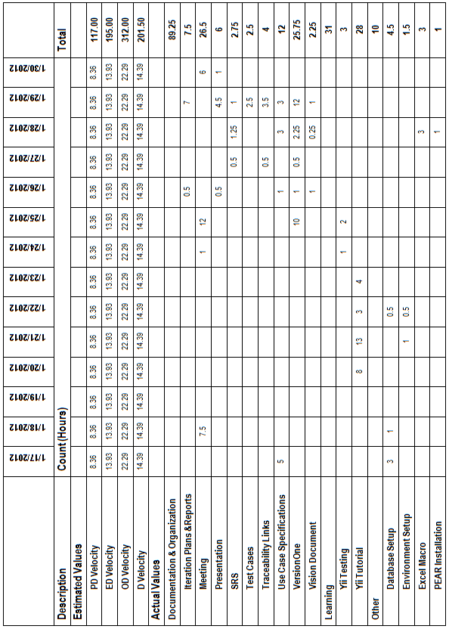

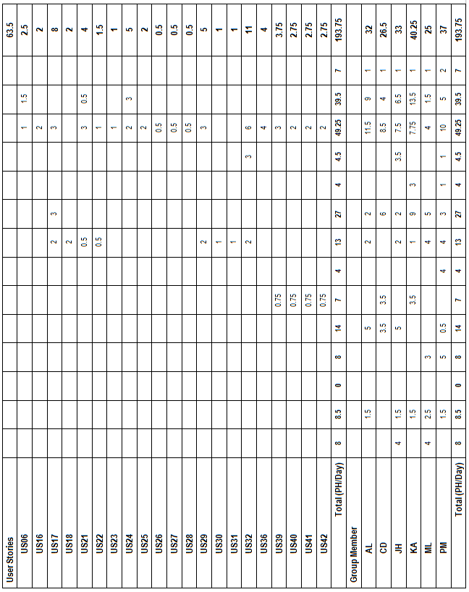

## Cumulative Velocities vs. Time

## Cumulative Activity Velocity vs. Time

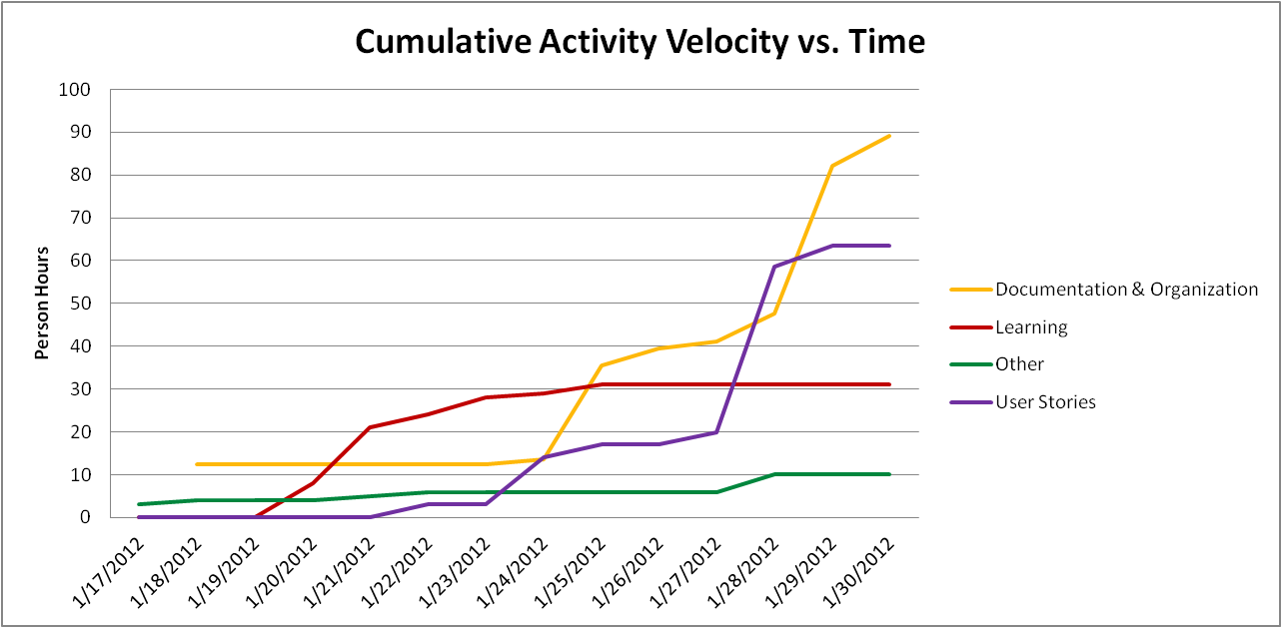

## Cumulative Group Member Velocity vs. Time

## Story Point Iteration Burndown Chart

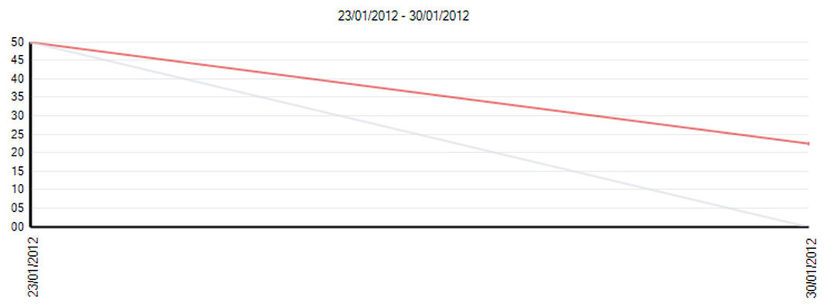

## Line Counter Statistics for Iteration 1

Line Counter Program:

|  |  |
| --- | --- |
| **Program Name** | LOC Counter, copyright (c) 2011, Gary Gocek |
| **Developer** | Gary Gocek |
| **License / Price** | BSD License / $0 |
| **Size / OS** | 659 KB / Windows 2K / XP / Vista / 7 |
| **Last Updated** | August 27th, 2011, 16:59 UTC |
| **Program Source** | <http://www.softpedia.com/get/Office-tools/Other-Office-Tools/LOC-Counter-GUI.shtml> |

Statistical Results:

|  |  |
| --- | --- |
| **Total Number of Files** | 2, 144 |
| **Total Number of Comment Lines** | 67, 729 |
| **Total Number of Blank Lines** | 24, 508 |
| **Total Number of Source Code Lines** | 616, 029 |
| **Total Number of Lines** | 708, 266 |
| **File Types** | HTML, XML, Jscript Script, SQL, Windows Batch File, PHP |

Sample Screenshot:

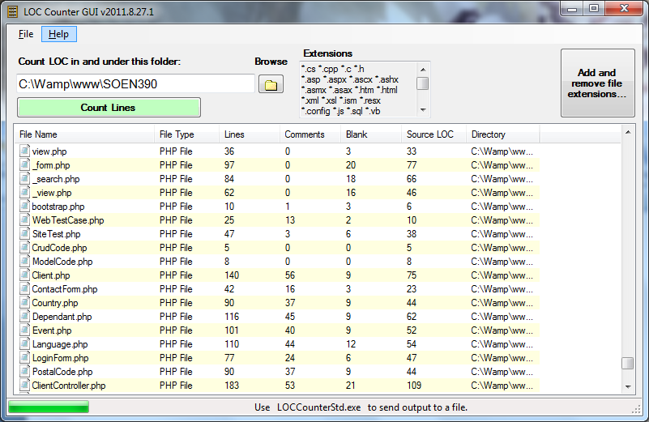

## Retrospective

Due to initial project overhead, which consisted of system configuration and learning technologies, we were unable to meet our goal of 34 user story points, therefore this iteration proved unsuccessful. Overall, we completed 19 story points and the user stories that were not completed were pushed to Iteration 2.

We completed the following user stories:

|  |  |  |  |
| --- | --- | --- | --- |
| **User Story ID** | **Feature Group** | **User Stories** | **Story Points** |
| US06 | Administrative Controls | As an administrator, I want users to log into FSTS, so that client information remains secure and user capabilities can be controlled. | 1.00 |
| US16 | Client File Management | As a user, I want to create new client files, so that I may gather necessary information about new clients. | 5.00 |
| US17 | Client File Management | As a user, I want to update client files, so that the client information remains relevant and so that errors may be rectified. | 1.00 |
| US21 | Client File Management | As an administrator, I want to create and automate predefined flags/notes, so that I may reduce data entry overhead for common client file exceptions. | 2.00 |
| US22 | Client File Management | As an administrator, I want to delete predefined flags/notes, so that flags/notes remain relevant to company standards. | 1.00 |
| US23 | Client File Management | As an administrator, I want to update predefined flags/notes, so that flags/notes remain relevant to company standards. | 1.00 |
| US39 | Event Management | As an administrator, I would like to create event templates, so that data-entry is reduced and event and appointment creation are cohesive. | 5.00 |
| US40 | Event Management | As an administrator, I want to delete event templates, so that stored event templates remain relevant. | 1.00 |
| US41 | Event Management | As an administrator, I would like to update event templates, so that errors can be rectified and variables remain relevant. | 1.00 |
| US42 | Event Management | As an administrator, I would like to view a summary of event templates, so that I may create event templates appropriately. | 1.00 |

The following positive and negative points show what we would like to continue doing and what we do not want to do in future iterations.

Positives:

* Good communication
* Daily scrum meetings(if a person couldn’t attend, he/she was informed by group email)
* Balanced division of work/tasks
* Planning and management were done efficiently

Negatives:

* Struggled to learn how to use VersionOne
* Original user stories were too big. They were broken down into smaller user stories during Iteration 1.
* Implementation was not started until one week into the iteration due to initial project overhead. Thus, some stories were not completed and pushed to Iteration 2.

130.25 out of 193.75 person – hours (67% of our time) were spent working on tasks other than user stories this iteration. We expect that this percentage will greatly decrease in the next iteration because the initial project overhead is mostly complete.

Project overhead included:

* Learning the Yii Framework
* Learning and setting up VersionOne
* Setting up the database
* Setting up the development environment
* Setting up documentation (Formatting, macro, etc)

# Iteration 2 Plan

## Planned User Stories and Story Point Total

We will be using VersionOne to document the progression of our story points. VersionOne automatically generates the estimated velocities of our project.

|  |  |  |
| --- | --- | --- |
| **User Story ID** | **Total Story Points** | **Related Use Cases** |
| **US18, US19, US24, US25, US29, US30, US31, US32, US33, US34, US35, US36, US37, US38, US43, US44, US45, US46, US47** | **30.00** | **UC1.1, UC1.2, UC1.3, UC1.4, UC1.5, UC1.6, UC1.7, UC1.8, UC2.2, UC2.4, UC2.5, UC2.6** |

## Person-Hour Estimation

Estimated person-hour measurements where calculated with the Expert Judgment Method. The table below illustrates our velocity predictions. The pessimistic and optimistic durations were calculated from the expected duration with a margin of 60% between them. Meaning the optimistic estimate is 30% lower than the expected duration estimate, while the pessimistic duration estimate is 30% higher than the expected duration estimate.

|  |  |  |  |  |
| --- | --- | --- | --- | --- |
| **User Story ID** | **Pessimistic Duration (ph)** | **Expected Duration (ph)** | **Optimistic Duration (ph)** | **Most Likely Case (ph)** |
| US18 | 12.80 | 8.00 | 4.80 | 8.27 |
| US19 | 19.20 | 12.00 | 7.20 | 12.40 |
| US24 | 12.80 | 8.00 | 4.80 | 8.27 |
| US25 | 12.80 | 8.00 | 4.80 | 8.27 |
| US29 | 12.80 | 8.00 | 4.80 | 8.27 |
| US30 | 12.80 | 8.00 | 4.80 | 8.27 |
| US31 | 12.80 | 8.00 | 4.80 | 8.27 |
| US32 | 25.60 | 16.00 | 9.60 | 16.53 |
| US33 | 16.00 | 10.00 | 6.00 | 10.33 |
| US34 | 9.60 | 6.00 | 3.60 | 6.20 |
| US35 | 9.60 | 6.00 | 3.60 | 6.20 |
| US36 | 9.60 | 6.00 | 3.60 | 6.20 |
| US37 | 16.00 | 10.00 | 6.00 | 10.33 |
| US38 | 38.40 | 24.00 | 14.40 | 24.80 |
| US43 | 9.60 | 6.00 | 3.60 | 6.20 |
| US44 | 9.60 | 6.00 | 3.60 | 6.20 |
| US45 | 9.60 | 6.00 | 3.60 | 6.20 |
| US46 | 9.60 | 6.00 | 3.60 | 6.20 |
| US47 | 12.80 | 8.00 | 4.80 | 8.27 |
| **Total (ph)** | **272.00** | **170.00** | **102.00** | **175.67** |
| **Velocity (ph/day)** | **19.43** | **12.14** | **7.29** | **12.55** |

# Iteration 2 Report

## Person-Hour Work Log

|  |  |  |  |  |  |
| --- | --- | --- | --- | --- | --- |
| **Date** | **Artifact Type** | **Artifact Name** | **Artifact Description** | **Cost (Hours)** | **Initials** |
| 1/31/2012 | Documentation & Organization | SCRUM Meeting | Daily SCRUM Meeting | 0.2 | AL |
| 1/31/2012 | Documentation & Organization | SCRUM Meeting | Daily SCRUM Meeting | 0.2 | CD |
| 1/31/2012 | Documentation & Organization | SCRUM Meeting | Daily SCRUM Meeting | 0.2 | JH |
| 1/31/2012 | Documentation & Organization | SCRUM Meeting | Daily SCRUM Meeting | 0.2 | KA |
| 1/31/2012 | Documentation & Organization | SCRUM Meeting | Daily SCRUM Meeting | 0.2 | ML |
| 1/31/2012 | Documentation & Organization | SCRUM Meeting | Daily SCRUM Meeting | 0.2 | PM |
| 2/1/2012 | Documentation & Organization | Agile quiz | Online quiz to determine to see if our team is Agile enough | 0.25 | CD |
| 2/1/2012 | Documentation & Organization | Agile quiz | Online quiz to determine to see if our team is Agile enough | 0.25 | JH |
| 2/1/2012 | Documentation & Organization | Meeting | Weekly Meeting | 1.5 | AL |
| 2/1/2012 | Documentation & Organization | Meeting | Weekly Meeting | 1.5 | CD |
| 2/1/2012 | Documentation & Organization | Meeting | Weekly Meeting | 1.5 | JH |
| 2/1/2012 | Documentation & Organization | Meeting | Weekly Meeting | 1.5 | KA |
| 2/1/2012 | Documentation & Organization | Meeting | Weekly Meeting | 1.5 | ML |
| 2/1/2012 | Documentation & Organization | Meeting | Weekly Meeting | 1.5 | PM |
| 2/2/2012 | Documentation & Organization | Agile quiz | Online quiz to determine to see if our team is Agile enough | 0.25 | AL |
| 2/2/2012 | Documentation & Organization | Agile quiz | Online quiz to determine to see if our team is Agile enough | 0.25 | KA |
| 2/2/2012 | Documentation & Organization | Agile quiz | Online quiz to determine to see if our team is Agile enough | 0.5 | ML |
| 2/2/2012 | Documentation & Organization | Agile quiz | Online quiz to determine to see if our team is Agile enough | 0.5 | PM |
| 2/2/2012 | Documentation & Organization | SCRUM Meeting | Daily SCRUM Meeting | 0.2 | AL |
| 2/2/2012 | Documentation & Organization | SCRUM Meeting | Daily SCRUM Meeting | 0.2 | CD |
| 2/2/2012 | Documentation & Organization | SCRUM Meeting | Daily SCRUM Meeting | 0.2 | JH |
| 2/2/2012 | Documentation & Organization | SCRUM Meeting | Daily SCRUM Meeting | 0.2 | KA |
| 2/2/2012 | Documentation & Organization | SCRUM Meeting | Daily SCRUM Meeting | 0.2 | ML |
| 2/2/2012 | Documentation & Organization | SCRUM Meeting | Daily SCRUM Meeting | 0.2 | PM |
| 2/2/2012 | Other | Yii Research | Forms and how to access form data | 1.5 | AL |
| 2/3/2012 | Documentation & Organization | VersionOne | Add tasks to US36 and US37 | 0.5 | JH |
| 2/3/2012 | User Stories | US36 | Advanced search | 4.5 | JH |
| 2/3/2012 | User Stories | US37 | Main search | 4.5 | ML |
| 2/3/2012 | User Stories | US44 | Coded create/delete/update event occurrence + added calendar widget | 1 | CD |
| 2/3/2012 | User Stories | US45 | Coded create/delete/update event occurrence + added calendar widget | 1 | CD |
| 2/3/2012 | User Stories | US46 | Coded create/delete/update event occurrence + added calendar widget | 1 | CD |
| 2/4/2012 | Documentation & Organization | VersionOne | Updated Tasks in US24 and US25 | 0.2 | AL |
| 2/4/2012 | Documentation & Organization | VersionOne | Updated Tasks in US29, US30 and US31 | 0.5 | PM |
| 2/4/2012 | User Stories | US24 | Add Flags | 3 | AL |
| 2/4/2012 | User Stories | US25 | Remove Flags | 1.5 | AL |
| 2/4/2012 | User Stories | US29 | Dependant Management | 6 | PM |
| 2/5/2012 | User Stories | US24 | Started on Notes Prototype | 1 | AL |
| 2/5/2012 | User Stories | US25 | Started on Notes Prototype | 1 | AL |
| 2/5/2012 | User Stories | US36 | Worked on design | 3.5 | CD |
| 2/6/2012 | Documentation & Organization | SCRUM Meeting | Daily SCRUM Meeting | 0.2 | AL |
| 2/6/2012 | Documentation & Organization | SCRUM Meeting | Daily SCRUM Meeting | 0.2 | CD |
| 2/6/2012 | Documentation & Organization | SCRUM Meeting | Daily SCRUM Meeting | 0.2 | JH |
| 2/6/2012 | Documentation & Organization | SCRUM Meeting | Daily SCRUM Meeting | 0.2 | KA |
| 2/6/2012 | Documentation & Organization | SCRUM Meeting | Daily SCRUM Meeting | 0.2 | ML |
| 2/6/2012 | Documentation & Organization | SCRUM Meeting | Daily SCRUM Meeting | 0.2 | PM |
| 2/6/2012 | Other | PHP Unit Research | Research on PHPUnit | 1 | CD |
| 2/6/2012 | Other | PHP Unit Research | Research on PHPUnit | 2 | PM |

|  |  |  |  |  |  |
| --- | --- | --- | --- | --- | --- |
| 2/7/2012 | Documentation & Organization | Meeting | Preparation for team meeting and team organization | 1 | KA |
| 2/7/2012 | Documentation & Organization | SCRUM Meeting | Daily SCRUM Meeting | 0.2 | AL |
| 2/7/2012 | Documentation & Organization | SCRUM Meeting | Daily SCRUM Meeting | 0.2 | CD |
| 2/7/2012 | Documentation & Organization | SCRUM Meeting | Daily SCRUM Meeting | 0.2 | JH |
| 2/7/2012 | Documentation & Organization | SCRUM Meeting | Daily SCRUM Meeting | 0.2 | KA |
| 2/7/2012 | Documentation & Organization | SCRUM Meeting | Daily SCRUM Meeting | 0.2 | ML |
| 2/7/2012 | Documentation & Organization | SCRUM Meeting | Daily SCRUM Meeting | 0.2 | PM |
| 2/7/2012 | Documentation & Organization | SRS | Updated Section 6 and 13 of SRS | 0.25 | AL |
| 2/7/2012 | Documentation & Organization | Use Cases | Use Cases | 1 | CD |
| 2/7/2012 | Documentation & Organization | Use Cases | Actor Goal List | 0.25 | CD |
| 2/7/2012 | Documentation & Organization | Use Cases | Use Case Model | 0.25 | CD |
| 2/7/2012 | Other | PHP Unit Research | PHPUnit Installation and Research | 2 | AL |
| 2/7/2012 | Other | PHP Unit Research | Research on PHP Testing Software | 1 | KA |
| 2/7/2012 | Other | PHP Unit Research | Research on PHPUnit | 3 | PM |
| 2/7/2012 | Other | PHP Unit Research | Testing and Instructions on PHPUnit | 1 | PM |
| 2/7/2012 | User Stories | US24 | Fixed Add/Remove Flag Methods | 1 | AL |
| 2/7/2012 | User Stories | US24 | Executed Test Cases | 0.5 | AL |
| 2/7/2012 | User Stories | US25 | Fixed Add/Remove Flag Methods | 1 | AL |
| 2/7/2012 | User Stories | US25 | Executed Test Cases | 0.5 | AL |
| 2/8/2012 | Documentation & Organization | Meeting | Weekly Meeting | 2 | AL |
| 2/8/2012 | Documentation & Organization | Meeting | Weekly Meeting | 2 | CD |
| 2/8/2012 | Documentation & Organization | Meeting | Weekly Meeting | 2 | JH |
| 2/8/2012 | Documentation & Organization | Meeting | Weekly Meeting | 2 | KA |
| 2/8/2012 | Documentation & Organization | Meeting | Weekly Meeting | 2 | ML |
| 2/8/2012 | Documentation & Organization | Meeting | Weekly Meeting | 2 | PM |
| 2/8/2012 | Documentation & Organization | SCRUM Meeting | Daily SCRUM Meeting | 0.2 | AL |
| 2/8/2012 | Documentation & Organization | SCRUM Meeting | Daily SCRUM Meeting | 0.2 | CD |
| 2/8/2012 | Documentation & Organization | SCRUM Meeting | Daily SCRUM Meeting | 0.2 | JH |
| 2/8/2012 | Documentation & Organization | SCRUM Meeting | Daily SCRUM Meeting | 0.2 | KA |
| 2/8/2012 | Documentation & Organization | SCRUM Meeting | Daily SCRUM Meeting | 0.2 | ML |
| 2/8/2012 | Documentation & Organization | SCRUM Meeting | Daily SCRUM Meeting | 0.2 | PM |
| 2/8/2012 | Documentation & Organization | Test Plan | Setting Up Document | 1 | KA |
| 2/8/2012 | Documentation & Organization | Test Report | Setting Up Document | 1 | KA |
| 2/8/2012 | Documentation & Organization | Traceability Matrix | Added Use Cases to Test Cases vs. Use Cases | 1 | KA |
| 2/8/2012 | Documentation & Organization | Use Cases | Add Use Cases to Main Document | 0.5 | CD |
| 2/8/2012 | Documentation & Organization | VersionOne | Configuring Tests | 1.5 | KA |
| 2/8/2012 | Other | PHP Code Quality Research | Figuring out how to get software Metrics | 3 | PM |
| 2/8/2012 | Other | PHP Unit Research | Set up PHP UNIT | 0.5 | CD |
| 2/8/2012 | User Stories | US24 | Updated Flag View | 1.5 | AL |
| 2/8/2012 | User Stories | US25 | Updated Flag View | 1.5 | AL |
| 2/8/2012 | User Stories | US29 | Created CRUD Test for Dependants | 1 | PM |
| 2/8/2012 | User Stories | US32 | Postal Code Ajax update | 2 | ML |
| 2/9/2012 | Documentation & Organization | SCRUM Meeting | Daily SCRUM Meeting | 0.2 | AL |
| 2/9/2012 | Documentation & Organization | SCRUM Meeting | Daily SCRUM Meeting | 0.2 | CD |
| 2/9/2012 | Documentation & Organization | SCRUM Meeting | Daily SCRUM Meeting | 0.2 | JH |
| 2/9/2012 | Documentation & Organization | SCRUM Meeting | Daily SCRUM Meeting | 0.2 | KA |
| 2/9/2012 | Documentation & Organization | SCRUM Meeting | Daily SCRUM Meeting | 0.2 | ML |
| 2/9/2012 | Documentation & Organization | SCRUM Meeting | Daily SCRUM Meeting | 0.2 | PM |
| 2/9/2012 | Documentation & Organization | VersionOne | Writing unit test cases | 2 | PM |
| 2/9/2012 | User Stories | US24 | Revised Methods for Adding | 1 | AL |
| 2/9/2012 | User Stories | US24 | Executed Acceptance Test(s) | 0.25 | AL |
| 2/9/2012 | User Stories | US24 | Started Unit Test | 0.5 | AL |
| 2/9/2012 | User Stories | US25 | Executed Acceptance Test(s) | 0.25 | AL |
| 2/9/2012 | User Stories | US25 | Started Unit Test | 0.5 | AL |
| 2/9/2012 | User Stories | US30 | Writing unit test cases | 1 | PM |
| 2/10/2012 | Documentation & Organization | Test Cases | Updated Tests Cases | 1 | AL |
| 2/10/2012 | Documentation & Organization | Test Cases | Write test cases | 2 | JH |
| 2/10/2012 | Documentation & Organization | Test Cases | Wrote Fully Dressed Test Cases | 3 | KA |
| 2/10/2012 | Documentation & Organization | Test Cases | Documenting Test cases | 2 | PM |
| 2/10/2012 | Documentation & Organization | Test Plan | Reviewed Section 5 | 0.5 | AL |
| 2/10/2012 | Documentation & Organization | Test Plan | Created Gantt Chart | 0.5 | AL |
| 2/10/2012 | Documentation & Organization | Test Plan | Wrote Test workflow | 1.5 | ML |
| 2/10/2012 | Documentation & Organization | Traceability Matrix | Updated Test Cases vs. Use Cases | 0.25 | AL |
| 2/10/2012 | Documentation & Organization | Traceability Matrix | Updated Test Cases vs. Use Cases | 0.25 | KA |
| 2/10/2012 | Documentation & Organization | VersionOne | Wrote Unit Tests for US24 and 25 | 0.25 | AL |
| 2/10/2012 | Documentation & Organization | VersionOne | Updated Tests for US24 and 25 | 0.5 | AL |
| 2/10/2012 | Documentation & Organization | VersionOne | Enter tasks, tests, estimates, etc | 2 | JH |
| 2/10/2012 | Documentation & Organization | VersionOne | Entered unit and acceptance test cases | 2 | KA |
| 2/10/2012 | Documentation & Organization | VersionOne | Version One Adding tests | 2 | PM |
| 2/10/2012 | Other | Database | Merged 2 Databases | 0.5 | CD |
| 2/10/2012 | User Stories | US24 | Wrote Unit Test | 1 | AL |
| 2/10/2012 | User Stories | US24 | Updated View | 1 | AL |
| 2/10/2012 | User Stories | US25 | Wrote Unit Test | 1 | AL |
| 2/10/2012 | User Stories | US29 | Completed Tasks for User Story | 1 | ML |
| 2/10/2012 | User Stories | US29 | Writing unit test cases | 1 | PM |
| 2/10/2012 | User Stories | US30 | Completed Tasks for User Story | 1 | ML |
| 2/10/2012 | User Stories | US31 | Completed Tasks for User Story | 1 | ML |
| 2/10/2012 | User Stories | US31 | Writing unit test cases | 1 | PM |
| 2/10/2012 | User Stories | US32 | Postal Code Ajax update | 2 | JH |
| 2/10/2012 | User Stories | US33 | Completed Tasks for User Story | 1 | ML |
| 2/10/2012 | User Stories | US33 | Writing unit test cases | 1 | PM |
| 2/10/2012 | User Stories | US34 | Completed Tasks for User Story | 1 | ML |
| 2/10/2012 | User Stories | US34 | Writing unit test cases | 1 | PM |
| 2/10/2012 | User Stories | US35 | Completed Tasks for User Story | 1 | ML |
| 2/10/2012 | User Stories | US35 | Writing unit test cases | 1 | PM |
| 2/10/2012 | User Stories | US36 | Worked on design | 1.5 | CD |
| 2/10/2012 | User Stories | US37 | Search by client id | 1 | JH |
| 2/10/2012 | User Stories | US38 | Advanced search | 1 | JH |
| 2/11/2012 | Documentation & Organization | SRS | Review | 0.5 | KA |
| 2/11/2012 | Documentation & Organization | Test Cases | Write test cases | 2.5 | JH |
| 2/11/2012 | Documentation & Organization | Test Cases | Wrote Fully Dressed Test Cases | 2 | PM |
| 2/11/2012 | Documentation & Organization | Test Plan | Testing Workflow Section & added Gant Charts | 2 | AL |
| 2/11/2012 | Documentation & Organization | Test Plan | Contributed Section 4 Approach | 2.5 | KA |
| 2/11/2012 | Documentation & Organization | Test Plan | Reviewed Section 3 and 5 | 2 | KA |
| 2/11/2012 | Documentation & Organization | Test Plan | Updated section 5 | 3 | ML |
| 2/11/2012 | Documentation & Organization | Test Report | Do section 3 | 1 | JH |
| 2/11/2012 | Documentation & Organization | Test Report | Updated Testing Plan | 1.5 | ML |
| 2/11/2012 | Documentation & Organization | Traceability Matrix | Updated Test Cases vs. Use Cases | 0.5 | JH |
| 2/11/2012 | Documentation & Organization | Use Cases | Review | 1 | KA |
| 2/11/2012 | Documentation & Organization | VersionOne | Updated US24 and US25 | 0.25 | AL |
| 2/11/2012 | Documentation & Organization | VersionOne | Enter tasks, tests, estimates, etc | 2.5 | JH |
| 2/11/2012 | Documentation & Organization | VersionOne | Set up Sprint 3 | 2 | KA |
| 2/11/2012 | Documentation & Organization | VersionOne | Updated Tasks and Tests | 1.5 | PM |
| 2/11/2012 | Documentation & Organization | Vision Document | Review | 0.5 | KA |
| 2/11/2012 | Other | PHP Code Quality Research | Learned and installed PHP Depend and XDebug. Read documentation on testing plans and reports. | 4 | PM |
| 2/11/2012 | User Stories | US24 | Unit Tests | 2 | AL |
| 2/11/2012 | User Stories | US25 | Unit Tests | 2 | AL |
| 2/11/2012 | User Stories | US32 | Unit Tests | 2 | PM |
| 2/11/2012 | User Stories | US36 | Worked on design | 2 | CD |
| 2/11/2012 | User Stories | US37 | Unit Tests | 1 | PM |
| 2/11/2012 | User Stories | US38 | Unit Tests | 4 | PM |
| 2/11/2012 | User Stories | US43 | Unit Tests | 0.5 | CD |
| 2/11/2012 | User Stories | US43 | Coded AJAX for creating event occurrences | 3.5 | CD |
| 2/11/2012 | User Stories | US44 | Unit Tests | 0.5 | CD |
| 2/11/2012 | User Stories | US45 | Unit Tests | 0.5 | CD |
| 2/12/2012 | Documentation & Organization | Appendix C | Add Client Evaluations from demo 1 | 0.5 | KA |

|  |  |  |  |  |  |
| --- | --- | --- | --- | --- | --- |
| 2/12/2012 | Documentation & Organization | Iteration 2 Report | Generate log stats, input burndown charts, interpret and generate code quality stats and review | 3 | KA |
| 2/12/2012 | Documentation & Organization | Iteration 2 Report | Input code quality expectations and Iteration 3 person hour estimates | 2 | KA |
| 2/12/2012 | Documentation & Organization | Presentation | Prepare summary for presentation | 2 | JH |
| 2/12/2012 | Documentation & Organization | Presentation | Set-up Document | 0.25 | KA |
| 2/12/2012 | Documentation & Organization | Presentation | Add slides to document | 1 | KA |
| 2/12/2012 | Documentation & Organization | Presentation | Demo and presentation Plan | 1.5 | PM |
| 2/12/2012 | Documentation & Organization | Test Cases | Review test cases, format and add to document | 1 | KA |
| 2/12/2012 | Documentation & Organization | Test Plan | Review Part 1 and 2 | 0.5 | KA |
| 2/12/2012 | Documentation & Organization | Test Report | Testing Plan Intro, Scope and Mission | 2 | PM |
| 2/12/2012 | Documentation & Organization | Traceability Matrix | Review and add to main document | 1 | KA |
| 2/12/2012 | Documentation & Organization | Traceability Matrix | Updated Test Cases vs. Use Cases | 0.5 | PM |
| 2/12/2012 | Documentation & Organization | VersionOne | Go over values for sprint 2, generate burndown charts and generate test report table | 2.5 | KA |
| 2/12/2012 | Documentation & Organization | VersionOne | Updated Tests | 1 | PM |
| 2/12/2012 | User Stories | Bug Fixing | Minor Bug fixes and adjustments | 3 | PM |
| 2/13/2012 | Documentation & Organization | Meeting | Presentation Meeting | 1.5 | AL |
| 2/13/2012 | Documentation & Organization | Meeting | Presentation Meeting | 1.5 | CD |
| 2/13/2012 | Documentation & Organization | Meeting | Presentation Meeting | 1.5 | JH |
| 2/13/2012 | Documentation & Organization | Meeting | Presentation Meeting | 1.5 | KA |
| 2/13/2012 | Documentation & Organization | Meeting | Presentation Meeting | 1.5 | ML |
| 2/13/2012 | Documentation & Organization | Meeting | Presentation Meeting | 1.5 | PM |
| 2/13/2012 | Documentation & Organization | Test Report | Generate unit test statistics, input status tables and set up acceptance test tables. | 3 | KA |

## Work Log Person-Hour Summary

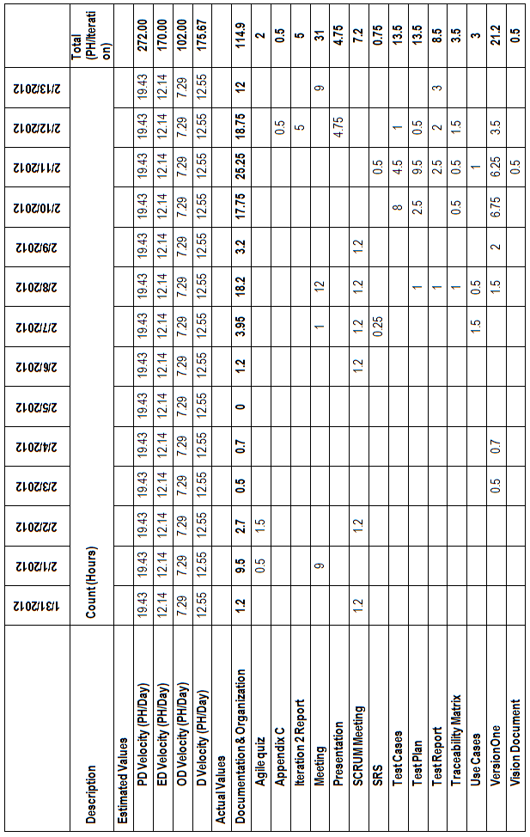

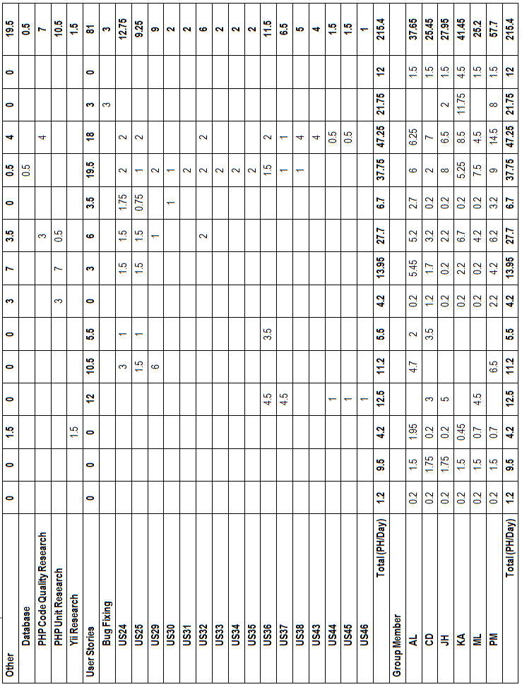

## Cumulative Velocities vs. Time

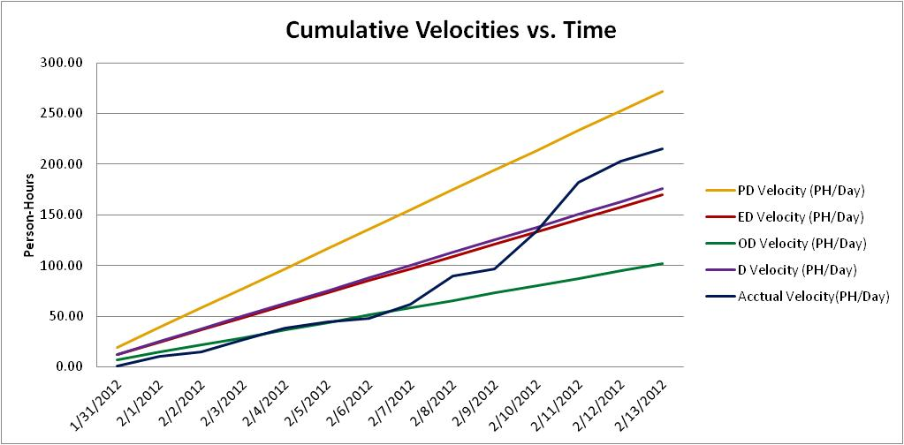

## Cumulative Activity Velocity vs. Time

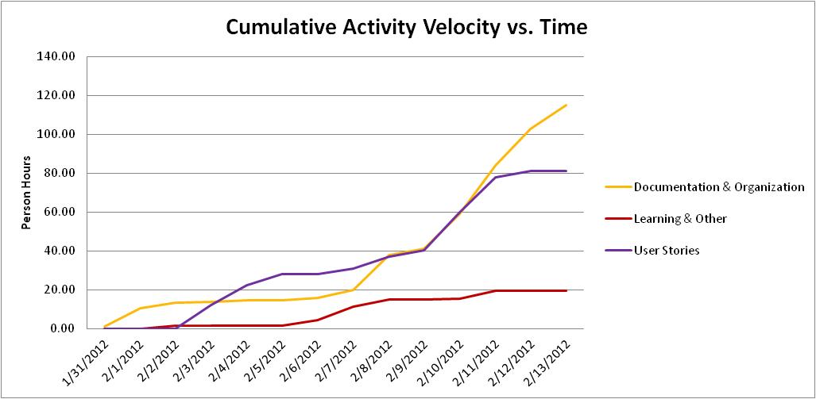

## Cumulative Group Member Velocity vs. Time

## Story Point Iteration Burndown Chart

The two burndown charts below were generated from the planning and tracking sections of VersionOne respectively. We had planned 30 story points in sprint 2; however the generated charts only go up to 18 story points. In sprint 3 we will set the to-do values at the beginning of the sprint, so that the charts generate appropriately.

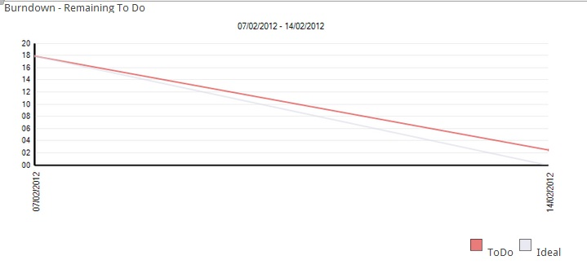

Figure 5.6.1 Sprint 2 Planning Burndown Trend Chart

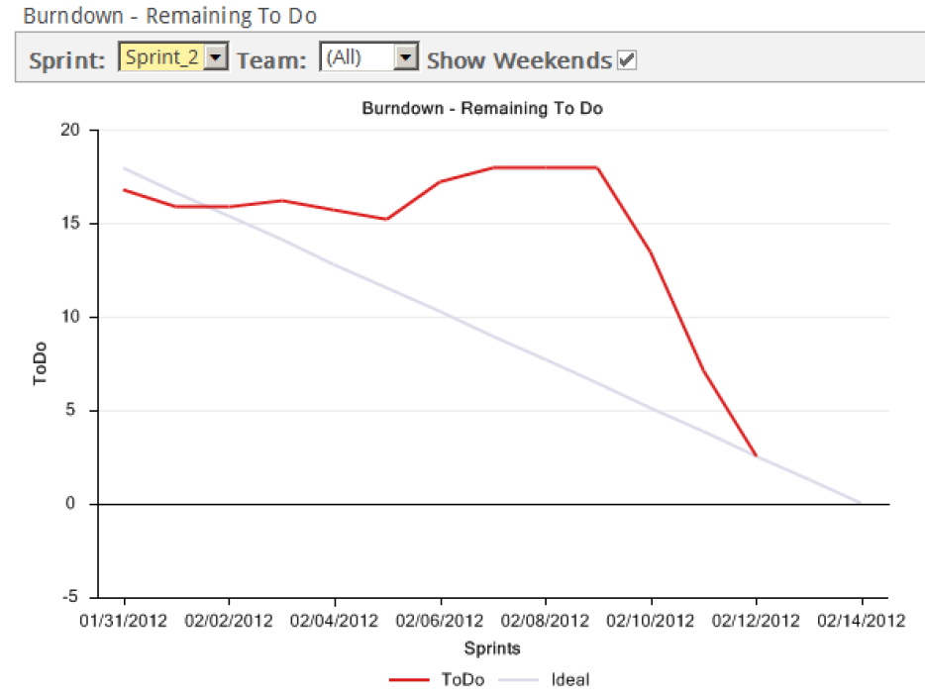

Figure 5.6.2 Sprint 2 Tracking Burndown Trend Chart

## Line Counter Statistics for Iteration 2

Line Counter Program:

|  |  |
| --- | --- |
| **Program Name** | LOC Counter, copyright (c) 2011, Gary Gocek |
| **Developer** | Gary Gocek |
| **License / Price** | BSD License / $0 |
| **Size / OS** | 659 KB / Windows 2K / XP / Vista / 7 |
| **Last Updated** | August 27th, 2011, 16:59 UTC |
| **Program Source** | <http://www.softpedia.com/get/Office-tools/Other-Office-Tools/LOC-Counter-GUI.shtml> |

Statistical Results:

|  |  |  |  |
| --- | --- | --- | --- |
|  | **Iteration 1** | **Iteration 2** | **Differences from Iteration 1** |
| **Total Number of Files** | 2, 144 | 2, 230 | 86 |
| **Total Number of Comment Lines** | 67, 729 | 69, 651 | 1, 922 |
| **Total Number of Blank Lines** | 24, 508 | 25, 710 | 1, 202 |
| **Total Number of Source Code Lines** | 616, 029 | 623, 205 | 7, 176 |
| **Total Number of Lines** | 708, 266 | 718, 566 | 10, 300 |
| **File Types** | HTML, XML, Jscript Script, SQL, Windows Batch File, PHP | | |

Sample Screenshot:

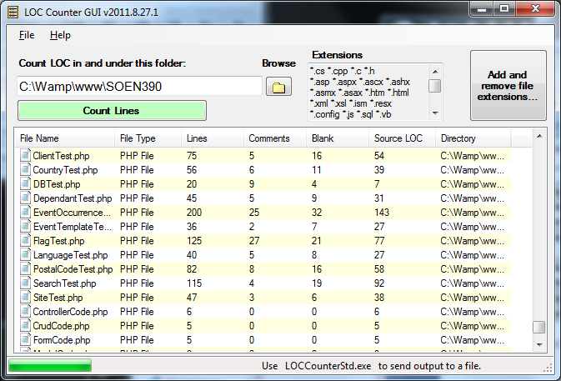

## Code Quality Analysis

To assess the quality of the F.S.T.S. code, the source files were analysed with PHP Depend. Given a source base, PHP Depend will perform a static analysis and provide a variety of metric values over five different levels of code: Project, Package, File, Class and Method.For our code quality analysis we will focus on the project as a whole and analyse the code’s level of inheritance, coupling, size and complexity [10]. To facilitate project analysis PHP Depend creates Pyramid charts, which highlight the most relevant matrices.

### PHP Depend Metric Values and Pyramid Tables

|  |  |  |  |
| --- | --- | --- | --- |
| **Project Metric Values** | | | **http://pdepend.org/documentation/handbook/reports/media/report-overview-pyramid-base.png** |
| **Metric** | **Description** | **Value** |
| **ahh** | *Average Hierarchy Height* (The average of the maximum length from a root class to its deepest subclass subclass) | 0.6 |
| **andc** | *Average Number of Derived Classes (*The average of direct subclasses of a class) | 0.83 |
| **calls** | *Number of Method or Function Calls* | 13026 | Figure 5.3 PHP Depend Pyramid Outline |
| **ccn** | Cyclomatic Complexity Number | 14043 |  |
| **ccn2** | Extended Cyclomatic Complexity Number | 15753 |
| **cloc** | *Comment Lines of Code* | 42073 |
| **clsa** | *Number of Abstract Classes* | 54 |
| **clsc** | *Number of Concrete Classes* | 651 |
| **eloc** | *Executable Lines of Code* | 72028 |
| **fanout** | *Number of Fanouts Referenced Classes* | 1484 |
| **leafs** | *Number of Leaf Classes (finla) classes* | 591 |
| **lloc** | *Logical Lines Of Code* | 38255 |
| **loc** | *Lines Of Code* | 123671 |
| **maxDIT** | *Max Depth of Inheritance Tree Maximum depth of inheritance* | 5 | Figure 5.4 Pyramid Reference Values |
| **ncloc** | *Non Comment Lines Of Code* | 81598 |  |
| **noc** | *Number Of Classes* | 705 |
| **nof** | *Number Of Functions* | 7 |
| **noi** | *Number Of Interfaces* | 28 |
| **nom** | *Number Of Methods* | 4856 |
| **nop** | *Number of Packages* | 42 | Figure 5.5 PHP Depend Iteration 2 Pyramid |

### Inheritance

**Inheritance Level: High**

Considering that the F.S.T.S. is built on top of the Yii Framework, it is not surprise that the Average Number of Derived Classes (ANDC) and the Average Hierarchy Height (AHH) metrics are considered high. Depending on the implementation of the code, high inheritance can be considered a good or a bad thing. In our case we know that it is a good thing, as it’s an indication of separation of concerns and reusability [10]. The Yii Framework appeals to PHP developers, because it can be applied to many types of systems [3].

### Coupling

**Coupling Level: Low-Average**

Project coupling is measured with two values: CALLS, which measures the number of distinct method and function calls and FANOUT, which “provides information on types referenced by classes and interfaces. “It only counts those types that are not part of the same Inheritance branch” [10]. The metrics of FANOUT/CALLS and CALLS/NOM are low and average respectively. Low-average coupling means that the F.S.T.S. is less likely to suffer from ripple effects generated during development and maintenance, thus minimizing the costs in coding effort and time. Low-average coupling also facilitates testing methods, such as unit testing, and increases the chances for reusability.

### Size & Complexity

**Size & Complexity Level: Average**

Size and complexity are evaluated from four metric ratios ( CYCLO/LOC, LOC/NOM, NOM/NOC, NOC/NOP), which are established by the following five values:

*NOP - The****Number of Packages****metric counts the packages within the analyzed software system.*

*NOC - The****Number Of Classes****metric counts the declared classes within the analyzed software system.*

*NOM- The****Number Of Methods****metric counts all declared methods, which in this context means class methods and simple functions.*

*LOC- The****Lines Of Code****metric shows the number of executable source lines within the analyzed software system. To calculate this value PHP_Depend counts all non whitespace lines and all non comment lines. PHP Depend, unlike the LOC Counter, only includes PHP files in its analysis, thus accounting for the discrepancy in values.*

*CYCLO - The****Cyclomatic Complexity****numberis a software metric (measurement). It was already developed in 1976 by Thomas J. McCabe and is used to calculate the complexity of a program. It directly measures the number of linearly independent paths through a program's source code [10].*

The LOC/NOM ratio value is considered high, while the CYCLO/LOC, NOM/NOC and NOC/NOP are evaluated to be average. This indicates that the F.S.T.S. code is of average-large size with average complexity. The complexity level of the F.S.T.S. is at a maintainable level, but should not increase in order to keep costs in coding effort and time down. In addition, systems with low complexity have a higher probability of containing reusable components.

## Retrospective

Although our velocity increased from Iteration 1, we were unable to meet our goal of 30 user story points, therefore this iteration proved unsuccessful. Overall, assuming that our acceptance tests pass, we completed 27 story points and the incomplete user stories, US19 and US36, were put back into the project backlog.

We completed the following user stories:

|  |  |  |  |
| --- | --- | --- | --- |
| **User Story ID** | **Feature Group** | **User Stories** | **Story Points** |
| US18 | Client File Management | As a user, I want to change client file status to active or inactive, so that I can properly filter out clients that no longer require services more quickly. | 1.00 |
| US24 | Client File Management | As a user, I want to add predefined flags/notes to client files, so that I may keep track of client exceptions. | 1.00 |
| US25 | Client File Management | As a user, I want to remove predefined flags/notes to client files, so that I may keep client exceptions relevant. | 1.00 |
| US29 | Client File Management | As a user, I want to create dependents for client files, so that I may gather relevant information about all members in a client family. | 1.00 |
| US30 | Client File Management | As a user, I want to delete dependents from client files, so that family information remains relevant. | 1.00 |
| US31 | Client File Management | As a user, I want to update dependents associated with client files, so that family information remains relevant. | 1.00 |
| US32 | Client File Management | As an administrator, I want to associate postal codes with city locations around the city, so that I may reduce data entry overhead in client files. | 3.00 |
| US33 | Client File Management | As an administrator, I want to add rows/options to drop-down fields in client files, so that I can create client files with customized options. | 3.00 |
| US34 | Client File Management | As an administrator, I want to update rows/options to drop-down fields in client files, so that I can create client files with customized options. | 1.00 |
| US35 | Client File Management | As an administrator, I want to delete rows/options to drop-down fields in client files, so that I can create client files with customized options. | 1.00 |
| US37 | Client File Management | As a user, I want to be able to search for client files by family id so that I may quickly access the family information. | 3.00 |
| US38 | Client File Management | As a user, I would like to be able to make an advanced search for a client file so that I may located client files for clients who do not have their file id with them. | 5.00 |
| US43 | Event Management | As an administrator, I would like to create/schedule events from event templates, so that activities can be managed and appointments created. | 1.00 |
| US44 | Event Management | As a user, I want to cancel events, so that events with poor attendance or special circumstances can be removes from the schedule. | 1.00 |
| US45 | Event Management | As an administrator, I want to update an event, so that variables remain relevant and errors can be corrected. | 1.00 |
| US46 | Event Management | As a user, I want to view a list of all active event occurrences, so that I may plan accordingly. | 1.00 |
| US47 | Event Management | As a user, I want to view all information about individual event occurrences, so that I may validate that capacity is not exceeded. | 1.00 |

The following positive and negative points show what we would like to continue doing and what we do not want to do in future iterations.

**Positives:**

* Good communication
* Daily scrum meetings(if a person couldn’t attend, he/she was informed by group email)
* Balanced division of work/tasks
* Started working on user stories earlier than in Iteration 1
* Spent less time learning new software and tools than in Iteration 1.
* Increased velocity
* Planning and management were done efficiently
* Prepared for the large amount of documentation to complete at the end of the iteration

**Negatives:**

* Did not complete 100% of user stories

In Iteration 1, only 33% of the hours spent working were spent on user stories. We expected this percentage to increase in Iteration 2. In Iteration 2, 38% of our time was spent working on user stories. This increase is not as great as expected because of added tasks such as test plans, test reports, quality assessment and other documentation.

The total number of hours spent working went up from 193.75 hours in Iteration 1 to 215.4 hours in Iteration 2.

Static code quality analysis was conducted for the first time in this iteration. Aside from establishing a quality basis for the rest of the project, analyzing the code proved that our code was cohesive, maintainable and reusable. The inheritance level was high, the coupling level was low-average and the complexity level was average.

# Iteration 3 Plan

## Planned User Stories and Story Point Total

We will be using VersionOne to document the progression of our story points. VersionOne automatically generates the estimated velocities of our project. Having completed 27 story points last iteration, we will be attempting to accomplish the same number in iteration 3.

|  |  |  |
| --- | --- | --- |
| **User Story ID** | **Total Story Points** | **Related Use Cases** |
| **US1, US2, US3, US4, US5, US7, US8, US9, US10, US11, US12, US13, US14, US20, US26, US27, US28,** | **27.00** | **UC1.4, UC1.6, UC2.8, UC3.1, UC3.2, UC3.3, UC3.4, UC4.1, UC4.2, UC4.3** |

## Person-Hour Estimation

Estimated person-hour measurements where calculated with the Expert Judgment Method. The table below illustrates our velocity predictions. The pessimistic and optimistic durations were calculated from the expected duration with a margin of 60% between them. Meaning the optimistic estimate is 30% lower than the expected duration estimate, while the pessimistic duration estimate is 30% higher than the expected duration estimate.

|  |  |  |  |  |
| --- | --- | --- | --- | --- |
| User Story ID | Worst Case | Most Likely Case | Best Case | Expected Case |
| US01 | 9.60 | 6.00 | 3.60 | 6.20 |
| US02 | 11.20 | 7.00 | 4.20 | 7.23 |
| US03 | 11.20 | 7.00 | 4.20 | 7.23 |
| US04 | 20.80 | 13.00 | 7.80 | 13.43 |
| US05 | 11.20 | 7.00 | 4.20 | 7.23 |
| US07 | 12.80 | 8.00 | 4.80 | 8.27 |
| US08 | 19.20 | 12.00 | 7.20 | 12.40 |
| US09 | 12.80 | 8.00 | 4.80 | 8.27 |
| US10 | 12.80 | 8.00 | 4.80 | 8.27 |
| US11 | 9.60 | 6.00 | 3.60 | 6.20 |
| US12 | 9.60 | 6.00 | 3.60 | 6.20 |
| US13 | 25.60 | 16.00 | 9.60 | 16.53 |
| US14 | 12.80 | 8.00 | 4.80 | 8.27 |
| US20 | 25.60 | 16.00 | 9.60 | 16.53 |
| US26 | 19.20 | 12.00 | 7.20 | 12.40 |
| US27 | 12.80 | 8.00 | 4.80 | 8.27 |
| US28 | 12.80 | 8.00 | 4.80 | 8.27 |
| Total (ph) | 249.60 | 156.00 | 93.60 | 161.20 |
| Velocity (ph/day) | 17.83 | 11.14 | 6.69 | 11.51 |
| Velocity (ph/team member/day) | 2.97 | 1.86 | 1.11 | 1.92 |

## Code Quality Goals

Having established a base line for system quality in Iteration 2, we will be looking to maintain the following metric and ratio values in Iteration 3.

|  |  |
| --- | --- |
| **Metric** | **Level** |
| CYCLO/LOC | Average (or lower) |
| LOC/NOM | Average (or lower) |
| NOM/NOC | Average (or lower) |
| NOC/NOP | Average (or lower) |
| CALLS/NOM | Average (or lower) |
| FANOUT/CALLS | Average (or lower) |
| ANDC | High |
| AHH | High |

# Iteration 3 Report

## Person-Hour Work Log

|  |  |  |  |  |  |
| --- | --- | --- | --- | --- | --- |
| **Date** | **Artifact Type** | **Artifact Name** | **Artifact Description** | **Cost (Hours)** | **Initials** |
| 2/14/2012 | Documentation & Organization | SCRUM Meeting | Daily SCRUM Meeting | 0.2 | AL |
| 2/14/2012 | Documentation & Organization | SCRUM Meeting | Daily SCRUM Meeting | 0.2 | CD |
| 2/14/2012 | Documentation & Organization | SCRUM Meeting | Daily SCRUM Meeting | 0.2 | JH |
| 2/14/2012 | Documentation & Organization | SCRUM Meeting | Daily SCRUM Meeting | 0.2 | KA |
| 2/14/2012 | Documentation & Organization | SCRUM Meeting | Daily SCRUM Meeting | 0.2 | ML |
| 2/14/2012 | Documentation & Organization | SCRUM Meeting | Daily SCRUM Meeting | 0.2 | PM |
| 2/15/2012 | Documentation & Organization | Test Report | Compiled Iteration 2 Test Report | 3 | KA |
| 2/16/2012 | Documentation & Organization | SCRUM Meeting | Daily SCRUM Meeting | 0.2 | AL |
| 2/16/2012 | Documentation & Organization | SCRUM Meeting | Daily SCRUM Me eting | 0.2 | CD |
| 2/16/2012 | Documentation & Organization | SCRUM Meeting | Daily SCRUM Meeting | 0.2 | JH |
| 2/16/2012 | Documentation & Organization | SCRUM Meeting | Daily SCRUM Meeting | 0.2 | KA |
| 2/16/2012 | Documentation & Organization | SCRUM Meeting | Daily SCRUM Meeting | 0.2 | ML |
| 2/16/2012 | Documentation & Organization | SCRUM Meeting | Daily SCRUM Meeting | 0.2 | PM |
| 2/18/2012 | Documentation & Organization | Agile quiz | Online quiz to determine to see if our team is Agile enough | 0.25 | AL |
| 2/18/2012 | Documentation & Organization | Agile quiz | Online quiz to determine to see if our team is Agile enough | 0.25 | CD |
| 2/18/2012 | Documentation & Organization | Agile quiz | Online quiz to determine to see if our team is Agile enough | 0.25 | JH |
| 2/18/2012 | Documentation & Organization | Agile quiz | Online quiz to determine to see if our team is Agile enough | 0.25 | KA |
| 2/18/2012 | Documentation & Organization | Agile quiz | Online quiz to determine to see if our team is Agile enough | 0.25 | ML |
| 2/18/2012 | Documentation & Organization | Agile quiz | Online quiz to determine to see if our team is Agile enough | 0.25 | PM |
| 2/18/2012 | Documentation & Organization | SCRUM Meeting | Daily SCRUM Meeting | 0.2 | AL |
| 2/18/2012 | Documentation & Organization | SCRUM Meeting | Daily SCRUM Meeting | 0.2 | CD |
| 2/18/2012 | Documentation & Organization | SCRUM Meeting | Daily SCRUM Meeting | 0.2 | JH |
| 2/18/2012 | Documentation & Organization | SCRUM Meeting | Daily SCRUM Meeting | 0.2 | KA |

|  |  |  |  |  |  |
| --- | --- | --- | --- | --- | --- |
| 2/18/2012 | Documentation & Organization | SCRUM Meeting | Daily SCRUM Meeting | 0.2 | ML |
| 2/18/2012 | Documentation & Organization | SCRUM Meeting | Daily SCRUM Meeting | 0.2 | PM |
| 2/18/2012 | Documentation & Organization | Test Report | Reviewed Test Report | 0.5 | CD |
| 2/19/2012 | Other | Selenium Research | Research for integration and system testing | 3 | PM |
| 2/20/2012 | Documentation & Organization | Deliverable 3 | Set up Document | 0.5 | KA |
| 2/20/2012 | Documentation & Organization | Meeting | Prepared Meeting Notes, agenda of tasks for everyone, ect... | 1.5 | KA |
| 2/20/2012 | Documentation & Organization | Presentation | Set up Presentation | 0.5 | KA |
| 2/20/2012 | Documentation & Organization | Test Cases | Wrote Acceptance Tests for US10 - US13 | 2 | KA |
| 2/20/2012 | Documentation & Organization | Tracability Matrix | Updates | 0.5 | KA |
| 2/20/2012 | Documentation & Organization | Version One | Updated Tasks and Tests, added user stories and defects | 3 | KA |
| 2/20/2012 | Documentation & Organization | Version One | Update and created tasks and tests in Version One | 1 | PM |
| 2/20/2012 | Documentation & Organization | Work Log | Set up Worklog | 0.5 | KA |
| 2/20/2012 | User Stories | D01 | Worked on fixing defects reported by clients | 7 | ML |
| 2/20/2012 | User Stories | D01 | Worked on fixing defects reported by clients | 7 | PM |
| 2/20/2012 | User Stories | D06 | Worked on adding time slots to event template | 3 | CD |
| 2/20/2012 | User Stories | D06 | Worked on adding time slots to event occurrences | 3 | CD |
| 2/20/2012 | User Stories | D06 | Created timeslots and linked to event occurrence | 3 | CD |
| 2/20/2012 | User Stories | D08 | Worked on fixing defects reported by clients | 1 | ML |
| 2/20/2012 | User Stories | D08 | Worked on fixing defects reported by clients | 1 | PM |
| 2/20/2012 | User Stories | US26 | Worked on Add Notes | 2 | AL |
| 2/20/2012 | User Stories | US27 | Worked on Remove Notes | 2 | AL |
| 2/20/2012 | User Stories | US28 | Worked on Update Notes | 2 | AL |
| 2/21/2012 | Documentation & Organization | Test Cases | Acceptance tests | 0.75 | PM |
| 2/21/2012 | User Stories | D01 | Unit tests for D01 | 0.75 | PM |
| 2/21/2012 | User Stories | D01 | Bug clearance | 1 | PM |
| 2/22/2012 | Documentation & Organization | SCRUM Meeting | Daily SCRUM Meeting | 0.2 | AL |
| 2/22/2012 | Documentation & Organization | SCRUM Meeting | Daily SCRUM Meeting | 0.2 | CD |
| 2/22/2012 | Documentation & Organization | SCRUM Meeting | Daily SCRUM Meeting | 0.2 | JH |
| 2/22/2012 | Documentation & Organization | SCRUM Meeting | Daily SCRUM Meeting | 0.2 | KA |
| 2/22/2012 | Documentation & Organization | SCRUM Meeting | Daily SCRUM Meeting | 0.2 | ML |
| 2/22/2012 | Documentation & Organization | SCRUM Meeting | Daily SCRUM Meeting | 0.2 | PM |
| 2/22/2012 | Documentation & Organization | Version One | Update and created tasks and tests in Version One | 0.5 | PM |
| 2/22/2012 | Other | Integration Test Research | Integration tests Research | 0.5 | PM |
| 2/22/2012 | User Stories | D01 | Bug clearance | 1 | PM |
| 2/22/2012 | User Stories | D08 | Worked on fixing defects reported by clientsin dependants | 1 | PM |
| 2/23/2012 | Documentation & Organization | Test Plan | Updated Gantt Chart | 0.5 | KA |
| 2/23/2012 | Documentation & Organization | Tracability Matrix | Updated traceability Matrices for tests | 0.5 | PM |
| 2/23/2012 | Documentation & Organization | Version One | Update and created tasks and tests in Version One | 0.5 | PM |
| 2/23/2012 | Other | Integration Test Research | Researching integration tests & Selenium | 1 | KA |
| 2/23/2012 | Other | Integration Test Research | Integration tests Research | 2 | PM |
| 2/23/2012 | Other | System Test Research | Researching system tests & Selenium | 1 | KA |
| 2/23/2012 | User Stories | US26 | Worked on Add Notes | 2 | AL |
| 2/23/2012 | User Stories | US27 | Worked on Remove Notes | 2 | AL |
| 2/24/2012 | Documentation & Organization | Meeting | Organising Team Members and work (talking on phone, writing emails to clients and profs) | 4 | KA |
| 2/24/2012 | Documentation & Organization | Test Cases | Created and ran Tests for Notes | 0.5 | AL |
| 2/24/2012 | Documentation & Organization | Test Plan | Included Integration and System Test Plans and Revised | 2 | KA |
| 2/24/2012 | Documentation & Organization | Test Report | Revised Test All Documents | 3.5 | AL |
| 2/24/2012 | Documentation & Organization | Version One | Updated Notes Tasks and Tests | 0.5 | AL |
| 2/24/2012 | Other | Integration Test Research | Researching integration tests & Selenium | 2 | KA |
| 2/24/2012 | Other | System Test Research | Researching system tests & Selenium | 2 | KA |
| 2/24/2012 | User Stories | US24 | Revamped Add/Update Client Flags backend | 0.2 | AL |
| 2/24/2012 | User Stories | US26 | Touchups on Add Notes | 1 | AL |
| 2/25/2012 | Other | Integration Test Research | Researching integration tests & Selenium | 1 | PM |
| 2/25/2012 | Other | Integration Test Research | Working in Selenium on Integration testing | 4 | PM |
| 2/25/2012 | User Stories | D01 | Worked on fixing defects reported by clientsin dependants | 0.5 | PM |
| 2/25/2012 | User Stories | TC10-2 | Write test case | 0.5 | CD |
| 2/25/2012 | User Stories | TC11-2 | Write test case | 0.5 | CD |
| 2/25/2012 | User Stories | TC12-2 | Write test case | 0.5 | CD |
| 2/25/2012 | User Stories | US08 | Show list of all clients attending an appointment | 0.5 | CD |
| 2/25/2012 | User Stories | US11 | Worked on functionality to view and delete appointments plus integrate with client page | 4 | CD |
| 2/25/2012 | User Stories | US12 | Worked on canceling appointments from client page | 4 | CD |
| 2/25/2012 | User Stories | US14 | show summary of users coming to an appointment | 0.5 | CD |
| 2/26/2012 | Documentation & Organization | Presentation | Create Slides | 1.5 | KA |
| 2/27/2012 | Documentation & Organization | Meeting | Presentation Meeting | 1.5 | AL |
| 2/27/2012 | Documentation & Organization | Meeting | Presentation Meeting | 1.5 | CD |
| 2/27/2012 | Documentation & Organization | Meeting | Presentation Meeting | 1.5 | JH |
| 2/27/2012 | Documentation & Organization | Meeting | Presentation Meeting | 1.5 | KA |
| 2/27/2012 | Documentation & Organization | Meeting | Presentation Meeting | 1.5 | KA |
| 2/27/2012 | Documentation & Organization | Meeting | Presentation Meeting | 1.5 | ML |
| 2/27/2012 | Documentation & Organization | Meeting | Presentation Meeting | 1.5 | PM |
| 2/20/2012 | Documentation & Organization | Version One | Enter tasks and tests | 1.5 | JH |
| 2/20/2012 | User Stories | US01 | Create User | 0.5 | JH |
| 2/20/2012 | User Stories | US02 | Update User | 1 | JH |
| 2/20/2012 | User Stories | US03 | Delete User | 0.5 | JH |
| 2/20/2012 | User Stories | US04 | Assign Permissions | 2 | JH |
| 2/20/2012 | User Stories | US05 | View User summary | 2 | JH |
| 2/23/2012 | User Stories | US10 | Worked on creating flow for adding appointments | 2 | CD |
| 2/24/2012 | User Stories | Integration Testing | Code Integration Tests | 4 | KA |
| 2/24/2012 | User Stories | System Testing | Code SystemTests | 2 | KA |
| 2/24/2012 | User Stories | TC26-1 | Test Cases touch up | 0.2 | ML |
| 2/24/2012 | User Stories | TC26-2 | Test Cases touch up | 0.2 | ML |
| 2/24/2012 | User Stories | TC26-3 | Test Cases touch up | 0.2 | ML |
| 2/24/2012 | User Stories | TC27-1 | Test Cases touch up | 0.1 | ML |
| 2/24/2012 | User Stories | TC27-2 | Test Cases touch up | 0.1 | ML |
| 2/24/2012 | User Stories | TC28-1 | Test Cases touch up | 0.1 | ML |
| 2/24/2012 | User Stories | TC28-2 | Test Cases touch up | 0.1 | ML |
| 2/24/2012 | User Stories | US02 | Fix password bug | 1 | JH |
| 2/24/2012 | User Stories | US10 | Worked on creating flow for adding appointments | 2 | CD |
| 2/24/2012 | User Stories | US27 | Worked on client flags | 4 | ML |
| 2/24/2012 | User Stories | US28 | Worked on client flags | 5 | ML |
| 2/25/2012 | Documentation & Organization | Iteration 3 Plan | Input code quality expectations and Iteration 4 person hour estimates | 2 | KA |
| 2/25/2012 | Documentation & Organization | Iteration 3 Report | Generate log stats, input burndown charts, interpret and generate code quality stats and review | 3 | KA |

|  |  |  |  |  |  |
| --- | --- | --- | --- | --- | --- |
| 2/25/2012 | Documentation & Organization | Iteration 3 Test Report | Generate unit, acceptance, system and integration test statistics, input status tables and set up acceptance test tables. | 4 | KA |
| 2/25/2012 | Documentation & Organization | Presentation | Set-up Document | 0.25 | KA |
| 2/25/2012 | Documentation & Organization | Presentation | Add slides to document | 1 | KA |
| 2/25/2012 | Documentation & Organization | SRS | Review | 0.5 | KA |
| 2/25/2012 | Documentation & Organization | Test Cases | Test cases for US01 - US05 | 1 | JH |
| 2/25/2012 | Documentation & Organization | Test Cases | Review test cases, format and add to document | 2 | KA |
| 2/25/2012 | Documentation & Organization | Tracability Matrix | Review and add to main document | 1 | KA |
| 2/25/2012 | Documentation & Organization | Use Cases | Review | 1 | KA |
| 2/25/2012 | Documentation & Organization | Version One | Updates and Sprint 4 planning | 3 | JH |
| 2/25/2012 | Documentation & Organization | Vision Document | Review | 0.5 | KA |
| 2/25/2012 | User Stories | US10 | Worked add appointments | 4 | CD |

## Work Log Person-Hour Summary

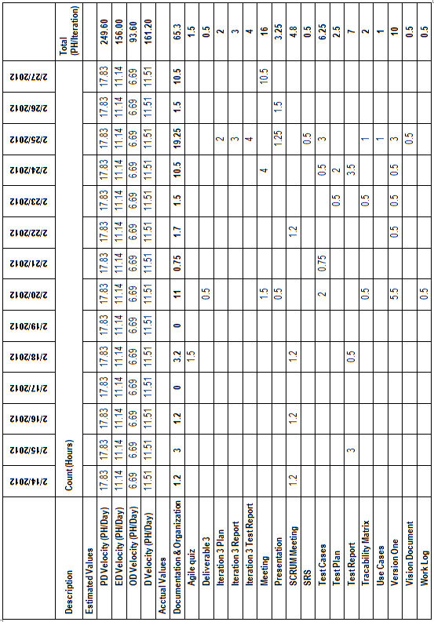

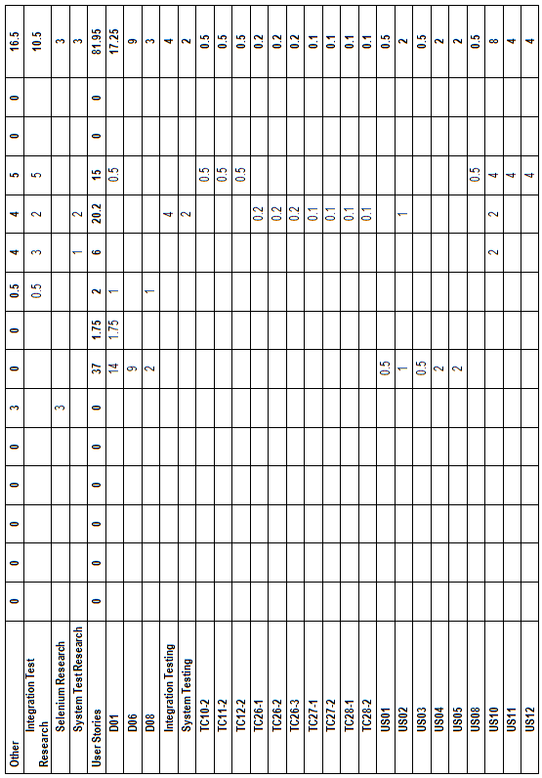

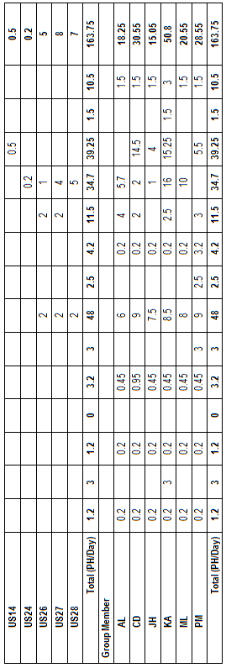

## Cumulative Velocities vs. Time

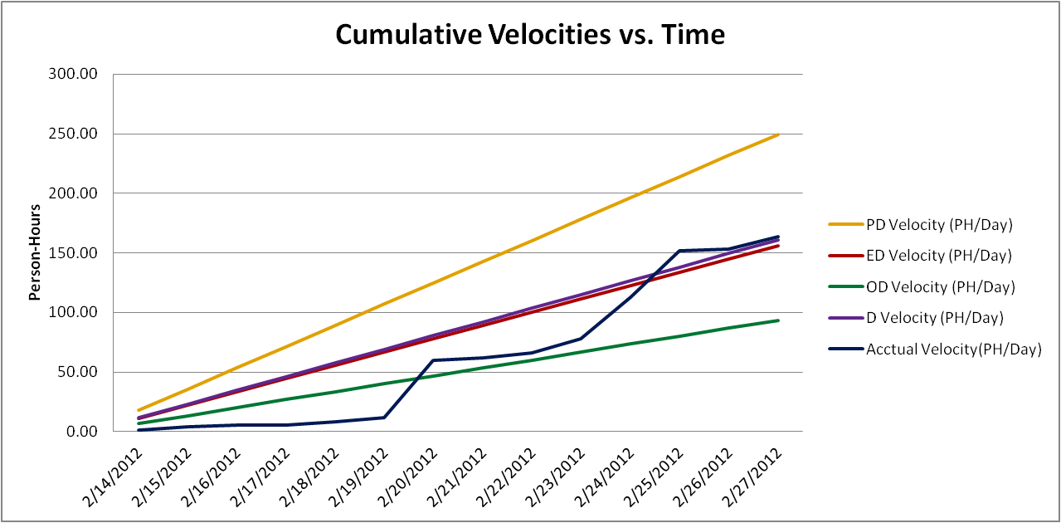

## Cumulative Activity Velocity vs. Time

## Cumulative Group Member Velocity vs. Time

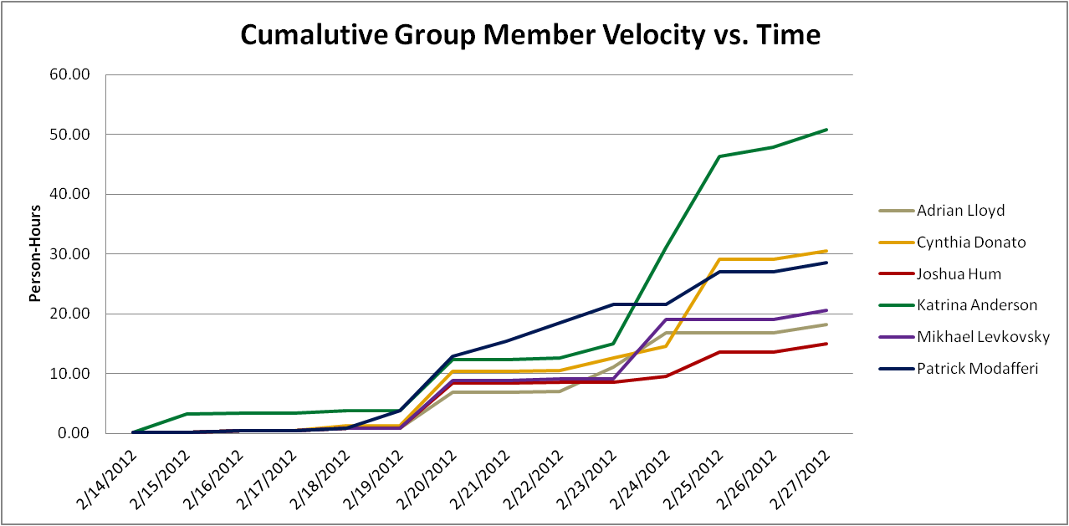

## Story Point Iteration Burndown Chart

The two burndown charts below were generated from the planning and tracking sections of VersionOne respectively. We came across some defects early in the iteration and had to address them in order to continue, thus the incline in the Iteration charts.

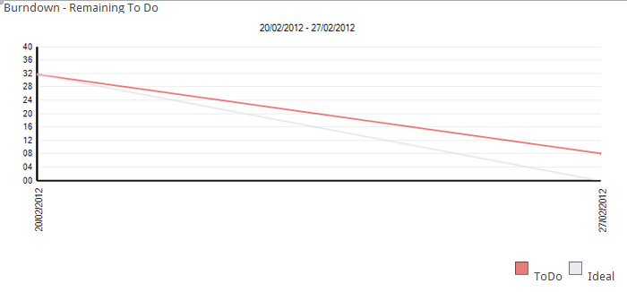

Figure 7.7.6.1 Sprint 3Planning Burndown Trend Chart

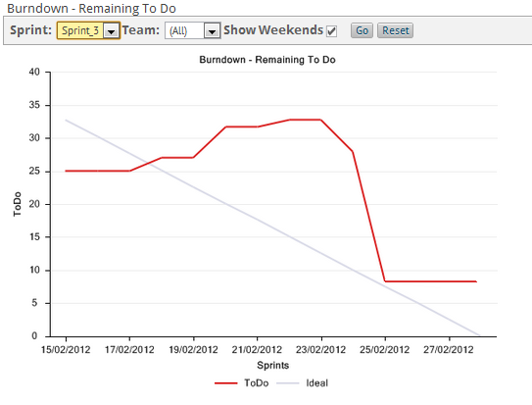

Figure7.7.6.2 Sprint 3 Tracking Burndown Trend Chart

## Line Counter Statistics for Iteration 3

Line Counter Program:

|  |  |
| --- | --- |
| **Program Name** | LOC Counter, copyright (c) 2011, Gary Gocek |
| **Developer** | Gary Gocek |
| **License / Price** | BSD License / $0 |
| **Size / OS** | 659 KB / Windows 2K / XP / Vista / 7 |
| **Last Updated** | August 27th, 2011, 16:59 UTC |
| **Program Source** | <http://www.softpedia.com/get/Office-tools/Other-Office-Tools/LOC-Counter-GUI.shtml> |

Statistical Results:

|  |  |  |  |  |  |
| --- | --- | --- | --- | --- | --- |
|  | **Iteration 1** | **Iteration 2** | **Iteration 3** | **Difference of Iterations 2 & 1** | **Difference of Iterations 3 & 2** |
| **Total Number of Files** | 2, 144 | 2, 230 | 2, 311 | 86 | 81 |
| **Total Number of Comment Lines** | 67, 729 | 69, 651 | 70, 941 | 1, 922 | 1, 290 |
| **Total Number of Blank Lines** | 24, 508 | 25, 710 | 26, 571 | 1, 202 | 8, 61 |
| **Total Number of Source Code Lines** | 616, 029 | 623, 205 | 627, 622 | 7, 176 | 4, 417 |
| **Total Number of Lines** | 708, 266 | 718, 566 | 725, 134 | 10, 300 | 6, 568 |
| **File Types** | HTML, XML, Jscript Script, SQL, Windows Batch File, PHP | | | | |

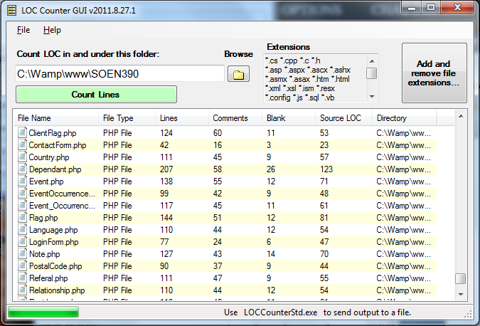Sample Screenshot:

## Code Quality Analysis

To assess the quality of the F.S.T.S. code, the source files were analyzed with PHP Depend. Given a source base, PHP Depend will perform a static analysis and provide a variety of metric values over five different levels of code: Project, Package, File, Class and Method.For our code quality analysis we will focus on the project as a whole and analyse the code’s level of inheritance, coupling, size and complexity [10]. To facilitate project analysis PHP Depend creates Pyramid charts, which highlight the most relevant matrices.

### PHP Depend Metric Values and Pyramid Tables

|  |  |  |  |
| --- | --- | --- | --- |
| **Metric** | **Description** | **Value**  **Project without Framework** | **Values**  **Project with Framework** |
| **ahh** | *Average Hierarchy Height* (The average of the maximum length from a root class to its deepest subclass subclass) | 2.17 | 0.6 |
| **andc** | *Average Number of Derived Classes (*The average of direct subclasses of a class) | 0.29 | 0.83 |
| **calls** | *Number of Method or Function Calls* | 1260 | 13500 |
| **ccn** | Cyclomatic Complexity Number | 945 | 14409 |
| **ccn2** | Extended Cyclomatic Complexity Number | 1020 | 16168 |
| **cloc** | *Comment Lines of Code* | 3210 | 43104 |
| **clsa** | *Number of Abstract Classes* | 1 | 55 |
| **clsc** | *Number of Concrete Classes* | 77 | 681 |
| **eloc** | *Executable Lines of Code* | 6033 | 74214 |
| **fanout** | *Number of Fanouts Referenced Classes* | 226 | 1569 |
| **leafs** | *Number of Leaf Classes (finla) classes* | 63 | 620 |
| **lloc** | *Logical Lines Of Code* | 3112 | 39383 |
| **loc** | *Lines Of Code* | 10446 | 127359 |
| **maxDIT** | *Max Depth of Inheritance Tree Maximum depth of inheritance* | 3 | 5 |
| **ncloc** | *Non Comment Lines Of Code* | 7236 | 84255 |
| **noc** | *Number Of Classes* | 78 | 736 |
| **nof** | *Number Of Functions* | 0 | 7 |
| **noi** | *Number Of Interfaces* | 1 | 29 |
| **nom** | *Number Of Methods* | 525 | 5056 |
| **nop** | *Number of Packages* | 3 | 44 |

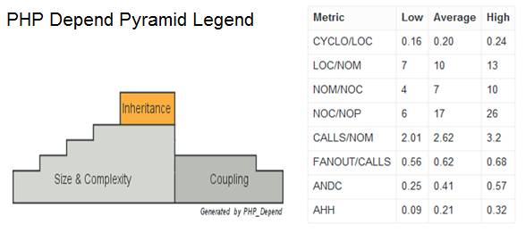

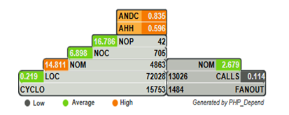

Figure 7.3 Pyramid Project With Framework

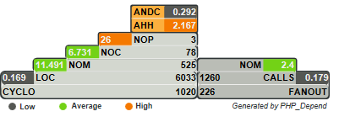

Figure 7.4 Pyramid Project Without Framework

### Inheritance

**Project With Framework Inheritance Level: High**

**Project Without Framework Inheritance Level: Average**

Considering that the F.S.T.S. is built on top of the Yii Framework, it is no surprise that the Average Number of Derived Classes (ANDC) and the Average Hierarchy Height (AHH) metrics are considered high. Depending on the implementation of the code, high inheritance can be considered a good or a bad thing. In our case we know that it is a good thing, as it’s an indication of separation of concerns and reusability [10]. When analyzing the project without the framework the inheritance falls to an average level. This is to be expected as many of the interfaces our project inherits from are not included. The Yii Framework appeals to PHP developers, because it can be applied to many types of systems [3].

### Coupling

**Project With Framework Coupling Level: Low-Average**

**Project Without Framework Coupling Level: Low-Average**

Project coupling is measured with two values: CALLS, which measures the number of distinct method and function calls and FANOUT, which “provides information on types referenced by classes and interfaces. “It only counts those types that are not part of the same Inheritance branch” [10]. The metrics of FANOUT/CALLS and CALLS/NOM are low and average respectively. Low-average coupling means that the F.S.T.S. is less likely to suffer from ripple effects generated during development and maintenance, thus minimizing the costs in coding effort and time. Low-average coupling also facilitates testing methods, such as unit testing, and increases the chances for reusability.

### Size & Complexity

**Project With Framework Size & Complexity Level: Average**

**Project Without Framework Size & Complexity Level: Average**

Size and complexity are evaluated from four metric ratios ( CYCLO/LOC, LOC/NOM, NOM/NOC, NOC/NOP), which are established by the following five values:

NOP –The**Number of Packages**metric counts the packages within the analyzed software system.

NOC–The**Number Of Classes**metric counts the declared classes within the analyzed software system.

NOM- The**Number Of Methods**metric counts all declared methods, which in this context means class methods and simple functions.

LOC- The**Lines Of Code**metric shows the number of executable source lines within the analyzed software system. To calculate this value PHP_Depend counts all non whitespace lines and all non comment lines. PHP Depend, unlike the LOC Counter, only includes PHP files in its analysis, thus accounting for the discrepancy in values.

CYCLO–The**Cyclomatic Complexity**numberis a software metric (measurement). It was already developed in 1976 by Thomas J. McCabe and is used to *calculate the complexity of a program. It directly measures the number of linearly independent paths through a program's source code [10].*

At the framework level the LOC/NOM ratio value is considered high, while the CYCLO/LOC, NOM/NOC and NOC/NOP are evaluated to be average. This indicates that the F.S.T.S. code is of average-large size with average complexity. At the project level the value of the NOC/NOP is high, this is an anomaly from not including the framework. The complexity level of the F.S.T.S. is at a maintainable level, but should not increase in order to keep costs in coding effort and time down. In addition, systems with low complexity have a higher probability of containing reusable components.

## Retrospective

In Iteration 3, we completed 27 user story points. This was the initial planned number of story points; However, there were defects found early in the iteration. Some new user stories were added after feedback was given by the stakeholders. The user stories (US51, US52, US53, US54) were put in the backlog but some of the defects needed to be addressed immediately. These defects (D01, D06, and D08) were added to and completed in Iteration 3. The other 5 defects were added to the backlog.

This increased the number of story points to complete in Iteration 3 from 27 to 35. Thus, we actually completed our initial goal of 27 user story points, but did not complete the sprint due to the added defects.

We completed the following user stories and defects:

|  |  |  |  |
| --- | --- | --- | --- |
| **User Story ID** | **Feature Group** | **User Stories** | **Story Points** |
| US01 | Administrative Controls | As an administrator, I want to create users for the FSTS, so that traceability is maintained by associating users with actions. | 1.00 |
| US02 | Administrative Controls | As an administrator, I want to update user information, so that the system remains relevant. | 1.00 |
| US03 | Administrative Controls | As an administrator, I want to delete users from the FSTS, so that the system remains relevant and can only be accessed by proper personnel. | 1.00 |
| US04 | Administrative Controls | As an administrator, I want to assign permissions to users, so that I may control what actions users are allowed to execute. | 3.00 |
| US05 | Administrative Controls | As an administrator, I want to view a summary of all users and their permissions, so that I may create, update and delete users appropriately. | 1.00 |
| US10 | Appointment Management | As a user, I want to create an appointment, so that clients can be registered for an event occurrence. | 1.00 |
| US11 | Appointment Management | As a user, I want to update appointments, so that clients may change their appointment times. | 1.00 |
| US12 | Appointment Management | As a user, I want to cancel appointments, so that clients will no longer be accounted for in the event capacity or listed for the event attendance. | 1.00 |
| US13 | Appointment Management | As a user, I want client appointment eligibility to be validated, so that appointments go to families who best fit the criteria. | 3.00 |
| US14 | Appointment Management | As a user, I want to view a summary of clients with appointments to events, so that I can prepare supplies accordingly. | 2.00 |
| US26 | Client File Management | As a user, I want to create custom flags/notes to client files, so that I may keep track of client exceptions. | 2.00 |
| US27 | Client File Management | As a user, I want to delete custom flags/notes to client files, so that I may keep client exceptions relevant. | 1.00 |
| US28 | Client File Management | As a user, I want to update custom flags/notes to client files, so that I may keep client exceptions relevant. | 1.00 |
| D01 | Defects | Client File Missing Fields | 5.00 |
| D06 | Defects | Events Mandate how many people per day/per hour | 2.00 |
| D08 | Defects | Dependent Missing Fields | 1.00 |

The following table shows the metric and ration values of the code after completing Iteration 3. The goals were met in all categories except for in the category LOC/NOM. See section 7.8.1 for detailed analysis.

|  |  |
| --- | --- |
| **Metric** | **Level** |
| CYCLO/LOC | Average |
| LOC/NOM | High |
| NOM/NOC | Average |
| NOC/NOP | Average |
| CALLS/NOM | Average |
| FANOUT/CALLS | Low |
| ANDC | High |
| AHH | High |

The following positive and negative points show what we would like to continue doing and what we do not want to do in future iterations.

**Positives:**

* Good communication
* Daily scrum meetings(if a person couldn’t attend, he/she was informed by group email)
* Met our personal deadlines
* Planning and management were done efficiently
* Prepared for the large amount of documentation to complete at the end of the iteration

**Negatives:**

* Found defects and had to add three of them to this iteration.
* Did not complete 100% of the planned user stories.

163.75 person-hours were spent working in Iteration 3. This is a drop from the previous two iterations. The drop can be accounted for as some hours were missing from the work log and team members had many other school/work tasks to complete.

Approximately 50% of the person-hours were spent working on user stories/coding. This is a positive sign because we wanted to focus on producing quality code and proper functionality this iteration.

Static code quality analysis was conducted for the second time in this iteration. Analyzing the code proved that our code was cohesive, maintainable and reusable. The inheritance level was high, the coupling level was low-average and the complexity level was average.

# Iteration 4 Plan

## Planned User Stories and Story Point Total

We will be using VersionOne to document the progression of our story points. VersionOne automatically generates the estimated velocities of our project. Having completed 27 story points last iteration, we will be attempting to accomplish the same number in iteration 3.

|  |  |  |
| --- | --- | --- |
| **User Story ID** | **Total Story Points** | **Related Use Cases** |
| **D02, D03, D04, D07, US20, US36, US51, US52, US53, US54** | **26.00** | **UC1.1, UC1.2, UC1.5, UC1.6, UC1.8, UC1.9, UC1.11, UC1.12** |

## Person-Hour Estimation

Estimated person-hour measurements where calculated with the Expert Judgment Method. The table below illustrates our velocity predictions. The pessimistic and optimistic durations were calculated from the expected duration with a margin of 60% between them. Meaning the optimistic estimate is 30% lower than the expected duration estimate, while the pessimistic duration estimate is 30% higher than the expected duration estimate.

|  |  |  |  |  |
| --- | --- | --- | --- | --- |
| **User Story ID** | **Worst Case** | **Most Likely Case** | **Best Case** | **Expected Case** |
| D04 | 6.40 | 4.00 | 2.40 | 4.13 |
| D06 | 9.60 | 6.00 | 3.60 | 6.20 |
| D07 | 9.60 | 6.00 | 3.60 | 6.20 |
| US07 | 12.80 | 8.00 | 4.80 | 8.27 |
| US08 | 19.20 | 12.00 | 7.20 | 12.40 |
| US09 | 12.80 | 8.00 | 4.80 | 8.27 |
| US19 | 19.20 | 12.00 | 7.20 | 12.40 |
| US20 | 25.60 | 16.00 | 9.60 | 16.53 |
| US37 | 16.00 | 10.00 | 6.00 | 10.33 |
| US38 | 38.40 | 24.00 | 14.40 | 24.80 |
| US51 | 14.40 | 9.00 | 5.40 | 9.30 |
| US52 | 4.80 | 3.00 | 1.80 | 3.10 |
| US53 | 9.60 | 6.00 | 3.60 | 6.20 |
| US54 | 9.60 | 6.00 | 3.60 | 6.20 |
| **Total (ph)** | **208.00** | **130.00** | **78.00** | **134.33** |
| **Velocity (ph/day)** | **14.86** | **9.29** | **5.57** | **9.60** |
| **Velocity (ph/team member/day)** | **2.48** | **1.55** | **0.93** | **1.60** |

## Code Quality Goals

Having established a base line for system quality in Iteration 2, we will be looking to maintain the following metric and ratio values in Iteration 4 for both our code and the combination of our code with the Yii Framwork.

|  |  |
| --- | --- |
| **Metric** | **Level** |
| CYCLO/LOC | Average (or lower) |
| LOC/NOM | Average (or lower) |
| NOM/NOC | Average (or lower) |
| NOC/NOP | Average (or lower) |
| CALLS/NOM | Average (or lower) |
| FANOUT/CALLS | Average (or lower) |
| ANDC | High |
| AHH | High |

# Iteration 4 Report

## Person-Hour Work Log

|  |  |  |  |  |  |
| --- | --- | --- | --- | --- | --- |
| **Date** | **Artifact Type** | **Artifact Name** | **Artifact Description** | **Cost (Hours)** | **Initials** |
| 2/29/12 | Documentation & Organization | Meeting | Weekly Meeting | 2 | CD |
| 2/29/12 | Documentation & Organization | Meeting | Weekly Meeting | 2 | KA |
| 2/29/12 | Documentation & Organization | Meeting | Weekly Meeting | 2 | PM |
| 2/29/12 | Documentation & Organization | Meeting | Weekly Meeting | 2 | AL |
| 2/29/12 | Documentation & Organization | Version One | Fixed the defects in VersionOne | 1 | KA |
| 3/01/12 | Documentation & Organization | SCRUM | Daily SCRUM Meeting | 0.2 | AL |
| 3/01/12 | Documentation & Organization | SCRUM | Daily SCRUM Meeting | 0.2 | CD |
| 3/01/12 | Documentation & Organization | SCRUM | Daily SCRUM Meeting | 0.2 | JH |
| 3/01/12 | Documentation & Organization | SCRUM | Daily SCRUM Meeting | 0.2 | KA |
| 3/01/12 | Documentation & Organization | SCRUM | Daily SCRUM Meeting | 0.2 | ML |
| 3/01/12 | Documentation & Organization | SCRUM | Daily SCRUM Meeting | 0.2 | PM |
| 3/02/12 | Documentation & Organization | Interview | Client Interview | 2 | AL |
| 3/02/12 | Documentation & Organization | Interview | Client Interview | 2 | KA |
| 3/02/12 | Documentation & Organization | Interview | Client Interview | 2 | ML |
| 3/03/12 | Coding | D04 | Coding | 1 | ML |
| 3/03/12 | Coding | D04 | Coding | 1 | PM |
| 3/03/12 | Coding | D06 | Coding | 10 | CD |
| 3/03/12 | Coding | D07 | Coding | 1 | ML |
| 3/03/12 | Coding | D07 | Coding | 1 | PM |
| 3/03/12 | Coding | GUI | Administrative control panel | 2 | KA |
| 3/03/12 | Coding | System Testing | Administritive controls integration testing | 6 | KA |
| 3/03/12 | Coding | US19 | Coding | 4 | AL |
| 3/03/12 | Coding | US20 | Coding | 4 | AL |
| 3/03/12 | Coding | US37 | Coding | 3.5 | JH |
| 3/03/12 | Coding | US38 | Coding | 3.5 | JH |
| 3/03/12 | Coding | US51 | Coding | 2 | ML |
| 3/03/12 | Coding | US51 | Coding | 2 | PM |
| 3/03/12 | Coding | US52 | Coding | 2 | ML |
| 3/03/12 | Coding | US52 | Coding | 2 | PM |
| 3/03/12 | Coding | US53 | Coding | 1 | ML |
| 3/03/12 | Coding | US53 | Coding | 1 | PM |
| 3/03/12 | Coding | US54 | Coding | 1 | ML |
| 3/03/12 | Coding | US54 | Coding | 1 | PM |
| 3/03/12 | Documentation & Organization | Document Set-Up | Set up log, deliverable & presentations | 1 | KA |
| 3/03/12 | Documentation & Organization | Version One | VersionOne | 1 | KA |
| 3/04/12 | Coding | GUI | Fixed Titles Spelling and Spaces and Administrative Panel | 3 | KA |
| 3/04/12 | Coding | System Testing | Administritive controls integration testing | 1 | KA |
| 3/04/12 | Coding | US37 | Coding | 3 | JH |
| 3/04/12 | Coding | US37 | Coding - Search Algorithm | 3 | PM |
| 3/04/12 | Coding | US38 | Coding | 3 | JH |
| 3/04/12 | Coding | US51 | Coding | 3 | ML |
| 3/04/12 | Coding | US51 | Bug fixing | 2 | PM |
| 3/05/12 | Coding | US37 | Search | 1 | JH |
| 3/05/12 | Coding | US37 | Coding - Search Algorithm | 2.5 | PM |
| 3/05/12 | Coding | US38 | Search | 1 | JH |
| 3/05/12 | Coding | US51 | Coding | 5 | ML |
| 3/05/12 | Documentation & Organization | Architecture Diagrams | architecture diagrams | 2 | JH |
| 3/06/12 | Coding | US08 | Coding | 1 | CD |
| 3/06/12 | Documentation & Organization | Document Set-Up | Researched Architectual views and split up work | 0.5 | KA |
| 3/06/12 | Documentation & Organization | SCRUM | SCRUM | 0.2 | AL |
| 3/06/12 | Documentation & Organization | SCRUM | SCRUM | 0.2 | CD |
| 3/06/12 | Documentation & Organization | SCRUM | SCRUM | 0.2 | JH |
| 3/06/12 | Documentation & Organization | SCRUM | SCRUM | 0.2 | KA |
| 3/06/12 | Documentation & Organization | SCRUM | SCRUM | 0.2 | ML |
| 3/06/12 | Documentation & Organization | Unit Tests | General Unit test for various components | 1.5 | PM |
| 3/06/12 | Documentation & Organization | Version One | Updated Tasks and Test | 1 | PM |
| 3/06/12 | Documentation & Organization | Version One | Updated Tasks and Test | 0.5 | PM |
| 3/07/12 | Coding | US08 | Coding | 1 | CD |
| 3/07/12 | Documentation & Organization | Meeting | Weekly Meeting | 1 | AL |

|  |  |  |  |  |  |
| --- | --- | --- | --- | --- | --- |
| 3/07/12 | Documentation & Organization | Meeting | Meeting with Olga | 0.5 | CD |
| 3/07/12 | Documentation & Organization | Meeting | Weekly Meeting | 1 | CD |
| 3/07/12 | Documentation & Organization | Meeting | Weekly Meeting | 1 | JH |
| 3/07/12 | Documentation & Organization | Meeting | Weekly Meeting | 1 | KA |
| 3/07/12 | Documentation & Organization | Meeting | Meeting with Olga | 0.5 | KA |
| 3/07/12 | Documentation & Organization | Meeting | Weekly Meeting | 1 | ML |
| 3/07/12 | Documentation & Organization | Meeting | Weekly Meeting | 1 | PM |
| 3/08/12 | Coding | US07 | Coding | 3 | CD |
| 3/08/12 | Coding | US09 | Coding | 3 | CD |
| 3/08/12 | Coding | US19 | Coding | 2 | AL |
| 3/08/12 | Coding | US19 | Unit Testing | 0.5 | AL |
| 3/08/12 | Coding | US20 | Coding | 2 | AL |
| 3/08/12 | Coding | US20 | Unit Testing | 0.5 | AL |
| 3/08/12 | Coding | US51 | Coding | 3 | ML |
| 3/08/12 | Coding | US54 | Coding - Total Income Calculation | 3.5 | PM |
| 3/08/12 | Documentation & Organization | SCRUM | Daily SCRUM Meeting | 0.2 | AL |
| 3/08/12 | Documentation & Organization | SCRUM | Daily SCRUM Meeting | 0.2 | CD |
| 3/08/12 | Documentation & Organization | SCRUM | Daily SCRUM Meeting | 0.2 | JH |
| 3/08/12 | Documentation & Organization | SCRUM | Daily SCRUM Meeting | 0.2 | KA |
| 3/08/12 | Documentation & Organization | SCRUM | Daily SCRUM Meeting | 0.2 | ML |
| 3/08/12 | Documentation & Organization | SCRUM | Daily SCRUM Meeting | 0.2 | PM |
| 3/09/12 | Coding | US19 | Unit Testing | 1.5 | AL |
| 3/09/12 | Coding | US20 | Unit Testing | 1.5 | AL |
| 3/09/12 | Coding | US37 | Search | 3 | JH |
| 3/09/12 | Coding | US38 | Search | 3 | JH |
| 3/09/12 | Coding | US51 | Unit Testing | 1.5 | PM |
| 3/09/12 | Documentation & Organization | Acceptance Testing | Wrote test cases | 1 | AL |
| 3/09/12 | Documentation & Organization | Acceptance Testing | Wrote test cases | 3 | ML |
| 3/09/12 | Documentation & Organization | Architecture Diagrams | Operational Contracts | 4 | KA |
| 3/09/12 | Documentation & Organization | SCRUM | Daily SCRUM Meeting | 0.2 | AL |
| 3/09/12 | Documentation & Organization | SCRUM | Daily SCRUM Meeting | 0.2 | CD |
| 3/09/12 | Documentation & Organization | SCRUM | Daily SCRUM Meeting | 0.2 | JH |
| 3/09/12 | Documentation & Organization | SCRUM | Daily SCRUM Meeting | 0.2 | KA |
| 3/09/12 | Documentation & Organization | SCRUM | Daily SCRUM Meeting | 0.2 | ML |
| 3/09/12 | Documentation & Organization | SCRUM | Daily SCRUM Meeting | 0.2 | PM |
| 3/09/12 | Documentation & Organization | SSR | Corrections | 0.5 | KA |
| 3/09/12 | Documentation & Organization | Test Plan | Corrections | 1 | KA |
| 3/09/12 | Documentation & Organization | Traceability Matrix | Updated test vs use case matrix | 0.5 | PM |
| 3/09/12 | Documentation & Organization | Use Cases | Corrections | 1 | KA |
| 3/09/12 | Documentation & Organization | Version One | Updated Tasks and Test | 1 | AL |
| 3/09/12 | Documentation & Organization | Version One | Updated Tasks and Test | 1 | PM |
| 3/09/12 | Documentation & Organization | Vision Document | Corrections | 0.5 | KA |
| 3/10/12 | Coding | System Testing | Programmed | 6 | KA |
| 3/10/12 | Coding | US07 | Unit Testing | 0.5 | CD |
| 3/10/12 | Coding | US09 | Unit Testing | 0.5 | CD |
| 3/10/12 | Coding | US37 | Bug fixing | 1 | PM |
| 3/10/12 | Coding | US54 | Improvement and testing | 3 | PM |
| 3/10/12 | Documentation & Organization | Acceptance Testing | Wrote acceptance test | 1 | CD |
| 3/10/12 | Documentation & Organization | Acceptance Testing | wrote acceptance test | 1 | CD |
| 3/10/12 | Documentation & Organization | Architecture Diagrams | Worked on class diagram | 2 | CD |
| 3/10/12 | Documentation & Organization | Test Plan | Test Path Diagram | 2 | KA |
| 3/10/12 | Documentation & Organization | Traceability Matrix | Updated test vs use case matrix | 0.5 | AL |
| 3/10/12 | Other | IPad Configuration | Configure iPad access to server | 1 | CD |
| 3/10/12 | Other | Research | System Testing Research | 2 | KA |
| 3/11/12 | Coding | US51 | Bug fixing | 2 | PM |
| 3/11/12 | Documentation & Organization | Architecture Diagrams | Activity and Deployment Diagrams | 4 | AL |
| 3/11/12 | Documentation & Organization | Architecture Diagrams | Architecture Communication diagrams | 3 | PM |
| 3/11/12 | Documentation & Organization | Iteration 4 Retrospective | Line Counter Statistics | 0.25 | AL |
| 3/11/12 | Documentation & Organization | Iteration 4 Retrospective | Summary | 1 | JH |
| 3/11/12 | Documentation & Organization | Iteration 4 Retrospective | Person Hour, VersionOne and Quality Reports | 5 | KA |
| 3/11/12 | Documentation & Organization | Iteration 5 Plan | Sprint 5 Report | 0.5 | AL |
| 3/11/12 | Documentation & Organization | Iteration 5 Plan | Person Hour Estimation | 1 | KA |
| 3/11/12 | Documentation & Organization | Presentation | Sprint 5 Report | 0.5 | AL |
| 3/11/12 | Documentation & Organization | Presentation | Power Points, Meeting Preperation and Check List | 2 | KA |
| 3/11/12 | Documentation & Organization | Presentation | Architecture | 4 | ML |
| 3/11/12 | Documentation & Organization | Presentation | Demo preparation | 0.5 | PM |
| 3/11/12 | Documentation & Organization | Test Report | Iteration 4 Test Report | 2 | KA |
| 3/11/12 | Documentation & Organization | Version One | Closed up sprint 4 and set up sprint 5 | 1 | KA |
| 3/12/12 | Documentation & Organization | Presentation | Presentation Meeting | 1 | AL |
| 3/12/12 | Documentation & Organization | Presentation | Presentation Meeting | 1 | CD |
| 3/12/12 | Documentation & Organization | Presentation | Presentation Meeting | 1 | JH |
| 3/12/12 | Documentation & Organization | Presentation | Presentation Meeting | 1 | KA |
| 3/12/12 | Documentation & Organization | Presentation | Presentation Meeting | 1 | ML |
| 3/12/12 | Documentation & Organization | Presentation | Presentation Meeting | 1 | PM |
| 3/12/12 | Documentation & Organization | Presentation | Power Points, Meeting Preperation and Check List | 2 | KA |

## Work Log Person-Hour Summary

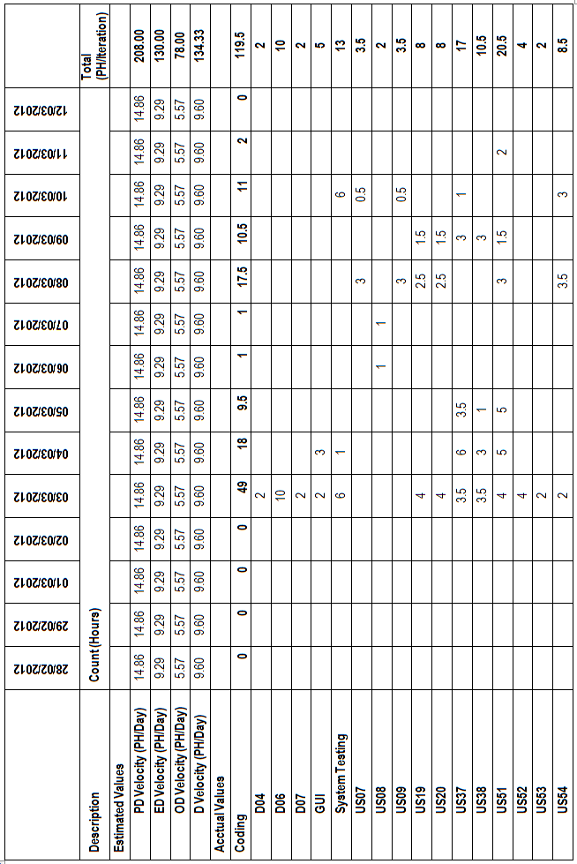

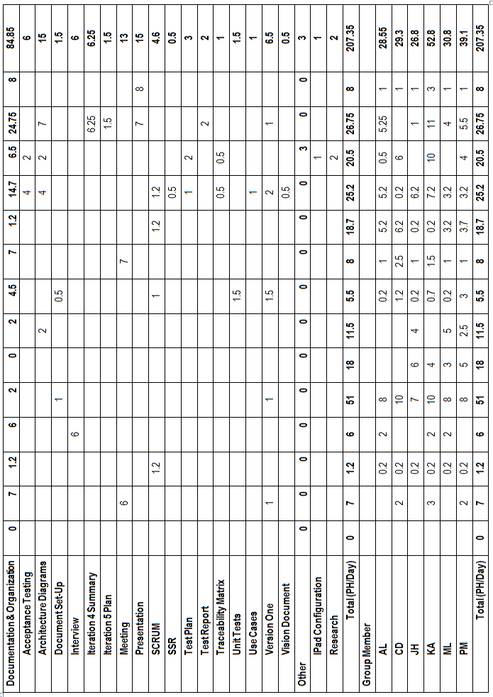

## Cumulative Velocities vs. Time

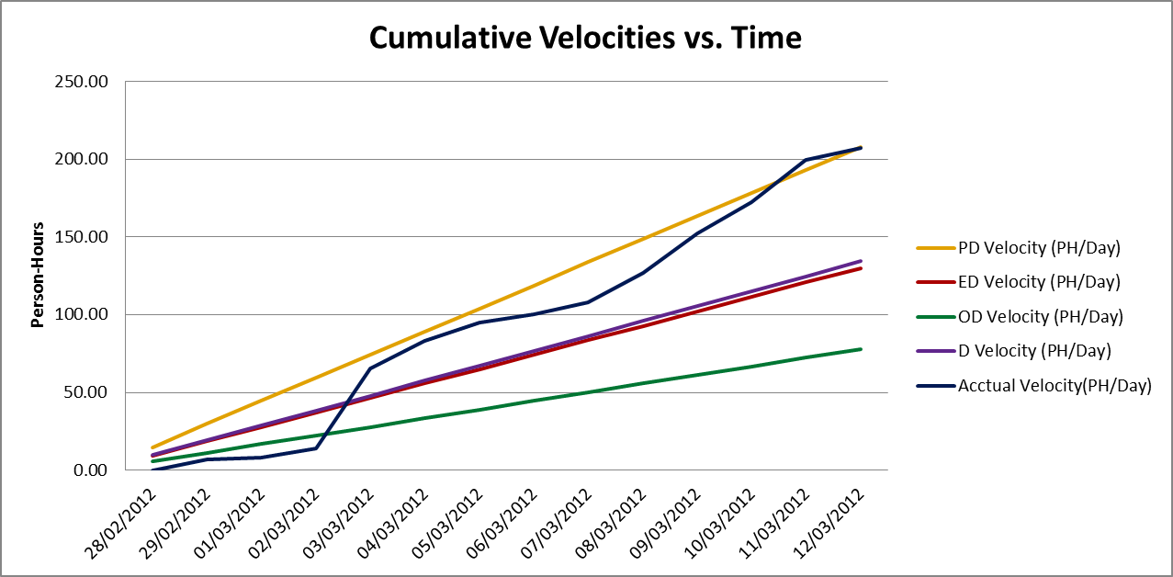

## Cumulative Activity Velocity vs. Time

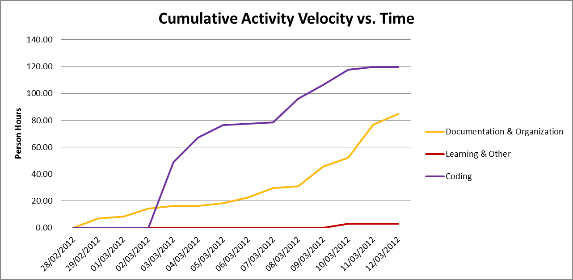

## Cumulative Group Member Velocity vs. Time

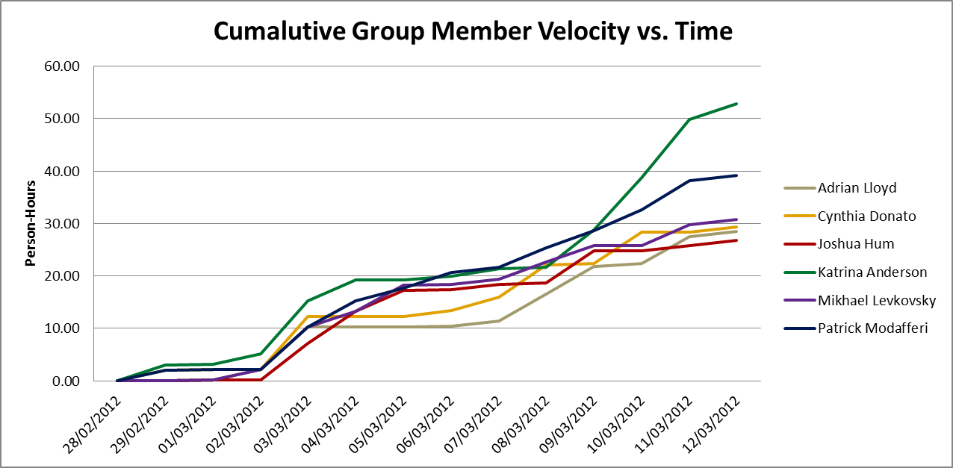

## Story Point Iteration Burndown Chart

The burndown chart below was generated from the tracking section of VersionOne. In actual fact, we completed 26 story points; However the graph only seems to illustrate 18 story points.

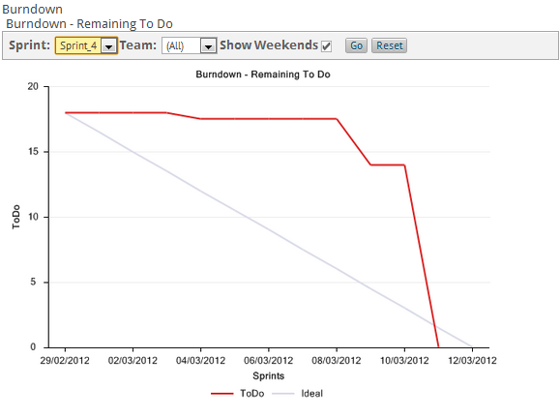

Figure 9.6.1 Sprint 4 Tracking Burndown Trend Chart

## Line Counter Statistics for Iteration 4

**Line Counter Statistics for Iteration 4**

Line Counter Program:

|  |  |
| --- | --- |
| **Program Name** | LOC Counter, copyright (c) 2011, Gary Gocek |
| **Developer** | Gary Gocek |
| **License / Price** | BSD License / $0 |
| **Size / OS** | 659 KB / Windows 2K / XP / Vista / 7 |
| **Last Updated** | August 27th, 2011, 16:59 UTC |
| **Program Source** | <http://www.softpedia.com/get/Office-tools/Other-Office-Tools/LOC-Counter-GUI.shtml> |

Statistical Results:

|  |  |  |  |  |  |  |  |
| --- | --- | --- | --- | --- | --- | --- | --- |
|  | **Iteration 1** | **Iteration 2** | **Iteration 3** | **Iteration 4** | **Difference of Iterations 2 & 1** | **Difference of Iterations 3 & 2** | **Difference of Iterations 4 & 3** |
| **Total Number of Files** | 2,144 | 2,230 | 2,311 | 2,169 | 86 | 81 | -142 |
| **Total Number of Comment Lines** | 67,729 | 69,651 | 70,941 | 68,041 | 1,922 | 1,290 | -2,900 |
| **Total Number of Blank Lines** | 24,508 | 25,710 | 26,571 | 25,292 | 1,202 | 861 | -1,279 |
| **Total Number of Source Code Lines** | 616,029 | 623,205 | 627,622 | 620,701 | 7,176 | 4,417 | -6,921 |
| **Total Number of Lines** | 708,266 | 718,566 | 725,134 | 714,034 | 10,300 | 6,568 | -11,100 |
| **File Types** | HTML, XML, Jscript Script, SQL, Windows Batch File, PHP | | | | | | |

## Code Quality Analysis

To assess the quality of the F.S.T.S. code, the source files were analyzed with PHP Depend. Given a source base, PHP Depend will perform a static analysis and provide a variety of metric values over five different levels of code: Project, Package, File, Class and Method.For our code quality analysis we will focus on the project as a whole and analyse the code’s level of inheritance, coupling, size and complexity [10]. To facilitate project analysis PHP Depend creates Pyramid charts, which highlight the most relevant matrices.

### PHP Depend Metric Values and Pyramid Tables

|  |  |  |  |
| --- | --- | --- | --- |
| **Metric** | **Description** | **Value**  **Project without Framework** | **Values**  **Project with Framework** |
| **Ahh** | *Average Hierarchy Height* (The average of the maximum length from a root class to its deepest subclass subclass) | 2.167 | 0.591 |
| **Andc** | *Average Number of Derived Classes (*The average of direct subclasses of a class) | 0.320 | 0.836 |
| **Calls** | *Number of Method or Function Calls* | 1726 | 13920 |
| **Ccn** | Cyclomatic Complexity Number | 1257 | 14683 |
| **ccn2** | Extended Cyclomatic Complexity Number | 1357 | 16453 |
| **Cloc** | *Comment Lines of Code* | 4117 | 43887 |
| **Clsa** | *Number of Abstract Classes* | 1 | 55 |
| **Clsc** | *Number of Concrete Classes* | 92 | 695 |
| **Eloc** | *Executable Lines of Code* | 8321 | 75855 |
| **Fanout** | *Number of Fanouts Referenced Classes* | 310 | 1653 |
| **Leafs** | *Number of Leaf Classes (finla) classes* | 78 | 634 |
| **Lloc** | *Logical Lines Of Code* | 4501 | 40219 |
| **Loc** | *Lines Of Code* | 14079 | 130055 |
| **maxDIT** | *Max Depth of Inheritance Tree Maximum depth of inheritance* | 3 | 5 |
| **Ncloc** | *Non Comment Lines Of Code* | 9962 | 86168 |
| **Noc** | *Number Of Classes* | 93 | 750 |
| **Nof** | *Number Of Functions* | 3 | 10 |
| **Noi** | *Number Of Interfaces* | 1 | 29 |
| **Nom** | *Number Of Methods* | 677 | 5193 |
| **Nop** | *Number of Packages* | 3 | 44 |



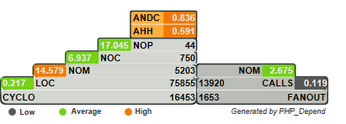

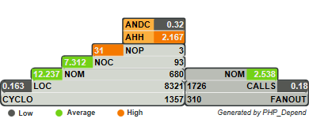

Figure 9.8.1 Pyramid Project With Framework

Figure 9.8.2 Pyramid Project Without Framework

### Inheritance

**Project With Framework Inheritance Level: High**

**Project Without Framework Inheritance Level: Average**

Considering that the F.S.T.S. is built on top of the Yii Framework, it is no surprise that the Average Number of Derived Classes (ANDC) and the Average Hierarchy Height (AHH) metrics are considered high. Depending on the implementation of the code, high inheritance can be considered a good or a bad thing. In our case we know that it is a good thing, as it’s an indication of separation of concerns and reusability [10]. When analyzing the project without the framework the inheritance falls to an average level. This is to be expected as many of the interfaces our project inherits from are not included. The Yii Framework appeals to PHP developers, because it can be applied to many types of systems [3].

### Coupling

**Project With Framework Coupling Level: Low-Average**

**Project Without Framework Coupling Level: Low-Average**

Project coupling is measured with two values: CALLS, which measures the number of distinct method and function calls and FANOUT, which “provides information on types referenced by classes and interfaces. “It only counts those types that are not part of the same Inheritance branch” [10]. The metrics of FANOUT/CALLS and CALLS/NOM are low and average respectively. Low-average coupling means that the F.S.T.S. is less likely to suffer from ripple effects generated during development and maintenance, thus minimizing the costs in coding effort and time. Low-average coupling also facilitates testing methods, such as unit testing, and increases the chances for reusability.

### Size & Complexity

**Project With Framework Size & Complexity Level: Average**

**Project Without Framework Size & Complexity Level: Average**

Size and complexity are evaluated from four metric ratios ( CYCLO/LOC, LOC/NOM, NOM/NOC, NOC/NOP), which are established by the following five values:

NOP –The**Number of Packages**metric counts the packages within the analyzed software system.

NOC–The**Number Of Classes**metric counts the declared classes within the analyzed software system.

NOM- The**Number Of Methods**metric counts all declared methods, which in this context means class methods and simple functions.

LOC- The**Lines Of Code**metric shows the number of executable source lines within the analyzed software system. To calculate this value PHP_Depend counts all non whitespace lines and all non comment lines. PHP Depend, unlike the LOC Counter, only includes PHP files in its analysis, thus accounting for the discrepancy in values.

CYCLO–The**Cyclomatic Complexity**numberis a software metric (measurement). It was already developed in 1976 by Thomas J. McCabe and is used to *calculate the complexity of a program. It directly measures the number of linearly independent paths through a program's source code [10].*

At the framework level the LOC/NOM ratio value is considered high, while the CYCLO/LOC, NOM/NOC and NOC/NOP are evaluated to be average. This indicates that the F.S.T.S. code is of average-large size with average complexity. At the project level the value of the NOC/NOP is high, this is an anomaly from not including the framework. The complexity level of the F.S.T.S. is at a maintainable level, but should not increase in order to keep costs in coding effort and time down. In addition, systems with low complexity have a higher probability of containing reusable components.

## Retrospective

In Iteration 4, we completed 26 user story points. Therefore, it was a successful iteration. This was the first iteration in which we completed 100% of the story points planned. The defects D02, D03, D04, and D07 were also completed in this iteration.

We completed the following user stories and defects:

|  |  |  |  |
| --- | --- | --- | --- |
| **User Story ID** | **Feature Group** | **User Stories** | **Story Points** |
| D02 | Defects | Client File Missing Error Message | 0 |
| D03 | Defects | Dependents Fix the Flow | 0 |
| D04 | Defects | Events Mandate how many people per day/per hour | 0 |
| D07 | Defects | Client File Management separate citizenship status from work status | 0 |
| US07 | Appointment Fullfillment | As a user, I want to view a list of all clients coming to an event, so that I may check-in families on a computing device. | 2.00 |
| US08 | Appointment Fullfillment | As a user, I want to view a list of all clients coming to an event, so that I may print the list and manually check-in families. | 2.00 |
| US09 | Client File Managemnet | As a user, I want to close an event for the day, so that all no-shows are automatically flagged. | 1.00 |
| US19 | Client File Managemnet | As an administrator, I want to automatically change the status of active client files to inactive after a mutable period of time, so that I maintain the relevance of the client database. | 3.00 |
| US20 | Client File Managemnet | As an administrator, I want to archive client files after a mutable time period of inactivity, so that I maintain the relevance of the client database and reduce search overhead. | 2.00 |
| US37 | Client File Search | As a user, I want to be able to search for client files by family id so that I may quickly access the family information. | 3.00 |
| US38 | Client File Search | As a user, I would like to be able to make an advanced search for a client file so that I may located client files for clients who do not have their file id with them | 5.00 |
| US51 | Client File Management | As a user, I want to add income and work information to clients and dependants, so that I can derive statistical information | 3.00 |
| US52 | Client File Management | As a user, I want to delete income and work information to clients and dependants, so that I can derive statistical information. | 2.00 |
| US53 | Client File Management | As a user, I want to update income and work information to clients and dependants, so that I can derive statistical information. | 2.00 |
| US54 | Client File Management | As a user, I want to view income and work information to clients and dependants, so that I can derive statistical information. | 2.00 |

The following table shows the metric and ration values of the code after completing Iteration 4. The goals were met in all categories except for in the category LOC/NOM. See section 9.8.1 for detailed analysis.

|  |  |
| --- | --- |
| **Metric** | **Level** |
| CYCLO/LOC | Average |
| LOC/NOM | High |
| NOM/NOC | Average |
| NOC/NOP | Average |
| CALLS/NOM | Average |
| FANOUT/CALLS | Low |
| ANDC | High |
| AHH | High |

The following positive and negative points show what we would like to continue doing and what we do not want to do in future iterations.

**Positives:**

* Completed 100% of planned user story points
* Fixed quite a few defects and still stayed on track for completing stories
* Good communication
* Daily scrum meetings(if a person couldn’t attend, he/she was informed by group email)
* Met our personal deadlines
* Planning and management were done efficiently
* Prepared for the large amount of documentation to complete at the end of the iteration

**Negatives:**

* None

207.35 person-hours were spent working in Iteration 3. This is an increase compared to Iteration 3 although it is close to the time spent working in iterations 1 and 2. These hours paid off as we completed all planned user story points.

Approximately 60% of the person-hours were spent working on user stories/coding. This is a positive sign because we wanted to focus on producing quality code and proper functionality this iteration while also fixing defects. There was very little time spent learning which is a good sign at this point of the project.

Static code quality analysis was conducted for the third time. Analyzing the code proved that our code was cohesive, maintainable and reusable. The inheritance level was high, the coupling level was low-average and the complexity level was average.

# Iteration 5 Plan

## Planned User Stories and Story Point Total

We will be using VersionOne to document the progression of our story points. VersionOne automatically generates the estimated velocities of our project. We re-evaluated the story point values for iteration 5 and will be attempting to finish off the main system functionalities, thus our story point goal is 29.00.

|  |  |  |
| --- | --- | --- |
| **User Story ID** | **Total Story Points** | **Related Use Cases** |
| **US36, US48, US49, US50** | **29.00** | **UC1.1, UC1.4, UC1.5, UC5.1, UC5.2** |

## Person-Hour Estimation

Estimated person-hour measurements were calculated with the Expert Judgment Method. The table below illustrates our velocity predictions. The pessimistic and optimistic durations were calculated from the expected duration with a margin of 60% between them. Meaning the optimistic estimate is 30% lower than the expected duration estimate, while the pessimistic duration estimate is 30% higher than the expected duration estimate.

|  |  |  |  |  |
| --- | --- | --- | --- | --- |
| **User Story ID** | **Worst Case** | **Most Likely Case** | **Best Case** | **Expected Case** |
| **US36** | 9.60 | 6.00 | 3.60 | 6.20 |
| **US48** | 115.20 | 72.00 | 43.20 | 74.40 |
| **US49** | 182.40 | 114.00 | 68.40 | 117.80 |
| **US50** | 115.20 | 72.00 | 43.20 | 74.40 |
| **Total (ph)** | **422.40** | **264.00** | **158.40** | **272.80** |
| **Velocity (ph/day)** | **30.17** | **18.86** | **11.31** | **19.49** |
| **Velocity (ph/team member/day)** | **5.03** | **3.14** | **1.89** | **3.25** |

## Code Quality Goals

Having established a base line for system quality in Iteration 2, we will be looking to maintain the following metric and ratio values in Iteration 5 for both our code and the combination of our code with the Yii Framwork.

|  |  |
| --- | --- |
| **Metric** | **Level** |
| CYCLO/LOC | Average (or lower) |
| LOC/NOM | Average (or lower) |
| NOM/NOC | Average (or lower) |
| NOC/NOP | Average (or lower) |
| CALLS/NOM | Average (or lower) |
| FANOUT/CALLS | Average (or lower) |
| ANDC | High |
| AHH | High |

# Iteration 5 Report

## Person-Hour Work Log

|  |  |  |  |  |  |
| --- | --- | --- | --- | --- | --- |
| **Date** | **Artifact Type** | **Artifact Name** | **Artifact Description** | **Cost (Hours)** | **Initials** |
| 3/13/2012 | Documentation & Organization | SCRUM | Daily Meeting | 0.1 | AL |
| 3/13/2012 | Documentation & Organization | SCRUM | Daily Meeting | 0.1 | CD |
| 3/13/2012 | Documentation & Organization | SCRUM | Daily Meeting | 0.1 | JH |
| 3/13/2012 | Documentation & Organization | SCRUM | Daily Meeting | 0.1 | KA |
| 3/13/2012 | Documentation & Organization | SCRUM | Daily Meeting | 0.1 | ML |
| 3/13/2012 | Documentation & Organization | SCRUM | Daily Meeting | 0.1 | PM |
| 3/14/2012 | Documentation & Organization | Meeting | Daily Meeting | 1.5 | AL |
| 3/14/2012 | Documentation & Organization | Meeting | Daily Meeting | 1.5 | CD |
| 3/14/2012 | Documentation & Organization | Meeting | Daily Meeting | 1.5 | JH |
| 3/14/2012 | Documentation & Organization | Meeting | Daily Meeting | 1.5 | KA |
| 3/14/2012 | Documentation & Organization | Meeting | Daily Meeting | 1.5 | ML |
| 3/14/2012 | Documentation & Organization | Meeting | Daily Meeting | 1.5 | PM |
| 3/14/2012 | Documentation & Organization | VersionOne | Input Defects | 2 | KA |
| 3/15/2012 | Coding | D08 | Coding | 0.1 | AL |
| 3/15/2012 | Coding | D09 | Coding | 0.1 | AL |
| 3/15/2012 | Coding | D10 | Coding | 0.1 | AL |
| 3/15/2012 | Coding | D11 | Coding | 0.1 | AL |
| 3/15/2012 | Coding | D12 | Coding | 0.1 | AL |
| 3/15/2012 | Coding | D13 | Coding | 1 | PM |
| 3/15/2012 | Coding | D21 | Coding | 2 | PM |
| 3/15/2012 | Documentation & Organization | Document Set-Up | Setting up the various deliverables, presentations and logs. | 3 | KA |
| 3/15/2012 | Documentation & Organization | SCRUM | Daily Meeting | 0.1 | AL |
| 3/15/2012 | Documentation & Organization | SCRUM | Daily Meeting | 0.1 | CD |
| 3/15/2012 | Documentation & Organization | SCRUM | Daily Meeting | 0.1 | JH |
| 3/15/2012 | Documentation & Organization | SCRUM | Daily Meeting | 0.1 | KA |
| 3/15/2012 | Documentation & Organization | SCRUM | Daily Meeting | 0.1 | ML |
| 3/15/2012 | Documentation & Organization | SCRUM | Daily Meeting | 0.1 | PM |
| 3/16/2012 | Coding | D22 | Coding | 0.1 | PM |
| 3/16/2012 | Coding | D23 | Coding | 0.1 | PM |
| 3/16/2012 | Coding | D24 | Coding | 0.1 | PM |
| 3/16/2012 | Coding | D25 | Coding | 0.1 | PM |
| 3/16/2012 | Coding | D26 | Coding | 0.1 | PM |
| 3/16/2012 | Coding | D27 | Coding | 0.1 | PM |
| 3/16/2012 | Coding | D28 | Coding | 0.1 | PM |
| 3/16/2012 | Coding | D29 | Coding | 0.1 | PM |
| 3/16/2012 | Coding | D30 | Coding | 0.1 | PM |
| 3/16/2012 | Coding | D31 | Coding | 0.1 | PM |
| 3/16/2012 | Coding | D32 | Coding | 0.1 | PM |
| 3/16/2012 | Documentation & Organization | SCRUM | Daily Meeting | 0.1 | AL |
| 3/16/2012 | Documentation & Organization | SCRUM | Daily Meeting | 0.1 | CD |
| 3/16/2012 | Documentation & Organization | SCRUM | Daily Meeting | 0.1 | JH |
| 3/16/2012 | Documentation & Organization | SCRUM | Daily Meeting | 0.1 | KA |
| 3/16/2012 | Documentation & Organization | SCRUM | Daily Meeting | 0.1 | ML |
| 3/16/2012 | Documentation & Organization | SCRUM | Daily Meeting | 0.1 | PM |
| 3/17/2012 | Coding | D14 | Coding | 0.1 | ML |
| 3/17/2012 | Coding | D15 | Coding | 0.1 | ML |
| 3/17/2012 | Coding | D16 | Coding | 6 | ML |
| 3/17/2012 | Coding | D16 | Coding | 1 | PM |
| 3/17/2012 | Coding | D16 | Coding - warning message for postal | 1 | PM |
| 3/17/2012 | Coding | D16 | Tested residence unique method | 1 | PM |
| 3/17/2012 | Coding | D19 | Cascading delete | 6 | JH |
| 3/17/2012 | Coding | D33 | Coding | 7 | CD |
| 3/17/2012 | Coding | D34 | Coding | 3 | CD |
| 3/17/2012 | Coding | D35 | Coding | 2 | CD |
| 3/17/2012 | Coding | Other | Defect Coding | 0.5 | PM |
| 3/17/2012 | Coding | Other | Defect Coding | 0.5 | PM |
| 3/18/2012 | Coding | D20 | Coding | 3.5 | CD |
| 3/18/2012 | Coding | D36 | Coding | 3.5 | CD |
| 3/18/2012 | Coding | UI | Changed side menu and removed list view ect… | 2 | KA |
| 3/18/2012 | Coding | US36 | UI and Navigation | 8 | JH |
| 3/18/2012 | Coding | US48 | Coding | 4 | ML |
| 3/18/2012 | Coding | US48 | Coding | 4 | PM |
| 3/18/2012 | Documentation & Organization | SAD | Added UC5.3 | 0.75 | AL |
| 3/18/2012 | Documentation & Organization | Testing Document | Added Acceptance Tests for US48 and US50 | 1 | AL |
| 3/18/2012 | Documentation & Organization | Testing Document | Created defect excel file | 3 | KA |
| 3/18/2012 | Documentation & Organization | VersionOne | Added Acceptance Tests for US48 and US50 | 0.2 | AL |
| 3/18/2012 | Documentation & Organization | VersionOne | Modified Version One and exported defect data. | 1 | KA |
| 3/19/2012 | Coding | US36 | UI and Navigation | 2 | JH |
| 3/19/2012 | Coding | US48 | Coding | 4 | PM |
| 3/19/2012 | Documentation & Organization | IC and User Guide | Reviewed Example I&C document | 1 | AL |
| 3/19/2012 | Documentation & Organization | IC and User Guide | Started writing installation guide | 1 | AL |
| 3/19/2012 | Documentation & Organization | Testing Document | TCD20-1, TCD33-1, TCD34-1, TCD34-2, & TCD35-1 | 5 | CD |
| 3/19/2012 | Documentation & Organization | VersionOne | Organized Tasks for US48-49-50 | 0.5 | PM |
| 3/19/2012 | Other | Learning | UI testing | 3 | KA |
| 3/20/2012 | Coding | US36 | UI and Navigation | 12 | JH |
| 3/20/2012 | Coding | US48 | Waiting List | 5 | ML |
| 3/20/2012 | Coding | US50 | Coded and ran unit tests | 1 | AL |
| 3/20/2012 | Coding | US55 | Coded and ran unit tests | 1 | AL |
| 3/20/2012 | Coding | US55 | Coding | 5 | PM |
| 3/20/2012 | Documentation & Organization | IC and User Guide | Wrote preliminary I&C document | 2 | AL |
| 3/20/2012 | Documentation & Organization | SAD | Update actor goal list | 1 | CD |
| 3/20/2012 | Documentation & Organization | SAD | Update use case model | 4 | CD |
| 3/20/2012 | Documentation & Organization | SAD | Updated SAD | 2 | KA |
| 3/20/2012 | Documentation & Organization | SCRUM | Daily meeting | 0.15 | AL |
| 3/20/2012 | Documentation & Organization | SCRUM | Daily meeting | 0.15 | CD |
| 3/20/2012 | Documentation & Organization | SCRUM | Daily meeting | 0.15 | JH |
| 3/20/2012 | Documentation & Organization | SCRUM | Daily meeting | 0.15 | KA |
| 3/20/2012 | Documentation & Organization | SCRUM | Daily meeting | 0.15 | ML |
| 3/20/2012 | Documentation & Organization | SCRUM | Daily meeting | 0.15 | PM |
| 3/20/2012 | Documentation & Organization | SRS | Updated SRS | 1 | KA |
| 3/20/2012 | Documentation & Organization | Testing Document | Acceptance Test for US55 | 0.5 | AL |
| 3/20/2012 | Documentation & Organization | Testing Document | Updated test plan and reports | 4 | KA |
| 3/20/2012 | Documentation & Organization | Traceability Matrices | Updated Traceability Matrices | 0.25 | AL |
| 3/20/2012 | Documentation & Organization | VersionOne | Updated/Added Tests in US48, US50 and US55 | 1 | AL |
| 3/20/2012 | Documentation & Organization | Vision Document | Updated vision document | 1 | KA |
| 3/21/2012 | Coding | D17 | Unique Medicare only | 3 | ML |
| 3/21/2012 | Coding | D18 | Can't add appointment for client who is inactive | 0.1 | ML |
| 3/21/2012 | Coding | Unit Testing | test appointment creation by household | 0.5 | CD |
| 3/21/2012 | Coding | Unit Testing | test appointment creation by person | 0.5 | CD |
| 3/21/2012 | Coding | US36 | UI and Navigation | 8 | JH |
| 3/21/2012 | Coding | US46 | Add search to view event | 1 | CD |
| 3/21/2012 | Coding | US48 | Fixed flow | 1 | ML |
| 3/21/2012 | Coding | US48 | Finish operational report | 2 | PM |
| 3/21/2012 | Coding | US50 | Updated and ran Unit Test | 1 | AL |
| 3/21/2012 | Coding | US55 | Finalized waiting list | 2 | PM |
| 3/21/2012 | Documentation & Organization | Architecture Document | Started writing architecture Sections 1, 2 and 3 | 0.5 | AL |
| 3/21/2012 | Documentation & Organization | Architecture Document | Class Diagram | 2 | CD |
| 3/21/2012 | Documentation & Organization | IC and User Guide | Added more to & revised installation guide | 1.5 | AL |
| 3/21/2012 | Documentation & Organization | Testing Document | Added Acceptance Tests for US55 | 0.25 | AL |
| 3/21/2012 | Documentation & Organization | Testing Document | Defects & Test Plan | 6 | KA |
| 3/21/2012 | Documentation & Organization | VersionOne | Reviewed Tests for US 48, 50 and 55 | 0.25 | AL |
| 3/21/2012 | Documentation & Organization | VersionOne | added unit tests | 0.5 | CD |
| 3/22/2012 | Coding | System Testing | Programmed System Tests | 7 | KA |
| 3/22/2012 | Coding | US36 | UI touch ups | 0.5 | JH |
| 3/22/2012 | Coding | US36 | HTML and CSS validation | 3 | JH |
| 3/22/2012 | Coding | US55 | Bug fixing for waiting list | 2 | PM |
| 3/22/2012 | Documentation & Organization | Architecture Document | System Sequence Diagrams | 1 | JH |
| 3/22/2012 | Documentation & Organization | IC and User Guide | Search instructions | 2 | JH |
| 3/22/2012 | Documentation & Organization | IC and User Guide | Wrote about installation | 1.5 | ML |
| 3/22/2012 | Documentation & Organization | IC and User Guide | User Manual for client and reports | 6 | PM |
| 3/22/2012 | Documentation & Organization | SAD | use cases | 1 | CD |
| 3/22/2012 | Documentation & Organization | SAD | Class Diagram | 5 | CD |
| 3/22/2012 | Documentation & Organization | SAD | Wrote about architecture | 6 | ML |
| 3/22/2012 | Documentation & Organization | Testing Document | Reported on testing results | 2 | KA |
| 3/23/2012 | Coding | US55 | Bug fixing for waiting list | 1 | PM |
| 3/23/2012 | Documentation & Organization | IC and User Guide | User Manual for events and appointments | 4 | CD |
| 3/23/2012 | Documentation & Organization | Presentation | Sprint 6 Plan | 0.5 | AL |
| 3/23/2012 | Documentation & Organization | Presentation | Iteration 5 Retrospective | 1 | JH |
| 3/23/2012 | Documentation & Organization | Reports & Planning Document | Iteration 5 LOC | 0.25 | AL |
| 3/23/2012 | Documentation & Organization | Reports & Planning Document | Sprint 6 Plan | 0.5 | AL |
| 3/23/2012 | Documentation & Organization | Reports & Planning Document | Iteration 5 Retrospective | 2 | JH |
| 3/23/2012 | Documentation & Organization | SAD | Class Diagram | 5 | CD |
| 3/24/2012 | Documentation & Organization | Reports & Planning Document | Calculating metrics, creating graphs, ect... | 10 | KA |
| 3/24/2012 | Documentation & Organization | Testing Document | Defect | 1.5 | KA |
| 3/25/2012 | Documentation & Organization | Presentation | 2 presentation documents & organisation of presentation | 2 | KA |
| 3/25/2012 | Documentation & Organization | Reports & Planning Document | Planning document | 1.5 | KA |
| 3/25/2012 | Documentation & Organization | SAD | Operational Contract | 1 | KA |
| 3/26/2012 | Documentation & Organization | Meeting | Presentation Meeting | 1 | AL |
| 3/26/2012 | Documentation & Organization | Meeting | Presentation Meeting | 1 | CD |
| 3/26/2012 | Documentation & Organization | Meeting | Presentation Meeting | 1 | JH |
| 3/26/2012 | Documentation & Organization | Meeting | Presentation Meeting | 1 | KA |
| 3/26/2012 | Documentation & Organization | Meeting | Presentation Meeting | 1 | ML |
| 3/26/2012 | Documentation & Organization | Meeting | Presentation Meeting | 1 | PM |

## Work Log Person-Hour Summary

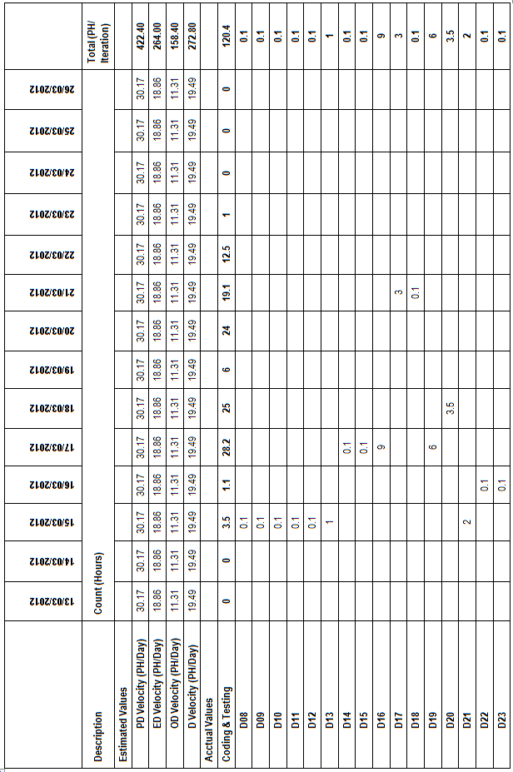

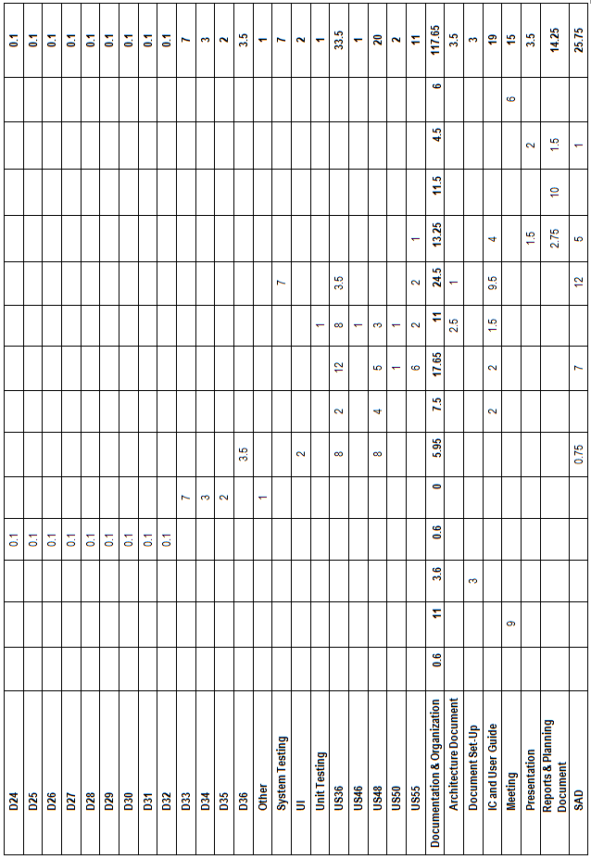

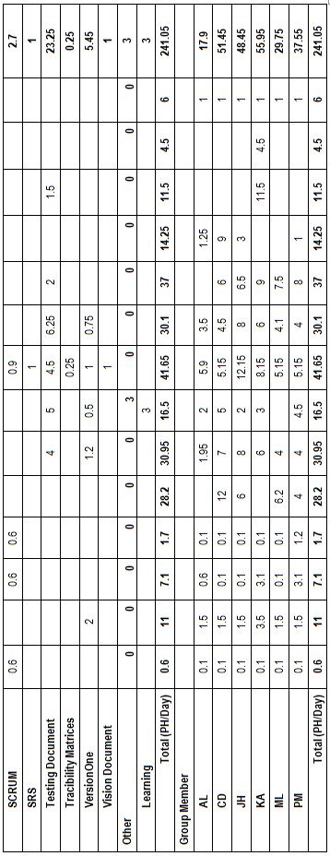

## Cumulative Velocities vs. Time

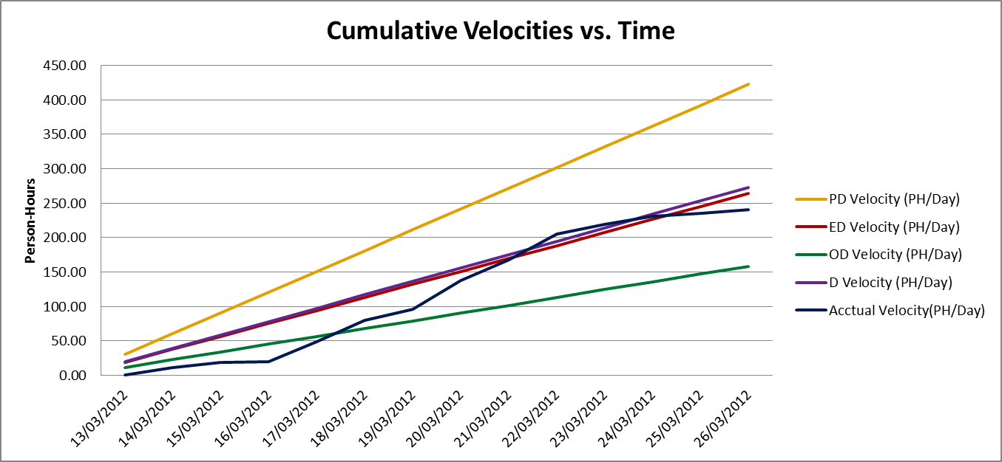

## Cumulative Activity Velocity vs. Time

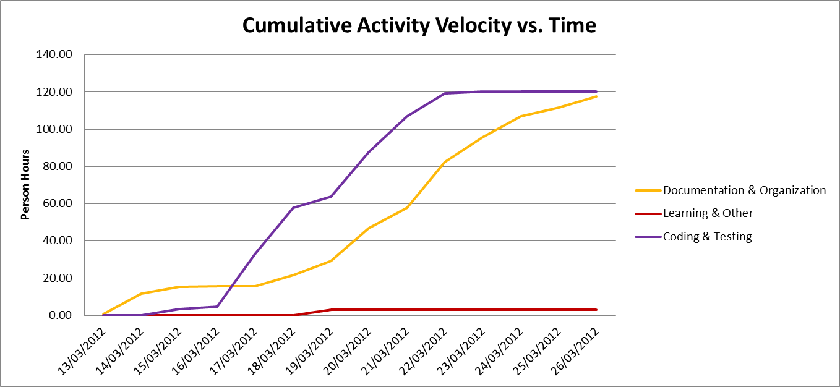

## Cumulative Group Member Velocity vs. Time

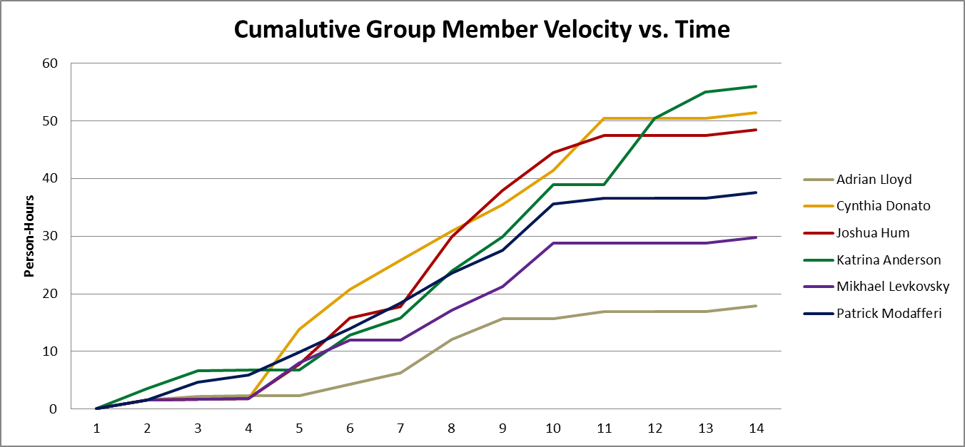

## Story Point Iteration Burndown Chart

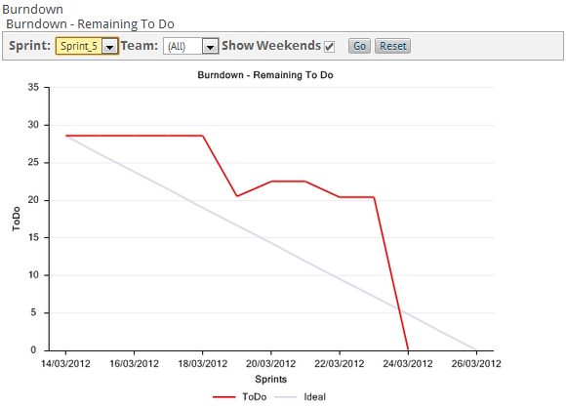

Figure 11.6.1 Sprint 5 Tracking Burndown Trend Chart

## Line Counter Statistics for Iteration 5

Line Counter Program:

|  |  |
| --- | --- |
| **Program Name** | LOC Counter, copyright (c) 2011, Gary Gocek |
| **Developer** | Gary Gocek |
| **License / Price** | BSD License / $0 |
| **Size / OS** | 659 KB / Windows 2K / XP / Vista / 7 |
| **Last Updated** | August 27th, 2011, 16:59 UTC |
| **Program Source** | <http://www.softpedia.com/get/Office-tools/Other-Office-Tools/LOC-Counter-GUI.shtml> |

Statistical Results:

|  |  |  |  |  |  |
| --- | --- | --- | --- | --- | --- |
|  | **Iteration 1** | **Iteration 2** | **Iteration 3** | **Iteration 4** | **Iteration 5** |
| **Total Number of Files** | 2,144 | 2,230 | 2,311 | 2,169 | 2,271 |
| **Total Number of Comment Lines** | 67,729 | 69,651 | 70,941 | 68,041 | 69,203 |
| **Total Number of Blank Lines** | 24,508 | 25,710 | 26,571 | 25,292 | 25,832 |
| **Total Number of Source Code Lines** | 616,029 | 623,205 | 627,622 | 620,701 | 628,278 |
| **Total Number of Lines** | 708,266 | 718,566 | 725,134 | 714,034 | 723,313 |
| **File Types** | HTML, XML, Jscript Script, SQL, Windows Batch File, PHP | | | | |

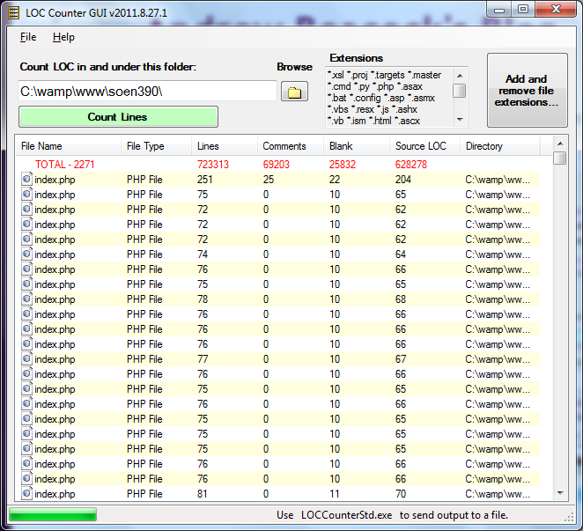

Figure 11.7.1 LOC Counter Iteration 5

## PHP Depend Code Quality Analysis

To assess the quality of the F.S.T.S. code, the source files were analyzed with PHP Depend. Given a source base, PHP Depend will perform a static analysis and provide a variety of metric values over five different levels of code: Project, Package, File, Class and Method. For our code quality analysis we will focus on the project as a whole and analyze the code’s level of inheritance, coupling, size and complexity [10]. To facilitate project analysis PHP Depend creates Pyramid charts, which highlight the most relevant matrices.

### PHP Depend Metric Values and Pyramid Tables

|  |  |  |  |
| --- | --- | --- | --- |
| **Metric** | **Description** | **Value**  **Project without Framework** | **Values**  **Project with Framework** |
| **ahh** | *Average Hierarchy Height* (The average of the maximum length from a root class to its deepest subclass subclass) | 1.923 | 0.589 |
| **andc** | *Average Number of Derived Classes (*The average of direct subclasses of a class) | 0.336 | 0.836 |
| **calls** | *Number of Method or Function Calls* | 2425 | 14665 |
| **ccn** | Cyclomatic Complexity Number | 1893 | 15279 |
| **ccn2** | Extended Cyclomatic Complexity Number | 2058 | 17108 |
| **cloc** | *Comment Lines of Code* | 4728 | 44433 |
| **clsa** | *Number of Abstract Classes* | 1 | 55 |
| **clsc** | *Number of Concrete Classes* | 102 | 706 |
| **eloc** | *Executable Lines of Code* | 12033 | 79009 |
| **fanout** | *Number of Fanouts Referenced Classes* | 349 | 1692 |
| **leafs** | *Number of Leaf Classes (finla) classes* | 88 | 644 |
| **lloc** | *Logical Lines Of Code* | 7129 | 42480 |
| **loc** | *Lines Of Code* | 18682 | 133973 |
| **maxDIT** | *Max Depth of Inheritance Tree Maximum depth of inheritance* | 3 | 5 |
| **ncloc** | *Non Comment Lines Of Code* | 13954 | 89540 |
| **noc** | *Number Of Classes* | 103 | 761 |
| **nof** | *Number Of Functions* | 17 | 24 |
| **noi** | *Number Of Interfaces* | 1 | 29 |
| **nom** | *Number Of Methods* | 815 | 5346 |
| **nop** | *Number of Packages* | 3 | 44 |



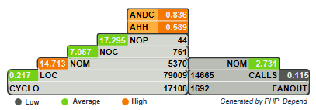

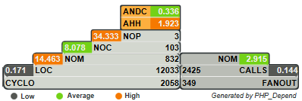

Figure 11.8.1 Pyramid Project With Framework

Figure 11.8.2 Pyramid Project Without Framework

### Inheritance

**Project With Framework Inheritance Level: High**

**Project Without Framework Inheritance Level: Average**

Considering that the F.S.T.S. is built on top of the Yii Framework, it is no surprise that the Average Number of Derived Classes (ANDC) and the Average Hierarchy Height (AHH) metrics are considered high. Depending on the implementation of the code, high inheritance can be considered a good or a bad thing. In our case we know that it is a good thing, as it’s an indication of separation of concerns and reusability [10]. When analyzing the project without the framework the inheritance falls to an average level. This is to be expected as many of the interfaces our project inherits from are not included. The Yii Framework appeals to PHP developers, because it can be applied to many types of systems [3].

### Coupling

**Project With Framework Coupling Level: Low-Average**

**Project Without Framework Coupling Level: Low-Average**

Project coupling is measured with two values: CALLS, which measures the number of distinct method and function calls and FANOUT, which “provides information on types referenced by classes and interfaces. “It only counts those types that are not part of the same Inheritance branch” [10]. The metrics of FANOUT/CALLS and CALLS/NOM are low and average respectively. Low-average coupling means that the F.S.T.S. is less likely to suffer from ripple effects generated during development and maintenance, thus minimizing the costs in coding effort and time. Low-average coupling also facilitates testing methods, such as unit testing, and increases the chances for reusability.

### Size & Complexity

**Project With Framework Size & Complexity Level: Average**

**Project Without Framework Size & Complexity Level: Average**

Size and complexity are evaluated from four metric ratios ( CYCLO/LOC, LOC/NOM, NOM/NOC, NOC/NOP), which are established by the following five values:

NOP –The **Number of Packages** metric counts the packages within the analyzed software system.

NOC–The **Number of Classes** metric counts the declared classes within the analyzed software system.

NOM- The **Number of Methods** metric counts all declared methods, which in this context means class methods and simple functions.

LOC- The **Lines Of Code** metric shows the number of executable source lines within the analyzed software system. To calculate this value PHPDepend counts all non whitespace lines and all non comment lines. PHP Depend, unlike the LOC Counter, only includes PHP files in its analysis, thus accounting for the discrepancy in values.

CYCLO–The **Cyclomatic Complexity** numbers a software metric (measurement). It was already developed in 1976 by Thomas J. McCabe and is used to *calculate the complexity of a program. It directly measures the number of linearly independent paths through a program's source code [10].*

At the framework level the LOC/NOM ratio value is considered high, while the CYCLO/LOC, NOM/NOC and NOC/NOP are evaluated to be average. This indicates that the F.S.T.S. code is of average-large size with average complexity. At the project level the value of the NOC/NOP is high, this is an anomaly from not including the framework. The complexity level of the F.S.T.S. is at a maintainable level, but should not increase in order to keep costs in coding effort and time down. In addition, systems with low complexity have a higher probability of containing reusable components.

## Measurement Report

### Size

The following values were found using PHP Depend.

|  |  |  |  |  |  |  |  |  |
| --- | --- | --- | --- | --- | --- | --- | --- | --- |
| **Metric** | **Description** | **Iteration 2 Values** | **Iteration 3 Values** | | **Iteration 4 Values** | | **Iteration 5 Values** | |
| **Project with Framework** | **Project without Framework** | **Project with Framework** | **Project without Framework** | **Project with Framework** | **Project without Framework** | **Project with Framework** |
| **cloc** | *Comment Lines of Code* | 42073 | 3210 | 43104 | 4117 | 43887 | 4728 | 44433 |
| **clsa** | *Number of Abstract Classes* | 54 | 1 | 55 | 1 | 55 | 1 | 55 |
| **clsc** | *Number of Concrete Classes* | 651 | 77 | 681 | 92 | 695 | 102 | 706 |
| **eloc** | *Executable Lines of Code* | 72028 | 6033 | 74214 | 8321 | 75855 | 12033 | 79009 |
| **lloc** | *Logical Lines Of Code* | 38255 | 3112 | 39383 | 4501 | 40219 | 7129 | 42480 |
| **loc** | *Lines Of Code* | 123671 | 10446 | 127359 | 14079 | 130055 | 18682 | 133973 |
| **ncloc** | *Non Comment Lines Of Code* | 81598 | 7236 | 84255 | 9962 | 86168 | 13954 | 89540 |
| **noc** | *Number Of Classes* | 705 | 78 | 736 | 93 | 750 | 103 | 761 |
| **nof** | *Number Of Functions* | 7 | 0 | 7 | 3 | 10 | 17 | 24 |
| **noi** | *Number Of Interfaces* | 28 | 1 | 29 | 1 | 29 | 1 | 29 |
| **nom** | *Number Of Methods* | 4856 | 525 | 5056 | 677 | 5193 | 815 | 5346 |
| **nop** | *Number of Packages* | 42 | 3 | 44 | 3 | 44 | 3 | 44 |

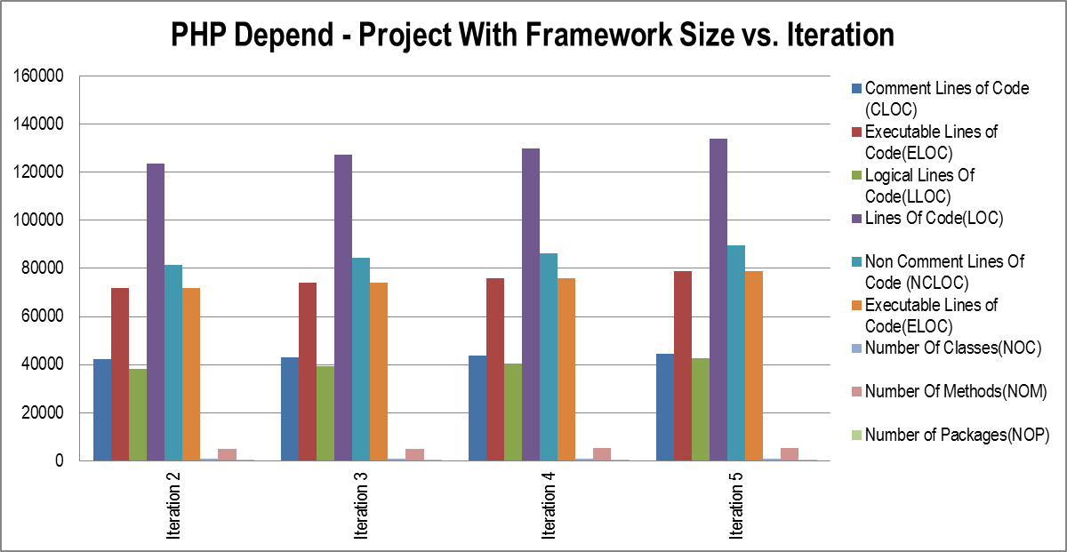

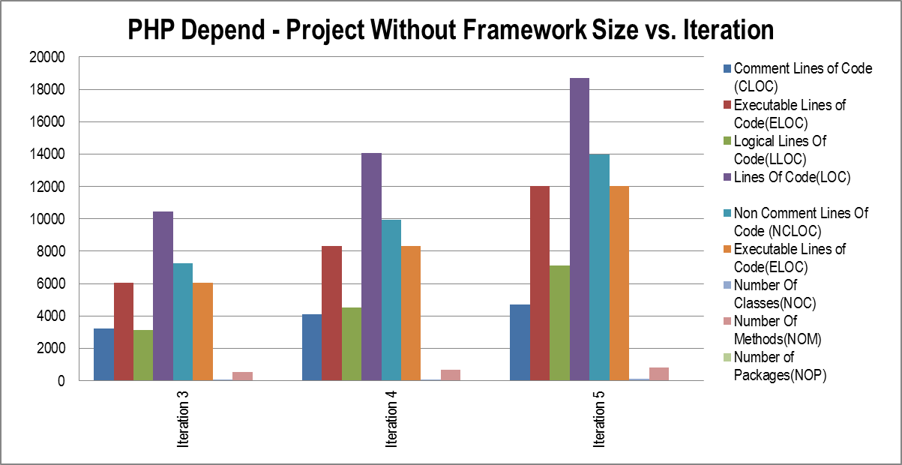

### Complexity

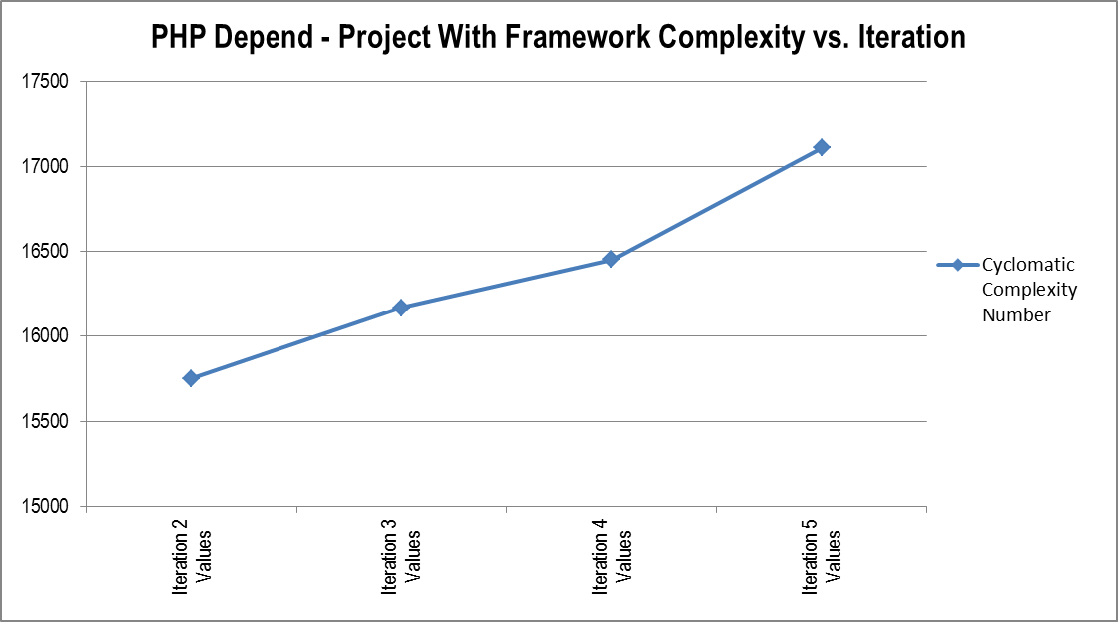

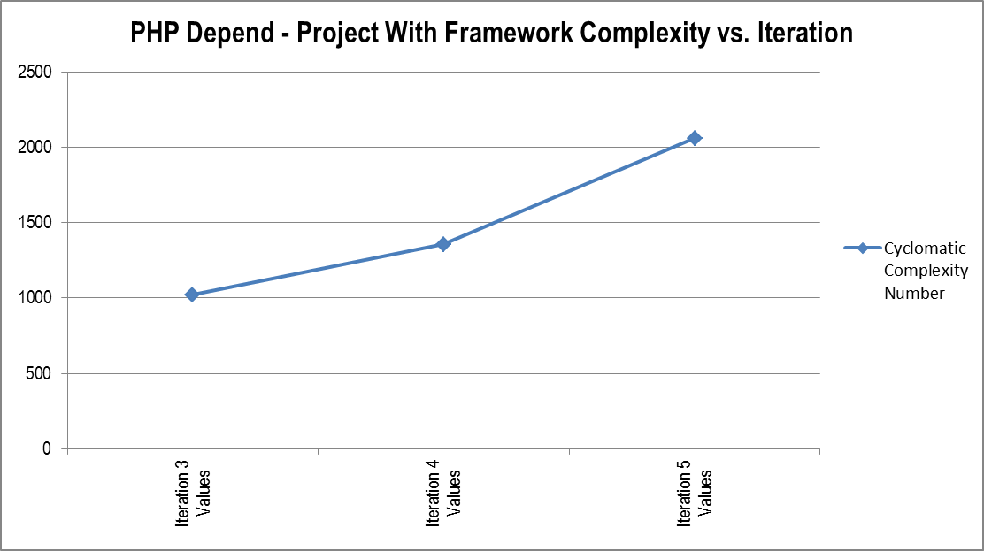

### Cost/Effort

Values were derived from the person hour logs from each iteration.

|  |  |  |  |  |  |  |  |
| --- | --- | --- | --- | --- | --- | --- | --- |
|  | **Iteration 1 (ph)** | **Iteration 2 (ph)** | **Iteration 3 (ph)** | **Iteration 4 (ph)** | **Iteration 5 (ph)** | **Total Overall (ph)** | **Percentage %** |
| **Documentation** | 63.25 | 50.20 | 24.75 | 54.75 | 99.95 | **292.90** | **28.68%** |
| **Meetings** | 20.50 | 29.20 | 20.80 | 17.60 | 17.70 | **105.80** | **10.36%** |
| **Coding** | 51.50 | 71.00 | 44.20 | 82.50 | 50.50 | **299.70** | **29.34%** |
| **Testing** | 22.00 | 45.50 | 28.25 | 35.50 | 28.00 | **159.25** | **15.59%** |
| **Other** | 36.50 | 19.50 | 16.50 | 3.00 | 3.00 | **78.50** | **7.69%** |
| **Defects** | 0.00 | 0.00 | 29.25 | 14.00 | 41.90 | **85.15** | **8.34%** |
| **Total** | 193.75 | 215.40 | 163.75 | 207.35 | 241.05 | **1021.30** |  |

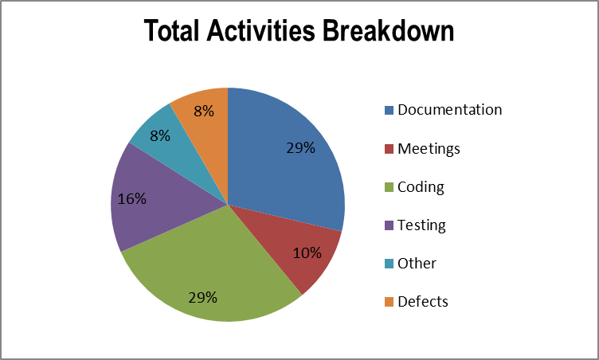

The pie chart on the left represents the breakdown of total person hours dedicated to six activity groups over the whole project: Documentation, meetings, coding, testing, defects and other….The graph below shows the breakdown of the same six activity groups over the project iterations.

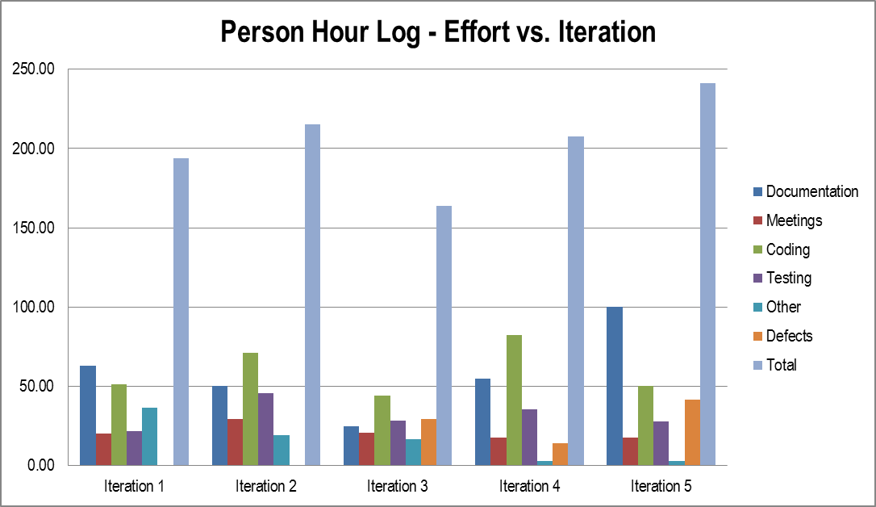

### Defects Found In Testing

Data was derived from the test report documents and person-hour logs. A total of 24 defects were discovered in testing up until and including iteration 5.

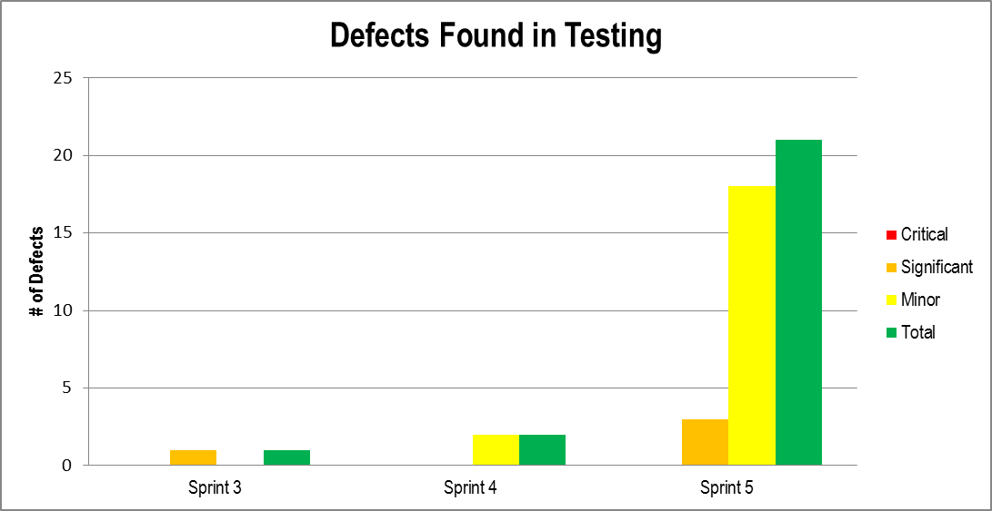

### Defects Found By the Client

Data was derived from the test report documents and person-hour logs. A total of 13 defects were discovered by clients up until and including iteration 5.

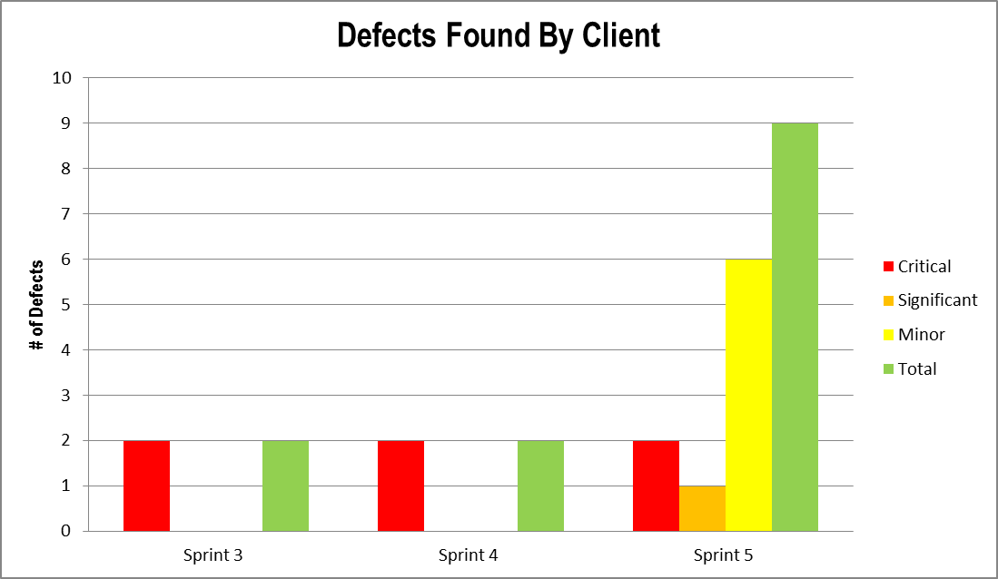

### Test Development Progress

Number of Unit Tests: 41

Unit Test Coverage: 60.69% statement coverage

Number of Acceptance Tests: 92

Acceptance Test Coverage: 8 Feature Groups

Number of System Tests: 6

System Test Coverage: 8 Feature Groups

Number of UI Tests: 13

UI Test Coverage: 8 Feature Groups

Unit, system and UI tests are regressive.

### Difficulty

**Stability of Requirements: Low**

Changes to requirements are made quite frequently by the stakeholder, including changes to the core architecture and UI.

**Level of Experience of Testing Staff: Low**

Few members of the testing staff have tested software outside of academia. Technologies such as PHP Unit, PHPDepend and Selenium are new to all members of the team.

**Level of Familiarity With Technology Being Used: Medium**

Many members of the team have a high level of experience with PHP and HTML; However no one on the team has used the Yii Framework.

**Ease of access to facilities used in testing: Low**

Clients have not allowed access to their facilities for testing, nor have they provided the source code for their current system.

**Difficulty of software production and testing: Medium-High**

Given the above criteria and general feeling of this project, we believe that the difficulty of producing this project has been medium-high. Many criteria could have been improved to decrease difficulty.

### Defect Detection Effectiveness Percentage (DDE)

DDE = (TDFT / (TDFC + TDFT)) x 100

TDFT = Total Defects Found by Testing (by testing team)

TDFC = Total Defects Found by Client

%

### Defect Removal Effectiveness Percentage (DRE)

DRE = (TDCT / TDFT) x 100

TDCT = Total Defects Closed During Testing

TDFT = Total Defects Found During Testing

### 11.9.10 Test Case Design Efficiency Percentage (TDE)

TDE = (TDFT / NTC) x 100

TDFT = Total Defects Found During Testing

NTC = Number of Test Cases Run

%

### 11.9.11 CSS Validation

The W3C CSS Validation Service was used to verify the validity of the CSS file that is included on all pages of the FSTS software. No errors were found. The following is a screenshot of the results.

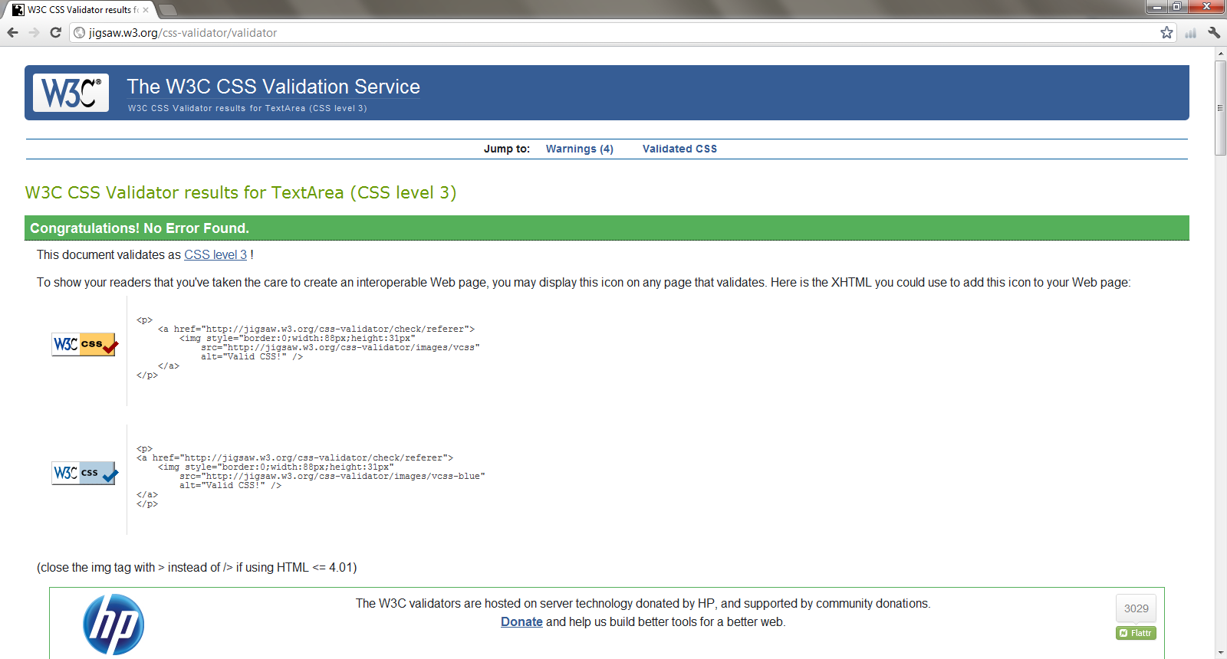

## Retrospective

In Iteration 5, we planned and completed 29 user story points. Therefore, it was a successful iteration. This was the second iteration in which we completed 100% of the story points planned.

30 defects were added to this sprint and 29 of them were completed as well. The full list follows.

We completed the following user stories and defects:

|  |  |  |  |
| --- | --- | --- | --- |
| **User Story ID** | **Feature Group** | **User Stories** | **Story Points** |
| US36 | Client File Management | As a user, I want to view all client information, related dependents and flags/notes in one concise screen, so that I reduce time spent navigating to find client information. | 1.00 |
| US48 | Appointment Management | As a user, I want to create operational reports, so that I may view concise information related to the day-to-day operation of the Welcome Hall Mission. | 8.00 |
| US50 | Operating Reports | As a user, I want to create statistical reports, so that I may view concise information related to the clientele of the Welcome Hall Mission. | 8.00 |
| US55 | Statistical Reports | As a user, I want to add clients to a waiting list for events that have reached capacity, so that I may assure full attendance to events and service to clients. | 12.00 |
| D08 | Defects | Client File Missing Create Date and "Created By" initials should not appear to be modifiable. | 0 |
| D09 | Defects | Client File missing "Update Date" and "Updated By" initials should not appear to be modifiable.. | 0 |
| D10 | Defects | Household missing "Create Date" and "Created By" initials should not appear to be modifiable. | 0 |
| D11 | Defects | Household missing "Update Date" and "Updated By" initials should not appear to be modifiable | 0 |
| D12 | Defects | Flags missing "Creation Date" and initials should not appear to be modifiable. | 0 |
| D13 | Defects | Income: The additional incomes should be added below current incomes, to be more cohesive with notes and household. | 0 |
| D14 | Defects | Client File: Different postal code field inputs should be modified to fit DB criteria. | 0 |
| D15 | Defects | Client File: Different telephone field inputs should be modified to fit DB criteria. | 0 |
| D16 | Defects | Client File: Indicate if client files share the same address. | 0 |
| D17 | Defects | Client File: Indicate if client and dependant Medicare numbers exist elsewhere. | 0 |
| D18 | Defects | Client File: Prevent users from adding an appointment if the file is set to inactive. | 0 |

|  |  |  |  |
| --- | --- | --- | --- |
| D19 | Defects | Client File: Cascading delete button that appears on a client file up until they have been registered for an appointment. | 0 |
| D20 | Defects | Event Management: Cascading delete button that appears on an event as long so no one has booked an appointment | 0 |
| D21 | Defects | Missing error msg for deleting country types. | 0 |
| D22 | Defects | Missing error msg for deleting citizenship status types | 0 |
| D23 | Defects | Missing error msg for deleting flag types. | 0 |
| D24 | Defects | Missing error msg for deleting income types. | 0 |
| D25 | Defects | Missing error msg for deleting income periods. | 0 |
| D26 | Defects | Missing error msg for deleting language types. | 0 |
| D27 | Defects | Missing error msg for deleting marital status types. | 0 |
| D28 | Defects | Missing error msg for deleting postal code types | 0 |
| D29 | Defects | Missing error msg for deleting referral types. | 0 |
| D30 | Defects | Missing error msg for deleting relationship types. | 0 |
| D31 | Defects | Missing error msg for deleting work status types. | 0 |
| D32 | Defects | Missing error msg for deleting event template types. | 0 |
| D33 | Defects | Allow Events to be created per person as well as per household | 0 |
| D34 | Defects | Missing active and amount field for event occurrences | 0 |
| D35 | Defects | Closing an event does not modify the last visited date on the client file. | 0 |
| D37 | Defects | Missing error msg for deleting users (can't delete yourself). | 0 |

For more information on defects please see the Testing Document.

The following table shows the metric and ration values of the code after completing Iteration 5. The goals were met in all categories except for in the category LOC/NOM. See section 11.8.1 for detailed analysis.

|  |  |
| --- | --- |
| **Metric** | **Level** |
| CYCLO/LOC | Average |
| LOC/NOM | High |
| NOM/NOC | Average |
| NOC/NOP | Average |
| CALLS/NOM | Average |
| FANOUT/CALLS | Low |
| ANDC | High |
| AHH | High |

The following positive and negative points show what we would like to continue doing and what we do not want to do in future iterations.

**Positives:**

* Completed 100% of planned user story points
* Fixed many defects
* Good communication
* Daily scrum meetings(if a person couldn’t attend, he/she was informed by group email)
* Met our personal deadlines
* Planning and management were done efficiently
* Majority of software is functional as desired

**Negatives:**

* None

241.05 person-hours were spent working in Iteration 5. This is the most hours spent working in an iteration thus far. However, because many defects needed to be addressed, the hours were required.

Coding was completed a few days before the end of the iteration as was planned. This is positive. The last few days of the iteration were spent preparing documentation. There was very little time spent learning which is a good sign at this point of the project.

Static code quality analysis was conducted for the fourth time. Analyzing the code proved that our code was cohesive, maintainable and reusable. The inheritance level was high, the coupling level was low-average and the complexity level was average.

# Iteration 6 Plan

## Planned Activities & Person-Hour Estimation

The final two user stories US15 and US49 and their accompanying feature groups were scoped out by our clients at the Welcome Hall Mission. We have completed all other user stories and will spend iteration 6 on the following activities:

|  |  |  |  |  |
| --- | --- | --- | --- | --- |
| **Activity** | **Person-Hour Estimation** | | | |
| **Worst Case** | **Most Likely Case** | **Best Case** | **Expected Case** |
| Defects | 45.41 | 28.38 | 17.03 | 29.33 |
| Documentation | 93.73 | 58.58 | 35.15 | 60.53 |
| Meetings | 33.86 | 21.16 | 12.70 | 21.87 |
| Testing | 50.96 | 31.85 | 19.11 | 32.91 |
| Other | 25.12 | 15.7 | 9.42 | 16.22 |
| **Total (ph)** | **249.07** | **155.67** | **93.40** | **160.86** |
| **Velocity (ph/day)** | **15.57** | **9.73** | **5.84** | **10.05** |

The activities above were derived from the measurement data provided in the iteration 5 report.

## Code Quality Goals

Having established a base line for system quality in Iteration 2, we will be looking to maintain the following metric and ratio values in Iteration 6 for both our code and the combination of our code with the Yii Framwork.

|  |  |
| --- | --- |
| **Metric** | **Level** |
| CYCLO/LOC | Average (or lower) |
| LOC/NOM | Average (or lower) |
| NOM/NOC | Average (or lower) |
| NOC/NOP | Average (or lower) |
| CALLS/NOM | Average (or lower) |
| FANOUT/CALLS | Average (or lower) |
| ANDC | High |
| AHH | High |

# Iteration 6 Report

## Person-Hour Work Log

|  |  |  |  |  |  |
| --- | --- | --- | --- | --- | --- |
| **Date** | **Artifact Type** | **Artifact Name** | **Artifact Description** | **Cost (Hours)** | **Initials** |
| 3/28/2012 | Testing | Usability Testing | Performed usability tests | 1.50 | KA |
| 3/30/2012 | Meetings | Client Meeting | Met with stakeholders | 2.00 | AL |
| 3/30/2012 | Meetings | Client Meeting | Met with stakeholders | 2.00 | KA |
| 3/30/2012 | Meetings | Client Meeting | Met with stakeholders | 2.00 | PM |
| 3/30/2012 | Meetings | SCRUM | Daily Meeting | 0.10 | AL |
| 3/30/2012 | Meetings | SCRUM | Daily Meeting | 0.10 | CD |
| 3/30/2012 | Meetings | SCRUM | Daily Meeting | 0.10 | JH |
| 3/30/2012 | Meetings | SCRUM | Daily Meeting | 0.10 | KA |
| 3/30/2012 | Meetings | SCRUM | Daily Meeting | 0.10 | ML |
| 3/30/2012 | Meetings | SCRUM | Daily Meeting | 0.10 | PM |
| 4/3/2012 | Documentation | VersionOne | Entered defects into Version One | 1.00 | KA |
| 4/3/2012 | Meetings | Meeting Preparation | Prepared agenda for meeting | 0.75 | KA |
| 4/3/2012 | Meetings | SCRUM | Daily Meeting | 0.10 | AL |
| 4/3/2012 | Meetings | SCRUM | Daily Meeting | 0.10 | CD |
| 4/3/2012 | Meetings | SCRUM | Daily Meeting | 0.10 | JH |
| 4/3/2012 | Meetings | SCRUM | Daily Meeting | 0.10 | KA |
| 4/3/2012 | Meetings | SCRUM | Daily Meeting | 0.10 | ML |
| 4/3/2012 | Meetings | SCRUM | Daily Meeting | 0.10 | PM |
| 4/4/2012 | Documentation | VersionOne | Entered defects into Version One | 0.25 | KA |
| 4/4/2012 | Meetings | Weekly Meeting | Daily Meeting | 1.50 | AL |
| 4/4/2012 | Meetings | Weekly Meeting | Daily Meeting | 1.50 | CD |
| 4/4/2012 | Meetings | Weekly Meeting | Daily Meeting | 1.50 | JH |
| 4/4/2012 | Meetings | Weekly Meeting | Daily Meeting | 1.50 | KA |
| 4/4/2012 | Meetings | Weekly Meeting | Daily Meeting | 1.50 | ML |
| 4/4/2012 | Meetings | Weekly Meeting | Daily Meeting | 1.50 | PM |
| 4/4/2012 | Other | Log | Set-up log for iteration 6 | 0.50 | KA |
| 4/5/2012 | Defects | D49 | Coding and fixing bugs | 0.50 | JH |
| 4/5/2012 | Defects | D50 | Coding and fixing bugs | 2.00 | JH |
| 4/5/2012 | Defects | D51 | Coding and fixing bugs | 1.00 | JH |
| 4/5/2012 | Defects | D59 | Coding and fixing bugs | 0.25 | JH |
| 4/5/2012 | Defects | D70 | Coding and fixing bugs | 1.00 | PM |
| 4/5/2012 | Defects | D71 | Coding and fixing bugs | 1.00 | PM |
| 4/5/2012 | Defects | D72 | Coding and fixing bugs | 0.50 | PM |
| 4/5/2012 | Defects | D73 | Coding and fixing bugs | 0.50 | JH |
| 4/5/2012 | Defects | D74 | Coding and fixing bugs | 0.50 | PM |
| 4/5/2012 | Documentation | UIR | Navigability and ease of use | 3.00 | ML |
| 4/5/2012 | Documentation | VersionOne | Managed personal defects and tests in V1 | 0.75 | PM |
| 4/5/2012 | Meetings | SCRUM | Daily Meeting | 0.10 | AL |
| 4/5/2012 | Meetings | SCRUM | Daily Meeting | 0.10 | CD |
| 4/5/2012 | Meetings | SCRUM | Daily Meeting | 0.10 | JH |
| 4/5/2012 | Meetings | SCRUM | Daily Meeting | 0.10 | KA |
| 4/5/2012 | Meetings | SCRUM | Daily Meeting | 0.10 | ML |
| 4/5/2012 | Meetings | SCRUM | Daily Meeting | 0.10 | PM |
| 4/5/2012 | Other | Agenda & Tasks | Set up agenda and tasks & report scanning | 0.75 | KA |
| 4/5/2012 | Testing | Unit Test | Retested ScriptConfigurationTest | 0.50 | AL |
| 4/5/2012 | Testing | Unit Test | Unit Test D70 | 0.25 | PM |
| 4/5/2012 | Testing | Unit Test | Unit Test D71 | 0.25 | PM |
| 4/6/2012 | Defects | D38 | Coding and fixing bugs | 0.25 | ML |
| 4/6/2012 | Defects | D47 | Coding and fixing bugs | 0.50 | ML |
| 4/6/2012 | Defects | D48 | Coding and fixing bugs | 0.50 | ML |
| 4/6/2012 | Defects | D56 | Coding and fixing bugs | 1.00 | ML |
| 4/6/2012 | Defects | D56 | Coding and fixing bugs | 2.00 | PM |
| 4/6/2012 | Defects | D57 | Coding and fixing bugs | 1.00 | ML |
| 4/6/2012 | Defects | D57 | Coding and fixing bugs | 2.00 | PM |
| 4/6/2012 | Defects | D60 | Script for Postal Codes | 0.50 | AL |
| 4/6/2012 | Defects | D61 | Script for Countries | 0.50 | AL |
| 4/6/2012 | Defects | D63 | Script for Languages | 0.75 | AL |
| 4/6/2012 | Defects | D68 | Coding and fixing bugs | 0.50 | ML |
| 4/6/2012 | Documentation | UIR | Set of Tasks Performed | 2.00 | AL |
| 4/6/2012 | Documentation | UIR | Section 2.3 | 1.00 | CD |
| 4/6/2012 | Documentation | UIR | Context of Use | 2.00 | PM |
| 4/6/2012 | Documentation | VersionOne | Updated D60, D61 and D63 | 0.10 | AL |
| 4/6/2012 | Other | Learning | Researched Excel plugin for reports | 1.00 | PM |
| 4/6/2012 | Testing | Unit Test | Fixed unit tests from past iterations | 0.50 | PM |
| 4/7/2012 | Defects | D41 | Coding and fixing bugs | 1.00 | CD |
| 4/7/2012 | Defects | D43 | Coding and fixing bugs | 0.50 | CD |
| 4/7/2012 | Defects | D46 | Coding and fixing bugs | 1.00 | PM |
| 4/7/2012 | Defects | D50 | Coding and fixing bugs | 1.50 | JH |
| 4/7/2012 | Defects | D55 | Coding and fixing bugs | 3.00 | JH |
| 4/7/2012 | Defects | D56 | Coding and fixing bugs | 1.00 | PM |
| 4/7/2012 | Defects | D57 | Coding and fixing bugs | 4.00 | PM |
| 4/7/2012 | Defects | D58 | Coding and fixing bugs | 0.50 | CD |
| 4/7/2012 | Defects | D64 | Coding and fixing bugs | 1.00 | JH |
| 4/7/2012 | Defects | D69 | Coding and fixing bugs | 0.50 | CD |
| 4/7/2012 | Documentation | UIR | Site Architecture | 2.00 | JH |
| 4/7/2012 | Documentation | UIR | Corrected, Reviewed and Wrote. | 8.00 | KA |
| 4/8/2012 | Defects | D39 | Coding and fixing bugs | 0.25 | ML |
| 4/8/2012 | Defects | D40 | Coding and fixing bugs | 2.00 | CD |
| 4/8/2012 | Defects | D42 | Coding and fixing bugs | 0.25 | CD |
| 4/8/2012 | Defects | D44 | Coding and fixing bugs | 1.50 | JH |
| 4/8/2012 | Defects | D45 | Coding and fixing bugs | 2.50 | JH |
| 4/8/2012 | Defects | D52 | Event Template GUI | 2.00 | KA |
| 4/8/2012 | Defects | D53 | Event Occurrence GUI | 2.00 | KA |
| 4/8/2012 | Defects | D54 | Coding and fixing bugs | 0.25 | JH |
| 4/8/2012 | Defects | D56 | Coding and fixing bugs | 3.50 | ML |
| 4/8/2012 | Defects | D57 | Coding and fixing bugs | 7.00 | PM |
| 4/8/2012 | Defects | D62 | Coding and fixing bugs | 0.25 | ML |
| 4/8/2012 | Defects | D64 | Coding and fixing bugs | 2.00 | JH |
| 4/8/2012 | Defects | D65 | Event Occurrence GUI | 0.25 | KA |
| 4/8/2012 | Defects | D67 | Coding and fixing bugs | 0.25 | ML |
| 4/8/2012 | Defects | D73 | Coding and fixing bugs | 0.25 | JH |
| 4/8/2012 | Documentation | SAD | Edited & Updated | 1.00 | KA |
| 4/8/2012 | Documentation | Testing Document | Documented Volume Test and Plan | 4.00 | PM |
| 4/8/2012 | Documentation | Testing Document | Acceptance + Testing | 1.00 | PM |
| 4/8/2012 | Other | Agenda & Tasks | Set up agenda for rest of project | 1.00 | KA |
| 4/8/2012 | Testing | Unit Test | Fixed unit tests from past iterations | 1.50 | AL |
| 4/9/2012 | Defects | D55 | Coding and fixing bugs | 7.00 | JH |
| 4/9/2012 | Documentation | Documentation | Review Instruction Manual and Installation Guide | 3.00 | CD |
| 4/9/2012 | Documentation | Testing Document | Set up Volume and Stress Tables | 0.50 | AL |
| 4/9/2012 | Documentation | Testing Document | Documented Volume Test and Plan | 1.00 | PM |
| 4/9/2012 | Documentation | Testing Document | Documented Volume Test and Plan | 2.00 | PM |
| 4/9/2012 | Documentation | Traceability Links | Review Traceability Matrices | 2.50 | AL |
| 4/9/2012 | Documentation | Vision Document & AHP | Revise | 2.00 | ML |
| 4/9/2012 | Meetings | Meeting | Meeting | 8.00 | AL |
| 4/9/2012 | Meetings | Meeting | Meeting | 8.00 | CD |
| 4/9/2012 | Meetings | Meeting | Meeting | 8.00 | JH |
| 4/9/2012 | Meetings | Meeting | Meeting | 8.00 | KA |
| 4/9/2012 | Meetings | Meeting | Meeting | 8.00 | ML |
| 4/9/2012 | Meetings | Meeting | Meeting | 6.00 | PM |
| 4/10/2012 | Documentation | Installation & User Guide | Revise User Guide Sections | 1.50 | AL |
| 4/10/2012 | Documentation | Installation & User Guide | Reviewed & Formatted | 1.00 | KA |
| 4/10/2012 | Documentation | Installation & User Guide | Revise User Guide Sections | 2.00 | PM |
| 4/10/2012 | Documentation | Planning & Reporting Document | Review Planning & Reporting Document | 3.00 | JH |
| 4/10/2012 | Documentation | Planning & Reporting Document | Contribute iteration 6 report, reviewed and formatted document. | 5.00 | KA |
| 4/10/2012 | Documentation | Presentation | Prepare Demo and Presentation | 2.00 | AL |
| 4/10/2012 | Documentation | Presentation | Prepare Demo and Presentation | 2.00 | JH |
| 4/10/2012 | Documentation | Presentation | Prepare Demo and Presentation | 2.00 | PM |
| 4/10/2012 | Documentation | SRS | Reviewed & Formatted | 1.00 | KA |
| 4/10/2012 | Documentation | Testing Document | Formatted and Reviewed Document. Contributed Iteration 6 Report. | 7.00 | KA |
| 4/10/2012 | Documentation | Traceability Links | Formatted & Updated | 1.00 | KA |
| 4/10/2012 | Documentation | Vision Document & AHP | Reviewed & Formatted | 1.00 | KA |
| 4/11/2012 | Documentation | Presentation | Prepare slides for presentation & review other slides | 3.00 | KA |
| 4/11/2012 | Meetings | Presentation | Prepare for presentation | 2.00 | AL |
| 4/11/2012 | Meetings | Presentation | Prepare for presentation | 2.00 | CD |
| 4/11/2012 | Meetings | Presentation | Prepare for presentation | 2.00 | JH |
| 4/11/2012 | Meetings | Presentation | Prepare for presentation | 2.00 | KA |
| 4/11/2012 | Meetings | Presentation | Prepare for presentation | 2.00 | ML |
| 4/11/2012 | Meetings | Presentation | Prepare for presentation | 2.00 | PM |

## Work Log Person-Hour Summary

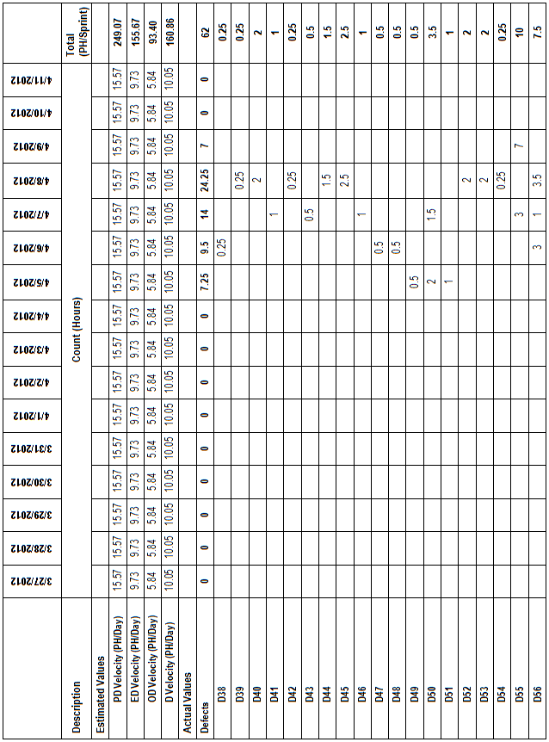

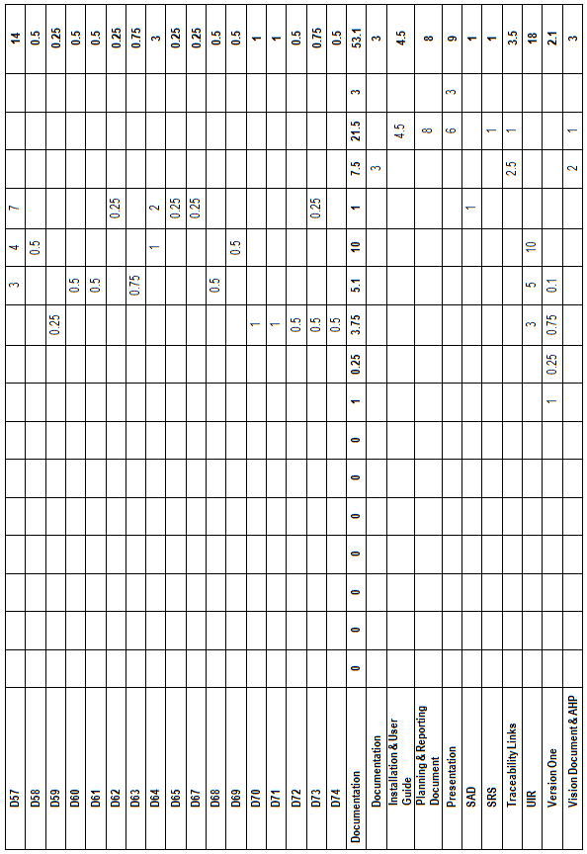

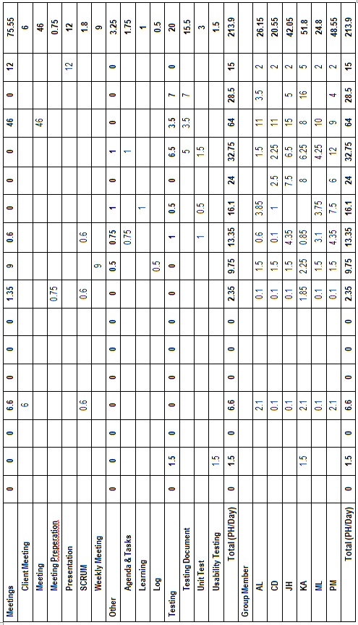

## Cumulative Velocities vs. Time

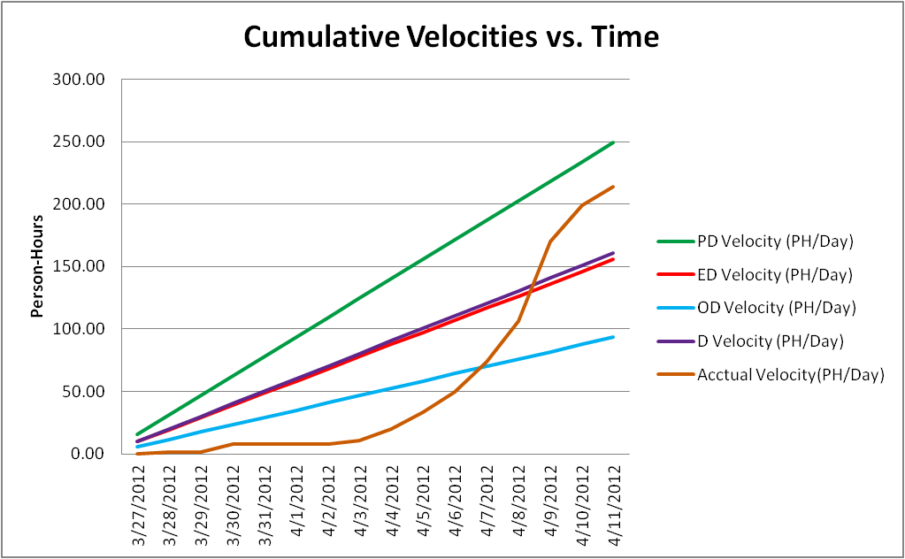

## Cumulative Activity Velocity vs. Time

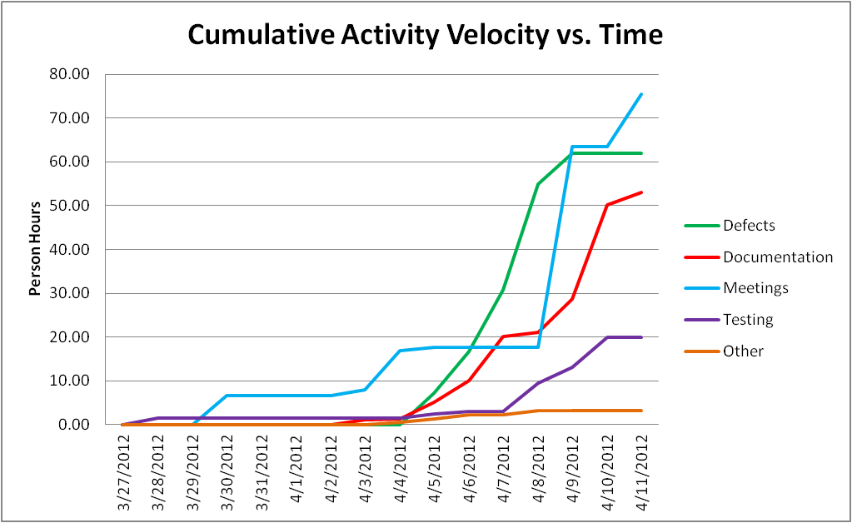

## Cumulative Group Member Velocity vs. Time

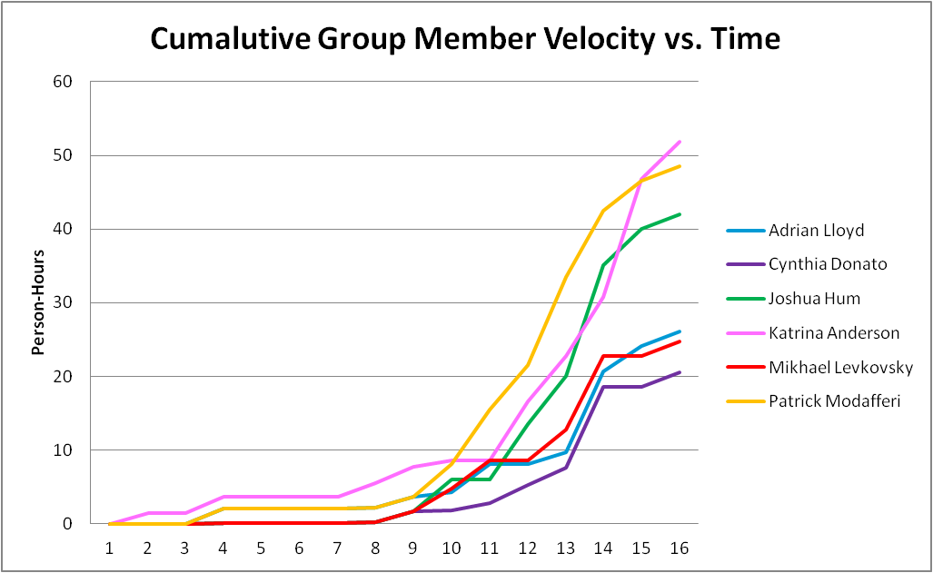

## Story Point Iteration Burndown Chart

We did not implement any new functionality in iteration 6; Therefor we planned no user stories and cannot measure progress by burning down story points. All remaining user stories in the backlog, were scoped out by the client.

## Line Counter Statistics for Iteration 6

Line Counter Program:

|  |  |
| --- | --- |
| **Program Name** | LOC Counter, copyright (c) 2011, Gary Gocek |
| **Developer** | Gary Gocek |
| **License / Price** | BSD License / $0 |
| **Size / OS** | 659 KB / Windows 2K / XP / Vista / 7 |
| **Last Updated** | August 27th, 2011, 16:59 UTC |
| **Program Source** | <http://www.softpedia.com/get/Office-tools/Other-Office-Tools/LOC-Counter-GUI.shtml> |

Statistical Results:

|  |  |  |  |  |  |  |
| --- | --- | --- | --- | --- | --- | --- |
| **Iteration** | **1** | **2** | **3** | **4** | **5** | **6** |
| **Total Number of Files** | 2,144 | 2,230 | 2,311 | 2,169 | 2,271 | 2,449 |
| **Total Number of Comment Lines** | 67,729 | 69,651 | 70,941 | 68,041 | 69,203 | 99,030 |
| **Total Number of Blank Lines** | 24,508 | 25,710 | 26,571 | 25,292 | 25,832 | 36,299 |
| **Total Number of Source Code Lines** | 616,029 | 623,205 | 627,622 | 620,701 | 628,278 | 99,030 |
| **Total Number of Lines** | 708,266 | 718,566 | 725,134 | 714,034 | 723,313 | 811,197 |
| **File Types** | HTML, XML, Jscript Script, SQL, Windows Batch File, PHP | | | | | |

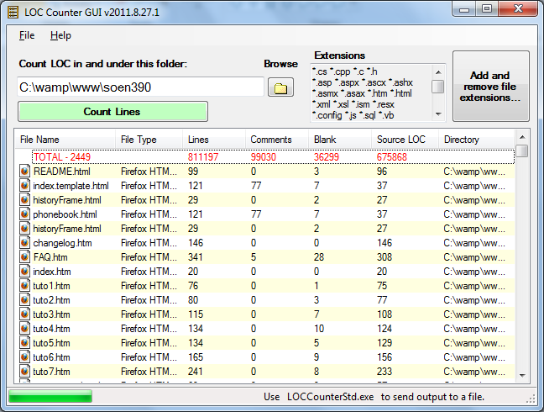

Figure .1 LOC Counter Iteration 6

## PHP Depend Code Quality Analysis

To assess the quality of the F.S.T.S. code, the source files were analyzed with PHP Depend. Given a source base, PHP Depend will perform a static analysis and provide a variety of metric values over five different levels of code: Project, Package, File, Class and Method. For our code quality analysis we will focus on the project as a whole and analyze the code’s level of inheritance, coupling, size and complexity [10]. To facilitate project analysis PHP Depend creates Pyramid charts, which highlight the most relevant matrices.

### PHP Depend Metric Values and Pyramid Tables

|  |  |  |  |
| --- | --- | --- | --- |
| **Metric** | **Description** | **Value**  **Project without Framework** | **Values**  **Project with Framework** |
| **ahh** | *Average Hierarchy Height* (The average of the maximum length from a root class to its deepest subclass subclass) | 1.923 | 0.589 |
| **andc** | *Average Number of Derived Classes (*The average of direct subclasses of a class) | 0.330 | 0.835 |
| **calls** | *Number of Method or Function Calls* | 2505 | 14745 |
| **ccn** | Cyclomatic Complexity Number | 1987 | 15332 |
| **ccn2** | Extended Cyclomatic Complexity Number | 2151 | 17161 |
| **cloc** | *Comment Lines of Code* | 4862 | 44418 |
| **clsa** | *Number of Abstract Classes* | 1 | 55 |
| **clsc** | *Number of Concrete Classes* | 104 | 708 |
| **eloc** | *Executable Lines of Code* | 12471 | 78991 |
| **fanout** | *Number of Fanouts Referenced Classes* | 346 | 1689 |
| **leafs** | *Number of Leaf Classes (finla) classes* | 90 | 646 |
| **lloc** | *Logical Lines Of Code* | 7421 | 42453 |
| **loc** | *Lines Of Code* | 19273 | 133938 |
| **maxDIT** | *Max Depth of Inheritance Tree Maximum depth of inheritance* | 3 | 5 |
| **ncloc** | *Non Comment Lines Of Code* | 14411 | 89520 |
| **noc** | *Number Of Classes* | 105 | 763 |
| **nof** | *Number Of Functions* | 14 | 21 |
| **noi** | *Number Of Interfaces* | 1 | 29 |
| **nom** | *Number Of Methods* | 832 | 5363 |
| **nop** | *Number of Packages* | 3 | 44 |



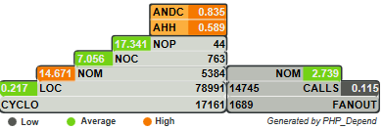

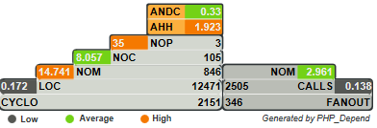

Figure 13.8.1 Pyramid Project With Framework

Figure 13.8.2 Pyramid Project without Framework

### Inheritance

**Project With Framework Inheritance Level: Average-High**

**Project Without Framework Inheritance Level: Average**

Considering that the F.S.T.S. is built on top of the Yii Framework, it is no surprise that the Average Number of Derived Classes (ANDC) and the Average Hierarchy Height (AHH) metrics are considered high. Depending on the implementation of the code, high inheritance can be considered a good or a bad thing. In our case we know that it is a good thing, as it’s an indication of separation of concerns and reusability [10]. When analyzing the project without the framework the inheritance falls to an average level. This is to be expected as many of the interfaces our project inherits from are not included. The Yii Framework appeals to PHP developers, because it can be applied to many types of systems [3].

### Coupling

**Project With Framework Coupling Level: Low-Average**

**Project Without Framework Coupling Level: Low-Average**

Project coupling is measured with two values: CALLS, which measures the number of distinct method and function calls and FANOUT, which “provides information on types referenced by classes and interfaces. “It only counts those types that are not part of the same Inheritance branch” [10]. The metrics of FANOUT/CALLS and CALLS/NOM are low and average respectively. Low-average coupling means that the F.S.T.S. is less likely to suffer from ripple effects generated during development and maintenance, thus minimizing the costs in coding effort and time. Low-average coupling also facilitates testing methods, such as unit testing, and increases the chances for reusability.

### Size & Complexity

**Project With Framework Size & Complexity Level: Average**

**Project Without Framework Size & Complexity Level: Average**

Size and complexity are evaluated from four metric ratios ( CYCLO/LOC, LOC/NOM, NOM/NOC, NOC/NOP), which are established by the following five values:

NOP –The **Number of Packages** metric counts the packages within the analyzed software system.

NOC–The **Number of Classes** metric counts the declared classes within the analyzed software system.

NOM- The **Number of Methods** metric counts all declared methods, which in this context means class methods and simple functions.

LOC- The **Lines Of Code** metric shows the number of executable source lines within the analyzed software system. To calculate this value PHPDepend counts all non whitespace lines and all non comment lines. PHP Depend, unlike the LOC Counter, only includes PHP files in its analysis, thus accounting for the discrepancy in values.

CYCLO–The **Cyclomatic Complexity** numbers a software metric (measurement). It was already developed in 1976 by Thomas J. McCabe and is used to *calculate the complexity of a program. It directly measures the number of linearly independent paths through a program's source code [10].*

At the framework level the LOC/NOM ratio value is considered high, while the CYCLO/LOC, NOM/NOC and NOC/NOP are evaluated to be average. This indicates that the F.S.T.S. code is of average-large size with average complexity. At the project level the value of the NOC/NOP is high, this is an anomaly from not including the framework. The complexity level of the F.S.T.S. is at a maintainable level, but should not increase in order to keep costs in coding effort and time down. In addition, systems with low complexity have a higher probability of containing reusable components.

## Measurement Report

### Size

The following values were found using PHP Depend.

|  |  |  |  |  |  |  |  |  |  |  |
| --- | --- | --- | --- | --- | --- | --- | --- | --- | --- | --- |
| **Metric** | **Description** | **Iteration 2 Values** | **Iteration 3 Values** | | **Iteration 4 Values** | | **Iteration 5 Values** | | **Iteration 6 Values** | |
| **Project with Framework** | **Project without Framework** | **Project with Framework** | **Project without Framework** | **Project with Framework** | **Project without Framework** | **Project with Framework** | **Project without Framework** | **Project with Framework** |
| **cloc** | *Comment Lines of Code* | 42073 | 3210 | 43104 | 4117 | 43887 | 4728 | 44433 | 4862 | 44418 |
| **clsa** | *Number of Abstract Classes* | 54 | 1 | 55 | 1 | 55 | 1 | 55 | 1 | 55 |
| **clsc** | *Number of Concrete Classes* | 651 | 77 | 681 | 92 | 695 | 102 | 706 | 104 | 708 |
| **eloc** | *Executable Lines of Code* | 72028 | 6033 | 74214 | 8321 | 75855 | 12033 | 79009 | 12471 | 78991 |
| **lloc** | *Logical Lines Of Code* | 38255 | 3112 | 39383 | 4501 | 40219 | 7129 | 42480 | 7421 | 42453 |
| **loc** | *Lines Of Code* | 123671 | 10446 | 127359 | 14079 | 130055 | 18682 | 133973 | 19273 | 133938 |
| **ncloc** | *Non Comment Lines Of Code* | 81598 | 7236 | 84255 | 9962 | 86168 | 13954 | 89540 | 14411 | 89520 |
| **noc** | *Number Of Classes* | 705 | 78 | 736 | 93 | 750 | 103 | 761 | 105 | 763 |
| **nof** | *Number Of Functions* | 7 | 0 | 7 | 3 | 10 | 17 | 24 | 14 | 21 |
| **noi** | *Number Of Interfaces* | 28 | 1 | 29 | 1 | 29 | 1 | 29 | 1 | 29 |
| **nom** | *Number Of Methods* | 4856 | 525 | 5056 | 677 | 5193 | 815 | 5346 | 832 | 5363 |
| **nop** | *Number of Packages* | 42 | 3 | 44 | 3 | 44 | 3 | 44 | 3 | 44 |

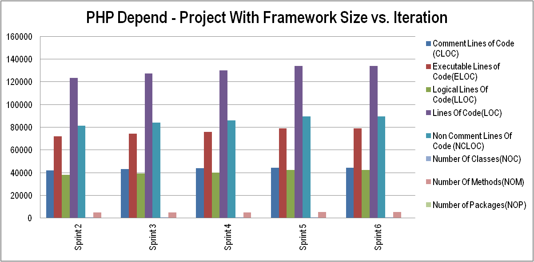

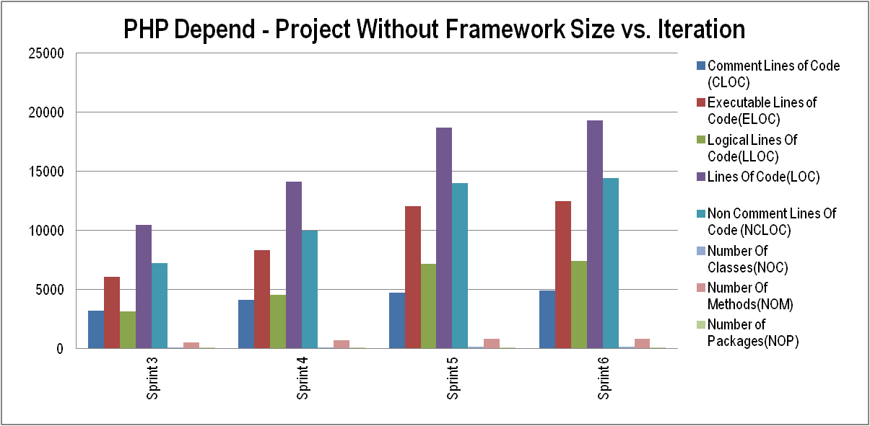

### Complexity

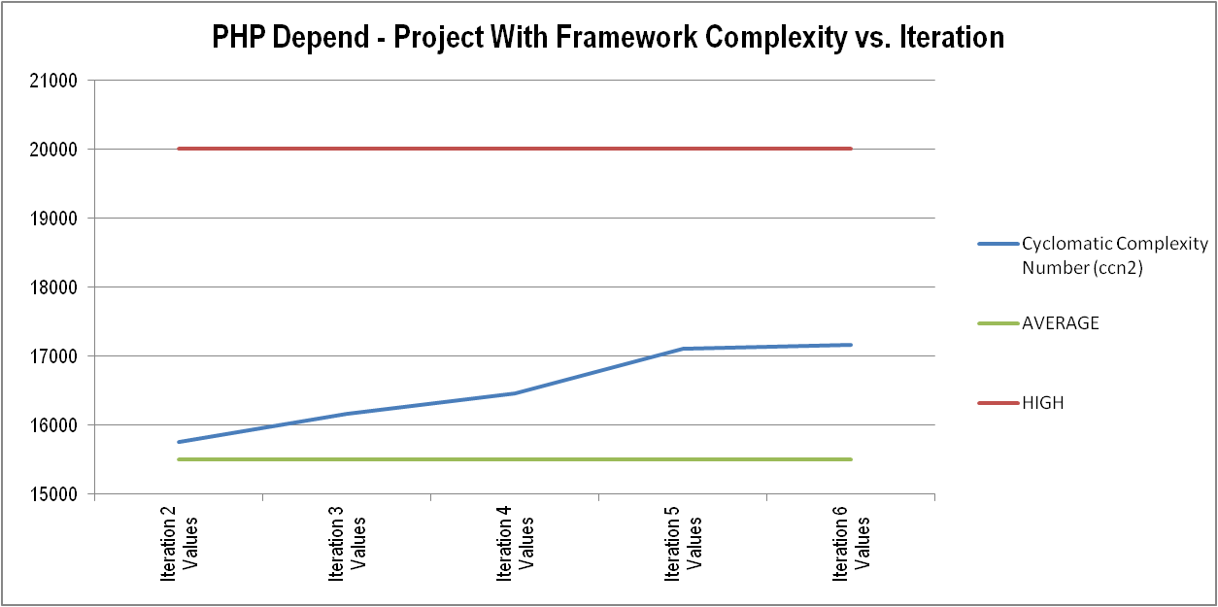

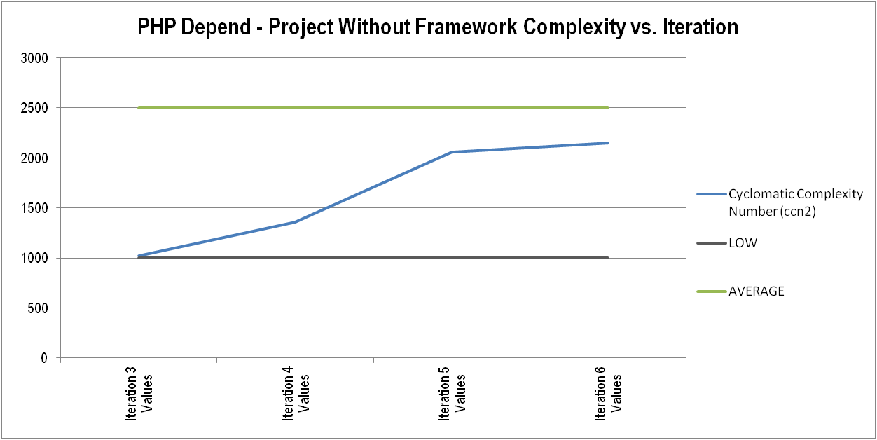

### Cost/Effort

Values were derived from the person hour logs from each iteration.

|  |  |  |  |  |  |  |  |  |
| --- | --- | --- | --- | --- | --- | --- | --- | --- |
|  | **Sprint 1 (ph)** | **Sprint 2 (ph)** | **Sprint 3 (ph)** | **Sprint 4 (ph)** | **Sprint 5 (ph)** | **Sprint 6 (ph)** | **Total Overall** | **Percentage** |
| **Documentation** | 63.25 | 50.20 | 24.75 | 54.75 | 99.95 | 53.10 | **346.00** | **28.01%** |
| **Meetings** | 20.50 | 29.20 | 20.80 | 17.60 | 17.70 | 75.55 | **181.35** | **14.68%** |
| **Coding (new features)** | 51.50 | 71.00 | 44.20 | 82.50 | 50.50 | 0.00 | **299.70** | **24.26%** |
| **Testing** | 22.00 | 45.50 | 28.25 | 35.50 | 28.00 | 20.00 | **179.25** | **14.51%** |
| **Other** | 36.50 | 19.50 | 16.50 | 3.00 | 3.00 | 3.25 | **81.75** | **6.62%** |
| **Defects** | 0.00 | 0.00 | 29.25 | 14.00 | 41.90 | 62.00 | **147.15** | **11.91%** |
| **Total** | 193.75 | 215.40 | 163.75 | 207.35 | 241.05 | 213.90 | **1235.20** |  |

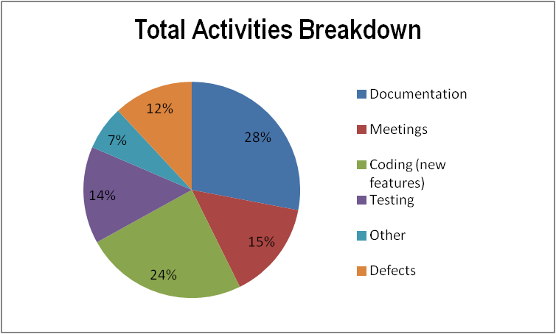The pie chart on the left represents the breakdown of total person hours dedicated to six activity groups over the whole project: Documentation, meetings, coding, testing, defects and other….The graph below shows the breakdown of the same six activity groups over the project iterations.

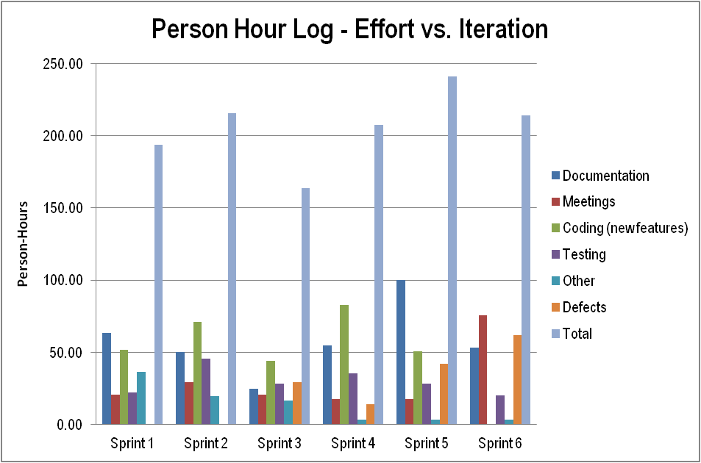

**Average Velocity: 199.08ph/sprint**

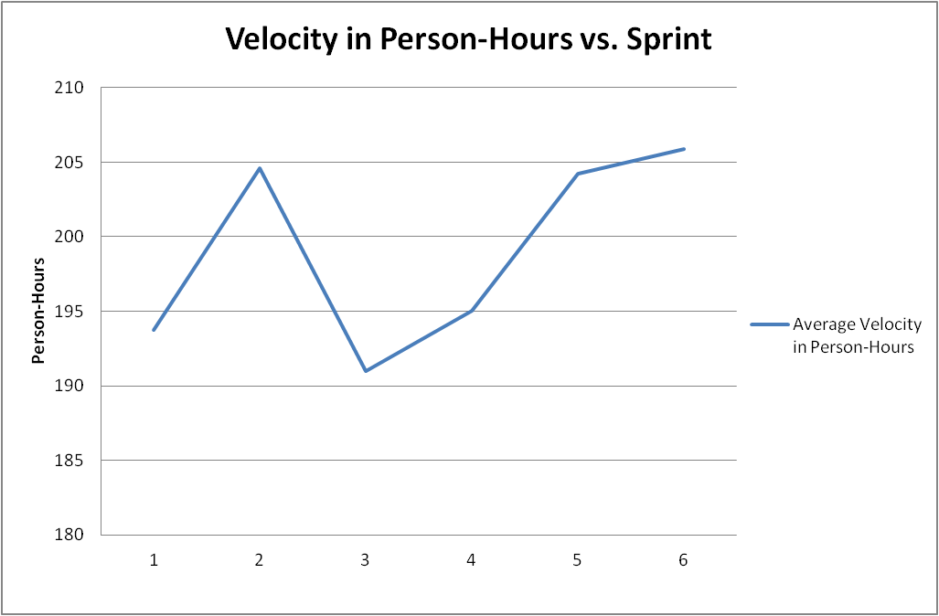

**Average Velocity: 23.33 story-points/sprint** (5 sprints)

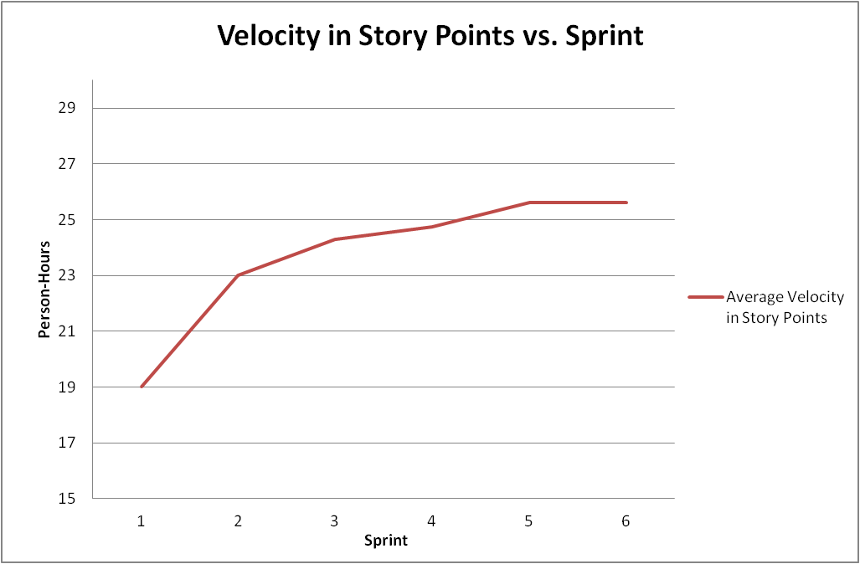

### Defects Found In Testing

Data was derived from the test report documents and person-hour logs. A total of 40 defects were discovered in testing up until and including iteration 6.

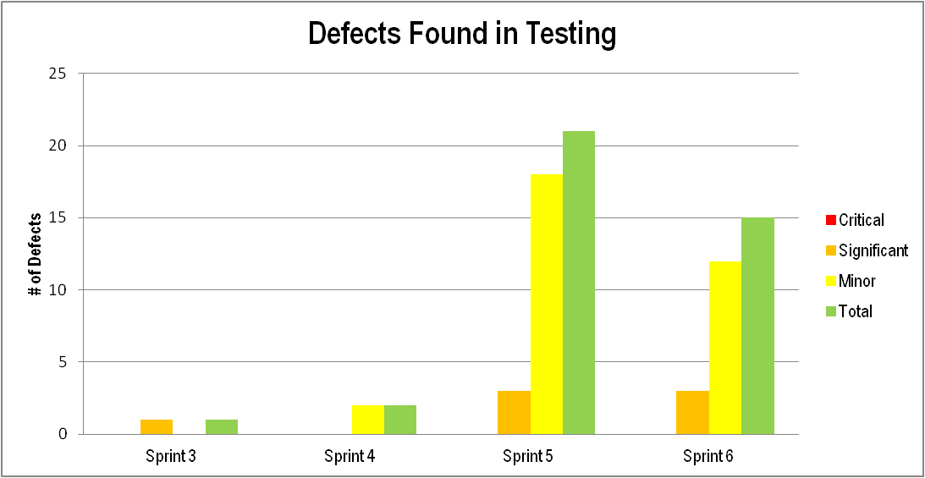

### Defects Found By the Client

Data was derived from the test report documents and person-hour logs. A total of 34 defects were discovered by clients up until and including iteration 6.

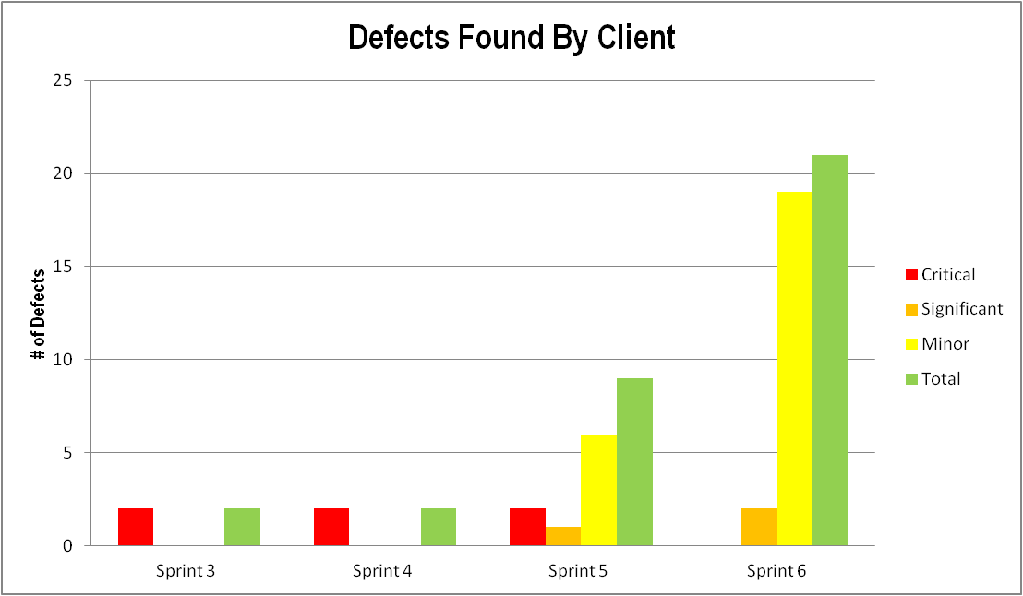

### Test Development Progress

Number of Unit Tests: 45

Unit Test Coverage: **64.17%** statement coverage

Number of Acceptance Tests: 93

Acceptance Test Coverage: 8 Feature Groups

Number of System Tests: 6

System Test Coverage: 8 Feature Groups

Number of UI Tests: 13

UI Test Coverage: 8 Feature Groups

Number of Volume Tests: 3

Volume Test Coverage: Up to 100,000 client files

Number of Usability Tests: 1

Usability Test Coverage: 8 Feature Groups

Unit, System, UI and Volume tests are regressive.

### Difficulty

**Stability of Requirements: Low**

Changes to requirements are made quite frequently by the stakeholder, including changes to the core architecture and UI.

**Level of Experience of Testing Staff: Low**

Few members of the testing staff have tested software outside of academia. Technologies such as PHP Unit, PHPDepend and Selenium are new to all members of the team.

**Level of Familiarity With Technology Being Used: Medium**

Many members of the team have a high level of experience with PHP and HTML; However no one on the team has used the Yii Framework.

**Ease of access to facilities used in testing: Low**

Clients have not allowed access to their facilities for testing, nor have they provided the source code for their current system.

**Difficulty of software production and testing: Medium-High**

Given the above criteria and general feeling of this project, we believe that the difficulty of producing this project has been medium-high. Many criteria could have been improved to decrease difficulty.

### Defect Detection Effectiveness Percentage (DDE)

DDE = (TDFT / (TDFC + TDFT)) x 100

TDFT = Total Defects Found by Testing (by testing team)

TDFC = Total Defects Found by Client

%

### Defect Removal Effectiveness Percentage (DRE)

DRE = (TDCT / TDFT) x 100

TDCT = Total Defects Closed During Testing

TDFT = Total Defects Found During Testing

### 11.9.10 Test Case Design Efficiency Percentage (TDE)

TDE = (TDFT / NTC) x 100

TDFT = Total Defects Found During Testing

NTC = Number of Test Cases Run (Unit, System, Volume Tests)

%

### 11.9.11 CSS Validation

The W3C CSS Validation Service was used to verify the validity of the CSS file that is included on all pages of the FSTS software. No errors were found. The following is a screenshot of the results.

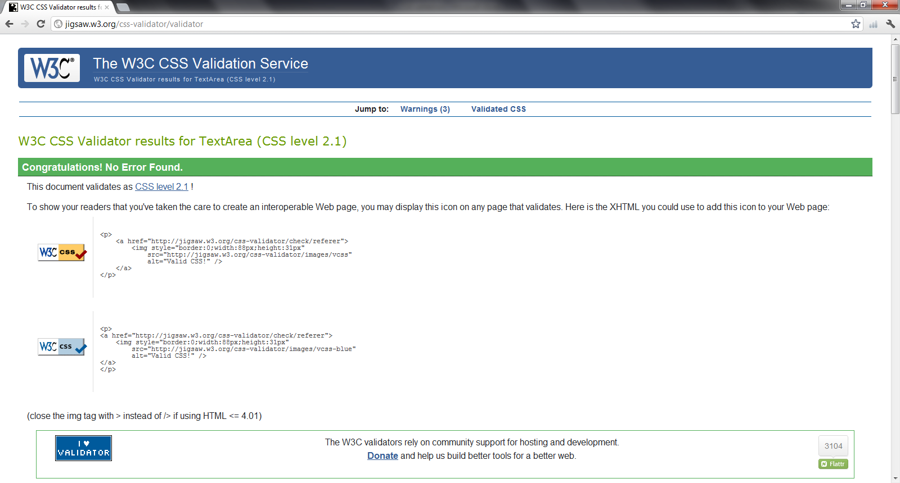

## Retrospective

For iteration 6 we estimated the following amount of effort. Overall we were much higher than our expected estimate. This is due to the amount of meetings we had this iteration. Our meetings this iteration took over 3 times as long as we expected.

|  |  |  |  |  |  |
| --- | --- | --- | --- | --- | --- |
| **Activity** | **Person-Hour Estimation** | | | | |
| **Worst Case** | **Most Likely Case** | **Best Case** | **Expected Case** | **Actual Case** |
| Defects | 45.41 | 28.38 | 17.03 | 29.33 | 62.00 |
| Documentation | 93.73 | 58.58 | 35.15 | 60.53 | 53.10 |
| Meetings | 33.86 | 21.16 | 12.70 | 21.87 | 75.55 |
| Testing | 50.96 | 31.85 | 19.11 | 32.91 | 20.00 |
| Other | 25.12 | 15.7 | 9.42 | 16.22 | 3.25 |
| **Total (ph)** | **249.07** | **155.67** | **93.40** | **160.86** | **213.90** |
| **Velocity (ph/day)** | **15.57** | **9.73** | **5.84** | **10.05** | **13.37** |

In iteration 6 we completed the following defects:

|  |
| --- |
| **Title** |
| D38 Client File Income field duration in weeks must be of type double. |
| D39 Fix the built in search functionality in IE. |
| D40 Filter events by event type |
| D41 Automatically sort event list by date |
| D42 Error Msg deleting events from management |
| D43 Check-In must be sorted in alphabetical order |
| D44 Fit Event information on check in list into 2 lines |
| D45 Search should have paging system |
| D46 Search must have a limit on search results (stack-overflow) |
| D47 Client File conflict on postal codes that are left blank/ blank postal codes should be ignored |
| D48 Client File conflict on Medicare card numbers that are left blank/ blank Medicare cards should be ignored. |
| D49 Client Name should appear in appointment window |
| D50 Auto capitalize first letter in all fields |
| D51 Display postal code and phone number with spaces. |
| D52 Modify event template view |
| D53 Modify Event view |
| D54 Change "X" to close window button in make appointment window. |
| D56 Change formatting of report. Please see scan. |
| D57 Change report file type to an excel capable file. |
| D58 Amount Field in Event produces error if left blank. Remove 0. |
| D59 Client File Add Flag button should be with notes. |
| D60 Populate postal code table with the list given by client. |
| D61 Populate countries table with world countries |
| D62 AJAX error when deleting income. |
| D63 Populate languages table with world languages |
| D64 Opening calendar widget requires mouse. |
| D65 Event creation form button should say "next define appointment timeslots" instead of "Create" |
| D67 Client age should not be auto set to 12. |
| D68 Conflict on addresses that are left blank/blank fields should be ignored. |
| D69 Income and Phone Number have "0" in the field and crash if the field is left blank |
| D70 Date Validation in Income Section. |
| D71 Time Validation in Event Templates. |
| D72 Date and Time Validation in Event Occurrence |
| D73 All links should be converted to buttons |
| D74 Date Validation for Reports Generation |

For more information on defects please see the Testing Document.

The following table shows the metric and ratio values of the code after completing Iteration 6. The goals were met in all categories except for in the category LOC/NOM. See section 11.8.1 for detailed analysis.

|  |  |
| --- | --- |
| **Metric** | **Level** |
| CYCLO/LOC | Average |
| LOC/NOM | High |
| NOM/NOC | Average |
| NOC/NOP | Average |
| CALLS/NOM | Average |
| FANOUT/CALLS | Low |
| ANDC | High |
| AHH | High |

Our goal for this iteration was to improve code quality through testing and resolving defects. We implemented two new types of testing, usability and volume, which resulted in the identification of many defects. Overall we improved code quality greatly during this iteration and consider it to be successful.

# Project Retrospective

## What We Would Do the Same:

**1) Meetings** – We had weekly meetings on Wednesdays and SCRUM meetings on the other weekdays that kept us communicating and on track.

**2) Agenda’s and Google Calendar** – Every sprint the group leader would create an agenda or check list of tasks that team members were to complete. Also important dates and deadlines were kept in a communal Google calendar. These two methods of scheduling proved valuable for staying on track.

**3) Framework** – Using a framework saved time and effort and enforced our architecture. Given the complexity of this project and future plans of the Welcome Hall Mission, we also believe the Yii framework, and its extensive online community, will be beneficial to the stakeholders.

**4) Paired Coding/Coding Days** – Often we coded in groups of 2 or in giant coding sessions. This increased our productivity and improved code quality.

**5) Equal Division of Tasks** – Every member of the team participated in coding new feature, testing, repairing defects and documenting. Team members were more aware of the overall picture and were able to increase their skills in multiple areas.

**6) Coding Environment** – Every member of the team set up their coding environment in the same way. This reduced errors between computers and enhanced coding communication.

## What We Would Do Differently:

**1) Client Meetings** – We only started meeting the client on a one-on-one basis regularly in sprint 4. Meeting on a regular basis from the beginning of the project would have reduced errors in requirements gathering and would have prevented errors we made early on.

**2) Document Environment** – We often had formatting issues in our documentation, because we neglected to synchronize our document environments. It would have been beneficial if we had synchronized our documenting tools, like we had synchronized our coding environments.

**3) Team Size** – We are one of the smallest teams, if not the smallest. We found the workload for this class to be heavy and would have benefited from having an extra one or two group members.

**4) Coding Language** – While we believe that our choice in coding language and framework are ideal for our clients, we do not believe that it was the best choice for ourselves. PHP is not compatible with many of the testing software we were required to use and searching for and learning new software tools was time consuming and frustrating.

**5) Version One** – In future we would not use the Version One tool. Overall, it hindered our productivity and created work duplication.

## Project Goals and Conclusion:

In the *Vision Document* we stated that “The objective for this project will be to replace the current system with modern technologies, allowing for additional features, fields and expansions, while updating the old functionalities to make them more relevant.” Judging from client feedback, 100% in sprint 5, we have accomplished our goal. Of course this project is academic, so our secondary objective was to learn. Here are some of the things we learned this semester:

- Project Management

- Effective Communication

- Yii Framework

- PHP

- Testing methodologies and related software (Selenium, PHPUnit, XDebug, ect…)

- Project documentation (Vision, SRS, UIR, SAD, ect…)

- Presentation Skills

- Agile Methodology

- ….

Overall, our two main goals of pleasing the stakeholders by providing a viable software solution and of learning were accomplished, thus we believe this project to have been successful.

# ****Appendix A References****

[1] W3C. (2012, January 15). *HTML & CSS Standards*[Online]. Available:[http://www.w3.org/standards/webdesign/htmlcss#specifications](http://www.w3.org/standards/webdesign/htmlcss" \l "specifications)

**[2] The jQuery Project. (2012, January 15). jQuery [Online]. Available:**<http://jquery.com/>

[3] Yii Software LLC. (2012, January 15) *Yii PHP Framework* [Online]. Available: [*http://www.yiiframework.com/*](http://www.yiiframework.com/)

[4] The PHP Group. (2012, January 15) *PHP* [Online]. Available: <http://www.php.net/>

[5] C. Larman. *Applying UML and Patterns*, 3rd edition. Prentice Hall. 2005.

[6] Oracle Corporation. (2012, January 12) *Netbeans IDE 7.1* [Online] Available: http://netbeans.org/index.html.

[7] Yii Software LLC. (2012, January 12) *Yii Framework; Unit Testing.* [Online] Available: http://www.yiiframework.com/doc/guide/1.1/en/test.unit

**[8] D. Rethans.** (2012, January 12) **XDebug Extension For PHP [Online]** Available: http://xdebug.org/

**[9] IEEE.** (2012, January 12) *Test Plan Outline (IEEE 829 Format*) [Online] Available: http://www.gerrardconsulting.com/tkb/guidelines/ieee829/main.html#9

[10] M. Pichler. (2012,January 12) *PHP Depend; Documentation* [Online] Available : http://pdepend.org/documentation/getting-started.html

[11] O. Ormandjieva. (2012, February 24) *Lecture14;Integration Testing* [Online]: Available: http://users.encs.concordia.ca/~s345_4/

**[12] Selenium Project. (2012, February 23). Selenium Documentation [Online] Available :** http://seleniumhq.org/docs/

[13] CSS-Tricks. (2012, March 23). *A web design community* [Online]. Available: http://css-tricks.com/label-placement-on-forms/