|  |
| --- |
| **Concordia University**  **Department of Computer Science**  **and Software Engineering** |

|  |
| --- |
| **F.S.T.S.**  ***Family Services Tracking System*** |

|  |
| --- |
| **UIR** |

|  |
| --- |
| **SOEN 390**  **Software Development Project**  **Winter 2012** |

**JAM PACK**

Katrina Anderson

Cynthia Donato

Joshua Hum

Mikhael Levkovsky

Adrian Lloyd

Patrick Modafferi

**Table of Contents**

1. User Centered Design 5

1.1 User Characteristics 5

1.1.1 Persona 1 - Administrator 5

1.1.2 Persona 2 – Data Entry Clerk 6

1.2 Set of Tasks Performed 6

1.2.1 Search for Client/Household Member 6

1.2.2 Manage Client Files 7

1.2.3 Manage Events 8

1.2.4 Managing Appointments 9

1.2.5 Check-In Clients for an Event 10

1.2.6 Reports 10

1.3 Context of Use 11

1.3.1 Context 1 – Client meeting (Registration) 11

1.3.2 Context 2 – Event client (Check-In) 12

1.3.3 Context 3 – Phone Multitasking 12

1.3.4 Context 4 – Solitary 12

1.4 Stakeholder Objectives 13

2. UI evaluation 13

2.1 Overall site architecture 13

2.1.1 Home Page 13

2.1.2 Repeated UI Items 13

2.1.3 Colours 14

2.1.4 Similar Features 15

2.2 Navigation 15

2.2.1 Option Visibility 15

2.2.2 Ease of navigation 16

2.3 Feedback 16

2.3.1 Search Feedback 16

2.3.2 Success and Failure Messages 17

2.3.3 Pop-ups 18

2.4 Screen layout 18

2.4.1 Frames 18

2.4.2 Tables 19

2.4.3 Buttons or Icons 20

Appendix A References 21

**Table of Figures**

Figure 1.2.1 Search for a Client File Hierarchical Task Model 7

Figure 1.2.2 Create/Update Client File Hierarchical Task Model 8

Figure 1.2.3 Create Event Hierarchical Task Model 9

Figure 1.2.4 Create Appointment Hierarchical Task Model 10

Figure 1.2.5 Create Report Hierarchical Task Model 11

Figure 2.2.1 Top Menu Bar 15

Figure 2.2.2 Search 15

Figure 2.2.3 Field Label Placement and Highlighting 16

Figure 2.3.1 Search Feedback Without Matches 16

Figure 2.2.4 Side Menu 16

Figure 2.3.2 Search FeedBack With Matches 17

Figure 2.3.3 Creation Success Message 17

Figure 2.3.4 Modification Success Message 17

Figure 2.3.5 Failure Message 17

Figure 2.3.6 Pop-up Message 18

Figure 2.4.1 Search Result Frames 18

Figure 2.4.2 Client File Frames 19

Figure 2.4.3 Manage Events Table 19

Figure 2.4.4 Client File Main Representative Buttons 20

Figure 2.4.5 Table Action and Paging Buttons 20

Figure 2.4.6 Admin Panel Icons 20

|  |
| --- |
| **F.S.T.S.** |

|  |
| --- |
| **UIR** |

|  |
| --- |
| **Version 6.7** |

**Revision History**

|  |  |  |  |
| --- | --- | --- | --- |
| **Date** | **Rev.** | **Description** | **Author(s)** |
| 2012-04-06 | 6.0 | Section 1.2 Set of Tasks Performed | Adrian Lloyd |
| 2012-04-06 | 6.1 | Section 1.3 Context of Use | Patrick Modafferi |
| 2012-04-06 | 6.2 | Section 2.1 Overall Site Architecture | Josh Hum |
| 2012-04-06 | 6.3 | Section 2.2 Navigation | Mikhael Levkovsky |
| 2012-04-06 | 6.4 | Section 2.3 Feedback | Cynthia Donato |
| 2012-04-07 | 6.5 | Section 1.4 Stakeholder Objectives & Section 2.4 Screen Layout | Katrina Anderson |
| 2012-04-07 | 6.6 | Section 1.1 User Characteristics | Josh Hum & Katrina Anderson |
| 2012-04-07 | 6.7 | Document Revision and Formatting | Katrina Anderson |

# User Centered Design

## User Characteristics

The. F.S.T.S has two basic user types, administrators and data entry clerks, the details of which are illustrated in the following personas. Personas don’t represent specific people, but are developed based on the characteristics of real users or groups of users. Every persona will have real person attributes like name, age, characteristics, goals, and background.

### Persona 1 - Administrator

Name:John

Background:

* 40 years old, Male
* Director of a charitable organization
* Wants to help people
* Friendly

Goals:

* Research member needs based on statistical reports
* Incite donations from the general public and various corporations
* Create, organize, and oversee events
* Ensure that food pick-up events are not overbooked in order to guarantee that enough food is available
* Provide an accurate list of families in need of Christmas baskets

Frustrations:

* Unclear navigation of software
* Complicated steps to perform a task

About John:

John is a director at a charitable organization. His goal is to help less fortunate people by providing them with food, shelter, and other aid. He currently oversees a food drive twice a week as well as a mattress distribution.

John is not very computer savvy. Although he uses a computer every day, he completes his computer tasks more out of routine than by understanding. The current system he uses involves a lot of shortcut keys and popups. However, this is what he is used to and knows it very well.

### Persona 2 – Data Entry Clerk

Name:Brittany

Background:

* 35 years old, Female
* Employee at a charity
* Wants to do social work

Goals:

* To ensure the proper creation of client files
* To ensure that all client file information is up-to-date and complete
* To book appointments for ongoing events
* Prepare food bundles for food pick-up events
* Prepare Christmas baskets using operational reports generated by the system

Frustrations:

* Too many mouse clicks, prefers to type and use keyboard shortcuts

About Brittany:

Brittany is a part-time employee at a charity. She enjoys her work and likes to know that she is helping people. Brittany knows how to use the basic functionalities of a computer; she can type quickly but still has some trouble navigating and using a mouse cuts down on her efficiency.

Brittany’s main job is to enter information about clients or schedule appointments for events. Thus, she is typing a lot. Quick access to all the forms is a must for Brittany.

## Set of Tasks Performed

The set of tasks performed are centered on the feature groups described in detail in the *Vision Document* and the use cases located in the *SAD.*

### Search for Client/Household Member

Use Case Reference: UC 1.7 and 1.8

Users are frequently searching for client files in order to modify the file, create appointments, view the eligibility of the client for an event and more…. In order to achieve the goal of locating a client’s file, the user will access the search feature (first thing they see when logged in or use the search link in the navigation bar). Typically, the user will ask the client (that has contacted them) for their client number or name and will search for that client number or name to find the file. The other criteria that can be used as search parameters include: postal code, phone number and medicare number. Once a search has been made, the user can go through the results and select the file they wish to view.



Figure 1.2.1 Search for a Client File Hierarchical Task Model

### Manage Client Files

Use Case Reference: UC 1.1, 1.2, 1.3, 1.4, 1.5, 1.9, 1.10, 1.11, and 1.12

Users will create and update a client files on a daily basis. Client files need to be created in order to let a client use the Welcome Hall Mission services. The user will also want to add, modify or remove elements from the client file, such as: notes about the client, pre-defined flags, appointments for events, income sources or household members. In order to create new clients, the user will typically access the “create client” link on the navigation bar. To locate files that need updating, users will use the search (explained in part 1above).

To create a client file, requires that the client come in to the Welcome Hall Mission; therefore, the user goes through filling the form in a Q&A fashion. For example the user would ask questions like: “What is your name?” and “What is your medicare number?” This type of Q&A is used for adding household members and income sources. Documentation such as proof of address is required. If a client is missing paperwork during their registration, a flag is set so that any other users accessing the file will know that the client has not brought in their proof of address yet. Updating a client file involves keeping client information relevant. For example, a client can call in order to add a household member or to provide a new phone number. In these cases the user would open the file and perform the updates as needed.



Figure 1.2.2 Create/Update Client File Hierarchical Task Model

### Manage Events

Use Case Reference: UC 2.1, 2.2, 2.3, 2.4, 2.5, 2.6, 2.8, 2.9, 2.10, 2.11, and 2.12

Users, in this case mostly the administrators of the system, will create, modify or remove events from the F.S.T.S. This is done in order to specify the days and times that the Welcome Hall Mission will provide services. The frequency for managing events can vary, because recurring events can be made for a day or over the span of a few weeks. Updating events involves: modifying attributes like dates or times, opening or closing an event or removing an event (which is rarely done, but is possible if no appointments have been assigned to the event).

To achieve the goal of managing events, first the proper event template must exist. If a template for an event does not exist, one can be created in the event templates section in the “Admin Panel”. This requires the administrator to fill in a form to create the event template. Event templates can be modified or removed from the application.

To create an event, the user must go to the “Create Event” link found in the navigation bar. From here the user fills out the event form. To modify or remove an event, the user must go to the “View Events” section that can be accessed from the navigation bar. This displays a list of events where the user can choose to view the event information, update the event information or delete the event.



Figure 1.2.3 Create Event Hierarchical Task Model

### Managing Appointments

Use Case Reference: UC 3.1, 3.2, 3.3 and 3.4

Users book appointments for clients when the clients call in wanting to attend an event. Users may also want to remove a client from an event if the client calls in to say they can no longer attend. If an event is full, the client may request to be added to the waiting list for an event. The user can also remove a client from an event’s waiting list if the client makes a request or if an appointment in an event opens up. Appointments are frequently made (daily basis) as it is one of the main features of the system.

To achieve the goal of managing appointments the user goes into a client’s file and access the “Appointment Section.” From here the user can select to add an appointment for a client to an event. A pop up appears in order for the user to select the event the client wishes to attend. Once an event is selected, the user can add the client to a timeslot. The user tells the client that the appointment has been make and which timeslot he or she is added to. In case the event timeslots are full, the user can add the client to the event’s waiting list (if the client wishes to be added).

To remove a client from an event or waiting list, the user selects the view appointments from the appointment section in the client’s file and a popup will be displayed showing all the client appointments and waiting list entries. The user selects the remove option from the appointments or waiting list, to remove the client from the event or waiting list respectively.



Figure 1.2.4 Create Appointment Hierarchical Task Model

### Check-In Clients for an Event

Use Case Reference: UC 4.1, 4.2, 4.3

Users will check-in clients that attend an event. To achieve this, the user that is checking in clients will open the event attendee list (which is accessible by viewing the information about the event from the view events section). From here the user can ask the client for their name and check them off on an alphabetical list. If a mistake is made, the user can uncheck the name he or she selected. This process is done at every event, typically bi-weekly.

### Reports

Use Case Reference: UC5.2 and 5.3

Users, in this case the administrator, will generate reports about the operations that occur at Welcome Hall Mission. To achieve this, the user must navigate to the “Admin Panel” and select “Statistical Reports.” From here, the user has the option to regenerate a report or make one of their own choosing. The user then selects the generate option and the report is displayed to the user. Reports are typically generated once every month.



Figure 1.2.5 Create Report Hierarchical Task Model

## Context of Use

The following contexts of use were derived from the goals defined in section 1.2, Set of Tasks Performed, of this document.

### Context 1 – Client meeting (Registration)

|  |  |
| --- | --- |
| **Environmental Constraint** | A typical office setting. The user is sitting at a desk with a desktop computer, keyboard and mouse. The client is seated facing them and cannot see the screen. |
| **Social Constraint** | Clients can be of many different nationalities and have difficulty speaking French or English. They are indirectly commanding through voice what is going to be input to the system. |
| **Location** | Seated at the registration desk area. With the environment described above. |
| **State of Mind** | Busy and focused on the task at hand |
| **Other System** | None |
| **Tasks Performed\*** | 2 |

### Context 2 – Event client (Check-In)

|  |  |
| --- | --- |
| **Environmental Constraint** | Seated or standing using an iPad (touch screen interface). Performing simple tasks. No access to mouse or keyboard. |
| **Social Constraint** | Clients can be of many different nationalities and have difficulty speaking French or English. User is concerned with being certain to identify and check-in the correct user. |
| **Location** | Standing away from the typical desk setup. Could be anywhere that goods are being distributed. |
| **State of Mind** | Pressed for time more than other contexts, they must serve clients as quickly as possible. |
| **Other System** | None |
| **Tasks Performed\*** | 5 |

### Context 3 – Phone Multitasking

|  |  |
| --- | --- |
| **Environmental Constraint** | the user uses only a single hand to type on the keyboard or use the mouse to click. |
| **Social Constraint** | The language barrier also occurs in this scenario. |
| **Location** | At the workstation where the software is available. |
| **State of Mind** | Slightly distracted as they must speak on the phone and use the software simultaneously. |
| **Other System** | None |
| **Tasks Performed\*** | 1 - 2 - 4 |

### Context 4 – Solitary

|  |  |
| --- | --- |
| **Environmental Constraint** | A typical office setting. The user is sitting at a desk with a desktop computer, keyboard and mouse. |
| **Social Constraint** | No interactions occur in this context so there are no social constraints. |
| **Location** | At the workstation where the software is available. |
| **State of Mind** | Fully concentration and alone at their desk to perform specific tasks. |
| **Other System** | None |
| **Tasks Performed\*** | 1 – 2 – 3 - 6 |

## Stakeholder Objectives

Please see the Vision Document as well as the SRS document for additional detatials on stakeholder objectives and constraints.

# UI evaluation

## Overall site architecture

The F.S.T.S. UI architecture was designed around the feature groups defined in the Vision Document, making the system functions evident to the users. This section of the document will describe the UI details that are maintained throughout the system to promote coherence and comprehensibility.

### Home Page

The home page displays a search bar to search for clients. It is clear that this is the main entry point to the system. The search page was picked to be the home page, because it will be the most used feature in the F.S.T.S. Like all the pages in the system, the search page includes the main top menu and footer.

### Repeated UI Items

Some UI items are included on all pages to give the software a common look and feel. One of these items is the main top menu. All pages have the same main top menu which gives users access to the main features of the application. These features are “Client Search”, “Create Client”, “Create Event”, “View Events” and “Help”. An “Admin Panel” option is available if the user is logged in as an administrator. These options provide the user with a user-goal level entry point into the system. They are displayed at the top of every page so the user can quickly see what the software offers them.

The other repeated UI item is the footer. Although it isn’t much more than a line across the bottom with a copyright, it lets the user know that they are at the bottom of the page. Having a footer on all pages helps bring continuity to the site.

Both the main menu and the footer can be found in the following file:

**/protected/views/layouts/main.php**

This file is included by Yii on all pages. If a CSS or Javascript file needs to be created and accessed by all pages, it should be included in “main.php”. The CSS files “screen.css”, “print.css”, “main.css”, and “form.css” are included in “main.php”. The Javascript files “shortcut.js” and “myapp.js” are also included.

### Colours

Although various pages have different displays (ex. Forms, tables, search bar, etc.), the colour scheme is common across all pages. Headings, links, menu items and text all keep the same colour scheme in order to make it easy for the user to quickly find what they are looking for and and recognize what they are looking at.

The main colours used on the site are:

|  |  |  |
| --- | --- | --- |
| **Colour Code** | **Colour Sample** | **Usage** |
| #FBE3E4 (Light Red) |  | Error Message Background |
| #8A1F11 (Red) |  | Error Message Text |
| #0175B0 (Blue) |  | Links  Highlights  Menus |
| #E5F1F4 (Light Blue) |  | Table Background |
| #A2FF73 (Light Green) |  | Highlight Check-In List  Highlight Table Entries  Success Messages Background |
| #264409 (Dark Green) |  | Success Message Text |
| #2B2B2B (Dark Grey) |  | Text |
| Black |  | Text |
| #F0F0F0 (Light Grey) |  | Table Background |
| White |  | Background |

### Similar Features

Each main page serves a particular function; However, within those pages, there may be a feature that serves a similar purpose to another feature on another page. For example, adding a country and adding an income via the “Admin Panel” are similar features. The UI was designed so that similar features would have a common look and feel. Thus, the “Create Country” menu option would be styled and located in the same way as the “Create Income Period” menu option. This helps bring consistency to the site.

In the “Admin Panel” section, each component has four views: “Create”, “View”, “Update”, and “Delete”. The “Create” option is accessible from the side menu and the other three options are available on rows of existing data. No matter which component you pick in the “Admin Panel” section, the presentation is the same.

One important feature of the UI design is that all similar elements are styled the same. All buttons have the same design. Links have the same colour and rollover effect. Headers are the same size and the same colour. Basically, similar features were designed to have the same look and feel. This design keeps different pages coherent with each other.

## Navigation

### Option Visibility

Once a user has been authenticated he/she is redirected to the main page of our site.

From the main page the user can navigate through two means: the search option or the top navigation bar.



Figure 2.2.1 Top Menu Bar

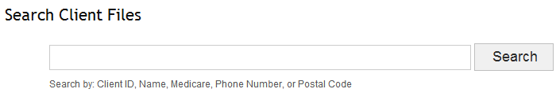

Figure 2.2.2 Search

Whenever users navigate to one of the 7 main pages, the selected page is always made evident to the users via visual feedback. The tab of the selected page becomes highlighted to make it apparent to the user what page they are currently on. For the pages that can be accessed via keyboard shortcuts, the shortcuts are all visibly outlined next to the name of the page that they link to.

Once on a page, all the input fields have labels as specified by the stakeholders. Research was done to achieve clarity and efficient input on all the forms, for instance field labels were placed on top, since studies have shown this placement enhances comprehension [13]. The names of the labels have been approved by the stakeholders to make sure that they are unambiguous and representative of the data they relate to.In order to make sure that users don’t get lost on the pages, all of the input fields are highlighted if they have focus.

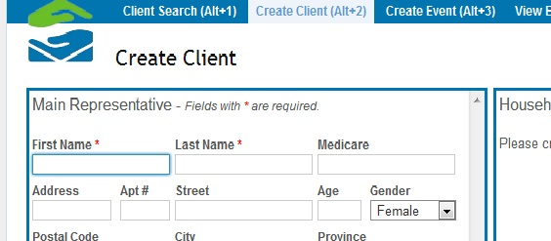

Figure 2.2.3 Field Label Placement and Highlighting

### Ease of navigation

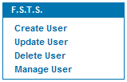Since F.S.T.S. is a web application, in order to navigate to a previous page the users can use the onboard previous page option. All modern browsers come with a previous and forward page option.The users can also navigate using the top and side menus of the F.S.T.S. In the “Admin Panel” there is an extra layer of navigation for system features, the side menu. The “Admin Panel” is going to be used by more advanced users and the side menu is necessary to manipulate each feature.

Figure 2.2.4 Side Menu

To verify the navigability and ease of use of the application, usability tests were conducted with people of different backgrounds and technical knowledge. The results, which can be found in the *Testing Document*, have been analyzed and documented to determine the navigability of the application. Overall, the F.S.T.S. has proven to be navigable by users of all levels.

## Feedback

The F.S.T.S. provides appropriate feedback when performing various actions throughout the system. Feedback can be seen when searching, creating, updating and deleting records in the system whether the action is successful or not.

### Search Feedback

An example of feedback received when a user tries to search for a client that does not exist in the system.



Figure 2.3.1 Search Feedback Without Matches

An example of feedback given when a search is successful:

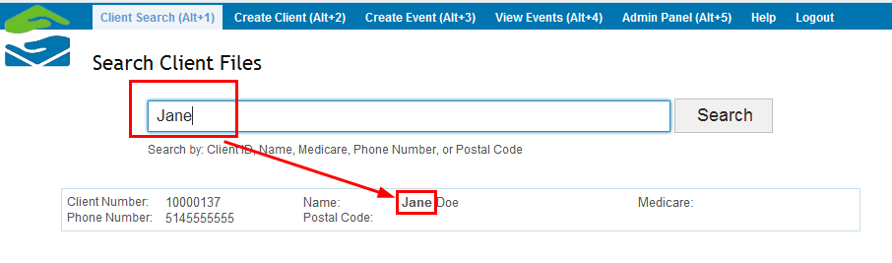

Figure 2.3.2 Search Feedback With Matches

### Success and Failure Messages

Success messages are displayed when an entry has been successfully created or updated. They appear at the top of a page below the top menu and have a green tint. Example of feedback given when a client file is successfully created and updated is given below:

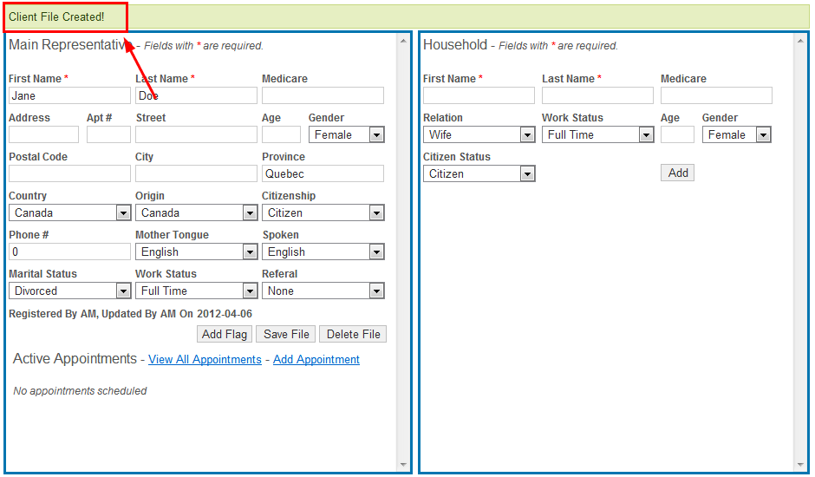

Figure 2.3.3 Creation Success Message

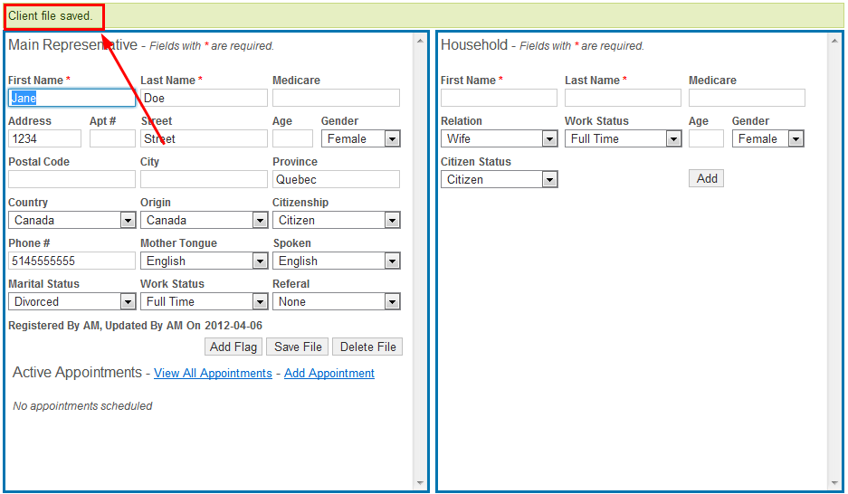

Figure 2.3.4 Modification Success Message

Failure messages are displayed, in the event that a user attempts to delete an entry that contains dependant items. The F.S.T.S. will inform the user that the particular item cannot be deleted with a red tinted failure message.

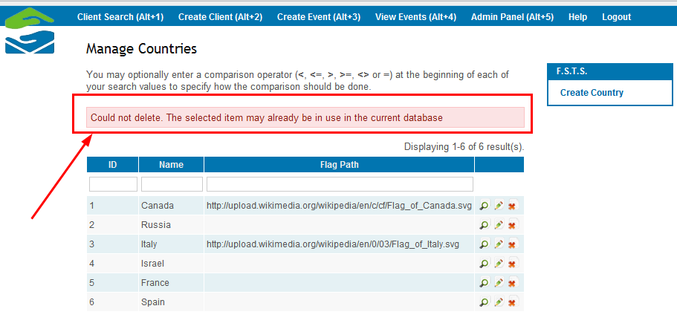

Figure 2.3.5 Failure Message

### Pop-ups

The F.S.T.S. system also provides users with the opportunity to recover from errors. The most predominant example of this would be when pressing the delete button accidentally. The F.S.T.S. asks users to confirm that they would really like to delete an entry through a pop up. This ensures that the user only performs the delete operation if it is truly their desired.

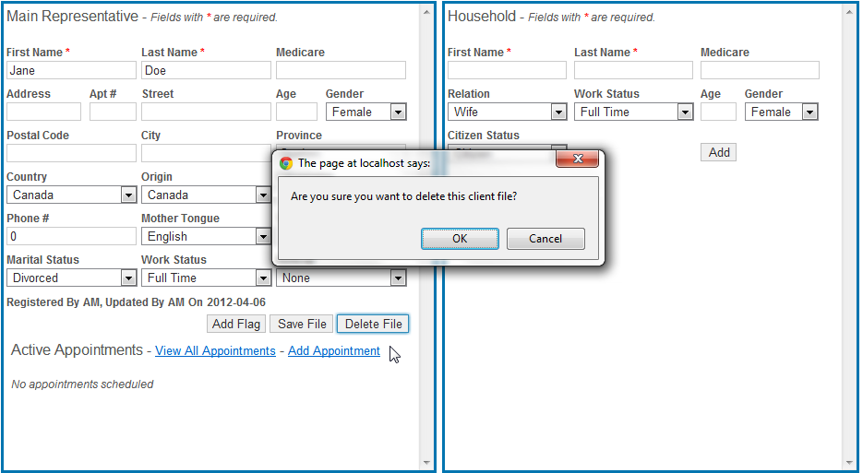

Figure 2.3.6 Pop-up Message

## Screen layout

The stakeholders have asked that the UI hold only essential details and that white space in the client file be kept to a minimum. As such the F.S.T.S has a minimalist feel, with very few visual add-ons. Apart from the top menu bar, which frames the top of every page, and the footer, which can be found at the bottom of every page, we use the following architectural details to contain information or add clarity.

### Frames

Frames are used in the client search, the client file and the side menu, in order to make different feature sets stand out, improving the visual comprehensibility of the system.

The search functionality uses frames to differentiate results. A blue frame differentiates a household and its main representative, while a green frame indicates other household members.

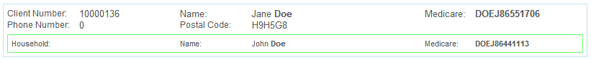

Figure 2.4.1 Search Result Frames

In the client file, frames are used to separate the main representative, household member, income source and note functionalities.

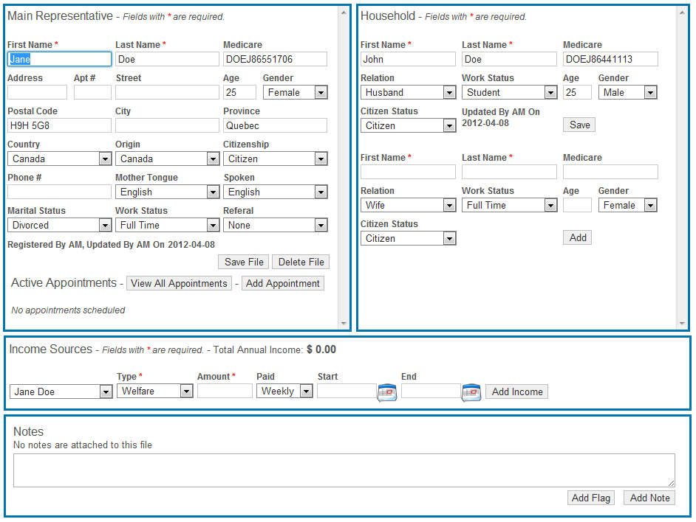

Figure 2.4.2 Client File Frames

The “Admin Panel” has a side menu to access advanced functionalities. The side menu is located on the right of the screen and has a blue frame to enhance its visibility. See Figure 2.2.4 Side Menu.

### Tables

Many portions of the F.S.T.S. involve managing entries, for instance when viewing all scheduled events, spoken languages, countries, ect…. In these instances tables are used to differentiate the attributes of each system and to offer sorting of entries. Below is the table for managing events, all other tables resemble its appearance.

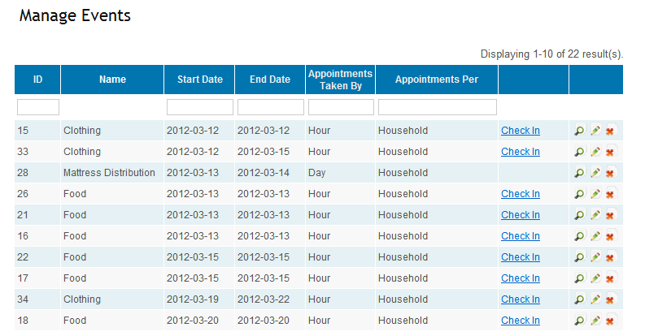

Figure 2.4.3 Manage Events Table

### Buttons or Icons

Most navigable options are available through the top menu, side menu or the internet browser. In all other cases either buttons or icons are used for navigating or performing actions (create delete and update).

Buttons are a simple grey with black text indicating the action they perform. There are a few exemptions, such as the



Figure 2.4.4 Client File Main Representative Buttons

For efficiency of use and space, tables contain icons for viewing, modifying and deleting entries. In addition, paging indicators are found at the bottom of tables when more than 10 entries are found.



Figure 2.4.5 Table Action and Paging Buttons

The “Admin Panel” contains many customizable features. In order to add recognition, icons were added to each feature.

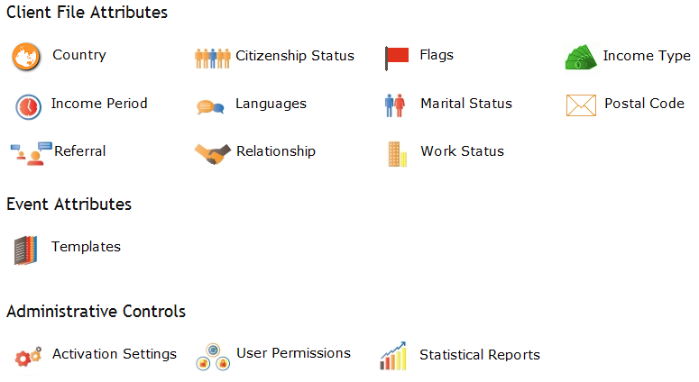

Figure 2.4.6 Admin Panel Icons

# ****Appendix A References****

[1] W3C. (2012, January 15). *HTML & CSS Standards*[Online]. Available:http://www.w3.org/standards/webdesign/htmlcss#specifications

**[2] The jQuery Project. (2012, January 15). jQuery [Online]. Available:** <http://jquery.com/>

[3] Yii Software LLC. (2012, January 15) *Yii PHP Framework* [Online]. Available: [*http://www.yiiframework.com/*](http://www.yiiframework.com/)

[4] The PHP Group. (2012, January 15) *PHP* [Online]. Available: <http://www.php.net/>

[5] C. Larman. *Applying UML and Patterns*, 3rd edition. Prentice Hall. 2005.

[6] Oracle Corporation. (2012, January 12) *Netbeans IDE 7.1* [Online] Available: http://netbeans.org/index.html.

[7] Yii Software LLC. (2012, January 12) *Yii Framework; Unit Testing.*[Online] Available: http://www.yiiframework.com/doc/guide/1.1/en/test.unit

**[8] D. Rethans.** (2012, January 12) **XDebug Extension For PHP [Online]** Available: http://xdebug.org/

**[9] IEEE.** (2012, January 12) *Test Plan Outline (IEEE 829 Format*) [Online] Available: http://www.gerrardconsulting.com/tkb/guidelines/ieee829/main.html#9

[10] M. Pichler. (2012,January 12) *PHP Depend; Documentation* [Online] Available : http://pdepend.org/documentation/getting-started.html

[11] O. Ormandjieva. (2012, February 24) *Lecture14;Integration Testing* [Online]: Available: http://users.encs.concordia.ca/~s345_4/

**[12] Selenium Project. (2012, February 23). Selenium Documentation [Online] Available :** http://seleniumhq.org/docs/

[13] CSS-Tricks. (2012, March 23). *A web design community* [Online]. Available: http://css-tricks.com/label-placement-on-forms/