|  |
| --- |
| **Concordia University**  **Department of Computer Science**  **and Software Engineering** |

|  |
| --- |
| **F.S.T.S.**  ***Family Services Tracking System*** |

|  |
| --- |
| **Vision, AHP & Supplementary Specification** |

|  |
| --- |
| **SOEN 390**  **Software Development Project**  **Winter 2012** |

**JAM PACK**

Katrina Anderson

Cynthia Donato

Joshua Hum

Mikhael Levkovsky

Adrian Lloyd

Patrick Modafferi

**Table of Contents**

**Vision Document 5**

1. Introduction 6

2. Positioning 6

2.1 Problem Statement 6

2.2 Product Position Statement 6

3. Stakeholder Descriptions 7

3.1 Stakeholder Summary 7

3.2 User Environment 8

4. Product Overview 9

4.1 Product Perspective 9

4.2 Assumptions and Dependencies 9

4.3 Needs and Features 10

4.4 Alternatives and Competition 11

5. Other Product Requirements 12

**AHP 13**

1. Value Prioritization 14

1.1 AHP Comparison Matrix 14

1.2 Normalized Matrix 15

2. Cost Prioritization 16

2.1 AHP Comparison Matrix 16

2.2 Normalized Matrix 17

3. Cost/Value Percentage Graph 18

**Supplementary Specification and Glossary 19**

1. Introduction 20

1.1 Purpose 20

1.2 Scope 20

1.3 Definitions, Acronyms and Abbreviations 20

1.4 References 20

1.5 Overview 20

2. Functionality 20

2.1 Administrative Controls 20

~~2.2~~ ~~Bilingual System~~ 20

2.3 Help Functionality 21

3. Usability 21

3.1 Required Training Time for a Normal User 21

3.2 Required Training Time for an Administrative User 21

4. Reliability 21

4.1 Availability 21

4.2 Mean Time Between Failures (MTBF) 21

4.3 Mean Time To Repair (MTTR) 21

4.4 Accuracy 21

4.5 Maximum Bug Rate 22

4.6 Categorization of Bug Rate 22

5. Performance 22

5.1 Response Time 22

5.2 Capacity 23

5.3 Degradation modes 23

5.4 Resource utilization 23

6. Supportability 23

6.1 Coding Standards 23

6.2 Naming Conventions 23

6.3 Maintenance Group Response Time 23

6.4 Updates 23

6.5 Authentication 24

7. Design Constraints 24

7.1 Agile Project Management 24

7.2 Database Adaptability 24

7.3 Modifiability 24

7.4 No Mouse 24

7.5 Web Application 24

7.6 MVC 24

8. Online User Documentation and Help System Requirements 24

9. Purchased Components 24

10. Interfaces 25

10.1 User Interfaces 25

10.2 Hardware Interfaces 25

10.3 Software Interfaces 25

10.4 Communications Interfaces 25

11. Licensing Requirements 25

12. Legal, Copyright and Other Notices 26

13. Applicable Standards 26

14. Glossary 26

**Appendix A References 28**

**Appendix B Interview (01/09/2012) 29**

Part I: Establishing the Customer Profile 29

Part II: Assessing the Problem 30

Part III: Understanding the User Environment 32

Part IV: Recap for Understanding 34

Part V: Assessing the Opportunity 35

Part VI: Assessing the Reliability, Performance, and Support Needs 35

Part VII: Other Requirements 36

Part VIII: Follow Up Questions 36

**Appendix C Iteration 1 Demo Feedback 38**

Gordon McPhee 38

Tania Togias 39

|  |
| --- |
| **F.S.T.S.** |

|  |
| --- |
| **Vision Document** |

# Vision Document

|  |
| --- |
| **Version 6.16** |

**Revision History**

|  |  |  |  |
| --- | --- | --- | --- |
| **Date** | **Rev.** | **Description** | **Author(s)** |
| 2012-01-12 | 0.0 | Contributed Appendix B Interview | Patrick Modafferi |
| 2012-01-14 | 0.1 | Contributed Section 1 Introduction | Patrick Modafferi |
| 2012-01-14 | 0.2 | Contributed Section 3 Stakeholder Descriptions | Cynthia Donato |
| 2012-01-14 | 0.3 | Contributed Section 5 Other Product Requirements | Mikhael Levkovsky |
| 2012-01-14 | 0.4 | Contributed Section 4 Product Overview | Katrina Anderson |
| 2012-01-15 | 0.5 | Contributed Section 2 Positioning. | Josh Hum |
| 2012-01-15 | 0.6 | Formatted and reviewed document | Katrina Anderson |
| 2012-01-27 | 1.7 | Updated Needs and Features Table to provide more detail. | Katrina Anderson |
| 2012-01-29 | 1.8 | Updated Vision DOC – Section 5 – Other Product Requirements | Mikhail Levkovsky |
| 2012-01-30 | 1.9 | Revised Document | Katrina Anderson |
| 2012-02-13 | 2.10 | Revised Document | Katrina Anderson |
| 2012-02-25 | 3.11 | Revised Document | Katrina Anderson |
| 2012-03-09 | 4.12 | Modified Section 4 Needs and Features | Katrina Anderson |
| 2012-03-09 | 4.13 | Revised Document | Katrina Anderson |
| 2012-03-20 | 5.14 | Corrections and Scoping | Katrina Anderson |
| 2012-04-09 | 6.15 | Review | Mikhail Levkovsky |
| 2012-02-10 | 6.16 | Formatting | Katrina Anderson |

# Introduction

The software solution proposed in this document is a web application aimed at helping the charitable organization Welcome Hall Mission, by developing a new Family Services Tracking System (F.S.T.S.) software to replace their old one. F.S.T.S. is a tool used by the Welcome Hall Mission to speed up the process of serving families by distributing food, mattresses and other services. The system keeps track of all their client records, as well as upcoming events scheduled by the organization. Furthermore, employees can use the current software to book appointments for clients and print various operational and statistical reports. Despite working efficiently, the current system is outdated, hard to maintain and restrictive in its capabilities; therefore, The Welcome Hall Mission is looking to modernize the F.S.T.S. system. The objectivefor this project will be to replace the current system with modern technologies,allowing for additional features, fields and expansions, while updating the old functionalities to make them more relevant. This document will determine some high level goals of this project, identify the stakeholders, give a brief overview of the desired product and determine some high level non-functional requirements.

# Positioning

## Problem Statement

|  |  |
| --- | --- |
| **The problem of** | being limited by the current F.S.T.S. and not being able to maintain it adequately. |
| **Affects** | the users of F.S.T.S. and the families frequenting the Welcome Hall Mission. |
| **The impact of which is** | reduced efficiency due to excessive data entry. |
| **A successful solution would be** | to create a new flexible and maintainable software system that makes updates the current features to make them relevant, while offering new features to the users. |

## Product Position Statement

|  |  |
| --- | --- |
| **For** | the employees of the Welcome Hall Mission. |
| **Who** | need to have more features, options and functionality available to them than what their current software offers. |
| **F.S.T.S.** | is a client management web application, |
| **That** | provides the current functionality (made relevant) of the current F.S.T.S. and offers new reporting features, appointment management, administration tools, and a client file flagging system. |
| **Unlike** | the current F.S.T.S. |
| **Our product** | allows quicker check in of clients and automates processes that are currently carried out manually by employees of the Welcome Hall Mission. |

# Stakeholder Descriptions

## Stakeholder Summary

| **Name** | **Description** | **Responsibilities** |
| --- | --- | --- |
| Board of Directors | Group of members with the highest authority who oversee the activities of the organization. | *-* Approve annual budgets and accounting for the organization’s performance by reviewing reports provided by senior management.  - Communicate and maintain organization objectives and status with the public. |
| Mr. Nicholas Kaminaris | Treasurer | *-* Oversee financial matters in regards to the organization by reviewing statistical reports provided by senior management. |
| Major Donors | People and organizations which donate large amounts of capital to the Welcome Hall Mission® | - Reports generated by the F.S.T.S. will provide transparency to the donors and incite further donations. |
| Accountant | Provide expertise for financial planning and maintain fiscal control. | *-* Oversee the financial well-being of the institution.  *-* Prepare required documentation for government tax exemptions using operational reports provided by senior management. |
| Mrs. Tania Togias | Family Services Director of the Welcome Hall Mission® | *-* Research member needs based on statistical reports.  *-* Incite donations from the general public and various corporations.  *-* Create, organize and oversee events.  *-* Ensure that food pick-up events are not overbooked in order to guarantee that enough food is available.  *-* Provide an accurate list of families in need of Christmas baskets. |
| Mr. Gordon McPhee | I. T. Coordinator for the Welcome Hall Mission® | *-* Install all new software systems  *-* Provide maintenance and support for all software systems running in the Welcome Hall Mission  *-* Hire developers or contractors for future maintenance of the software |
| Employee | Welcome Hall Mission® Employee | *-* To ensure the proper creation of client files  *-* To ensure that all client file information is up-to-date and complete  *-* To book appointments for ongoing events  *-* Prepare food bundles for food pick-up events  *-* Prepare Christmas baskets using operational reports generated by the system |
| Members | Individuals and families who take advantage of the services provided by the Welcome Hall Mission® | - Book and attend appointments for Welcome Hall Mission events. |
| Dr. Olga Ormandjieva | SOEN 390 professor and coordinator at Concordia University | - To ensure communication of important information between the Welcome Hall Mission and the SOEN 390 students.  - Organize iterations and deliverables to ensure continuous feedback from the Welcome Hall Mission. |
| Team JAM PACK | Software engineering students | - Gather requirements from the stakeholders.  - Analyze and design a software solution according to the users requirements.  - To write code according to the design.  - Test code in order to maintain quality and security. |

## User Environment

The target market of the new F.S.T.S. application is the family services department of the Welcome Hall Mission.There are currently 4 employees involved in completing the tasks of creating client files, creating appointments for events organized by the Welcome Hall Mission and recording attendance to these events. Currently tasks, such as client file creation and appointment creation take approximately 15-20 minutes and 1 minute respectively. Unfortunately, the task of recording appointment attendance is tedious and time consuming with an estimated 10 hours spent per event. The new F.S.T.S. will continue to provide quick and efficient file and appointment creation and will greatly improve the time it takes to record a client’s attendance to events.

The current F.S.T.S. system runs as a DOS application with a dBase database server running on VMWare virtual servers and desktops. The facility currently provides limited WiFi capabilities and has purchased an iPad for future use with the new F.S.T.S. The Welcome Hall Mission is also in possession of various Microsoft software products such as Excel, ASP.NET and MSSQL 2008. The Welcome Hall Mission has made it clear that they can easily acquire more software published by Microsoft for a minimal price if the need should arise. The development of the F.S.T.S. is not limited to integrating it with Microsoft products. The Welcome Hall Mission also has access to the H.I.F.I.S. system, which is provided by Human Resources and Skills Development Canada. H.I.F.I.S. is used by the second floor at the Welcome Hall Mission and by the men’s shelter along with other organizations such as the Old Brewery Mission. The software is used to register, monitor and track homeless men and provide statistical information to the Canadian government. H.I.F.I.S. only reports statistics on a national level. The H.I.F.I.S. system does not need to be integrated into the new F.S.T.S. system, however, it is important that data from the previous version of F.S.T.S. be migrated into the new system in order to keep a historical record of past events and to be able to generate statistical reports in the future.

# Product Overview

## Product Perspective

The new F.S.T.S., like its predecessor, is a system used exclusively by the staff at the Welcome Hall Mission. More specifically, it is a self containted web application, developed exclusively for the Mission, used to manage clients, events and reporting. The F.S.T.S. will be installed on a server and accessed from work stations with web browsers.

## Assumptions and Dependencies

| **Assumptions** | **Dependencies** |
| --- | --- |
| Windows 7 will be installed on the user’s workstation. | The application will only be tested on Windows 7 operating system. Behavior of the F.S.T.S. will be unpredictable on any other operating system. |
| Internet Explorer 9 will be installed on the user’s workstation. | The application will only be tested on Internet Explorer 9. Behavior ofthe F.S.T.S. will be unpredictable on any other web browser. |
| Safari will be installed on the iPad | The application will only be tested on Safari. Behavior of the F.S.T.S. will be unpredictable on any other web browser. |

## Needs and Features

|  |  |  |  |
| --- | --- | --- | --- |
| **Need** | **Priority** | **Features** | **Planned Release (Milestone#)** |
| Client Files Management | High | - Create and manage files of the Welcome Hall Mission’s clients.  - Add flags and notes to client files. | M1 |
| Client Files Search | High | - Search families by ID number or advanced search criteria. | M2 |
| Event Management | Medium | - Schedule and manage events.  - Define appointment criteria.  - View event related reports, such as guest lists, available materials, ect… | M1 |
| Appointment  Management | High | - Create, update and cancel appointments. | M3 |
| Appointment Fulfillment | Medium | - Paper based check in system.  - IPad based check in system. | M4 |
| Operating Reports | Medium | - View concise information related to the operation of events at the Welcome Hall Mission. | M5 |
| Statistical Reports | Low | - View concise information related to the clientele of the Welcome Hall Mission. | M5 |
| ~~Special Query and Reporting~~ | ~~Low~~ | ~~- Extrapolate information not specified in an operating or statistical report template.~~  *This functionality has been scoped out by the clients. | ~~M5~~ |
| Administrative Controls. | High | - Define criteria in client files.  - Automate flags for client files.  - Archive old client files.  - Design event templates.  - Manage user permissions. | M2 |
| ~~Bilingual System~~ | ~~Medium~~ | ~~- View system controls in either French or English.~~  *This functionality has been scoped out by the clients. | ~~M5~~ |

## Alternatives and Competition

|  |  |  |
| --- | --- | --- |
| **Alternatives or Competition** | **Benefits** | **Disadvantages** |
| Current F.S.T.S. System | - Maintains the status quo  - Users are familiar with this system and are resistant to change.  - All system features are contained within one application.  - Tailored for the Welcome Hall Mission. | - Was originally designed for what is now considered antiquated hardware and software configurations.  - Hard to maintain, since it uses older technologies.  - No longer meets all the needs of the administration, meaning some features are considered obsolete, while other features need evolving. |
| H.I.F.I.S. | - Used throughout Canada  - Cost effective (Free)  - Maintained by the Canadian government  - Designed for modern hardware and software configurations. | - Does not encompass all of Welcome Hall Mission’s current software system’s functionalities, meaning it must be used in combination with other software systems.  - Does not allow fast data entry. |
| Other SOEN390 projects. | - All system features are contained within one application.  - Tailored for the Welcome Hall Mission.  - May provide a more effective design, in terms of features, feel, performance, etc…. | - May not provide a more effective design, in terms of features, feel, performance, etc…. |
| Off The Shelf Third Party Applications (such as Microsoft Office Access) | - Designed for modern hardware and software configurations.  - May have a guarantee and better support systems. | - Not tailored for the Welcome Hall Mission.  - Might not encompass all of Welcome Hall Mission’s current software system’s functionalities, meaning it might need to be used in combination with other software systems. |

# Other Product Requirements

The F.S.T.S. will run on a system that supports a WASP environment. During installation all external dependencies (MSSQL, a framework, a browser) must be installed on the hosting machine in order for F.S.T.S. to run. F.S.T.S. will consistently back up data and archive data as needed. Data persistence on tapes would be preferable as well.

F.S.T.S. must be a responsive application,since it will be running on an intranet connection, internet speeds are not a concern. Certain features of F.S.T.S. must also be available during scheduled “down time” (e.g. creation of reports).

F.S.T.S. will provide a CMS so that administrators can adjust certain features of the system to match their needs.

The most important requirement is that F.S.T.S. is responsive and does not crash. F.S.T.S. must ensure consistent and effective data entry and retrieval by the employees/volunteers of Welcome Hall Mission.

|  |
| --- |
| **F.S.T.S.** |

|  |
| --- |
| **AHP** |

# AHP

|  |
| --- |
| **Version 6.9** |

**Revision History**

|  |  |  |  |
| --- | --- | --- | --- |
| **Date** | **Rev.** | **Description** | **Author(s)** |
| 2012-01-15 | 0.1 | Contributed Cost Value Prioritization | Katrina Anderson |
| 2012-01-27 | 1.2 | Modified AHP to encompass user groups defined in VersionOne | Katrina Anderson |
| 2012-01-30 | 1.3 | Revised Document | Katrina Anderson |
| 2012-02-13 | 2.4 | Revised Document | Katrina Anderson |
| 2012-02-25 | 3.5 | Revised Document | Katrina Anderson |
| 2012-03-09 | 4.6 | Revised Document | Katrina Anderson |
| 2012-03-25 | 5.7 | Revised Document | Katrina Anderson |
| 2012-04-09 | 6.8 | Rrevised Document | Mikhail Levkovsky |
| 2012-04-10 | 6.9 | Formatting | Katrina Anderson |

# Value Prioritization

## AHP Comparison Matrix

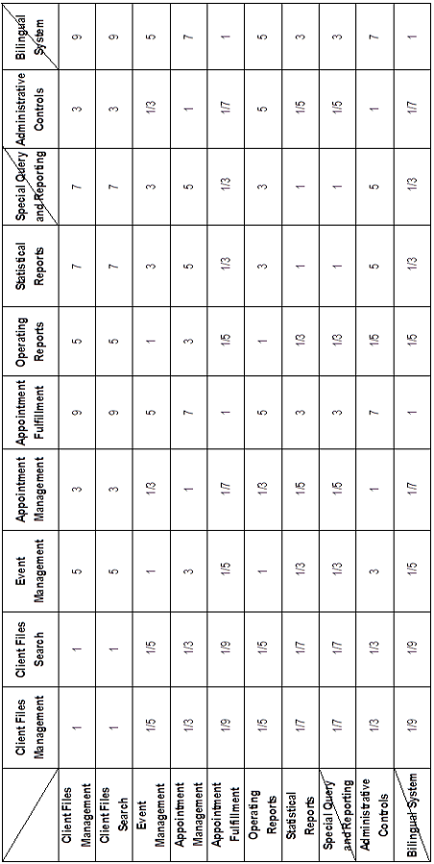

## Normalized Matrix

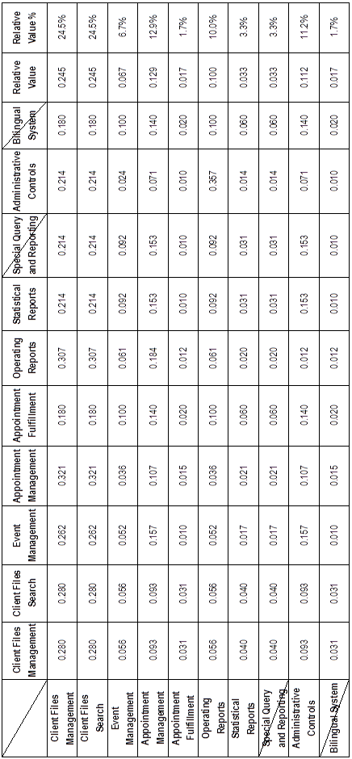

# Cost Prioritization

## AHP Comparison Matrix

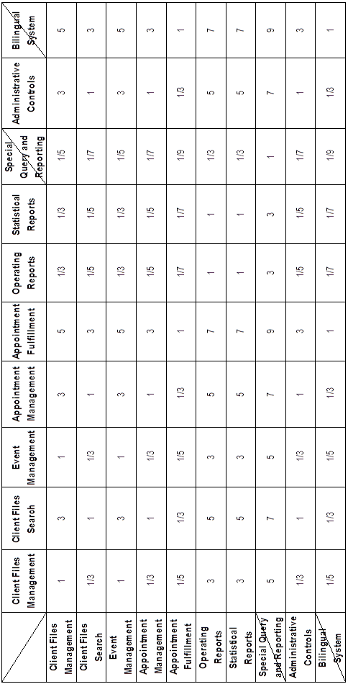

## Normalized Matrix

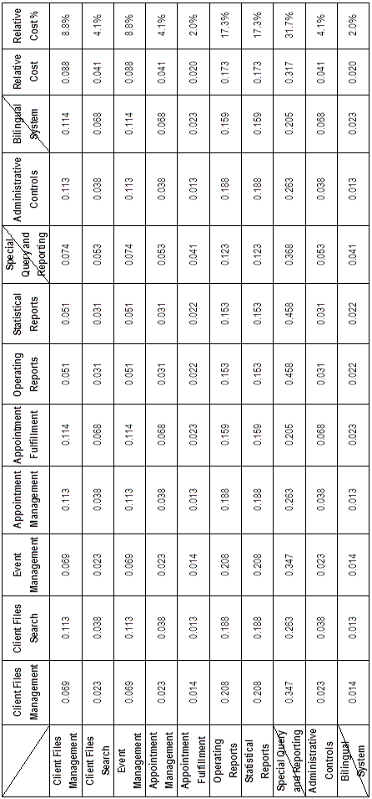

# Cost/Value Percentage Graph

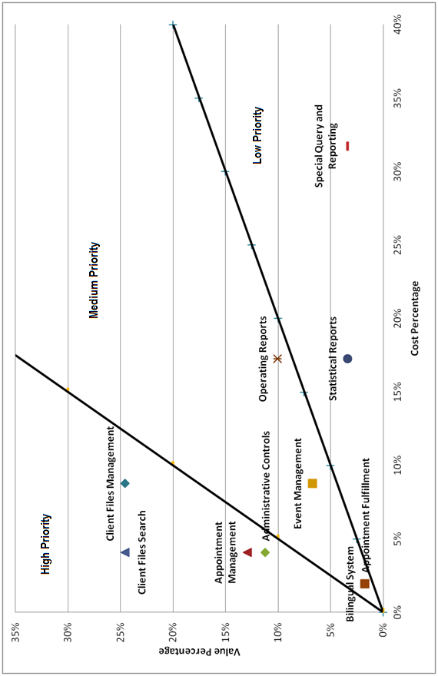

|  |
| --- |
| **F.S.T.S.** |

|  |
| --- |
| **Supplementary Specification and Glossary** |

# Supplementary Specification and Glossary

|  |
| --- |
| **Version 6.16** |

**Revision History**

|  |  |  |  |
| --- | --- | --- | --- |
| **Date** | **Rev.** | **Description** | **Author(s)** |
| 2012-01-14 | 0.0 | Contributed sections 3,9 and 12. | Mikhael Levkovsky |
| 2012-01-14 | 0.1 | Contributed sections 4 and 11. | Cynthia Donato |
| 2012-01-15 | 0.2 | Contributed sections 2 and 8. | Katrina Anderson |
| 2012-01-15 | 0.3 | Contributed sections 5 and 10. | Josh Hum |
| 2012-01-15 | 0.4 | Contributed sections 1 and 7 | Patrick Modafferi |
| 2012-01-15 | 0.5 | Contributed sections 6, 13 and 14 | Adrian Lloyd |
| 2012-01-15 | 0.6 | Formatted and reviewed document | Katrina Anderson |
| 2012-01-28 | 1.7 | Updated SRS – Section 10 (Interfaces) – User Interfaces | Josh Hum |
| 2012-01-29 | 1.8 | Updated SRS – Section 9 – Purchased Components | Mikhael Levkovsky |
| 2012-01-30 | 1.9 | Revised Document | Katrina Anderson |
| 2012-02-13 | 2.10 | Revised Document | Katrina Anderson |
| 2012-02-25 | 3.11 | Revised Document | Katrina Anderson |
| 2012-03-09 | 4.12 | Updated Section 2 and Revised Document | Katrina Anderson |
| 2012-03-11 | 4.13 | Updated Section 7 | Patrick Modafferi |
| 2012-03-20 | 5.14 | Corrected and updated document | Katrina Anderson |
| 2012-04-10 | 6.15 | Document Review | Mikhail Levkovksy |
| 2012-04-10 | 6.16 | Formatting | Katrina Anderson |

# Introduction

## Purpose

This document shall list non functional, technical, quality, legal, technological and other types of requirements for the F.S.T.S. Other important functional requirements will also be included here. These requirements serve as a reference to ensure the team adheres to performance, quality and other technical standards. It also makes sure that these aspects of the application are thought out and written early in the development process. Please refer to the user stories and the use case models for the major functional requirements.

## Scope

Contents of these documents discuss all additional requirements to accompany the use case documentation and the vision document, all of which are encompassed in iteration 0 of the F.S.T.S. replacement project.

## Definitions, Acronyms and Abbreviations

Please see section 14-Glossary of the Supplementary Specification document.

## References

Please see Appendix A, References, of this document.

## Overview

The supplementary specifications document is split into thirteen sections. It begins with the Functionality section, which describes the functional requirements of the F.S.T.S. in natural language. The next four sections outline the quality attributes of the system: Usability, Reliability, Performance and Supportability. The self explanatory Design Constraints, Online User Documentation, Purchased Components and Interface requirements sections make up the center portion of the specifications document. The necessary legal and regulatory qualifications are outlined next in the Licensing Requirements, Legal, Copyright and Other Notices and Applicable Standards sections, before finishing off with a Glossary of terms, acronyms and abbreviations

# Functionality

## Administrative Controls

F.S.T.S. shall allow administrators to manage user permissions, costumize fields in client files, automate flags for client files, archive old client files, design event templates and design operational and statistical report templates.

## ~~Bilingual System~~

~~F.S.T.S. shall allow users to view system controls in either French or English.~~

*This functionality has been scoped out by the client

## Help Functionality

F.S.T.S shall allow users to learn about the system through a user guide.

# Usability

## Required Training Time for a Normal User

Since F.S.T.S. will try and emulate the same type of functionality (i.e. shortcut function keys) the training time for a normal user will be around 2 days.

## Required Training Time for an Administrative User

F.S.T.S. will introduce a new section for administrators. This will allow administrators to customize the F.S.T.S. application how they see fit. This will take approximately 1 day of training time.

# Reliability

System reliability requirements are defined in this section of the supplemental specifications document. Availability of system components as well as MTBF, MTTR statistical report calculation accuracy and postal code mapping accuracy will be discussed in this section along with bug rate and categorization.

## Availability

Client file management, appointment management and event management should be available 99% of the time during regular working hours. The ability to print out forms for manual creation of client files, appointments and to print out a list of attendees to an event should be available 99% of the time. The 1% downtimes in these two scenarios will pertain to failure and maintenance downtimes. All reporting functionality should be available 97% of the time. The 3% downtime will pertain to any necessary updates on the reports.

## Mean Time Between Failures (MTBF)

Please see Test Reports

## Mean Time To Repair (MTTR)

Please see Test Reports

## Accuracy

### Statistical Report Calculation Accuracy

The system shall provide 99% accuracy when returning statistical calculations from the F.S.T.S.® database in regards to appointment attendance per demographic, per date range and when comparing usage per event.

### Postal Code Mapping Accuracy

The system shall provide 99% accuracy when mapping postal codes to geographical areas in Montreal.

Medicare Mapping Accuracy

The system shall provide 99% accuracy when mapping the gender and age of clients from their medicare cards.

## Maximum Bug Rate

Please see Quality Metrics

## Categorization of Bug Rate

|  |  |
| --- | --- |
| **Categorization** | **Description** |
| Minor | A minor bug is categorized as an error that does not hamper the performance of the F.S.T.S. Most errors in this category will have to do with the application’s visual output. |
| Significant | A significant bug is categorized as an error that will return incorrect or undesirable results in the F.S.T.S. Most errors in this category will be a result of faults in program logic and will reflect in calculations. |
| Critical | A critical bug is categorized as an error that will cause unrecoverable errors or performance issues, rendering parts or all of F.S.T.S. unusable. Most errors in this category will be a result of hardware crashes or corrupted data. |

# Performance

System performance requirements are defined in this section of the supplemental specifications document. The system response time, capacity, degradation modes, and resource utilization are described below.

## Response Time

All transactions in the system must take no longer than 5 seconds. On average, it should take less than 2 seconds for the system to respond for any transaction.

In certain cases the response time will vary depending on the client input. These two main cases where response time may vary are: the search and the report generation. If a search returns up to 10000 results then the response time should take 5 seconds or less. If the search returns less than 100 results then the response time should take less than 1 secon.d

When generating a yearly report the response time may take up to 5 minute to create the report. This can very with upgrades to the hardware.

## Capacity

The system must have the ability to handle 6 users at the same time. The system must also be able to handle 6 transactions at the same time.

## Degradation modes

A user must be able to print reports even if the system is taken down (for server maintenance, software maintenance or any other kind of planned failure).

## Resource utilization

The system must take up no more than 100 GB of disk space.

# Supportability

This section defines requirements to improve the maintainability and supportability of the F.S.T.S. system.

## Coding Standards

* One tab indentation should be done within parenthesis of code blocks for clarity of encased code.
* New lines shall be created between “if”, “else if” and “else” statements.
* All branching statements must be enclosed in brackets, even if unnecessary (i.e. one line branches).
* PHP code developed shall follow the strict standards instead of free style standards.

## Naming Conventions

All variable names and methods shall use camel case lettering as the naming convention.

## Maintenance Group Response Time

* All minor bugs/defects discovered will be addressed in the scheduled maintenance iteration.
* All significant bugs/defects will be addressed on a case by case basis but should be addressed within an iteration.
* All critical bugs/defects will be addressed within 24 hours.

See Section 4.6 for classification of minor, significant and critical bugs/defects.

## Updates

Updates to the system shall be determined at the disclosure of Welcome Hall Mission.

## Authentication

Due to the addition of administrators as a user type, users will have to log onto the system to determine if they are a regular user or an administrator.

# Design Constraints

System design constraints are defined in this section of the supplemental specifications document. The following software languages, processes and developmental tools need to be adhered to during the construction of F.S.T.S.

## Agile Project Management

This software shall be developed using the Agile methodology process.

## Database Adaptability

The new F.S.T.S. shall implement a database which can be migrated with the current database.

## Modifiability

The system shall be subject to frequent enhancement of existing features. Reports may change fields frequently and it should be possible for the user to customize the reports.

## No Mouse

The usage of the mouse for data entry and routine tasks must be kept to a minimum. The keyboard should be a predominant means of navigation through the application.

## Web Application

The system shall work as a web application.

## MVC

Because the yii framework enforces MVC architecture, the code design must follow the Model, View and Controller pattern.

# Online User Documentation and Help System Requirements

F.S.T.S. shall provide an installation manual and a user guide to promote manageability for the employees/volunteers of Welcome Hall Mission after deployment.

# Purchased Components

An iPad may need to be purchased to test the mobile part of F.S.T.S.

# Interfaces

This section of the supplementary specifications document contains requirements for the user, hardware, software and communication interfaces.

## User Interfaces

The user interface for the software system will be designed according to the needs of the Welcome Hall Mission. The new F.S.T.S. will be a web application, so the user will interact with the software through a web browser. Thus, the software must comply with the following standards:

W3C HTML & CSS standards - [http://www.w3.org/standards/webdesign/htmlcss#specifications](http://www.w3.org/standards/webdesign/htmlcss" \l "specifications) [3].

Because the Welcome Hall Mission computers are standardized on Windows 7, the software must be compliant with Internet Explorer 9.

## Hardware Interfaces

1) Display & Graphics – A monitor is necessary to view the running application. As F.S.T.S. will not have a heavy graphical interface, there are no special requirements for a video card.

2) Input Devices – Keyboard and mouse.

3) Database & Storage – MSSQL database

## Software Interfaces

The following software additions will be used as part of F.S.T.S:

* jQuery - <http://jquery.com/> [2]
* Yii PHP framework - <http://www.yiiframework.com/>[3]

*More software interfaces may be added during implementation if necessary.

## Communications Interfaces

The software will be running on an intranet. Thus, there will be no communication with any external systems or devices. The user will be accessing the server that F.S.T.S. is running on through VMware, but this should not affect F.S.T.S. in any way.

# Licensing Requirements

Usage of the F.S.T.S.application is currently restricted to use by the Welcome Hall Mission only.

# Legal, Copyright and Other Notices

The F.S.T.S. system must be used in compliance with Welcome Hall Mission’s regulations. This is free software, but it may not be redistributed without JAM PACK’s consent. Modifications to the code are allowed after initial distribution, as maintenance cannot be guaranteed by us.

# Applicable Standards

This system will be developed according to the accepted standards of:

PHP – <http://www.php.net/>[4]

Yii Framework – <http://www.yiiframework.com/doc/>[3]

W3C HTML & CSS - [http://www.w3.org/standards/webdesign/htmlcss#specifications](http://www.w3.org/standards/webdesign/htmlcss" \l "specifications) [1]

The Welcome Hall Mission has the applicable standard of no mouse clicks during any data entry (for example creating a new client file). This standard is in place to maximize the speed of data entry, thereby improving work performance.

# Glossary

|  |  |
| --- | --- |
| **Acceptance Testing** | Visual functional test run by a tester or a user on the actual product |
| Administrative User | A user that has access to the CMS and can modify attributes of the system. An administrative user can also create other users and assign permissions. |
| App. | Application |
| Client | A person who partakes of the Welcome Hall Mission’s services. |
| CMS | Content Management System. Allows a user to modify the content of the application |
| **DOS** | Disk Operating System |
| Employee | A person who is employed by the Welcome Hall Mission. |
| F.S.T.S. | Family Services Tracking System |
| **Gantt Chart** | Estimation and planning tool used for planning a process or iterations |
| H.I.F.I.S. | Homeless Individuals and Families Information System is provided free by the government of Canada. It is an electronic records management system built for providers of services to the homeless population |
| IDE | Integrated Development Environment |
| **KLOC** | 1000 lines of code |
| **LAMP** | Linux, Apache, MySQL and PHP software bundle |
| **MTBF** | Mean Time Between Failures - the predicted time rate of system failure during operation |
| **MTTR** | Mean Time To Repair - average measure of time to repair a system component |
| **MVC** | Model – View – Controller |
| Normal User | A typical user without any administrative functions. This user is in charge of creating appointments, creating user files, making sure people attend appointments |
| UI | User Interface |
| **Unit Testing** | Automated type of tests run on specific components or methods in the code. |
| **User Acceptance** | An agreement or compromise reached on a functionality of a component based on customer feedback. |
| PHP | Web programming language |
| SDK | Software Development Kit |

# ****Appendix A References****

[1] W3C. (2012, January 15). *HTML & CSS Standards*[Online]. Available:[http://www.w3.org/standards/webdesign/htmlcss#specifications](http://www.w3.org/standards/webdesign/htmlcss" \l "specifications)

**[2] The jQuery Project. (2012, January 15). jQuery [Online]. Available:**<http://jquery.com/>

[3] Yii Software LLC. (2012, January 15) *Yii PHP Framework* [Online]. Available: [*http://www.yiiframework.com/*](http://www.yiiframework.com/)

[4] The PHP Group. (2012, January 15) *PHP* [Online]. Available: <http://www.php.net/>

[5] C. Larman. *Applying UML and Patterns*, 3rd edition. Prentice Hall. 2005.

[6] Oracle Corporation. (2012, January 12) *Netbeans IDE 7.1* [Online] Available: http://netbeans.org/index.html.

[7] Yii Software LLC. (2012, January 12) *Yii Framework; Unit Testing.* [Online] Available: http://www.yiiframework.com/doc/guide/1.1/en/test.unit

**[8] D. Rethans.** (2012, January 12) **XDebug Extension For PHP [Online]** Available: http://xdebug.org/

**[9] IEEE.** (2012, January 12) *Test Plan Outline (IEEE 829 Format*) [Online] Available: http://www.gerrardconsulting.com/tkb/guidelines/ieee829/main.html#9

[10] M. Pichler. (2012,January 12) *PHP Depend; Documentation* [Online] Available : http://pdepend.org/documentation/getting-started.html

[11] O. Ormandjieva. (2012, February 24) *Lecture14;Integration Testing* [Online]: Available: http://users.encs.concordia.ca/~s345_4/

**[12] Selenium Project. (2012, February 23). Selenium Documentation [Online] Available :** http://seleniumhq.org/docs/

[13] CSS-Tricks. (2012, March 23). *A web design community* [Online]. Available: http://css-tricks.com/label-placement-on-forms/

# Appendix B Interview (01/09/2012)

## Part I: Establishing the Customer Profile

**Name:** Gordon McPhee

**Company:**Mission Bon Acceuil

**Job title:** IT Coordinator

**What are your key goals?**

Upgrade and improve the F.S.T.S. in order to better serve the clients of the charitable organization

**How is success measured?**

Time saving and effectiveness of the software system used to track families

**What problems interfere with your success?**

Outdated software and database model

**What, if any, trends make your job easier or more difficult?**

Easier: Having a more flexible software

Difficult: Having an outdate software and design

**Name:** Tania Togias

**Company:**Mission Bon Acceuil

**Job title:** Data Entry

**What are your key goals?**

Upgrade and improve the F.S.T.S. in order to better serve the clients of the charitable organization, speed up the data entry process.

**How is success measured?**

Time saving and effectiveness of the software system used to track families, quickness of data entry process

**What problems interfere with your success?**

Outdated software and hard to use system

**What, if any, trends make your job easier or more difficult?**

Easier: Using the keyboard exclusively

Difficult: Having to use the mouse

## Part II: Assessing the Problem

**For each of the seven tasks:**

1. Client Files Management
2. Event Management
3. Appointment Creation
4. Appointment Fulfillment
5. Operating Reports
6. Statistical Reporting
7. Special Query and Reporting
8. **What is the purpose of this task?**
   * + 1. *Create a file for a client containing all relevant information and flags*
       2. *View list, create new events and view attending clients*
       3. *Create appointments for a client, associate the client to a list of attendees*
       4. *Check-in users who attended and flag users who did not attend*
       5. *Generate reports on event usage and attendance*
       6. *Generate reports on client demographics and other information*
       7. *Search for various information, usually for a client by client ID*
9. **How do you solve it now?**

Refer to screenshot documentation

1. **How would you like to solve it?**

N/A

**How would you rank these tasks in order of most important to least important?**

They are all important.

**What is meant by “manual production of the event”? What must the predetermined pre and post reports contain? Can we have an example?**

In case of emergency, computer maintenance or failure, there must be some sort of alternative to using a computer. We will provide you with examples of pre and post reports.

**Do users need to be able to create different types of events or are there a fixed number of events? How are these events organized?**

Users need to be able to create different events. Events are organized based on distribution dates. Planned on the hour.

**Do events happen in specific rooms?**

N/A

**“...conducts biweekly distributions of food to often over 1,000 families every week” By biweekly does it mean every two weeks or twice a week?**

Every two weeks.

**Is the biweekly food distribution a strict schedule or can there be cancellations/additions? If so, how would the families be notified?**

Clients can always be added and removed form the list. The event should be able to be cancelled but this should not happen.

**How are your goods quantified? How should we keep track of goods given out per family/individual?**

N/A (For the moment this is a nice to have)

**How is an appointment created? What information is needed to create an appointment:**

1. **What event the appointment is for?**

N/A

1. **Who the appointment is for?**

The client who has called asking for the appointment

1. **Is it just one person or a whole family?**

One person.

1. **The amount of “goods” given out, is it determined at the time of the appointment?**

Depends on the type of event, size of family and client.

**What does appointment fulfillment mean?**

The client has show up to the appointment on time and the exchange was completed.

**How often can this appointment booking take place? What are the limitations (i.e. family/distribution, individual/distribution…)?**

Every two weeks for food and month for mattress distribution.

**Does the mobile version of F.S.T.S. only need to take care of appointment confirmation?**

Mobile app is a nice to have, might be a web app.

**Is there a penalty for missing an appointment? If so, what type?**

The client should get flagged for misuse of the services and a ban does incur.

**"As clientele arrive at their appointment they are identified and logged in. This process is currently accomplished manually from a printed report.” If the wireless scanners are a future idea, how can the system reduce check in time? Will you have computing devices available at check in?**

Right now they are crossed off a printed list of clients. In the future they would like to check them in via iPad.

**What is the difference between operating reports and statistical reports? Please list the specific criteria you wish to analyse in these reports. Can we have examples of operating and statistical reports?**

See Part II and screen shot documentation.

**What is meant by special query and reporting? Please list the specific criteria you wish to query?**

Usually search by client ID, but the search by person needs improvements. They would like to search through the database for the family representative, but also query the dependants and spouses.

## Part III: Understanding the User Environment

**Who are the users?**

The users are the Welcome Hall Mission employees who perform data entry for appointments, new files, and verification.

**If there are multiple user groups, which ones are the main users?**

N/A

**How is the representative determined? Can this be changed at a later time? Is this crucial for registration? Is this crucial for appointment creation? Is this crucial for picking up goods?**

The representative is determined when the file is made. The representative can be changed at a later time (assuming id and the number of the file are given). Having a representative is crucial for a file registration. It is not, however, crucial for appointment creation. Any dependant can create an appointment, but they need their representative’s id number. The same applies for picking up goods.

**Does "the representative of the family" refer to one person in the family or any family member?If the former is true, can a family member that's not the representative create an appointment under special circumstances?**

The representative refers to one person of the family/household. Again, any dependant can create an appointment, but they need their representative’s id number.

**“Eligibility is governed by strict guidelines which are verified at the time of client registration.” What are these guidelines? Are they clearly defined somewhere where we can easily access them?**

These guidelines are known by the employees who register new clients therefore the system itself doesn’t know the guidelines. The guidelines of client registration can be made available.

**Once a client has been accepted, how are they re-evaluated to see if they are still eligible?**

To re-evaluate a client, a manual check is done. To solve this, a flag would go off every 6 months to check a client’s file to see if they are eligible for the services.

**Do most members of your organization have internet access?**

Everything is done internally so the members of our organization that will use the system will have access to internet.

**Who are the main users per task?**

The main users are the Welcome HallMission employees that perform the data entry

**What is their educational background?**

N/A

**What is their computer background?**

N/A

**Are users experienced with this type of application?**

Yes, the data entry users are experienced with the system.

**Are there any additional applications in use that are relevant to this application?**

HIFIS (Homeless Individuals and Families Information System)

**Can you walk us through a common task using the old F.S.T.S. (so that we can grasp how it works)?**

See screenshots to view process

**What are your expectations for usability of the product?**

It should be very quick to make appointments and other data entry tasks. There should be no or a minimal amount of mouse clicks during data entry.

**What are your expectations for training time?**

We expect that the time for training should be short (a day or two), since the system should have the same functionality as the old system.

**What kinds of user help (hard copy/online documentation) do you need?**

A user and installation manual

**What type of user interface are you expecting?**

**Simple (big font, big buttons, minimal words, etc)?**

**Standard (more text, top dropdown navigation menus, etc)?**

**Form based (user inputs and then receives some output)?**

An interface where little to no mouse clicks are needed during data entry; However, more mouse clicks can be possible in other aspects of the system.

**Does F.S.T.S. need to be a bilingual application?**

If it is possible to make it bilingual, yes.

## Part IV: Recap for Understanding

**You have told me:**

1. Modifiability (to be able to update or extend the system)
2. User Efficiency (no or minimal mouse clicks during data entry)
3. Migrate Data (to be able to move data from old database into a new database)
4. Web Application (to automatically update database during distributions instead of manually updating the database afterwards)
5. Report Templates
6. Flags for checking for missing documents or no shows during distributions
7. Ban option
8. To be able to give appointments by hour
9. Remove X from our Christmas Basket list if they are already receiving a basket from another service.
10. Keep shortcuts relatively the same
11. To be able to search by id, name (and spouse name in addition if necessary)
12. Remove SIN from file form and warnings

**Does this cover everything?**

Yes

## Part V: Assessing the Opportunity

**How many users would use the application (total and at one time)?**

Right now 4 – 5 people doing data entry and ideally one person will be checking people off with an iPad during the services. Ideally it should be assumed around 15 people will use the system at one time.

**How would you value a successful solution?**

A successful solution would be the same functionality of the old system but with modifiability, user efficiency, and data migration. (see Part IV)

## Part VI: Assessing the Reliability, Performance, and Support Needs

**What are your expectations for reliability?**

The current system is effective and reliable so any upgrade solution that would make it less reliable would be rejected.

**What are your expectations for performance?**

Since this is a lightweight system, performance should not be an issue in terms of response time.

**Will you support the product or will others support it?**

The product will be supported by Welcome HallMission’s I.T. department. The Mission will hire outside help if needed.

**Do you have special needs for support?**

Product Documentation

**What about maintenance and service access?**

The product will be supported by Welcome HallMission’s I.T. department. The Mission will hire outside help if needed.

**What are the security requirements?**

Client data is private during the project. Everything run on the server internally so there is no security issues.

**What are the installation and configuration requirements?**

It should be configured on the Welcome Hall Mission’s server.

**“The new F.S.T.S. system should fit into the VMWare environment.” What does this mean exactly?**

The new F.S.T.S. should not conflict with the VMWare environment.

**Is there a stable and fast internet connection at all the centers of Mission Bon Accueil? If so, is a web application an acceptable solution?**

There is a stable internet connection, but it is not fast. A web application would run on our internal system. A web application is suitable.

**If need be, would the Welcome Hall Mission be willing to work with us to install any new type of software that may be needed?**

It depends on the software, but in general yes.

**What are the specifications for the hardware needed?**

1. **Wireless handheld**
2. **Scanners**

N/A

**Is there a budget for this project?**

The Welcome Hall Mission already has software on their servers such as SQL (2008 R2), Filemaker, .NET Framework, and Hyphus. They’re open to new software options if needed.

## Part VII: Other Requirements

**Are there any legal, regulatory or environmental requirements or other standards that must be supported?**

The client information is private.

**Can you think of any other requirements we should know about?**

Refer to provided documentation.

## Part VIII: Follow Up Questions

**Are there any user restrictions to be imposed?**

There are two types of users, Data entry personnel and Administrator. Only admin can edit fields and add new fields. Other than that there are not many restrictions.

**Are there any technical specifications for this system?**

VMware is currently in use on large scale servers, Computer replacement program planned this year, gigabit inter office connection and slow internet speeds.

**What if the required documents for registering are not provided?**

The data entry person should be able to create a file anyways, but the file should have visual flags that some information is required for the next meeting.

**What is the situation with the iPads?**

Old system required printed lists to be brought at event and volunteer workers scratch attendees off list. Later, they must open the application and enter the ID for every client who attended and flag every one who missed the appointment.

**What if two families are at the same address?**

The system works by household, so the second family could get included into the first family’s list of dependants.

**How many users can be using the system at once?**

Currently: 2-5 Maximum: 10-15

**What happens if a new family moves into the same address as an old family?**

Documents are provided to prove this and the address should be marked as inactive for the old record of family who has moved out, so that both records can contain the same address.

**What should happen if two people are viewing the same file?**

The file becomes locked automatically when someone is modifying it.

**How should we contact you in the future?**

Meetings in person are encouraged.

Emails:[gmcphee@missionba.com](mailto:gmcphee@missionba.com)&[ttogias@missionba.com](mailto:ttogias@missionba.com)

**What should be the size of this software?**

Small, lightweight. Current program is ~20MB.

**How many entries does the current database contain?**

**18,000 currently, should anticipate rise up to 100,000.**

# ****Appendix C Iteration 1 Demo Feedback****

## Gordon McPhee

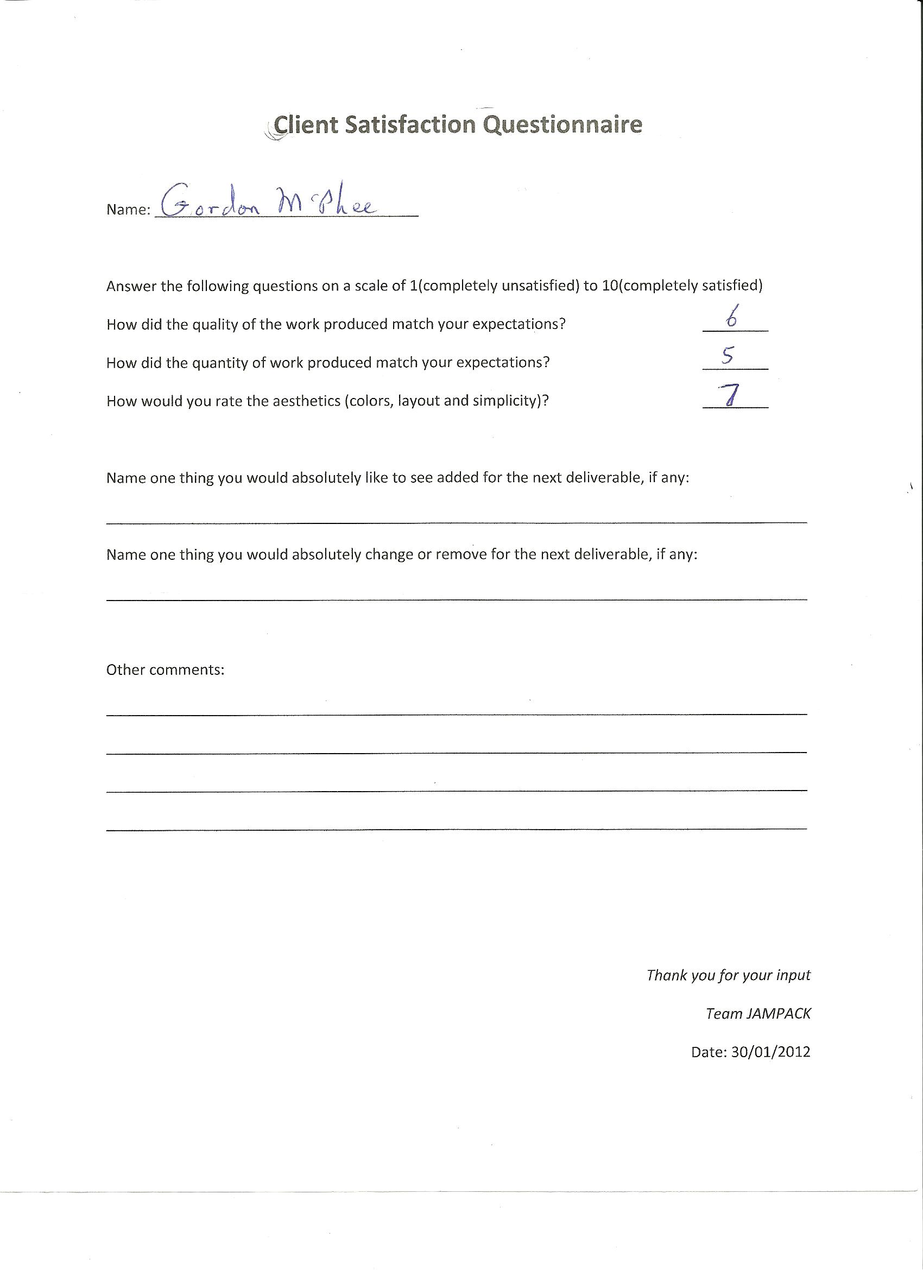

## Tania Togias

