|  |
| --- |
| **Concordia University**  **Department of Computer Science**  **and Software Engineering** |

|  |
| --- |
| **Touch For Food** |

|  |
| --- |
| **User Interface Requirements** |

|  |
| --- |
| **SOEN 490**  **Capstone Project**  **Fall 2012 – Winter 2013** |

|  |  |
| --- | --- |
| **CloudNine** |  |
| Josh Hum (Team Leader) | 9583157 |
| Katrina Anderson | 9106251 |
| Cristian Asenjo | 9280014 |
| Christian Daher | 9599673 |
| Cynthia Donato | 9353852 |
| Mikhail Levkovsky | 9583165 |
| Patrick Modafferi | 9401377 |
| Ryan Nasr | 9605614 |
| Matthew Tam | 9675701 |

**Table of Contents**

1 User Centered Design 5

1.1 User Characteristics 5

1.2 Set of Tasks Performed 8

1.3 Context of Use 18

1.4 Stakeholder Objectives 21

2 UI evaluation 22

2.1 Overall site architecture 22

2.2 Navigation 25

2.3 Feedback 26

2.4 Screen layout 27

Appendix A References 32

Appendix B Glossary 33

**Table of Figures**

Figure 1‑1 Create User Profile Hierarchical Task Model 8

Figure 1‑2 Manage User Profile Hierarchical Task Model 9

Figure 1‑3 View Previous Orders/Reviews Hierarchical Task Model 10

Figure 1‑4 Deliver Order Item Hierarchical Task Model 11

Figure 1‑5 View Menu Hierarchical Task Model 12

Figure 1‑6 Populate Menu Hierarchical Task Model 13

Figure 1‑7 Manage Tables Hierarchical Task Model 14

Figure 1‑8 Manage Bill Hierarchical Task Model 15

Figure 1‑9 Place Order Hierarchical Task Model 16

Figure 1‑10 Submit a Review Hierarchical Task Model 17

Figure 1‑11 Call Waiter Hierarchical Task Model 17

Figure 2‑1 Creating a New Menu 24

Figure 2‑2 Creating a New Account 24

Figure 2‑3 TFF Top Menu According To User Role 25

Figure 2‑4 Search Bar 25

Figure 2‑5 Search Results 25

Figure 2‑6 Account Creation With Error 26

Figure 2‑7 Account Creation Successful 26

Figure 2‑8 Adding Item To Order Confirmation 27

Figure 2‑9 Menu Details Overlay 31

|  |
| --- |
| **Touch For Food** |

|  |
| --- |
| **User Interface Requirements** |

|  |
| --- |
| **Version 11.26** |

**Revision History**

|  |  |  |  |
| --- | --- | --- | --- |
| **Date** | **Rev.** | **Description** | **Author(s)** |
| 2012-09-17 | 0.0 | Document Creation | Katrina Anderson |
| 2013-01-20 | 6.1 | Section 1.3 Context of Use | Mikhail Levkovsky |
| 2013-01-23 | 6.2 | Section 1.4 Stakeholder Objectives | Christian Daher |
| 2013-01-24 | 6.3 | Section 2.1 Overall Site Architecture | Matthew Tam |
| 2013-01-26 | 6.4 | Section 1.2 Set of Tasks Performed | Cristian Asenjo |
| 2013-01-26 | 6.5 | Reviewed Section 1.4 Stakeholder Objectives | Matthew Tam |
| 2013-01-26 | 6.6 | Section 1.2 updated | Cristian Asenjo |
| 2013-01-26 | 6.7 | Added Section 2.2 Navigation | Katrina Anderson |
| 2013-01-26 | 6.8 | Added section 1.1 | Cynthia Donato |
| 2013-01-26 | 6.9 | Updated section 1.3 Context of Use | Mikhail Levkovsky |
| 2013-01-26 | 6.10 | Section 1.2 updated | Cristian Asenjo |
| 2013-01-27 | 6.11 | Reviewed section 1.1 | Cristian Asenjo |
| 2013-01-27 | 6.12 | Updated section 1.3 Context of Use | Mikhail Levkovsky |
| 2013-01-27 | 6.13 | Section 2.3 Feedback | Ryan Nasr |
| 2013-01-28 | 6.14 | Reviewed Section 2.2 Navigation | Josh Hum |
| 2013-01-28 | 6.15 | Added Section 2.4 Screen Layout | Josh Hum |
| 2013-01-28 | 6.16 | Reviewed Section 2.1 and formatted document | Katrina Anderson |
| 2013-01-29 | 6.17 | Updated Section 1.3 as per review | Mikhail Levkovsky |
| 2013-01-29 | 6.18 | Review and updated section 1.2 | Cynthia Donato |
| 2013-02-07 | 7.19 | Review document for submission and make necessary updates | Cynthia Donato |
| 2013-02-12 | 7.20 | Updated Figure 2-5 and Figure 2-3 | Josh Hum |
| 2013-03-30 | 11.21 | Updated section 2.2-Navigation | Katrina Anderson |
| 2013-03-30 | 11.22 | Updated section 1.2 – Set of Tasks Performed | Cristian Asenjo |
| 2013-03-30 | 11.23 | Updated section 1.3 – Context of use | Mikhail Levkovsky |
| 2013-03-30 | 11.24 | Updated section 2.4 | Josh Hum |
| 2013-03-30 | 11.25 | Updated Section 2.1 | Matthew Tam |
| 2013-03-31 | 11.26 | Reviewed Section 1.2 – Tasks performed | Mikhail Levkovsky |

# User Centered Design

## User Characteristics

The TFF application has six basic user types; administrator, developer, customer, restaurant owner, chef and waiter/waitress. The following personas will illustrate the details of a typical type of user. Personas don’t represent specific people, but are developed based on the characteristics of a real user or group of users. Every persona will have real person attributes like name, age, characteristics, goals and background. [1]

### Persona 1 – Administrator

Name:Mat

Background:

* 30 years old, Male
* Works for Cloud9
* Friendly

Goals:

* Create user accounts
* Administer user accounts
* Troubleshoot technical issues

Frustrations:

* Unclear navigation of software
* Complicated steps to perform a task

About Mat:

Mat is an administrator for the Cloud9 software company. Mat is computer savvy and has high standards in regards to how websites look and feel should be implemented.

His mandate is to administer accounts purchased for the TFF application. His daily tasks include creating user accounts and providing them with the necessary privileges to be able to create and administer their restaurant site in TFF. Mainly Mat troubleshoots various issues which clients report in the TFF application and finds solutions for these issues.

### Persona 2 – Developer

Name:Fred

Background:

* 27 years old, Male
* Works for Cloud9
* Friendly and talkative

Goals:

* Develop new features for the TFF application
* Maintain the TFF application
* Test the TFF application

Frustrations:

* Lack of visual representation of important information when debugging and testing

About Fred:

Fred is a web developer at Cloud9. Fred is computer savvy and enjoys spending hours coding and working out difficult issues. His goal is to develop software that is easily maintainable and functioning according to the needs of his clientele. It is also important to Fred that all deployed software be thoroughly tested to ensure optimized performance for customers using the application.

### Persona 3 – Customer

Name:Jonathan

Background:

* 26 years old, Male
* Busy lifestyle
* Is a iPhone enthusiast

Goals:

* Order food in a timely manner
* Be able to effortlessly flag down a waiter when needed
* Be able to view billing information in real time
* Be able to leave reviews on different menu items

Frustrations:

* Waiting for waiters/waitresses to place an order wastes time on a short lunch break
* Difficult to get the attention of a waiter/waitress when a restaurant is very busy
* Difficulty to predict how much of a tab we have collected prior to receiving the bill
* Ordering a dish and not receiving what was expected

About Jonathan:

Jonathan is construction worker who loves his iPhone smartphone. With his busy lifestyle Jonathan’s goal is to be able to maximize his lunch hour by decreasing the time spent waiting on waiters and waitresses in restaurants.

Jonathan is not technology savvy but can easily manipulate iPhone and mobile apps that are simple and intuitive.

### Persona 4 – Restaurant Owner

Name:Sara

Background:

* 25 years old, Female
* Busy lifestyle
* Small business restaurant owner

Goals:

* Provide efficient service for breakfast, lunch and dinner
* Provide customers a unique experience
* Easily manager orders
* Easily manage bills
* Collect statistical information on clientele
* Create waiters/waitresses effortlessly
* Manage restaurant attributes

Frustrations:

* Difficulty finding waiters/waitresses
* Difficult to collect customer feedback and statistical information

About Sara:

Sara is a dynamic and youthful entrepreneur. Managing a restaurant takes up most of her time. Her goal is to draw in youthful clientele looking for a unique restaurant experience. At the same time she needs a system that is easy to maintain as she is not very technology savvy.

### Persona 5 – Waiter/Waitress

Name:Jessica

Background:

* 17 years old, Female
* Student
* Part-time waitress

Goals:

* Provide efficient service for breakfast, lunch and dinner
* Easily manage orders
* Easily manage bills
* Easily identify needs of her customers

Frustrations:

* Difficulty catering to needs of all clients when restaurant is busy
* Difficulty in managing bills made by multiple individuals
* Difficulty in remembering specific requests associated to orders placed

About Jessica:

Jessica is a full-time high school student who works as a waitress part-time to make extra money for college. Her goals at work are to be able to serve customers in an efficient and polite manner. She would like to have a way to organize orders and bills so that nothing is forgotten. It is also very important to her to be able to know when a customer needs her help.

### Persona 6 – Chef

Name:Sabrina

Background:

* 26 years old, Female
* Head chef

Goals:

* Provide efficient service for breakfast, lunch and dinner
* Easily manage orders

Frustrations:

* Difficulty managing special requests made by clients in regards to their order
* Lost order papers
* Difficulty in prioritizing orders that come in

About Sabrina:

Sabrina is a full time chef in a local Montreal restaurant. During busy peak hours it is often cumbersome to try and organize order processing by prioritization. It is also not always clear when a customer has special requests associated to their order such as allergies or dietary preferences. Often Sabrina has to deal with order slips getting lost in the busy kitchen traffic which results in unhappy customers.

## Set of Tasks Performed

The set of tasks performed are based on the user types that exist within the TFF application (user and restaurant) and the use cases described in the *SAD*.

### Create User Profile

Use Case Reference: UC 4.1

Before a user can access and use TFF it must first create a user profile. In order to do this the user will access the application through a mobile web browser or through the TFF application and Create an Account. On the sign up page the user will provide its information and will then tap on the Create Account button to finalize the user profile creation.



Figure 1‑1 Create User Profile Hierarchical Task Model

### Manage User Profile

Use Case Reference: UC 4.2 and 4.3

When a user has an existing account it has the ability to manage its personal profile. The user might want to change its password, update its email address~~, or add (or remove) a profile picture~~.

In order to perform these actions the user will need to have an existing account (explained in 1.2.1) and be logged in. Once logged in, the user will tap on the link represented by the user’s name which will take it to the personal profile page. At the personal profile page the user will tap on the edit link (represented by a pencil icon), which will take it to the edit profile page. Once there the user may change its information and then tap on the save button in order to save the changes made.



Figure 1‑2 Manage User Profile Hierarchical Task Model

### View Previous Orders/Reviews

Use Case Reference: UC 4.2, 4.4

When a user has previously used the application to successfully eat at a restaurant, this is recorded in the user's profile. This allows the user to review all previous activity and permits it to see the dishes that were consumed during that visit.

In order to achieve this the user must be logged in and have at least one complete visit at a restaurant having used TFF to place the order. On the main page the user will tap on the link represented by the user’s name which will take it to the personal profile page. Once there the most recent past orders and past reviews can be seen.



Figure 1‑3 View Previous Orders/Reviews Hierarchical Task Model

### Deliver Order Item

Use Case Reference: UC 2.2

When using TFF the restaurant will need to oversee the orders placed by the customers and apply appropriate actions to them such as declining them or accepting them. All of these actions are found when viewing a general list of orders or when viewing the orders related to a specific table.

To achieve this objective the restaurant will access the TFF restaurant page and then tap on the Orders link. This will display a list of all the orders currently in place. If the restaurant wishes to view the orders of a specific table then it can tap on the table number and the orders for that table will be displayed. Once viewing the order desired, the desired action can be applied to the order.



Figure 1‑4 Deliver Order Item Hierarchical Task Model

### View Menu

Use Case Reference: UC 1.1 and 4.2

Both the user and the restaurant will want to view the menus available. The user will view the menu in order to decide the items to add to its order while the restaurant will use the menus to display the items they have available for consumption.

In both situations the navigation is the same. The user/restaurant will log in to TFF (explained in 1.2.1) and click on the Menus button/link. From there the different menus will be shown. Tapping on a specific menu will show the items that belong to that menu.



Figure 1‑5 View Menu Hierarchical Task Model

### Populate Menu

Use Case Reference: UC 3.1

When the restaurant is initially starting to use TFF it will need to populate at least one menu with items that will be offered for consumption. This area also allows the restaurant to activate or deactivate menus, such as having one available for lunch and another one for dinner.

In order to achieve this the restaurant will access the TFF main page and then tap on Menus. Once there the menus will be displayed and can be modified by clicking on one of them, or activated/deactivated by tapping on the checkmark next to it. When a menu is clicked the categories already in the menu as well as the ones available to add will be displayed. The restaurant will tap on the add button next to an available category to add it to the menu and on the remove button to remove the category from the menu. Once editing is finished the Back To List button will be tapped to return to the menu display.



Figure 1‑6 Populate Menu Hierarchical Task Model

### Manage Tables

Use Case Reference: UC 5.1

When the restaurant is initially starting to use TFF it will need to have at least one table on its list of tables to manage. This area allows the restaurant to add or remove tables, view table details as well as viewing the NFC link associated to each table.

In order to achieve this the restaurant will access the TFF main page and then tap on Tables. Once there the tables will be displayed and the relevant information for the table can be seen by tapping on the Details button. The table may also be removed by tapping on the Delete button, and a new one may be created by tapping on the Create New button.



Figure 1‑7 Manage Tables Hierarchical Task Model

### Manage Bill

Use Case Reference: UC 8.1

It is a common occurrence for restaurant patrons to ask for their bills to be split up. In order to accommodate for this the functionality will be available directly from order page. The restaurant will tap on the manage bill page to access options for the bill such as splitting up or combining it with another one.



Figure 1‑8 Manage Bill Hierarchical Task Model

### Place Order

Use Case Reference: UC 2.1

The main functionality for a normal user is to place its food orders through TFF. A user will access the main TFF page and go view a specific menu. When a desired menu item is seen, the user can optionally tap on it and will be taken to the item description page. If everything is satisfactory then the user will return to the menu page and tap on the Add to Order button associated to that particular food item to add it to the current order. If more items are desired then the user may repeat the previous two steps to do so.

Once all desired items are in the order, then the user will tap on the Order button in order to view the order. The user will then tap the Finalize button in order to submit it to the restaurant for processing and delivery.



Figure 1‑9 Place Order Hierarchical Task Model

### Submit a Review

Use Case Reference: UC 6.1

A user, having used TFF to place and complete an order (explained in 1.2.9), might want to leave a review after doing so. The review page includes a rating dropdown to rate the user’s experience from 1 to 5, as well as a text box for the user to leave more specifics about the experience.

In order to achieve this the user will have to place an order and successfully complete it. After completion, the user will be offered the option to leave a review related to the order that was just finished.



Figure 1‑10 Submit a Review Hierarchical Task Model

### Call a Waiter

Use Case Reference: UC 7.1

If the user needs a waiter then it can request one to come to the table directly from the TFF application. In order to do this the user will access TFF and tap on the Call Waiter button from the main menu.



Figure 1‑11 Call Waiter Hierarchical Task Model

## Context of Use

The following contexts of use were derived from the goals defined in section 1.2, Set of Tasks Performed, of this document.

### Context 1 – Create User Profile

|  |  |
| --- | --- |
| **Environmental Constraint** | The user needs to have internet access on his/her mobile device. |
| **Technical Constraint** | Designed for phone ~~and tablet~~ |
| **Social Constraint** | The user may not want to give their personal information to create an account. |
| **Location** | At the restaurant where the user first finds out about Touch For Food (typically). |
| **State of Mind** | Relaxed and hungry |
| **Other System** | None |
| **Tasks Performed\*** | 4 |

### Context 2 – Manage User Profile

|  |  |
| --- | --- |
| **Environmental Constraint** | The user needs to have internet access on his/her mobile device. |
| **Technical Constraint** | Designed for phone ~~and tablet~~ |
| **Social Constraint** | NA |
| **Location** | Anywhere that conforms to the Environmental Constraint above |
| **State of Mind** | NA |
| **Other System** | None |
| **Tasks Performed\*** | 5 |

### Context 3 – View Previous Orders/Reviews

|  |  |
| --- | --- |
| **Environmental Constraint** | The user needs to have internet access on his/her mobile device. |
| **Technical Constraint** | Designed for phone ~~and tablet~~ |
| **Social Constraint** | NA |
| **Location** | Anywhere that conforms to the Environmental Constraint above |
| **State of Mind** | Curious |
| **Other System** | None |
| **Tasks Performed\*** | 3 |

### Context 4 – Deliver Order Item

|  |  |
| --- | --- |
| **Environmental Constraint** | The user needs to have internet access on his/her mobile device. |
| **Technical Constraint** | Designed for phone ~~, tablet~~ and PC |
| **Social Constraint** | NA |
| **Location** | A restaurant that uses the TFF application. |
| **State of Mind** | Rushed |
| **Other System** | None |
| **Tasks Performed\*** | 3 |

### Context 5 – View Menu

|  |  |
| --- | --- |
| **Environmental Constraint** | The user needs to have internet access on his/her mobile device. |
| **Technical Constraint** | Designed for phone |
| **Social Constraint** | Customers might not know what the items on the menu are. |
| **Location** | A restaurant that uses the TFF application. |
| **State of Mind** | Hungry |
| **Other System** | None |
| **Tasks Performed\*** | 3 |

### Context 6 – Populate Menu

|  |  |
| --- | --- |
| **Environmental Constraint** | The restaurant needs to have internet access. |
| **Technical Constraint** | Designed for ~~tablet or~~ PC |
| **Social Constraint** | Restaurant owners/managers might not be tech savy. |
| **Location** | A restaurant that uses the TFF application. |
| **State of Mind** | Eager |
| **Other System** | None |
| **Tasks Performed\*** | 7 |

### Context 7 – Manage Tables

|  |  |
| --- | --- |
| **Environmental Constraint** | The restaurant needs to have internet access. |
| **Technical Constraint** | Designed for ~~tablet or~~ PC |
| **Social Constraint** | Restaurant owners/managers might not be tech savy. |
| **Location** | A restaurant that uses the TFF application. |
| **State of Mind** | Eager |
| **Other System** | None |
| **Tasks Performed\*** | 10 |

### Context 8 – Manage Bill

|  |  |
| --- | --- |
| **Environmental Constraint** | The restaurant needs to have internet access. |
| **Technical Constraint** | Designed for phone ~~and tablet~~ |
| **Social Constraint** | Restaurant owners/managers/customers might not be tech savy. |
| **Location** | A restaurant that uses the TFF application. |
| **State of Mind** | Impatient to leave |
| **Other System** | None |
| **Tasks Performed\*** | 4 |

### Context 9 – Place Order

|  |  |
| --- | --- |
| **Environmental Constraint** | The restaurant needs to have internet access. |
| **Technical Constraint** | Designed for phone ~~and tablet~~ |
| **Social Constraint** | Restaurant owners/managers/customers might not be tech savy. The customers might not understand what the dishes are. |
| **Location** | A restaurant that uses the TFF application. |
| **State of Mind** | Hungry |
| **Other System** | None |
| **Tasks Performed\*** | 6 |

### Context 10 – Submit a Review

|  |  |
| --- | --- |
| **Environmental Constraint** | The user must have internet access on his/her mobile device. |
| **Technical Constraint** | Designed for phone ~~, tablet~~ and PC |
| **Social Constraint** | Restaurant owners/managers/customers might not be tech savy. The customers might not understand what the dishes are. |
| **Location** | A restaurant that uses the TFF application. |
| **State of Mind** | Either satisfied with the service/food or upset with it. |
| **Other System** | None |
| **Tasks Performed\*** | 3 |

### Context 11 – Call a Waiter

|  |  |
| --- | --- |
| **Environmental Constraint** | The user must have internet access on his/her mobile device. |
| **Technical Constraint** | Designed for phone |
| **Social Constraint** | NA |
| **Location** | A restaurant that uses the TFF application. |
| **State of Mind** | Hungry/Impatient/Inquisitive |
| **Other System** | None |
| **Tasks Performed\*** | 1 |

## Stakeholder Objectives

For information regarding stakeholder objectives, please refer to the Vision Document in Section 3.

# UI evaluation

## Overall site architecture

The overall site architecture of TFF is based on the feature groups outlined in the Vision Document. This design divides up system functions, clearly showing actions available to the user. This section of the document will detail UI specifications for coherence and comprehensibility.

### Repeated UI Elements

The TFF web interface contains UI elements that are persistent on every page. These elements are the TFF logo, the user login status,a search bar, the menu bar centered at the top and the footer at the bottom of the page, which includes the CloudNine copyright. This makes up the general look and feel of TFF.

The menu bar immediately displays the options available to the user. Features visible on the menu bar depends on the type of user that logs in. For regular users, the menu bar shows “Order” and “Menu”. Admin users have access to restaurant functionalities, which include “Menu Management”, “Order Management”, “Table Management” and “Bill Management”. For developers, they have access to all of the above including “Users”.

The repeated UI items are contained in the following file:

\TouchForFood\TouchForFood\Views\Shared\_Layout.cshtml

This is a partial view that the MVC3 Razor framework applies to every page that a user can navigate to. If a user navigates to another page, it will have this partial view applied.

### Colours

With the different UI aspects of TFF, a commonality shared between all pages is the colour scheme. Specifically, any text displayed uses the colour scheme. This helps the user find what they are looking for, but also allows the system to display success and error messages. The colour scheme that was picked has similar tones of green and blue [2]. The main colours of the colour scheme are:

|  |  |  |
| --- | --- | --- |
| **Colour Code** | **Colour Sample** | **Usage** |
| #269926 | C:\Users\Kazamidori\Desktop\Dropbox\School\SOEN 490 - Capstone\Sprint 6\Colours\269926.PNG | TFF Logo |
| #1D7373 | C:\Users\Kazamidori\Desktop\Dropbox\School\SOEN 490 - Capstone\Sprint 6\Colours\1D7373.PNG | Header |
| #5CCCCC | C:\Users\Kazamidori\Desktop\Dropbox\School\SOEN 490 - Capstone\Sprint 6\Colours\5CCCCC.PNG | Management Instructions |
| #333 | C:\Users\Kazamidori\Desktop\Dropbox\School\SOEN 490 - Capstone\Sprint 6\Colours\333.PNG | Button Hover Text |
| #006363 | C:\Users\Kazamidori\Desktop\Dropbox\School\SOEN 490 - Capstone\Sprint 6\Colours\006363.PNG | Hyperlinks |
| #0D8800 | C:\Users\Kazamidori\Desktop\Dropbox\School\SOEN 490 - Capstone\Sprint 6\Colours\0D8800.PNG | Logo Hover Text |
| #FFFFFF | C:\Users\Kazamidori\Desktop\Dropbox\School\SOEN 490 - Capstone\Sprint 6\Colours\FFFFFF.png | Body background-color |
| #FF0000 | C:\Users\Kazamidori\Desktop\Dropbox\School\SOEN 490 - Capstone\Sprint 6\Colours\FF0000.PNG | Error Message Text |
| #FFEEEE | C:\Users\Kazamidori\Desktop\Dropbox\School\SOEN 490 - Capstone\Sprint 6\Colours\FFEEEE.PNG | Error Message Background |
| #000EEE | C:\Users\Kazamidori\Desktop\Dropbox\School\SOEN 490 - Capstone\Sprint 6\Colours\000EEE.PNG | Text colour on buttons |

### Similar Features

Regarding the look and feel of TFF, each section is responsible for a particular function. Many of the forms that a user fills out use the same template. For example, creating a new menu and creating a new account are two particular functions that have nothing to do with one another, but since the process is the same, the UI design for both forms are identical. This holds true for other aspects of the application, such as the buttons and font. Figure 2-1 and Figure 2-2 reflect this aspect.

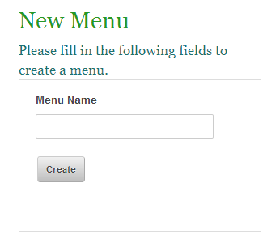

Figure 2‑1 Creating a New Menu

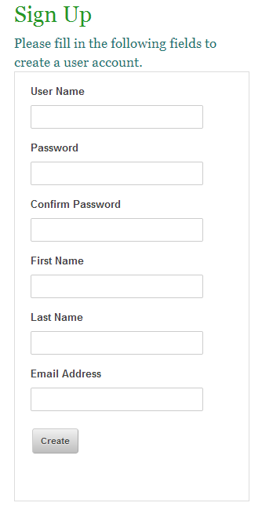

Figure 2‑2 Creating a New Account

## Navigation

Users of TFF will navigate around the system primarily with the menu located horizontally across the top of each page. This menu is visible on both mobile and desktop platforms. The appearance of the top menu will change according to the user role; Meaning that the options or links displayed on the top menu will change according to the type of user logged into the system and their assumed end goals. The main menu will arrange itself to accommodate different screen sizes or window dimensions.

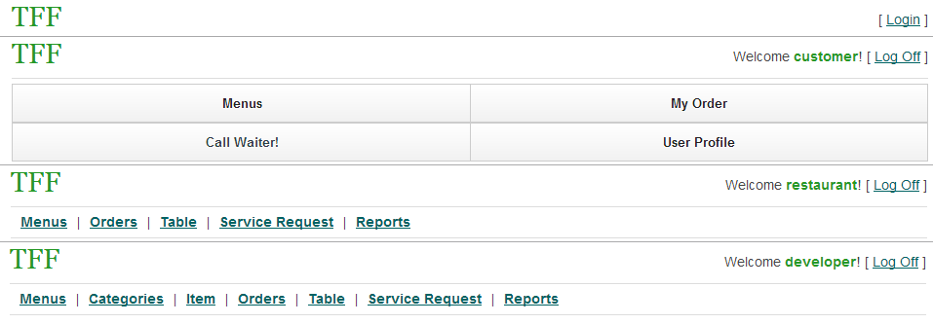

Figure 2‑3 TFF Top Menu According To User Role

Users may also use the search bar, located beneath the top site menu, to navigate through a restaurant’s food menu. Users can type in keywords and the search function will filter through food descriptions in order to provide matches. Users can select search results to see more in depth descriptions or add items from the search results directly to their order.



Figure 2‑4 Search Bar

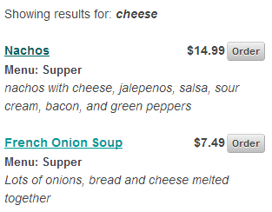

Figure 2‑5 Search Results

TFF is a web application, so users can also navigate around the system using the back, forward and address bar components in their web browser.

## Feedback

The application provides appropriate feedback when performing various operation throughout the TFF system. Feedback is provided when adding items to an order, signing up for an account, and leaving a review for a particular restaurant.

### Account Creation Feedback

An example of feedback received when attempting to create an account with invalid input data.

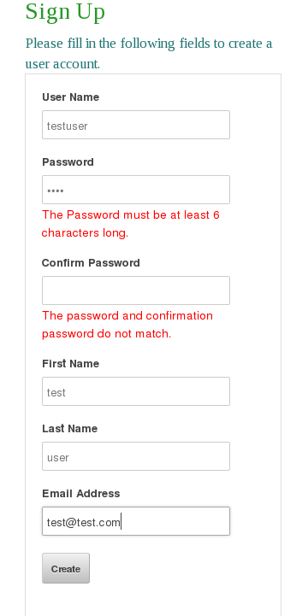

Figure 2‑6 Account Creation With Error

When an account is successfully created, the user receives feedback by seeing that he is now logged in with the

newly created account.



Figure 2‑7 Account Creation Successful

### Popups

The TTF application also provides the user with information by the use of pop-ups. These pop-ups allow the user to confirm an operation. One example of such usage is when a user adds a menu item to his current order.

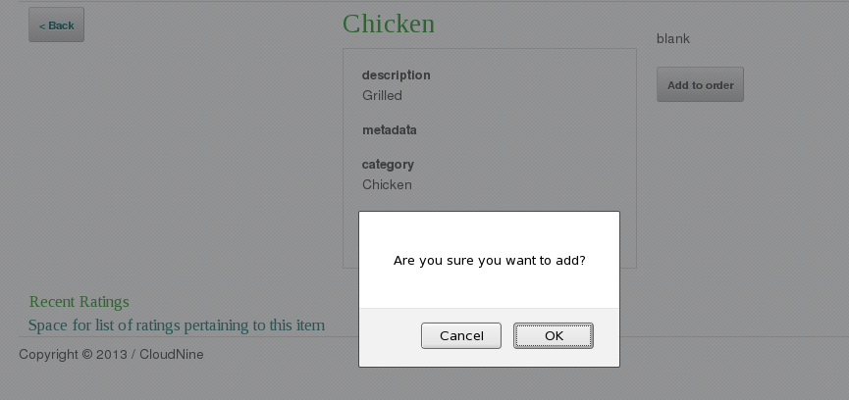

Figure 2‑8 Adding Item To Order Confirmation

## Screen layout

The screen layout for TFF is designed to be simple in order to provide easy navigation on a computer screen or a mobile device. The theme is designed to be optimized for mobile devices while still providing the same functionality on a monitor or screen. There are a few common layout schemes that are used that help provide a consistent look and feel to the user.

### Restaurant Management Grids

Many of the pages that are available to restaurant managers contain functionality for content management system type operations. However, instead of using tables to display data, we use grids. One such example can be found in the menu manager page.

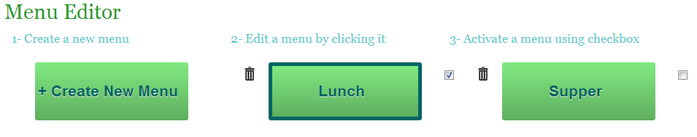

Figure 2‑8 Menu Manager Grid

Grids are also used in other areas of the system such as Bill Management as seen in the following figure.

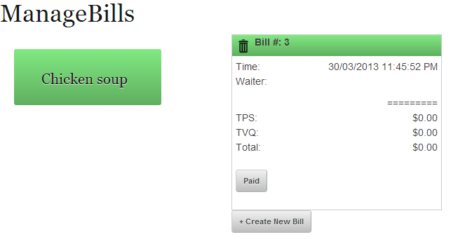

Figure 2‑9 Bill Management Grid

Grids are used to simplify and highlight items throughout the system. Grid buttons are themed with a dark blue border and font with a light green to green gradient.

### Buttons or Icons

Buttons are themed to have a very light to light grey gradient. Button text is a dark grey. All buttons follow this color scheme except for buttons that are part of a management grid like in Figure 2-2.

Figure 2-3 shows an example of the buttons used to order an item. Figure 2-4 shows a create button which has the same theme as the order buttons except that it is slightly larger.

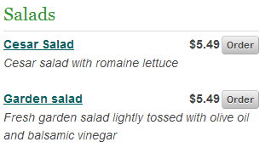

Figure 2‑10 Order from Menu

### Forms

Forms get used for creating or updating models from the content management system. They are also used for search and login. Form text inputs have a light grey border and grey text. If it is a create or update form, a grey box outlines it. Figure 2-4 shows an example of a create form.

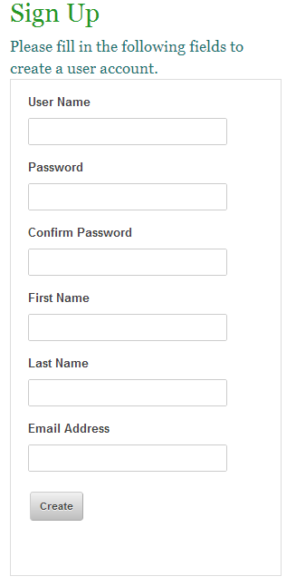

Figure 2‑11 User Creation

### Overlays

Overlays are used to display information to a user without refreshing the page. One example of this is the menu item details page as seen in Figure 2-5.

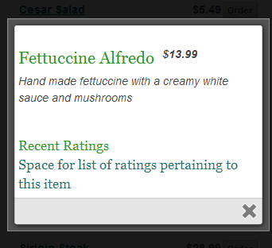

Figure 2‑9 Menu Details Overlay

Overlays are also used on the menu browse and search pages.

# ****Appendix A References****

x

|  |  |
| --- | --- |
| [1] | JAMPACK, "UIR," Concorida University, Montreal, Documentation 2012. |
| [2] | Petr Stanicek. (2010) Colr Scheme Designer. [Online]. <http://colorschemedesigner.com/#2P51Tw0w0w0w0> |

x

# Appendix B Glossary

Refer to the SRS document - Appendix B Glossary and Appendix C Acronyms for a complete list of terms and definitions.