Looking for a game that's easy to learn yet impossible to master? Challenge a friend to Wallscape, an original strategy game that puts your cunning to the test! Get your peices safely across the board as you watch your opponent struggle through the maze of walls you've built up in an attempt to thwart their plans and make victory yours!

++++ Rules ++++

The main objective of Wallscape is to get all of your pieces to safety before your opponents.

Players take turns moving pieces and placing walls until someone wins. Each turn is comprised of a certain amount of Operations. For each operation, a player can choose to either place a wall or move a piece.

In order to balance the odds, the player who plays first will have a fraction of the normal amount of Operations for their first turn only.

The amount of operations per turn and tokens can be customized or adjusted using any of the three games modes in the Settings.

____ Game Modes ____

Classic – Recommended Settings

Quick – For an easy to use quick game

Epic – For more advanced users (better for devices with larger screens)

AI and Animation Update planned for October 2012

GAME BOARD

SCOREBOARD

MAKE WALL

MOVE

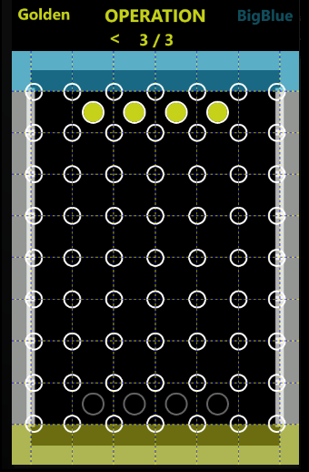 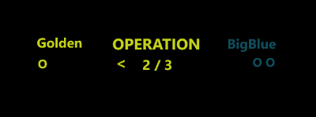

**3**

**2**

**1**

**5**

**6**

**4**