TERRAFORM TASK -04
- Execute the script shown in the video.
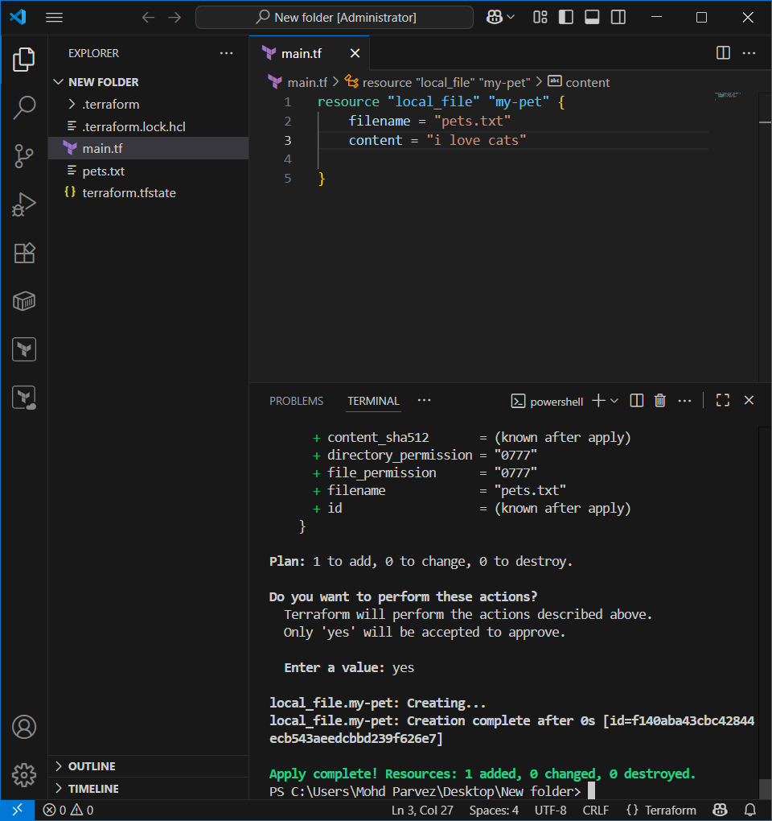
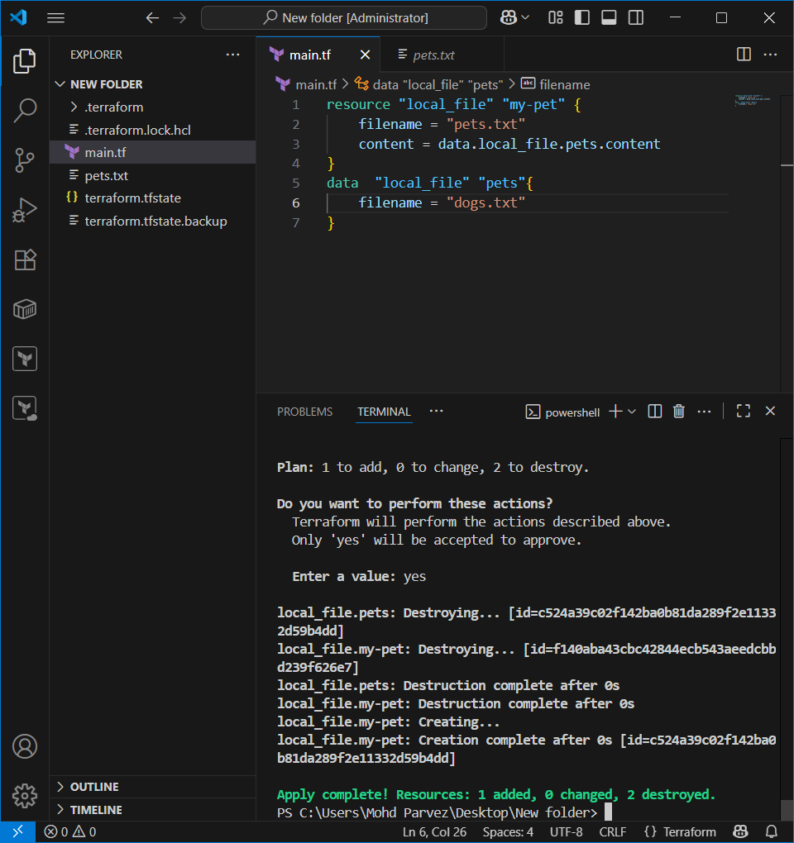

Use the specific version
version = "2.3.0" --> download the exact version
version = "!=2.3.0" --> will not use the mentioned version
version = "< 2.3.0" --> lesses than the mention version
version = "> 2.3.0" --> greater than the given version
version = "~> 2.3.0" --> specific version or higher version.

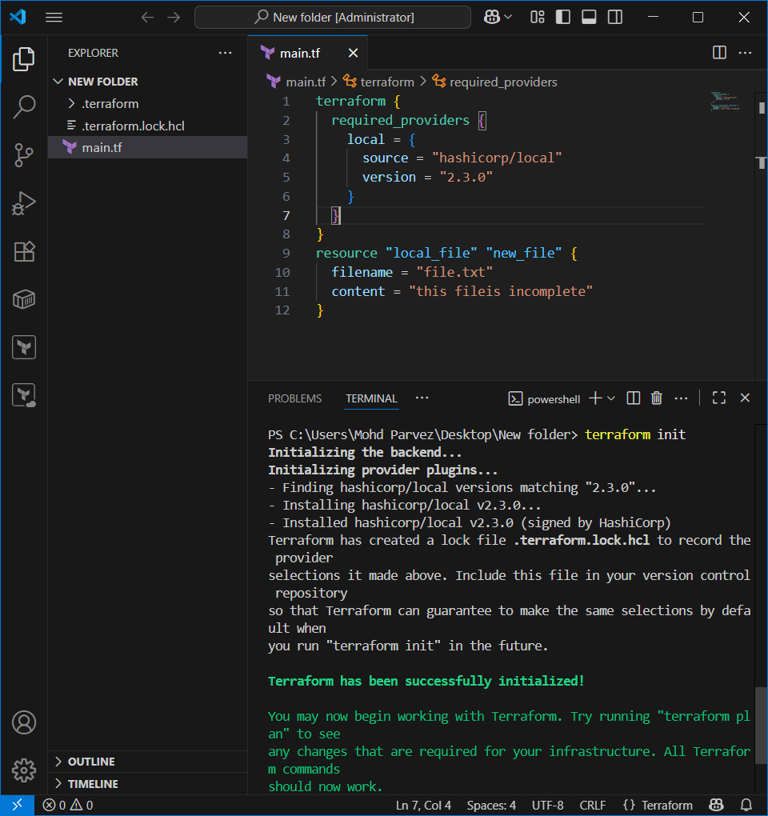
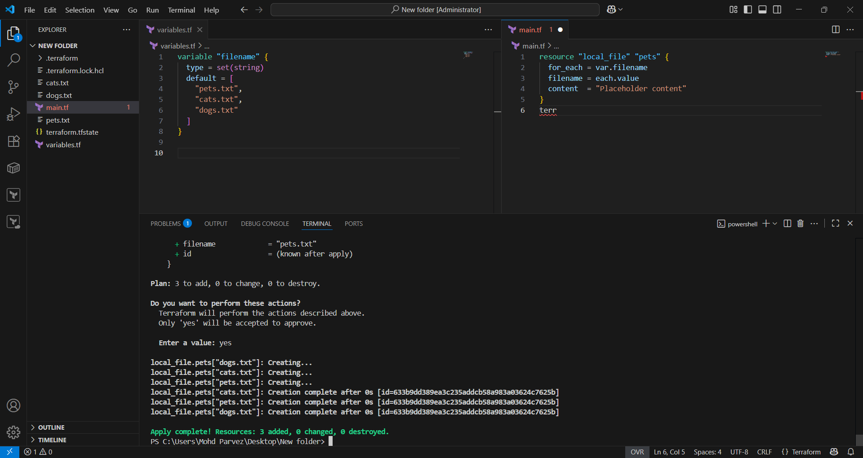

- Integrate Terraform in Jenkins using the Terraform plugin. 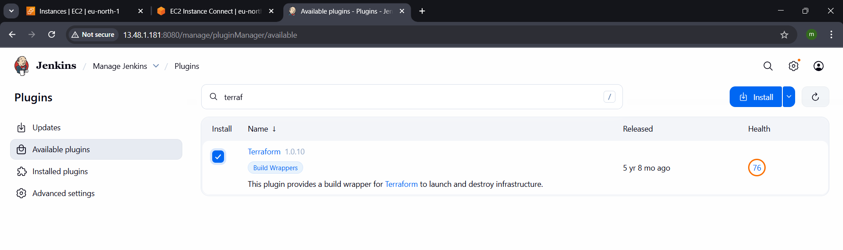

- Create a CI/CD pipeline for a Nodejs Application: https://github.com/betawins/Trading-UI.git

Download node js plugin in the jenkins
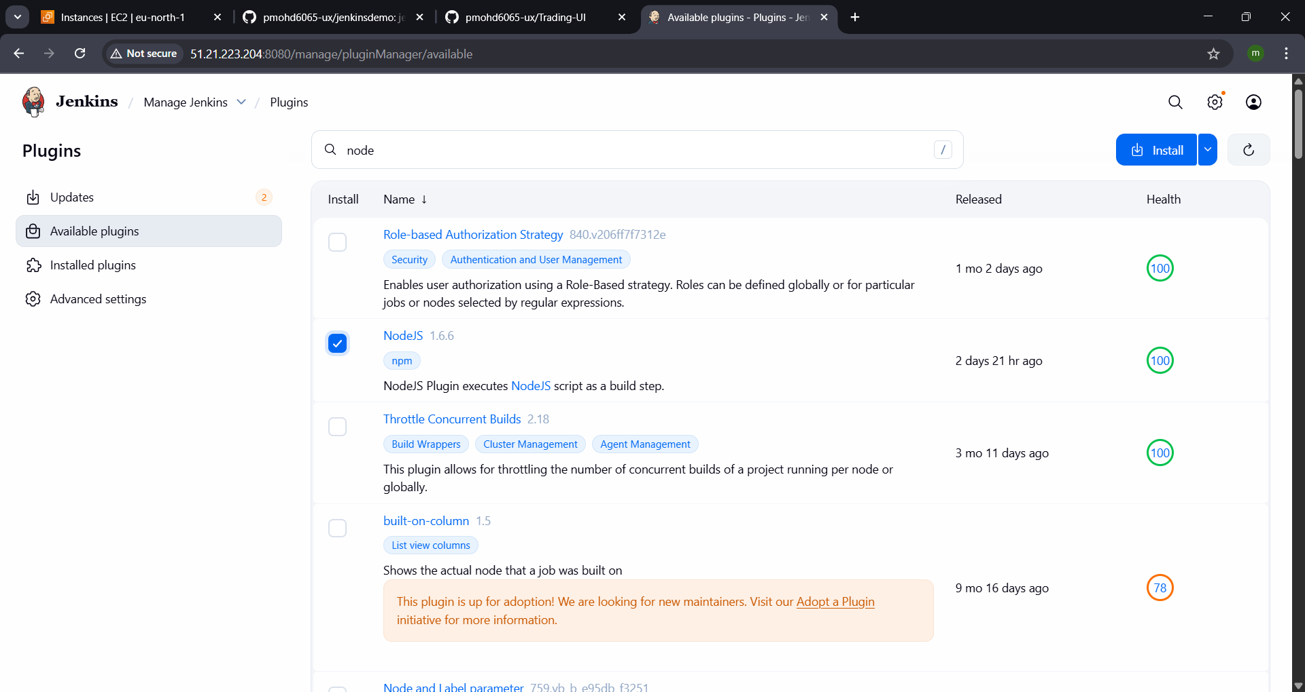
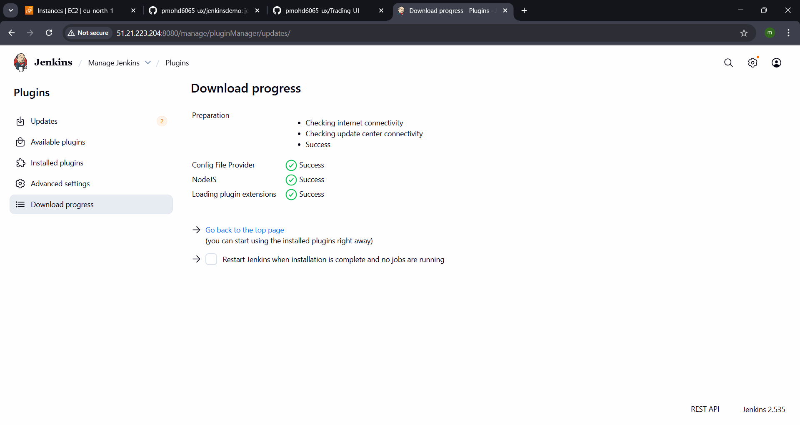
Install node js in server
curl -sL https://rpm.nodesource.com/setup_18.x | bash -
yum install -y nodejs
npm --version
node --version
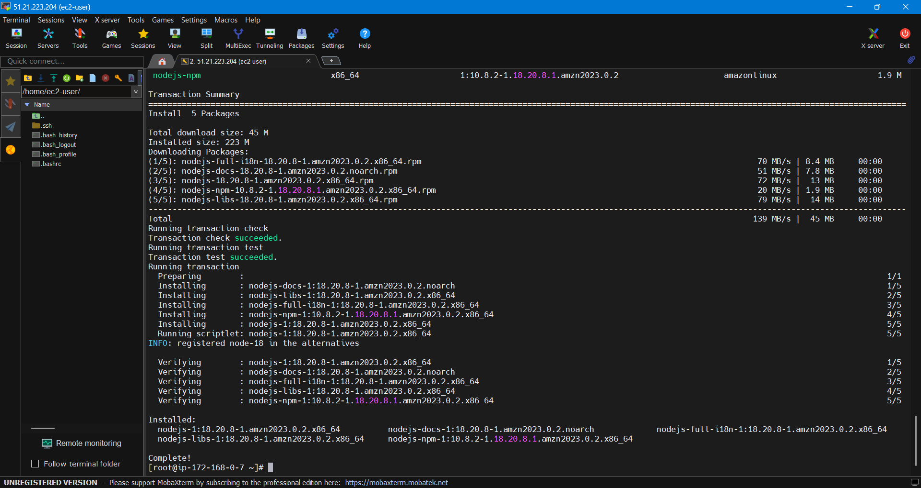
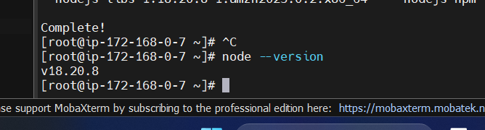

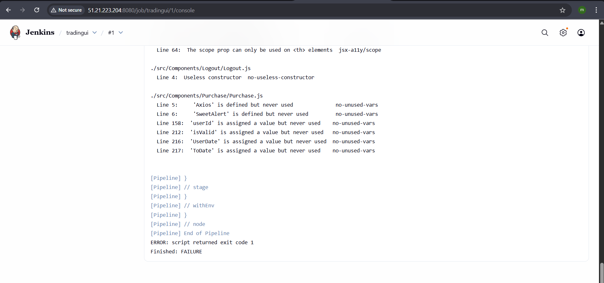

Fixed it with skipping the npm audit step
pipeline {
agent any

stages {
stage('Git checkout') {
steps {
git 'https://github.com/pmohd6065-ux/Trading-UI.git'
}
}

stage('Install npm prerequisites') {
steps {
// Skip audit completely
sh 'npm install --no-audit || true'

// Show build logs even on failure
sh 'npm run build || true'

// Move into build folder
dir('build') {
// PM2 often returns exit code 1 if already running
sh 'pm2 --name Trading-UI start npm -- start || true'
}
}
}
}
}

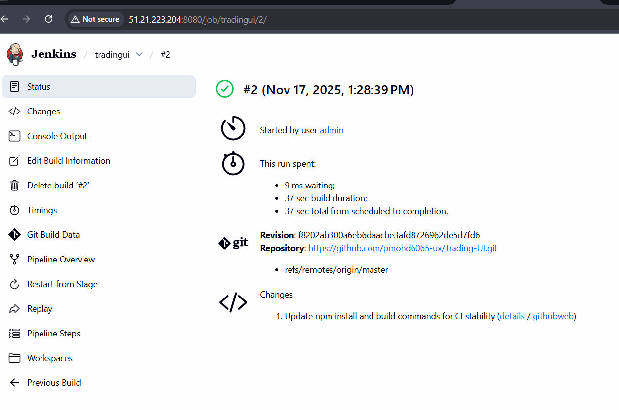

- EXPLAIN 10 MAVEN COMMANDS

mvn **validate** | Checks if the project structure is correct and all necessary information and dependencies are available in the local repository.
mvn **compile** | Compiles the source code of the project (files in src/main/java) and places the compiled class files in the target/classes directory.
mvn **test** | Runs the unit tests for the compiled source code using a suitable testing framework (like JUnit or TestNG). It automatically compiles the code and test sources first.
mvn **package** | Compiles, runs tests, and packages the compiled code into its distributable format, such as a JAR or WAR file, stored in the target directory.
mvn **verify** | Runs all checks and integration tests on the packaged artifact to ensure it meets quality criteria before it is installed or deployed.
mvn **install** | Runs all previous lifecycle phases, then installs the project's artifact (e.g., JAR or WAR file) into your local Maven repository for use as a dependency in other local projects.
mvn **deploy** | Runs all previous phases and copies the final package to a remote repository (e.g., a company's internal repository or Maven Central) for sharing with other developers and projects.
mvn **clean** | Removes all files and directories generated by the previous build, most notably deleting the target directory. This ensures a clean, fresh build when run before another command (e.g., mvn clean install).
mvn **dependency:tree** | Prints the dependency tree of the project to the console, which helps in visualizing and resolving dependency-related issues and version conflicts.
mvn **--version** | Displays the installed Maven version, Java version, and operating system information, useful for verifying your setup.

