ANSIBLE TASK -04

Create ansible playbook to create ansible vault.
---
# Playbook: create_vault_file.yml
yaml
---
- name: Create and encrypt an Ansible Vault file
hosts: localhost
connection: local
gather_facts: no

vars:
vault_file: secret_vars.yml

tasks:

- name: Create a normal YAML file with variables
copy:
dest: "{{ vault_file }}"
content: |
db_user: admin
db_password: MySecretPass123
api_key: ABCD-XYZ-123

- name: Encrypt the file using Ansible Vault
command: ansible-vault encrypt {{ vault_file }} --vault-password-file vault.pass
args:
chdir: "{{ playbook_dir }}”
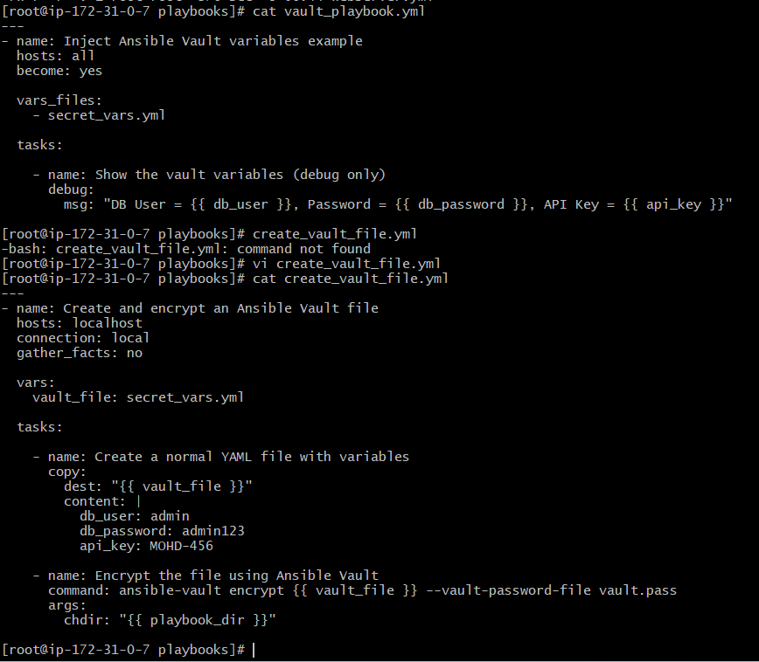

#STEP 1 — Create a vault password file

Before running the playbook, create a vault password file:

```bash
echo <My_Vault_Password> > vault.pass
chmod 600 vault.pass
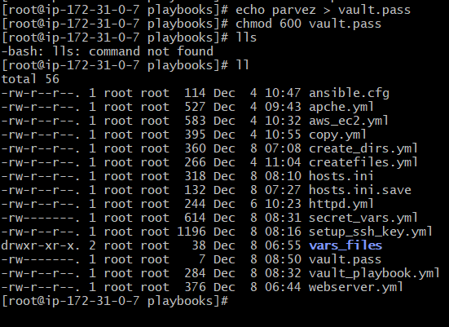
---

# **STEP 2 — Run the playbook**

```bash
ansible-playbook create_vault_file.yml
```
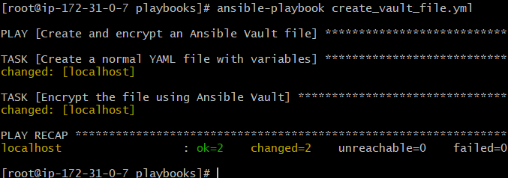
After running:

* `secret_vars.yml` will be encrypted
* You can view it with:

```bash
ansible-vault view secret_vars.yml --vault-password-file vault.pass
```
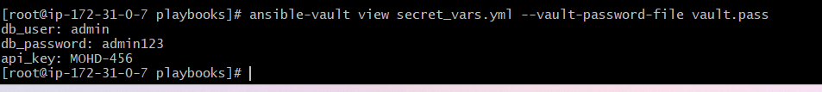

Write a ansible playbook to install apache in linux and ubuntu machine by using when condition.
---
#Playbook: install_apache.yml
---
- name: Install Apache on Linux & Ubuntu using when condition
hosts: all
become: yes
tasks:
# For RHEL / CentOS / Amazon Linux
- name: Install Apache on RHEL-based systems
package:
name: httpd
state: present
when: ansible_os_family == "RedHat"
- name: Start and enable Apache on RHEL-based systems
service:
name: httpd
state: started
enabled: yes
when: ansible_os_family == "RedHat"
# For Ubuntu / Debian
- name: Install Apache on Debian-based systems
package:
name: apache2
state: present
when: ansible_os_family == "Debian"
- name: Start and enable Apache on Debian-based systems
service:
name: apache2
state: started
enabled: yes
when: ansible_os_family == "Debian"
# Run the playbook
bash
ansible-playbook install_apache.yml -i hosts.ini
---
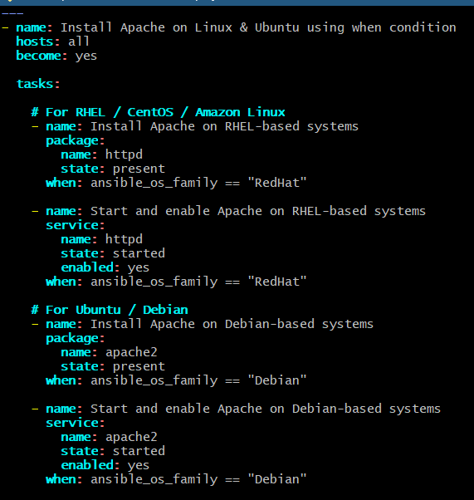
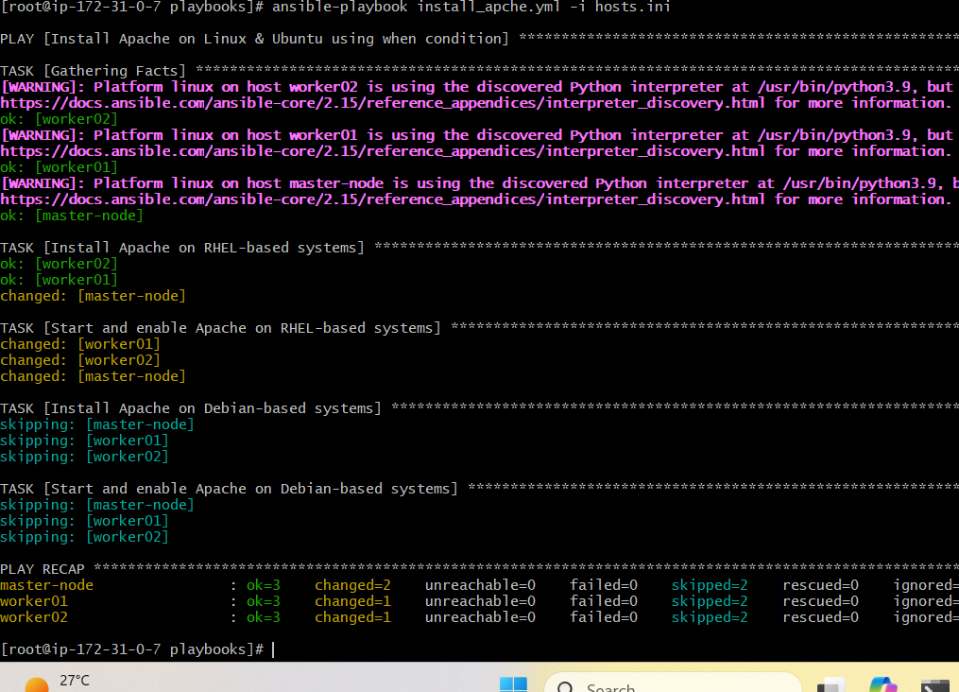

Create ansible playbook using roles to configure LAMP stack
* **L** → Linux (your EC2 instance)
* **A** → Apache
* **M** → MariaDB/MySQL
* **P** → PHP

---

1. Directory Structure

Inside your `lampplaybook/` folder:

```
lampplaybook/
├── site.yml
├── hosts.ini
└── roles/
├── apache/
│ └── tasks/main.yml
├── mysql/
│ └── tasks/main.yml
└── php/
└── tasks/main.yml
```

---

2. site.yml

```yaml
---
- name: Configure LAMP Stack using Roles on AL2023
hosts: webservers
become: yes

roles:
- apache
- mysql
- php
```

---

3. Apache Role — roles/apache/tasks/main.yml

```yaml
---
- name: Install Apache on Amazon Linux 2023
package:
name: httpd
state: present

- name: Start and enable Apache
service:
name: httpd
state: started
enabled: yes
```

---

4. MySQL Role — roles/mysql/tasks/main.yml

```yaml
---
- name: Add MySQL Yum Repo for Amazon Linux 2023
dnf:
name: https://repo.mysql.com/mysql80-community-release-el9.rpm
state: present

- name: Install MySQL Community Server
dnf:
name: mysql-community-server
state: present

- name: Enable and start MySQL
service:
name: mysqld
state: started
enabled: yes
```

5. PHP Role — roles/php/tasks/main.yml

Amazon Linux 2023 ships PHP 8.2:

```yaml
---
- name: Install PHP 8.2 and MySQL module
package:
name:
- php8.2
- php8.2-mysqlnd
- php8.2-cli
- php8.2-common
state: present

- name: Restart Apache for PHP support
service:
name: httpd
state: restarted

6. hosts.ini

```ini
[webservers]
172.31.0.7 ansible_user=ec2-user ansible_ssh_private_key_file=/root/key.pem

7. Run the LAMP setup

bash
ansible-playbook -i hosts.ini site.yml

---

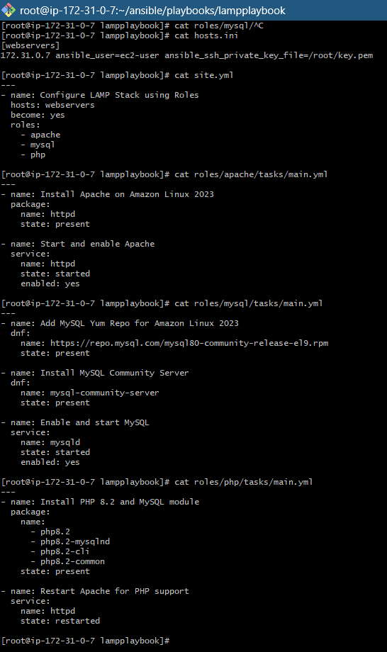

#7. Run the LAMP Installation
Run from the project root:
bash
ansible-playbook -i hosts.ini site.yml
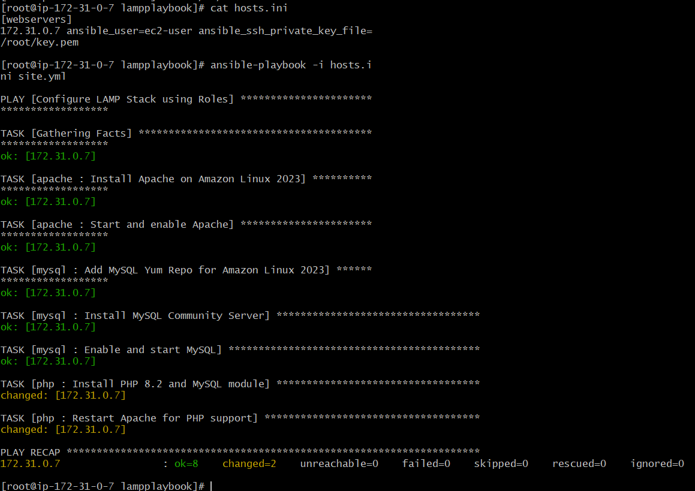
#This will:
* Install Apache
* Install and start MySQL/MariaDB
* Install PHP
* Restart Apache so PHP works
* Organize everything into clean **roles**, which is best practice
---

Setup ansible AWX and explore the options.
What is Ansible AWX?

AWX is the web-based UI and REST API for Ansible.
It provides:

🔹 GUI to run playbooks

🔹 Role-based access control (RBAC)

🔹 Scheduling

🔹 Logging & job history

🔹 Credentials & secrets management

🔹 Multi-inventory automation

🔹 Workflow automation

STEP 1 — Install Docker:

```bash
sudo yum install -y docker
sudo systemctl enable --now docker
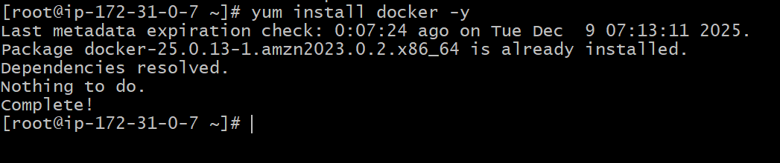

STEP 2 — Start Minikube with Docker driver
Download Minikube
Run:
curl -LO https://storage.googleapis.com/minikube/releases/latest/minikube-linux-amd64
install Minikube
sudo install minikube-linux-amd64 /usr/local/bin/minikube

minikube version
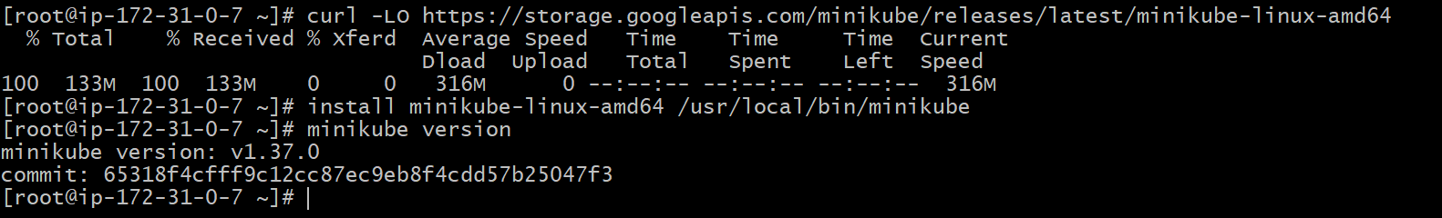
```bash
minikube start --driver=docker –force
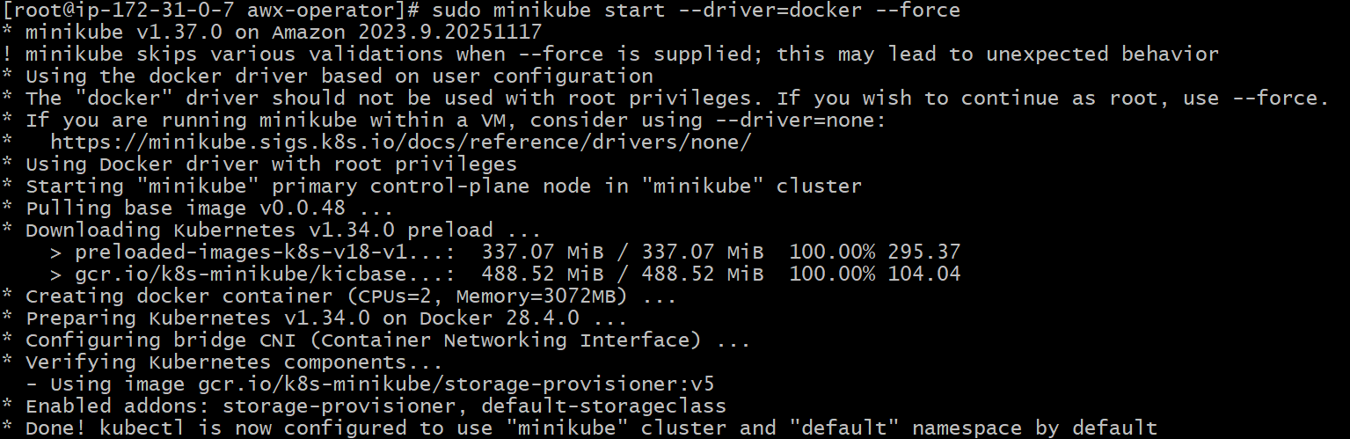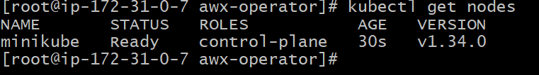

```
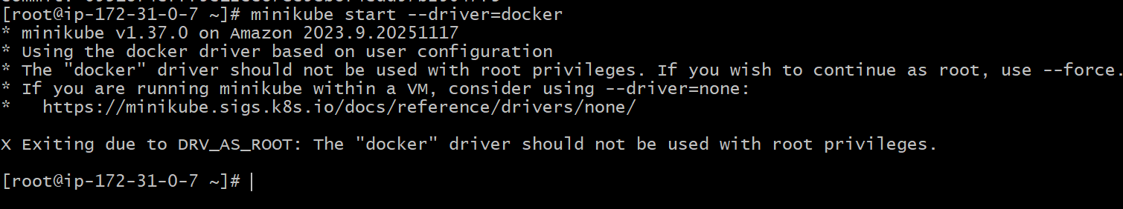

Install kubectl

Run these commands:

LATEST=$(curl -L -s https://dl.k8s.io/release/stable.txt)
echo $LATEST
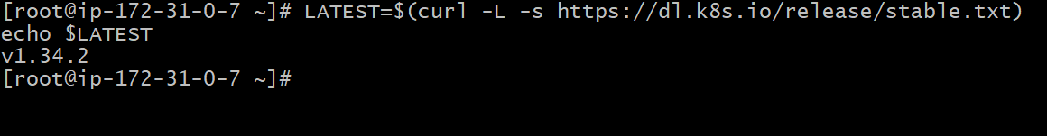
Download kubectl using the version variable

curl -LO https://dl.k8s.io/release/$LATEST/bin/linux/amd64/kubectl```
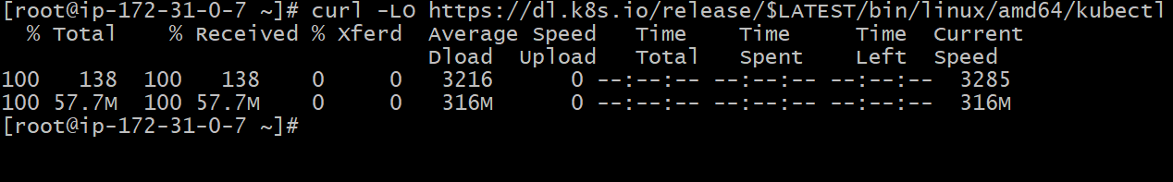
---
Install kubectl
chmod +x kubectl
sudo mv kubectl /usr/local/bin/
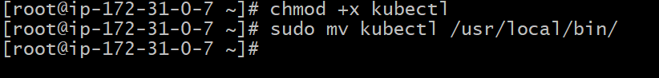
kubectl version –client
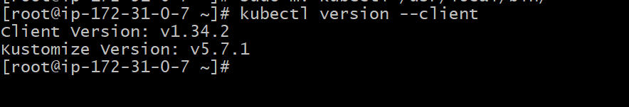

STEP 3 — Install AWX Operator (same steps)

```bash
git clone https://github.com/ansible/awx-operator.git

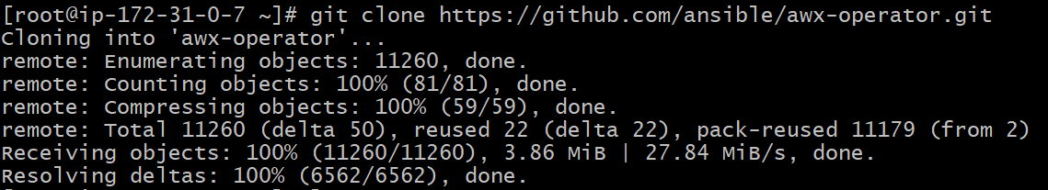
cd awx-operator
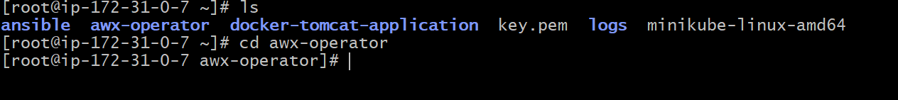
git checkout tags/2.17.0

sudo dnf install -y make
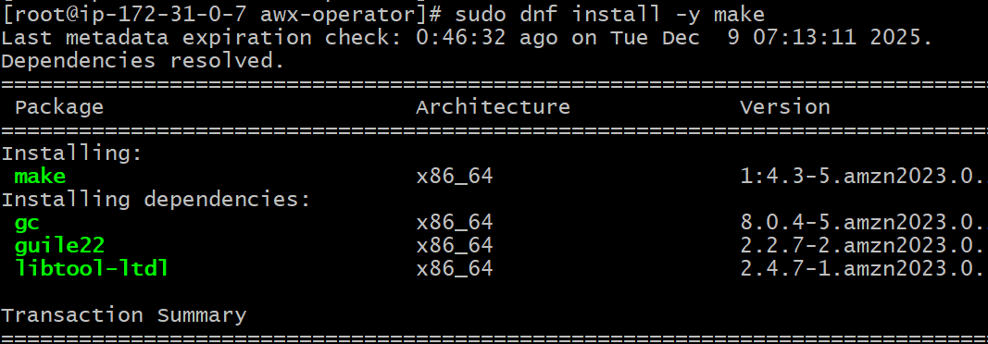

make deploy
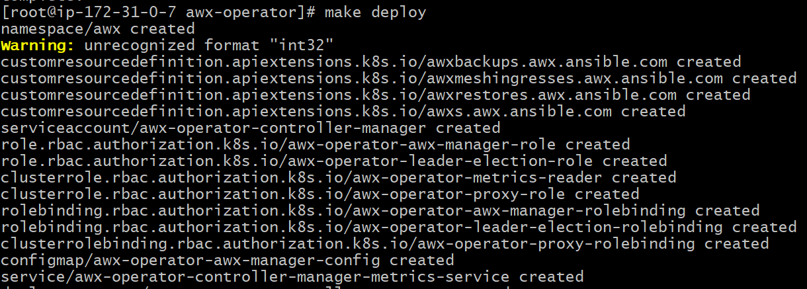

Kubectl get pods -n awx

STEP 4 — Deploy the AWX instance

Create the file:

`awx.yaml`

apiVersion: awx.ansible.com/v1beta1
kind: AWX
metadata:
name: awx
namespace: awx
spec:
service_type: nodeport
ingress_type: none

Apply it:

```bash
kubectl apply -f awx.yaml
```
kubectl get pods -n awx -w
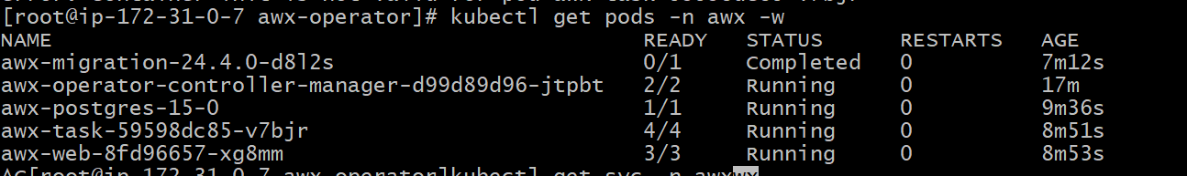

---

STEP 5 — Get AWX password and access UI

```bash
kubectl get svc -n awx
kubectl get secret awx-admin-password -n awx -o jsonpath="{.data.password}" | base64 --decode
```

Open AWX in browser using:

```
http://<minikube-ip>:<nodeport>
```
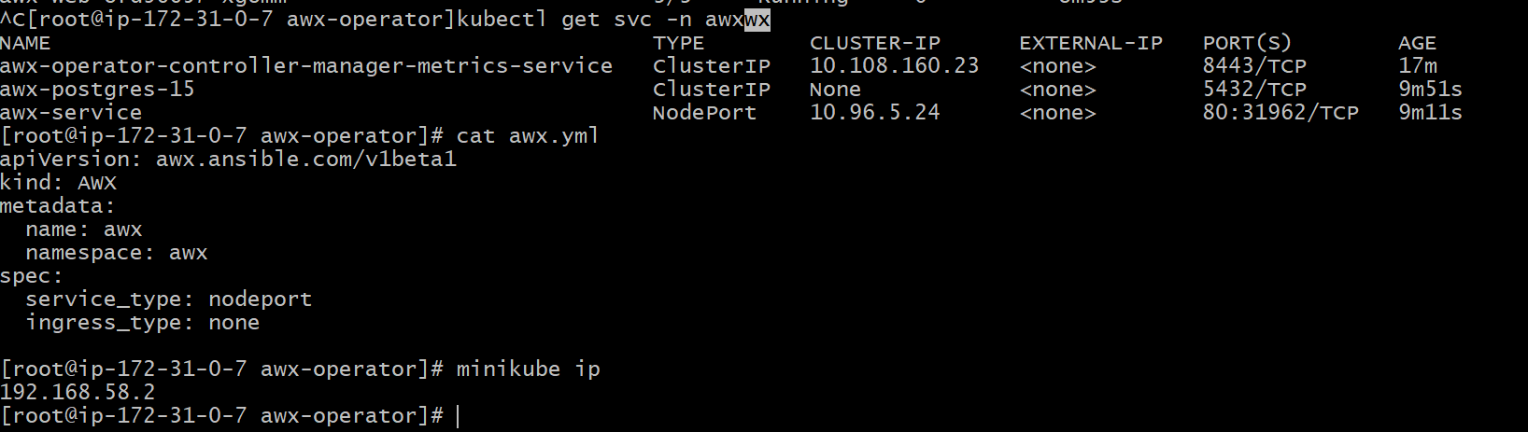

kubectl port-forward -n awx svc/awx-service --address 0.0.0.0 8080:80
http://54.226.154.113:8080

