**LIST OF COMMANDS EXECUTED IN GIT BASH:**

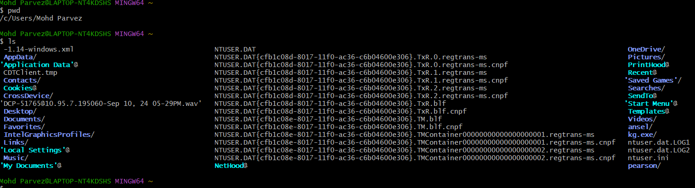

1. **pwd** - used for to know the present working directory that is the location of the file.
2. **ls –** usedforlisting the files that are in the directory.

**___________________________________________________________________________**

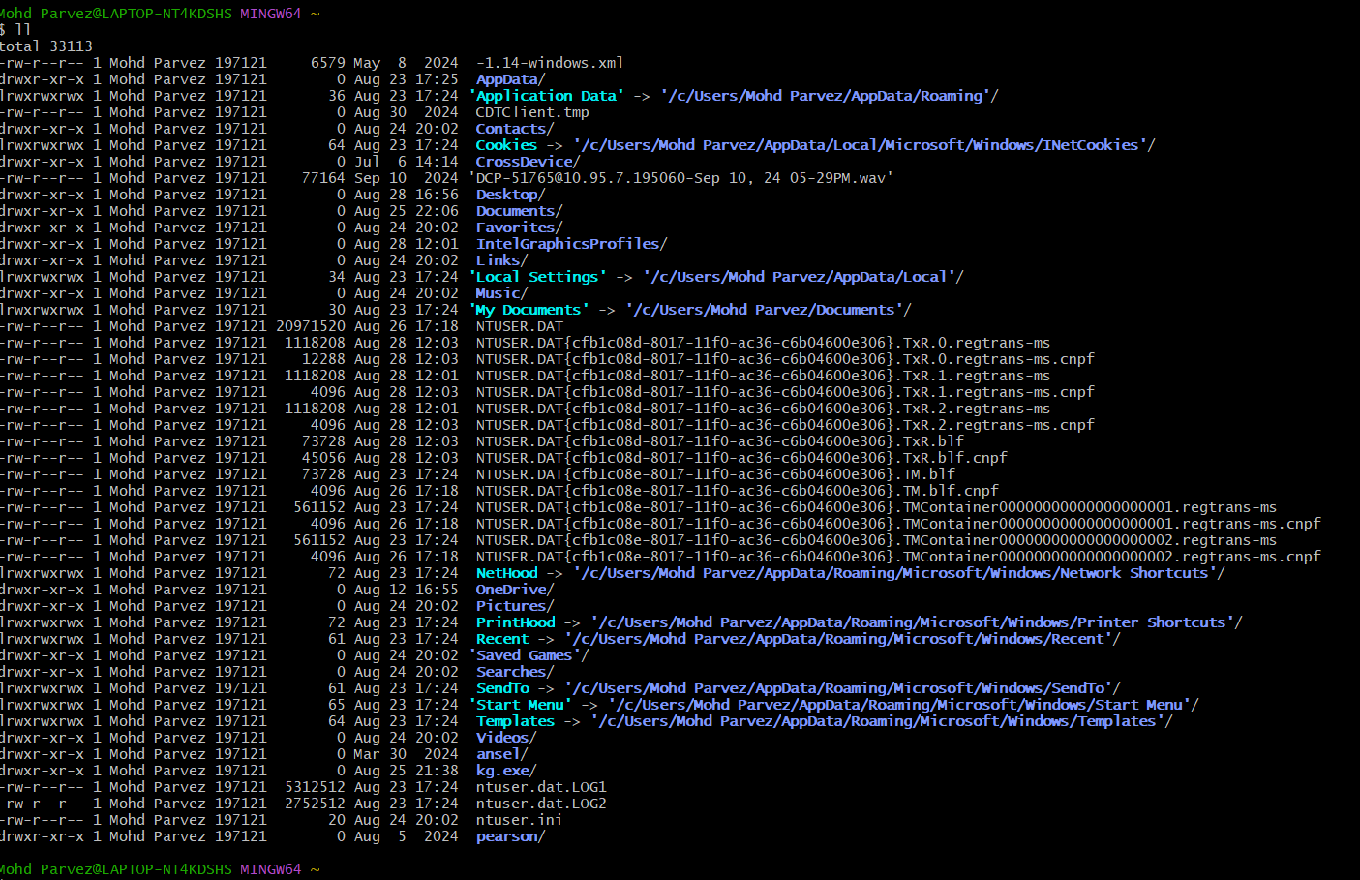

1. **ll** - long format listing providing the more detail about each and every entry.

___________________________________________________________________________

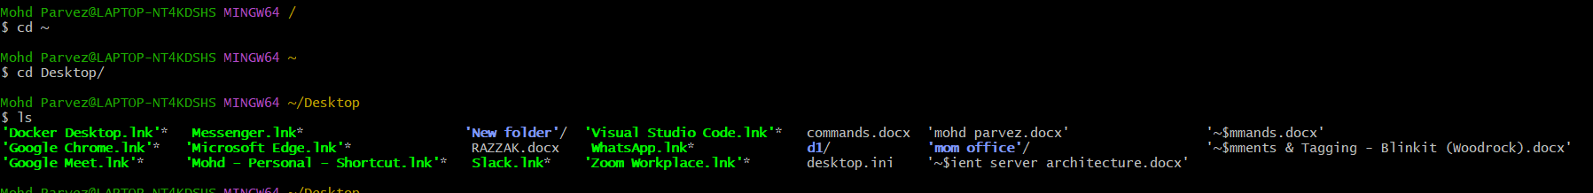

1. **cd** – to change the directory of the current directory to required or which you are working.

___________________________________________________________________________

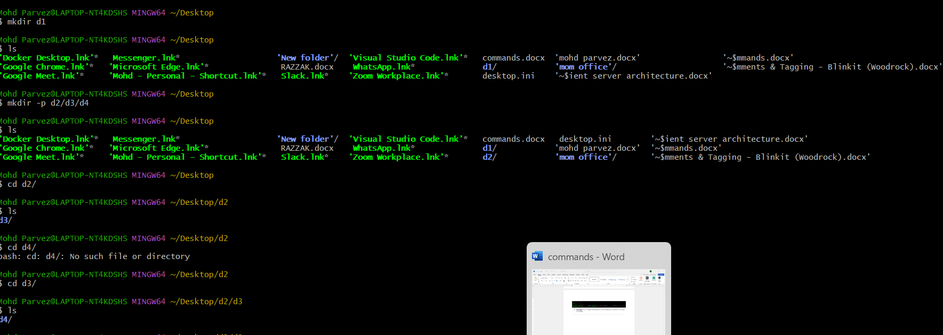

1. **mkdir d1** - to create new directory
2. **Mkdir -p d2/d3/d4**  - to create path directory to the directory.

___________________________________________________________________________

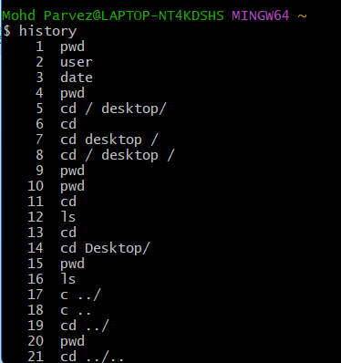

1. **history –** to see the history of commands.

___________________________________________________________________________

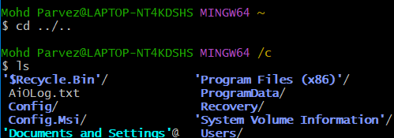

1. **cd ../..** : to go two steps from current directory

___________________________________________________________________________

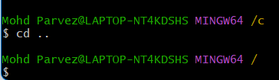

1. **cd ..** : to go one step back from the current directory.

___________________________________________________________________________

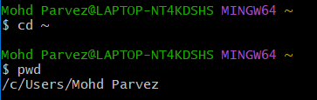

1. **cd ~ :**  home directory command.

___________________________________________________________________________

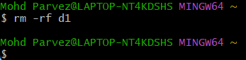

1. **rm -rf d1 :**  to delete the directory.

___________________________________________________________________________

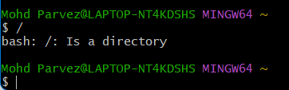

1. **/** : to show the root directory.

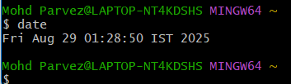

1. **date :**  to know date and time

__________________________________________________________________________________

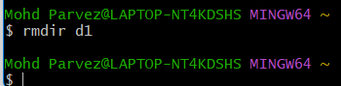

1. **rmdir :** to remove file name.

__________________________________________________________________________________

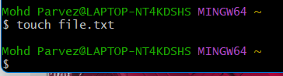

1. **touch file.txt :** to create an empty file.

__________________________________________________________________________________

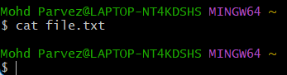

1. **Cat file.txt :** view contents of a file.

__________________________________________________________________________________

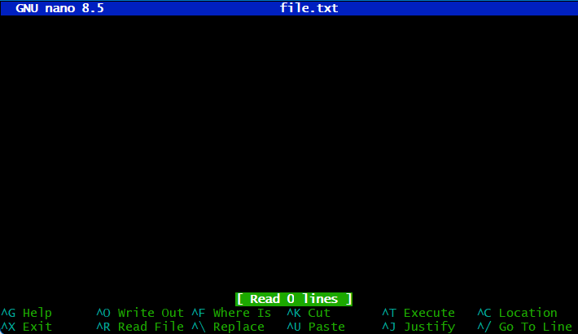

1. **nano file.txt :** to edit a file.

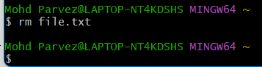

1. **rm file.txt –** to delete the file

__________________________________________________________________________________



1. **clear :**  to clear the terminal.

_________________________________________________________________________________

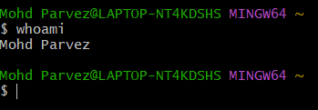

1. **whoami :**  to show the current logged in user.

_________________________________________________________________________________