**Client server architecture**

a computing model where a central server provides resources and services to multiple client devices (computers, phones, etc.) over a network.

* Client- which is trying for a request resource/query

Devices (workstations, computers, phones, etc.) that request services or resources from the server.

* Server- which responds to the server.

Powerful computers that host resources and services, process client requests, and manage data.

**Examples :**

* **Websites:**

Your web browser (client) requests a webpage from a web server, which sends back the HTML, CSS, and JavaScript to display the page.

* **Email:**

Email clients (like Outlook or Gmail) send and receive emails through email servers.

* **Online Banking:**

Banking apps (clients) connect to banking servers to perform transactions, check balances, etc.

* **E-commerce:**

Online shopping platforms rely on client-server architecture for browsing products, adding them to carts, and completing purchases.

* **Online Gaming:**

In many online games, the game client on your device interacts with a game server to manage game state, player actions, and interactions.

**Types of architecture**

The primary types of client-server architecture are defined by the number of tiers, or layers, into which the application's components are logically and physically separated

. These components include the user interface (presentation), the business logic (application processing), and the data management (database).

* **1-Tier Architecture**(development environment)
  + **Description:** All components of the application—user interface, business logic, and data storage—reside on the same device or a single server.
  + 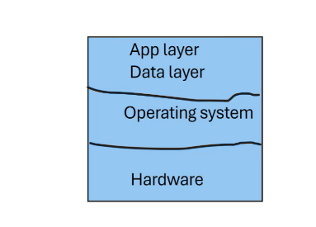**Example:** A standalone desktop application that stores all its data locally.

* **2-Tier Architecture**(development environment)
  + **Description:** This architecture separates the application into two tiers: the presentation and business logic on the client side, and the data (database :mysql, oracle) on the server side. (using jav,.net, pyhon)
  + **Example:** A desktop application that connects to a remote database, like a simple web application with an online account. Ex-facebook
  + Stores user information in data base.ram is responsible for executing the processes.if the required ram and storage is less than the requirement the application slow down the operation.
  + Application layer and server layer are same .Anyone can hack and steel the data easily because of public server.

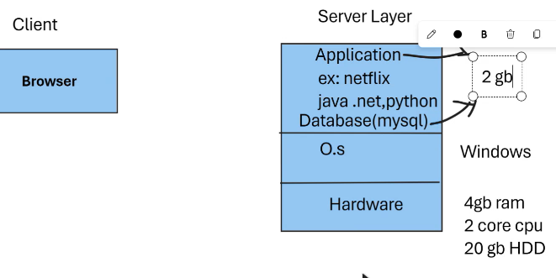

* **3-Tier Architecture**
  + **Description:** A three-layer model that introduces a middleware layer, often called the application or business logic layer, between the client (presentation layer) and the data (database layer).
  + Browser-application layer-datalayer
  + **Benefits:** This separation improves flexibility, security, and maintainability.
  + **Example:** E-commerce applications or banking systems.
  + Private server no one can access.

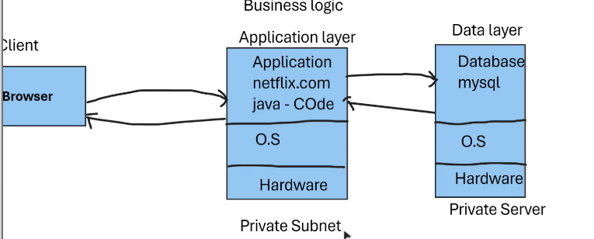

* **N-Tier Architecture**
  + **Description:** An extension of the 3-tier model where the application is divided into multiple independent layers, with each layer handling a specific function.
  + **Benefits:** Promotes modularity, scalability, and allows for more complex and distributed systems.
  + **Browser-**websever(public)no code only configuration-application layer(private)- database(private)
  + N no.of layers can be added.
  + **Example:** Large enterprise-level applications with many components.

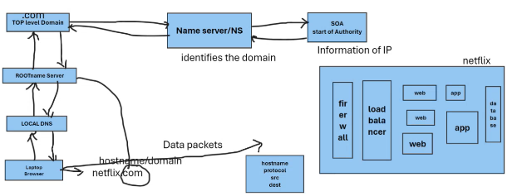

**Types of environments:**

**Lower environment**

1. Development –developers testing the codes after successfully done move to 2.
2. Staging environment t – user acceptance test .implanting test on application and after successfully function move to 3.
3. Production environment – live environment(getting Reponses from client servers)

We can also have environments and more according to the requirement.

Communicating the client and server is based on the “IPaddress” which is provided.

IPv4 :ex-192.168.0.0-conecting devices like Bluetooth, wifi etc

IPV6: 2001:db8:3333:4444:5555:6666:7777:8888

For every server you will have host name that is name of the device ex-laptop.

**Web servers :** used for static content deployment

Ex:apache(httpd), nginx

**Application server**: used for dynamic content deployment.

Ex: weblogic,apache tomcat,jboss.

**Data base:**  to store the data

Ex: mysql,oracle,pssql.

* For security purpose firewall is added to the tier where fire wall will only accept the request from https only as per the prottocal or rule.
* Browser-firewall(security)-web server-apllication layer-data base layer used for development or production environment.
* Getting requests from multiple users applicatin may get slow down or crashed
* Soto avoid we add layer of load balancer and add more browser layerS.
* Load balancer layer is to maintain the traffic on internet that is users.
* 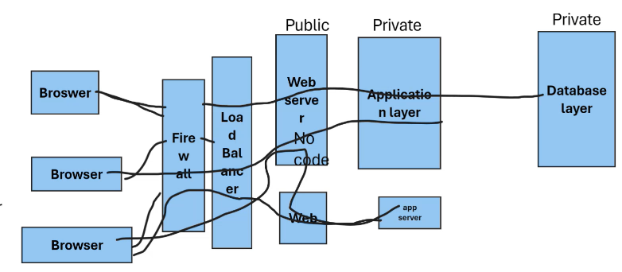

LINUX commands :