**INSTALL APACHE TOMCAT ON PORT NUMBER 8082**

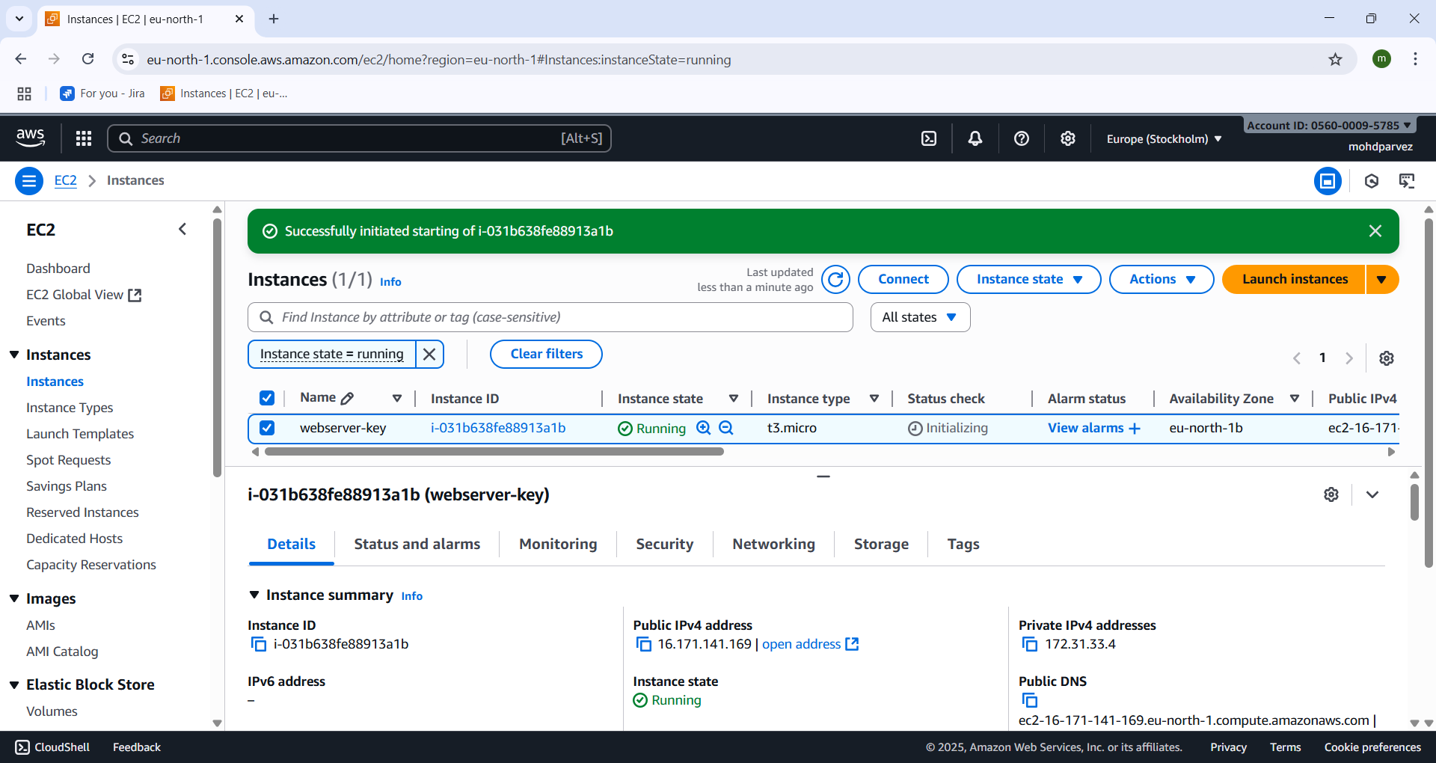

* Lauch aws ec2 instance .

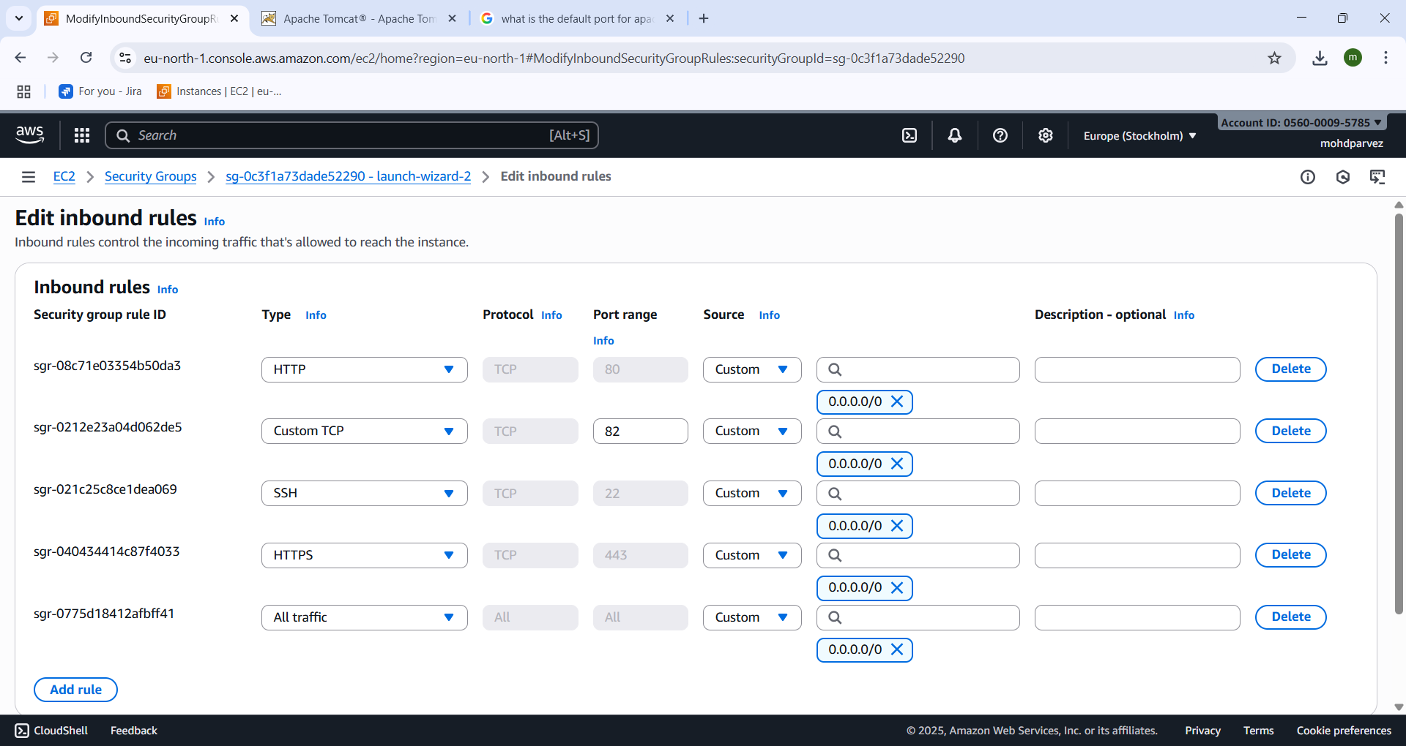

* Go to security groups and click on edit inbound rules
* Add security group with custom tcp and give port no all and save.

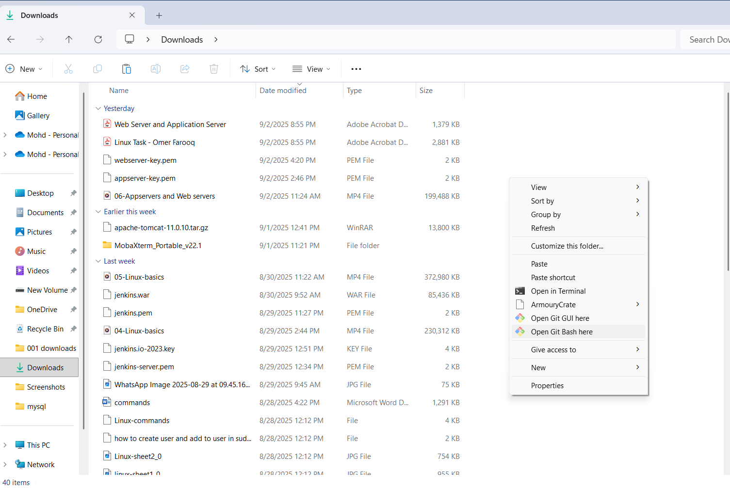

* Go to the location where keypar.pem is downloaded and right click and select open git bash here.

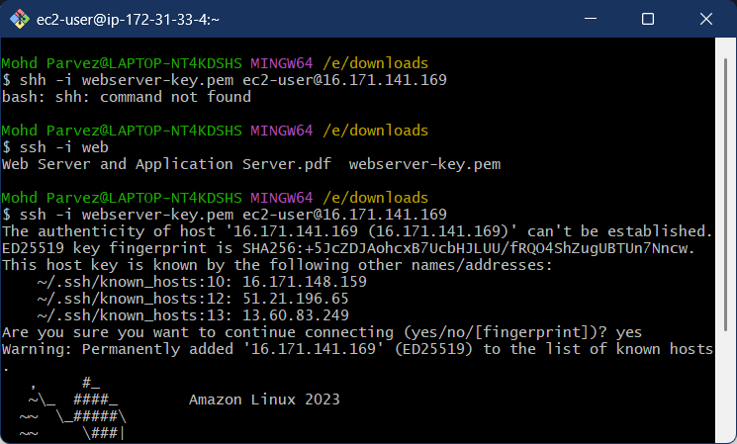

* Connect to the remote machine by using : ssh -i “keypair.pem” ec2-user@ “ip_v4 _public address”.

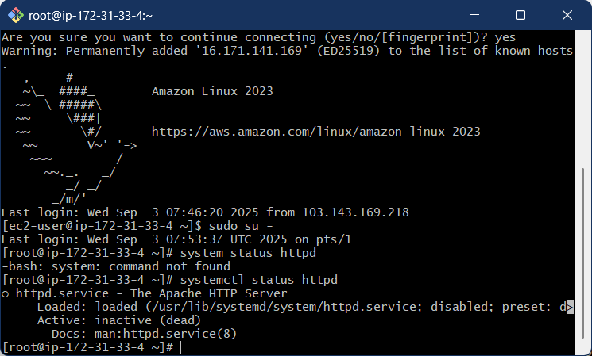

* Here you can see the aws ec2 remote machine has been connected .
* Switch to root user to not get any issues regarding the permission: sudo su –

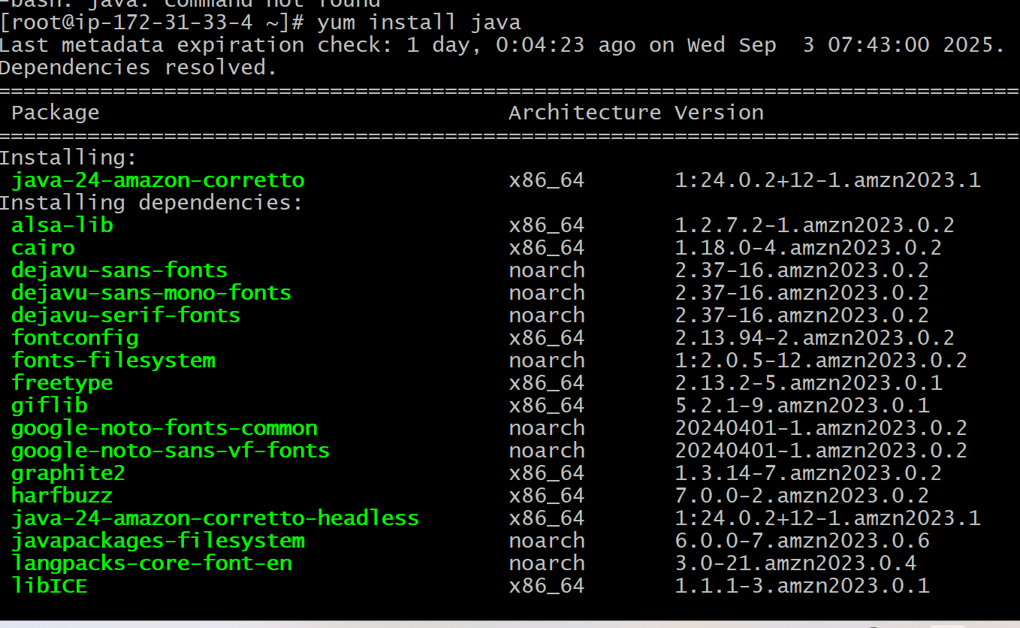

* Install java because the java is the soure or language that is used for tomcat is creted using java script or language
* Yum install java.

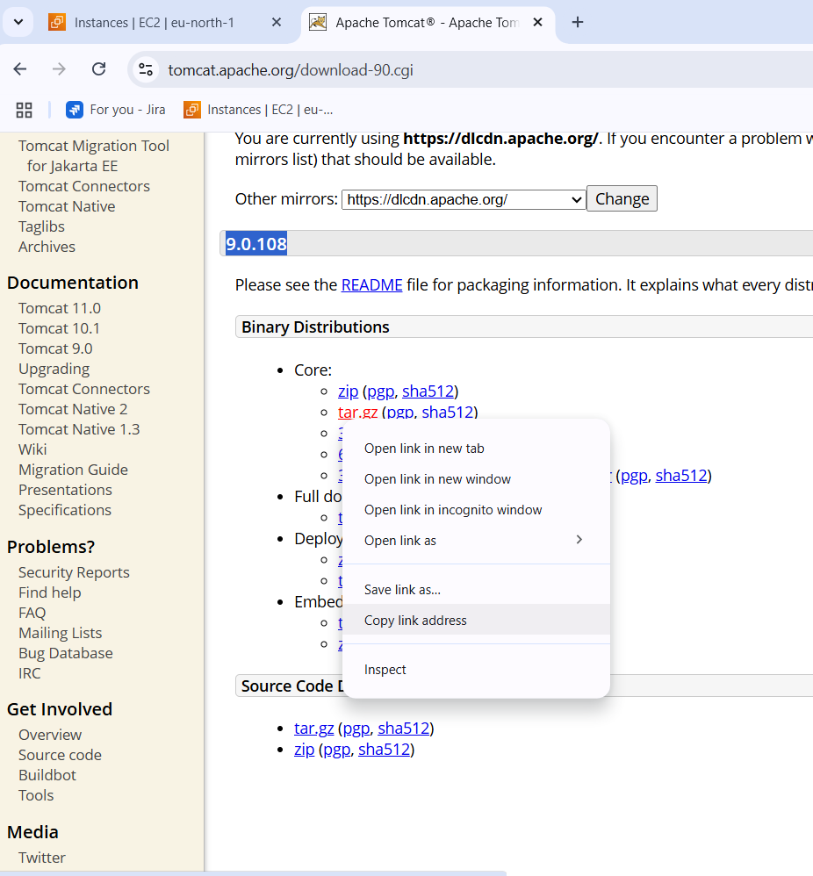

* Every aaplication is cannot be installed by “yum”
* Go to google and search for apache tomcat download select version copy the link of the download file that is zip or tar.

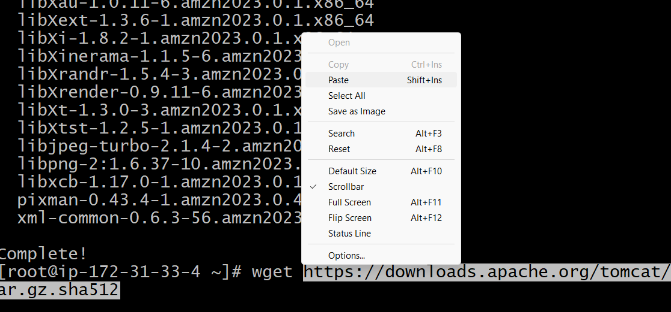

* Enter wget “url” that uou cpied and enter to download the tomcat.
* 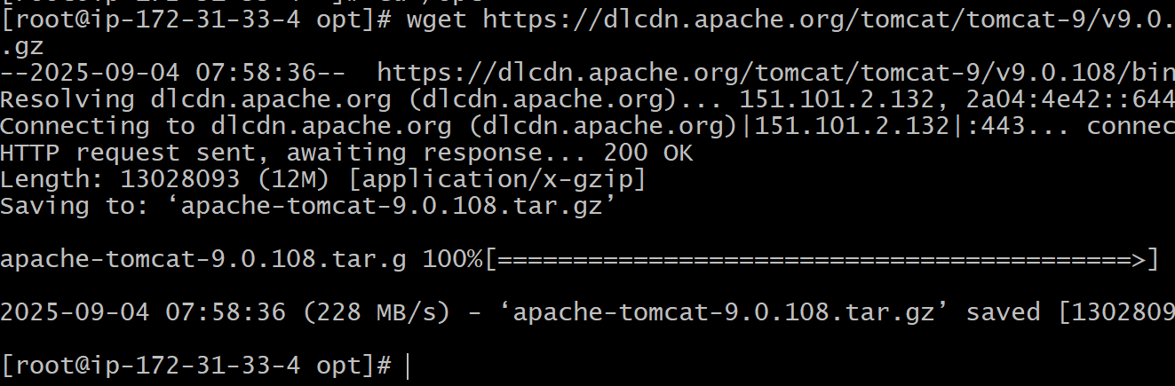here you can see the file has been downloaded.
* Now you need to extract the file

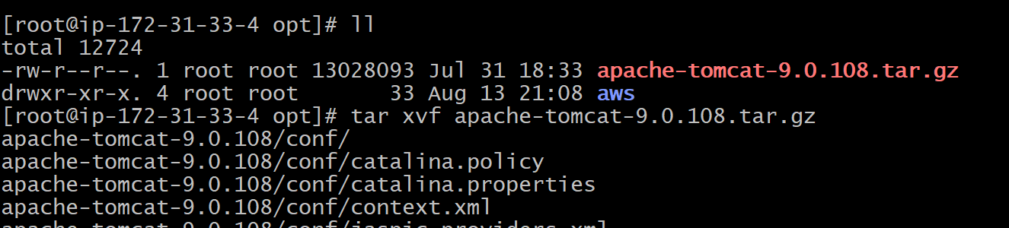

* ll – to list the files
* tar xvf “file name” .gz : to extract the tomcat file.

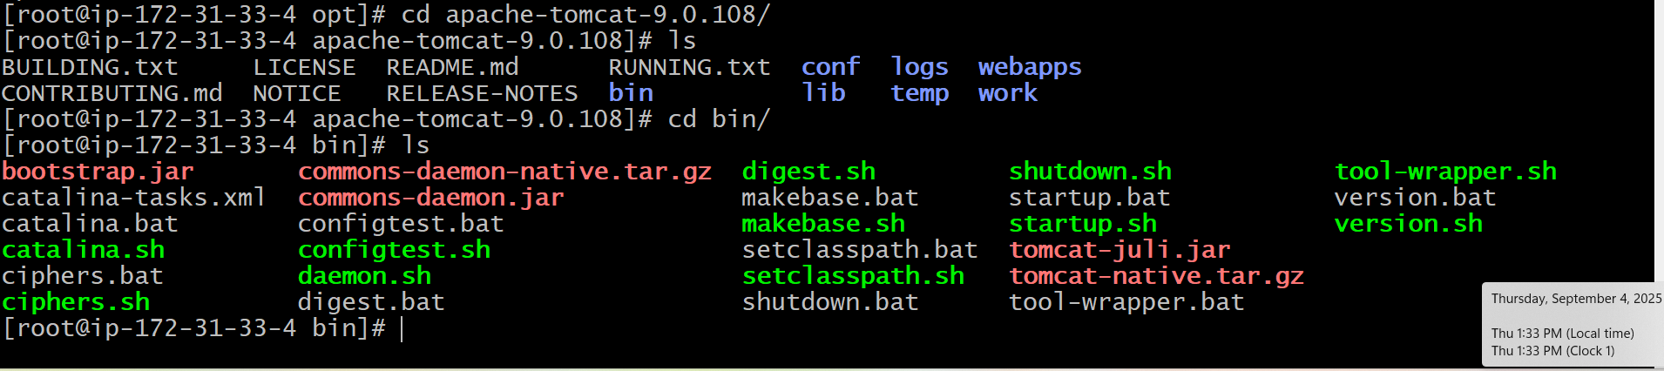

* go to the tomcat directory where it is downloaded : cd “filename”/
* ls – to list the files you can find the configuration files of tomcat.
* Go to bin directory : cd bin/
* Ls - list the files you can find the startup.sh , sh- means shell & .bat is for windows

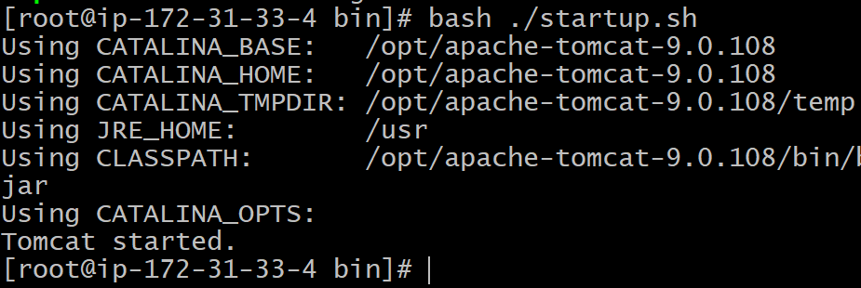

* Startb the tomcat : bash ./startup.sh – to start the service.
* Note : systemctl start cannot be used for every application

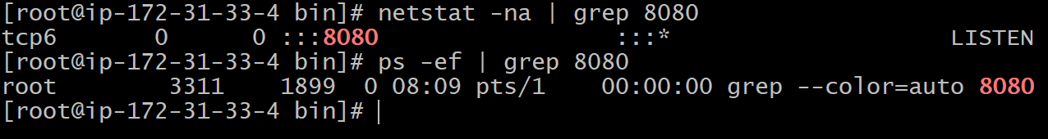

* Check the status using : netstat -na | grep 8080
* Ps -ef | grep 8080 - you see the port 8080 is listening.
* Default log files for tomcat is catlina.out you can see logs.