This is my system setting before downloading and installing Docker

Search for "Turn Windows features on or off" in the Windows search bar and ensure that "Windows Subsystem for Linux" and "Virtual Machine Platform" are on, then restart.

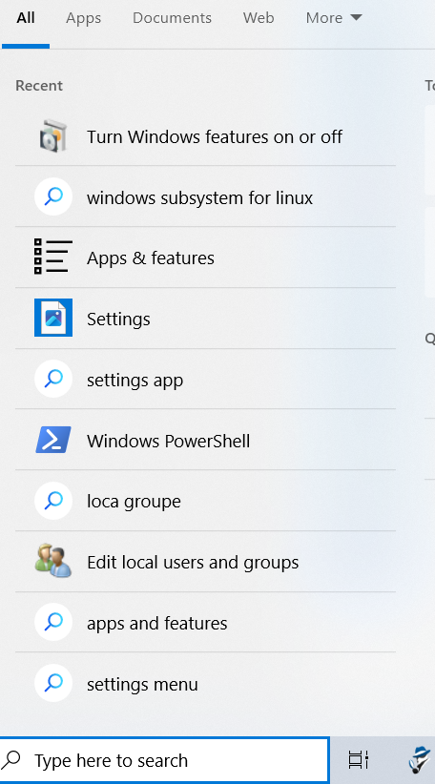

XXXXXXXX

Docker Desktop - Unexpected WSL error

An unexpected error was encountered while executing a WSL command. Common causes

include access rights issues, which occur after waking the computer or not being connected

to your domain/active directory.

Please try shutting WSL down (wsl --shutdown) and/or rebooting your computer. If not sufficient, WSL may need to be reinstalled fully. As a last resort, try to uninstall/reinstall

Docker Desktop. If the issue persists please collect diagnostics and submit an issue

(https://docs.docker.com/desktop/troubleshoot/overview/#diagnose-from-the-terminal).

