Pierce Mohney

Brad Lance

SDEV200

12/14/23

Final Project UML and Screenshots

Project Repository link: <https://github.com/pmohney/M08_finalproject.git>

UML:

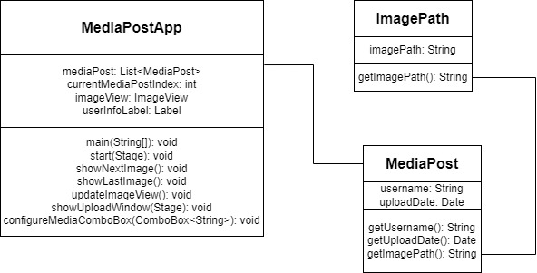

Screenshots:

