Memetic Relationships as Tillet’s Shared Characteristics (Paper)

#### Abstract or Résumé:

The field of knowledge organization, and cataloguing in particular, has increasingly become concerned with bibliographic relationships. Tillett (2001) developed a taxonomy of bibliographic relationships that is largely shared by Functional Requirements for Bibliographic Records (FRBR), with the exception of the “shared characteristic” relationship including such features as shared creator or subject headings. This paper will offer another possible shared characteristic: “memes.” Memes are units of cultural inheritance and include literary tropes, character archetypes, and genre conceits, and can link otherwise unconnected works.

#### 1. Introduction

Arsenault and Noruzi (2012) define a bibliographic relationship as “the association, relation, connection, and interaction between different bibliographic entities, or components of entities.” Current cataloguing standards, including FRBR and RDA, acknowledge the importance of such relationships: “Taxonomies of bibliographic relationships have been proposed by Tillett, with an extension by Smiraglia, and in [Functional Requirements for Bibliographic Records] FRBR itself” (Riva, 2013, 130). According to Smiraglia (2002, 3) “explicit linkage of relationships among entities is critical for document-based information retrieval.”Tillett’s taxonomy of bibliographic relationships is largely shared by FRBR, with the exception of the “shared characteristic” relationship which was skipped in order to simplify FRBR taxonomy (Noruzi, 2012).

The field of knowledge organization, and cataloguing in particular, has increasingly become concerned with bibliographic relationships (IFLA 1998, Noruzi 2012, Smiraglia 2002, Tillett 2001). According to Smiraglia (2002, 3) “explicit linkage of relationships among entities is critical for document-based information retrieval.” Noruzi (2012) also argues that “Bibliographic relationships are one of the most active research areas in knowledge organization, especially in cataloguing.”

Due to the enduring interest in bibliographic relationships it is worth revisiting the notion of shared characteristic relationships. While Tillett defined shared characteristic relationships as subject headings and shared creators, there is another possible kind of shared characteristic relationship: memes. A meme is a unit of cultural inheritance and which can include literary tropes, character archetypes, and genre conceits, and can link otherwise unconnected Works. In this paper I propose to explore the possibilities of encoding memes as shared characteristics in library catalogues, thereby enabling richer connections between Works.

#### 2. Tillett’s Concept of Shared Relationships

Tillett defines seven types of bibliographic relationships.: Equivalence relationships, Derivative relationships, Descriptive relationships, Whole-part relationships, Accompanying relationships, Sequential relationships, and Shared characteristic relationships. (See Appendix A for more details). Bibliographic relationships have risen in importance with the rise of RDA and the promise of future encoding systems to succeed MARC. While RDA has adopted many of the relationships defined by Tillet, one--shared characteristics--not been incorporated.

Knowledge organization has a long-standing concern with shared characteristics, broadly understood. In cataloguing these might be elements such as creator responsibility and subject heading access points, or “shared language, date of publication, or country of publication” (Tillett, 2001). “Shared characteristic” holds between an entity and otherwise unrelated entities sharing some properties or characteristics (Tillett 1991).

A “shared characteristic” is common information that is shared among bibliographic entities and potentially can be used as an access point or a device to collocate otherwise unrelated entities using a common characteristic. To begin the analogy with relationships with people, we could imagine two unrelated people who happen to have the same birth date, belong to the same organization, or have the same eye colour. To focus on organization membership for a moment, both people have a ‘membership relation’ to the organization, but they also have a ‘shared organization membership’ relation to each other. It is shared organization membership’ that is analogous to “Shared characteristics”.

#### 3. Memes as Shared Characteristics

One such shared characteristic is the “meme”, an entity that has become prominent in social media discourse. Memes are units of cultural inheritance. The idea of the meme was based on an analogy borrowed from biology, genes being the unit of biological inheritance. In principle all or an organism's genes could be discovered and their role in constituting the whole understood. In practice this is beyond the scope of human knowability. Memes are often difficult to even characterize and are much more subject to interpretation than genes. But the concept is still potentially useful.

In 1976, Richard Dawkins, the English evolutionary biologist, proposed an idea in his book, The Selfish Gene: What if ideas were like organisms, where they could breed and mutate? These ideas, he claimed, are actually the basis for human culture, and they are born in the brain.

(Scarbrough)

A common subtype of the meme is that of the trope, a term common in the field of literary studies. A trope is “a figure of speech, especially one that uses words in senses beyond their literal meanings. [...] The most generally agreed distinction in modern theory is that tropes change the meanings of words, by a 'turn' of sense, whereas schemes merely rearrange their normal order. The major figures that are agreed upon as being tropes are metaphor, simile, metonymy, synecdoche, irony, personification, and hyperbole” (Baldick, 264).

More recently the concept of the trope has broadened somewhat. The website tvtropes.org defines a trope as:

“a storytelling shorthand for a concept that the audience will recognize and understand instantly. [Recently], "trope" has the even more general meaning of a pattern in storytelling, not only within the media works themselves, but also in related aspects such as the behind-the-scenes aspects of creation, the technical features of a medium, and the fan experience. The idea being that storytelling is not just writing, it is the whole process of creating and telling/showing a story.”

(tvtropes.org, Trope)

Tropes are commonly recurring rhetorical devices, character archetypes, genre conceits, motifs, or clichés in literary and creative works.

An example of a meme that fits this broader definition of a trope would be the phrase “jump the shark.”

“To jump the shark means to pass a peak of quality or popularity and begin an irreversible decline. The phrase was thought to have been used first in 1985 by a college student named Sean J. Connolly, in reference to an episode of the television series “Happy Days” in which the character Fonzie (Henry Winkler), on water skies, jumps over a shark”

(Gleick).

The phrase is now common enough to have a Wikipedia entry.

Memes as a whole are not confined to literary conventions though. For example: a common research method could be recurring meme in a particular academic discipline. One could easily imagine one group of researchers choosing to use a research design based on a previous study in the field. We can imagine going a bit further: consider a philosophical assumption as a trope, linking diverse works that manifest, for example, a teleological assumption about human progress, or an empirical philosophy of research. Or to return to the example of research papers, we can imagine differentiating between those quantitative papers that use a significance threshold of 0.05 from those that use 0.01. These diverse works may be similar in no other respect, but collocation on the basis of this shared trope could conceivably be useful in a catalogue.

In literature a classic example of a meme would be the literature trope of the “star-crossed lovers”, two characters who fall in love only for it to end tragically. Many authors have used this trope, either in a conscious decision to echo or pay tribute to a previous work, or in a simple act of picking it out of the air. In a catalogue this could be represented as a relationship between two works that are otherwise unrelated bibliographically. For example, according to some scholars (Gibbons, 1980) Shakespeare’s *Romeo and Juliet* borrows from *Pyramus and Thisbe* in Ovid's *Metamorphoses*, specifically tropes that include the “star-crossed lovers.”

Taking this idea further, we could imagine entire lines of descent of “star-crossed lovers” meme. For example: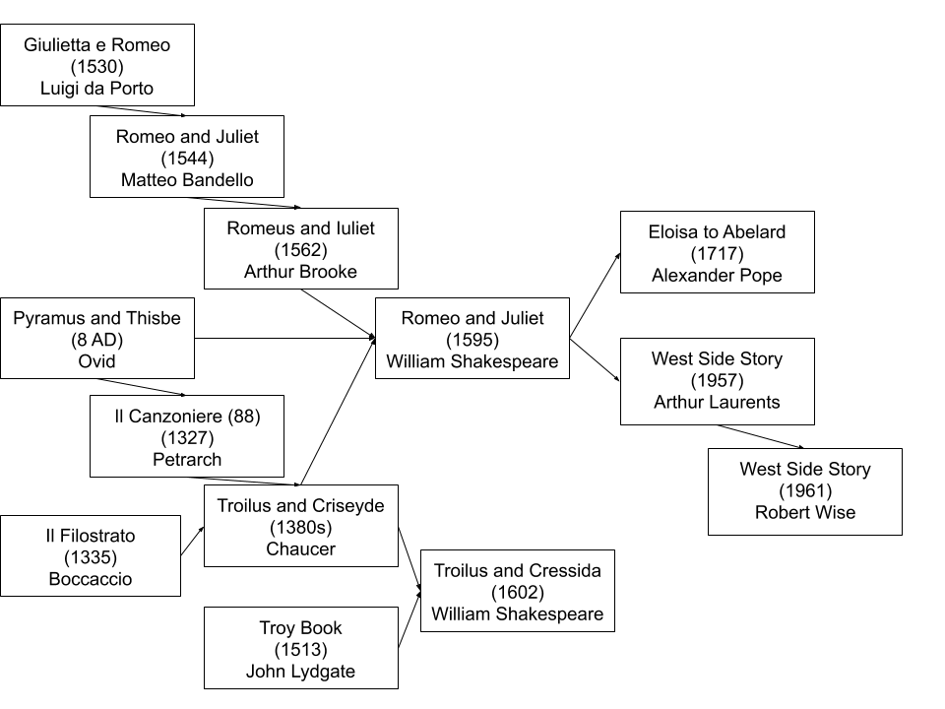

By treating tropes as shared characteristics, multiple otherwise unconnected works can be linked by one or more memes in a catalogue, allowing new forms of navigation between Works.

#### 6. Implications

There are several important implications that emerge from the possibility of linking Works through inherited memes. First, we can notice that the current cataloguing standard, RDA, offers some limited support through the relationship designators for derivative relationships. However, representing these tropes in a library catalogue would go beyond conventional cataloguing capabilities, requiring some intervention and assistance outside the cataloguing environment.

The second thing to notice is that trope and meme relationships can vary widely in authority and utility; some might represent a firm scholarly consensus (we can be sure that *West Side Story* draws deliberately on *Romeo and Juliet*), while others might be suspect (describing *Troilus and Cressida* as a tale of star-crossed lovers is a stretch). Some might be widely useful (gathering a set of materials that manifest a qualitative research approach), while some might be only of limited utility (marking a set of required texts for a particular course in order of reading).

Finally, this all means that incorporating shared characteristics at this level of specificity would inevitably require significant changes in the ways catalogues are designed and maintained.

#### 5. Conclusion

The question of how, exactly, to integrate Shared Characteristics Relationships into catalogues remains. While conventional cataloguing methods may be unable to handle the potentially overwhelming number of such relationships, we should examine them anyway, in light of new functionalities such as participatory folksonomies that might make representations of these relationships possible.

As a matter of practicality, the decision to not include “ Shared Characteristics Relationships” into FRBR makes a great deal of sense. Perhaps what is needed is a model to organize all the possible additions that could find their way into the catalogue.

The possibility of incorporating greater user participation and possible modifications to the FRBR or LRM model are beyond the scope of this paper, but remain an interesting possibility for the future.

#### Appendix A: *Tillett’s seven types of bibliographic relationships*

* Equivalence relationships, “which hold between exact copies of the same manifestation of a work or between an original item and its reproductions, as long as the intellectual and artistic content and authorship are preserved”;
* Derivative relationships, “which hold between a bibliographic item and a modification based on that item”;
* Descriptive relationships, “which hold between a bibliographic item or work and a description, criticism, evaluation, or review of that work”;
* Whole-part (or part-whole) relationships, “which hold between a component part of a bibliographic item or work and its whole”;
* Accompanying relationships, “which hold between a bibliographic item and the bibliographic item it accompanies, such that the two items augment each other equally or one item augments the other principal or predominant item”;
* Sequential relationships, “which hold between bibliographic items that continue or precede one another”; and
* Shared characteristic relationships, “which hold between a bibliographic item and other bibliographic items that [are] not otherwise related but coincidentally has a common author, title, subject, or other characteristic used as an access point in a catalog.”

(Tillet, 1987, 24-25)

#### 

#### Appendix B: *FRBR’s bibliographic relationships and entities:*

* Group 1 Entities: Work, Expression, Manifestation, Item (Figure 1.1 Appendix A). The entities in the first group represent the different aspects of user interests in the products of intellectual or artistic endeavour. The entities defined as work (a distinct intellectual or artistic creation) and expression (the intellectual or artistic realization of a work) reflect intellectual or artistic content. The entities defined as manifestation (the physical embodiment of an expression of a work) and item (a single exemplar of a manifestation), on the other hand, reflect physical form.
* Group 2 Entities: Person, Corporate Body (Figure 1.2 Appendix A). The entities in the second group represent those responsible for the intellectual or artistic content, the physical production and dissemination, or the custodianship of the entities in the first group. The entities in the second group include person (an individual) and corporate body (an organization or group of individuals and/or organizations).
* Group 3 Entities: Concept, Object, Event, Place (Figure 1.3 Appendix A). The entities in the third group represent an additional set of entities that serve as the subjects of works. The group includes concept (an abstract notion or idea), object (a material thing), event (an action or occurrence), and place (a location).

(IFLA, 1998)

#### Appendix C: *FRBR Group 1, 2, and 3 Entities and Relationships.*

|  |  |
| --- | --- |
| Figure 1.1: Group 1 Entities and Primary Relationships | Figure 1.3: Group 3 Entities and "Subject" Relationships |
| Figure 1.2: Group 2 Entities and "Responsibility" Relationships |

Figure 1.1, 1.2, and 1.3 (IFLA, 1998)

#### Appendix D: *LRM Entities and Relationships*

Figure 2, originally 5.6 (Riva, P., Le Boeuf, P., & Žumer, M., 2017, p.85)

#### Reference List:

Arsenault, C. and Noruzi, A. (2012). Analysis of work-to-work bibliographic relationships through FRBR: A Canadian perspective. *Cataloging and Classification Quarterly,* 50:5-7, 641-652. <https://doi.org/10.1080/01639374.2012.679580>

Auray, N. (2007). Folksonomy: The new way to serendipity. *Communications and Strategies*, No. 65.

Baldick, C. (2001). *The Concise Oxford Dictionary of Literary Terms*. Oxford University Press.

Coyle, K. (2015). FRBR, twenty years on. *Cataloging & Classification Quarterly*, *53*(3–4), 265–285. <https://doi.org/10.1080/01639374.2014.943446>

Coyle, K. (2016). *FRBR, Before and After: A Look at Our Bibliographic Models*. Chicago: ALA Editions

Eda, T., Yoshikawa, M., Uchiyama, T. et al. (2009). The Effectiveness of Latent Semantic Analysis for Building Up a Bottom-up Taxonomy from Folksonomy Tags. *World Wide Web* 12: 421. <https://doi.org/10.1007/s11280-009-0069-1>

Gleick, J. (2011). What Defines a Meme? *Smithsonian Magazine*. Retrieved from <https://www.smithsonianmag.com/arts-culture/what-defines-a-meme-1904778/>

IFLA. (1998). Functional requirements for bibliographic records: final report, *UBCIM Publications.* Munich: Saur, K.G vol. 19, 136 p. <https://www.ifla.org/publications/functional-requirements-for-bibliographic-records>

Noruzi, A. (2012). FRBR and Tillet’s Taxonomy of Bibliographic Relationships. *KO KNOWLEDGE ORGANIZATION*, 39(6), 409-416. <https://doi.org/10.5771/0943-7444-2012-6-409>

Riva, P. (2013). Mapping MARC 21 linking entry fields to FRBR and Tillett’s taxonomy of bibliographic relationships. *Library resources & technical services*, *48*(2), 130-143. <https://journals.ala.org/index.php/lrts/article/view/5422>

Scarbrough, J. (2017). Where Does the Word 'Meme' Come From? *MentalFloss.com*. Retrieved from <https://www.mentalfloss.com/article/61843/what-is-a-meme>

Smiraglia, R. (2002). Musical works as information retrieval entities: Epistemological perspectives. *Notes (Quarterly Journal of the Music Library Association)*, 58: 747-764.

Tillett, B. B. (1987). *Bibliographic relationships: toward a conceptual structure of bibliographic information used in cataloging.* Ph.D. dissertation, University of California, Los Angeles.

Tillett, B. B. (2001). Bibliographic relationships. In *Relationships in the Organization of Knowledge*. 19-35. Springer, Dordrecht. <https://doi.org/10.1007/978-94-015-9696-1_2>

Zapounidou, S., Sfakakis, M., & Papatheodorou, C. (2017, September). Preserving bibliographic relationships in mappings from FRBR to BIBFRAME 2.0. In *International Conference on Theory and Practice of Digital Libraries*. 15-26. Springer, Cham. <https://doi.org/10.1007/978-3-319-67008-9_2>