Final Year Project 2015/2016



**Online Generic QR Coding System**

|  |  |
| --- | --- |
| Student Name: | Paul Moran |
| Student Number: | C12370211 |
| Supervisor: | Mark Foley |

**Project Declaration**

I hereby declare that the work described and presented as part of this project and dissertation is entirely my own work (except where specifically stated) and has not been submitted as an exercise for a degree at this or any other university.

__________________________

Paul Moran

Table of Contents

1. Project Introduction 4

1. Project Statement 4

2. Project Objectives 4

3. Structure of Project Report 4

4. Conclusion 5

2. Research 5

1. Background research 5

2. Existing Systems and Solutions 5

3. Technologies researched 5

4. Other Research Performed 5

5. Resultant Findings/Requirements according to Research 5

3. Design 5

1. Approach and Methodology 5

2. System Architecture 5

3. Design of User Interface 5

4. Design of System Structure 5

5. Design of Source Code 5

6. Project Features 5

7. Other Design Documents 5

4. Development and Implementation 5

1. Development of Database 5

2. Development of MVC – Model, View, Controller 5

3. Development of HTML Templates 5

4. Development of Functions and Features 5

5. Implementation of QR Code Features 5

6. Use of Other API’s and Software 5

5. Project Validation 5

1. Introduction 5

2. Testing 5

3. Demonstration of Project Features 5

4. Problems and Issues 5

6. Project Plan 5

1. Introduction 5

2. Deviations from Initial Plan and Design 5

3. Changes to be Addressed if Project was Repeated 5

4. Future Development of Project 5

7. Conclusions 6

1. Report Summary 6

2. Learning Outcomes 6

3. Personal Reflection 6

4. Final Conclusion 6

Bibliography 6

Appendix 9

# Project Introduction

## Project Statement

The idea behind the Generic Online QR Coding System is to simplify some everyday tasks for users by removing some inconvenient aspects of those tasks.

Essentially it will allow the user to generate a barcode which will be used for a specific purpose in which the system will recognise, and when scanned the system will handle the appropriate data accordingly.

This barcode will be unique to each use, each user and to each specific task.

The applications which will be implemented to demonstrate the use of this system will be as follows:

* Postal Stamp Generation
* Car Parking Ticket Generation
* Event Creation

The use of this system could be developed and implemented on a much broader and general scale. It could be used a general identification system, or validation system in various infrastructures, such as transport, postage systems, essentially anywhere that needs proof of payment, validation or identification.

## Project Objectives

## Structure of Project Report

In this report we will be looking at each and every aspect during the research, planning, design and development of this project.

The chapters throughout are as follows:

#### Chapter 1 – Project Introduction

In the first chapter the idea behind the project will be outlined by mentioning some of the problems in which it may be a suitable solution to. The project goals and objectives will also initially be mentioned here to outline some of the common features expected in the project. Finally the structure of the project report will give glimpse into the content of each other chapter.

#### Chapter 2 - Research

Within the Research chapter every aspect of research performed either prior or during the design or development of the project is outlined here. Topics mentioned include background research into the purpose and proposal of the project idea, evaluation of similar systems and technologies and other researched sources such as questionnaire results, possible user’s opinions, and advice given by other members of the IT sector.

Finally the chapter will conclude with the overall given results and findings of the researched data and information.

#### Chapter 3 – Design

In this section of the report, all design and structural aspects will be portrayed. Firstly, the approach, methodology and system architecture is expanded on based on the research results given in the previous chapter. For the next three sections to this chapter the physical design of the User’s Interface, the System Structure and the Source Code will all be explained here. Following on from the design of some of structural coding parts, details about other feature’s uses are described. Lastly, detailed design documents including use cases, ERD’s etc. are provided.

#### Chapter 4 – Development and Implementation

The Development and Implementation chapter will outlined the process regarding the building and development of the system. The chapter has been broken up into separate sections outlining the development of each aspect. Those aspects include:

* Database
* General MVC Framework
* HTML templates
* Functions
* QR Code Features
* Other API’s and Software.

Finally the chapter will conclude on the development while giving a short summary on the development phase.

#### Chapter 5 - Project Validation

Testing analysis and evaluations will primarily be outlined in the Project Validation chapter. Testing methods such as White/Black box testing will be mentioned and described where used. Brief results will be outlined before the last section in which all results and findings will be evaluated concluded. After the Testing section, simple individual demonstrations will be provided given examples of the various aspects of the system. Links and screenshots are also provided. Problems and issues which occurred throughout the development phases are also outlined here. This topic includes issues and solved and unsolved as well as describing the used solution.

#### Chapter 6 – Project Plan

Within the second to final chapter, aspects and possibilities of the finished system will be described. Firstly, deviations of the initial proposed idea will be outlined as the system did not turn out fully as expected. If the project was to be repeated, changes and new approaches are proposed here as well new ideas and solutions to unresolved issues. But to conclude this part of the report, the topic outlining possible future plans for development uses of the system will be portrayed in detail.

#### Chapter 7 – Conclusions

In the final chapter of the report, a summary of the report will be provided given a short reminders of the chapters read. Most importantly, learning outcomes for the developer will be described along with some personal reflection regarding experiences, choices and preferences throughout the participation of this project.

Lastly a final project conclusion will be presented.

## Conclusion

As described in the previous sections, we have looked at the possible scenarios in which this project will be able to be applied. The goals and objectives outlined will be discussed further in the report in almost each chapter where relevant. After given a brief overview of the chapters and topics to come, next we will look at the research executed and how certain results and evaluations were made in order to decide various technologies and approaches to be used.

# 2. Research

## Introduction of Background Research

This section briefly outlines the following information which will be expanded on progression through the chapter:

* Why my system is relevant
* Various uses of my system as well as brief similarities
* Simplicity and Flexibility of its use
* Inconvenient aspects of other systems in place

Considering the proposed idea various research was carried out in regard to how this system may be deployed. It was decided that a website using a stable, flexible framework would be sufficient to demonstrate and implement the system. After having some basic experience with MVC (Model, View, Controller) it was decided that that would be the foundations of the system.

Companies such as An Post which was developed in 1984 have been using the same conventional postage stamp system since it was erected. It methods, though effective, are quite old-fashioned in terms of ordinary conventional postal letter. Whereas with the Generic Barcoding System users would not need to leave the comfort of their own home to purchase a postal stamp. Ref. [1]

Parking Tag is another company who have similar systems in place to that of the system in question. Although its methods are very modern, with the Generic Online Barcode Generating System users can make their own parking tickets and top up when needed all within one site. Ref. [2]

Finally, another site which reflects some similarities is Eventbrite (2006) which allows users to create, promote and host events of their choosing. This site charges a rate based on the amount of tickets sold through the site as well as a service fee. Whereas with the Generic Online Barcode System, self-generated barcodes/QR codes will be used to identify each type of ticket sold to each individual person effectively with control and sufficient validation. Ref. [3]

Before taking aspects such as design and approach into consideration, a list was drawn up of solutions and ideas to a number of everyday tasks which this system may be able to improve in one way or another. After speaking to number of friends, colleagues, classmates, family and lecturers and explaining some of these simple applications of the proposed system, one thing everyone agreed on was that with the implementation of this project, it will reduced or completely eradicate some very inconvenient everyday tasks such as purchasing a postal stamp Ref. [4], or returning to your parked car to buy a new parking ticket or even as a control mechanism to validate entrance to a venue etc. It is almost a known fact that the purchasing of postal stamps in today’s world is rather out-dated and old-fashioned. With the exception of stamp collectors Ref. [5], having to buy a stamp in order to send a letter in this ever growing technological world is very inconvenient.

After speaking to two family members and two neighbours, who are approximately between the ages of 40-60, they too agreed that they would be willing to register and use the system to give them access to simplified tasks such as generating their own postal stamp, generate their own parking ticket when needed so they would not need to leave the house, or return to their car.

Although improvements in this regard cannot be outlined for applications such as Eventbrite, the inclusion of event management using this system will prove yet another application this systems use.

Next we will look deeper into the existing systems in which have just been mentioned.

## Existing Systems and Solutions

#### Introduction

In the following section some of the research aspects of the project will be outlined in regard similar systems and software which are available. After extensive research gathered about multiple companies, software, and systems have been found which provide similar services to the project in question. During this chapter the key similarities and differences between these systems and software are described and evaluated.

In order to achieve such a comparison, a list of heuristics (similar to Nielsen’s Heuristics Ref. [6]) have been drawn up to compare each system to and created a rating system. Based on the results of this chapter, an accurate evaluation will be drawn up.

#### Development Heuristics

As mentioned before, some systems researched contained similar concepts, goals and principles as this project. In this section the positives, negatives, similarities and contrasts between each of these systems including the Generic Online QR Code System will be detailed. Based on some of the results gained from research gathered, some faults and improvements will be outlined which may affect the design of this project.

***Login/Registration***

The process in which a new user is added to the system. However, this process should not be in any way a struggle to a new user. Questions asked and information provided should be straight forward for both an experience as well as a less technically advanced user. In terms of logging in, should false parameters be provided whilst a user is logging in, sufficient error messages should be displayed? Logging in should also be clear and user friendly.

***Site Navigation***

The website should be easy to navigate and tasks should be easy to perform without additional help from guides or internet assistance.

***Scanning System***

Labels, stamps and barcodes, when scanned return accurate, valid and correct information regarding the sender of the parcel/letter/parking etc.

***Labelling System***

The system in place marks each package with the necessary token to distinguish one package/letter from another as well as providing minimal, yet sufficient information to allow for successful postage. This mark/stamp/barcode will successfully establish a sufficient relationship with the appropriate sender and the system in place.

***UI and Aesthetics***

The User Interface is pleasing to the eye and template details are aligned correctly. The font and sizing throughout the website is clearly readable and each detail which is necessary for the user is easily perceived and understood.

***Help and Documentation***

Help, information and sufficient guides are provided throughout each part of the website should the user of any experience need it.

***Suitable form constraints***

Each form throughout the website has sufficient data handling techniques, regular expressions are used where needed, and frontend error handling is in place to prevent erroneous data from being received by the system.

***Accurate Data Handling***

When data is read into the system, is it handled appropriately giving back accurate results and information?

#### Similar Systems for Evaluation

###### System 1 – EventBrite



Eventbrite is an event creation website which allows a user to create, organise, host and promote events of their choosing. Charging applies based on the number of tickets sold, with the exception of free events.

* Registration & Login – 8/10
* Site Navigation – 9/10 Simple, Lists other events on throughout the coming weeks
* Scanning System – 7/10 Scanning System works as supposed to, but the ticket can be used by anyone
* Labelling/Addressing System – 10/10 Very similar to that of my own proposed idea. Barcode is present on a conventional ticket to be scanned.
* UI and Aesthetics – 9/10 Easily Readable website, with white background.
* Help and Documentation – 10/10 Explains what to do one the first page on entering the website.
* Suitable form constraints – 8/10 When creating an event, the User has the option to accurately detail the event being created.
* Accurate Data Handling – 8/10 On approach with a valid ticket, it is scanned returning the validity of that ticket, although the ticket is unique to other tickets but is not unique regarding the ticket holder.

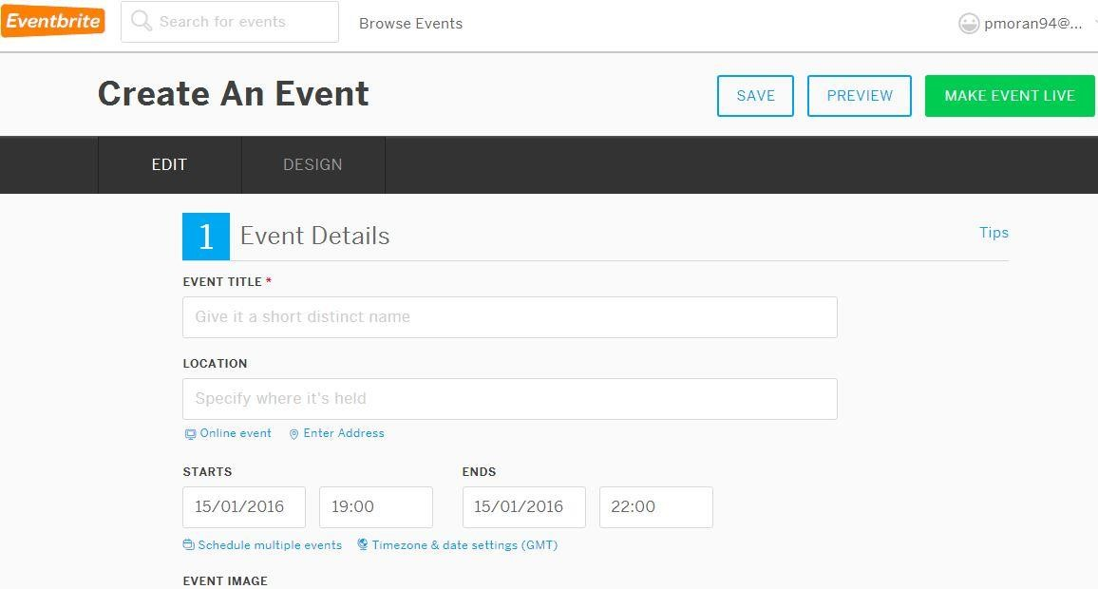

###### System 2 – Franking Machine

Similar to this project idea, Franking is a process where a company can register a stamp or logo, which is printed onto a postal package. This stamp contains the *price paid, date, ID number* and *logo.* Most Franking Machines have a built-in scale to calculate the price of the package. The Franking stamp is essentially proof that the postal package has been paid for by the company directly from their account.

Ref. [7]

* Registration & Login – N/A
* Site Navigation – N/A
* Scanning System – 10/10
* Labelling System – 10/10
* UI and Aesthetics – N/A
* Help and Documentation – N/A
* Suitable form constraints – N/A
* Accurate Data Handling – 10/10

###### System 3 – An Post

An Post is the current postal system in place in Ireland. They use standard postal stamps on their letters and packages where a sender must purchase a standard stamp prior to sending the letter. They also use the concept of the Franking Machine as seen above for bigger packages sent by businesses and companies.

* Registration & Login - N/A
* Site Navigation – 8/10 (Small website, Less is more)
* Scanning System -9/10
* Labelling System – 3/10 Standard Postal Stamp
* UI and Aesthetics – 4/10 Light Green font with white background -Not clearly visible(Even with contrast option)
* Help and Documentation – 7/10 Most is covered
* Suitable form constraints – 6/10 Not much interactive content
* Accurate Data Handling – 7/10

###### System 4 – Parking Tag

Parking Tag is a convenient way to pay for the parking of a vehicle by text. The user simply registers their car registration and the time and place they have parked.

Sample Text would contain the word Park, with a two letter area identification code and the number of minutes in which the user wishes to park. Like so:

Park DA 60 to 53311 = Parking in zone DA for 60 minutes Ref. [8]

The authorities then scan the car registration to determine the validity of the payment. This system acts in a similar way to the Car Parking aspect as the Generic Online Barcoding System as it requires registration, topping up and scanning. The same concept is to be incorporated into the development of the system in question.

* Registration & Login – 10/10 Very quick efficient straight forward
* Site Navigation – 9/10 Clear (not over developed)
* Scanning System – 8/10
* Labelling System – 8/10 Car Registration
* UI and Aesthetics – 7/10 (3 main colours)
* Help and Documentation – 8/10 Short concise , and answers the most relevant questions
* Suitable form constraints - 6/10 Any value can be entered for County(), Mobile number is not limited
* Accurate Data Handling – 8/10

#### Application of Heuristics

**Unweighted Evaluation of Systems**

|  |  |  |  |  |
| --- | --- | --- | --- | --- |
| **Heuristic** | **System 1** | **System 2** | **System 3** | **System 4** |
| **Registration & Login** | 8/10 | -- | -- | 10/10 |
| **Site Navigation** | 9/10 | -- | 8/10 | 9/10 |
| **Scanning System** | 7/10 | 10/10 | 9/10 | 8/10 |
| **Labelling System** | 10/10 | 10/10 | 3/10 | 8/10 |
| **UI and Aesthetics** | 9/10 | -- | 4/10 | 7/10 |
| **Help and Documents** | 10/10 | -- | 7/10 | 8/10 |
| **Form Constraints** | 8/10 | -- | 6/10 | 6/10 |
| **Accurate Data Handling** | 8/10 | 10/10 | 7/10 | 8/10 |
| **Total** | 69/80 | 30/30 | 44/70 | 64/80 |

*Table 1 – Unweighted Heuristics*

**Weight Evaluation of Systems**

|  |  |  |  |  |  |
| --- | --- | --- | --- | --- | --- |
| **Heuristic** | **Weight** | **System 1** | **System 2** | **System 3** | **System 4** |
| **Registration & Login** | 10 | 8*10=80 | -- | -- | 10*10=100 |
| **Site Navigation** | 10 | 9*10=90 | -- | 8*10=80 | 9*10=100 |
| **Scanning System** | 15 | 7*15=105 | 10*15=150 | 9*15=135 | 8*15=120 |
| **Labelling System** | 20 | 10*20=200 | 10*20=200 | 3*20=60 | 8*20=160 |
| **UI and Aesthetics** | 15 | 9*15=135 | -- | 4*15=60 | 7*15=105 |
| **Help and Documents** | 5 | 10*5=50 | -- | 7*5=35 | 8*5=40 |
| **Form Constraints** | 10 | 8*10=80 | -- | 6*10=60 | 6*10=60 |
| **Accurate Data Handling** | 15 | 8*15=120 | 10*15=150 | 7*15=105 | 8*15=120 |
| **Weighted Total** | 100 | 660/100 | 500/50 | 535/90 | 805/100 |
| **System Score** | .out of  10 | 6.6 | 10 | 5.94 | 8.05 |

*Table 2 – Weighted Heuristics*

#### Results

1. System 1 – (Event Brite), All of the heuristics applied for this system. Website is very easy to navigate and easy to read.
   * Forms and event creation is extraordinarily easy for the user. This aspect is one in which will have to be taken into high consideration whilst developing the Generic Online Barcoding System.
   * The labelling system is very similar to the system being developed although the system in question will be making the barcodes unique to both the event and the user not just to other individual tickets.

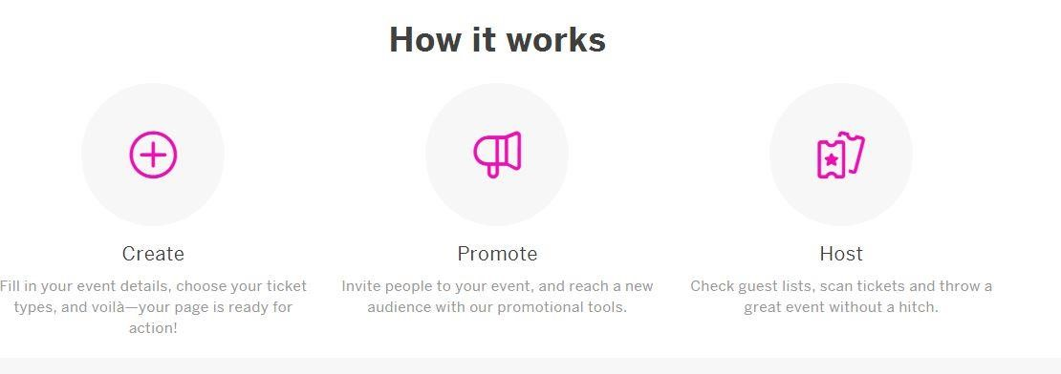

*Figure 1 - Simple Explanation of Service*

1. System 2 – (Franking)

◦ Uses just 3 of the heuristics listed

◦ Perfect Score on all 3 heuristics

◦ This proves that purpose of the Franking machine is perfect for the job it does. It is simple, effective and very efficient for companies and businesses.

1. System 3 – (An Post)

◦ Uses 7/8 of the heuristics listed

◦ Website was small and easy to navigate, although the fonts and colours used did not contrast with each other well. Some formatting was lost after the *change contrast option* is pressed.

◦ Labelling system, is a single postage stamp which the sender requires in order to send a post. Postage stamps are purchasable from the post office and participating newsagents and retailers. Fault is that the postage stamp needs to be purchased prior to sending, which is rather inconvenient for a conventional sender.

◦ The website provides good help and FAQ's for the user.

◦ Overall the system is very standard but the method in which is used by a user to send a postal letter is very out-dated and inconvenient.

4. System 4 – (Parking Tag)

◦ Uses all of the heuristics

◦ Very short, concise website with good aesthetical features.

◦ Easy to navigate, and easy to understand.

◦ I have realised the importance of correct form controls as the forms within this website didn’t have proper controls and should the user make a mistake, they would have to reset the form.

◦ Similar scanning system as the idea in my project. Scans tag for car, and will be notified of the parked cars validity.

◦ Overall the service has a good website, and the system uses quick convenient methods to check the validity of the parked cars.

#### Conclusion

So after researching these systems it is clear that the weighted heuristics demonstrates how each system is similar in its own way. Although not all characteristics were applied or necessary to each system. This was due to the fact that each of these systems provided different services to each other, but provided some similar concepts to that of my project. A *System Score* was given based on how well that system does its own job. In System 2(Franking), although it does not use or required many of the heuristics mentioned, it however does what it's supposed to do very effectively based on the weighted totals given to each topic.

Therefore, after seeing the results of each system valuable evidence has been gathered in order to evaluate, improve and include various ideas and aspects to incorporate into the development of the system In question.

## Technologies Researched

#### Introduction

As mentioned in the previous chapter there were various software, technologies and systems which were discovered which provided a similar service as the Generic Online Barcoding System whether that be its overall purpose or partial.

In this chapter various technologies, software and tools are listed which are available and suitable for use in order to develop this project.

Pros and cons, advantages and disadvantages to each of these technologies and architectures are described in this section, as well as hardware aspects which may have been required.

Furthering the software aspects which may be used, various platforms and programming languages will be discussed which may be used in order to complete the goals and objectives that have set for the development of the system.

#### Platforms/Browsers

-Considering the BIG 3 (Chrome, Firefox, Internet Explorer)



* ***Google Chrome***

Overall the dominant internet web browser. Almost all newer systems are using it for one purpose or another. It has a number of positive aspects such as the feature to allow for non-responsive pages to be killed without shutting down the entire browser**.** It also has the translation function to detect a foreign language within a web page and allow the user to convert the text. Ref. [9]

It also allows the user to download new content to a page without having to restart the browser.

Although all these gadgets provide the user with control, it simply does not make for the prettiest browser available.

* ***Firefox***

Firefox is next in line to Google Chrome. It has a huge library of add-ons available for the general user. Allows for great customization of the browsers making it not one of the easiest to use.

One major fault of Firefox, is that it can automatically allow hidden add-ons to attach to your browser causing it to run slower. Although it has some good security features, it has a slow page load time on image-heavy pages. Ref. [9]

* ***Internet Explorer***

Known for being slower than the rest of the browsers, it also has greater security features. It allows the user to block sites from cataloguing behavioural habits on the web.

This can be automatic or sites can be added manually. Ref. [9]

#### Methodologies

#### Programming Languages

One troubling aspect of design was deciding what language to use when building my framework. I personally have much more experience using PHP, but after some brief research I was also persuaded towards the idea of learning Python Django.

So essentially, the debate was between using PHP or Python's Django as a backend framework. Other languages and possibilities were also researched. Ref. [10]

#### Backend Languages

* ***Java (JVM Languages)***

Java is often used by the bigger companies, but this does not necessarily mean it is the best choice. It is primarily based around reliability but can be rather expensive due to over complicated web solutions. Nowadays, using Java as a backend solution programming language is been more or less replaced by the newer, fresher languages such as *Play, Scala etc.*  Although I have sufficient experience in general Java programming I personally only have basic experience with it as a backend language. Ref. [11]

* ***Python***

Python is known for being very fast for development and prototyping. Coding is easier to maintain and refactor. Python is one of the languages in which most of the web is designed, along with PHP and Ruby etc.

A lot of people argue that the likes of Python is rather error-prone, although in comparison to Java based languages, it is easier to control and develop with whereas with Java languages development is slowed due to its hierarchy and makes refactoring hard. Python's newest popular web-framework, Django is growing ever so fast and in a positive way. It is open-source and is constantly being developed almost every day.

According to my research using Django as a backend framework would work well with my system, although unfortunately I have not used Python in quite some time therefore I can only put it under consideration. Ref. [10]

• ***C***

C is one of the oldest programming languages and yet it's still holding firm in the Top 10 Ref. [11]. C is a cross-platform development language and is compatible with compilers available for almost all machines and operating systems. C is a very well structured language, although this does not provide good flexibility for a developer when trying to achieve particular functionality. But because of its smaller vocabulary it is easier to read and maintain.

In my personal experience of C Programming, it was the first programming language which I became accustomed to using. Although its vocabulary is quite smaller, it doe's reduce flexibility during development and can be very time consuming trying to figure out some particular solutions.

• ***PHP***

PHP, is possibly the most popular backend language although this is debated. Personally, I have some strong general knowledge with developing with PHP in particular areas. It has a huge support of frameworks and tools compared to Python. It is also very simple and fast to find and debug errors within a system.

PHP was solely designed for web-development. One of the most popular websites which used PHP during its development was, and still is, Facebook.

One of the unnoticed advantages of the use of PHP is its ability for rapid reloading. This is where simple changes the PHP code you get immediate feedback, without server restart, whereas with Python there is a slight delay. Ref. [10]

Although I have only been introduced to PHP in the past year, I have become quite accustomed to it. I have had some regular experience in web development in PHP during my participation of college assignments. From some of the feedback I have researched about PHP, it seems perfect for the development for my system.

* ***Go***

Go is one of the newer languages is stream at the moment. It's basically formulated around the best aspects of both Java and Python. It provides a simple yet powerful hierarchy.

One of the known downsides to developing in Go, is the fact that there are plenty of tools surrounding it, although some of these tools are not as mature as some of the ones which we are more familiar with in other languages.

Overall, according to my research, teams who make the switch with involving Go in there projects are often happy with the results.

* ***Hack***

Hack is a language which is formally a superset of the functionality provided by PHP. It was developed by Facebook in order to improve reliability within the PHP world of programming.

Programming languages such as *Hack* are mainly proven as solutions to some particular company programming solutions.

Since I have had some experience with PHP, I will be having a look into *Hack* as the following weeks commence. With general PHP, Hack may prove quite useful during the development of my system.

#### Frontend Languages

* **JavaScript**

JavaScript is very simple and versatile, and is used to extend multiple functionalities in a website. One positive aspect of JavaScript is that it executes on the client-side of the website and does not fully need server connection. It is fast and effective to get a suitable frontend UI for the user. Some downsides to the use of JavaScript include security issues. Ref. [12]

* **JQuery**

JQuery, essentially is a god send for JavaScript. In essence it condenses blocks of JavaScript syntax into smaller, easier blocks of code to perform various tasks.

It has a very simple syntax and requires a lot less code than that of JavaScript. Although it is generally a much simplified version of JavaScript, it can be very limited in terms of functionality. Ref. [13]

* **HTML**

HTML(Hypertext Mark-up Language) is the programming language which allows for the creation of websites. It uses tags as identifiers throughout its syntax. It uses hyperlinks to move from page to page or to determine the output on the screen. It is relatively simple to learn and is used for website templating and layout. It controls the layout, format, and links throughout a webpage. Should java script, CSS etc., be used they will all be included or be linked using HTML tags in order to interact with the page. Ref. [14]

* **CSS/Bootstrap**

Essentially CSS(Cascading Style Sheet)/ Bootstrap is the styling of a webpage. Height, width , colour, shading, style, transition, position, margins etc. can all be defined in CSS file and called in separate file such as HTML page to apply certain styling where needed.

* **ActionScript**

ActionScript is OOP Language designed specifically for web-animation. ActionScript is often used for user – keyboard interaction. It allows for the development of onscreen environments to be made a lot simpler. It is an *event-based* language Ref. [15], which means that actions are triggered by events.

Newer versions of the language have been released which bare some similarities to JavaScript. Ref.

[16]

#### Development Tools and Software



* ***Sublime Text***

One of the more powerful text editors, and known for being perfectly suited with keyboard savvy users. It supports multiple languages. It is a general purpose text editor which provides some useful built in tools to navigate, specific selection, quick edit a particular document. It is very useful should the developer need multiple windows open during work. Ref. [17]

* ***Notepad++***

Notepad++ is very similar to Sublime described above. It is a lightweight tool, with plenty of add-ons and plugins to satisfy the user. It supports over 50 languages. Ref. [18]

One negative aspect is that official download is exclusive for Microsoft Windows systems, as well as the fact that some earlier versions have been known to crash, although this has been fixed in later versions and updates.

* ***Eclipse***

Eclipse is known for being a rather heavy editor, which comes in multiple forms and flavours depending on what the developer wishes to use it for. The UI is very configurable and provides a good folder structure for your project. Similar to the other two editors mentioned above, it too has plenty on plugins and add-ons, including Android SDK, ADT etc. Ref. [19]

Its main advantage is that it is well suited for a larger scale project, with multiple collaborators.

But because of its bulky nature, it can be very slow and resource heavy. Since there are so many different plugins and “flavours” it can be confusing choosing which ones to choose based on what goals may have been set. Java is the basic and most supported language with Eclipse.

##### Conclusion

The overall results gained from the research into these three code development tools it has been concluded that because of its simplicity, flexibility, ability to make light of work it was decided that *Sublime Text* should be used during the development of the system. It is simple to download, simple to use, has multiple built-in tools for development and has a very aesthetically pleasing interface.

Eclipse proved to be quite “buggy” from time to time and very heavy to implement. Notepad++ is quite nice to use to it did not contain all the same built-in tools which sublime text contained.

#### Labelling Systems (based on Similar Systems)

• ***Parking Ticket***

Parking Tickets in Ireland are simple and basic but the user is required to purchase one from a machine every time they wish to park somewhere. A parking ticket is usually left in clear visibility under the windscreen to be checked by the inspector. The ticket will display the time of purchase, amount paid for, and the time of expiry.



*Figure 2 – Parking Ticket*

• ***QR Code (Quick Response Code)***



*Figure 3 – QR Code*

A QR Code is a two-dimensional barcode matrix. A QR Code uses 4 standard encoding modes to store data within this visual 2D barcode (Numeric, Alphanumeric, Binary, and Kanji). A QR Code is arranged in a square image populated with black modules and can be read using most imaging devices such as a scanner or a camera. Their use has grown due to its fast readability and it's capability to store more data than that of a standard UPC barcode

* ***Barcode (ExtendedCode39)***

Code 39 Barcodes are one of the more used, and simpler barcode styles. It contains a character selfchecking method, making it simpler to develop. It can represent numbers, upper-case, lower-case, the space character, as well as some special characters. Ref. [20]



*Figure 4 – Extended Code 39*

* ***Conventional Stamp(Sticker)***

A conventional Postage Stamp, is generally a simple sticker like visual proof of payment of stamp duty in order to allow for a package/ parcel to be sent through a postal service. By law, a postal stamp can contain the following: Ref. [4]

* Country Emblem
* The word Postage(in relevant language)
* The Expiry Date
* Year of Issue
* Personal Stamps can contain image of person(alive)
* Logo of Private Company
* Copyright Symbolism
* Registry Mark



*Figure 5 – Postal Stamp*

* ***Franking***

Franking is a process used usually by bigger companies to send a package or letters. Franking in general is the application of stamps or markings to identify the validity of a posted letter or package. A franking machine is used to apply an individual stamp which can bare the personalized logo of a company along with the date of application, price paid and other baring marks. It is a simple and effective concept but it can be costly to purchase a larger franking machine. But should a general user wish to own a franking machine it too need to be purchased and refilled. Ref. [21]



*Figure 6*

##### Conclusion

According to research gathered, it has been found that for this particular system the use of barcodes and QR Codes are perfect for their purpose. They are both simple to generate, and can encrypt enough information to store for multiple purposes.

They also require less production cost as they do not require coloured ink, special paper or special design like the conventional postage stamp, franking machine or parking ticket. They are both simple and effective.

#### Database Technologies

* ***Oracle***

The Oracle DBMS is one of the most trusted and widely used relational database engines. Data is structured to allow users to access it through the use of SQL. It is built on a relational database framework. It also contains a component to allow cross network compatibility. Oracle runs well on most operating systems. One of the main features of Oracle is that is allow for robustness, which means there is no single point of failure which will bring the database down. Ref. [22]

* ***SQL Server***

Microsoft's answer to Oracle. It supports standard ANSI SQL languages. Over the years SQL Server has been focussing on advanced featuring options, and security. It bares the very same architecture as Oracle which is a plus for developers. Ref. [23]

* ***MySQL***

Another competitor to Oracle and SQL Server, is owned by Oracle Corp. Its source code is freely available as it was originally developed as freeware. It was developed in C and C++ and is compatible with major Operating Systems. Ref. [24]

MySQL is mostly known for web-hosting applications, due to its web-optimizing features as well as the fact that it is freely available. It is part of the structure which is known for delivering advanced web applications (Linux, Apache, MySQL, and PHP (LAMP)). MySQL is often used as a backend data handling system, used in sites such as Google and Facebook.

#### Third Party Payment Method

* ***Pay-Pal***

Pay-Pal is a well-known third-party payment company where users register an account with PayPal pay for goods and services using its utilities rather than paying directly from their personal banking accounts using their banking details. Other websites and companies often allow their good/services to be paid for through Pay-Pal when it is built into their website.

Pay-Pal also provides a demo simulation of payments into company accounts from made up accounts to give a user/developer a taste of what they may be expecting should they use or implement the service in their website.

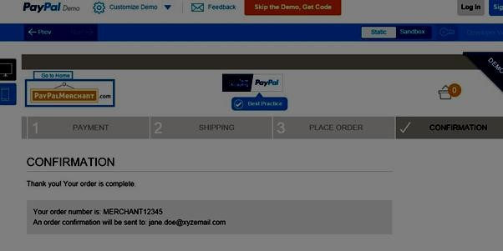

*Figure 7 – Pay Pal*

* ***Stripe***

Stripe is a very similar service as Pay-Pal regarding how it may be used in this project. It too provides a demo service to allow both consumers and developers to experience its service within their purchases and websites.

It was developed in Ireland and provides powerful tool-kits, and is perfectly scaled for any website or infrastructure.

##### Conclusion

Ref**.** [25]

|  |  |  |
| --- | --- | --- |
| **Characteristics** | **Pay-Pal** | **Stripe** |
| **Transaction Fees** | Charges 2.9% + 30c, but this rate is discounted as higher valued purchases are made. | Charges a flat rate of 2.9% + 30c per successful charge. This rate does not change. Service fees tend to be generally cheaper than Pay-Pal |
| **Security** | Now stores cards in vaults, but data still has to go through the servers, which puts a burden on security. | Use Stripe.js, which means the transaction data is sent directly to stripe and not servers. Server breaches not disclose details. |
| **API** | RESTful PayPal API is now more developed and documented since Stripe. Whereas it was quite buggy before Stripes release. | The Stripe API is clean, welldocumented, and easy to use therefore making other API's up their game. |
| **Data Portability** | Pay Pal has a severe lack of data portability in regards to registered customers. | Stripe on the other hand has great data portability and allows its customers to move and transfer important card data easily. |
| **Customer Service** | Pay Pal provide both a phone service and an emailing service should a customer need to contact , although recently they have been known to have very poor responsive rates | Stripe only provide an emailing service, but this emailing service is a 24hr live, free service, open to both engineers, and Stripe themselves. |

*Table 3 – Third Party Payment Comparisons*

Therefore based on the following research found which notes the key differences between *Pay-Pal* and *Stripe* I have decided to implement Stripe's demo API to handle money transactions within my system.

#### Deployment Method

#### Methods of Contact

## Other Research Performed

• Interview with Seamus Kilmartin To be concluded.

* Interview with Charles Gagnon Alexandre

## Resultant Findings/Requirements according to Research

So after extended research on these technologies and weighing up some of the pros and cons of some of the technologies as well as considering personal preference the following technologies have been chosen to develop this system and website:

|  |  |
| --- | --- |
| **Technology Type** | **Technology Name** |
| Browser : | Google Chrome |
| Backend Programming Language: | PHP |
| Frontend Programming Language: | HTML, JavaScript, CSS |
| Development Tool: | Sublime Text |
| Labelling System: | Barcoding/QR Coding |
| Database Technology: | MySQL |
| Third Party Payment: | Stripe |

*Table 4 – Technology Conclusions*

#### Hardware Requirements

To provide a sufficient proof of concept it has been decided to use a hand-held barcode scanner as part of the system. This will be used by the “employee” to scan the barcode in order to read in the relevant data to be handled or manipulated with an accurate result.

A fully functional laptop will also be required in order to run the system and website as the client side.

The file structure and system content will be stored on a server. Therefore access to a server will be required to deploy the website files and folders.

To demonstrate the effectiveness of the QR Code in the project as a substitution of a barcode should the user wish, an Android Smartphone with a QR Reading application will be used such as Androids QR *Droid Code Scanner*. Ref. [26]

# 3. Design

## Introduction to Design

The following chapter will outline all of the planning and design aspects of the project in detail. Further details are provided regarding the methodologies used throughout the project development as well as the system architecture of the proposed project. Following that, both the structural and visual design elements are outlined before looking at design documents including use-cases, ERD’s etc.

Timetables and Gantt charts are also provided in this chapter to outline the time allocated to the development phases of the project.

## Approach and Methodology

### Approach

For this project, the most important part of development was making sure the structure of the system and website was sustainable. MVC was the chosen structure for the system, as it is very simple to implement, control, expand and develop. Ref. [27]

Getting started on the project, firstly a pen-written design was drawn out of the folder structure, database tables and connection, then followed by some simple functionality to get the website up and running. This process included listing all templates, html forms, constraints for each form, and a breakdown of the accessibility of each type of user.

After that, rather than focusing on all design at once or all development at once for the whole project throughout, a step-by-step process was established. By doing this it makes it possible to design, implement and test each individual aspect/function one at a time (similar to TDD (Test Driven Development) [REF]). This also gave a possible estimate of output based on some assumed inputs.

The View was to be populated with specific data and templates based on the type of user logged on. By doing this a simple User Interface was designed allowing for sufficient testing of basic data and functionality. Since the idea of this project is generic barcoding, it was clear that the sooner development of a proof of concept was developed, the easier the progress of the system would become.

The approach has been followed since the beginning of the project, and progression has been evident throughout.

### Design Methodology

#### • *Agile Methodology*

The Agile Methodology is typically used in software development, but can be used in multiple fields of study and development. It allows for quick response to unpredictability by using incremental, iterative work cadences which are known as *sprints.* Ref.[28]

*Agile Methodology* is an effective alternative to sequential development and waterfall model method.

Essentially, the *Agile Methodology* has been applied throughout the project thus so far. Firstly, a proposed idea/function is designed and given sample data on paper to estimate a possible output. Should this not prove accurate during implementation, then a new approach and design to the same function is drawn up and tested.

So far, this has been used effectively and giving back accurate results mainly regarding database inputs and outputs.

Agile Methodology provides flexible, accurate testing on a regular basis throughout development in each of the Model, View and the Controller of the MVC framework. Although the MVC structure does provide some stability when it comes to the development of the system including each individual function, when applying the Agile Methodology it allows separate design, implementation and testing when needed during development.

All aspects of development will be implemented and tested using the Agile Methodology, such as:

* The Database(Tables, Constraints, Relationships)
* MVC Structure(Layout, Folder Structure, Factories, Connections)
* Registrations and Sample Data Handling within MVC and Database(CRUD operations, error handling, validation methods)
* QR Code Implementation
* Individual HTML Templates/Forms/visuals.

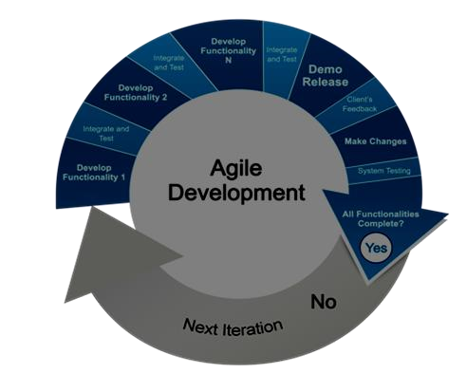

In the next section we will outline the system architecture used for the project being deployed.

[THE FOLLOWING WAS THE PROJECT ANALYSIS]

The purpose of the Generic Online Barcoding System is quite simple. The main aim is to make barcodes/ QR Codes which can be used in almost any situation to replace old fashioned, inconvenient activities which we may or may not have to perform every day.

The targeted solution is generic website which will allow registered users to perform various tasks in which the use of Visually Encrypted Codes will make these tasks a lot easier and more controllable.

On registration of the website the user will receive an SMS message notifying them to upload a personal portrait of themselves, as a profile image. This will be used as a part of identifying the valid attendee or driver who the barcode represents.

In order to prove this concept, it has been decided upon to focus on 3 aspects (Postal Stamping, Event Creating, and Car Parking).

The user will have the option, within the website, to make use of these 3 utilities.

**Postal Stamping** – Should the user decide they wish to send a letter, but have no conventional stamps in their possession, this system will generate a barcode containing the required information to simply identify the purpose of the barcode, the user, and the date it was generated.

The user simply has to print this barcode and stick it to an envelope/package and post it.

When the barcode is scanned, the appropriate stamp duty will be deducted from the users account. This process can be completed by using the users’ personal banking details, or a third party such as Pay-Pal or Stripe. Stripe's third party simulator will be used to fake a monetary transaction.

The process eradicates the personal inconvenience of an individual having to buy a conventional postage stamp, but yet they still manage to send their letter and pay the stamp duty with very little effort.

**Event Creating** –

This aspect of the system will show how the use of how this generated code can be used to provide a sufficient amount of control as well as ensuring validity of the entrants to the event. For this aspect the event creator will have the option to create the event and specify the names of each person attending in which on arrival they will be given their appropriate barcode/ QR code tag to as proof of ID and validity. The other option available for the creator will be to create the event, and publish it to a number of email addresses who are also members of the system. The guests will receive notification of this event both online and as an SMS and choose to *attend/reject.*

Should the guest decide to choose 'attend', a name tag will be generated for that individual user. I.e., when this user (guest) arrives at the event, they will be given the name tag which will contain their information embedded in a barcode. Before that user receives this name tag the provider will be able to know if this person is who they say they are due to the fact that their account contains a picture of them. (In a real life situation, Naming identification may also be used).

Again, systematic control, and validation is provided with the use of this system in the given scenario.

**Car Parking** -

Although it may seem that this is three systems in one, effectively it is one system which can be used for multiple use and purpose. In this final implementation of its use we will see its effectiveness to allow people to park their car without having to worry about purchasing parking tickets.

Firstly, a user simply goes onto the website, and chooses that they wish to generate a parking ticket. The ticket is generated and is printed off. The user can then use their mobile to top up the amount on the ticket. The amount they choose to top up by determines the duration of the ticket.

Approaching the final 15 minutes of the duration, the user will receive a text notifying them to either return to their car or to top up to extended their stay.

## System Architecture

### This system will consist of a *Three-Tiered Architecture* which will be made up of a *front-end user interface, a data modelling system and a data storage.* Ref. [29]

For the frontend a View will be used to populate the content of a template, which too will have an MVC structure made up of frontend languages such as HTML, JavaScript and JQuery.

As for the data-modelling of the project an MVC structure will be design and implemented using PHP and MySQL queries. Data will be controlled here and passed to and from the database. This file structure will be saved in a server such as Microsoft Azure [REF].

The data will be then be stored in a MySQL database server.

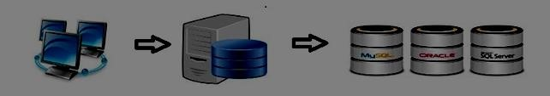

*Figure 8 – Technical Architecture*

Presentation Tier --> Application Tier --> Data Tier

## Design of User Interface

For the UI (User Interface) Design it was essential to keep it ‘clean and simple’. By using the utility provided by *Palleton.com [REF]* I was able to find a suitable colour scheme for the interface. Paletton provides accurate well-looking colour contrasts and shades. Other tools and API’s were used in order to provide essential graphical elements such as fonts, structure, colour, and graphics. These tools include:

* Twitter Bootstrap
* CSS
* Other Glyphicons provided by Marco Ceppi.[REF]

Testing multiple structures and UI elements gave an insight as to how the website should look. Bootstraps *‘col’* attribute allowed for specific columns and margins to be defined where needed. Each operation in which the user interact with the system is to be centred on the screen. For example:

<IMG>

By centralising all visual templates and forms on the screen contributes to the ease of access for the user.

Paper diagrams were first drawn up of various possibilities for the UI structure. After some consideration and the webpage structure chosen was designed as follows.

<IMG>

The following candidates were also strong possibilities:

<IMG><IMG>

I decided to add a “side-menu” to provide hidden options for each user type. Although each user type is been given its own html template, the structure of the templates are prominently the same.

Contrast in the UI between each user type:

|  |  |  |  |
| --- | --- | --- | --- |
| Element | Customer | Employee | Admin |
| Side Menu |  |  |  |
| Header Bar |  |  |  |
| Side-Scroller |  |  |  |
|  |  |  |  |
|  |  |  |  |

The next section outlines structural development for the System.

## Design of System Structure

While considering the structure of the system various elements were taken into thought such as the MVC framework, QR implementation, use of API’s, folder structure etc.

The following was the initial folder structure of the proposed system.

<IMG>

Here is the final folder structure of the system (not including the files within).

<IMG>

The following figure describes the relationship of the components of the core MVC, as well as one which includes attached elements.

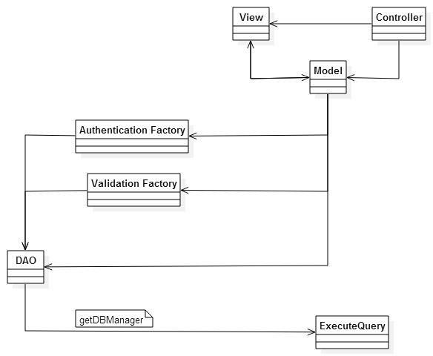

Figure 12. – MVC General Structure

<IMG>

Here is a breakdown of the content of each folder:

|  |  |
| --- | --- |
| **Folder** | **Description/Contents/Examples** |
|  |  |
|  |  |
|  |  |
|  |  |
|  |  |
|  |  |
|  |  |

## Design of Source Code

In terms of the structure of the coding elements most of it is structured based on the MVC framework.

Rather than commenting on each line of code, a comment box will be provided at the top of each coding file. Every function will be described by a small comment box located above the method definition.

## Project Features

#### SMS Messaging

For the SMS Messaging element of the system, the Clickatell API proved rather effective. This API is simply called from a separate PHP file which executes a cURL [REF] command passing in the appropriate parameters for the API. Unfortunately for this project, I am limited to the amount of texts I can send. The content of the message is also unable to be changed due to the account being used being a test account.

<IMG where the file is located><IMG where the file is being called(CONTROLLER)>

#### Automatic Emailing

As part of the system, the event creation aspect was to simply create an event which would generate individual QR Codes for each invite, and email this QR to the invitee email address.

In order to achieve this, PHP’s mailing API was considered as the simplest and most effective solution.

#### QR Code Generation

For the QR Code generation an external 2D-QR generator was used. This generator is a fre-to-use software and licensed to Dominik Dzienia [REF]. It provides accurate data readings for multiple lengths of data as well as multiple input characters.

The idea of creating a new QR generator would’ve been rather extensively time consuming. Therefore, I manipulated this code and library to suit this projects requirements.

Again, in order to perform the QR generation a cURL command is called from within an external PHP file which is triggered where needed.

<IMG where file is located><IMG where the file is being called(CONTROLLER)>

#### Stripe Payments

[NOT YET IMPLEMENTED]

#### Scanning QR Codes

[NOT YET IMPLEMENTED]

## Other Design Documents

#### Use Case Diagram

• Users : User, Admin, Employee, Third Party

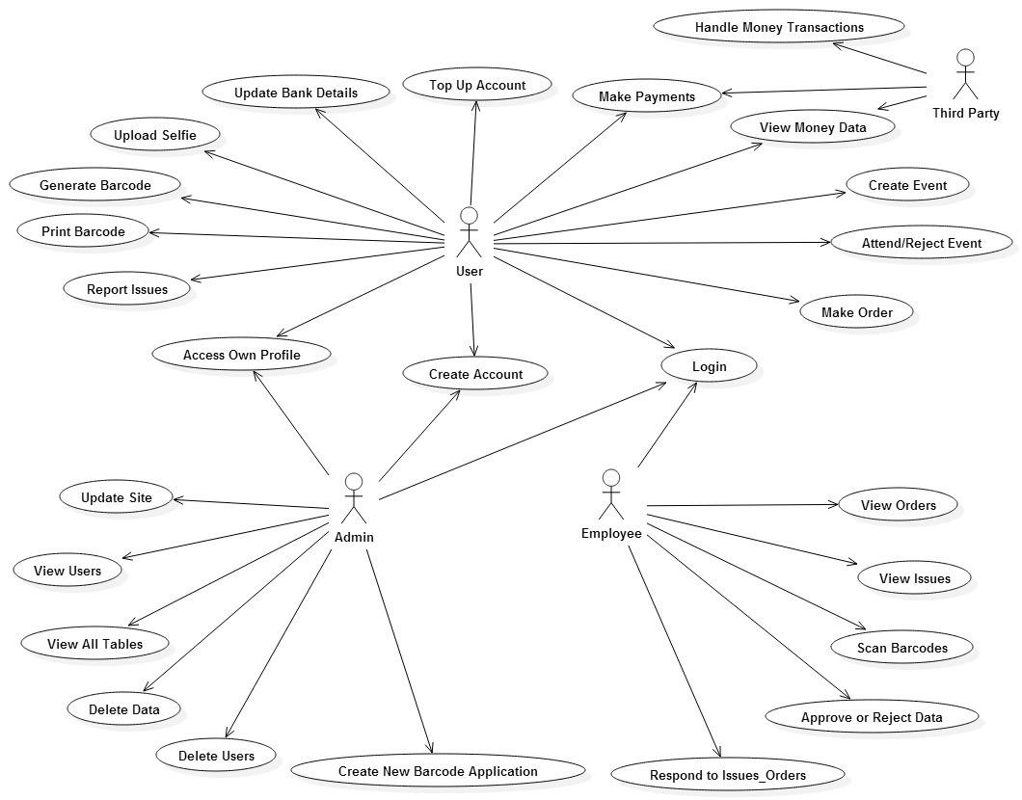

*Figure 9 - Use Case*

#### Gantt Charts

* **Gantt Chart (Unexpanded)**

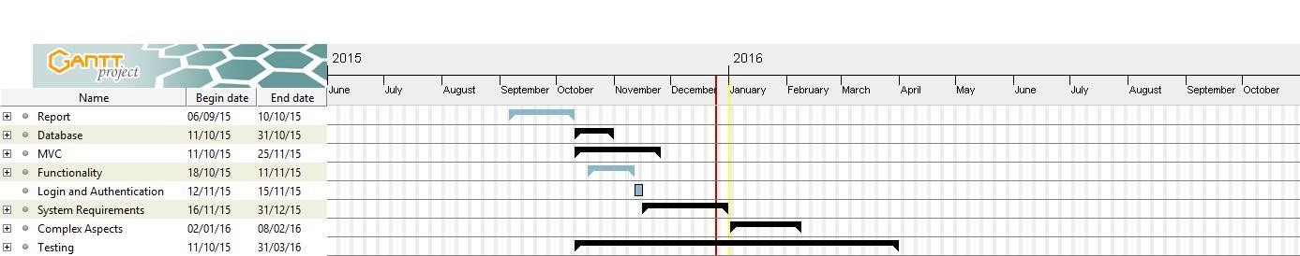

*Figure 10 - Unexpanded Gantt Chart*

* **Gantt Chart (Expanded)**

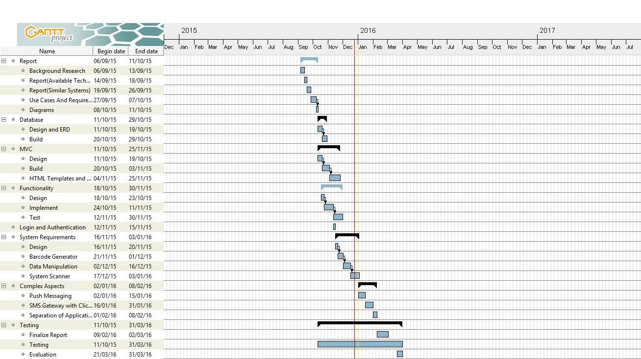

*Figure 11 - Expanded Gantt Chart*

[IMG – MVC VENN DIAGRAM]

#### ERD Diagram

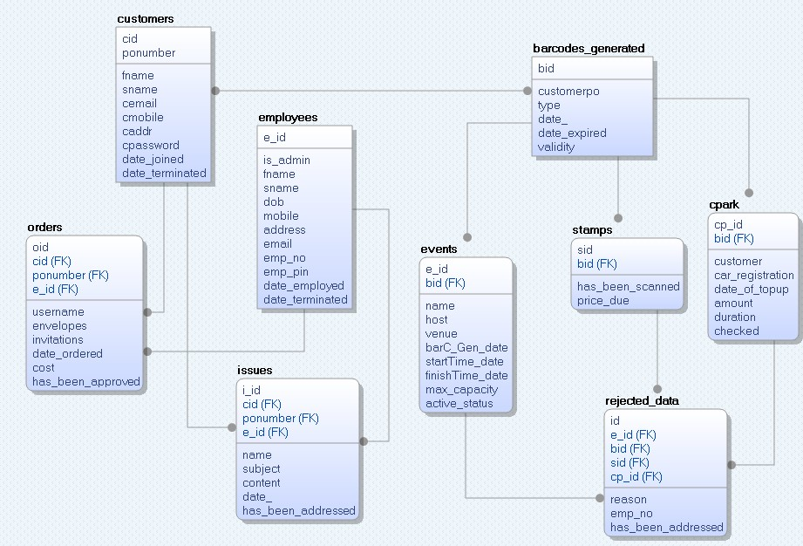

*Figure 13 - ERD Diagram*

# 4. Development and Implementation

## Development of Database

The development of the Database was predominantly based on the ERD described in the Design chapter. In this section we will be outlining the step-by-step development of the database, and its relationships.

<IMG – DAO’S FILE>

*Figure 14 - Developed DAO's*

Designing and implementing the database was the first key priority. It was majorly important that data used at any given time, was stored correctly, using the appropriate software, hash functions, data types and structure. In order to test the each column and table, sample data (both correct and incorrect ie. Using null in a non-null column) was inserted.

1. Firstly, all the database tables were designed and developed that were needed in order to complete the structure of the database as well as listing them under the appropriate user-type (i.e., General User, Employee, Issues, etc.).
2. Access to each table was based on the SQL Queries and templates provided to each user type. For example.

*A customer would not be given the option to view other customer’s details within their own template.*

1. Next, all indexes for each table were added including Primary Keys, Foreign Keys, and Unique Constraints etc. Following this step it was then important to create the appropriate relationships for each table.
2. Now that each table was almost fully designed in my database, sample data was tested using some manual CRUD operations using the localhost/PHPmyAdmin server. If a different database was to be used at a later stage. The current build script of this database can be “’*exported*’ for use on a different database.
3. Finally activity and validity columns were added and tested. The purpose of these columns is to keep track of various validations factors in particular generated data. This would include columns to ensure that a customer has paid for a particular service, or making sure that a ticket is still within its validation date before being accepted into the system.

For example:

*Should a customer create a new parking ticket, this would in turn make the old one redundant due to the concept that the car can only be parked in the one spot at any given time. This in turn prevents others from using a lost ticket if that ticket was still within its validation date*.

Following the creation of the database, the next essential step for the database was to write out a list of the queries in which would be each of the DAO’s. In order for each of these queries to be executed to affect the database, a PHP file (simple_db_manager.php) was created which contained the methods needed to connect to the database and execute the queries. See Figure 15.

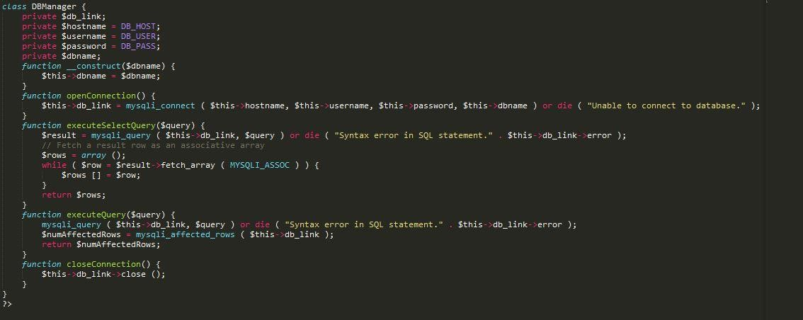

*Figure 15 - DBManager Code*

Essentially this DBManager is the access point to the database.

All database related files are contained within the FYP/db folder. This folder is structured as designed in the Design chapter, see Figure []. The main DAO_Factory class was then created to allow other classes to access the individual DAO’s methods and the DBManager as seen in Figure [].

Now that the methods were created to return each of the DAO’s, the next step was to develop each of the DAO’s themselves.

* BaseDAO

The BaseDAO simply extend its uses to each of the other DAO’s which in this case is the use of the DBManager.

<IMG OF BASE_DAO>

* CustomersDAO

The CustomersDAO contains all of the queries which manipulate the customers table in the database. Below is the list of all queries in which affect the customers table in the database.

* EmployeesDAO

The EmployeesDAO is more or less the same as the CustomersDAO except we are dealing with the employees table in the database. This DAO relates to both employees and admins of the system.

* NotificationsDAO

The NotificationsDAO handles all queries regarding issues from both employees and customers. Issues are used as a simple non-instant messaging service between the customer, employee and admin of the system.

* QrticketsDAO

The QrticketsDAO is the largest DAO, which is connected to the qrcodes, parkingtickets, events, stamps, parking_price, invites tables. This DAO handles all queries which are related to the generation, scanning or manipulation of the QR data.

In the next section the implementation of the Model, View and Controller is detailed. It will describe how the model as well as other classes interact with the methods defined in each of the DAO’s.

## Development of MVC – Model, View, Controller

Following the design of the MVC structure, the Model, View and Controller were implemented in accordance with the database in place. As part of the MVC structure, the necessary factories were implemented in order to get the index, controller, model, database connections and view to work together effectively. This also included connections between the Model and the factories to the necessary DAO’s.

Like every website, an *index* file was created which was to link the *[model to controller]* and the *[model and controller to the view].* This was to handle any user input to the system using a PHP *$_REQUEST*. See Figure []

<IMG – INDEX FILE CODE>

Next was the file and folder structure was designed and created for MVC framework, starting with the *model, view and controller* folders. These were followed by the *authentication factories, validation factories* within the model folder*.* Once some of the functions in the DAO's were tested with some sample data it was important to move ahead with initialising the model, view and controller files.

#### MODEL

The model file handles any data transactions, methods or functions which are called in the controller. The model is also instantiated with a copy of the necessary data checking factories (*authorisation, validation*).

<IMG – MODEL CONSTRUCT>

#### VIEW

The view is simply a control to determine what is being output on the screen for the user to see. The view is used to determine what user is logged on. Therefore determines which template to be applied for the user to ‘view’. The view is instantiated with a copy of both the model and the controller. This is so values may be taken from the model or factories to be displayed for the user such as a *username* or *numeric value* from the database. Whereas the controller is also instantiated in order for specific set values to be displayed such as the confirmation and errors messages.

<IMG – VIEW CONSTRUCT>

#### CONTROLLER

The controller receives all user input from the *index.php* file. This is instantiated with a copy of the model in order to pass various values to the model and then receive results such as Boolean values from the model to set certain variables such as confirmation/error messages.

<IMG – CONTROLLER SWITCH AND CONSTRUCT>

#### OTHER NECESSARY FOLDERS

On creating the MVC files the configuration (*conf*) folder was then created which contained the *config.inc.php* file to hold the constant values throughout the website such as the database connection variables and error messages.

An *images* folder which holds all external images and graphics used.

A *js* folder was created to hold some of the *JavaScript (js)* files which are used in the client side views.

Then the Cascading Style Sheet (*css*) folder to hold all the styling code as well as some of the bootstrap variables.

Now that the folder structure has been implemented, the next step was to begin populating them with appropriate coding files such as PHP, JavaScript, CSS, HTML files.

<IMG – FOLDER STRUCTURE>

Next we will have a look at the development of them html templates and forms. These are primarily used by the View to populate part of a given HTML template. (NOTE : HTML templates which contain tables populated by values from the database are called specifically in the HTML template itself.)

## Development of HTML Templates

One of the folders which was added at a later stage was the *templates* folder. This held all the user forms, index-structures for each type of user and html tables which were used to display the data taken from the database tables.

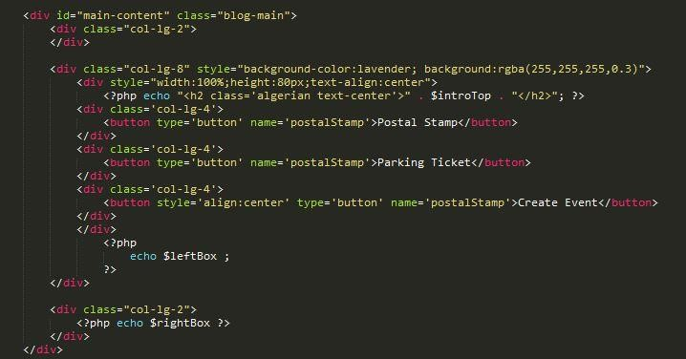

*Figure 20 - User Template Main Content*

1. Firstly the template index for each user (*4:customer, employee, admin, login-page*).
   1. *Template_index.php*
   2. *Template_index_employee.php*
   3. *Template_index_admin.php*
   4. *Template_index_login.php*
2. The appropriate forms for each user type were listed by hand See Figure[]. After being listed the next step was to build each of them, and provide sample data to test each submission. A list of all forms and templates is listed below. See Figure[]
3. Next was to list all required data tables to be displayed for each user. This was an important step as each user should only have access to particular data, so knowing what data was being displayed on each table, for each user is important.
4. Now that all the templates, forms and tables have been created it is now possible to include each of them in the view were required. The structure of the webpage is as follows:

<IMG BREAKDOWN OF VIEW, TEMPLATE, FORMS>

## User Interface

<IMG LOGIN SCREEN>

<IMG CUSTOMER TEMPLATE>

<IMG EMPLOYEE TEMPLATE>

<IMG ADMIN TEMPLATE>

<IMG SAMPLE FORM>

<IMG SAMPLE TABLE>

## Development of Functions and Factories

The functions and methods proved to be one of the most time consuming and most difficult aspects of creating the project. By beginning with the functions called in the *controller,* it was possible to quickly map each of them to the appropriate functions in the model.

To start with building the functions in the controller, the first aspect to be create was the *switch statement* which in this case was to check the value of the *action* parameter passed in from the *index.php* as described in Section 2 of Development and Implementation. This was then followed by the appropriate methods being created in the same script which were called after a case in the switch statement had been triggered.

<IMG – CASE IN SWITCH>

<IMG – METHOD CALLED BY SWITCH>

On triggering a statement within the switch, it would call the required function as mentioned above. From here this function would then call the opposing method inside the model, whilst passing any necessary parameters.

<IMG – CONTROLLER METHOD>

<IMG – MODEL METHOD>

Once the pattern is formed of the connections for each function within the controller matching the ones the model/factories, it was then easier to map data movements throughout the system. The controller requires the methods in the model in order to access the database and the factories. This is because the only entities which have access to the DAO’s are the model and factories as seen in Figure[].

<IMG FACTORIES AND MODEL INSTANTIATING THE DAO’S>

After creating the necessary functions within the controller, and model, as well as some in the factories which are described later in this chapter. It was then decided to begin mapping the methods from the model/factory to the appropriate DAO. See this sample scenario to understand the passing of the data between each entity

Scenario:

*If the user wished register, they would be required to enter in their necessary details in the HTML form. These values are then submitted to the index.php, which redirects them to the controller, and based on the ‘action’ passed from the HTML form, a method is called in the controller. After the method is called in the controller, the values are checked using the factories See Figure[] . If all of the values be acceptable they are then passed to method in the model, which calls the opposing function in the correct DAO and echoes the parameters to that method. From here the SQL statement is executed using the entered parameters.*

The DAO would handle the SQL statement required to execute the insert statement passing in the parameters containing the new user's details.

5. It is evident that a simple task is quite drawn out, but yet rather effectively. This was the process for almost all tasks and user interactions. Anything that may needed to be changed or laid out slightly differently was done so as required. Although this is the main structure and process used throughout my MVC website.

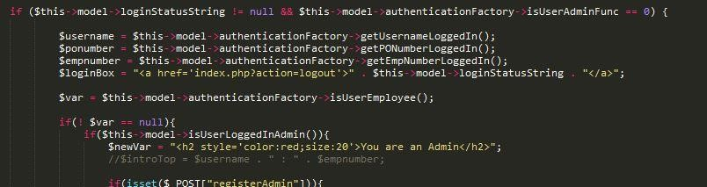

*Figure 24 –Method s to recognise User/Employee/Admin*

## Implementation of QR Code Features

## Use of Other API’s and Software

# 5. Project Validation

## Introduction

Explain your planned testing approach: For example: who will be involved, what test scripts are planned, how will the testing be executed.

Since a MVC Framework is used, it will be ensuring appropriate structure to both my system and website. Each aspect and component will be tested through both, *Black Box and White Box Testing*. In order to complete a full software examination both types of testing are required.

## Testing

### White Box

White Box testing is performed where by the tester has extensive knowledge of the code behind the system. By knowing and understanding the code within the system, the tester is hereby able to estimate sample data to test within the system. The tester is hereby also able to evaluate the results, to determine if the program diverges from the intended objective. Ref. [30]

For this project I will be the main white-box tester, by listing all possible inputs based on my code and constraints I will be making sure the correct error messages are displayed when needed, and as much invalid input error handling is managed in both my factories and my controller.

I plan to have a simplified working version of the system by January 31st, in which I will be demonstrating my code with my supervisor.

### Black Box

Black Box testing is testing which is performed by a tester who has no prior knowledge of the internal code. The tester (who may or may not have any knowledge of programming code) can only assume what the possible output may be based on the type of system and whatever input they may have tested. Unfortunately, not every aspect/path or possible input can be tested, therefore some gaps maybe left unattended. Ref. [31]

In terms of my project, to gain a sufficient evaluation on the functions, design, and controls I will need to extensively perform both of these forms of testing. As mentioned above, during Black Box testing, not all aspects can be covered 100%, therefore I have decided to perform Black Box Testing at monthly intervals by three separate testers. This approach will allow a variety of users with different levels of computer understanding to test the system. All results will be recorded, analysed and updated as each test is performed.

## Demonstration of Project Features

## Problems and Issues

#### Introduction to Problems and Issues

Explain the main issues / challenges that are unresolved on your project. – And your suggested approach to solving them. This is a critical part of your report to show that you understand what is required to complete the project.

* ***SMS Messaging***

One of the issues which has yet to be addressed is trying to figure out a gateway solution to make the system send a self-generated SMS message to a user in certain circumstances, such as, should a user’s parking duration be approaching it's limit they will receive a message notifying them to either top up their duration or return to their vehicle.

* ***Send Selfie Request***

When a user completes registration, a Push Message is to be sent to their mobile requesting them to upload a selfie which will automatically be used as a profile picture for various applications of the system, such as name tags, validation of correct user, on entering a venue, or even proof the correct driver of the car.

* ***The Header File Problem(1)***

One of the most time consuming errors which was found was dealing with an external PHP file which was to be used within the website. At first the problem turned out to be the *white space error* Ref.[32] within my controller file. But unfortunately this only raised more problems.

* ***The Header File Problem(2)***

The problem then was that after fixing the white space problem, now when the external PHP was executed, the header file of the external page overwrote the header of the source page. Therefore the main page was no longer in the view but the external page was. This meant the page was no longer interactive and simply only display the content of the external file.

* ***Various User Login***

Another problem which arose during implementation was dealing with views for each type of user. At first the idea and approach was to create one single index-template for all users and populate that template with content based on the type of user which was logged in. Unfortunately a problem kept arising from this approach where after any entity on the page was clicked after logging in, the content of the view would swap from user to user.

* ***Internet Needed for my Bootstrap file***

Unfortunately for a one week period of developing my website, my internet at home was down. Only then was it realised that some of the bootstrap was using was being referenced using a live link. An attempt to download a later version of the bootstrap file was tried but with no luck.

* ***Separating the factories***

Inside the model folder is both the *authentication factory* and *a validation factory.* At a later stage of the project development it was decided to attempt to separate these factories into individual factories for each type of user, or each table. After spending a number of days on trying to divide each file and connect these files to the appropriate DAO, it was causing more errors than it was solving.

### 7 Solving Problems

* ***Send Selfie Request***

For this problem exists an API class which allows for push messages to be sent to Android

Smartphones and iOS devices. It pushes a notification message to registered devices ID. Ref. [33]

* ***SMS Push Messaging***

To solve this problem, an API provided by *Clickatell*  which performs SMS standard messages to be sent through a gateway to a mobile device will provide sufficient functionality for this complex aspect of the system. Ref. [34]

* ***Header File Problem(1) Solution***

Solving the first problem in regard to the external header file was an exceptionally simple solution which would never have been discovered had it not been researched.

As it turns out, in order for an external header file to be recognised, there is a common error called the *white space problem.* In order to solve this problem, the white space (if any) before the PHP tags i.e., <?php> , must be removed.

* ***Header File Problem(2) Solution***

Yet to be solved

* ***Various User Login Solution***

To overcome this simple problem, a different approach was attempted, in which requires using multiple index-templates (one for each type of user), where depending on the type of user that is logged in, the template would vary. This proved rather effective.

* ***Internet Needed for Bootstrap***

Although this was not so much an error as it was a setback, other aspects of the project which did not require an internet link were focused on.

* ***Separating the factories Solution***

To solve the problem of separating the factories inside the model folder, it was decided to un-do the changes made and progress with a single authentication factory and a single validation factory to cover all tables. This was a simple error due to the fact that this approach was not considered during the initial design.

# 6. Project Plan

## Introduction

## Deviations from Initial Plan and Design

## Changes to be addressed if Project was repeated

## Future Development of Project

Overall the main goal of this project is to be completed by the end of January. This will be a functional website which implements the system been demonstrated.

### Key Completion Components Include

* Aesthetically Pleasing Web Interface
* Good Form Controls throughout the Website
* Successfully Implemented MVC Framework and backend deployment
* Effective Barcode Generation to successfully identify, its use at any given time, the unique ID of the person, and a timestamp as proof of validation depending on the use of the barcode.
* Data is manipulated effectively where intended.
* Proof of concept regarding point of sale / money transaction when Barcode is scanned.
* SMS Gateway Successfully Established
* Push-Messaging Successfully Created within System
* Mobile Photo Upload

Essentially, the idea of the completed system is to allow the user to use this unique generated barcode for multiple purposes as proof of validation on payments and as a point of payment also.

Example 1,

Postal System – User Registers with system, and is given their unique id code. Should that user wish to send a letter, they can simply, select from the website the option to *Generate Stamp*. They will then be shown a *barcode on – screen* which will be made up from the following data.

1. 6 character ID for Barcode Type i.e., STAMP
2. Personal Unique ID Number i.e., 1234567
3. Timestamp i.e., 12000025112015

Therefore the Barcode generated will contain the following data:

STAMP123456712000025112015

When scanned by the system it will recognise what the barcode is for – i.e., Postal Stamp,

Then it will recognise the user account to deduct the appropriate amount from that user account.

As a security feature a time limit from the time of generation from which the barcode is valid was implemented. This would be to prevent unauthorised users using someone’s generated barcode for more than the expiry time should they manage to attain the barcode.

Example 2,

Car Parking – Same as above, after registration the user will be given their unique personal id. Should that user wish to pay for a parking, they can simply select from the website the option to *Generate Parking Ticket*. They will then be shown a *barcode on – screen* which will be made up from the following data.

1. 6 character ID for Barcode Type i.e., CPARK
2. Personal Unique ID Number i.e., 1234567
3. Timestamp i.e., 12000025112015

Therefore the Barcode generated will contain the following data:

CPARK123456712000025112015

From here the user can top up the amount they wish to pay from their account. They can specify the time of parking, and the duration of which they wish to stay parked. The amount deducted from their account will be determined based on the duration they have specified. Should the user wish to stay longer than they initially opted for, they will have the option to update their parking status to extend their duration. Again based on this the amount deducted will also be updated.

As seen from the above examples of how the system can be used based on the type of barcode which is generated, essentially the system is an all-in-one way in which a user can simplify various everyday activities which require various identification and validation through the use of a scanning system.

This is the type of system which could be implemented into multiple aspects of everyday life all within one system. Ranging from postal stamp system, ticket validation, and user identification it could also be expanded at a later phase to implement a simple limited point of sale utility.

For example,

Similar to *Pay-Pal,* where people can top up their Pay-Pal account and purchase things online using that utility rather than providing personal banking information. This system could be expanded to an over the counter point of sale system, where the user could carry a copy of their barcode with them within their wallet or as a wristband, in which a shop keeper will scan the barcode and the amount will be deducted from their personal account with this system or from a third party account such as PayPal or Stripe rather than their personal bank.

Essentially, this is system could be expanded to cover a wide range of applications across various uses incorporated with NFC (Near Field Communication), Bluetooth etc.

[http://www.techradar.com/news/phone-and-communications/what-is-nfc-and-why-is-it-in-yourphone-948410](http://www.techradar.com/news/phone-and-communications/what-is-nfc-and-why-is-it-in-your-phone-948410)

# 7. Conclusions

## Report Summary

## Learning Outcomes

## Personal Reflection

## Final Conclusion

To finally conclude the research performed prior to the development and design of this project it is evident that there is a gap in society for a project like this. It’s simplicity of completing some basic tasks all within one system gives a huge advantage over its current competitors.

A plan for other aspects of both development and design has been devised in order to complete this project by the deadline. With the structure, design and planning and former research provided software tools and requirements have also been decided upon.

I feel that with the progression of this project I will develop my skills further in the role of website building and software development. I will be making use of my basic knowledge of PHP programming as well as including my skills in SQL Database development. One of the main challenges I face in terms of developing my skills is to make my system sustainable.

The most complex aspects of the system include:

* SMS Messaging using clickatell-sms-gateway
* Selfie notification and upload
* Generation of Appropriate Barcodes/ QR Codes to be understood accurately by the system

# Bibliography

1. ToastieCoastie, “Why are postage stamps necessary?,” 2015. [Online]. Available:

https://www.reddit.com/r/explainlikeimfive/comments/2a2519/eli5_why_are_postage_stamps _necessary_they_just/. [Accessed 10 11 2015].

1. Parking Tag, “How it Works?,” 2015. [Online]. Available: https://www.parkingtag.ie/. [Accessed 12 11 2015].
2. EventBrite, “Fees and Pricing,” 2015. [Online]. Available: https://www.eventbrite.ie/fees/. [Accessed 20 11 2015].
3. Arekibo, “The Post Office and Stamps,” 2015. [Online]. Available:

http://www.anpost.ie/AnPost/History+and+Heritage/Learning/The+Post+Office+and+stamps/. [Accessed 15 11 2015].

1. 2-clicks-stamps, “What is a stamp collector?,” 2015. [Online]. Available: http://www.2-clicksstamps.com/article/what-is-a-stamp-collector.html. [Accessed 10 11 2015].
2. J. Nielsen, “10 Usability Heuristics for User Interface Design,” 2014. [Online]. Available: http://www.nngroup.com/articles/ten-usability-heuristics/. [Accessed 02 11 2015].
3. R. Miller, “The evolution of franking: different ways to indicate postage was paid,” 2015.
4. DLR, “Pay and Display Parking Methods,” 2015. [Online]. Available: http://www.dlrcoco.ie/aboutus/councildepartments/transportation/applyforit/parking/payand displayparkingmethods/. [Accessed 10 11 2015].
5. Apica, “Pros and Cons of Popular Web Browsers,” 4 August 2014. [Online]. Available: https://www.apicasystem.com/blog/pros-cons-popular-web-browsers/. [Accessed 19 10 2015].

[1 R. Zaremba, “Which programming language you should use for a web backend,” 08 03 2013.

0]

[Online].Available: http://rz.scaleit.pl/2013/03/08/which_programming_language_should_you_use_for_a_web_backend.html. [Accessed 01 11 2015].

[1 R. H. Technology, “C, C++ or Java — Which Is Best for Your Backend Developer Career?,” 2015.

1] [Online]. Available: http://www.roberthalf.com/technology/blog/c-c-or-java-which-is-best-foryour-backend-developer-career. [Accessed 09 11 2015].

[1 JScriptors, “Advantages and Disadvantages of Javascript,” 2015. [Online]. Available:

2] http://www.jscripters.com/javascript-disadvantages-and-advantages/. [Accessed 10 11 2015].

[1 JScriptors, “Advantages and Disadvantages of JQuery,” 2015. [Online]. Available:

3] http://www.jscripters.com/jquery-disadvantages-and-advantages/. [Accessed 10 11 2015].

[1 R. Shannon, “What is HTML?,” no. 1, 2012.

4]

[1 M. Rouse, “Event-Driven Application Definition,” 2012. [Online]. Available:

5] http://searchcloudapplications.techtarget.com/definition/event-driven-application. [Accessed 15 11 2015].

[1 M. Rouse, “ActionScript Definition,” 2005. [Online]. Available:

6] http://searchsoa.techtarget.com/definition/ActionScript. [Accessed 15 11 2015].

[1 Sublime Text, [Online]. Available: http://www.sublimetext.com/. [Accessed 02 11 2015].

7]

[1 R. Boudreaux, “Open source NotePad++ is a solid contender among text editors,” 2011.

8] [Online]. Available: http://www.techrepublic.com/blog/web-designer/open-source-notepadplus-plus-is-a-solid-contender-among-text-editors/. [Accessed 15 11 2015].

1. PhilKH, “Is Eclipse the best IDE for Java? If not, is there something better?,” [Online]. Available: 9] http://stackoverflow.com/questions/152691/is-eclipse-the-best-ide-for-java. [Accessed 19 11 2015].
2. Denso Wave Incorporated, “2D Barcodes,” 2014. [Online]. Available: https://archive.is/IuLU. 0] [Accessed 16 11 2015].

[2 Marketing VF, Expertmarket, “What is a Franking Machine?,” 2015. [Online]. Available: 1] http://www.ie.expertmarket.eu/franking-machines. [Accessed 29 10 2015].

[2 Janalta Interactive Inc., “Oracle Database (Oracle DB),” 2015. [Online]. Available:

2] https://www.techopedia.com/definition/8711/oracle-database. [Accessed 20 11 2015].

[2 Janalta Interactive Inc., “SQL Server,” 2015. [Online]. Available:

3] https://www.techopedia.com/definition/1243/sql-server. [Accessed 20 11 2015].

[2 Janalta Interactive Inc., “MySQL,” 2015. [Online]. Available:

4] https://www.techopedia.com/definition/3498/mysql. [Accessed 20 11 2015].

[2 Jestro LLC., “Stripe vs PayPal: Who should you choose?,” 2015. [Online]. Available:

5] https://memberful.com/blog/stripe-vs-paypal/. [Accessed 12 11 2015].

[2 DroidLa, “Droid QR Code Scanner,” DroidLa, 2015.

6]

[2 T. Dalling, “What is the advantage of MVC?,” 2015. [Online]. Available:

7] http://www.tomdalling.com/blog/software-design/model-view-controller-explained/. [Accessed 29 10 2015].

[2 admin, “Agile Methodology,” 2015. [Online]. Available: http://agilemethodology.org/. [Accessed 8] 12 11 2015].

[2 Technopedia, “Three-Tier Architecture,” 2015. [Online]. Available:

9] https://www.techopedia.com/definition/24649/three-tier-architecture. [Accessed 24 11 2015].

[3 QuinStreet Inc., “White Box Testing,” 2015. [Online]. Available:

0] http://www.webopedia.com/TERM/W/White_Box_Testing.html. [Accessed 24 11 2015].

[3 QuinStreet Inc., “Black Box Testing,” 2015. [Online]. Available:

1] http://www.webopedia.com/TERM/B/Black_Box_Testing.html. [Accessed 23 11 2015].

[3 The PHP Group, “header,” 2014. [Online]. Available:

2] http://php.net/manual/en/function.header.php. [Accessed 23 10 2015].

[3 Y. Ryu, “PHP Push Notification Android,” 2015. [Online]. Available:

3] http://www.phpclasses.org/package/8987-PHP-Send-push-notifications-to-Android-and-iOSdevices.html. [Accessed 28 11 2015].

[3 Clickatell, “SMS-Gateway,” 2015. [Online]. Available:

4] https://www.clickatell.com/developers/sms-gateway/. [Accessed 28 11 2015].

[3 Denso Wave Incorporated, “QR Codes,” 2014. [Online]. Available:

5] http://www.qrcode.com/en/qrfeature.html. [Accessed 09 11 2015].

# Appendix