CTO REPORT | PROMPT SECURITY
7d of activity under policy
What Prompt Security observed, what we intervened on, and where to take the insight next.
Window 2026-04-15 to 2026-04-22 (UTC)
Data source dataSource.name = 'Prompt Security'

Telemetry pulled live via the SentinelOne Singularity Data Lake (PowerQuery over the Management Console API).

Executive summary
Over the 7d window ending 2026-04-22 UTC, dataSource.name='Prompt Security' produced 37,094 events across 41 distinct users. The intervention rate is high. Either the policy is tuned aggressively or the traffic contains a lot of behaviour the business cares about; both are worth understanding before promoting or relaxing policies.
37,094  Total events (7d) | 15,922  Blocked events | 47.5 %  Intervention rate | 41  Distinct users
What the CTO should take away
■ Block rate of 42.9% (15,922 of 37,094). These are events the policy refused outright.
■ Modify action ran 1,706 times (4.60%). The system transformed the payload in place instead of refusing, letting the user continue.
■ Bypass activity sits at 0.135% (50 events). Bypass events are near-zero. Users are accepting policy decisions, which is the strongest signal that the policy is trusted.
■ Activity is extremely concentrated: a single principal drove the overwhelming majority of events, which distorts any baseline calculation until that account is understood. The top principal (drjones@flybynight.ru) drove 35,729 events (96.3% of volume).
What we recommend next
■ Resolve the top principal: drjones@flybynight.ru. A single principal drove 96.3% of the window's volume. Pivot into SentinelOne EDR / identity from this principal's session to establish whether this is a scripted harness, a shared account, a misconfigured integration, or hostile activity. A short investigation closes the largest single-source risk in this report.
■ Promote log-only policies to enforce. Block rate is 42.9% and bypass is 0.135%. That combination is as strong a signal as we ever get that principals accept policy decisions. Walk each currently-log-only policy and promote the ones with zero false positives.
■ Correlate bypass with endpoint posture. Build a Custom Detection Rule that chains a Prompt Security bypass event to a SentinelOne alert of medium-or-higher severity on the same principal within 60 minutes. One rule, two data sources, one unified alert.
■ Enrich ingestion where it is shallow. Today, Prompt Security events land with a subset of fields populated. Check whether prompt / payload / content is null; adding even one content field unlocks content-based detection and Purple AI hunts against the same data lake.

Volume and timing
Daily event count for Prompt Security, stacked by policy action where available. The timeline lets you see whether volume is steady, bursty, or driven by a handful of incidents during the window.
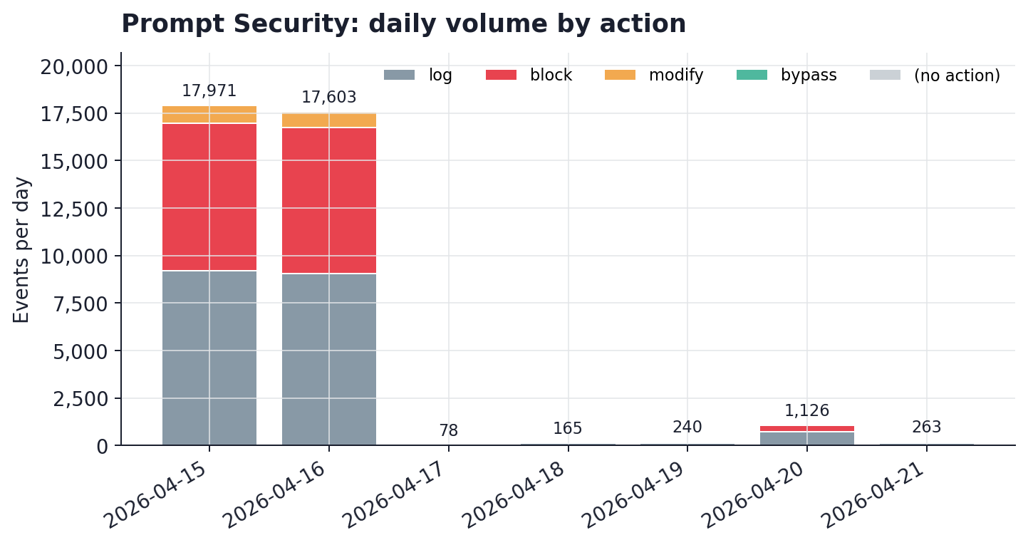
Timeline of Prompt Security events across the window.
What the shape tells us
■ Uneven but not pathological: the busiest slice (2026-04-15, 17,971 events) carried 48.0% of the window. A normal mix of bursty and quiet periods.
■ Dominant action across the window: 'log'. Check whether the ratio of 'log' to the next action stays stable across slices; drift is a useful early signal for policy change.
Policy action mix
Every Prompt Security event terminates in one of a small set of outcomes. The mix is the most compact answer to 'what is this policy doing for us'.
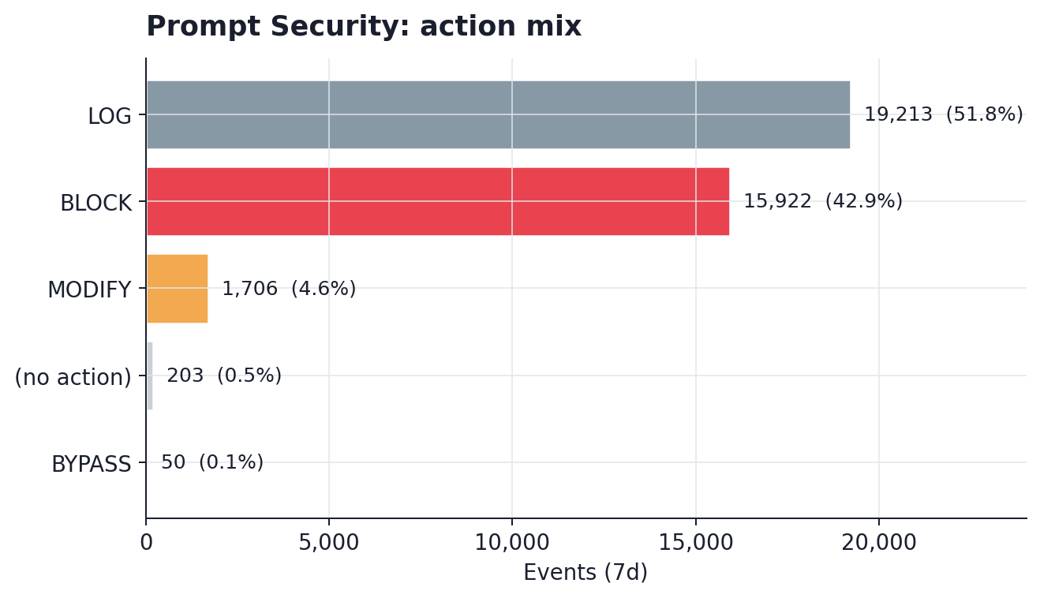
7d distribution of action outcomes across 37,094 events.
What each action means
Action | Count | % of total | Typical meaning
LOG | 19,213 | 51.8% | Event allowed, recorded for audit.
BLOCK | 15,922 | 42.9% | Event refused by policy; the request was not completed.
MODIFY | 1,706 | 4.6% | Payload rewritten in place and forwarded (eg. PII redacted).
(no action) | 203 | 0.5% | No action field recorded; typically internal or system traffic.
BYPASS | 50 | 0.1% | A principal explicitly overrode a policy decision.

Who is driving the traffic
Ranking users by volume is how we identify the accounts that shape the baseline and the accounts that warrant individual review. The chart uses a log scale so a dominant principal does not flatten the long tail.
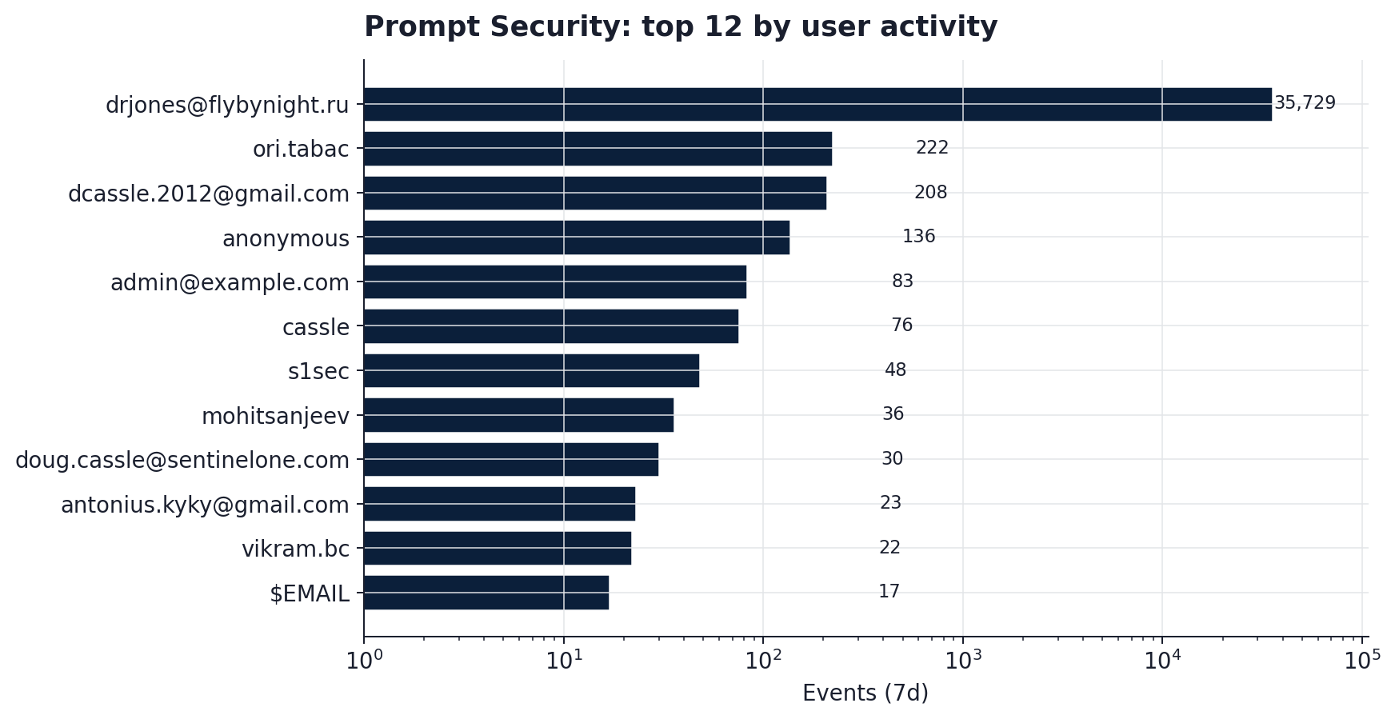
Top users by 7d event volume (logarithmic x-axis).
The concentration story
drjones@flybynight.ru drove 35,729 events (96.3% of the window). Activity is extremely concentrated: a single principal drove the overwhelming majority of events, which distorts any baseline calculation until that account is understood.
• If this was a demo, a test harness, or a scripted load: tag it out of baseline calculations before moving any policy into enforce.
• If this was a real principal: pivot into SentinelOne EDR/identity for the session history and posture of the underlying endpoint.
• If this cannot be attributed: the anonymous or shared-account pattern is itself worth tracking; a tag pass here will pay off for every future report.
Risk signals: interventions and overrides
Two lenses matter more than the headline numbers: who the system is intervening on, and who is overriding it. Intervention tells us where the policy is doing the most work. Override tells us where principals disagree.
Top users by BLOCK
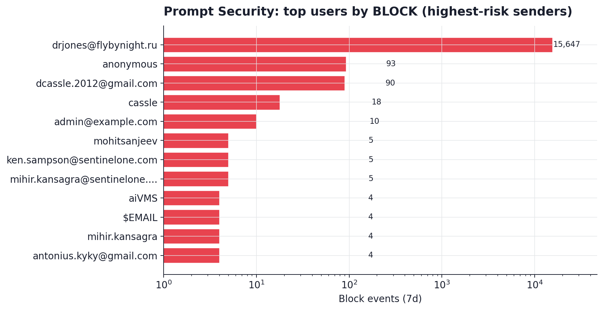
Users ranked by block count. The cohort near the top of the long tail is usually where human attention pays off.
Top users by BYPASS
Bypass is low-volume but highly informative. These are the users who saw a policy decision and chose to override. Bypass events are near-zero. Users are accepting policy decisions, which is the strongest signal that the policy is trusted.
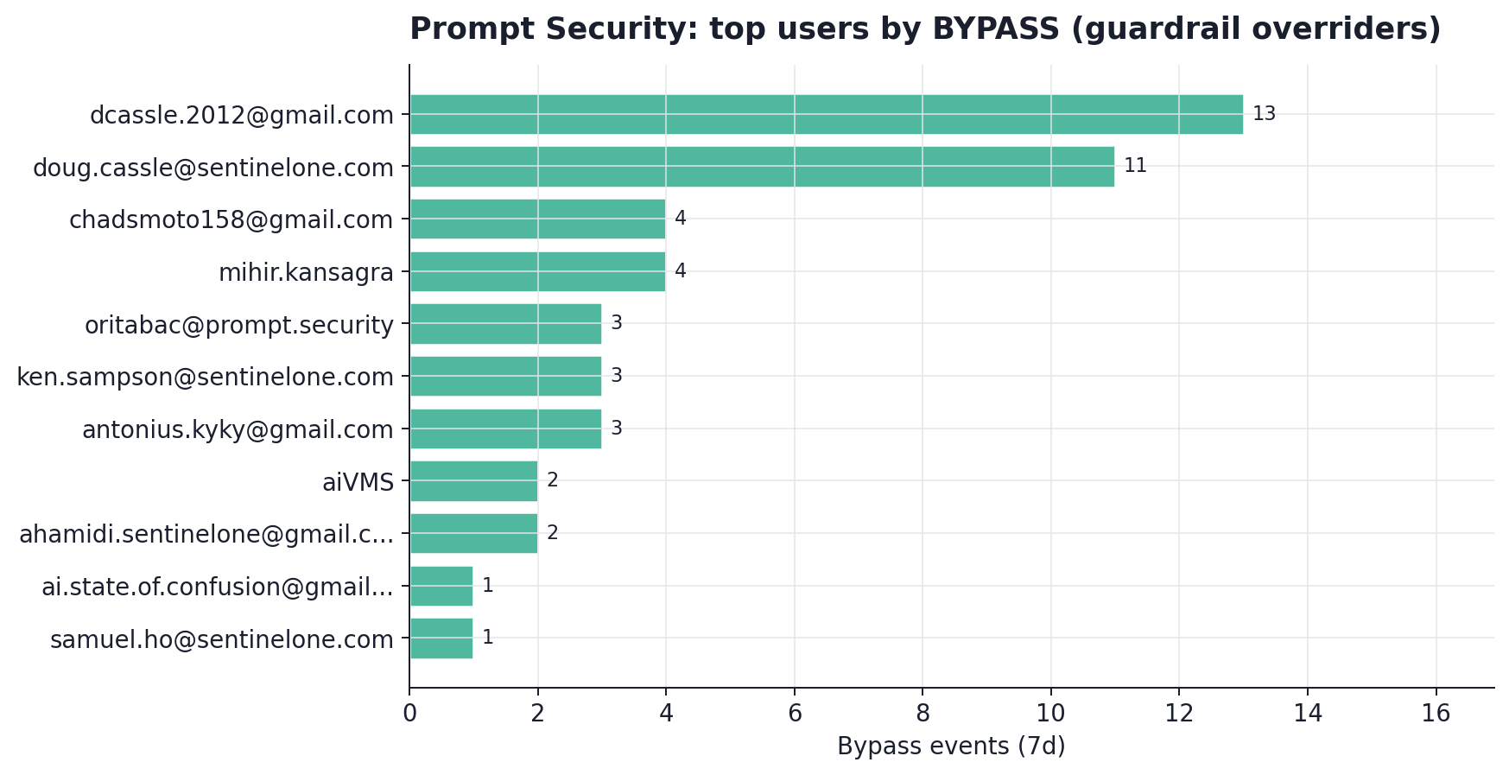
Top users by bypass count. The signal to watch over time is concentration.
Per-principal action mix
Stacked view of the top active users broken out by outcome. This is the clearest way to spot a mixed-use profile, in which a single principal is being both blocked and allowed across the window.
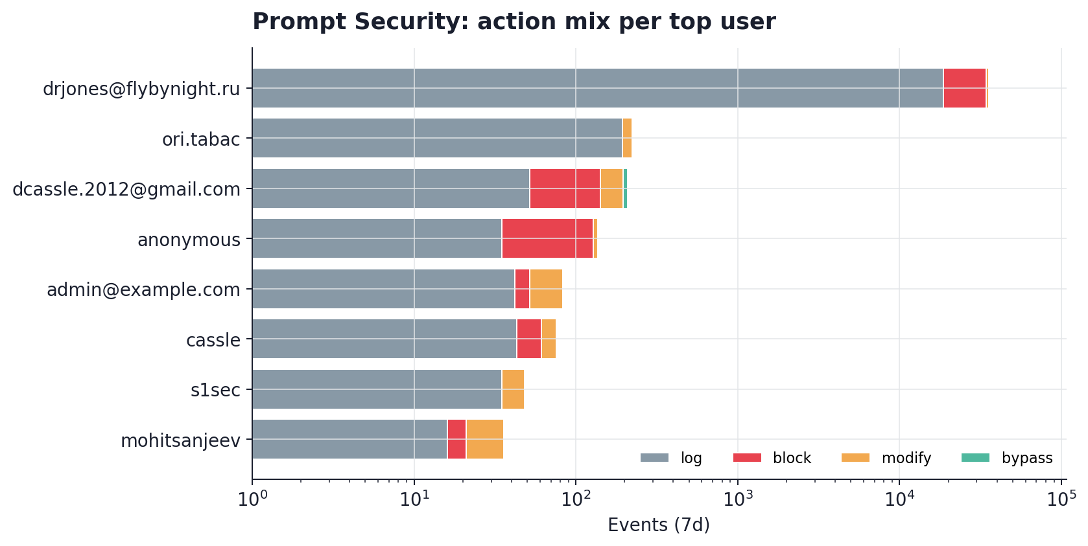
Action mix per top users (log-scale).

Where Prompt Security fits in the broader picture
In the last 24 hours, Prompt Security ranks #27 among the data sources landing in your SentinelOne tenant. The chart below places Prompt Security in context alongside EDR, network, identity, and cloud telemetry so you can see how it contributes to the overall detection surface.
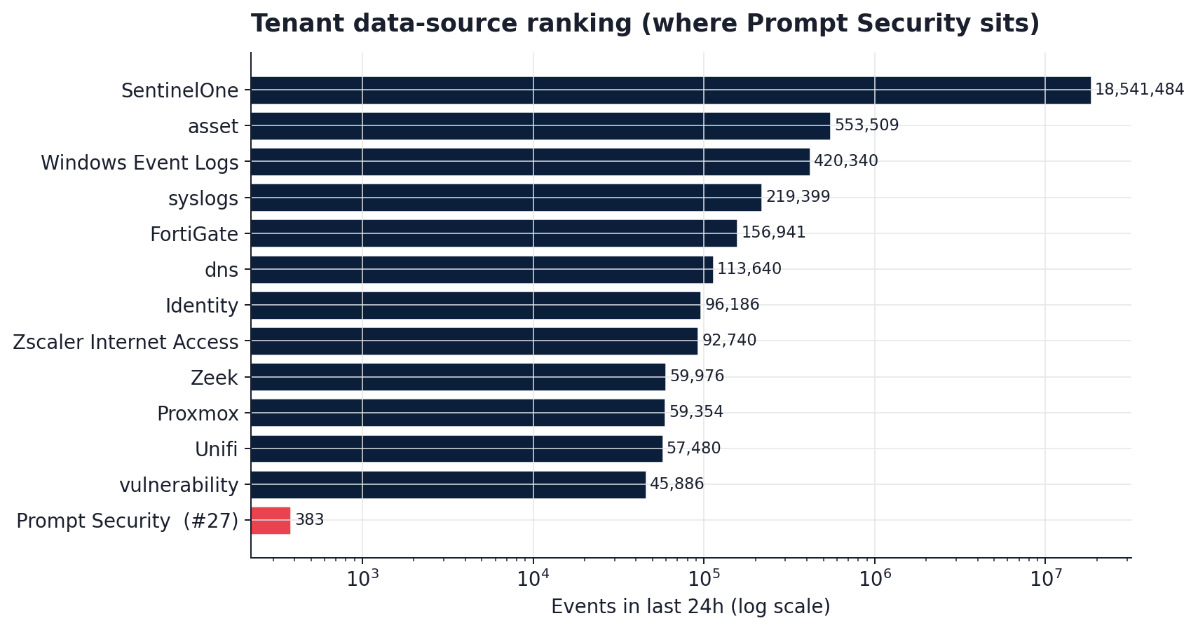
Data-source volume in the last 24 hours (Prompt Security highlighted).
Why this matters to the CTO
■ Prompt Security lives in the same data lake as EDR, identity, network, and cloud telemetry. Correlation is native, not a bolt-on.
■ Any detection built on Prompt Security can chain to SentinelOne endpoint context in a single query; a STAR / Custom Detection Rule needs no extra plumbing.
■ As usage grows, this source's share of daily events will climb in rank without any ingestion changes.
Recommendations, prioritised
[24 hours] Resolve the top principal: drjones@flybynight.ru
A single principal drove 96.3% of the window's volume. Pivot into SentinelOne EDR / identity from this principal's session to establish whether this is a scripted harness, a shared account, a misconfigured integration, or hostile activity. A short investigation closes the largest single-source risk in this report.
[This week] Promote log-only policies to enforce
Block rate is 42.9% and bypass is 0.135%. That combination is as strong a signal as we ever get that principals accept policy decisions. Walk each currently-log-only policy and promote the ones with zero false positives.
[This month] Correlate bypass with endpoint posture
Build a Custom Detection Rule that chains a Prompt Security bypass event to a SentinelOne alert of medium-or-higher severity on the same principal within 60 minutes. One rule, two data sources, one unified alert.
[This month] Enrich ingestion where it is shallow
Today, Prompt Security events land with a subset of fields populated. Check whether prompt / payload / content is null; adding even one content field unlocks content-based detection and Purple AI hunts against the same data lake.
[Quarterly] Baseline normal
Re-run this report on a fixed cadence. The charts are regenerated from a single JSON artefact, so a 30-day or 90-day view is a parameter flip. Anomalies against the baseline become the input to the next round of policy tuning.

Methodology
Every number and chart in this report was computed directly from the SentinelOne Singularity Data Lake using the Management Console API. No data was moved outside the tenant. No sampling was applied.
Data collection
■ Source: dataSource.name = 'Prompt Security', excluding the internal logVolume bookkeeping tag.
■ Window: 2026-04-15T16:42 to 2026-04-22T16:42 UTC (7d).
■ Transport: POST /sdl/v2/api/queries (Long Running Query API) authenticated with Bearer token scoped to the account.
■ Aggregations executed in parallel (max 3 concurrent) to respect the per-user rate limit. Timeline rendered via 7 day-size client-side slices (the engine does not expose a native timebucket function).
Provenance
A single JSON artefact (reports/Prompt_Security_7d/data.json) captures the raw aggregation output: query text, match counts, elapsed time, and every returned row. The charts and this document are pure rendering steps over that artefact, so the numbers can be reproduced at any time.
Dimensions observed
■ Present: action, user
■ Absent: src_ip, src_host, event_type

