CTO REPORT | WINDOWS EVENT LOGS
24h of activity under policy
What Windows Event Logs observed, what we intervened on, and where to take the insight next.
Window 2026-04-21 to 2026-04-22 (UTC)
Data source dataSource.name = 'Windows Event Logs'

Telemetry pulled live via the SentinelOne Singularity Data Lake (PowerQuery over the Management Console API).

Executive summary
Over the 24h window ending 2026-04-22 UTC, dataSource.name='Windows Event Logs' produced 396,405 events. No principal dimension (user, host, or IP) was present on this source, so this report focuses on volume, timing, and tenant context. The source does not carry a policy-action field, so this report treats it as an observability stream rather than an enforcement surface.
396,405  Total events (24h) | Windows Event Log Creation  Dominant event.type | 24  Slices (timeline) | #3  Tenant rank (24h)
What the CTO should take away
■ Dominant event.type: 'Windows Event Log Creation' at 396,405 events (100.0% of the window). Use this as the entry point when building detections against the source.
■ In the last 24 hours, Windows Event Logs ranks #3 among the data sources landing in this tenant. The ranking is a useful anchor for whether volume is trending or flat.
■ Windows Event Logs lives in the same data lake as SentinelOne EDR, identity, network, and cloud telemetry. Any detection or hunt built on this source can join to endpoint context in one PowerQuery.
What we recommend next
■ Enrich ingestion where it is shallow. Today, Windows Event Logs events land with a subset of fields populated. Check whether prompt / payload / content is null; adding even one content field unlocks content-based detection and Purple AI hunts against the same data lake.
■ Baseline normal. Re-run this report on a fixed cadence. The charts are regenerated from a single JSON artefact, so a 30-day or 90-day view is a parameter flip. Anomalies against the baseline become the input to the next round of policy tuning.

Volume and timing
Hourly event count for Windows Event Logs, stacked by policy action where available. The timeline lets you see whether volume is steady, bursty, or driven by a handful of incidents during the window.
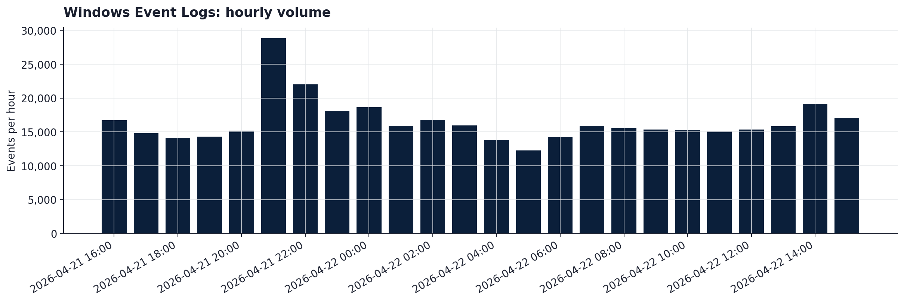
Timeline of Windows Event Logs events across the window.
What the shape tells us
■ Evenly distributed. The busiest slice (2026-04-21 21:00, 28,944 events, 7.3% of the window) is only modestly ahead of average; this is the steady-state shape.
■ Dominant action across the window: 'Windows Event Log Creation'. Check whether the ratio of 'Windows Event Log Creation' to the next action stays stable across slices; drift is a useful early signal for policy change.

Where Windows Event Logs fits in the broader picture
In the last 24 hours, Windows Event Logs ranks #3 among the data sources landing in your SentinelOne tenant. The chart below places Windows Event Logs in context alongside EDR, network, identity, and cloud telemetry so you can see how it contributes to the overall detection surface.
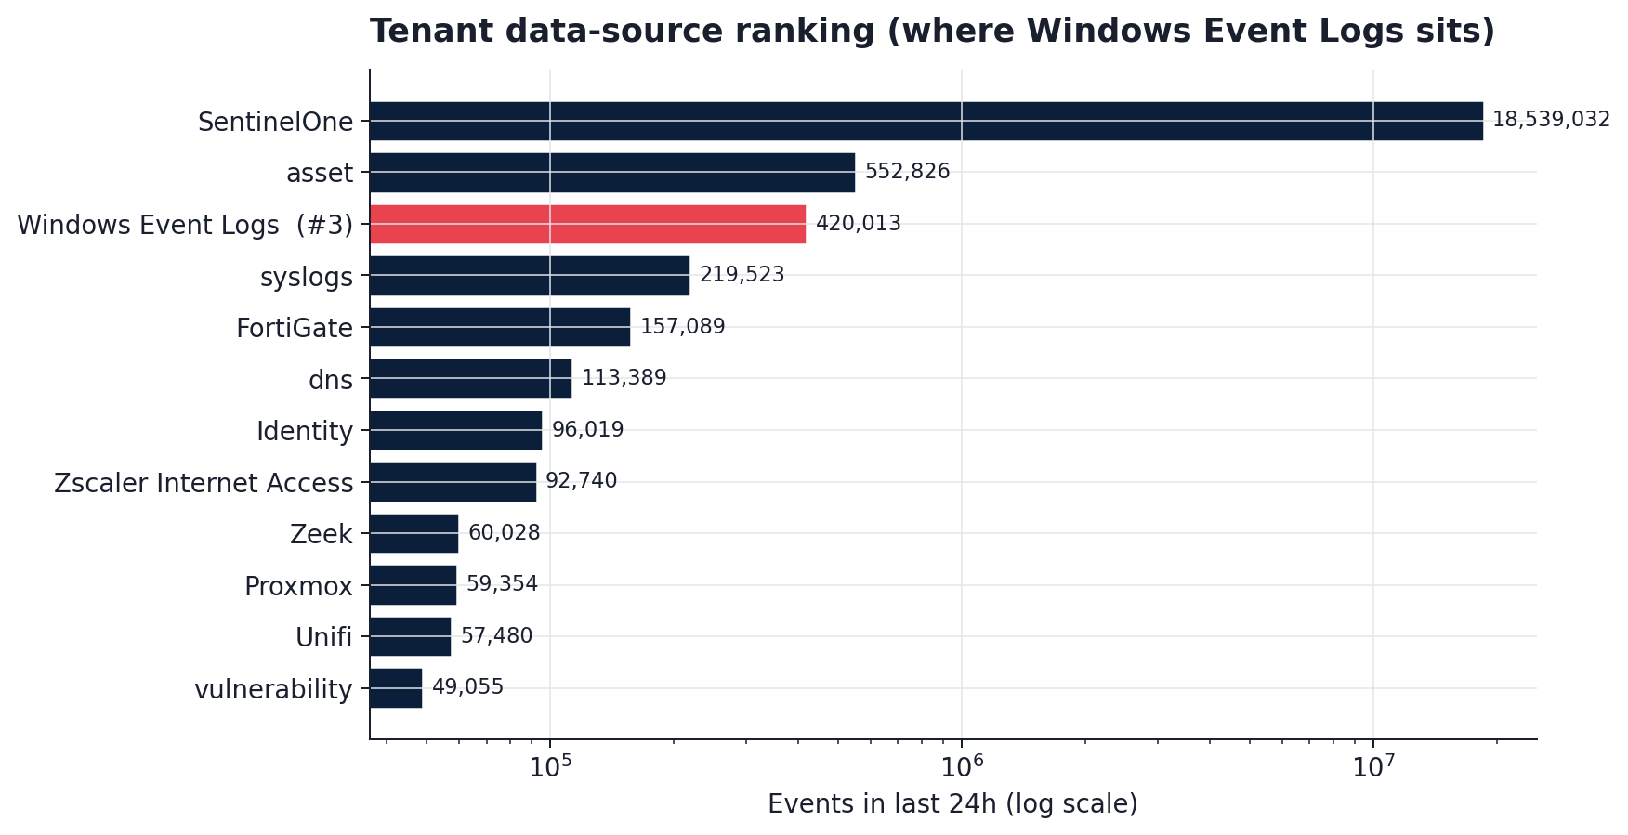
Data-source volume in the last 24 hours (Windows Event Logs highlighted).
Why this matters to the CTO
■ Windows Event Logs lives in the same data lake as EDR, identity, network, and cloud telemetry. Correlation is native, not a bolt-on.
■ Any detection built on Windows Event Logs can chain to SentinelOne endpoint context in a single query; a STAR / Custom Detection Rule needs no extra plumbing.
■ As usage grows, this source's share of daily events will climb in rank without any ingestion changes.
Recommendations, prioritised
[This month] Enrich ingestion where it is shallow
Today, Windows Event Logs events land with a subset of fields populated. Check whether prompt / payload / content is null; adding even one content field unlocks content-based detection and Purple AI hunts against the same data lake.
[Quarterly] Baseline normal
Re-run this report on a fixed cadence. The charts are regenerated from a single JSON artefact, so a 30-day or 90-day view is a parameter flip. Anomalies against the baseline become the input to the next round of policy tuning.

Methodology
Every number and chart in this report was computed directly from the SentinelOne Singularity Data Lake using the Management Console API. No data was moved outside the tenant. No sampling was applied.
Data collection
■ Source: dataSource.name = 'Windows Event Logs', excluding the internal logVolume bookkeeping tag.
■ Window: 2026-04-21T16:57 to 2026-04-22T16:57 UTC (24h).
■ Transport: POST /sdl/v2/api/queries (Long Running Query API) authenticated with Bearer token scoped to the account.
■ Aggregations executed in parallel (max 3 concurrent) to respect the per-user rate limit. Timeline rendered via 24 hour-size client-side slices (the engine does not expose a native timebucket function).
Provenance
A single JSON artefact (reports/Windows_Event_Logs_24h/data.json) captures the raw aggregation output: query text, match counts, elapsed time, and every returned row. The charts and this document are pure rendering steps over that artefact, so the numbers can be reproduced at any time.
Dimensions observed
■ Present: event_type
■ Absent: src_ip, action, user, src_host

