**Screenshots, logic, and validation for DRUID D2 final survey sent to sample.**

Last change: 22/10/2024

Note: Progress bar and previous/next buttons present on every page. All questions mandatory.

Page 1: Mandatory participant information sheet. “Yes” sends them to Page 3, “No” sends them to Page 2.

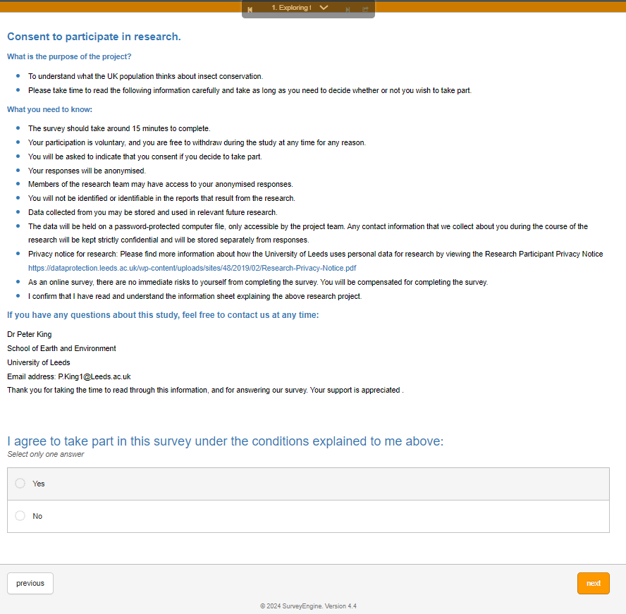

Page 2: “Yes” exits the survey. “No” returns to Page 1.

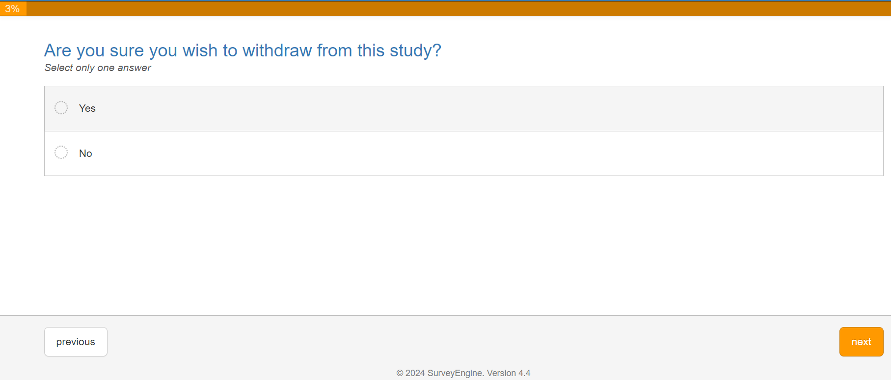

Page 3:

Age question validation: *“($Q1Age =~ /^[0-9]+$/ && $Q1Age < 100)”* with warning *“Only numbers allowed, within a reasonable range, and no spaces.”.* Hidden variable called “AgeDoubleCheck” which sends respondents under 18 to the survey exit screen.

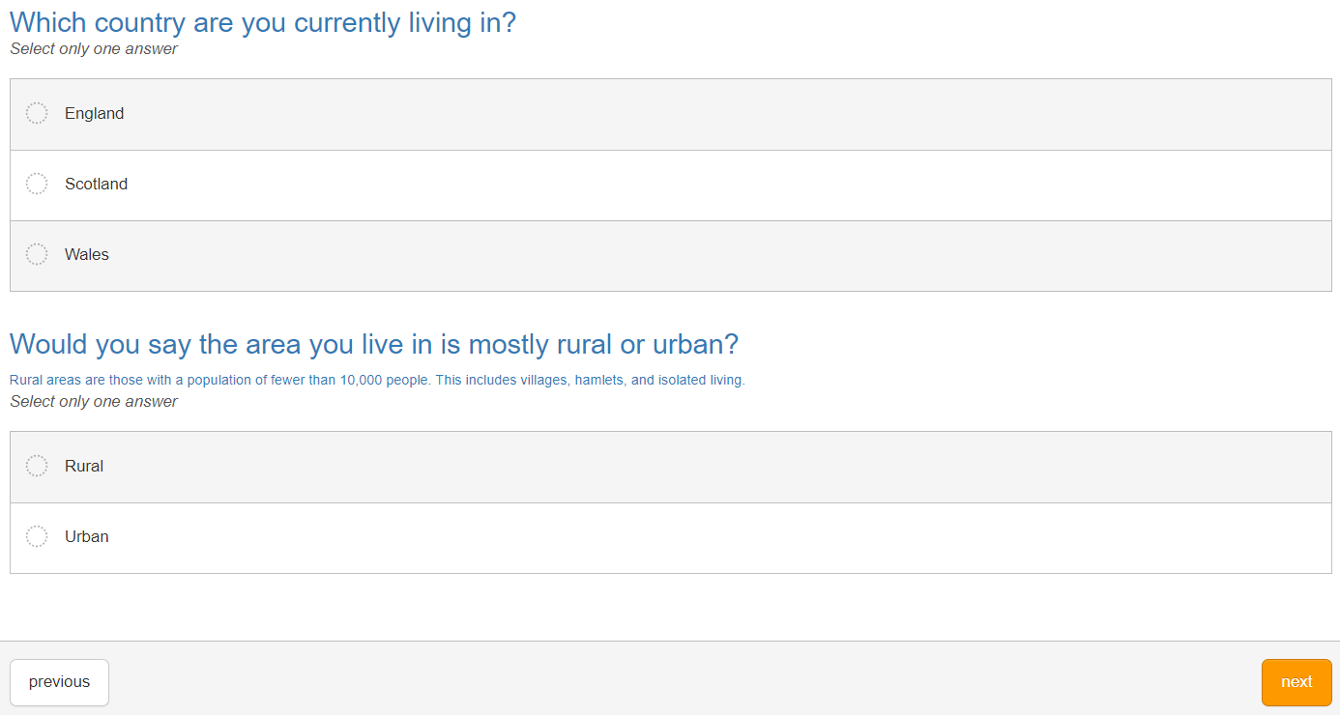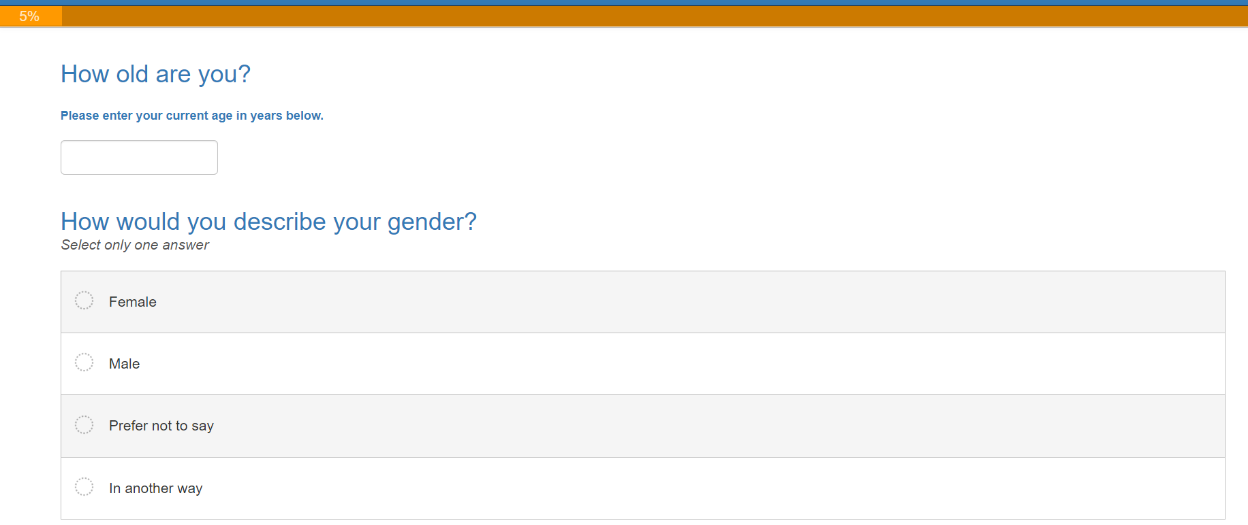

Page 4: Survey exit screen for under 18s.

Page 5: Postcode validation with code *“$Q8Postcode =~ /^(?=.*[A-Z])(?=.*\d)[A-Z\d]{2,4}$/i”* warning *“Please Enter Correct Format; must include letters and numbers, and no spaces.”*

Ethnicity options: *“White - British/English/Welsh/Scottish/Northern Irish, White – Irish, White – Gypsy, Roma, Showmen, or Irish Traveller, White - any other white background, Mixed - White and Black Caribbean, Mixed - White and Black African, Mixed - White and Asian, Mixed - any other mixed background, Asian or Asian British – Indian, Asian or Asian British – Pakistani, Asian or Asian British – Bangladeshi, Asian or Asian British – Chinese, Asian or Asian British - any other Asian background, Black or Black British – Caribbean, Black or Black British – African, Black or Black British - any other Black background, Other ethnic group – Arab, Any other ethnic group”*

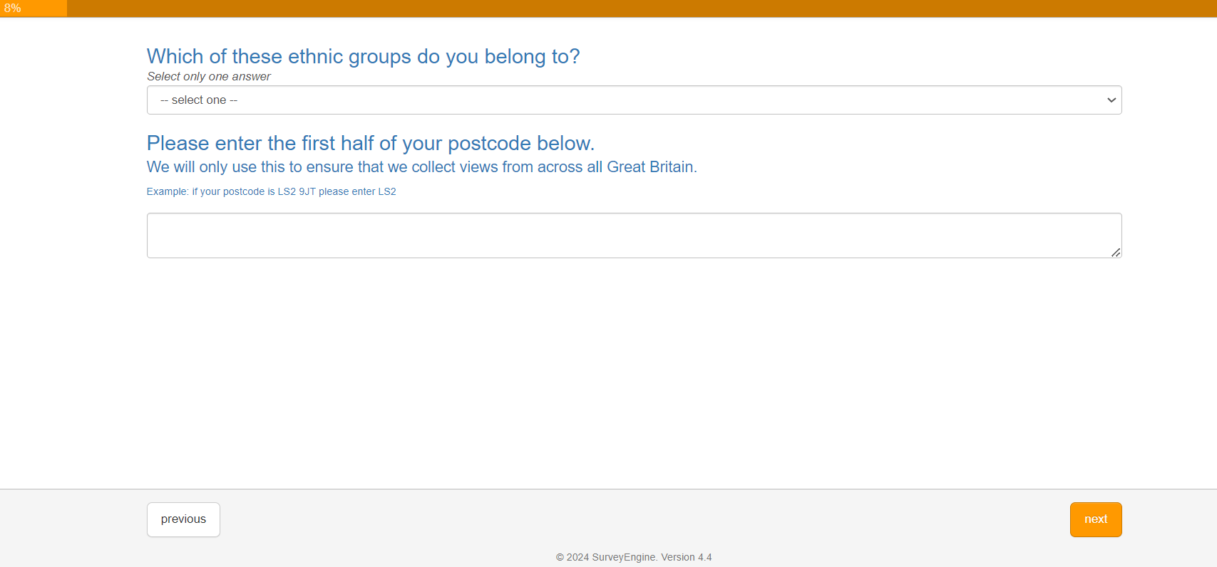

Page 6:

*Occupation options: “Homemaker/housewife or househusband, Student/Full time education, Retired, Unemployed/on benefit, Factory/manual worker, Crafts/tradesperson/skilled worker, Office/clerical/administration, Middle management, Senior management, Professional”*

Income options: “£0 to £1,000, £1,001 to £1,500, £1,501 to £2,000, £2,001 to £2,500, £2,501 to £3,000, £3,001 to £3,500, £3,501 to £4,000, £4,001 to £6,000, £6,001 or more, Prefer not to say.”

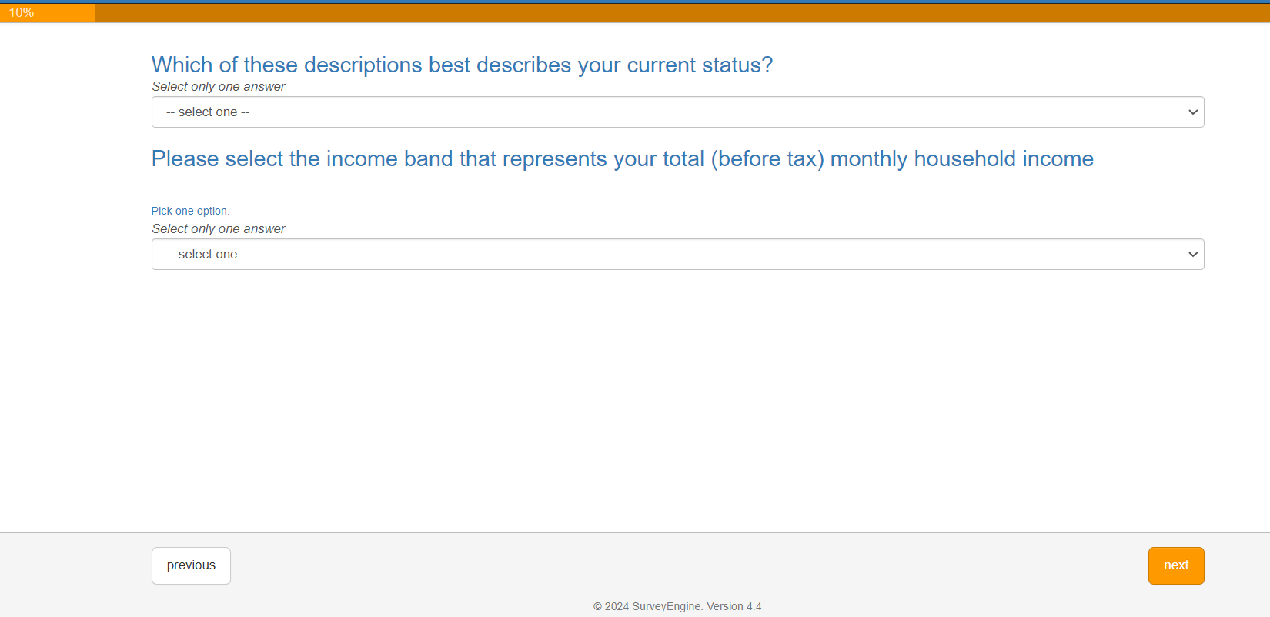

Page 7: Validation for all three questions *“($Q10Insect_Species1 =~ /^[a-zA-Z\s-]+$/)”*

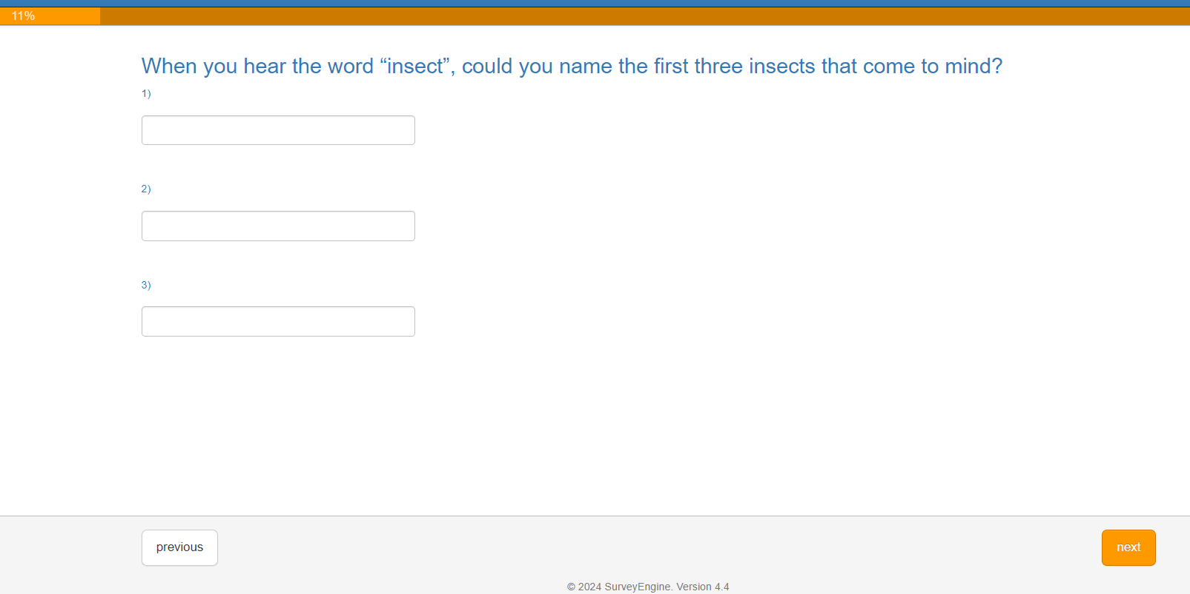

Page 8: Validation for all three *“($Q9Insect_Word1 =~ /^[a-zA-Z\s-]+$/)”.* Note that these are labelled “Q9” because Q9 and Q10 swapped order from pilot to main survey. Note that responses to both Q9 and Q10 are limited to ‘20x cols and 1x rows’ which limit text entry length.

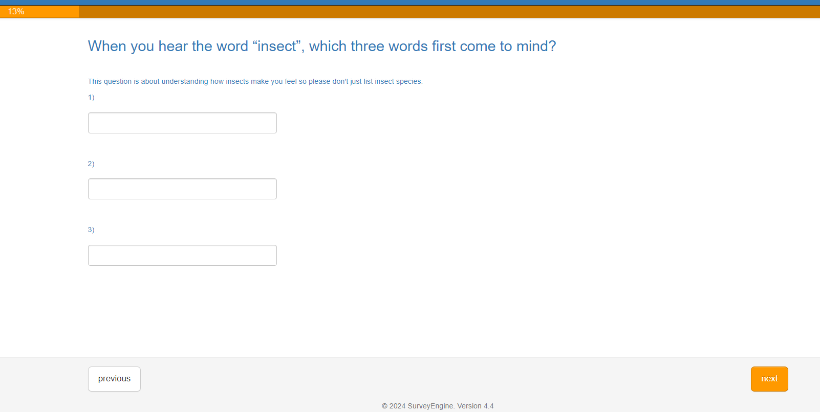

Page 9: “Please confirm” is used as an attention check and does not have branching logic.

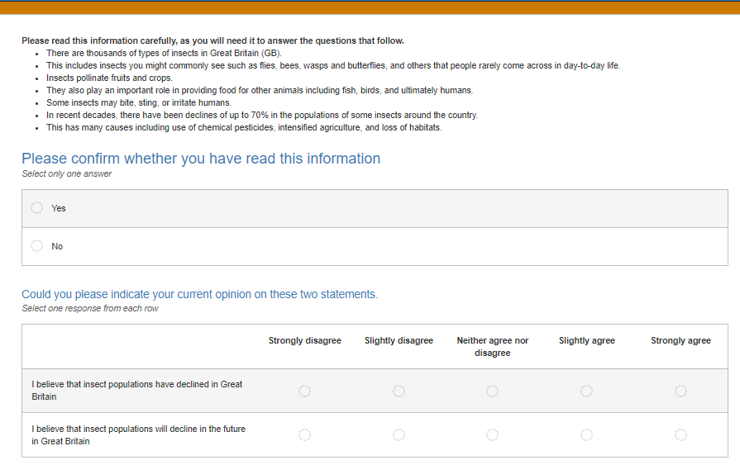

Page 10: Insect ID quiz. Possible responses: *“Ant, Bee, Beetle, Wasp, I don’t know”.*

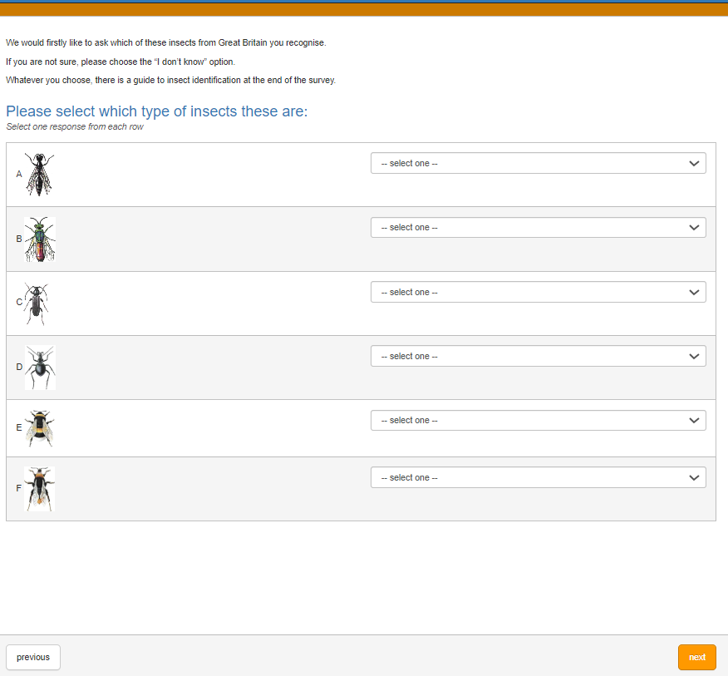

Page 11: Cropped screenshot with no answers present. The answers from Page 10 are piped through with correct/incorrect indicated with possible text for row 1 *“'Ant: incorrect', 'Bee: incorrect', 'Beetle: incorrect', 'Wasp: correct', 'I don’t know: incorrect.'”*

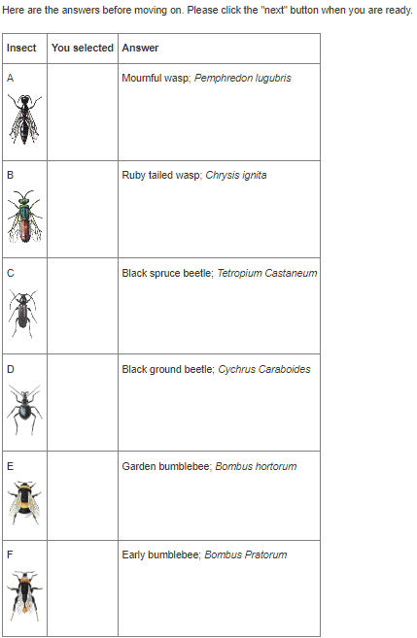

Page 12: 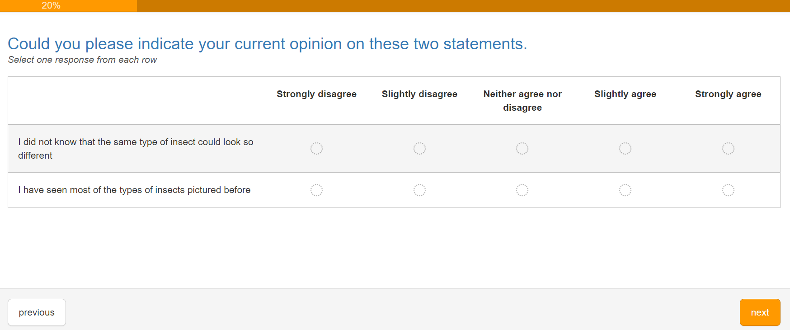

Page 13: No branching logic used just an attention check.

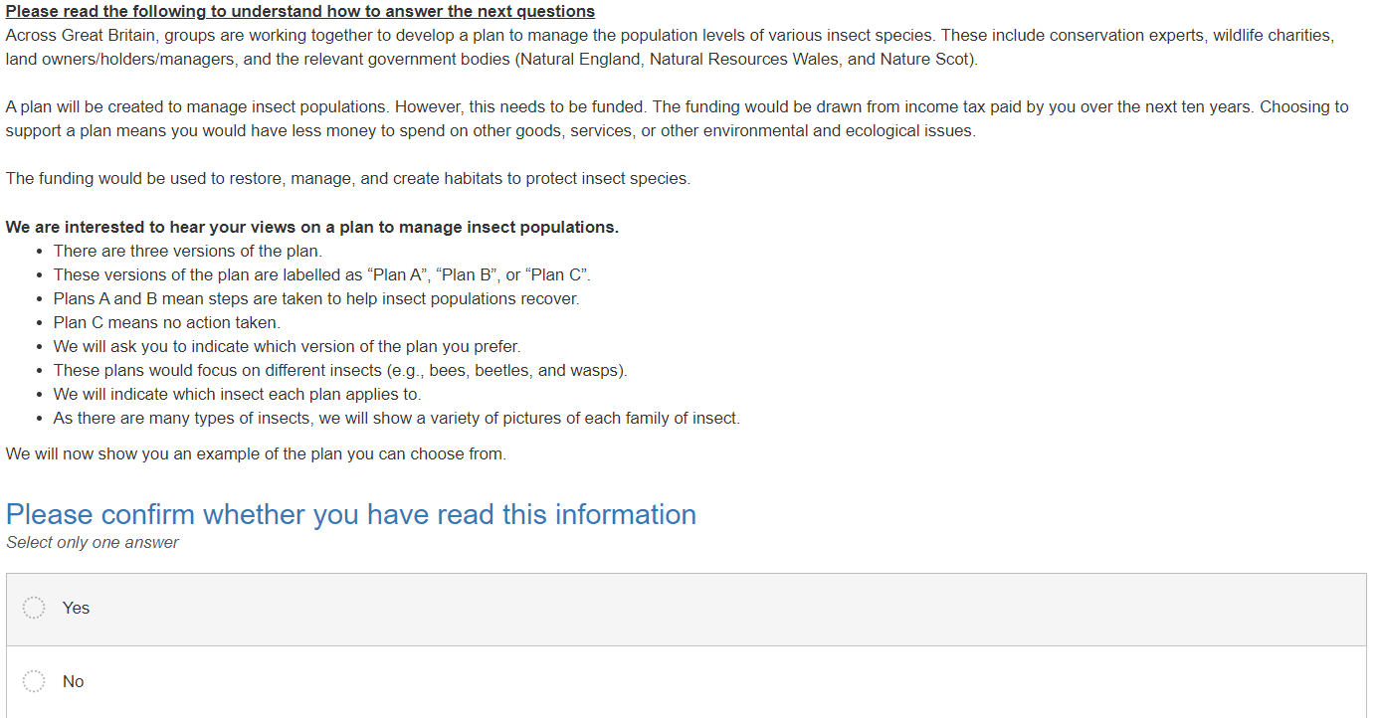

Page 14: Understanding of the CE alternatives with possible responses: *“Strongly disagree, Slightly disagree, Neither agree nor disagree, Slightly agree, Strongly agree”.*

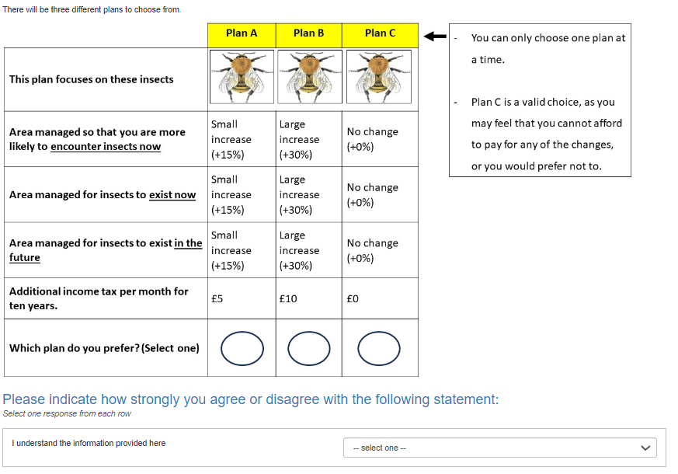

Page 15: Understanding of the insect attribute with possible responses: *“Strongly disagree, Slightly disagree, Neither agree nor disagree, Slightly agree, Strongly agree”.*

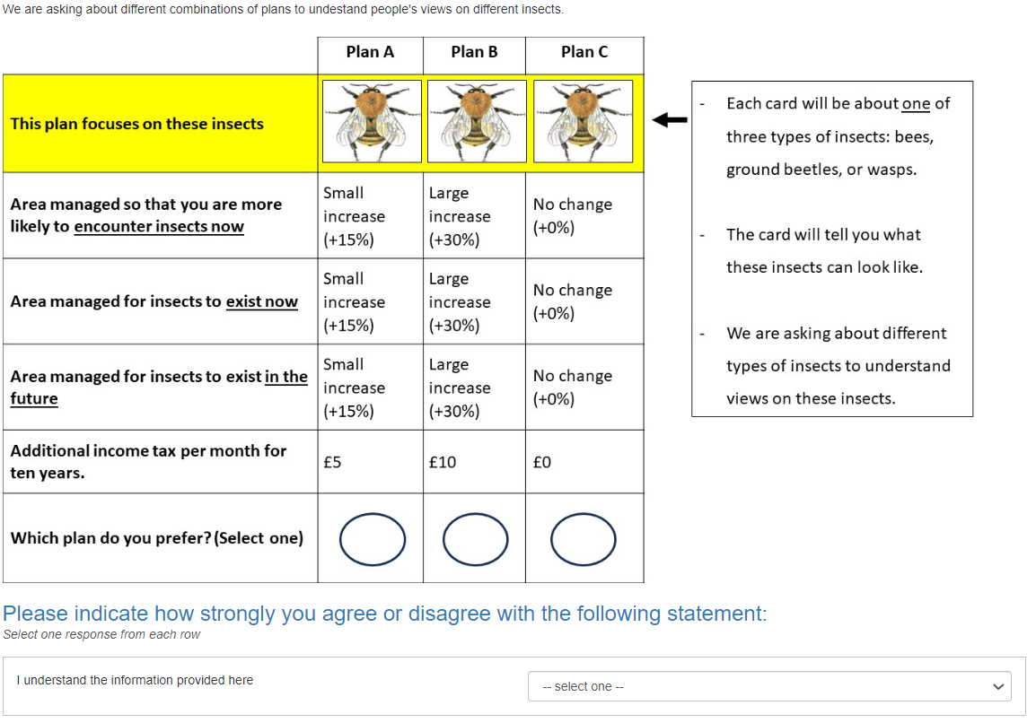

Page 16: Understanding of the interaction/recreation use attribute with possible responses: *“Strongly disagree, Slightly disagree, Neither agree nor disagree, Slightly agree, Strongly agree”.*

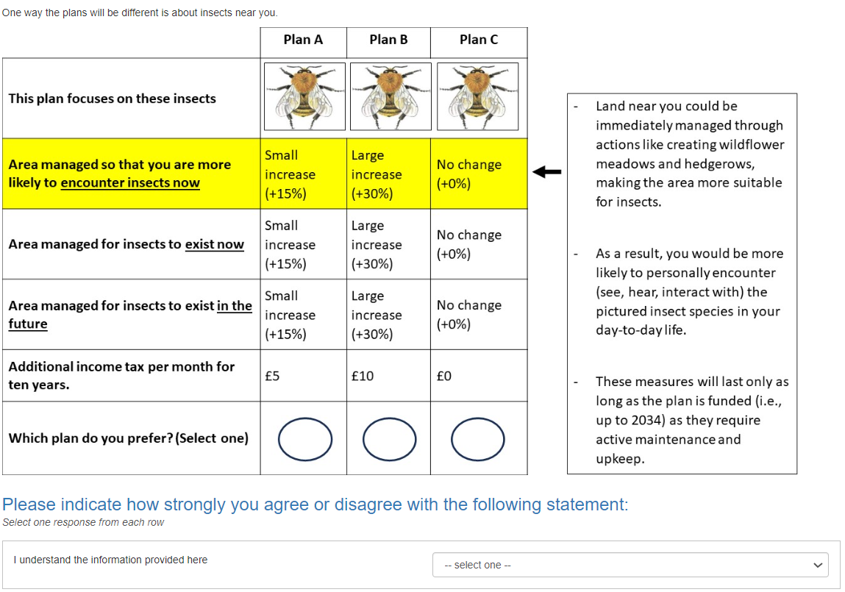

Page 17: Understanding of the existence attribute with possible responses: *“Strongly disagree, Slightly disagree, Neither agree nor disagree, Slightly agree, Strongly agree”.*

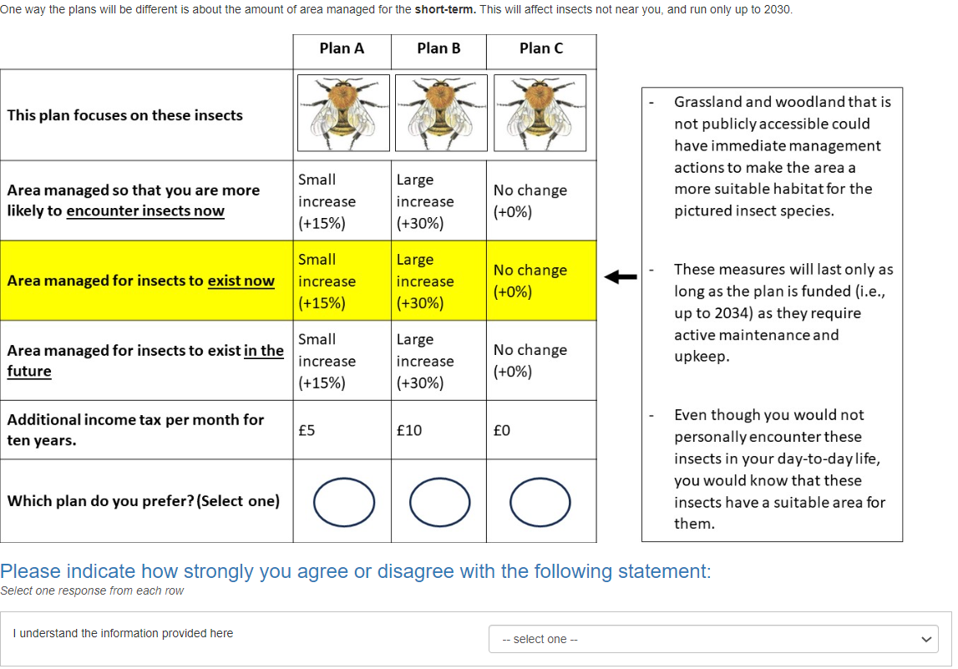

Page 18: Understanding of the bequest attribute with possible responses: *“Strongly disagree, Slightly disagree, Neither agree nor disagree, Slightly agree, Strongly agree”.* 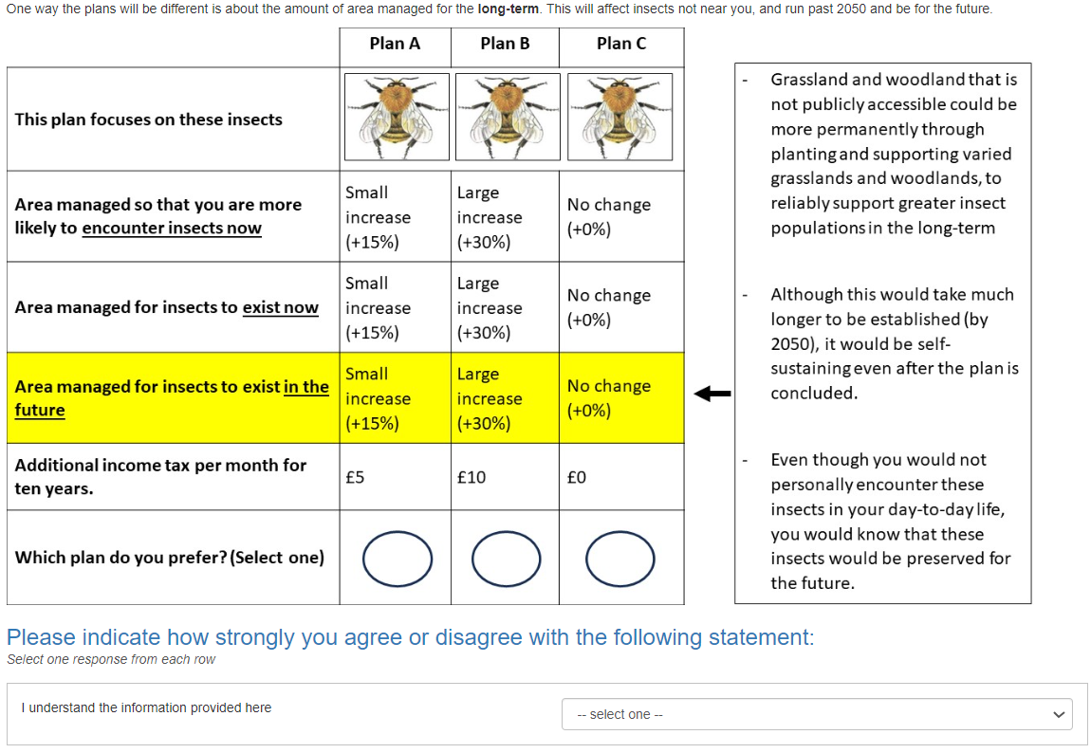

Page 19: Understanding of the tax attribute with possible responses: *“Strongly disagree, Slightly disagree, Neither agree nor disagree, Slightly agree, Strongly agree”.* 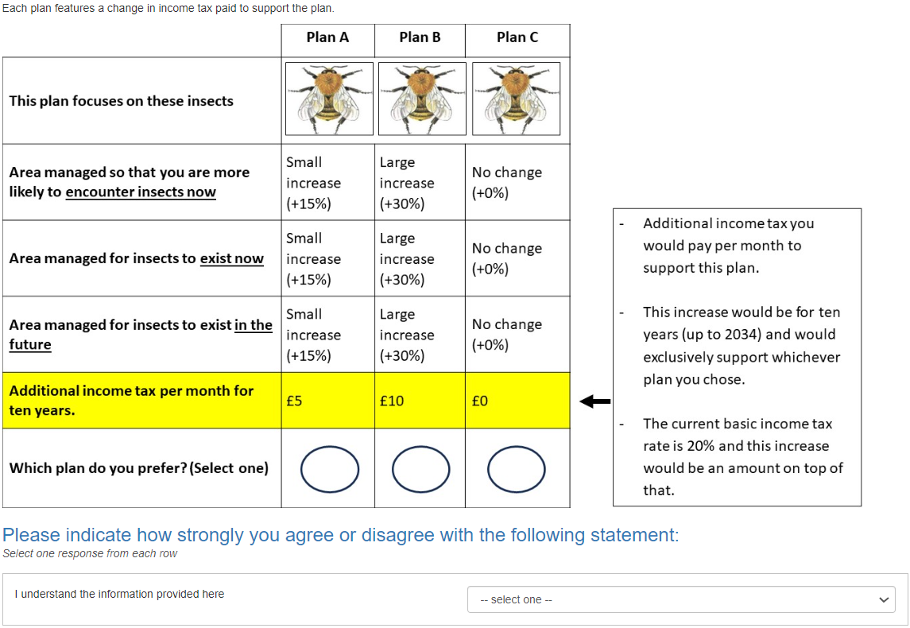

Page 20: Understanding of the CE choices with possible responses: *“Strongly disagree, Slightly disagree, Neither agree nor disagree, Slightly agree, Strongly agree”.* A “No” response loops back to Page 13. A “Yes” response goes to Page 21.

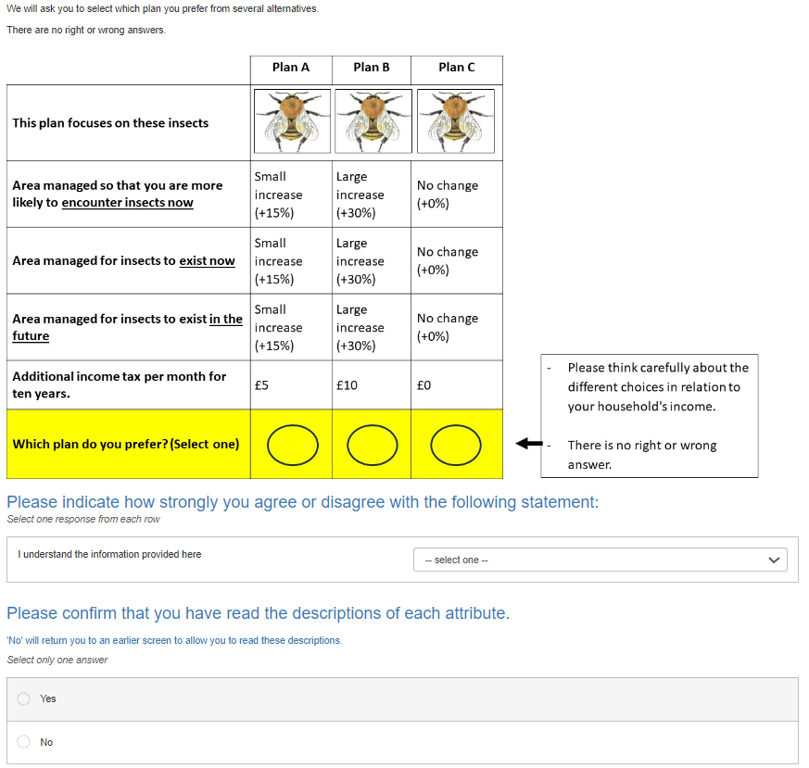

Page 21: Understanding of the perceived policy consequentiality and efficacy.

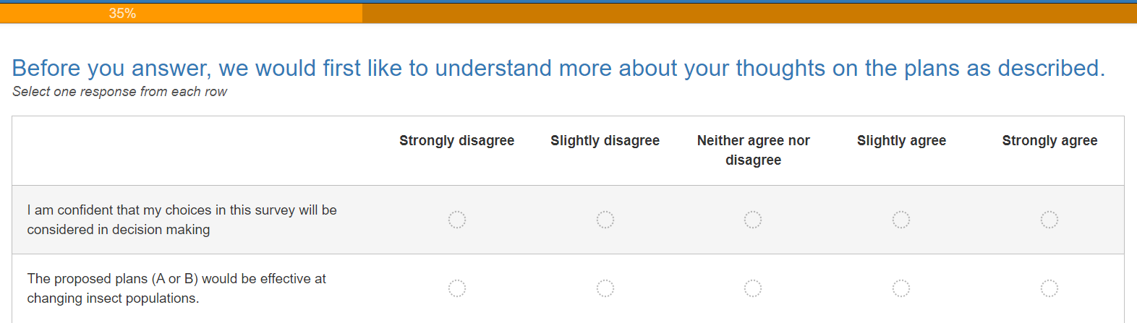

Pages 22 – 31: 9 mandatory CE tasks.

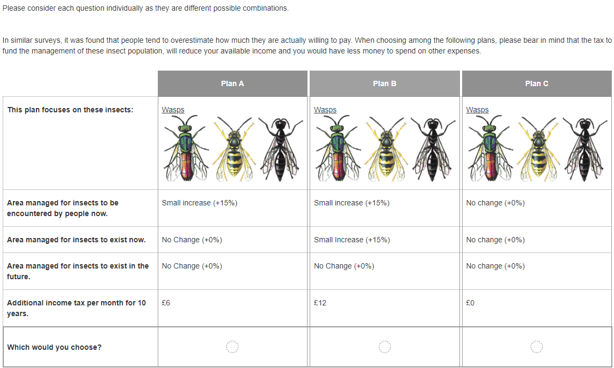

Page 31: Protest responses only shown if the respondent chose Plan C in every choice task. All options send the respondent to Page 33 except “Other” which goes to a text entry question on Page 32.

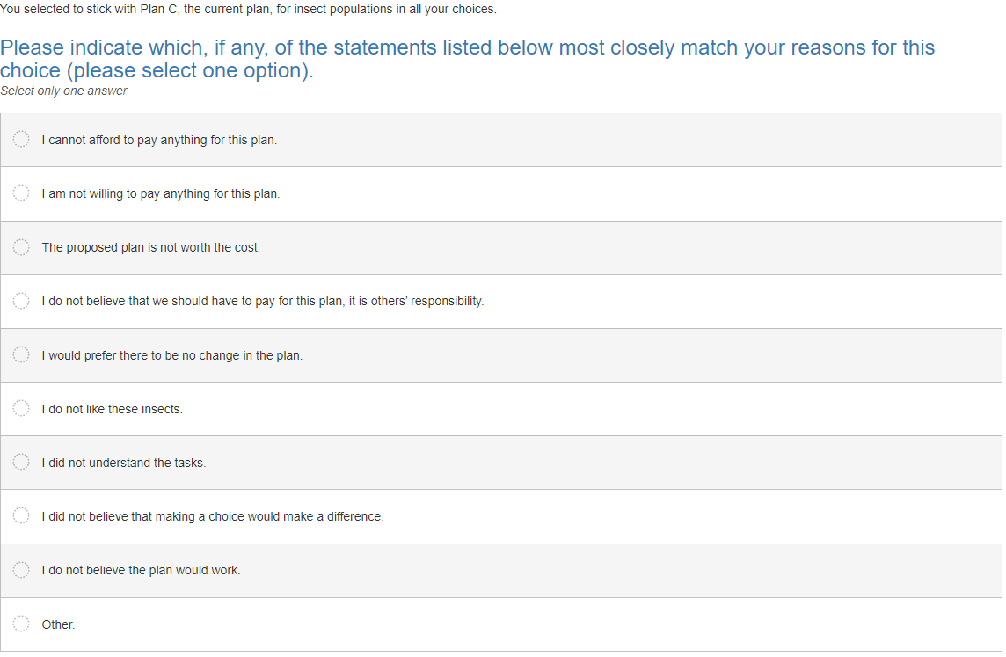

Page 32: Only shown if (a) respondent chose Plan C in every choice, and (b) they chose “Other” on Page 31.



Page 33: Sliding scale debriefing questions.

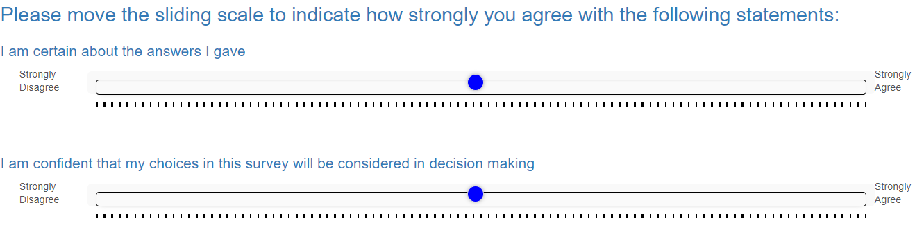

Page 34: Attribute non-attendance questions. 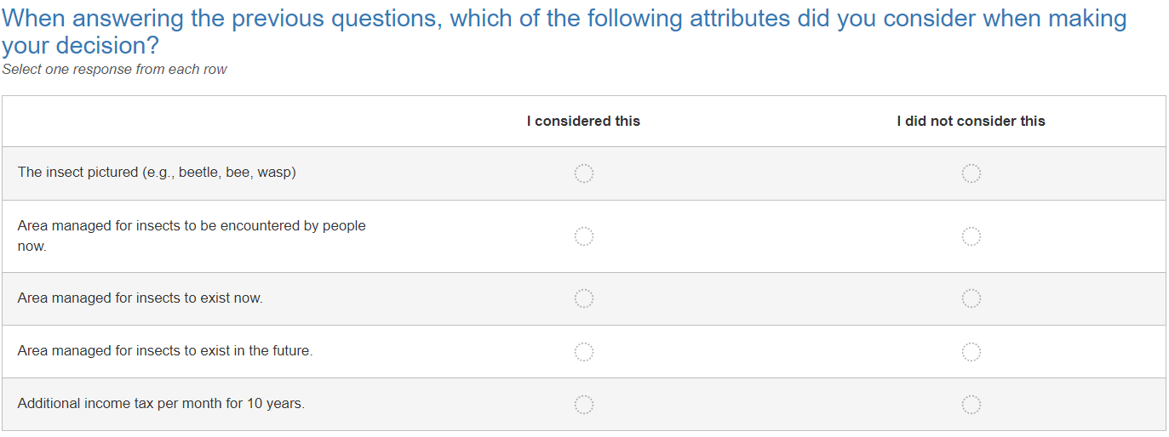

Page 35 – 46: Biowell wellbeing sliding scales. Text is small here to fit into the printout. Note that both the pictured insect (beetles -> bees -> wasps) and the statement (encountering outside, exist now, exist in the future) varied each task.

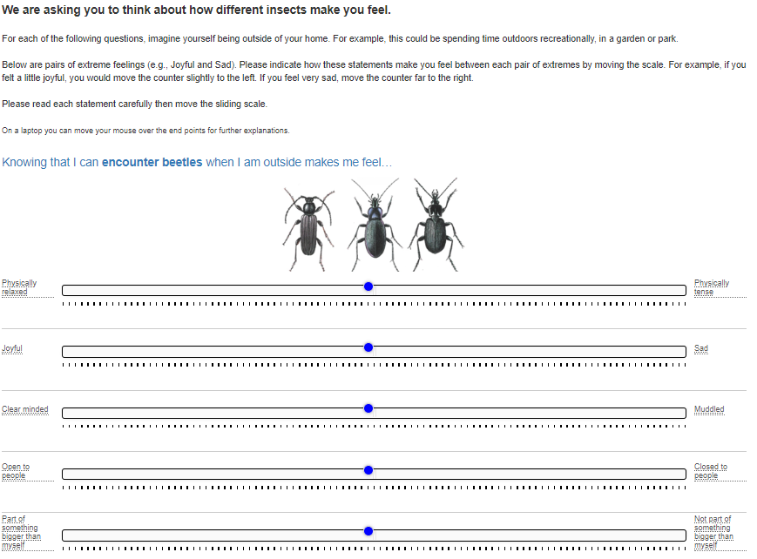

Page 46: Wellbeing debriefing questions.

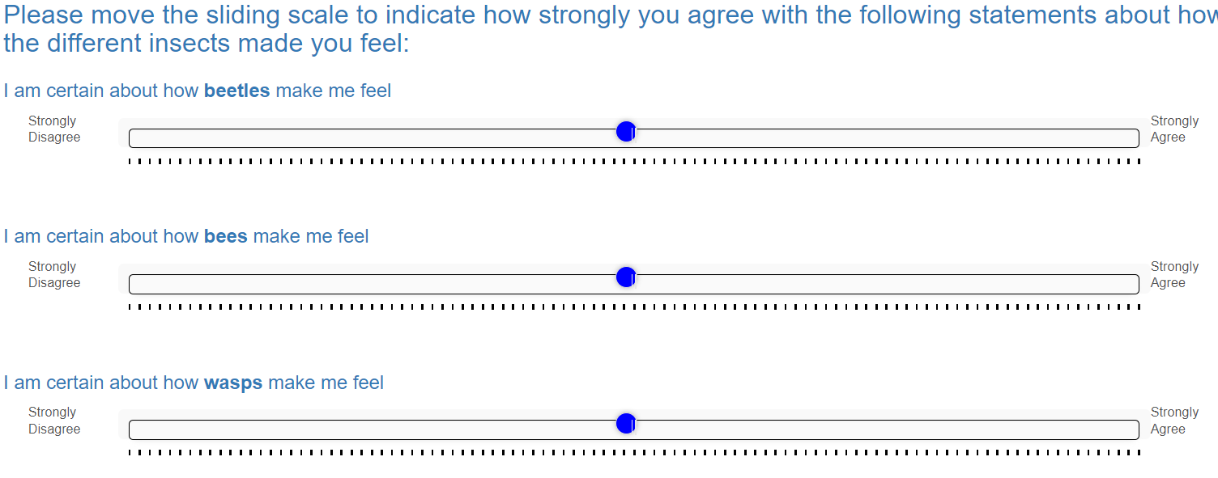

Pages 47 – 49 perceptions of beetles / bees / wasps.

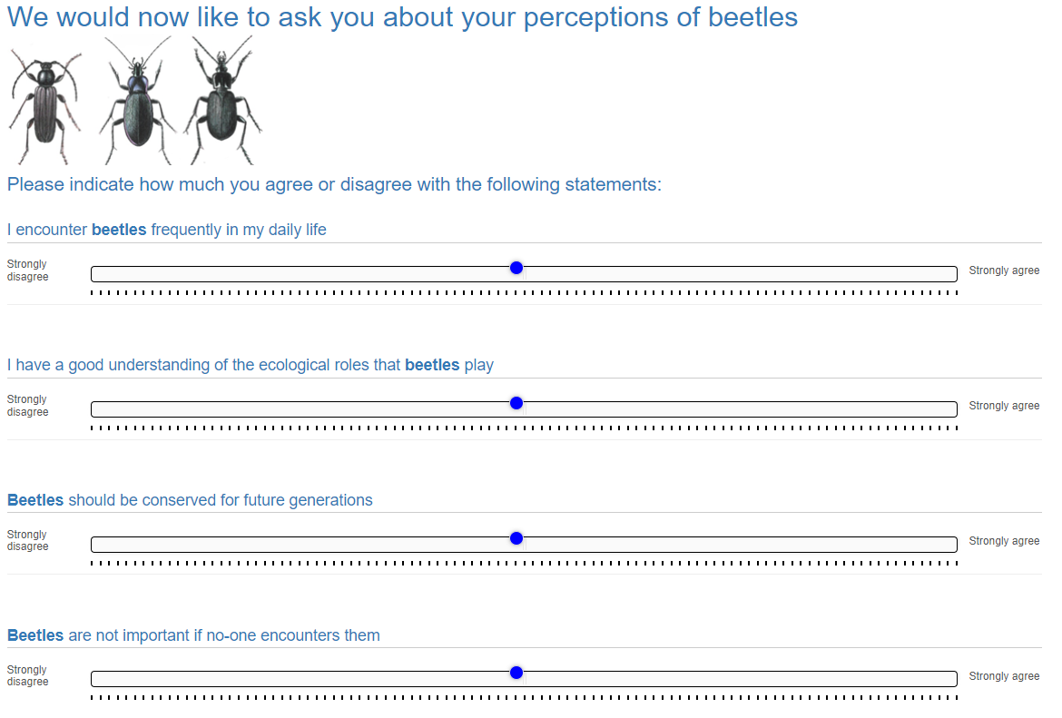

Page 50: 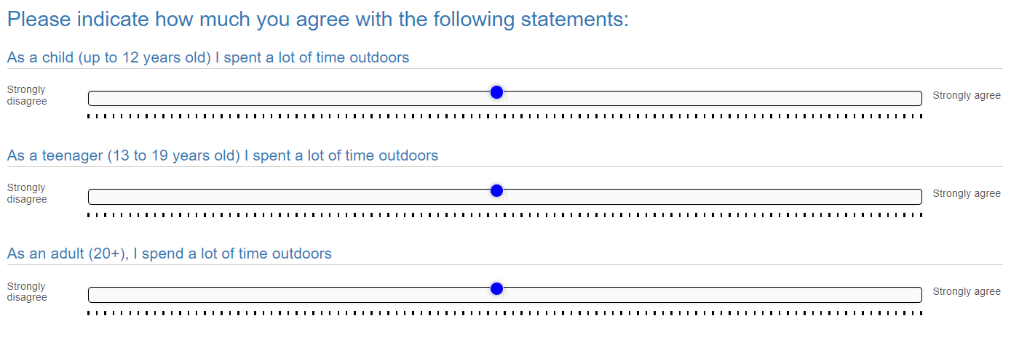

Page 51:

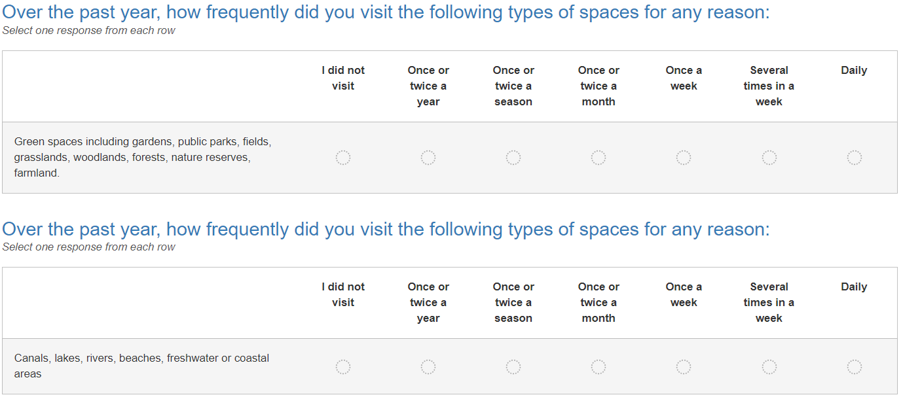

Page 52: 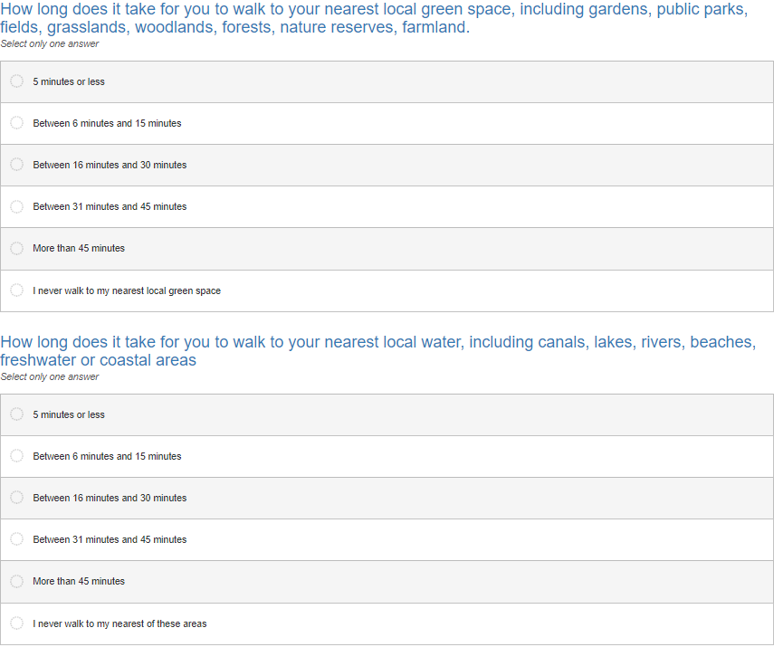

Page 53: 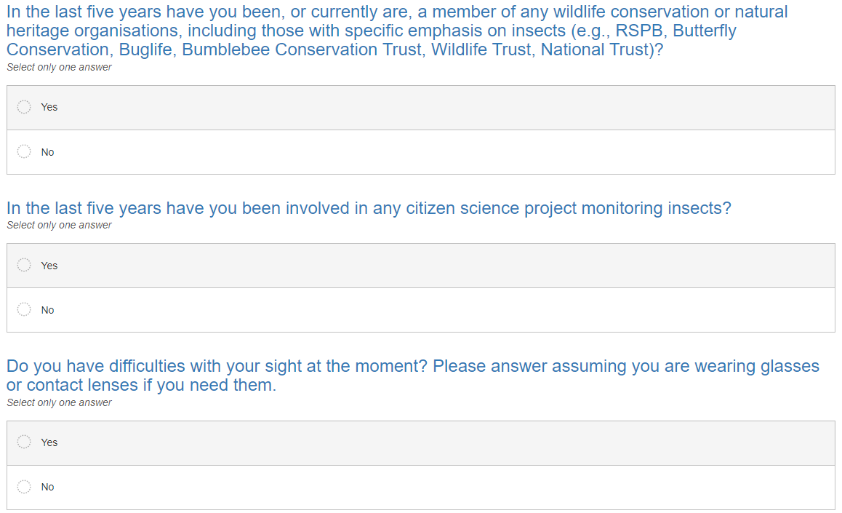

Page 53: Education drop down options were: *“No qualifications, 1 - 4 Levels / CSEs / GCSEs, NVQ Level 1, 5 + O Levels / CSEs / GCSEs, NVQ Level 2, AS Levels, Higher Diploma, Diploma Apprenticeship, 2 + A Levels, NVQ Level 3, BTEC National Diploma, Degree, Higher Degree, NVQ level 4-5, BTEC Higher Level, professional qualifications (e.g. teaching, nursing, accountancy), Doctoral degree or equivalent., Other qualifications (vocational/work related, foreign qualifications or level unknown)”* 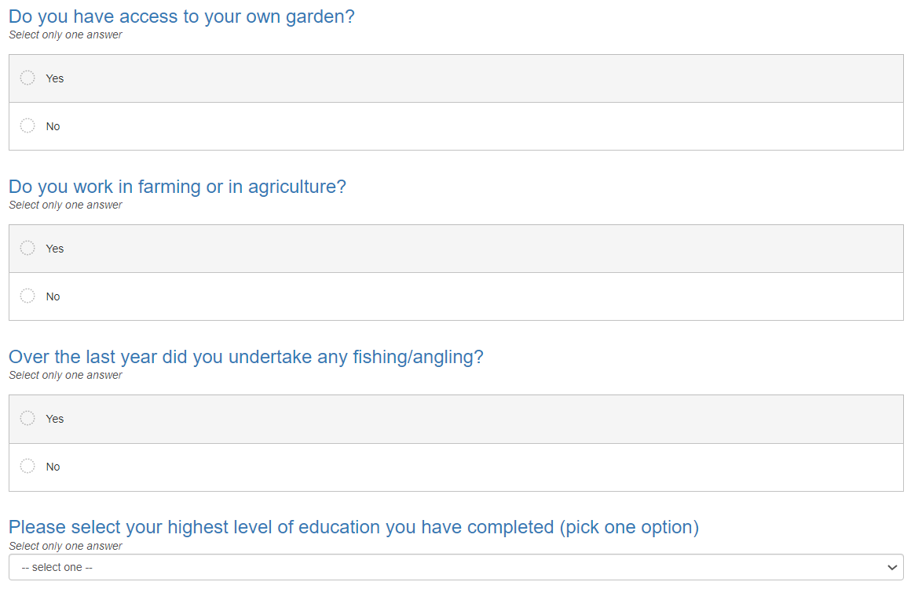

Page 55: Introduction to discounting questions.

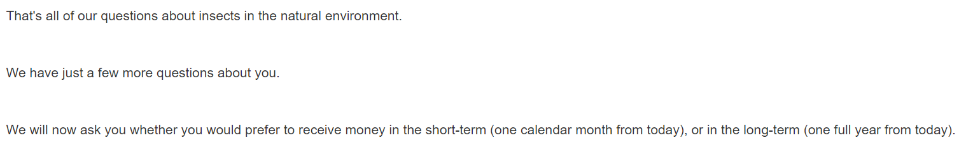

Page 56: Discounting questions. Note that the row order was randomsied.

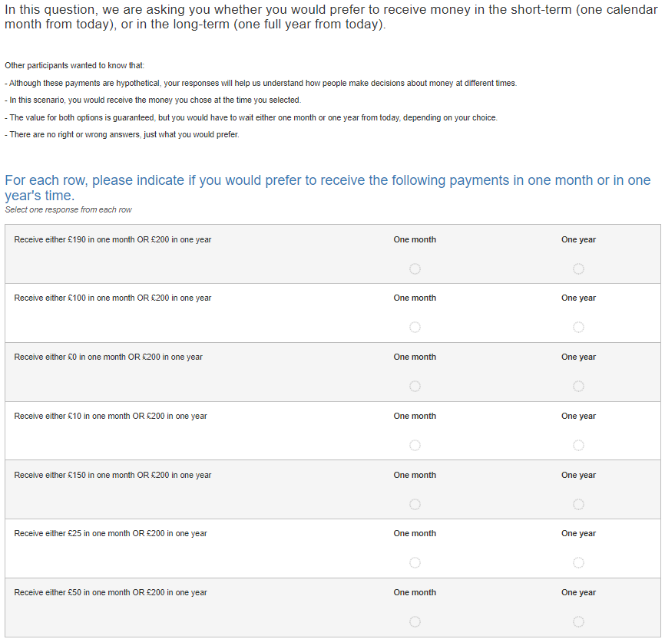

Page 57: Final questions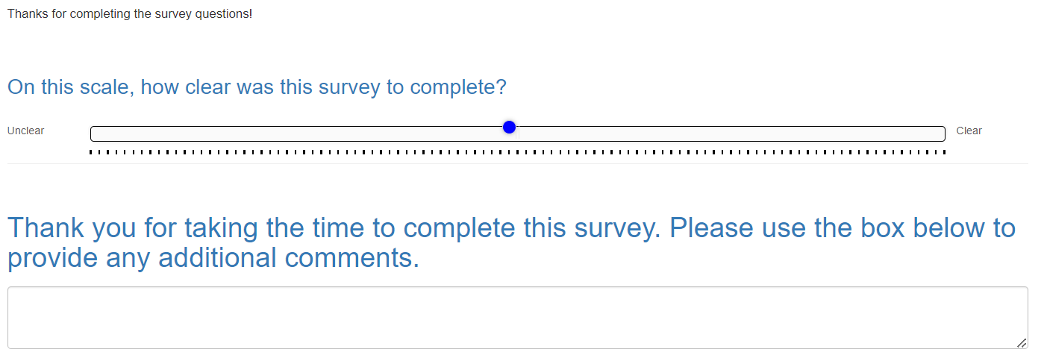

Page 58: Final screen shown to respondents.

