Appendix A: Survey Instrument
This appendix presents the full survey instrument for the DRUID insects survey. Questions are presented in the order shown to respondents, with response options listed beneath each question. Selected screenshots of the survey interface are included as figures where the visual presentation is methodologically relevant (e.g., choice cards, insect identification images, BIO-WELL scales). All questions were mandatory and could not be skipped. The survey was administered online using SurveyEngine.

To reproduce elements of this survey please cite the supporting paper: Heterogeneous Preferences for Use and Non-use Values Provided by Insects forthcoming at People and Nature authored by Peter King, Tom D. Breeze, Theresa Robinson, Martin Dallimer on the NERC-funded DRUID project.
Data: Peter King. (2026). pmpk20/DruidD2: DruidD2 (22_06_2026). Zenodo. https://doi.org/10.5281/zenodo.20799845

A1. Consent and Screening

A1.1 Participant Information and Consent
Respondents were shown a participant information sheet:
Consent to participate in research.
What is the purpose of the project?
- To understand what the GB population thinks about insect conservation.
- Please take time to read the following information carefully and take as long as you need to decide whether or not you wish to take part.
What you need to know:
- The survey should take around 15 minutes to complete.
- Your participation is voluntary, and you are free to withdraw during the study at any time for any reason.
- You will be asked to indicate that you consent if you decide to take part.
- Your responses will be anonymised.
- Members of the research team may have access to your anonymised responses.
- You will not be identified or identifiable in the reports that result from the research.
- Data collected from you may be stored and used in relevant future research.
- The data will be held on a password-protected computer file, only accessible by the project team. Any contact information that we collect about you during the course of the research will be kept strictly confidential and will be stored separately from responses.
- Privacy notice for research: Please find more information about how the University of Leeds uses personal data for research by viewing the Research Participant Privacy Notice [Link to relevant policy document].
- As an online survey, there are no immediate risks to yourself from completing the survey. You will be compensated for completing the survey.
- I confirm that I have read and understand the information sheet explaining the above research project.
If you have any questions about this study, feel free to contact us at any time:
Thank you for taking the time to read through this information, and for answering our survey. Your support is appreciated .
I agree to take part in this survey under the conditions explained to me above:
○ Yes
○ No

Note: Selecting “Yes” proceeded to the survey. Selecting “No” directed respondents to the withdrawal confirmation screen.

A1.2 Withdrawal Confirmation
Are you sure you wish to withdraw from this study?
○ Yes
○ No

Note: Selecting “Yes” exited the survey. Selecting “No” returned to the consent screen.

A2. Socio-demographics

A2.1 Age, Gender, Country, and Urban/Rural
Q1. How old are you?
Open text entry (numeric). Respondents under 18 were screened out.
Q2. How would you describe your gender?
○ Female
○ Male
○ Prefer not to say
○ In another way
Q3. Which country are you currently living in?
○ England
○ Scotland
○ Wales
Q4. Would you say the area you live in is mostly rural or urban?
○ Rural
○ Urban
Note: Rural areas defined as those with a population of fewer than 10,000 people, including villages, hamlets, and isolated living.

A2.2 Ethnicity and Postcode
Q5. Which of these ethnic groups do you belong to?
Drop-down selection with the following options: White – British/English/Welsh/Scottish/Northern Irish; White – Irish; White – Gypsy, Roma, Showmen, or Irish Traveller; White – any other white background; Mixed – White and Black Caribbean; Mixed – White and Black African; Mixed – White and Asian; Mixed – any other mixed background; Asian or Asian British – Indian; Asian or Asian British – Pakistani; Asian or Asian British – Bangladeshi; Asian or Asian British – Chinese; Asian or Asian British – any other Asian background; Black or Black British – Caribbean; Black or Black British – African; Black or Black British – any other Black background; Other ethnic group – Arab; Any other ethnic group.
Q6. Please enter the first half of your postcode below.
Open text entry. Validated to require both letters and numbers with no spaces.

A2.3 Occupation and Income
Q7. Which of these descriptions best describes your current status?
Drop-down selection: Homemaker/housewife or househusband; Student/Full time education; Retired; Unemployed/on benefit; Factory/manual worker; Crafts/tradesperson/skilled worker; Office/clerical/administration; Middle management; Senior management; Professional.
Q8. Please select the income band that represents your total (before tax) monthly household income.
Drop-down selection: £0 to £1,000; £1,001 to £1,500; £1,501 to £2,000; £2,001 to £2,500; £2,501 to £3,000; £3,001 to £3,500; £3,501 to £4,000; £4,001 to £6,000; £6,001 or more; Prefer not to say.

A3. Insect Knowledge and Perceptions

A3.1 Insect Species Naming
Q9. When you hear the word "insect", could you name the first three insects that come to mind?
Three open text entry fields (1, 2, 3). Validated to accept only letters, spaces, and hyphens. Entry length limited to 20 characters per field.

A3.2 Insect Word Associations

Q10. When you hear the word "insect", which three words first come to mind?
This question is about understanding how insects make you feel so please don’t just list insect species.
Three open text entry fields (1, 2, 3). Same validation as Q9.
Note: Q9 and Q10 swapped order between the pilot and main survey. The variable labels in the dataset retain the pilot ordering (Q9 for word associations, Q10 for species).

A4. Information Provision and Beliefs about Insect Decline

A4.1 Information Script and Attention Check
Respondents were shown the following information:
Please read this information carefully, as you will need it to answer the questions that follow.
- There are thousands of types of insects in Great Britain (GB).
- This includes insects you might commonly see such as flies, bees, wasps and butterflies, and others that people rarely come across in day-to-day life.
- Insects pollinate fruits and crops.
- They also play an important role in providing food for other animals including fish, birds, and ultimately humans.
- Some insects may bite, sting, or irritate humans.
- In recent decades, there have been declines of up to 70% in the populations of some insects around the country.
- This has many causes including use of chemical pesticides, intensified agriculture, and loss of habitats.
Please confirm whether you have read this information:
○ Yes
○ No

Note: This served as an attention check. No branching logic was applied to responses.

A4.2 Beliefs about Insect Decline
Q11. Could you please indicate your current opinion on these two statements.
5-point Likert scale (Strongly disagree to Strongly agree):
• I believe that insect populations have declined in Great Britain.
• I believe that insect populations will decline in the future in Great Britain.
Scale: Strongly disagree | Slightly disagree | Neither agree nor disagree | Slightly agree | Strongly agree

A5. Insect Identification Quiz

A5.1 Identification Task
Respondents were shown six illustrated images of insects (labelled A–F) and asked to identify each. The illustrations were sourced from Olsen et al. (2001).
Q12. Please select which type of insect these are:
For each of the six images, respondents selected from a drop-down menu: Ant; Bee; Beetle; Wasp; I don’t know.
The six insects shown were:
A: Mournful wasp (Pemphredon lugubris) – correct answer: Wasp
B: Ruby tailed wasp (Chrysis ignita) – correct answer: Wasp
C: Black spruce beetle (Tetropium Castaneum) – correct answer: Beetle
D: Black ground beetle (Cychrus Caraboides) – correct answer: Beetle
E: Garden bumblebee (Bombus hortorum) – correct answer: Bee
F: Early bumblebee (Bombus Pratorum) – correct answer: Bee

A5.2 Answer Reveal
Respondents were shown the correct answers alongside their own selections, with each marked as correct or incorrect. The table displayed: Insect label | You selected | Answer (common name and Latin binomial).

A5.3 Post-quiz Perceptions
Q13. Could you please indicate your current opinion on these two statements.
5-point Likert scale (Strongly disagree to Strongly agree):
• I did not know that the same type of insect could look so different.
• I have seen most of the types of insects pictured before.
Scale: Strongly disagree | Slightly disagree | Neither agree nor disagree | Slightly agree | Strongly agree

A6. Choice Experiment Introduction and Comprehension

A6.1 Scenario Description
Respondents were presented with the following scenario:
Across Great Britain, groups are working together to develop a plan to manage the population levels of various insect species. These include conservation experts, wildlife charities, land owners/holders/managers, and the relevant government bodies (Natural England, Natural Resources Wales, and Nature Scot).
A plan will be created to manage insect populations. However, this needs to be funded. The funding would be drawn from income tax paid by you over the next ten years. Choosing to support a plan means you would have less money to spend on other goods, services, or other environmental and ecological issues.
The funding would be used to restore, manage, and create habitats to protect insect species.
Key instructions provided to respondents:
- There are three versions of the plan, labelled “Plan A”, “Plan B”, or “Plan C”.
- Plans A and B mean steps are taken to help insect populations recover.
- Plan C means no action taken.
- Each card will be about one of three types of insects: bees, ground beetles, or wasps.
- As there are many types of insects, we will show a variety of pictures of each family of insect.
- An example of the plan was shown.
Please confirm whether you have read this information:
○ Yes
○ No

Note: This attention check had no branching logic.

A6.2 Attribute Comprehension Checks
Respondents were shown a series of screens, each highlighting one attribute of the choice experiment with explanatory text. After each, they indicated their understanding on a 5-point Likert scale (Strongly disagree to Strongly agree).

Plans A, B, C
Explanation that there are three plans, only one can be chosen, and Plan C (no change) is a valid choice.
• I understand the information provided here.
Scale: Strongly disagree | Slightly disagree | Neither agree nor disagree | Slightly agree | Strongly agree
Insect attribute
Explanation that each card features one of three insect types (bees, ground beetles, or wasps) with illustrations showing what these insects look like.
Encountering (use value)
Explanation that land near the respondent could be managed through creating wildflower meadows and hedgerows, making them more likely to personally encounter (see, hear, interact with) the pictured insects. Measures last only as long as the plan is funded (up to 2034).
Existence (non-use value)
Explanation that grassland and woodland not publicly accessible could have management actions to create suitable habitat. Respondents would not personally encounter the insects but would know they have suitable habitat. Measures funded until 2034 with active maintenance required.
Bequest (non-use value)
Explanation that grassland and woodland not publicly accessible could be managed permanently through planting and supporting varied habitats to support insect populations long-term. Established by 2050 and self-sustaining after the plan concludes. Respondents would know insects would be preserved for the future.
Additional income tax
Explanation that additional income tax would be paid monthly for ten years (up to 2034), exclusively supporting the chosen plan. The current basic income tax rate is 20% and the increase would be on top of that.
Choice confirmation
Respondents confirmed they had read and understood all attribute descriptions.
Please confirm that you have read the descriptions of each attribute:
○ Yes
○ No

Note: Selecting “No” looped respondents back to the scenario description. Selecting “Yes” proceeded to the choice tasks.

A7. Policy Consequentiality and Efficacy

A7.1 Consequentiality Beliefs
Q14. Before you answer, we would first like to understand more about your thoughts on the plans as described.
5-point Likert scale (Strongly disagree to Strongly agree):
• I am confident that my choices in this survey will be considered in decision making.
• The proposed plans (A or B) would be effective at changing insect populations.
Scale: Strongly disagree | Slightly disagree | Neither agree nor disagree | Slightly agree | Strongly agree

A8. Choice Experiment Tasks

A8.1 Instructions
Before the first choice task, respondents were reminded:
Please consider each question individually as they are different possible combinations.
In similar surveys, it was found that people tend to overestimate how much they are actually willing to pay. When choosing among the following plans, please bear in mind that the tax to fund the management of these insect populations, will reduce your available income and you would have less money to spend on other expenses.

A8.2 Choice Tasks
Nine mandatory choice experiment tasks were presented. Each task comprised three alternatives (Plan A, Plan B, Plan C) described by five attributes:
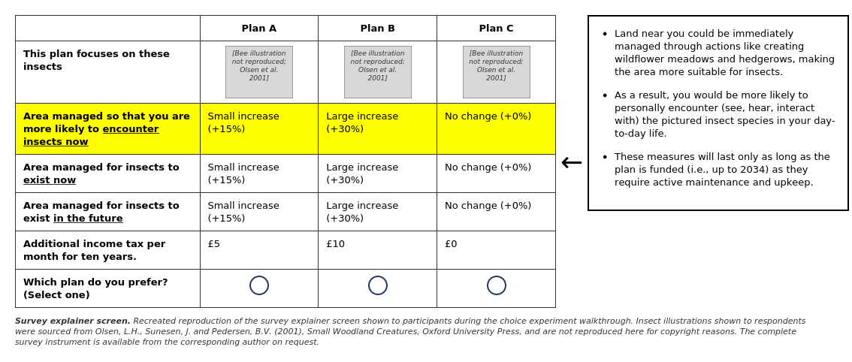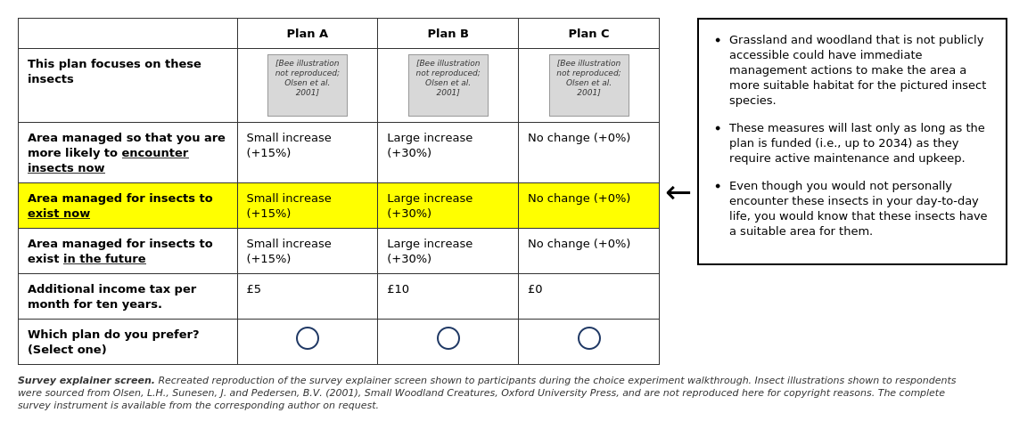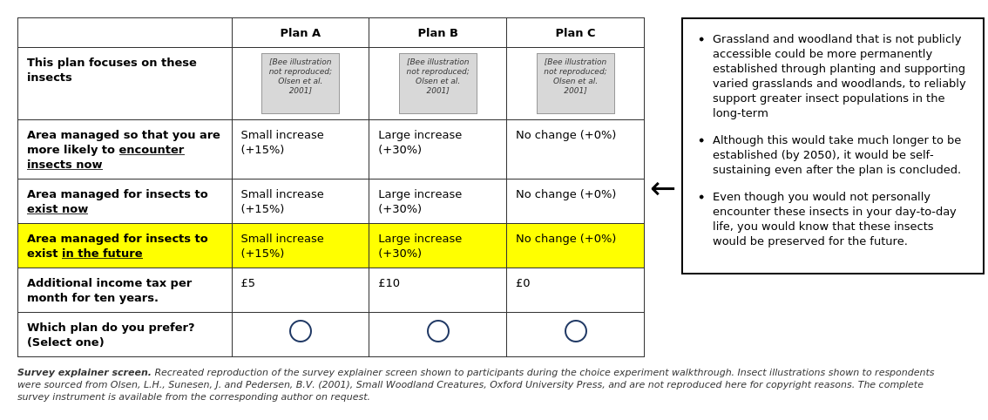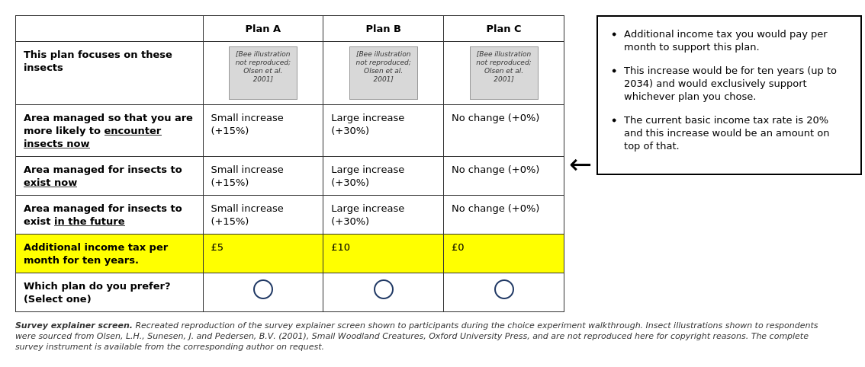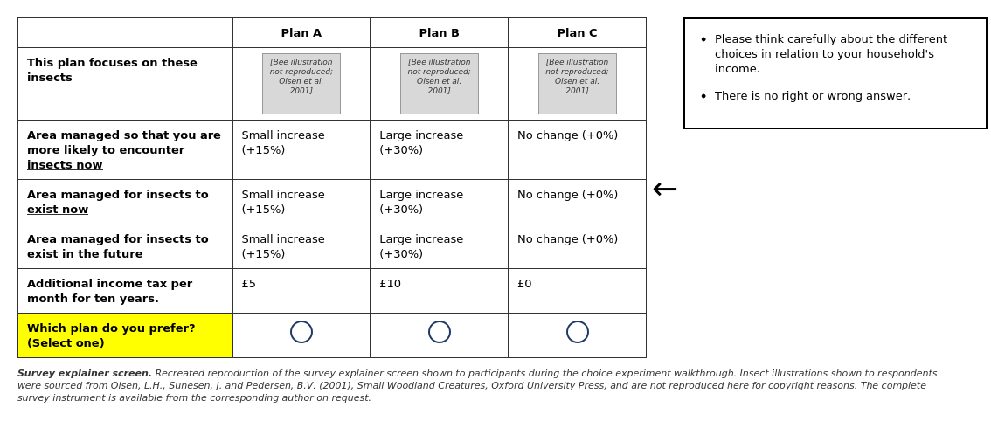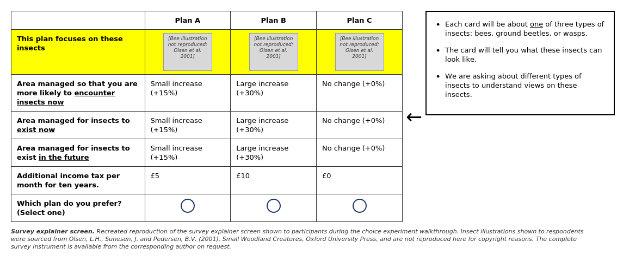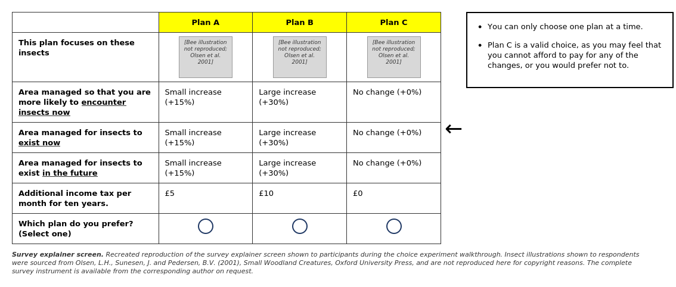

Attribute | Description | Levels
Insect | Three illustrated pictures of the focal insect taxon. | Bees:  Beetles:  Wasps:  [Illustrations for this task were sourced from Olsen, L.H., Sunesen, J. and Pedersen, B.V. (2001), Small Woodland Creatures, Oxford University Press.]
Encounter insects now | Area managed so respondent is more likely to encounter insects. Land near respondent managed through wildflower meadows and hedgerows. | No change (0%), Small increase (+15%), Large increase (+30%)
Insects to exist now | Area managed for insects to exist now. Grassland/woodland not publicly accessible managed to create suitable habitat. Funded until 2034. | No change (0%), Small increase (+15%), Large increase (+30%)
Insects to exist in the future | Area managed for insects to exist in the future. Permanent habitat established by 2050, self-sustaining after plan concludes. | No change (0%), Small increase (+15%), Large increase (+30%)
Additional income tax | Additional income tax per month for ten years. Exclusively supports chosen plan. | £2.50, £5.00, £10.00, £20.00, £40.00, £80.00

Plan C was always the status quo (no change, £0 tax). The insect type was held constant within each task but varied across tasks. Respondents were assigned to one of multiple blocks of choice tasks generated using an efficient experimental design.
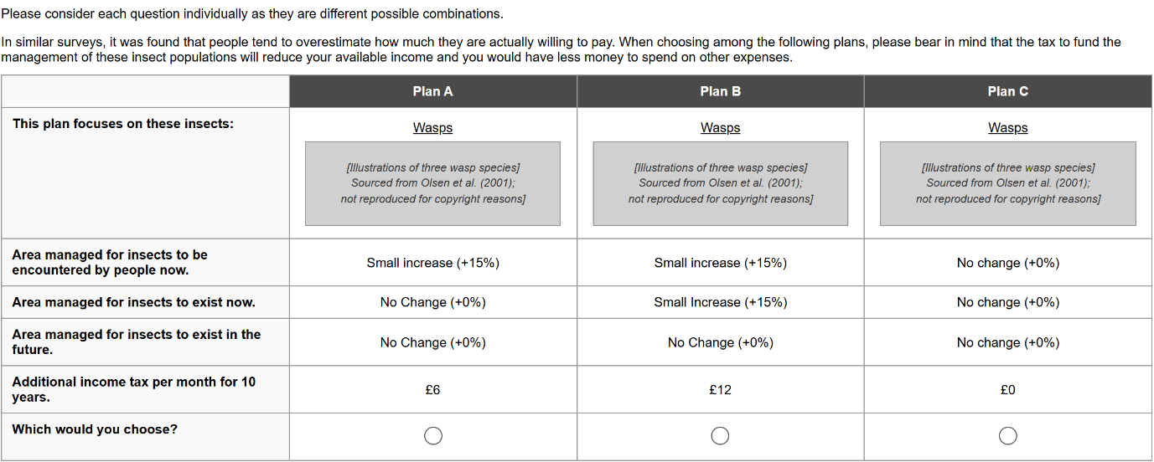

A9. Protest Responses and Debriefing

A9.1 Protest Response Identification
This page was only shown to respondents who selected Plan C in every choice task.
Q15. You selected to stick with Plan C, the current plan, for insect populations in all your choices. Please indicate which, if any, of the statements listed below most closely match your reasons for this choice (please select one option):

○ I cannot afford to pay anything for this plan.
○ I am not willing to pay anything for this plan.
○ The proposed plan is not worth the cost.
○ I do not believe that we should have to pay for this plan, it is others’ responsibility.
○ I would prefer there to be no change in the plan.
○ I do not like these insects.
○ I did not understand the tasks.
○ I did not believe that making a choice would make a difference.
○ I do not believe the plan would work.
○ Other

Note: Selecting “Other” directed respondents to a free-text entry page. All other options proceeded.

A9.2 Other Protest Reason
Shown only if respondent selected “Other”.
Q16. You selected ‘other’, please specify your reason below:
Open text entry field.

A9.3 Debriefing: Certainty and Consequentiality
Respondents moved sliding scale markers to indicate agreement with the following statements:
Q17a. I am certain about the answers I gave.
Sliding scale: Strongly Disagree ←→ Strongly Agree
Q17b. I am confident that my choices in this survey will be considered in decision making.
Sliding scale: Strongly Disagree ←→ Strongly Agree

A9.4 Attribute Non-attendance
Q18. When answering the previous questions, which of the following attributes did you consider when making your decision?
Binary response (I considered this / I did not consider this) for each attribute:
- The insect pictured (e.g., beetle, bee, wasp)
- Area managed for insects to be encountered by people now
- Area managed for insects to exist now
- Area managed for insects to exist in the future
- Additional income tax per month for 10 years

A10. Wellbeing (BIO-WELL) Scales

A10.1 BIO-WELL Tasks
Respondents completed a series of wellbeing assessments using the BIO-WELL framework. Each task combined one insect type (beetles, bees, or wasps) with one value framing (encountering, existing now, existing in the future), producing a 3×3 factorial design (9 tasks per respondent, with order varying by insect: beetles → bees → wasps, and within each insect: encountering → exist now → exist in the future).
Each task presented an illustrated image of the relevant insect type and the stem question:
Knowing that I can [encounter / know that they exist / know that they will exist in the future] [beetles/bees/wasps] when I am outside makes me feel...
Respondents moved five sliding scale markers between the following bipolar pairs:
- Physically relaxed ↔ Physically tense
- Joyful ↔ Sad
- Clear minded ↔ Muddled
- Open to people ↔ Closed to people
- Part of something bigger than myself ↔ Not part of something bigger than myself

A10.2 Wellbeing Certainty
Respondents indicated certainty about their wellbeing responses:
Q19a. I am certain about how beetles make me feel.
Sliding scale: Strongly Disagree ←→ Strongly Agree
Q19b. I am certain about how bees make me feel.
Sliding scale: Strongly Disagree ←→ Strongly Agree
Q19c. I am certain about how wasps make me feel.
Sliding scale: Strongly Disagree ←→ Strongly Agree

A11. Insect-specific Perceptions

A11.1 Perceptions of Beetles, Bees, and Wasps
Separate pages for each insect type (beetles, bees, wasps), each with the header:
We would now like to ask you about your perceptions of [beetles/bees/wasps].
Illustrated images of the relevant insect were shown. Four statements rated on sliding scales (Strongly disagree to Strongly agree):
• I encounter [beetles/bees/wasps] frequently in my daily life.
• I have a good understanding of the ecological roles that [beetles/bees/wasps] play.
• [Beetles/Bees/Wasps] should be conserved for future generations.
• [Beetles/Bees/Wasps] are not important if no-one encounters them.
Scale: Strongly disagree | ←→ | Strongly agree
Note: Each of the three insect types appeared on a separate page with the same four statements.

A12. Outdoor Recreation and Nature Access

A12.1 Time Spent Outdoors
Respondents indicated agreement on sliding scales (Strongly disagree to Strongly agree):
• As a child (up to 12 years old) I spent a lot of time outdoors.
• As a teenager (13 to 19 years old) I spent a lot of time outdoors.
• As an adult (20+), I spend a lot of time outdoors.
Scale: Strongly disagree | ←→ | Strongly agree

A12.2 Visit Frequency
Q20a. Over the past year, how frequently did you visit the following types of spaces for any reason?
Green spaces including gardens, public parks, fields, grasslands, woodlands, forests, nature reserves, farmland.
Response options: I did not visit; Once or twice a year; Once or twice a season; Once or twice a month; Once a week; Several times in a week; Daily.
Q20b. Over the past year, how frequently did you visit the following types of spaces for any reason?
Canals, lakes, rivers, beaches, freshwater or coastal areas.
Response options: I did not visit; Once or twice a year; Once or twice a season; Once or twice a month; Once a week; Several times in a week; Daily.

A12.3 Walking Distance to Nature
Q21a. How long does it take for you to walk to your nearest local green space, including gardens, public parks, fields, grasslands, woodlands, forests, nature reserves, farmland?
Response options: 5 minutes or less; Between 6 minutes and 15 minutes; Between 16 minutes and 30 minutes; Between 31 minutes and 45 minutes; More than 45 minutes; I never walk to my nearest local green space.
Q21b. How long does it take for you to walk to your nearest local water, including canals, lakes, rivers, beaches, freshwater or coastal areas?
Response options: 5 minutes or less; Between 6 minutes and 15 minutes; Between 16 minutes and 30 minutes; Between 31 minutes and 45 minutes; More than 45 minutes; I never walk to my nearest of these areas.

A13. Conservation Engagement, Farming, and Education

A13.1 Conservation Membership and Activities
Q22. In the last five years have you been, or currently are, a member of any wildlife conservation or natural heritage organisations, including those with specific emphasis on insects (e.g., RSPB, Butterfly Conservation, Buglife, Bumblebee Conservation Trust, Wildlife Trust, National Trust)?
○ Yes
○ No
Q23. In the last five years have you been involved in any citizen science project monitoring insects?
○ Yes
○ No
Q24. Do you have difficulties with your sight at the moment? Please answer assuming you are wearing glasses or contact lenses if you need them.
○ Yes
○ No
Q25. Do you have access to your own garden?
○ Yes
○ No
Q26. Do you work in farming or in agriculture?
○ Yes
○ No
Q27. Over the last year did you undertake any fishing/angling?
○ Yes
○ No

A13.2 Education
Q28. Please select your highest level of education you have completed (pick one option).
Drop-down selection: No qualifications; 1–4 Levels / CSEs / GCSEs; NVQ Level 1; 5+ O Levels / CSEs / GCSEs; NVQ Level 2; AS Levels; Higher Diploma; Diploma Apprenticeship; 2+ A Levels; NVQ Level 3; BTEC National Diploma; Degree; Higher Degree; NVQ Level 4–5; BTEC Higher Level; Professional qualifications (e.g. teaching, nursing, accountancy); Doctoral degree or equivalent; Other qualifications (vocational/work related, foreign qualifications or level unknown).

A14. Discounting Task

A14.1 Introduction
Respondents were told:
That’s all of our questions about insects in the natural environment. We have just a few more questions about you.
We will now ask you whether you would prefer to receive money in the short-term (one calendar month from today), or in the long-term (one full year from today).

A14.2 Discounting Questions
Q29. In this question, we are asking you whether you would prefer to receive money in the short-term (one calendar month from today), or in the long-term (one full year from today).
Other participants wanted to know that:
- Although these payments are hypothetical, your responses will help us understand how people make decisions about money at different times.
- In this scenario, you would receive the money you chose at the time you selected.
- The value for both options is guaranteed, but you would have to wait either one month or one year from today, depending on your choice.
- There are no right or wrong answers, just what you would prefer.
For each row, please indicate if you would prefer to receive the following payments in one month or in one year’s time.
Binary choice (One month / One year) for each of the following trade-offs:
- Receive either £190 in one month OR £200 in one year
- Receive either £100 in one month OR £200 in one year
- Receive either £0 in one month OR £200 in one year
- Receive either £10 in one month OR £200 in one year
- Receive either £150 in one month OR £200 in one year
- Receive either £25 in one month OR £200 in one year
- Receive either £50 in one month OR £200 in one year
Note: Row order was randomised across respondents. We later dummy coded the choice of £0 in one month over £200 in one year as an indicator of present bias.

A15. Survey Clarity and Final Comments

A15.1 Survey Feedback
Q30. On this scale, how clear was this survey to complete?
Sliding scale: Unclear ←→ Clear
Q31. Thank you for taking the time to complete this survey.
Please use the box below to provide any additional comments.
Open text entry field.

A15.2 End Screen
Thank You
That concludes the survey
This survey is part of a larger project on how the numbers of insects in the country are changing: https://www.ukri.org/news/nerc-funding-to-help-protect-uk-insect-populations
The work is funded by the Natural Environment Research Council (NERC) and supported by the Universities of Leeds and Reading.
Here is a guide to identifying insects if you would like more information: https://www.buglife.org.uk/bugs/identify-a-bug/

