 | Naive 2stage GLM, inconsistent SE |  |  |  |  | Proper 2stage, consistent SE using bootstrapping
Variables: | Estimate | Std. Error | z value | Pr(>|z|) |  | Estimate | Std..Error | z.value | P.values
(Intercept) | -1.732 | 0.234 | -7.392 | 0.000 *** |  | -1.732 | 0.235 | -7.369 | 0.000 ***
as.factor(AgeBracket)2 | 0.103 | 0.066 | 1.554 | 0.120 |  | 0.103 | 0.066 | 1.562 | 0.118
as.factor(AgeBracket)3 | 0.134 | 0.073 | 1.848 | 0.065 |  | 0.134 | 0.072 | 1.860 | 0.063 *
as.factor(AgeBracket)4 | 0.089 | 0.075 | 1.194 | 0.232 |  | 0.089 | 0.074 | 1.200 | 0.230
as.factor(AgeBracket)5 | 0.193 | 0.085 | 2.28 | 0.023 ** |  | 0.193 | 0.084 | 2.294 | 0.022 **
as.factor(AgeBracket)6 | 0.273 | 0.167 | 1.634 | 0.102 |  | 0.273 | 0.167 | 1.635 | 0.102
as.factor(Education)2 | 0.053 | 0.218 | 0.243 | 0.808 |  | 0.053 | 0.220 | 0.241 | 0.809
as.factor(Education)3 | -0.173 | 0.21 | -0.826 | 0.409 |  | -0.173 | 0.211 | -0.822 | 0.411
as.factor(Education)4 | -0.074 | 0.204 | -0.363 | 0.717 |  | -0.074 | 0.206 | -0.361 | 0.718
as.factor(Education)5 | -0.094 | 0.201 | -0.465 | 0.642 |  | -0.094 | 0.202 | -0.463 | 0.644
as.factor(Ethnicity)2 | 0.003 | 0.133 | 0.025 | 0.980 |  | 0.003 | 0.133 | 0.025 | 0.980
as.factor(Ethnicity)3 | 0.215 | 0.098 | 2.198 | 0.028 ** |  | 0.215 | 0.097 | 2.208 | 0.027 **
as.factor(Ethnicity)4 | 0.384 | 0.140 | 2.750 | 0.006 *** |  | 0.384 | 0.139 | 2.756 | 0.006 ***
as.factor(Ethnicity)5 | 0.379 | 0.231 | 1.643 | 0.100 |  | 0.379 | 0.234 | 1.618 | 0.106
Q16  MicroplasticsCurrentEnvironment | 0.094 | 0.019 | 4.970 | 0.000 *** |  | 0.094 | 0.019 | 4.998 | 0.000 ***
Q16  MicroplasticsCurrentSelf | 0.06 | 0.015 | 3.978 | 0.000 *** |  | 0.06 | 0.015 | 3.996 | 0.000 ***
Q16  MicroplasticsTen | 0.186 | 0.017 | 10.695 | 0.000 *** |  | 0.186 | 0.017 | 10.748 | 0.000 ***
as.factor(Uncertainty)0 | 1.177 | 0.053 | 22.182 | 0.000 *** |  | 1.177 | 0.053 | 22.15 | 0.000 ***
as.factor(Uncertainty)1 | 1.493 | 0.049 | 30.283 | 0.000 *** |  | 1.493 | 0.049 | 30.233 | 0.000 ***
as.factor(Uncertainty)3 | 1.765 | 0.089 | 19.872 | 0.000 *** |  | 1.765 | 0.089 | 19.780 | 0.000 ***
as.factor(Uncertainty)5 | 1.824 | 0.147 | 12.446 | 0.000 *** |  | 1.824 | 0.147 | 12.385 | 0.000 ***
LogBidIncome | 85.644 | 12.695 | 6.746 | 0.000 *** |  | 85.644 | 13.025 | 6.575 | 0.000 ***
I((betareg::predict(stage_1,  type = "response") + MEC)/2) | 1.858 | 0.123 | 15.109 | 0.000 *** |  | 1.858 | 0.121 | 15.342 | 0.000 ***
I(0 - betareg::predict(stage_1,  type = "variance")) | 15.677 | 2.558 | 6.13 | 0.000 *** |  | 15.677 | 2.542 | 6.168 | 0.000 ***

Brief welfare calculations:
Basic model utility function:

Expected option prices for each respondent:

In R code:
EOP <- Y - (Y * exp(- A / B0)) * exp(1 %>% divide_by(B0 %>% raise_to_power(2) %>% multiply_by(2)))

Defining variables as such where results is the bootstrapped model:
B0 <- results["LogBidIncome", "Estimate"] %>% as.numeric()
Y <- Data$Income_Annual
A <- ((results['I((predict(stage_1, type = "response") + MEC)/2)', "Estimate"] %>% as.numeric() * c(Data$MEF + MEC / 2)) +
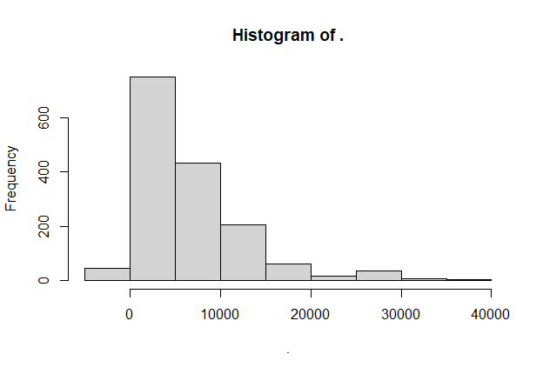
(results['I(0 - predict(stage_1, type = "variance"))', "Estimate"] %>% as.numeric() * c((Data$Uncertainty)))) %>% as.numeric()
[For mean – is this the correct transform here? For uncertainty - should we make it negative or use var.cameron?]

These calculations yield this distribution with summary stats below and histogram provided:
 | min | mean | median | sd | max
EOP: | -3635.32 | 6560.3 | 4940.27 | 6328 | 37241.6

